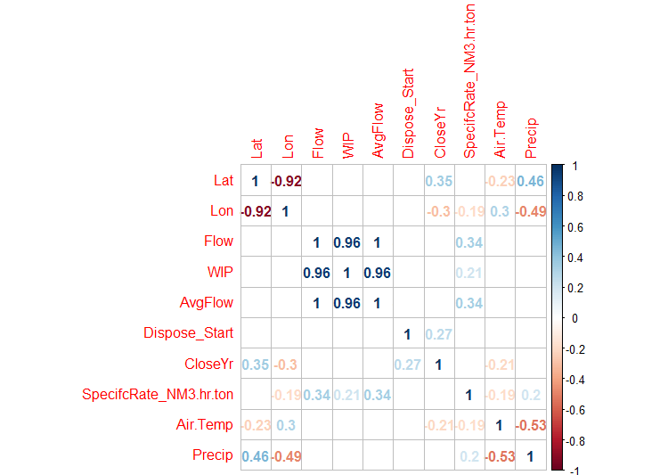
Figure S4. Correlations across the entire CA landfill database for sites with gas recovery data (n=129). Shown in the Figure is the Pearson correlation with the numbers showing only those correlations that were significant at the 95% confidence interval (P=0.05). Note the significant correlation (r=0.96) between WIP (waste in place) with flow and average annual flow of landfill gas. There were no other significant relationships observed.

