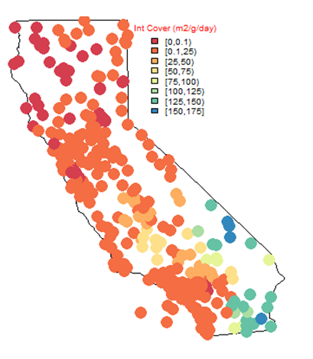

**Figure S6**. Estimated annual area normalized intermediate cover emissions for all California landfills (g m-2 d-1). Note the geographical clustering of the results, which is similar to the trends in the annual climate variability in California (see **Figure S7**).