Text S3: KRISS Measurement Report

KRISS Measurement report: Halocarbons in Dry Whole Air

Laboratory: Korea Research Institute of Standards and Science (KRISS)

Cylinder number : AAL073358

NOMINAL COMPOSITION: Various from 20 X 10-12 to 550 X 10-12 (pmol/mol; ppt)

Measurement  No. 1 | Date | Result  (pmol/mol) | Std. dev.  (%, relative) | # of sub- measurements
Dichlorodifluoromethane (CFC-12) | Sep. 18 | 529.538 | 0.1 | 4
Trichlorofluoromethane (CFC-11) | Sep. 18 | 238.923 | 0.2 | 4
1,1,2-Trichlorotrifluoroethane (CFC-113) | Sep. 18 | 75.094 | 0.2 | 4
Measurement  No. 2 | Date | Result  (pmol/mol) | Std. dev.  (%, relative) | # of sub- measurements
Dichlorodifluoromethane (CFC-12) | Sep. 19 | 529.295 | 0.1 | 2
Trichlorofluoromethane (CFC-11) | Sep. 19 | 238.983 | 0.1 | 2
1,1,2-Trichlorotrifluoroethane (CFC-113) | Sep. 19 | 75.094 | 0.2 | 2
Measurement  No. 2 | Date | Result  (pmol/mol) | Std. dev.  (%, relative) | # of sub- measurements
Dichlorodifluoromethane (CFC-12) | Sep. 20 | 529.563 | 0.1 | 2
Trichlorofluoromethane (CFC-11) | Sep. 20 | 239.213 | 0.1 | 2
1,1,2-Trichlorotrifluoroethane (CFC-113) | Sep. 20 | 75.103 | 0.2 | 2

Gas Mixture Component | Result (assigned value)  pmol/mol | Coverage factor | Assigned expanded Uncertainty [%]
Dichlorodifluoromethane (CFC-12) | 529.44 | 2 | 0.5
Trichlorofluoromethane (CFC-11) | 239.09 | 2 | 0.8
1,1,2-Trichlorotrifluoroethane (CFC-113) | 75.10 | 2 | 1.2

Measurement  No. 1 | Date | Result  (pmol/mol) | Std. dev.  (%, relative) | # of sub- measurements
1,1,1,2-Tetrafluoroethane (HFC-134a) |  | 70.21 | 1.06
Chlorodifluoromethane (HCFC-22) | Sep. 17 | 221.81 | 0.56 | 1
1,1-Difluoro-1-chloroethane (HCFC-142b) |  | 20.23 | 0.45
Measurement  No. 2 | Date | Result  (pmol/mol) | Std. dev.  (%, relative) | # of sub- measurements
1,1,1,2-Tetrafluoroethane (HFC-134a) |  | 65.67 | 0.60
Chlorodifluoromethane (HCFC-22) | Sep. 18 | 210.64 | 0.65 | 1
1,1-Difluoro-1-chloroethane (HCFC-142b) |  | 22.88 | 0.51
Measurement  No. 3 | Date | Result  (pmol/mol) | Std. dev.  (%, relative) | # of sub- measurements
1,1,1,2-Tetrafluoroethane (HFC-134a) |  | 72.08 | 3.4
Chlorodifluoromethane (HCFC-22) | Sep. 19 | 228.43 | 6.6 | 2
1,1-Difluoro-1-chloroethane (HCFC-142b) |  | 22.55 | 0.1

Measurement  No. 4 | Date | Result  (pmol/mol) | Std. dev.  (%, relative) | # of sub- measurements
1,1,1,2-Tetrafluoroethane (HFC-134a) |  | 64.44 | 2.75
Chlorodifluoromethane (HCFC-22) | Sep. 20 | 216.84 | 1.81 | 1
1,1-Difluoro-1-chloroethane (HCFC-142b) |  | 21.96 | 3.07
Measurement  No. 5 | Date | Result  (pmol/mol) | Std. dev.  (%, relative) | # of sub- measurements
1,1,1,2-Tetrafluoroethane (HFC-134a) |  | 68.39 | 10.89
Chlorodifluoromethane (HCFC-22) | Sep. 21 | 231.47 | 7.58 | 1
1,1-Difluoro-1-chloroethane (HCFC-142b) |  | 21.29 | 0.63
Measurement  No. 6 | Date | Result  (pmol/mol) | Std. dev.  (%, relative) | # of sub- measurements
1,1,1,2-Tetrafluoroethane (HFC-134a) |  | 69.41 | 1.87
Chlorodifluoromethane (HCFC-22) | Sep. 24 | 218.42 | 1.33 | 1
1,1-Difluoro-1-chloroethane (HCFC-142b) |  | 20.64 | 0.48

Gas Mixture Component | Result (assigned value)  pmol/mol | Coverage factor | Assigned expanded Uncertainty [%]
1,1,1,2-Tetrafluoroethane (HFC-134a) | 68.90 | 2 | 10
Chlorodifluoromethane (HCFC-22) | 222.29 | 2 | 8
1,1-Difluoro-1-chloroethane (HCFC-142b) | 21.73 | 2 | 10

Reference Method:
CFCs Analysis: The CFCs were analyzed using a GC/ECD (HP 7890). Prior to any connection of a sample to the analyzer, each analysis begins with purging the sample line and regulator of each cylinder several (5 or 6) times. In figure 1, a schematic diagram of analyzing system and analytical condition are shown. The measurement took 22 minutes to take a chromatogram. During the analysis, single control cylinder among various standard cylinders was used for drift control and ratio determination. Repeatability of 3 individual measurements was very good and a drift between cylinders was considerable compared to their repeatability uncertainty. The measurement was performed for a week.
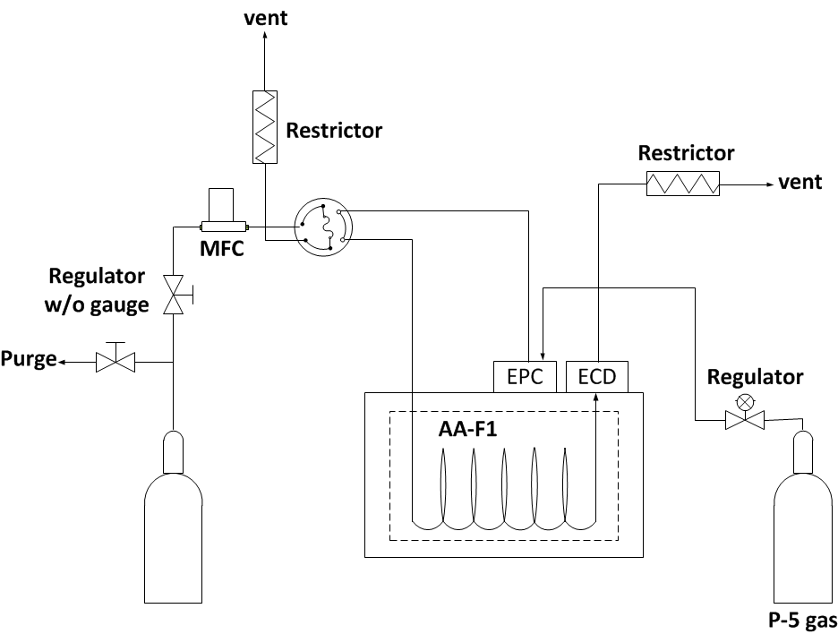
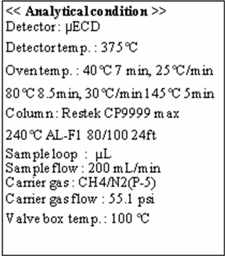

Fig 1. Schematic diagram of analyzing system and its analytical conditions of CFCs

HFCs Analysis: The HFCs were analyzed using a GC/MSD analyzer (HP 7890) with pre-concentrator (Gerstel co.). Before analysis, sample lines and regulators were purged 5 or 6 times. In figure 2, a schematic diagram of analyzing system and analytical condition are shown. It took to get a chromatogram about 60 minutes. Most of the measurement time was spent to concentrate target substances in ~ 17 L of gas mixture. During the analysis, one standard cylinder of which concentration s are the closest to the AAL073358 cylinder was used to quantify an amount of HFCs in air. Measurement was conducted for a week.
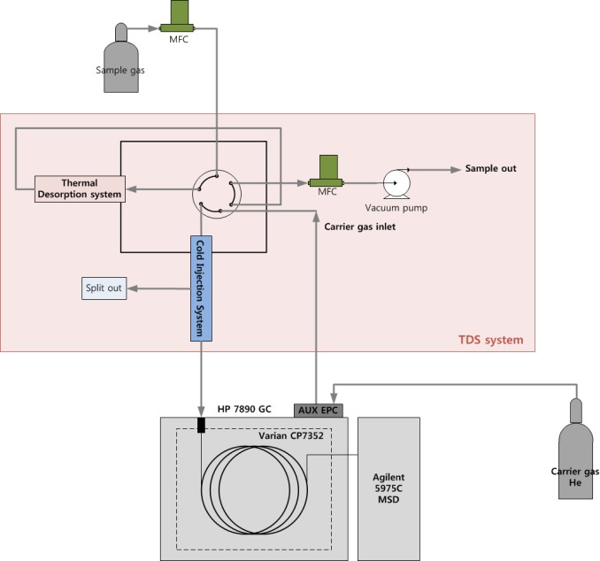
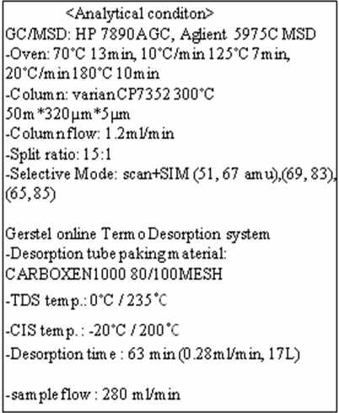
Fig 2. Schematic diagram of analyzing system and its analytical conditions of HFCs

Calibration Standards:
- CFCs standards:
Total eight (six (CFCs, N2, O2) and two (CFCs, N2, O2, and Ar)) KRISS primary standard mixtures were gravimetrically prepared to have various concentrations around ambient level according to ISO 6142:2001 “Gas analysis – Preparation of calibration gas mixtures - Gravimetric method”. Impurities of pure gases such as N2, O2, Ar and CFCs were analyzed. Significant amount of CFC impurities was not detected in the balance gases. D727508 cylinder was set t o a control cylinder. The PSMs used for this comparison are listed below:
Cylinder number | CFC12 | CFC11 [pmol/mol] | CFC113 | O2 (%) | N2 (%) | Ar (%)
D014953 | 521.69 | 235.30 | 72.55 | 20.694 | 79.306
rel. Unc. (%, k = 2) | 0.2 | 0.4 | 0.4
D985590 | 527.99 | 231.49 | 71.72 | 21.775 | 78.225
rel. Unc. (%, k = 2) | 0.2 | 0.4 | 0.4
D014942 | 530.90 | 243.67 | 75.07 | 20.588 | 79.412
rel. Unc. (%, k = 2) | 0.2 | 0.4 | 0.4
D727508 | 526.30 | 241.47 | 75.10 | 20.924 | 78.035 | 1.040
rel. Unc. (%, k = 2) | 0.2 | 0.4 | 0.4
D985691 | 525.54 | 239.31 | 75.08 | 20.616 | 79.383
rel. Unc. (%, k = 2) | 0.2 | 0.4 | 0.4

- HFCs standards:
Six (HFCs, N2, O2) KRISS primary standard mixtures were gravimetrically prepared to have various concentrations around ambient level, according to ISO 6142:2001 “Gas analysis - Preparation of calibration gas mixtures - Gravimetric method”. Impurities of pure gases such as N2, O2 and each HFCs were analyzed. Significant amount of HFC impurities was not detected in the balance gases. Basically, GC FID with pre cooling device was used for the measurement of HFCs. However, for the comparison with the cylinder (#AAL073358) HFCs mixtures were concentrated for 50 minutes in our pre cooling system to be introduced to GC MSD. Because of the necessity of long time and large sample volume, a measurement was performed in a way of sequence, such as A-B-C-D-A. Two cylinders whose response are the nearest to the AAL073358 cylinder were used for this comparison;

Cylinder number | HFC134a | HFC22 | HFC142b | O2 (%) | N2 (%) | Ar (%)
 | [pmol/mol]
D014989  rel. Unc. (%, k = 2) | 63.970 | 222.54 | 22.192 | 20.68207 | 79.31793
 | 2 | 2 | 2
D985689  rel. Unc. (%, k = 2) | 67.265 | 217.63 | 22.495 | 21.00723 | 78.99277
 | 2 | 2 | 2

Instrument Calibration:
CFCs calibration: KRISS PSMs are used for the calibration of instrument. Because ECD detector nonlinearly responds to the amount of analytes, the nearest 2 points in concentration were selected for the calibration of signal responses. During measurements, laboratory temperature were set to 26 ± 2 ℃. Inner pressure of gas lines was kept steady by using restrictors at the end.
HFCs calibration: Most of procedure was same with the case of CFCs calibration. Two PSMs were used instead. One point calibration was performed using the nearest.

Sample Handling:
Cylinders had stayed at the laboratory more than 2 weeks before the measurements. Cylinder was equipped with the regulator without the gauge that was purged several times between measurements. MFC then controlled the constant flow of sample.

Uncertainty:
There are potential sources that influence the uncertainty of the final measurement result. Depending on the equipment, the applied analytical method and the target uncertainty of the final result, they have to be taken into account or can be neglected.

- Uncertainty table:
(for example, CFC12)
Uncertainty source  X_{I} | Estimate  x_{I} | Assumed  distribution | relative  Standard uncertainty  u(x_{i}) [%]
Cylinder #1 ravimetrically  prepared | 525.635 | normal | 0.1
Cylinder #2 Gravimetrically  prepared | 521.688 | normal | 0.1
Reproducibility | 529.39 | - | 0.1
Drift |  | - | 0.2
Expanded uncertainty, k = 2  (relative, %) |  |  | 0.5

(for example, CFC11)
Uncertainty source  X_{I} | Estimate  x_{I} | Assumed  distribution | relative  Standard uncertainty  u(x_{i}) [%]
Cylinder #1 ravimetrically  prepared | 239.31 | normal | 0.2
Cylinder #2 Gravimetrically  prepared | 243.67 | normal | 0.2
Reproducibility | 529.39 | - | 0.1
Drift |  | - | 0.3
Expanded uncertainty, k = 2  (relative, %) |  |  | 0.8

(for example, CFC113)
Uncertainty source  X_{I} | Estimate  x_{I} | Assumed  distribution | relative  Standard uncertainty  u(x_{i}) [%]
Cylinder #1 G ravimetrically  prepared | 75.08 | normal | 0.2
Cylinder #2 Gravimetrically  prepared | 75.07 | normal | 0.2
Reproducibility | 529.39 | - | 0.2
Drift |  | - | 0.5
Expanded uncertainty, k = 2  (relative, %) |  |  | 1.2

