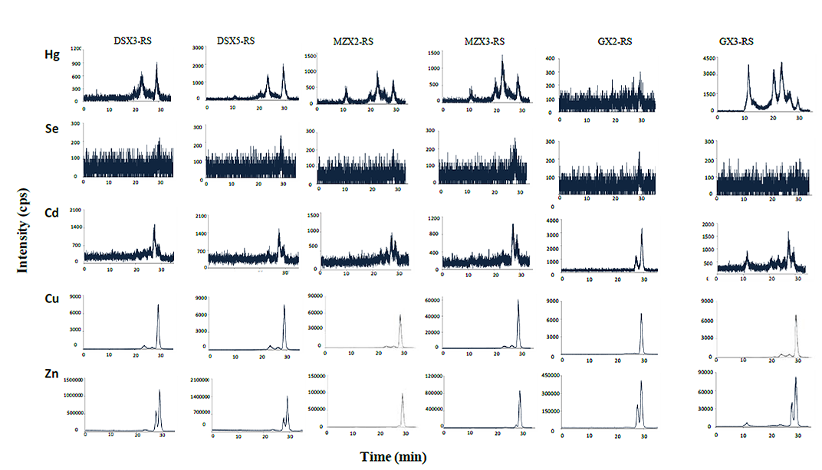
Figure S2. Screening of biomolecules binding different elements in rice seeds samples.
Rice seeds (RS) samples are selected from different locations of Wanshan Hg mining areas: Dashuixi (DSX), Meizixi (MZX) and Gouxi (GX). Screening of biomolecules binding elements (²⁰²Hg, ⁸²Se, ¹¹²Cd, ⁶⁵Cu and ⁶⁴Zn) are performed by HPLC-ICP-MS using a size exclusion chromatographic column. The molecular weight varies from approximately 650 to less than 10 kDa.

