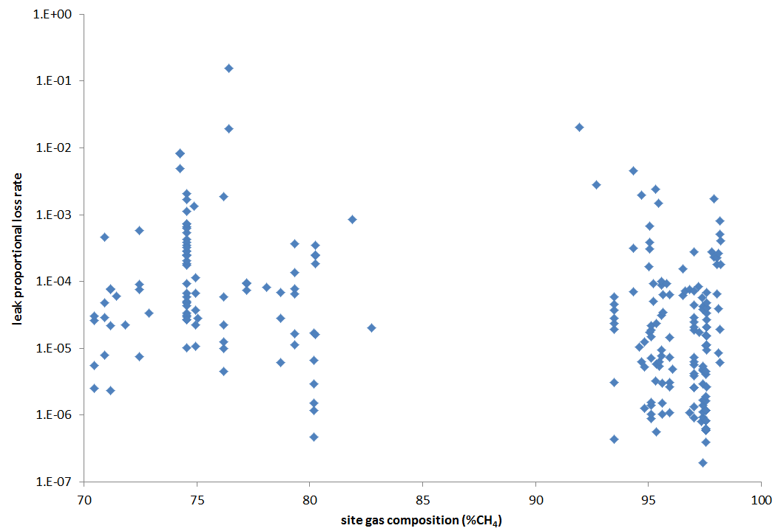
Figure S1. Proportional loss rates of individual equipment leaks as a function of site %CH₄. Data points with missing production data or zero emission rates are excluded.

