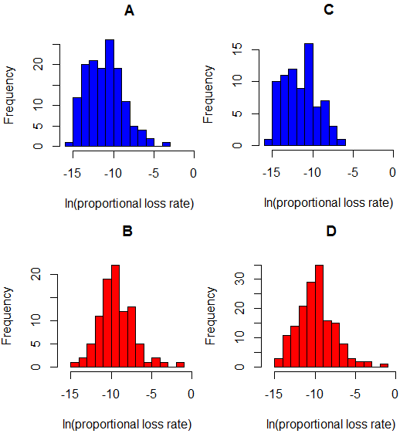
Figure S3. Histograms of EL proportional loss rates at low % CH₄ vs. high % CH₄ sites (paired comparisons are stacked vertically): A. >91% CH₄; B. <91% CH4; C. >97% CH₄; D. <97% CH₄.

