**Text S1. Analysis with AQS data**

The PM emission model used in this work was parameterized based on one year of PM flux measurements from a 2010 burn scar. The current paper uses a single case study from 2012 to evaluate the model. Additional evaluation work is desirable; however, lack of on-site post-fire PM flux measurements prohibits direct evaluation of the emission parameterization and necessitates model evaluation via other indirect metrics, such as downwind atmospheric PM concentrations, in-situ or remotely-sensed observations of dust plumes, or derived parameters such as AOD. There are difficulties and uncertainties associated with using these metrics. For example, (1) the Great Basin is sparsely populated, so in-situ observations are rare; (2) satellite imagery is only available at 1-2 discrete times per day and could easily miss the timing of a dust event, be obscured by clouds, or the bright ground surface could make it difficult to distinguish dust above the surface; (3) there are relatively few PM monitoring stations in close proximity to the burned areas investigated in this work; (4) use of downwind PM concentration data for evaluations requires modeling PM transport from the burned area which has its own uncertainties (quality of the meteorological data used to drive the transport model, proper dispersion coefficients, accounting for deposition, etc.). The case study presented in the paper provided a unique opportunity to evaluate the emission model because we had video of the dust plume, on-site meteorological observations including radar data, and near-by downwind PM stations that intercepted the dust plume.

We conducted additional analyses of the largest predicted events using AQS PM data, HYSPLIT modeling, and satellite imagery. Available AQS stations are shown in Fig 1. Fig. 2 shows the burn scars with the largest predicted events and mean 24-hr PM data measured at the nearest AQS stations during these events.

We chose two clusters of PM stations, one in the Boise area and one in the Pocatello area, (indicated in Fig. 2) based on their proximity to burn scars and prevailing wind directions. Fig. 2 indicates several spikes in observed PM10 concentrations which correspond to periods of predicted peak emissions from nearby fires. The largest spike occurred at the Boise stations during August 5-6. This spike was investigated in the case study presented in the paper and was attributed to the Long Draw fire. The next largest spike occurred during Sep 21-24; however, inspection of MODIS images indicated that was period of widespread smoke in the area. Because of the potential difficulties in attributing PM to smoke vs dust sources, we did not further investigate this event. The next largest spike in PM occurred on Oct 2-3 and correlated with the timing of predicted peak emissions from the Kinyon Road fire.

There were elevated PM concentrations at the Boise, Nampa, and Ballard Road (labeled as “Not in a City”) stations during Oct 2-3 (Fig. 2). MODIS imagery showed general haziness in the area and over the Kinyon Road burn scar located between Boise and Pocatello (Fig.3.). Simulated emissions from the Kinyon Road burns scar spiked during this period (Fig. 4.)

Analysis of observed winds from the closest meteorological stations (Fig. 5) indicated two peaks in wind speed, one around 1300 on Oct. 2 and a larger peak around 1200 on Oct 3. Winds were from the SW during the peaks on both days. Nighttime winds were from the N and NE. NAM winds compared well with observed winds on Oct 2 at KTWF, but slightly underpredicted the peak speeds on Oct 3 (not shown).

PM10 concentrations at the Ballard Road station just north of Pocatello peaked at around 210 µg m-3 on Oct. 2 and 400 µg m-3 on Oct. 3 (Fig. 6). The peak on Oct. 3 occurred around 0800 LT. Since nighttime winds were from the N and NE and daytime westerly winds didn’t peak near the burn scar until late morning, it doesn’t seem likely that dust from the Kinyon Road burn scar is responsible for the Oct. 3 morning peak. There was a second peak in PM concentrations on Oct. 2 of about 250 µg m-3 around 1500 LT. Dust from the Kinyon Road fire could have contributed to this spike in PM concentration. The peak concentration on Oct. 2 occurred just after noon and concentrations were elevated until around 1800 (LT). Based on the timing and strength of observed winds, it is possible that the Kinyon Road scar contributed to PM peaks at the Ballard Road station on Oct. 2. We conducted a HYSPLIT transport simulation using a constant average PM emission rate from the burn scar based on observed winds at KTWF during 1100 LT to 1800 LT. NAM meteorology was used to drive the HYSPLIT transport model. The simulated plume reaches the Pocatello area around 1800 LT (Fig. 7). Simulated plume arrival in the Pocatello area is after the peak PM concentration observations, but this could be due to underprediction of wind speed by NAM, which was used to drive the transport model. Based on observed winds near the burned area, timing of peak PM concentrations at the Ballard Road station, and the modeled plume trajectory, it is possible that the Kinyon Road burn scar contributed to PM concentrations in the Pocatello area on Oct. 2.

This additional analysis highlights the limitations associated with using existing networks (which are concentrated primarily near population centers) and remotely sensed data for dust source attribution. Ultimately, more on-site PM flux measurements in burn scars are needed to improve emission parameterizations. Our study shows that wind-driven dust from fire burn scars is potentially a significant source of atmospheric PM10 to warrant additional on-site PM flux measurements to improve emission parameterizations and constrain emission model estimates for a source that is currently completely ignored in emissions inventories.

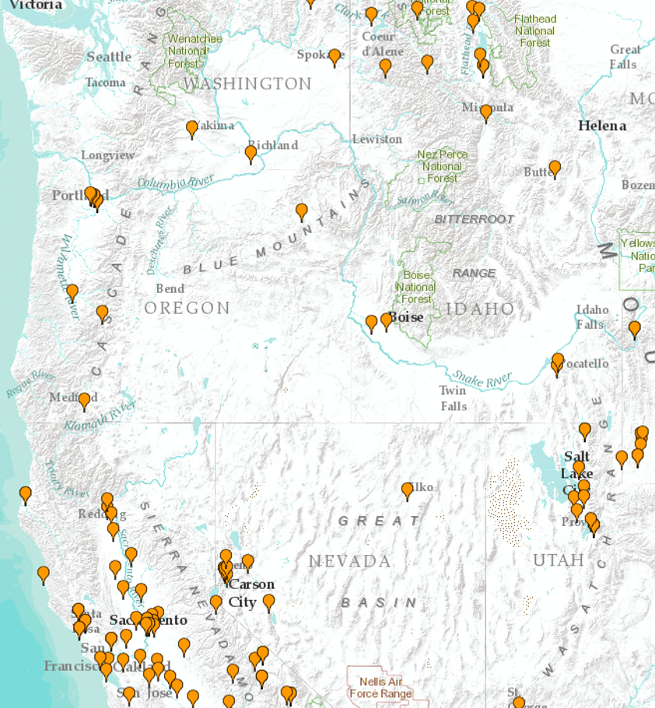

S4 -- Fig. 1. AQS stations available for analysis in and around the Great Basin.

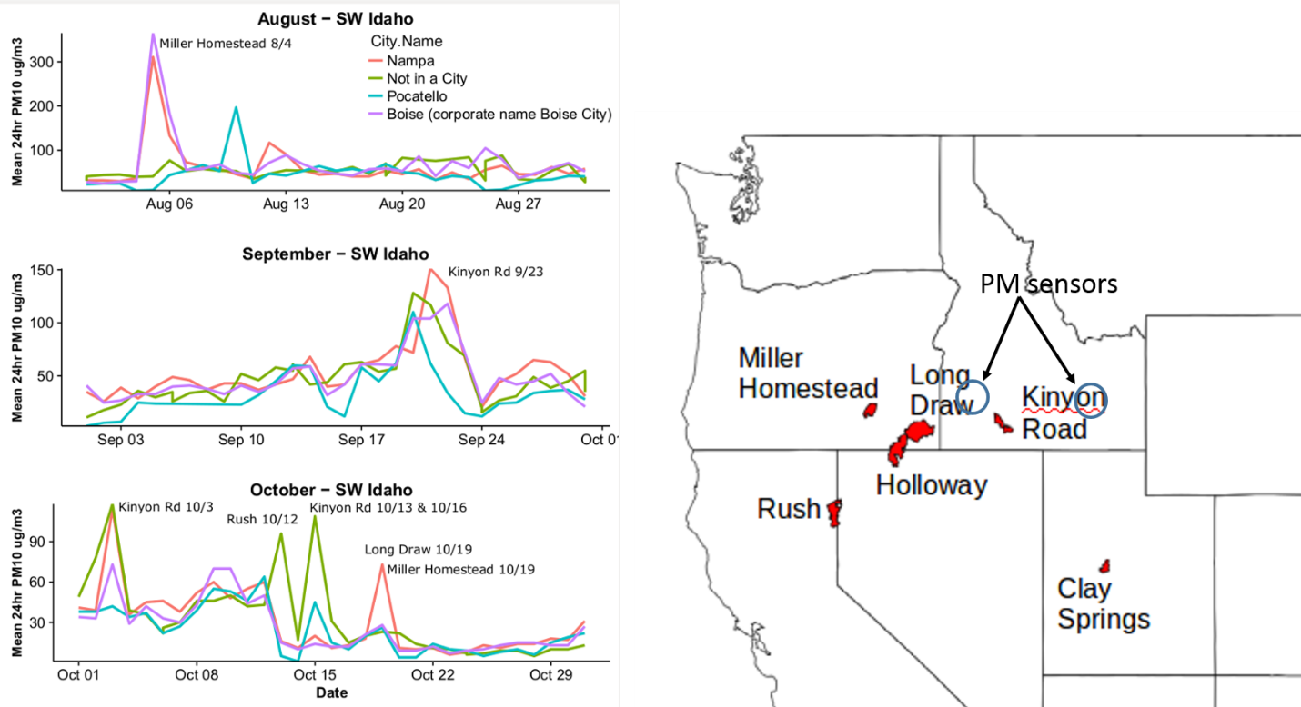

S4 -- Fig. 2. Burned areas where largest predicted emissions occurred and observed mean 24-hr PM10 concentrations at the nearest AQS stations. The Nampa and Boise stations were located in the blue circle NE of the Long Draw fire and the Pocatello and “Not in a City” stations were located in the blue circle NE of the Kinyon Road Fire.

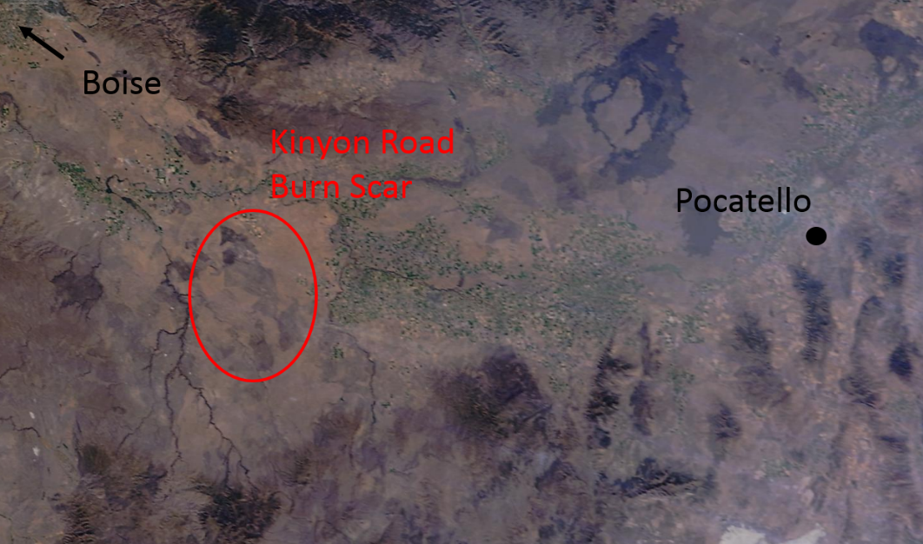

S4 -- Fig. 3. MODIS Terra imagery from Oct. 3 showing the Kinyon Road burn scar and general haziness in the region.

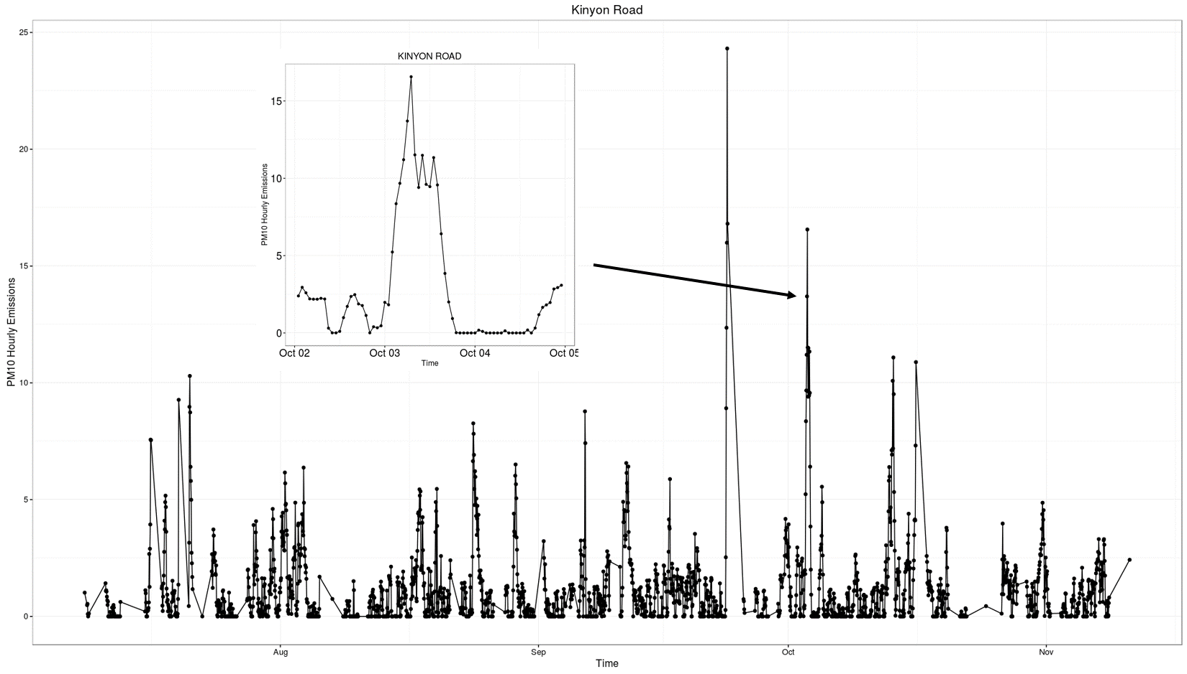

S4 -- Fig. 4. Simulated PM10 emissions from the Kinyon Road fire. The inset is zoomed in on Oct 2-4.

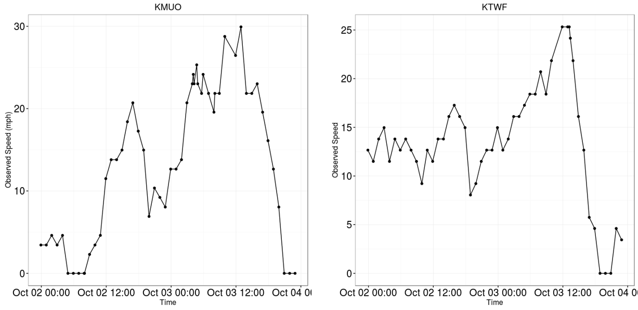

S4 -- Fig. 5. Observed winds at KMUO (~50 km NW of the burn scar) and at KTWF (~30 km E of the burn scar).

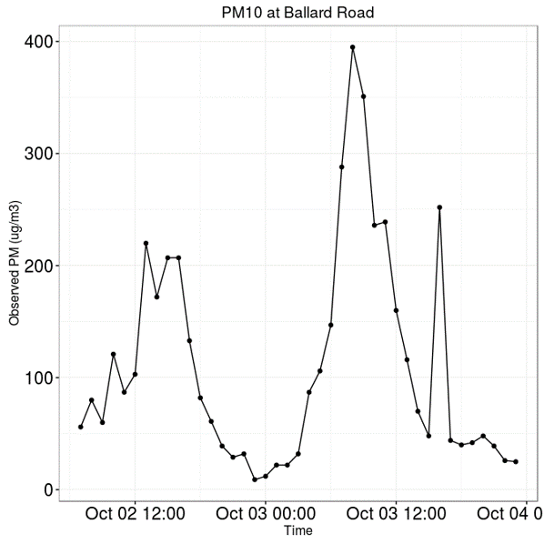

S4 -- Fig. 6. Observed PM10 north of Pocatello on Oct 2-4.

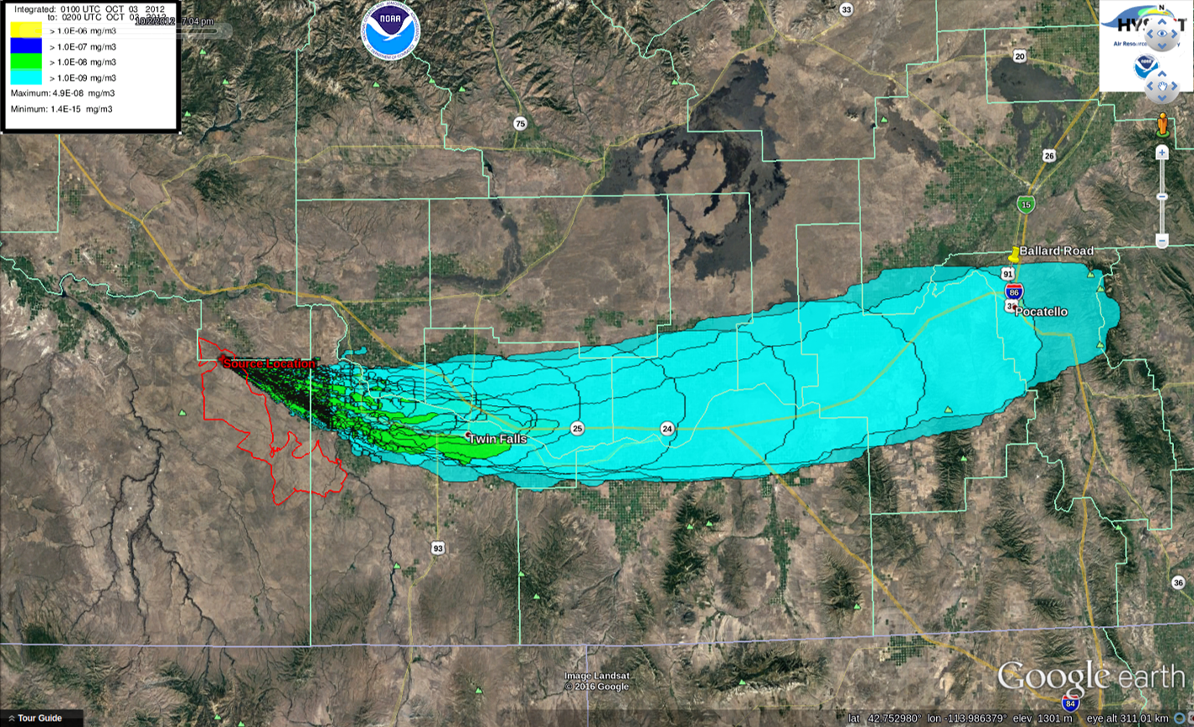

S4 -- Fig. 7. HYSPLIT-modeled PM10 plume based on PM emissions modeled with observed winds during 1100-1800 LT Oct. 2 at KTWF.