SUPPLEMENTAL MATERIALS

Assumed stage flows on the partitioning of agricultural crops and livestock production into functional elements

Common bean

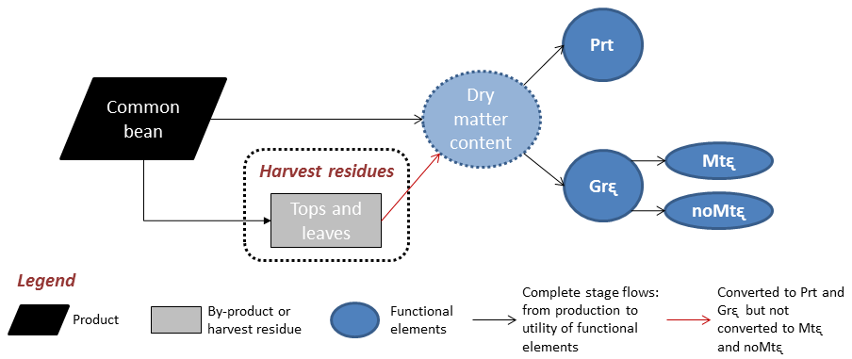
Figure S1 – Common bean partitioning into products, by-products and harvest residues and their conversions to functional elements.

Cotton seed (whole)

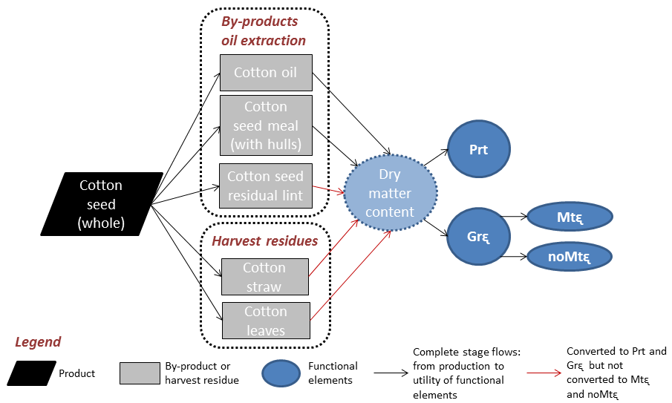
Figure S2 – Cottonseed partitioning into products, by-products and harvest residues and their conversions to functional elements.

Rice grain (with hulls)

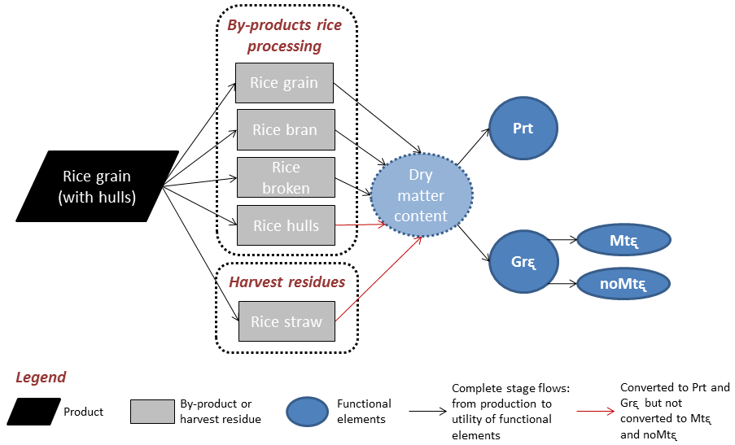
Figure S3 – Rice grain partitioning into products, by-products and harvest residues and their conversions to functional elements.

Maize grain

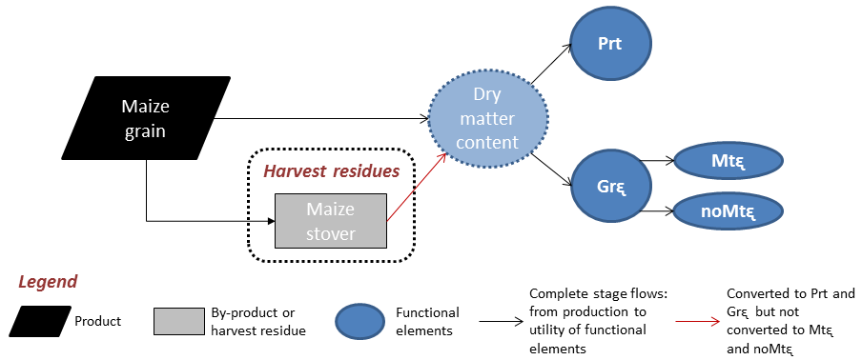
Figure S4 – Maize grain partitioning into products, by-products and harvest residues and their conversions to functional elements.

Soybean seed

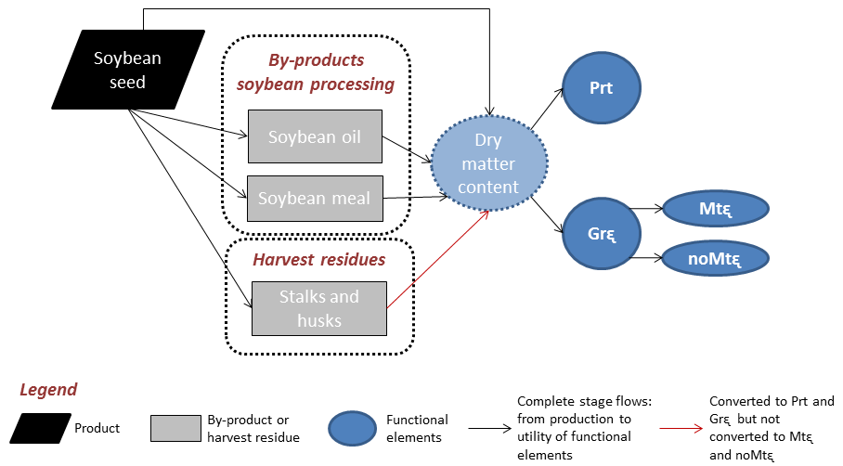
Figure S5 – Soybean seed partitioning into products, by-products and harvest residues and their conversions to functional elements.

Wheat grain

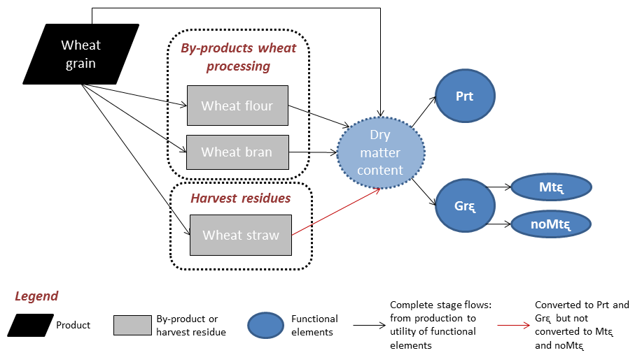
Figure S6 – Wheat grain partitioning into products, by-products and harvest residues and their conversions to functional elements.

Cocoa beans

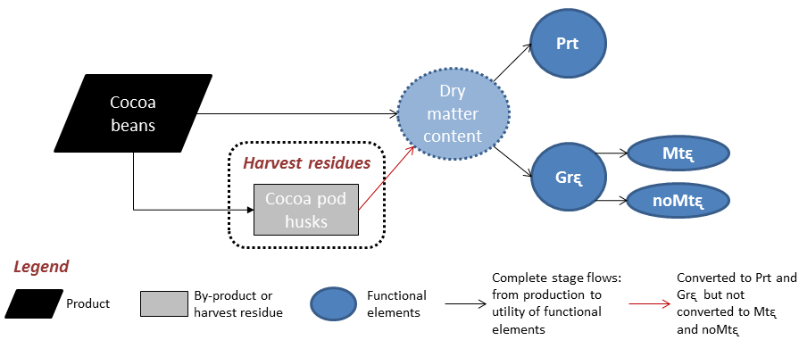
Figure S7 – Cocoa beans partitioning into products, by-products and harvest residues and their conversions to functional elements.

Coffee beans

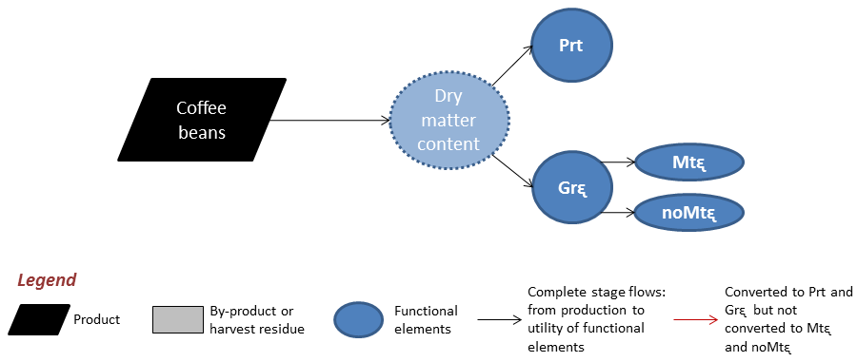
Figure S8 – Coffee beans partitioning into products, by-products and harvest residues and their conversions to functional elements.

Banana bunches

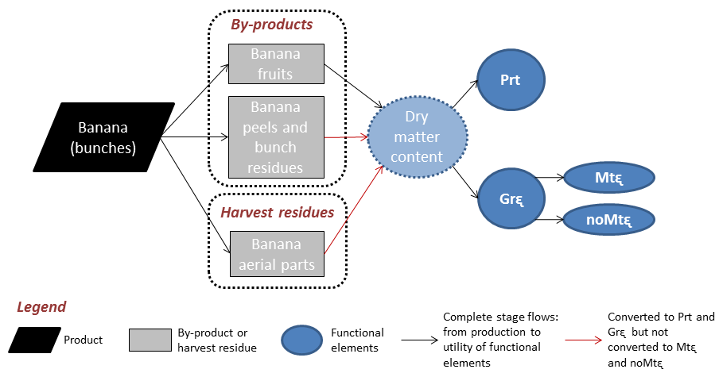
Figure S9 – Banana bunches partitioning into products, by-products and harvest residues and their conversions to functional elements.

Orange fruits

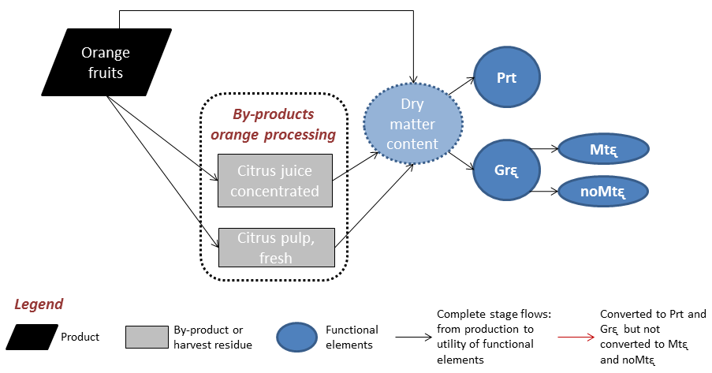
Figure S10 – Orange fruits partitioning into products, by-products and harvest residues and their conversions to functional elements.

Cassava tuber

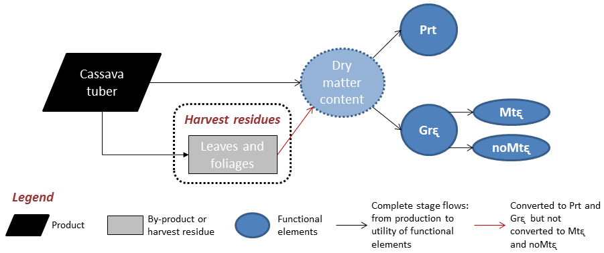
Figure S11 – Cassava tuber partitioning into products, by-products and harvest residues and their conversions to functional elements.

Sugarcane (sugar production)

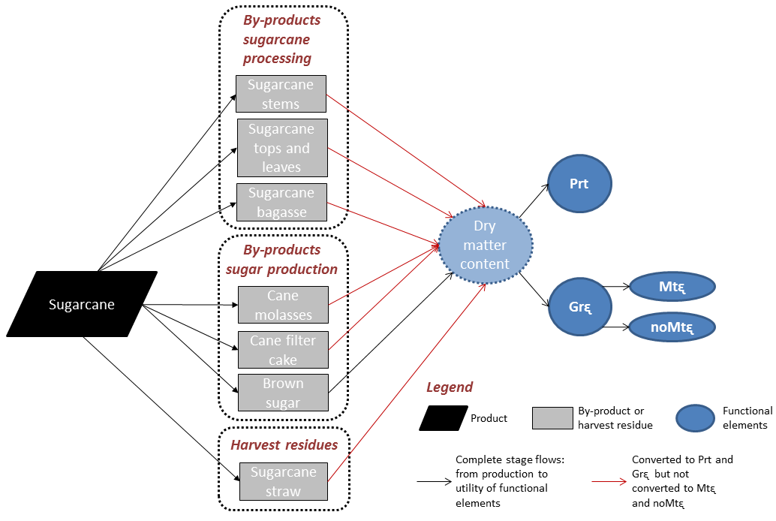
Figure S12 – Sugarcane partitioning into products, by-products and harvest residues and their conversions to functional elements. Sugar production stage flows.

Sugarcane (ethanol production)

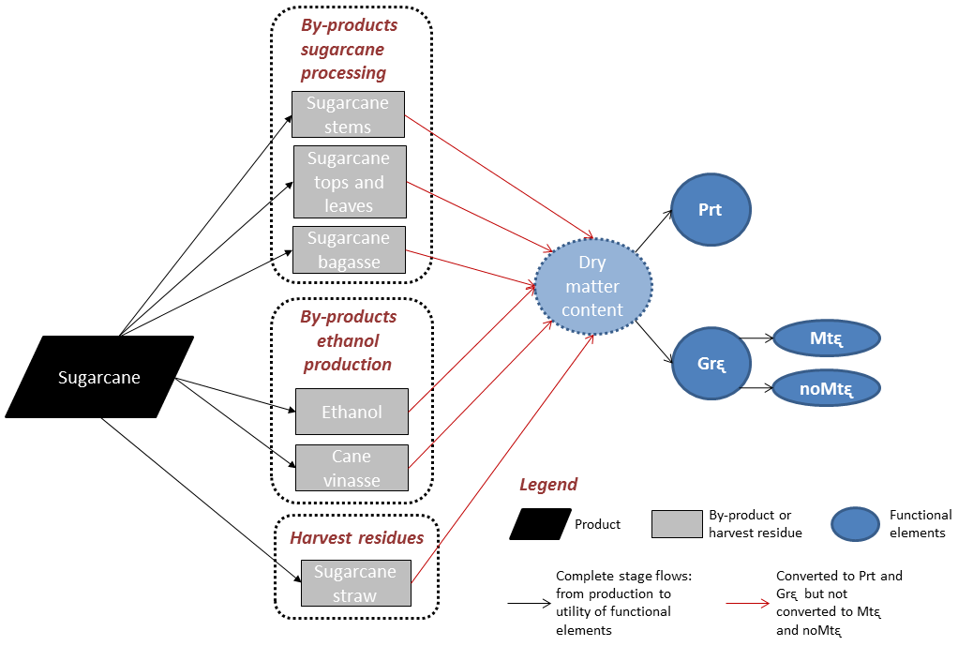
Figure S13 – Sugarcane partitioning into products, by-products and harvest residues and their conversions to functional elements. Ethanol production stage flows.

Animal carcass

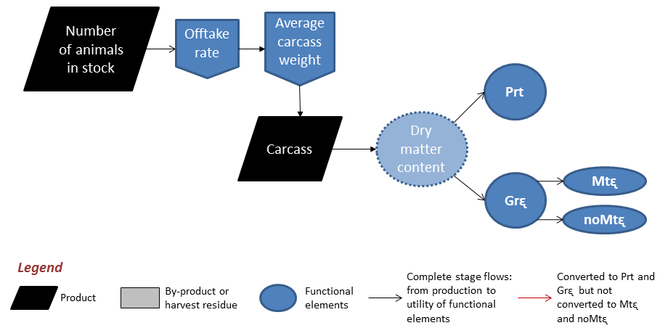
Figure S14 – Animal carcass conversion to functional elements. Offtake rate is defined as the proportion of animals sold or consumed in a year in comparison to animals in stock.

Other animal foodstuff

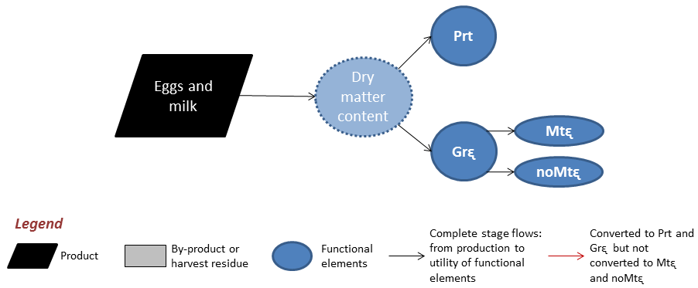
Figure S15 – Eggs and milk conversion to functional elements.

Feed to meat conversion

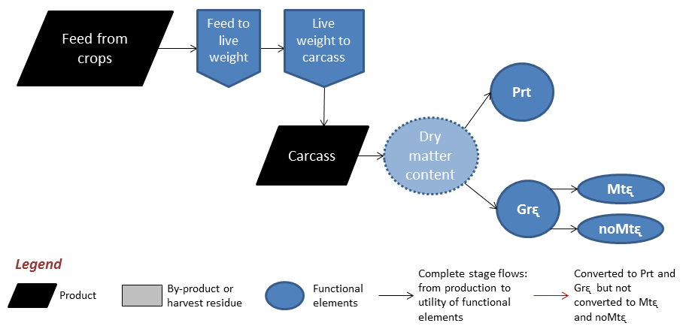
Figure S16 – Feed to carcass conversion coefficients.

Text S1. Assumed values on the partitioning of agricultural crops and livestock production into functional elements

As illustrated above, all modeled stage flows start from the agricultural products themselves and continue first with their transformation to dry matter (DM) content and then with their transformation to functional elements, i.e., protein (Prt), gross energy (Grᶓ) and metabolizable energy (Mtᶓ) contents. The calculation of Mtᶓ depends on the agricultural product allocation (food, feed, energy, field residue, fertilizer, industrial processing, and waste), in that only products allocated to either food or feed will have their Mtᶓ content calculated based on the Mtᶓ factors for humans, pigs or chickens.

Before functional elements can be obtained, the model implements the partitioning of the dry matter content of each agricultural product to specific sub-components or by-products based on a percentage of the DM content (% DM basis in Table S1). Further, each sub-component or by-product is converted to DM based on their representative shares in total product DM (% DM as-is in Table S1). For example, in Table S1, the product “soybean seed” has two sub-components, each one accounting for a specific share of the entire soybean production (20% allocated as soybean seeds and 80% allocated for industrial soybean processing). In this example, if one ton of soybean is produced, the model will allocate 200 kg as soybean seeds and 800 kg to be designated for oil extraction. Soybean seed is considered to be directly consumed by humans and its contents of DM, Prt, Grᶓ, and Mtᶓ are then calculated. The soybean processing sub-component is further decomposed in soybean oil (15%, or 120 kg in the given example) and soybean meal (85%, or 680 kg in the given example), and the amount of each sub-component is then converted to DM and latter to functional elements.

For the agricultural products allocated for any industrial process (i.e., rice, sugarcane, orange, soybean, and wheat), the total estimation of functional elements production and utility are not equivalent in quantity due to the losses and additions (other inputs) inherent to industrial processing steps. In average, the observed difference between production and utility was 4% and 13% respectively for protein and gross energy, with the biggest difference being observed for sugarcane gross energy (54%). Without considering sugarcane, the average difference between gross energy production and utility was only 3%. For the sake of clarity, we decided to present the results of functional elements production as being the sum of functional elements utility, making the total values of production and utility to be exactly the same.

Finally, the model accounts for the production of field residues based on the concept of harvest index, which is defined as the weight of a harvested product as a percentage of the total plant weight of a crop. Following the “soybean seed” example, this product has a harvest index of 0.5, what means that for each kilogram (kg) of soybean produced there is another kg produced of harvest residues (soybean stalks and husks in this case). Estimated field residues are then transformed to DM and Grᶓ.

Following we present the assumed values used on the partitioning and the allocation of agricultural crops and livestock stage flows (Tables S1, S2, S3).

Table S1 - Assumed values on partition and allocation of agricultural crops stage flows.
Agriculture crops production | Harvest Index |  | Partition (% DM basis) |  | DM Factor (% as-is) | Prt (% DM) | Grᶓ (GJ/tonne DM) |  | Human Mtᶓ (GJ/tonne DM) |  | Pig Mtᶓ (GJ/tonne DM) |  | Chicken Mtᶓ (GJ/tonne DM) |  | Allocation
Common bean | 0.40 ^{b} |  | - |  | 89.1^{c} | 24.8 ^{c} | 18.6^{c} |  | 13.1 ^{d} |  | - |  | - |  | Food
Harvest residues
Tops and leaves | 0.60 ^{b} |  | - |  | 88.0 ^{c} | 7.1 ^{c} | 17.9 ^{c} |  | - |  | - |  | - |  | Field residue
Cotton seed (whole) | 0.60 e |  | - |  | 92.3 ^{c} | 21.8 ^{c} | 23.8 ^{c} |  | - |  | - |  | - |  | Industrial processing
Cotton oil |  |  | 20.0 ^{c} |  | 100.0 ª | 0.0 ª | 39.3 ª |  | 37.0 ª |  | - |  | - |  | Food
Cotton seed meal |  |  | 70.0 ^{c} |  | 92.9 ^{c} | 37.4 ^{c} | 21.5 ^{c} |  | - |  | 12.3 ^{c} |  | 9.4 ^{c} |  | Feed
Cotton seed residual linter |  |  | 10.0 ^{c} |  | 94.7 ^{s} | 0.0 ^{s} | 39.6 ^{s} |  | - |  | - |  | - |  | Energy
Harvest residues | 0.40 e
Cotton straw |  |  | 70.0 ^{c} |  | 75.7 ^{c} | 6.4 ^{c} | 18.8 ^{c} |  | - |  | - |  | - |  | Field residue
Cotton leaves |  |  | 30.0 ^{c} |  | 27.3 ^{c} | 12.2 ^{c} | 19.0 ^{c} |  | - |  | - |  | - |  | Field residue
Rice grain (with hulls) | 0.45 ª |  | - |  | 90.1 ^{c} | 9.8 ^{c} | 18.4 ^{c} |  | - |  | - |  | - |  | Industrial processing
Rice grain (polished) |  |  | 50.0 ^{c} |  | 89.2 ^{c} | 10.4 ^{c} | 18.0 ^{c} |  | 16.7 ª |  | - |  | - |  | Food
Rice bran |  |  | 10.0 ^{c} |  | 90.1 ^{c} | 14.8 ^{c} | 21.2 ^{c} |  | - |  | 15.6 ^{c} |  | 12.7 ^{c} |  | Feed
Rice broken |  |  | 20.0 ^{c} |  | 89.2 ^{c} | 10.4 ^{c} | 18.0 ^{c} |  | - |  | 13.2 ^{c} |  | 10.7 ^{c} |  | Feed
Rice hulls |  |  | 20.0 ^{c} |  | 91.9 ^{c} | 3.7 ^{c} | 16.3 ^{c} |  | - |  | - |  | - |  | Energy
Harvest residues |  |  |  |  |  |  |  |  |  |  |  |  |  |  | -
Rice straw | 0.55 ª |  | - |  | 92.8 ^{c} | 4.2 ^{c} | 15.5 ^{c} |  | - |  | - |  | - |  | Field residue
Maize grain | 0.50 ^{f} |  | - |  | 88.0 ª | 10.0 ª | 18.8 ª |  | - |  | - |  | - |  | -
Maize grains (human share) |  |  | 40.0 ^{g}† |  | 88.0 ª | 10.0 ª | 18.8 ª |  | 16.0 ª |  | - |  | - |  | Food
Maize grains (animal share) |  |  | 60.0 ^{g}† |  | 88.0 ª | 10.0 ª | 18.8 ª |  | - |  | 16.4 ª |  | 15.7 ª |  | Feed
Harvest residues
Maize stover | 0.50 ^{f} |  | - |  | 85.0 ª | 5.5 ª | 16.5 ª |  | - |  | - |  | - |  | Field residue
Soybean seed | 0.50 ^{h} |  | 20.0 ^{i}† |  | 91.0 ª | 40.0 ª | 23.4 ª |  | 19.0 ª |  | - |  | - |  | Food
Soybean processing |  |  | 80.0 ^{i}†
Soybean oil |  |  | 15.0 ^{c} |  | 100.0 ª | 0.0 ª | 39.3 ª |  | 37.0 ª |  | - |  | - |  | Food
Soybean meal |  |  | 85.0 ^{c} |  | 87.9 ^{c} | 51.8 ^{c} | 19.7 ^{c} |  | - |  | 16.8 ^{c} |  | 10.9 ^{c} |  | Feed
Harvest residues
Soybean stalks and husks | 0.50 ^{h} |  | - |  | 90.0 ª | 5.0 ª | 16.5 ª |  | - |  | - |  | - |  | Field residue
Wheat grain | 0.40 ^{j} |  | - |  | 88.0 ª | 13.0 ª | 18.4 ª |  | - |  | - |  | - |  | Industrial processing
Wheat flour |  |  | 80.0 ^{k}† |  | 86.0 ª | 11.5 ª | 18.3 ª |  | 16.0 ª |  | - |  | - |  | Food
Wheat bran |  |  | 20.0 ^{k}† |  | 87.0 ^{c} | 17.3 ^{c} | 18.9 ^{c} |  | - |  | 10.8 ^{c} |  | 7.8 ^{c} |  | Feed
Harvest residues
Wheat straw | 0.60 ^{j} |  | - |  | 91.0 ^{c} | 4.2 ^{c} | 18.5 ^{c} |  | - |  | - |  | - |  | Field residue
Agriculture crops production |  | Harvest Index |  | Partition (% DM basis) | DM Factor (% as-is) | Prt (% DM) | Grᶓ (GJ/tonne DM) | Human Mtᶓ (GJ/tonne DM) |  | Pig Mtᶓ (GJ/tonne DM) |  | Chicken Mtᶓ (GJ/tonne DM) |  | Allocation
Cocoa beans |  | - |  | - | 97.0 ^{b} | 20.0 ^{b} | 17.8 ^{b} | 9.6 ^{b} |  | - |  | - |  | Food
Harvest residues
Cocoa pod husks |  | - |  | 300.0 ^{c} | 91.0 ^{c} | 7.7 ^{c} | 17.4 ^{c} | - |  | - |  | - |  | Field residue
Coffee beans |  | - |  |  | 94.5 ^{d} | 14.6 ^{d} | 19.9 ª | 16.6 ^{d} |  |  |  |  |  | Food
Banana bunches |  | 0.125 ^{l} |  |  |  |  |  |  |  |  |  |  |  | -
Banana fruits |  | - |  | 70.0 ^{m} | 22.0 ^{c} | 5.3 ^{c} | 17.2 ^{c} | 15.2 ^{b} |  | - |  | - |  | Food
Banana peels and bunch residues |  | - |  | 30.0 ^{m} | 15.4 ^{c} | 7.1 ^{c} | 18.4 ^{c} | - |  | - |  | - |  | Waste
Harvest residues |  |  |  |  |  |  |  |  |  |  |  |  |  | -
Banana aerial parts |  | 0.875 ^{l} |  | - | 16.0 ^{c} | 16.6 ^{c} | 17.7 ^{c} | - |  | - |  | - |  | Field residue
Orange fruits |  | - |  | 30.0 ^{n r}† | 13.5 ^{c} | 7.4 ^{c} | 17.6 ^{c} | 9.0 ª |  | - |  | - |  | Food
Orange processing |  | - |  | 70.0 ^{n r}† |  |  |  |  |  |  |  |  |  | Industrial processing
Citrus pulp (fresh) |  | - |  | 50.0^{r} | 23.0 ^{c} | 6.0 ^{c} | 18.1 ^{c} | - |  | 13.0 ^{c} |  | 5.8 ^{c} |  | Feed
Citrus juice (concentraded) |  | - |  | 4.8^{r} | 42.3 º | 6.0 º | 15.8 º | 9.0 ª |  | - |  | - |  | Food
Cassava tuber |  | 0.55 ª |  | - | 37.6 ^{c} | 2.6 ^{c} | 17.1 ^{c} | 12.8 ª |  | - |  | - |  | Food
Harvest residues
Cassava leaves and foliage |  | 0.45 ª |  | - | 22.5 ^{c} | 24.9 ^{c} | 19.9 ^{c} | - |  | - |  | - |  | Field residue
Sugarcane |  | 0.60 ª
Sugarcane tops and leaves |  |  |  | 8.0 ª | 28.0 ^{c} | 5.0 ^{c} | 17.0 ^{c} | - |  | - |  | - |  | Energy
Sugarcane stems |  |  |  | 92.0 ª | 27.0 ^{c} | 1.5 ^{c} | 17.0 ^{c} | - |  | - |  | - |  | Industrial processing
Harvest residues
Sugarcane straw |  | 0.40 ª |  | - | 42.4 ^{c} | 5.2 ^{c} | 17.0 ^{c} | - |  | - |  | - |  | Field residue
Sugarcane stems processing
Sugarcane bagasse |  |  |  | 28.0 ^{p} | 46.0 ^{c} | 1.8 ^{c} | 18.4 ^{c} | - |  | - |  | - |  | Energy
By-Products (sugar production) |  |  |  | 43.0 ^{q}†
Brown sugar |  |  |  | 11.8 ^{p} | 97.5 ^{d} | 0.0 ^{d} | 17.5 ª | 16.2 ^{d} |  | - |  | - |  | Food
Sugarcane molasses |  |  |  | 5.0 ^{p} | 73.0 ^{c} | 5.5 ^{c} | 14.7 ^{c} | - |  | - |  | - |  | Industrial processing
Sugarcane filter cake |  |  |  | 3.0 ^{p} | 25.0 ^{c} | 5.5 ^{c} | 24.6 ^{c} | - |  | - |  | - |  | Fertilizer
By-Products (ethanol production) |  |  |  | 57.0 ^{q}†
Ethanol |  |  |  | 6.3 ^{p} | - | - | - | - |  | - |  | - |  | Energy
Sugarcane vinasse |  |  |  | 109.7 ^{p} | 6.1 ^{c} | 12.2 ^{c} | 12.8 ^{c} | - |  | - |  | - |  | Fertilizer
Sources: ª WIRSENIUS et al., 2010; ^{b} Adapted from similar crops in WIRSENIUS et al., 2010; ^{c} FEEDIPEDIA, 2015; ^{d} FRIDA FOODDATA, 2017; ^{e} ABRAPA, 2016; ^{f} DURÃES et al., 2002; ^{g} ABIMILHO, 2016; ^{h} BRAGA and COSTA, 1983; ^{i} ABIOVE, 2016; ^{j} COELHO et al., 1998; ^{k} ABITRIGO, 2016; ^{l} FERIOTTI, 2010; ^{m} EMBRAPA, 2009; ^{n} BOTEON, 2008; º SELFNUTRITIONDATA, 2014; ^{p} EMBRAPA, 2016; ^{q} UNICA, 2016; ^{r} NEVES et al., 2010; ^{s} BEZERRA et al., 2017; † Numbers represent the historical average of the agricultural crops production allocation in domestic market, which were calculated based on the cited references. The exported production share received the same allocation of the domestic consumed production share.

Table S2 - Assumed values on partition and allocation of livestock stage flows.
Livestock production | Average carcass weight (ton) | Offtake rate^{g} | Carcass production (ton) | DM Factor (% as-is) | Protein (% DM) | Grᶓ (GJ/tonne DM) | Human Mtᶓ (GJ/tonne DM) | Allocation
Animal conversion rates - carcass
Bulls/Cattle carcass | - | - | 0.0352 ª | 40.7 ^{b} | 46.2 ^{b} | 26.1 ^{b} | 17.6 ^{b} | Food
Goats and sheep carcass | 0.02 ^{c} | 25.0%^{c} | 0.0039 ^{c} | 42.9 ^{d} | 42.5 ^{d} | 26.5 ^{d} | 17.9 ^{d} | Food
Horses, donkeys and mules carcass | 0.20 e | 5.0% ^{f} | 0.0101 e | 50.0 ^{d} | 41.7 ^{d} | 26.5 ^{d} | 17.9 ^{d} | Food
Pigs | - | - | 0.0427 ª | 45.4 ^{b} | 38.6 ^{b} | 29.5 ^{b} | 23.6 ^{b} | Food
Poultries | - | - | 0.0051 ª | 40.5 ^{b} | 43.5 ^{b} | 26.0 ^{b} | 16.6 ^{b} | Food
Animal conversion rates - milk & egg
Cattle milk | - | - | - | 12.2 ^{b} | 26.5 ^{b} | 31.5 ^{b} | 21.9 ^{b} | Food
Goats and sheep milk | - | - | - | 12.2 ^{b} | 26.5 ^{b} | 31.5 ^{b} | 21.9 ^{b} | Food
Chicken eggs | - | - | - | 32.3 ^{b} | 35.0 ^{b} | 29.1 ^{b} | 17.2 ^{b} | Food
Sources: ª Calculated based on ABATE (IBGE, 2006) and Agricultural Census (IBGE, 2006); ^{b} WIRSENIUS et al., 2010; ^{c} JUNIOR and NOGUEIRA, 2004; ^{d} Adapted from WIRSENIUS et al., 2010; ^{e} FURTADO et al., 2010; ^{f} Estimated value; ^{g} Offtake rate is defined as the proportion of animals sold or consumed in a year in comparison to animals in stock.

Table S3 - Assumed values on feed to meat conversion.
Animal conversion rates (feed to meat) | Feed to live weight conversion | Feed share | Live weight to carcass conversion | DM Factor (% as-is) | Protein (% DM) | Grᶓ (GJ/tonne DM) | Human Mtᶓ (GJ/tonne DM) | Allocation
Pig | 0.25 ª | 0.5 ^{b} | 0.7 ^{c} | 45.4 ^{d} | 38.6 ^{d} | 29.5 ^{d} | 23.6 ^{d} | Food
Chicken | 0.50 ª | 0.5 ^{b} | 0.6 ^{c} | 40.5 ^{d} | 43.5 ^{d} | 26.0 ^{d} | 16.6 ^{d} | Food
Sources: ª GODFRAY et al., 2010; ^{b} Assumed value; ^{c} SMIL, 2013; ^{d} WIRSENIUS et al., 2010.

SUPPLEMENTARY TABLES

This section presents aggregated results of Production Functionality for Brazilian states and regions (Table S4 to Table S14).

Table S4 – Functional elements production from crops.
States | Prt_{Cr} (kton) |  |  |  | Grᶓ_{Cr} (Peta joule)
 | 1975 | 1985 | 1995 | 2006 | 1975 | 1985 | 1995 | 2006
Rondônia | 32 | 77 | 65 | 115 | 6 | 15 | 12 | 16
Acre | 16 | 16 | 22 | 39 | 3 | 3 | 4 | 8
Amazonas | 59 | 77 | 85 | 34 | 10 | 12 | 13 | 6
Roraima | 3 | 7 | 12 | 18 | 0 | 1 | 2 | 3
Pará | 150 | 220 | 158 | 302 | 28 | 41 | 29 | 55
Amapá | 6 | 3 | 2 | 1 | 1 | 1 | 0 | 0
Tocantins | 0 | 96 | 60 | 266 | 0 | 19 | 12 | 30
Maranhão | 207 | 218 | 227 | 676 | 44 | 47 | 42 | 101
Piauí | 70 | 85 | 92 | 382 | 14 | 17 | 18 | 49
Ceará | 185 | 195 | 195 | 505 | 34 | 36 | 36 | 91
Rio Grande do Norte | 44 | 90 | 92 | 90 | 9 | 22 | 25 | 19
Paraíba | 111 | 203 | 237 | 171 | 24 | 49 | 64 | 38
Pernambuco | 413 | 644 | 444 | 563 | 109 | 175 | 116 | 142
Alagoas | 270 | 523 | 444 | 762 | 78 | 159 | 134 | 227
Sergipe | 41 | 65 | 43 | 73 | 9 | 16 | 10 | 16
Bahia | 416 | 649 | 705 | 1,855 | 70 | 107 | 96 | 227
Minas Gerais | 598 | 1,271 | 1,389 | 2,329 | 124 | 235 | 251 | 406
Espírito Santo | 101 | 226 | 183 | 174 | 18 | 42 | 32 | 38
Rio de Janeiro | 205 | 246 | 138 | 91 | 53 | 63 | 39 | 25
São Paulo | 1,649 | 3,751 | 4,010 | 5,652 | 365 | 973 | 1,113 | 1,630
Paraná | 2,351 | 3,467 | 4,299 | 5,879 | 312 | 506 | 612 | 817
Santa Catarina | 490 | 729 | 710 | 1,209 | 88 | 120 | 125 | 211
Rio Grande do Sul | 2,730 | 3,513 | 2,987 | 5,051 | 349 | 450 | 423 | 670
Mato Grosso do Sul | 185 | 969 | 1,114 | 2,217 | 31 | 110 | 148 | 283
Mato Grosso | 75 | 861 | 2,330 | 5,990 | 16 | 96 | 268 | 629
Goiás | 396 | 963 | 1,486 | 3,152 | 81 | 148 | 219 | 400
Distrito Federal | 2 | 32 | 40 | 77 | 0 | 3 | 6 | 9
Brazil | 10,805 | 19,197 | 21,571 | 37,674 | 1,879 | 3,467 | 3,850 | 6,149
Regions
North | 265 | 496 | 404 | 776 | 49 | 92 | 73 | 118
Northeast | 1,757 | 2,672 | 2,480 | 5,077 | 392 | 628 | 540 | 912
Southeast | 2,554 | 5,494 | 5,721 | 8,245 | 560 | 1,314 | 1,435 | 2,099
South | 5,571 | 7,709 | 7,996 | 12,140 | 749 | 1,076 | 1,160 | 1,698
Central-west | 658 | 2,825 | 4,970 | 11,436 | 128 | 357 | 642 | 1,322

Table S5 – Occupied area by agricultural crops and pastures.
States | Crops land use (kha) |  |  |  | Pastures land use (kha)
 | 1975 | 1985 | 1995 | 2006 | 1975 | 1985 | 1995 | 2006
Rondônia | 193 | 531 | 497 | 504 | 225 | 1,101 | 2,922 | 4,845
Acre | 41 | 69 | 106 | 164 | 124 | 326 | 614 | 1,051
Amazonas | 205 | 287 | 332 | 866 | 192 | 476 | 529 | 820
Roraima | 27 | 28 | 186 | 116 | 1,353 | 1,247 | 1,543 | 724
Pará | 704 | 1,079 | 1,257 | 1,885 | 3,037 | 6,596 | 7,456 | 11,069
Amapá | 25 | 33 | 58 | 61 | 350 | 479 | 245 | 267
Tocantins | - | 655 | 643 | 632 | - | 10,651 | 11,078 | 8,113
Maranhão | 1,056 | 1,305 | 1,815 | 2,453 | 3,809 | 5,447 | 5,311 | 5,752
Piauí | 687 | 1,075 | 1,245 | 1,351 | 3,700 | 3,550 | 2,398 | 2,690
Ceará | 2,140 | 2,376 | 2,086 | 1,922 | 3,602 | 3,493 | 2,632 | 2,614
Rio Grande do Norte | 826 | 1,029 | 805 | 675 | 1,668 | 1,535 | 1,246 | 1,200
Paraíba | 1,141 | 1,229 | 884 | 663 | 1,969 | 1,982 | 1,852 | 1,680
Pernambuco | 1,561 | 1,850 | 1,473 | 1,696 | 2,718 | 2,057 | 2,131 | 1,975
Alagoas | 719 | 998 | 921 | 904 | 770 | 806 | 862 | 872
Sergipe | 239 | 314 | 310 | 317 | 1,169 | 1,275 | 1,154 | 945
Bahia | 2,664 | 4,160 | 4,817 | 5,201 | 11,219 | 15,004 | 14,490 | 12,863
Minas Gerais | 3,981 | 5,340 | 4,915 | 5,325 | 31,931 | 28,924 | 25,349 | 18,212
Espírito Santo | 654 | 1,072 | 874 | 751 | 2,131 | 1,880 | 1,821 | 1,342
Rio de Janeiro | 618 | 625 | 375 | 349 | 1,859 | 1,757 | 1,545 | 1,290
São Paulo | 5,180 | 6,525 | 5,487 | 6,975 | 11,356 | 9,926 | 9,062 | 6,972
Paraná | 5,628 | 6,063 | 5,488 | 6,512 | 4,983 | 6,000 | 6,677 | 4,733
Santa Catarina | 1,434 | 1,869 | 1,722 | 1,723 | 2,404 | 2,469 | 2,339 | 1,707
Rio Grande do Sul | 5,929 | 6,592 | 6,242 | 6,955 | 13,773 | 12,963 | 11,680 | 9,243
Mato Grosso do Sul | 1,275 | 1,903 | 1,502 | 2,239 | 20,793 | 21,803 | 21,811 | 21,055
Mato Grosso | 501 | 2,129 | 3,446 | 6,417 | 11,243 | 16,404 | 21,452 | 22,053
Goiás | 2,561 | 2,928 | 2,419 | 3,785 | 29,164 | 20,895 | 19,405 | 15,836
Distrito Federal | 13 | 85 | 66 | 97 | 109 | 142 | 96 | 80
Brazil | 40,002 | 52,148 | 49,971 | 60,540 | 165,652 | 179,188 | 177,700 | 160,001
Regions
North | 1,195 | 2,681 | 3,079 | 4,228 | 5,281 | 20,876 | 24,387 | 26,889
Northeast | 11,033 | 14,336 | 14,356 | 15,182 | 30,624 | 35,148 | 32,076 | 30,591
Southeast | 10,432 | 13,562 | 11,651 | 13,402 | 47,277 | 42,487 | 37,777 | 27,815
South | 12,991 | 14,523 | 13,452 | 15,189 | 21,160 | 21,432 | 20,697 | 15,683
Central-west | 4,350 | 7,046 | 7,434 | 12,539 | 61,310 | 59,244 | 62,764 | 59,024

Table S6 - Crops potentially maximum utility for food.
${Mtᶓ}_{Cr}^{h}$ (Peta joule)
${Grᶓ}_{Cr}^{h}$ (Peta joule)
${Prt}_{Cr}^{h}$ (kton)
States
 | 1975 | 1985 | 1995 | 2006 | 1975 | 1985 | 1995 | 2006 | 1975 | 1985 | 1995 | 2006
Rondônia | 15 | 48 | 42 | 88 | 3 | 7 | 6 | 9 | 2 | 6 | 5 | 8
Acre | 5 | 6 | 7 | 17 | 1 | 1 | 2 | 4 | 1 | 1 | 1 | 3
Amazonas | 10 | 12 | 12 | 8 | 6 | 6 | 6 | 3 | 4 | 4 | 5 | 2
Roraima | 1 | 3 | 4 | 11 | 0 | 1 | 1 | 1 | 0 | 1 | 1 | 1
Pará | 41 | 72 | 52 | 114 | 15 | 20 | 15 | 31 | 12 | 16 | 12 | 24
Amapá | 1 | 1 | 0 | 0 | 0 | 0 | 0 | 0 | 0 | 0 | 0 | 0
Tocantins | - | 52 | 33 | 219 | - | 8 | 5 | 16 | - | 7 | 5 | 14
Maranhão | 98 | 97 | 122 | 455 | 21 | 20 | 18 | 50 | 18 | 17 | 16 | 44
Piauí | 34 | 42 | 47 | 290 | 6 | 8 | 8 | 24 | 5 | 6 | 7 | 22
Ceará | 62 | 60 | 74 | 256 | 13 | 13 | 13 | 40 | 10 | 11 | 11 | 33
Rio Grande do Norte | 13 | 14 | 14 | 31 | 3 | 5 | 5 | 6 | 2 | 4 | 4 | 5
Paraíba | 30 | 33 | 27 | 45 | 7 | 10 | 11 | 9 | 6 | 9 | 10 | 8
Pernambuco | 50 | 59 | 52 | 89 | 22 | 31 | 21 | 28 | 19 | 27 | 18 | 24
Alagoas | 21 | 17 | 23 | 53 | 12 | 23 | 20 | 36 | 11 | 21 | 18 | 32
Sergipe | 10 | 13 | 13 | 29 | 3 | 5 | 3 | 7 | 3 | 4 | 3 | 5
Bahia | 146 | 258 | 458 | 1,219 | 29 | 41 | 43 | 106 | 21 | 31 | 36 | 92
Minas Gerais | 320 | 749 | 875 | 1,483 | 55 | 105 | 116 | 178 | 47 | 90 | 99 | 154
Espírito Santo | 41 | 103 | 108 | 67 | 8 | 18 | 17 | 13 | 6 | 15 | 14 | 11
Rio de Janeiro | 17 | 23 | 8 | 7 | 9 | 11 | 6 | 4 | 8 | 10 | 6 | 4
São Paulo | 627 | 861 | 704 | 697 | 109 | 207 | 209 | 273 | 95 | 183 | 185 | 244
Paraná | 1,833 | 2,412 | 3,121 | 4,413 | 171 | 234 | 285 | 389 | 150 | 206 | 252 | 344
Santa Catarina | 300 | 465 | 459 | 768 | 45 | 59 | 62 | 104 | 38 | 50 | 53 | 90
Rio Grande do Sul | 2,187 | 2,816 | 2,327 | 4,062 | 180 | 231 | 213 | 346 | 161 | 207 | 191 | 311
Mato Grosso do Sul | 127 | 767 | 826 | 1,685 | 15 | 53 | 69 | 130 | 13 | 48 | 61 | 117
Mato Grosso | 42 | 697 | 1,854 | 4,801 | 7 | 48 | 128 | 328 | 6 | 44 | 117 | 299
Goiás | 233 | 662 | 1,049 | 2,390 | 37 | 66 | 102 | 181 | 32 | 59 | 90 | 163
Distrito Federal | 1 | 27 | 31 | 61 | 0 | 2 | 3 | 5 | 0 | 2 | 3 | 4
Brazil | 6,265 | 10,367 | 12,342 | 23,357 | 777 | 1,234 | 1,387 | 2,320 | 672 | 1,079 | 1,220 | 2,059
Regions
North | 74 | 192 | 151 | 457 | 25 | 43 | 35 | 64 | 20 | 35 | 29 | 53
Northeast | 463 | 593 | 829 | 2,468 | 116 | 156 | 143 | 306 | 95 | 131 | 122 | 265
Southeast | 1,006 | 1,735 | 1,695 | 2,253 | 181 | 341 | 348 | 468 | 156 | 298 | 304 | 413
South | 4,320 | 5,694 | 5,906 | 9,243 | 396 | 524 | 559 | 839 | 349 | 464 | 495 | 745
Central-west | 402 | 2,153 | 3,760 | 8,936 | 59 | 169 | 301 | 643 | 52 | 152 | 271 | 583
Table S7 – Pasture production and utility for food.
States |  |  | ${Prt}_{Pa}^{}$ (kton) |  |  |  |  | ${Grᶓ}_{Pa}^{}$ (Peta joule) | ${Mtᶓ}_{Pa}^{}$ (Peta joule)
 | 1975 | 1985 | 1995 | 2006 | 1975 | 1985 | 1995 | 2006 | 1975 | 1985 | 1995 | 2006
Rondônia | 0.4 | 5.2 | 26.5 | 57.0 | 0.0 | 0.3 | 1.5 | 3.2 | 0.0 | 0.2 | 1.0 | 2.2
Acre | 0.8 | 2.3 | 5.7 | 11.6 | 0.0 | 0.1 | 0.3 | 0.7 | 0.0 | 0.1 | 0.2 | 0.4
Amazonas | 1.4 | 2.9 | 5.2 | 8.1 | 0.1 | 0.2 | 0.3 | 0.5 | 0.1 | 0.1 | 0.2 | 0.3
Roraima | 1.7 | 2.1 | 2.7 | 3.6 | 0.1 | 0.1 | 0.2 | 0.2 | 0.1 | 0.1 | 0.1 | 0.1
Pará | 10.3 | 25.0 | 43.0 | 95.7 | 0.6 | 1.4 | 2.4 | 5.4 | 0.4 | 1.0 | 1.6 | 3.7
Amapá | 0.5 | 0.6 | 1.2 | 1.7 | 0.0 | 0.0 | 0.1 | 0.1 | 0.0 | 0.0 | 0.0 | 0.1
Tocantins | - | 24.4 | 35.1 | 44.0 | - | 1.4 | 2.0 | 2.5 | - | 0.9 | 1.3 | 1.7
Maranhão | 13.4 | 23.8 | 27.5 | 39.8 | 0.8 | 1.4 | 1.6 | 2.3 | 0.5 | 0.9 | 1.1 | 1.5
Piauí | 11.3 | 13.4 | 14.1 | 13.5 | 0.7 | 0.8 | 0.8 | 0.8 | 0.4 | 0.5 | 0.5 | 0.5
Ceará | 15.1 | 19.2 | 18.4 | 16.5 | 0.9 | 1.1 | 1.1 | 0.9 | 0.6 | 0.7 | 0.7 | 0.6
Rio Grande do Norte | 5.4 | 6.6 | 6.9 | 6.6 | 0.3 | 0.4 | 0.4 | 0.4 | 0.2 | 0.3 | 0.3 | 0.3
Paraíba | 8.6 | 9.9 | 9.7 | 9.8 | 0.5 | 0.6 | 0.6 | 0.6 | 0.3 | 0.4 | 0.4 | 0.4
Pernambuco | 11.6 | 14.2 | 14.4 | 14.3 | 0.7 | 0.8 | 0.8 | 0.8 | 0.4 | 0.5 | 0.6 | 0.6
Alagoas | 4.5 | 5.3 | 6.6 | 6.3 | 0.3 | 0.3 | 0.4 | 0.4 | 0.2 | 0.2 | 0.3 | 0.2
Sergipe | 5.5 | 6.0 | 6.5 | 6.2 | 0.3 | 0.3 | 0.4 | 0.4 | 0.2 | 0.2 | 0.2 | 0.2
Bahia | 59.2 | 67.3 | 63.1 | 73.0 | 3.4 | 3.8 | 3.6 | 4.2 | 2.3 | 2.6 | 2.4 | 2.8
Minas Gerais | 135.0 | 135.3 | 135.4 | 136.8 | 7.6 | 7.7 | 7.7 | 7.7 | 5.2 | 5.2 | 5.2 | 5.2
Espírito Santo | 14.2 | 11.9 | 12.1 | 12.0 | 0.8 | 0.7 | 0.7 | 0.7 | 0.5 | 0.5 | 0.5 | 0.5
Rio de Janeiro | 11.2 | 12.1 | 12.2 | 13.0 | 0.6 | 0.7 | 0.7 | 0.7 | 0.4 | 0.5 | 0.5 | 0.5
São Paulo | 77.4 | 82.7 | 83.1 | 70.9 | 4.4 | 4.7 | 4.7 | 4.0 | 3.0 | 3.2 | 3.2 | 2.7
Paraná | 45.2 | 58.9 | 67.6 | 61.6 | 2.6 | 3.3 | 3.8 | 3.5 | 1.7 | 2.3 | 2.6 | 2.4
Santa Catarina | 15.3 | 18.8 | 21.1 | 21.1 | 0.9 | 1.1 | 1.2 | 1.2 | 0.6 | 0.7 | 0.8 | 0.8
Rio Grande do Sul | 93.6 | 97.0 | 92.8 | 78.8 | 5.3 | 5.5 | 5.3 | 4.5 | 3.6 | 3.7 | 3.6 | 3.0
Mato Grosso do Sul | 59.6 | 100.5 | 132.0 | 137.7 | 3.4 | 5.7 | 7.5 | 7.8 | 2.3 | 3.8 | 5.0 | 5.2
Mato Grosso | 20.9 | 43.9 | 96.4 | 137.9 | 1.2 | 2.5 | 5.5 | 7.8 | 0.8 | 1.7 | 3.7 | 5.3
Goiás | 85.7 | 97.2 | 110.5 | 121.8 | 4.8 | 5.5 | 6.3 | 6.9 | 3.3 | 3.7 | 4.2 | 4.6
Distrito Federal | 0.3 | 0.5 | 0.6 | 0.6 | 0.0 | 0.0 | 0.0 | 0.0 | 0.0 | 0.0 | 0.0 | 0.0
Brazil | 708 | 887 | 1,050 | 1,200 | 40 | 50 | 60 | 68 | 27 | 34 | 40 | 46
Regions
North | 15 | 63 | 119 | 222 | 1 | 4 | 7 | 13 | 1 | 2 | 5 | 8
Northeast | 134 | 166 | 167 | 186 | 8 | 9 | 10 | 11 | 5 | 6 | 6 | 7
Southeast | 238 | 242 | 243 | 233 | 13 | 14 | 14 | 13 | 9 | 9 | 9 | 9
South | 154 | 175 | 181 | 162 | 9 | 10 | 10 | 9 | 6 | 7 | 7 | 6
Central-west | 166 | 242 | 340 | 398 | 9 | 14 | 19 | 22 | 6 | 9 | 13 | 15
Table S8 – Crops production and utility efficiency.
States | ${Efficiency Prt}_{Cr}^{h}$ (ton.ha⁻¹) |  |  |  | ${Efficiency Grᶓ}_{Cr}^{h}$ (TJ.ha⁻¹) |  |  |  | ${Efficiency Mtᶓ}_{Cr}^{h}$ (TJ.ha⁻¹)
 | 1975 | 1985 | 1995 | 2006 | 1975 | 1985 | 1995 | 2006 | 1975 | 1985 | 1995 | 2006
Rondônia | 0.08 | 0.09 | 0.08 | 0.17 | 14 | 14 | 12 | 18 | 12 | 12 | 10 | 16
Acre | 0.12 | 0.08 | 0.06 | 0.11 | 34 | 18 | 16 | 23 | 27 | 14 | 13 | 19
Amazonas | 0.05 | 0.04 | 0.04 | 0.01 | 28 | 20 | 19 | 3 | 21 | 15 | 14 | 3
Roraima | 0.03 | 0.11 | 0.02 | 0.09 | 8 | 21 | 5 | 13 | 6 | 18 | 4 | 11
Pará | 0.06 | 0.07 | 0.04 | 0.06 | 21 | 19 | 12 | 16 | 16 | 15 | 9 | 13
Amapá | 0.03 | 0.02 | 0.01 | 0.01 | 17 | 8 | 3 | 2 | 13 | 6 | 2 | 2
Tocantins | - | 0.08 | 0.05 | 0.35 | - | 12 | 8 | 25 | - | 11 | 7 | 23
Maranhão | 0.09 | 0.07 | 0.07 | 0.19 | 20 | 16 | 10 | 20 | 17 | 13 | 9 | 18
Piauí | 0.05 | 0.04 | 0.04 | 0.21 | 9 | 7 | 6 | 18 | 8 | 6 | 5 | 16
Ceará | 0.03 | 0.03 | 0.04 | 0.13 | 6 | 5 | 6 | 21 | 5 | 4 | 5 | 17
Rio Grande do Norte | 0.02 | 0.01 | 0.02 | 0.05 | 4 | 5 | 6 | 9 | 3 | 4 | 5 | 7
Paraíba | 0.03 | 0.03 | 0.03 | 0.07 | 6 | 9 | 13 | 14 | 5 | 7 | 11 | 12
Pernambuco | 0.03 | 0.03 | 0.04 | 0.05 | 14 | 17 | 14 | 17 | 12 | 15 | 12 | 14
Alagoas | 0.03 | 0.02 | 0.03 | 0.06 | 17 | 23 | 22 | 40 | 15 | 21 | 20 | 35
Sergipe | 0.04 | 0.04 | 0.04 | 0.09 | 13 | 15 | 10 | 21 | 11 | 12 | 8 | 17
Bahia | 0.05 | 0.06 | 0.09 | 0.23 | 11 | 10 | 9 | 20 | 8 | 7 | 7 | 18
Minas Gerais | 0.08 | 0.14 | 0.18 | 0.28 | 14 | 20 | 24 | 33 | 12 | 17 | 20 | 29
Espírito Santo | 0.06 | 0.10 | 0.12 | 0.09 | 12 | 17 | 20 | 18 | 10 | 14 | 16 | 15
Rio de Janeiro | 0.03 | 0.04 | 0.02 | 0.02 | 15 | 18 | 16 | 12 | 13 | 16 | 15 | 11
São Paulo | 0.12 | 0.13 | 0.13 | 0.10 | 21 | 32 | 38 | 39 | 18 | 28 | 34 | 35
Paraná | 0.33 | 0.40 | 0.57 | 0.68 | 30 | 39 | 52 | 60 | 27 | 34 | 46 | 53
Santa Catarina | 0.21 | 0.25 | 0.27 | 0.45 | 31 | 32 | 36 | 61 | 26 | 27 | 31 | 52
Rio Grande do Sul | 0.37 | 0.43 | 0.37 | 0.58 | 30 | 35 | 34 | 50 | 27 | 31 | 31 | 45
Mato Grosso do Sul | 0.10 | 0.40 | 0.55 | 0.75 | 11 | 28 | 46 | 58 | 10 | 25 | 41 | 52
Mato Grosso | 0.08 | 0.33 | 0.54 | 0.75 | 14 | 23 | 37 | 51 | 12 | 21 | 34 | 47
Goiás | 0.09 | 0.23 | 0.43 | 0.63 | 14 | 23 | 42 | 48 | 13 | 20 | 37 | 43
Distrito Federal | 0.04 | 0.32 | 0.47 | 0.62 | 8 | 20 | 46 | 52 | 7 | 18 | 40 | 45
Brazil | 0.08 | 0.13 | 0.16 | 0.25 | 16 | 19 | 21 | 28 | 13 | 16 | 18 | 25
Regions
North | 0.05 | 0.07 | 0.04 | 0.11 | 17 | 16 | 11 | 14 | 14 | 13 | 9 | 12
Northeast | 0.04 | 0.04 | 0.04 | 0.12 | 11 | 12 | 11 | 20 | 9 | 10 | 9 | 17
Southeast | 0.07 | 0.10 | 0.11 | 0.12 | 15 | 22 | 24 | 26 | 13 | 19 | 21 | 22
South | 0.30 | 0.36 | 0.40 | 0.57 | 31 | 35 | 41 | 57 | 27 | 31 | 36 | 50
Central-west | 0.08 | 0.32 | 0.50 | 0.69 | 12 | 23 | 43 | 52 | 10 | 21 | 38 | 47
Table S9 - Pasture production and utility efficiency
${Efficiency Prt}_{Pa}^{}$ (ton.ha⁻¹)
${Efficiency Grᶓ}_{Pa}^{}$ (T.ha⁻¹)
${Efficiency Mtᶓ}_{Pa}^{}$ (TJ.ha⁻¹)
States
 | 1975 | 1985 | 1995 | 2006 | 1975 | 1985 | 1995 | 2006 | 1975 | 1985 | 1995 | 2006
Rondônia | 0.002 | 0.005 | 0.009 | 0.012 | 0.098 | 0.268 | 0.512 | 0.666 | 0.066 | 0.181 | 0.346 | 0.449
Acre | 0.007 | 0.007 | 0.009 | 0.011 | 0.374 | 0.394 | 0.526 | 0.627 | 0.252 | 0.265 | 0.354 | 0.423
Amazonas | 0.007 | 0.006 | 0.010 | 0.010 | 0.405 | 0.349 | 0.553 | 0.560 | 0.273 | 0.235 | 0.373 | 0.378
Roraima | 0.001 | 0.002 | 0.002 | 0.005 | 0.071 | 0.096 | 0.101 | 0.283 | 0.048 | 0.065 | 0.068 | 0.191
Pará | 0.003 | 0.004 | 0.006 | 0.009 | 0.191 | 0.215 | 0.327 | 0.489 | 0.129 | 0.145 | 0.220 | 0.330
Amapá | 0.001 | 0.001 | 0.005 | 0.006 | 0.081 | 0.075 | 0.282 | 0.356 | 0.055 | 0.050 | 0.190 | 0.240
Tocantins | - | 0.002 | 0.003 | 0.005 | - | 0.129 | 0.180 | 0.307 | - | 0.087 | 0.121 | 0.207
Maranhão | 0.004 | 0.004 | 0.005 | 0.007 | 0.201 | 0.249 | 0.294 | 0.392 | 0.136 | 0.168 | 0.198 | 0.264
Piauí | 0.003 | 0.004 | 0.006 | 0.005 | 0.176 | 0.218 | 0.340 | 0.290 | 0.119 | 0.147 | 0.229 | 0.196
Ceará | 0.004 | 0.005 | 0.007 | 0.006 | 0.241 | 0.315 | 0.400 | 0.362 | 0.163 | 0.213 | 0.270 | 0.244
Rio Grande do Norte | 0.003 | 0.004 | 0.006 | 0.006 | 0.185 | 0.247 | 0.318 | 0.316 | 0.125 | 0.166 | 0.214 | 0.213
Paraíba | 0.004 | 0.005 | 0.005 | 0.006 | 0.249 | 0.284 | 0.299 | 0.334 | 0.168 | 0.192 | 0.201 | 0.226
Pernambuco | 0.004 | 0.007 | 0.007 | 0.007 | 0.244 | 0.395 | 0.387 | 0.414 | 0.165 | 0.266 | 0.261 | 0.279
Alagoas | 0.006 | 0.007 | 0.008 | 0.007 | 0.333 | 0.370 | 0.437 | 0.413 | 0.224 | 0.250 | 0.295 | 0.278
Sergipe | 0.005 | 0.005 | 0.006 | 0.007 | 0.267 | 0.267 | 0.319 | 0.374 | 0.180 | 0.180 | 0.215 | 0.252
Bahia | 0.005 | 0.004 | 0.004 | 0.006 | 0.301 | 0.256 | 0.248 | 0.323 | 0.203 | 0.173 | 0.168 | 0.218
Minas Gerais | 0.004 | 0.005 | 0.005 | 0.008 | 0.239 | 0.265 | 0.303 | 0.425 | 0.161 | 0.179 | 0.204 | 0.287
Espírito Santo | 0.007 | 0.006 | 0.007 | 0.009 | 0.377 | 0.359 | 0.375 | 0.507 | 0.254 | 0.242 | 0.253 | 0.342
Rio de Janeiro | 0.006 | 0.007 | 0.008 | 0.010 | 0.340 | 0.390 | 0.449 | 0.569 | 0.230 | 0.263 | 0.302 | 0.384
São Paulo | 0.007 | 0.008 | 0.009 | 0.010 | 0.386 | 0.472 | 0.519 | 0.576 | 0.260 | 0.318 | 0.350 | 0.388
Paraná | 0.009 | 0.010 | 0.010 | 0.013 | 0.514 | 0.556 | 0.574 | 0.737 | 0.347 | 0.375 | 0.387 | 0.497
Santa Catarina | 0.006 | 0.008 | 0.009 | 0.012 | 0.361 | 0.431 | 0.510 | 0.699 | 0.244 | 0.290 | 0.344 | 0.472
Rio Grande do Sul | 0.007 | 0.007 | 0.008 | 0.009 | 0.388 | 0.426 | 0.451 | 0.484 | 0.262 | 0.287 | 0.304 | 0.326
Mato Grosso do Sul | 0.003 | 0.005 | 0.006 | 0.007 | 0.162 | 0.261 | 0.342 | 0.370 | 0.109 | 0.176 | 0.231 | 0.249
Mato Grosso | 0.002 | 0.003 | 0.004 | 0.006 | 0.105 | 0.151 | 0.254 | 0.354 | 0.071 | 0.102 | 0.171 | 0.238
Goiás | 0.003 | 0.005 | 0.006 | 0.008 | 0.166 | 0.263 | 0.322 | 0.435 | 0.112 | 0.177 | 0.217 | 0.293
Distrito Federal | 0.003 | 0.004 | 0.006 | 0.007 | 0.144 | 0.208 | 0.345 | 0.408 | 0.097 | 0.140 | 0.232 | 0.275
Brazil | 0.004 | 0.005 | 0.007 | 0.008 | 0.244 | 0.293 | 0.369 | 0.447 | 0.165 | 0.197 | 0.249 | 0.301
Regions
North | 0.003 | 0.004 | 0.006 | 0.008 | 0.174 | 0.218 | 0.354 | 0.470 | 0.118 | 0.147 | 0.239 | 0.317
Northeast | 0.004 | 0.005 | 0.006 | 0.006 | 0.244 | 0.289 | 0.338 | 0.358 | 0.165 | 0.195 | 0.228 | 0.241
Southeast | 0.006 | 0.007 | 0.007 | 0.009 | 0.336 | 0.372 | 0.412 | 0.519 | 0.226 | 0.251 | 0.277 | 0.350
South | 0.007 | 0.008 | 0.009 | 0.011 | 0.421 | 0.471 | 0.512 | 0.640 | 0.284 | 0.317 | 0.345 | 0.432
Central-west | 0.003 | 0.004 | 0.006 | 0.007 | 0.144 | 0.221 | 0.316 | 0.392 | 0.097 | 0.149 | 0.213 | 0.264
Table S10 – Protein utility from crops for food, feed and field residues.
${Prt}_{Cr}^{r}$ (kton)
${Prt}_{Cr}^{a}$ (kton)
States |  | ${Prt}_{Cr}^{d}$ (kton)
 | 1975 | 1985 | 1995 | 2006 | 1975 | 1985 | 1995 | 2006 | 1975 | 1985 | 1995 | 2006
Rondônia | 10 | 34 | 32 | 38 | 6 | 14 | 11 | 50 | 16 | 30 | 23 | 28
Acre | 4 | 4 | 5 | 11 | 1 | 2 | 2 | 6 | 11 | 10 | 15 | 22
Amazonas | 10 | 11 | 12 | 6 | 1 | 1 | 1 | 1 | 49 | 65 | 73 | 27
Roraima | 1 | 2 | 3 | 5 | 0 | 1 | 2 | 6 | 2 | 4 | 7 | 7
Pará | 31 | 54 | 38 | 73 | 11 | 19 | 14 | 42 | 109 | 147 | 106 | 187
Amapá | 1 | 0 | 0 | 0 | 0 | 0 | 0 | 0 | 5 | 3 | 2 | 1
Tocantins | - | 26 | 17 | 52 | - | 26 | 16 | 167 | - | 45 | 26 | 47
Maranhão | 61 | 59 | 53 | 149 | 37 | 39 | 70 | 329 | 109 | 119 | 104 | 198
Piauí | 23 | 27 | 28 | 89 | 12 | 18 | 21 | 201 | 35 | 39 | 44 | 92
Ceará | 43 | 41 | 51 | 166 | 28 | 50 | 25 | 91 | 114 | 105 | 120 | 248
Rio Grande do Norte | 10 | 11 | 11 | 24 | 8 | 9 | 5 | 8 | 26 | 70 | 77 | 58
Paraíba | 23 | 24 | 19 | 33 | 14 | 18 | 9 | 13 | 74 | 161 | 208 | 125
Pernambuco | 39 | 43 | 40 | 63 | 14 | 19 | 12 | 26 | 360 | 582 | 392 | 474
Alagoas | 17 | 13 | 20 | 44 | 5 | 10 | 5 | 10 | 247 | 500 | 420 | 709
Sergipe | 7 | 9 | 10 | 18 | 3 | 7 | 5 | 14 | 31 | 49 | 28 | 42
Bahia | 130 | 215 | 201 | 402 | 22 | 79 | 269 | 981 | 264 | 355 | 235 | 472
Minas Gerais | 185 | 403 | 440 | 589 | 149 | 385 | 449 | 902 | 264 | 483 | 501 | 838
Espírito Santo | 32 | 92 | 104 | 65 | 9 | 11 | 5 | 3 | 60 | 123 | 75 | 107
Rio de Janeiro | 12 | 16 | 6 | 5 | 7 | 8 | 3 | 1 | 186 | 222 | 130 | 84
São Paulo | 301 | 416 | 294 | 277 | 435 | 623 | 498 | 476 | 913 | 2,712 | 3,218 | 4,898
Paraná | 658 | 828 | 863 | 1,185 | 1,242 | 1,791 | 2,324 | 3,234 | 452 | 849 | 1,112 | 1,461
Santa Catarina | 122 | 190 | 193 | 296 | 179 | 275 | 266 | 472 | 189 | 264 | 251 | 441
Rio Grande do Sul | 611 | 779 | 695 | 1,128 | 1,577 | 2,037 | 1,632 | 2,934 | 542 | 696 | 659 | 988
Mato Grosso do Sul | 49 | 178 | 193 | 371 | 86 | 611 | 651 | 1,330 | 50 | 180 | 269 | 516
Mato Grosso | 25 | 166 | 398 | 1,005 | 17 | 534 | 1,467 | 4,066 | 32 | 162 | 465 | 919
Goiás | 115 | 199 | 279 | 532 | 130 | 487 | 806 | 1,883 | 152 | 277 | 401 | 736
Distrito Federal | 0 | 6 | 10 | 19 | 0 | 21 | 21 | 43 | 2 | 5 | 9 | 15
Brazil | 2,519 | 3,847 | 4,012 | 6,645 | 3,991 | 7,096 | 8,588 | 17,289 | 4,295 | 8,255 | 8,971 | 13,740
Regions
North | 55 | 131 | 105 | 185 | 19 | 63 | 47 | 273 | 191 | 303 | 252 | 318
Northeast | 354 | 443 | 432 | 987 | 142 | 249 | 419 | 1,673 | 1,261 | 1,980 | 1,629 | 2,418
Southeast | 530 | 927 | 843 | 936 | 600 | 1,027 | 954 | 1,383 | 1,423 | 3,540 | 3,924 | 5,927
South | 1,390 | 1,797 | 1,752 | 2,610 | 2,998 | 4,104 | 4,222 | 6,640 | 1,183 | 1,808 | 2,022 | 2,891
Central-west | 190 | 549 | 880 | 1,928 | 232 | 1,653 | 2,947 | 7,322 | 236 | 624 | 1,144 | 2,186
Table S11 – Gross energy utility from crops for food, feed and field residues.
${Grᶓ}_{Cr}^{a}$(Peta joule)
${Grᶓ}_{Cr}^{r}$ (Peta joule)
${Grᶓ}_{Cr}^{d}$ (Peta joule)
States
 | 1975 | 1985 | 1995 | 2006 | 1975 | 1985 | 1995 | 2006 | 1975 | 1985 | 1995 | 2006
Rondônia | 1.7 | 5.1 | 4.4 | 5.6 | 1.0 | 2.3 | 1.8 | 3.5 | 3.7 | 7.7 | 5.5 | 7.3
Acre | 1.2 | 0.9 | 1.3 | 2.6 | 0.3 | 0.3 | 0.4 | 1.1 | 1.5 | 1.6 | 2.1 | 3.8
Amazonas | 5.7 | 5.5 | 6.1 | 2.8 | 0.1 | 0.2 | 0.2 | 0.2 | 4.4 | 6.4 | 7.1 | 2.9
Roraima | 0.1 | 0.4 | 0.6 | 0.9 | 0.1 | 0.2 | 0.3 | 0.6 | 0.3 | 0.7 | 1.3 | 1.9
Pará | 12.9 | 17.1 | 12.5 | 25.8 | 1.8 | 3.2 | 2.5 | 5.1 | 13.5 | 20.5 | 14.3 | 24.1
Amapá | 0.4 | 0.3 | 0.2 | 0.1 | 0.0 | 0.0 | 0.0 | 0.0 | 0.5 | 0.3 | 0.2 | 0.1
Tocantins | 0.0 | 4.7 | 3.1 | 7.5 | 0.0 | 3.1 | 2.2 | 8.1 | 0.0 | 11.2 | 7.2 | 14.4
Maranhão | 14.7 | 14.3 | 11.9 | 28.9 | 6.1 | 6.2 | 6.3 | 22.2 | 23.6 | 26.5 | 23.5 | 50.3
Piauí | 4.3 | 5.1 | 5.2 | 13.0 | 2.0 | 2.8 | 2.6 | 11.5 | 7.6 | 9.3 | 10.4 | 25.0
Ceará | 9.2 | 9.1 | 8.8 | 23.6 | 4.1 | 5.3 | 4.4 | 16.8 | 20.7 | 21.2 | 22.4 | 50.9
Rio Grande do Norte | 2.4 | 4.7 | 4.4 | 4.3 | 0.8 | 0.8 | 0.7 | 1.5 | 5.5 | 16.5 | 19.6 | 13.4
Paraíba | 5.8 | 8.7 | 10.0 | 7.2 | 1.8 | 2.3 | 1.5 | 2.3 | 16.3 | 38.1 | 53.0 | 28.7
Pernambuco | 19.7 | 28.3 | 18.5 | 23.3 | 2.2 | 3.1 | 2.2 | 4.9 | 87.5 | 143.7 | 95.6 | 113.6
Alagoas | 11.8 | 22.3 | 19.4 | 34.3 | 0.7 | 1.0 | 0.8 | 1.9 | 65.7 | 136.2 | 113.7 | 190.9
Sergipe | 2.7 | 4.1 | 2.7 | 4.5 | 0.5 | 1.1 | 1.2 | 2.8 | 6.2 | 10.5 | 5.9 | 8.8
Bahia | 26.0 | 35.9 | 28.6 | 60.7 | 3.4 | 7.5 | 15.7 | 54.8 | 40.6 | 63.1 | 51.6 | 111.8
Minas Gerais | 32.8 | 69.9 | 74.2 | 102.7 | 23.6 | 37.4 | 42.9 | 75.8 | 67.8 | 128.2 | 133.6 | 227.6
Espírito Santo | 5.9 | 16.2 | 16.4 | 12.9 | 1.7 | 2.0 | 0.9 | 0.5 | 10.3 | 24.0 | 15.1 | 24.5
Rio de Janeiro | 8.2 | 9.9 | 5.7 | 3.9 | 1.4 | 1.6 | 0.5 | 0.3 | 43.0 | 52.0 | 33.2 | 21.1
São Paulo | 77.4 | 168.8 | 171.7 | 238.4 | 40.9 | 58.3 | 55.1 | 49.4 | 246.9 | 746.0 | 885.9 | 1,342.1
Paraná | 95.2 | 135.0 | 144.7 | 190.6 | 79.2 | 110.9 | 144.5 | 198.5 | 137.6 | 260.1 | 322.6 | 428.2
Santa Catarina | 24.1 | 31.9 | 31.1 | 50.5 | 20.9 | 27.3 | 30.5 | 54.1 | 42.7 | 61.2 | 63.1 | 106.5
Rio Grande do Sul | 93.7 | 118.4 | 108.7 | 169.3 | 87.0 | 112.7 | 104.3 | 176.4 | 168.7 | 218.9 | 210.5 | 324.2
Mato Grosso do Sul | 8.3 | 26.9 | 33.2 | 62.2 | 6.7 | 27.1 | 36.4 | 68.5 | 15.9 | 55.8 | 78.6 | 152.3
Mato Grosso | 4.3 | 23.9 | 60.4 | 149.4 | 2.8 | 24.6 | 67.9 | 193.8 | 9.2 | 47.1 | 140.1 | 285.9
Goiás | 19.6 | 33.4 | 47.9 | 86.1 | 18.1 | 34.0 | 55.8 | 96.0 | 43.0 | 80.9 | 115.6 | 218.0
Distrito Federal | 0.1 | 0.8 | 1.4 | 2.5 | 0.0 | 0.9 | 1.7 | 2.6 | 0.2 | 1.4 | 2.6 | 4.3
Brazil | 488 | 801 | 833 | 1,314 | 307 | 476 | 583 | 1,053 | 1,083 | 2,189 | 2,434 | 3,783
Regions
North | 22 | 34 | 28 | 45 | 3 | 9 | 7 | 19 | 24 | 48 | 38 | 55
Northeast | 97 | 132 | 110 | 200 | 22 | 30 | 35 | 119 | 274 | 465 | 396 | 593
Southeast | 124 | 265 | 268 | 358 | 68 | 99 | 99 | 126 | 368 | 950 | 1,068 | 1,615
South | 213 | 285 | 285 | 410 | 187 | 251 | 279 | 429 | 349 | 540 | 596 | 859
Central-west | 32 | 85 | 143 | 300 | 28 | 87 | 162 | 361 | 68 | 185 | 337 | 660
Table S12 – Metabolizable and non-metabolizable energy utility from crops for food and feed.
${Mtᶓ}_{Cr}^{d}$ (Peta joule)
${Mtᶓ}_{Cr}^{a}$ (Peta joule)
no${Mtᶓ}_{Cr}^{d}$ (Peta joule)
$no{Mtᶓ}_{Cr}^{a}$ (Peta joule)
States
 | 1975 | 1985 | 1995 | 2006 | 1975 | 1985 | 1995 | 2006 | 1975 | 1985 | 1995 | 2006 | 1975 | 1985 | 1995 | 2006
Rondônia | 1.5 | 4.3 | 3.6 | 4.7 | 0.7 | 1.8 | 1.5 | 2.7 | 0.2 | 0.8 | 0.8 | 0.9 | 0.3 | 0.6 | 0.4 | 0.8
Acre | 0.9 | 0.7 | 1.1 | 2.1 | 0.2 | 0.3 | 0.3 | 0.9 | 0.3 | 0.2 | 0.3 | 0.5 | 0.1 | 0.1 | 0.1 | 0.2
Amazonas | 4.3 | 4.2 | 4.7 | 2.1 | 0.1 | 0.2 | 0.1 | 0.2 | 1.4 | 1.3 | 1.5 | 0.7 | 0.0 | 0.0 | 0.0 | 0.0
Roraima | 0.1 | 0.3 | 0.5 | 0.8 | 0.0 | 0.2 | 0.2 | 0.5 | 0.0 | 0.1 | 0.1 | 0.1 | 0.0 | 0.1 | 0.1 | 0.2
Pará | 10.1 | 13.3 | 9.7 | 19.8 | 1.4 | 2.4 | 1.9 | 3.9 | 2.9 | 3.8 | 2.8 | 6.0 | 0.4 | 0.8 | 0.6 | 1.1
Amapá | 0.3 | 0.2 | 0.1 | 0.1 | 0.0 | 0.0 | 0.0 | 0.0 | 0.1 | 0.1 | 0.0 | 0.0 | 0.0 | 0.0 | 0.0 | 0.0
Tocantins | 0.0 | 4.2 | 2.8 | 6.7 | 0.0 | 2.2 | 1.6 | 5.8 | 0.0 | 0.5 | 0.3 | 0.9 | 0.0 | 0.9 | 0.6 | 2.3
Maranhão | 12.4 | 12.1 | 10.2 | 24.8 | 4.3 | 4.5 | 4.6 | 16.1 | 2.3 | 2.2 | 1.8 | 4.1 | 1.8 | 1.7 | 1.7 | 6.1
Piauí | 3.5 | 4.2 | 4.3 | 11.1 | 1.6 | 2.2 | 2.0 | 8.5 | 0.8 | 0.9 | 0.9 | 1.9 | 0.4 | 0.6 | 0.6 | 3.0
Ceará | 7.4 | 7.5 | 7.2 | 19.0 | 3.2 | 3.9 | 3.6 | 14.1 | 1.7 | 1.5 | 1.6 | 4.6 | 0.9 | 1.5 | 0.8 | 2.6
Rio Grande do Norte | 1.9 | 4.0 | 3.8 | 3.5 | 0.6 | 0.6 | 0.5 | 1.2 | 0.5 | 0.8 | 0.6 | 0.8 | 0.2 | 0.3 | 0.1 | 0.2
Paraíba | 4.7 | 7.5 | 8.8 | 6.1 | 1.4 | 1.7 | 1.2 | 1.9 | 1.1 | 1.2 | 1.1 | 1.1 | 0.4 | 0.5 | 0.3 | 0.4
Pernambuco | 16.9 | 24.8 | 16.2 | 20.2 | 1.8 | 2.5 | 1.8 | 4.2 | 2.8 | 3.4 | 2.3 | 3.0 | 0.4 | 0.6 | 0.3 | 0.7
Alagoas | 10.5 | 20.3 | 17.4 | 30.5 | 0.6 | 0.7 | 0.6 | 1.6 | 1.3 | 2.0 | 1.9 | 3.8 | 0.2 | 0.3 | 0.2 | 0.4
Sergipe | 2.2 | 3.3 | 2.0 | 3.5 | 0.4 | 0.8 | 0.8 | 2.2 | 0.5 | 0.8 | 0.6 | 1.0 | 0.1 | 0.3 | 0.4 | 0.7
Bahia | 18.8 | 26.3 | 22.2 | 50.3 | 2.7 | 5.5 | 11.7 | 39.1 | 7.2 | 9.6 | 6.4 | 10.4 | 0.7 | 2.0 | 4.0 | 15.6
Minas Gerais | 27.7 | 59.5 | 62.9 | 87.7 | 19.1 | 29.2 | 34.4 | 60.7 | 5.1 | 10.4 | 11.3 | 15.0 | 4.4 | 8.1 | 8.5 | 15.0
Espírito Santo | 4.8 | 13.5 | 13.7 | 10.8 | 1.4 | 1.6 | 0.7 | 0.5 | 1.1 | 2.8 | 2.7 | 2.0 | 0.3 | 0.4 | 0.2 | 0.1
Rio de Janeiro | 7.3 | 8.8 | 5.1 | 3.5 | 1.0 | 1.2 | 0.4 | 0.2 | 1.0 | 1.1 | 0.5 | 0.4 | 0.4 | 0.5 | 0.1 | 0.1
São Paulo | 67.3 | 148.5 | 151.8 | 213.6 | 30.0 | 40.7 | 39.5 | 35.3 | 10.1 | 20.2 | 19.9 | 24.8 | 10.9 | 17.6 | 15.5 | 14.1
Paraná | 81.2 | 116.2 | 124.4 | 164.1 | 59.7 | 80.1 | 110.0 | 152.6 | 14.1 | 18.9 | 20.3 | 26.5 | 19.6 | 30.8 | 34.4 | 46.0
Santa Catarina | 19.9 | 26.4 | 26.1 | 42.9 | 17.1 | 22.0 | 24.7 | 43.9 | 4.2 | 5.5 | 5.0 | 7.6 | 3.8 | 5.3 | 5.8 | 10.2
Rio Grande do Sul | 81.3 | 103.6 | 95.8 | 149.3 | 63.2 | 81.5 | 76.4 | 129.8 | 12.4 | 14.8 | 12.9 | 20.0 | 23.8 | 31.2 | 27.9 | 46.5
Mato Grosso do Sul | 7.4 | 23.7 | 29.0 | 54.5 | 4.7 | 19.0 | 27.3 | 51.2 | 0.9 | 3.3 | 4.2 | 7.7 | 2.0 | 8.1 | 9.1 | 17.3
Mato Grosso | 3.8 | 21.1 | 53.4 | 131.5 | 2.0 | 17.5 | 49.3 | 139.3 | 0.5 | 2.8 | 7.0 | 17.9 | 0.8 | 7.1 | 18.6 | 54.5
Goiás | 17.2 | 29.3 | 41.7 | 75.5 | 14.0 | 25.7 | 43.2 | 71.5 | 2.4 | 4.2 | 6.3 | 10.6 | 4.1 | 8.3 | 12.6 | 24.4
Distrito Federal | 0.1 | 0.7 | 1.2 | 2.1 | 0.0 | 0.7 | 1.3 | 2.0 | 0.0 | 0.1 | 0.2 | 0.4 | 0.0 | 0.3 | 0.3 | 0.6
Brazil | 414 | 688 | 720 | 1,141 | 231 | 349 | 440 | 790 | 75 | 113 | 114 | 173 | 76 | 128 | 143 | 263
Regions
North | 17 | 27 | 22 | 36 | 2 | 7 | 6 | 14 | 5 | 7 | 6 | 9 | 1 | 2 | 2 | 5
Northeast | 78 | 110 | 92 | 169 | 17 | 22 | 27 | 89 | 18 | 22 | 17 | 31 | 5 | 8 | 8 | 30
Southeast | 107 | 230 | 233 | 316 | 52 | 73 | 75 | 97 | 17 | 35 | 35 | 42 | 16 | 27 | 24 | 29
South | 182 | 246 | 246 | 356 | 140 | 184 | 211 | 326 | 31 | 39 | 38 | 54 | 47 | 67 | 68 | 103
Central-west | 29 | 75 | 125 | 264 | 21 | 63 | 121 | 264 | 4 | 10 | 18 | 37 | 7 | 24 | 41 | 97

Table S13 – Protein production from crops considering its allocation to food or feed and its content in harvest residues.
Year | Food Prt share | Feed Prt share | Residues Prt content
1975 | 23% | 37% | 40%
1985 | 20% | 37% | 43%
1995 | 19% | 40% | 42%
2006 | 18% | 46% | 36%

Table S14 – Gross energy production from crops considering its allocation to food or feed and its content in harvest residues.
Year | Food Grᶓ share | Feed Grᶓ share | Residues Grᶓ content
1975 | 26% | 16% | 58%
1985 | 23% | 14% | 63%
1995 | 22% | 15% | 63%
2006 | 21% | 17% | 62%

References

ABIMILHO – Brazilian Association of the Maize Industries. Available at http://www.abimilho.com.br/estatisticas. Acessed 19 December 2017.

ABIOVE – Brazilian Association of Vegetable Oils Industries. Available at http://www.abiove.org.br/site/index.php?page=estatistica&area=NC0yLTE=. Acessed 19 December 2017.

ABITRIGO - Brazilian Association of Wheat Industries. Available at http://www.abitrigo.com.br/index.php?mpg=09.02.00. Acessed 19 December 2017.

ABRAPA – Brazilian Association of Cotton Producers. Available at http://www.abrapa.com.br/Paginas/dados/algodao-no-brasil.aspx. Acessed 19 December 2017.

BEZERRA, E.B.; FRANÇA, D.C.; MORAIS, D.D.S.; ROSA, M.F.; MORAIS, J.P.S.; ARAÚJO, E.M.; WELLEN, R.M.R. Processing and Properties of PCL/Cotton Linter Compounds. Materials Research, v. 20, n. 2, p. 317-325, 2017.

BOTEON, M. Cadeia agroindustrial de citros. CEPEA/Esalq, v. 12, 2008. Available at http://cepea.esalq.usp.br/citros/. Acessed 19 December 2017.

BRAGA, N. R.; COSTA, J. A. Avaliação de dez cultivares de soja pelo índice de colheita. Pesquisa Agropecuária Brasileira, v. 18, n. 3, p. 253-260, 1983.

SEDIYAMA, C. S.; SEDIYAMA, T.; RIBEIRO, A. C.; SOUZA, M. A.; COELHO, M. A. O. Resposta da produtividade de grãos e outras características agronômicas do trigo EMBRAPA-22 irrigado ao nitrogênio em cobertura. Revista Brasileira de Ciência do Solo, v. 22, n. 3, p. 555-561, 1998.

DURÃES, F. O. M.; MAGALHÃES, P. C.; OLIVEIRA, AC de. Índice de colheita genético e as possibilidades da genética fisiológica para melhoramento do rendimento de milho. Revista Brasileira de Milho e Sorgo, v. 1, n. 1, p. 33-40, 2002.

EMBRAPA - Brazilian Agricultural Research Company. Árvore do Conhecimento - Cana-de-açúcar. Available at http://www.agencia.cnptia.embrapa.br/gestor/cana-de-acucar/arvore/CONTAG01_108_22122006154841.html. Acessed 19 December 2017.

EMBRAPA - Brazilian Agricultural Research Company. Sistema de Produção da Bananeira Irrigada. Sistemas de Produção. Embrapa Semiárido, v. 4, 2009. Available at https://www.infoteca.cnptia.embrapa.br/bitstream/doc/662460/1/SistemadeProducaodaBananeiraIrrigada.pdf. Accessed 19 December 2017.

FAO (Food and Agriculture Organization) 2011. Crops statistics – concepts, definitions and classifications. Available at http://www.fao.org/economic/the-statistics-division-ess/methodology/methodology-systems/crops-statistics-concepts-definitions-and-classifications/en/. Accessed 19 December 2017.

FATSECRET, 2016. Available at http://www.fatsecret.com/calories-nutrition/generic/cottonseed-oil?portionid=55729&portionamount=100.000. Accessed 19 December 2017.

FEEDIPEDIA. Animal feed resources information system. INRA, CIRAD, AFZ and FAO. Available at http://www.feedipedia.org/. Accessed 19 December 2017.

FERIOTTI, D. G. Proposta de aproveitamento do pseudocaule da bananeira (Musa cavendish). 2010. 58p. Master thesis. Escola de Engenharia de Mauá, São Caetano do Sul. Available at http://maua.br/files/dissertacoes/proposta-de-aproveitamento-do-pseudocaule-da-bananeira-musa-cavendish.pdf. Accessed 19 December 2017.

FRIDA FOODDATA, version 3, 2017, National Food Institute, Technical University of
Denmark. Available at http://frida.fooddata.dk/index.php?lang=en. Accessed 19 December 2017.
FURTADO, C. E. et al. Influência do peso vivo, da idade e do sexo sobre características de carcaças de equinos. Revista Brasileira de Zootecnia, v. 39, n. 12, p. 2683-2686, 2010.

GODFRAY, H. C. J. et al. Food security: the challenge of feeding 9 billion people. Science, v. 327, n. 5967, p. 812-818, 2010.

IBGE - Brazilian Institute of Geography and Statistics. Agricultural Census, 2006. Available at http://www2.sidra.ibge.gov.br/bda/acervo/acervo2.asp?e=v&p=CA&z=t&o=11. Accessed 19 December 2017.

IBGE - Brazilian Institute of Geography and Statistics. Trimestral Research of Animals Slaughtering, 2006. Available at http://www2.sidra.ibge.gov.br/bda/acervo/acervo2.asp?e=v&p=AX&z=t&o=11. Accessed 19 December 2017.

IBGE - Brazilian Institute of Geography and Statistics. Systematic Statistic of Agricultural Production, 2016. Available at http://www2.sidra.ibge.gov.br/bda/acervo/acervo2.asp?e=v&p=LA&z=t&o=11. Accessed 19 December 2017.

JUNIOR, E. V. H.; NOGUEIRA, D. M. Estimativa dos recursos financeiros movimentados, dos animais comercializados e do consumo de carnes de caprinos e ovinos em três microrregiões da Bahia. In: III Congresso Nordestino de Produção Animal. Campina Grande, 2004. Available at https://www.embrapa.br/busca-de-publicacoes/-/publicacao/154571/estimativas-dos-recursos-financeiros-movimentados-dos-animais-comercializados-e-do-consumo-de-carnes-de-caprinos-e-ovinos-em-tres-microrregioes-da-bahia. Accessed 19 December 2017.

MAPA - Ministry of Agriculture, Livestock and Supply, 2015. Agriculture production value. Available at http://www.agricultura.gov.br/noticias/valor-da-producao-de-2017-e-de-r-533-5-bilhoes/201710ValorBrutodaProduoPrincipaisProdutosAgropecurios.xlsx. Accessed 18 December 2017.

NEVES, M. F., TROMBIN, V. G., MILAN, P., LOPES, F. F., CRESSONI, F., & KALAKI, R. O retrato da citricultura brasileira. Ribeirão Preto: CitrusBR - National Association of Orange Juice Exporters. 2010.
Available at http://www.citrusbr.com/download/Retrato_Citricultura_Brasileira_MarcosFava.pdf. Acessed 19 December 2017.

SELFNUTRITIONDATA, 2014. Available at http://nutritiondata.self.com/. Acessed 19 December 2017.

SMIL, VACLAV. Should We Eat Meat? Evolution and Consequences of Modern Carnivory. John Wiley & Sons, 2013.

UNICA – Union of sugarcane industries. Available at: http://www.unicadata.com.br/. Accessed 19 December 2017.

WIRSENIUS, STEFAN; AZAR, CHRISTIAN; BERNDES, GÖRAN. How much land is needed for global food production under scenarios of dietary changes and livestock productivity increases in 2030?. Agricultural systems, v. 103, n. 9, p. 621-638, 2010.

