SUPPLEMENT
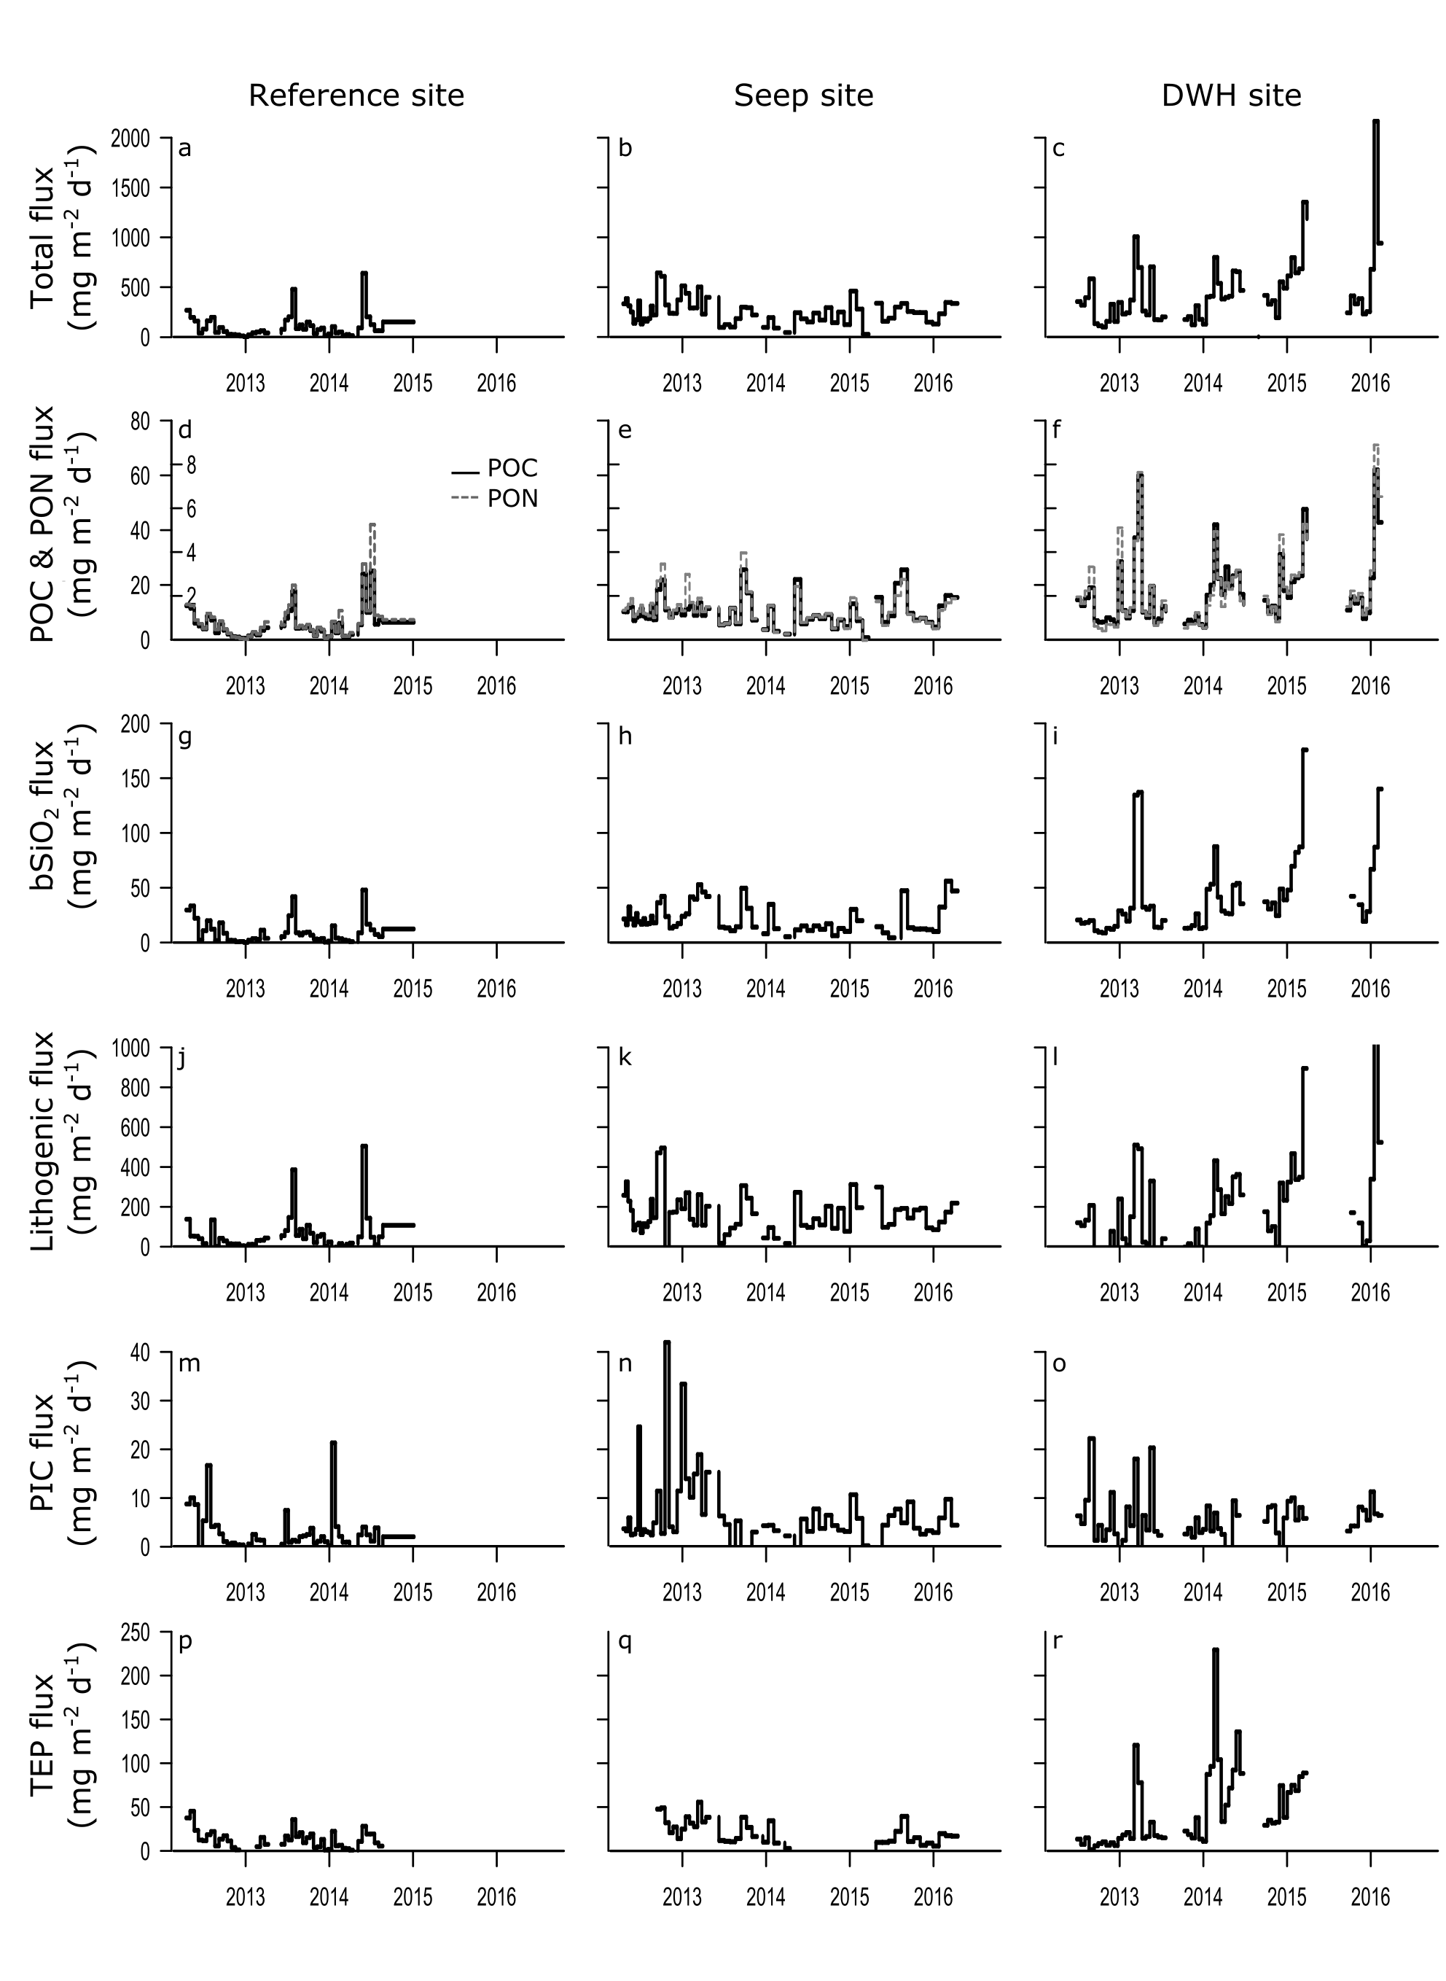
Figure S1. Particle flux rates in the Northern Gulf of Mexico at the three sites.
Fluxes are presented for the Reference site (1st column), the Seep site (2nd column) and the DWH site (3rd column). (a-c) Total matter (based on dry weight). (d-f) POC and PON (solid black and dotted grey line, respectively). (g-i) Biogenic silica (bSiO₂). (j-l) Lithogenic matter. (m-o) Particulate inorganic carbon (PIC). (p-r) Transparent exopolymer particles (TEP). All units in mg m^{–2} d^{–1}.
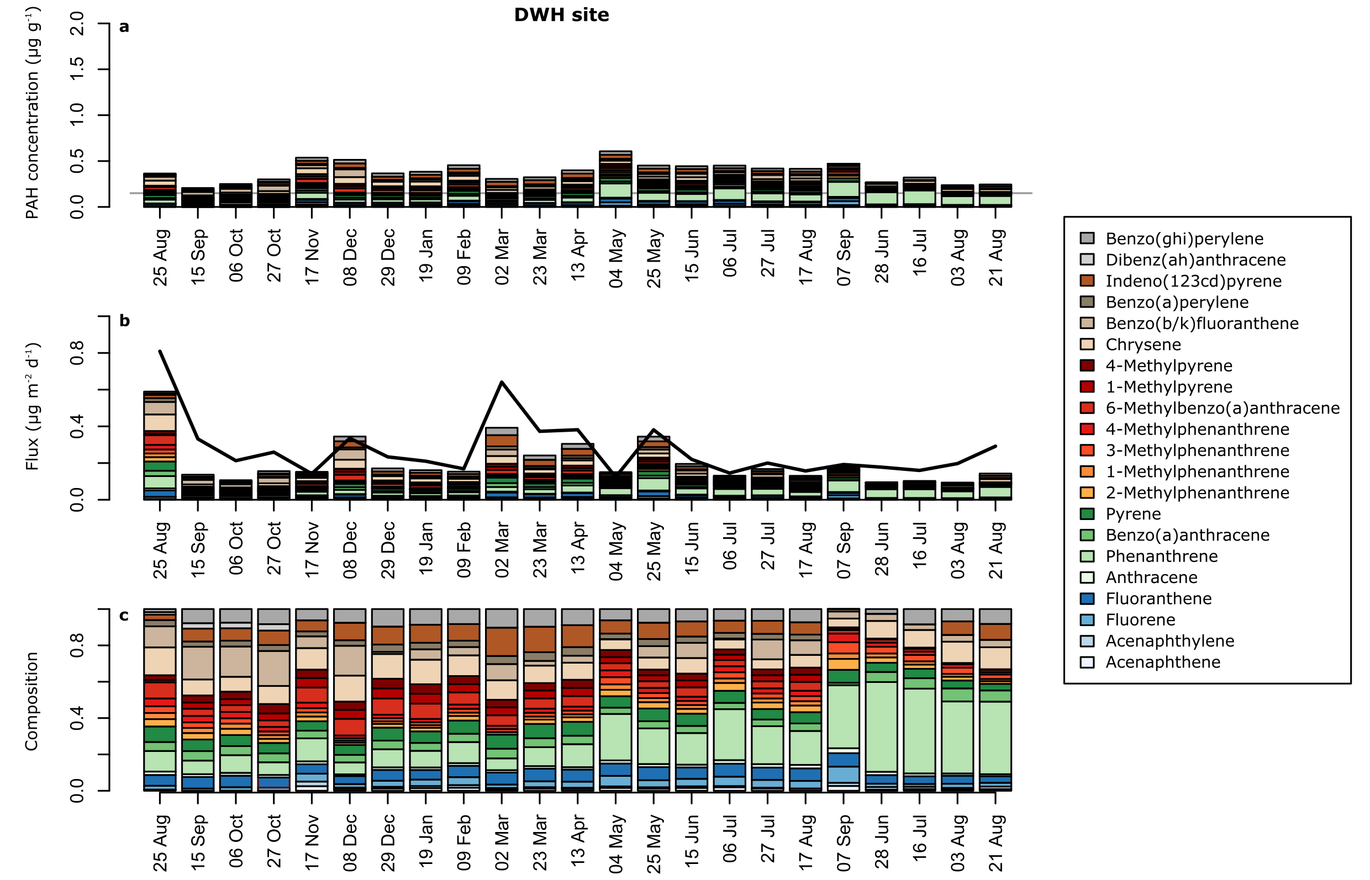

Figure S2. Polycyclic aromatic hydrocarbons (PAH) at the DWH site.
Fluxes were measured during August 2010–September 2012 and June–August 2012 (last four bars). (a) ΣPAH concentration in µg (g DW) ^{–1}. (b) ΣPAH flux in µg m^{–2} d^{–1}. Black line shows corresponding dry weight fluxes. (c) ΣPAH composition. Colours represent PAHs as in legend. Grey line shows overall-baseline level according to Reference site.

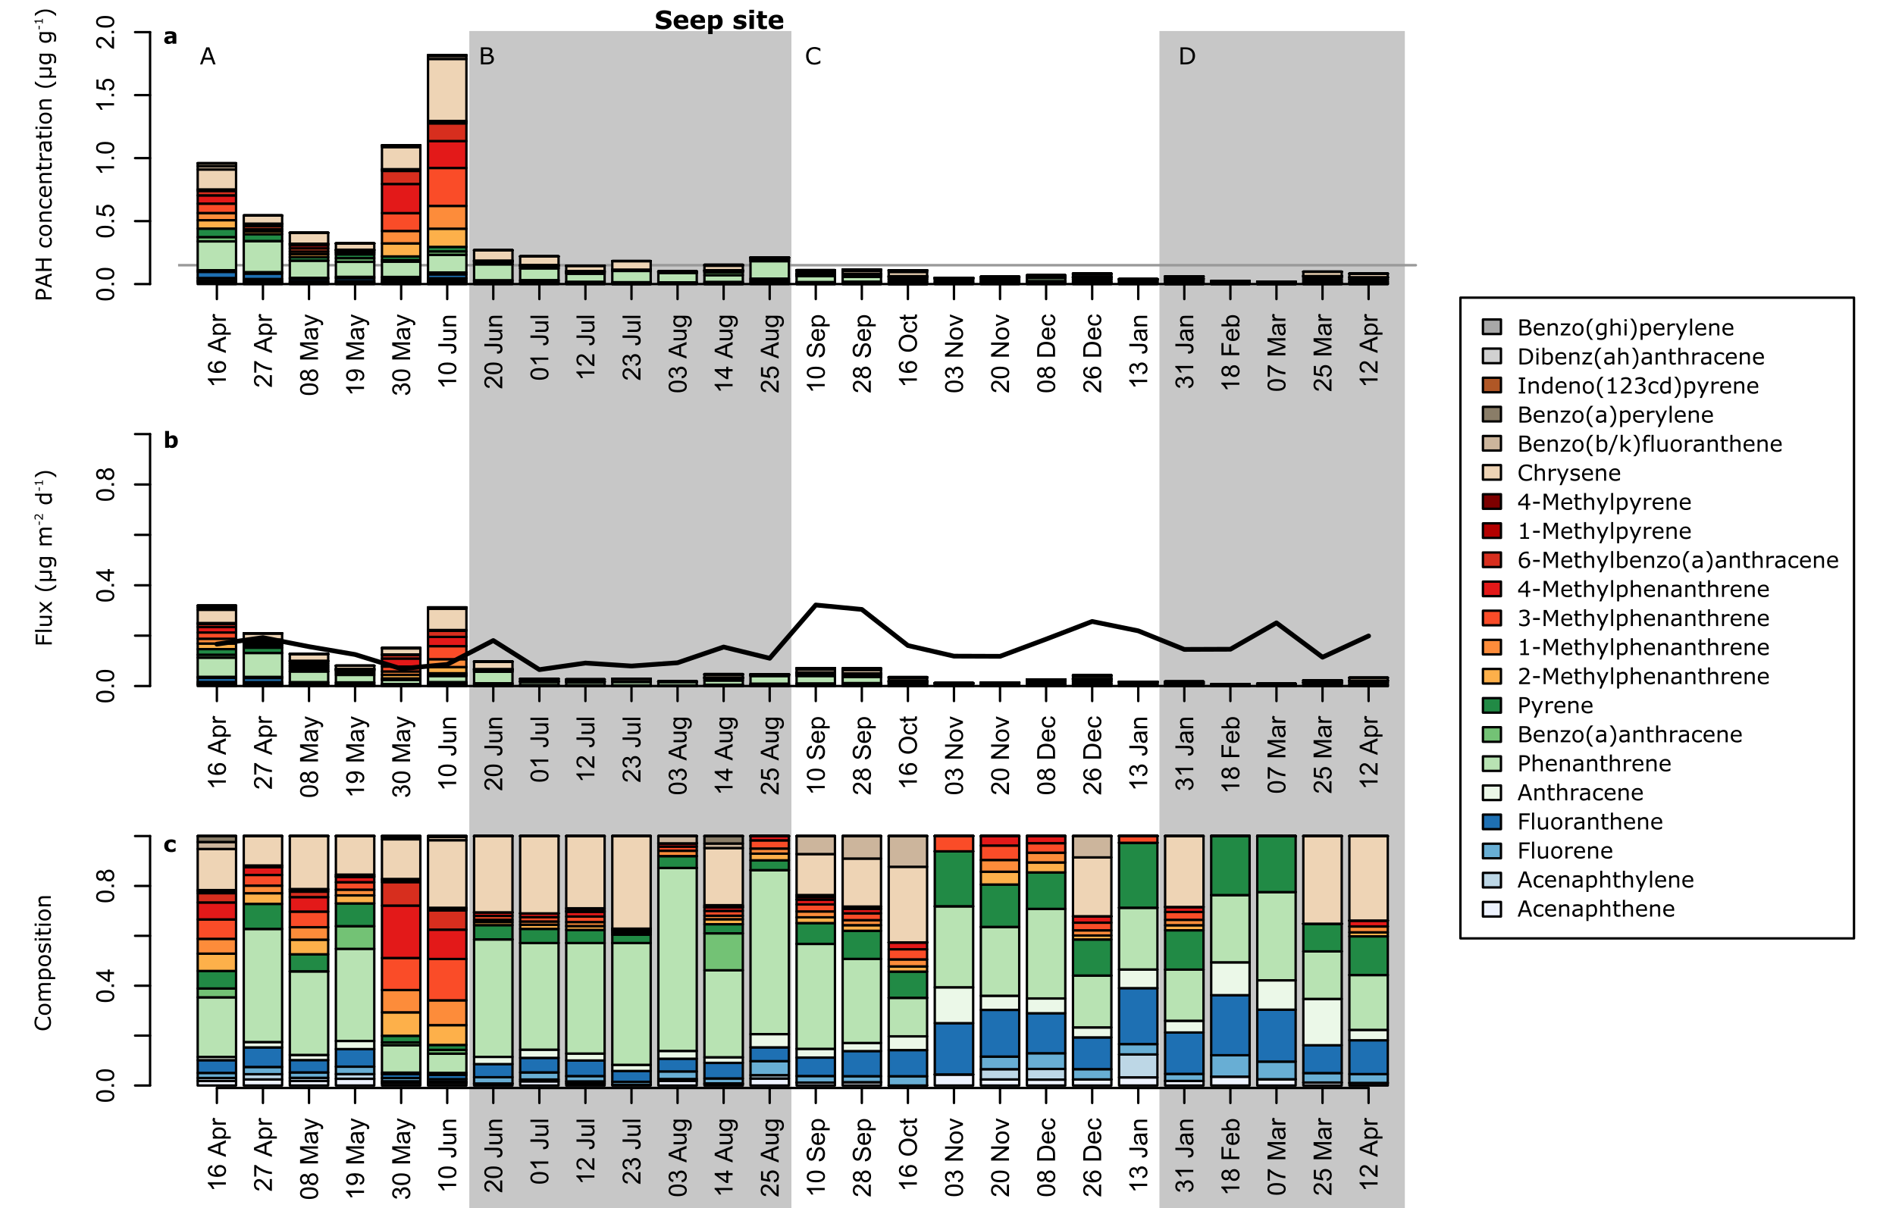

Figure S3. Polycyclic aromatic hydrocarbons (PAH) at the Seep site.
Fluxes were measured during April 2012–April 2013. (a) ΣPAH concentration in µg (g DW) ^{–1}. (b) ΣPAH flux in µg m^{–2} d^{–1}. Black line shows corresponding dry weight fluxes. (c) ΣPAH composition. Colours represent PAHs as in legend. Grey line shows overall-baseline level according to Reference site. Periods are highlighted that show clear signs of crude oil (A), predominantly combustion products (B), no unusual contamination but an old isotope signal (C), and no unusual contamination (D).

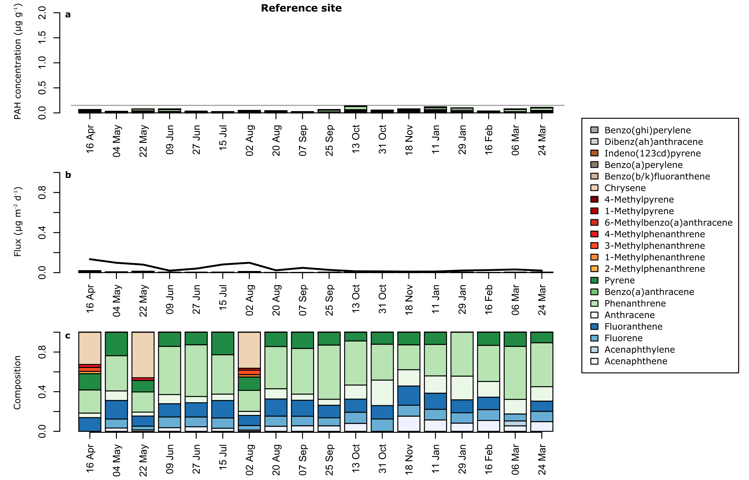

Figure S4. Polycyclic aromatic hydrocarbons (PAH) at the Reference site.
Fluxes were collected during April 2012–April 2013. (a) ΣPAH concentration in µg (g DW) ^{–1}. (b) ΣPAH flux in µg m^{–2} d^{–1}. Black line shows corresponding dry weight fluxes. (c) ΣPAH composition. Colours represent PAHs as in legend. Grey line shows overall-baseline level according to Reference site.

Table S1. List of analyzed hydrocarbons.
Compound | Group | Rings
Fluorene | PAH | 2 + 1
Acenaphthylene | PAH | 2 + 1
Acenaphthene | PAH | 2 + 1
4-Methylphenanthrene | PAH | 3
3-Methylphenanthrene | PAH | 3
1-Methylphenanthrene | PAH | 3
2-Methylphenanthrene | PAH | 3
Anthracene | PAH | 3
Phenanthrene | PAH | 3
Fluoranthene | PAH | 3 + 1
Chrysene | PAH | 4
6-Methylbenzo(a)anthracene | PAH | 4
4-Methylpyrene | PAH | 4
1-Methylpyrene | PAH | 4
Benzo[a]anthracene | PAH | 4
Pyrene | PAH | 4
Benzo[b/k]fluoranthene | PAH | 4 + 1
Dibenz[a,h]anthracene | PAH | 5
Indeno[1,2,3-cd]pyrene | PAH | 5 + 1
Benzo[g,h,i]perylene | PAH | 6
benzo[a]perylene | PAH | 6
17aH-21bH-Hopane | hopane
18a-22,29,30-trisnorneohopane | hopane
17a-22,29,30-trisnorhopane | hopane
C16 | n-alkane
C22 | n-alkane
C23 | n-alkane
C24 | n-alkane
C25 | n-alkane
C26 | n-alkane
C27 | n-alkane
C28 | n-alkane
C29 | n-alkane
C30 | n-alkane
C31 | n-alkane
C32 | n-alkane
C33 | n-alkane
C34 | n-alkane
Pristane | i-alkane
Phytane | i-alkane

