Supplemental material

Atmospheric vorticity sets the basin-scale circulation in Hudson Bay

Igor A. Dmitrenko^{1,}*, Paul G. Myers², Sergei A. Kirillov¹, David G. Babb¹, Denis L. Volkov^{3,4}, Jennifer V. Lukovich¹, Ran Tao², Jens K. Ehn¹, Kevin Sydor⁵, and David G. Barber¹

¹Centre for Earth Observation Science, University of Manitoba, Winnipeg, Manitoba, Canada
²Department of Earth and Atmospheric Sciences, University of Alberta, Edmonton, Alberta, Canada
³Cooperative Institute for Marine and Atmospheric Studies, University of Miami, Miami, Florida, USA
⁴NOAA, Atlantic Oceanographic and Meteorological Laboratory, Miami, Florida, USA
⁵Manitoba Hydro, Winnipeg, Manitoba, Canada

*Corresponding author’s email: igor.dmitrenko@umanitoba.ca

List of Contents:
Figure S1. Sea level atmospheric pressure and simulated currents and sea surface heights for storm #1.
(a–d) Sea level atmospheric pressure (hPa) for storm #1 (16–19 November 2016) and simulated top 30-m currents (arrows) and SSH in color shading (e) before and (f) during the storm on 16 November and 18 November 2016, respectively. (JPEG)
Figure S2. Sea level atmospheric pressure and simulated currents and sea surface heights for storm #2.
(a–d) Sea level atmospheric pressure (hPa) for storm #2 (7–10 December 2016) and simulated top 30-m currents (arrows) and SSH in color shading (e) before and (f) during the storm on 7 December and 9 December 2016, respectively. (JPEG)
Figure S3. Sea level atmospheric pressure and simulated currents and sea surface heights for storm #3.
(a–d) Sea level atmospheric pressure (hPa) for storm #3 (12–15 December 2016) and simulated top 30-m currents (arrows) and SSH in color shading (e) before and (f) during the storm on 12 December and 15 December 2016, respectively. (JPEG).
Figure S4. Sea level atmospheric pressure and simulated currents and sea surface heights for storm #5.
(a–d) Sea level atmospheric pressure (hPa) for storm #5 (19–22 March 2017) and simulated top 30-m currents (arrows) and SSH in color shading (e) before and (f) during the storm on 19 March and 21 March 2017, respectively. (JPEG)
Figure S5. Sea level atmospheric pressure and simulated currents and sea surface heights for storm #7.
(a–d) Sea level atmospheric pressure (hPa) for storm #7 (11–14 September 2017) and simulated top 30-m currents (arrows) and SSH in color shading (e) before and (f) during the storm on 10 September and 13 September 2017, respectively. (JPEG)

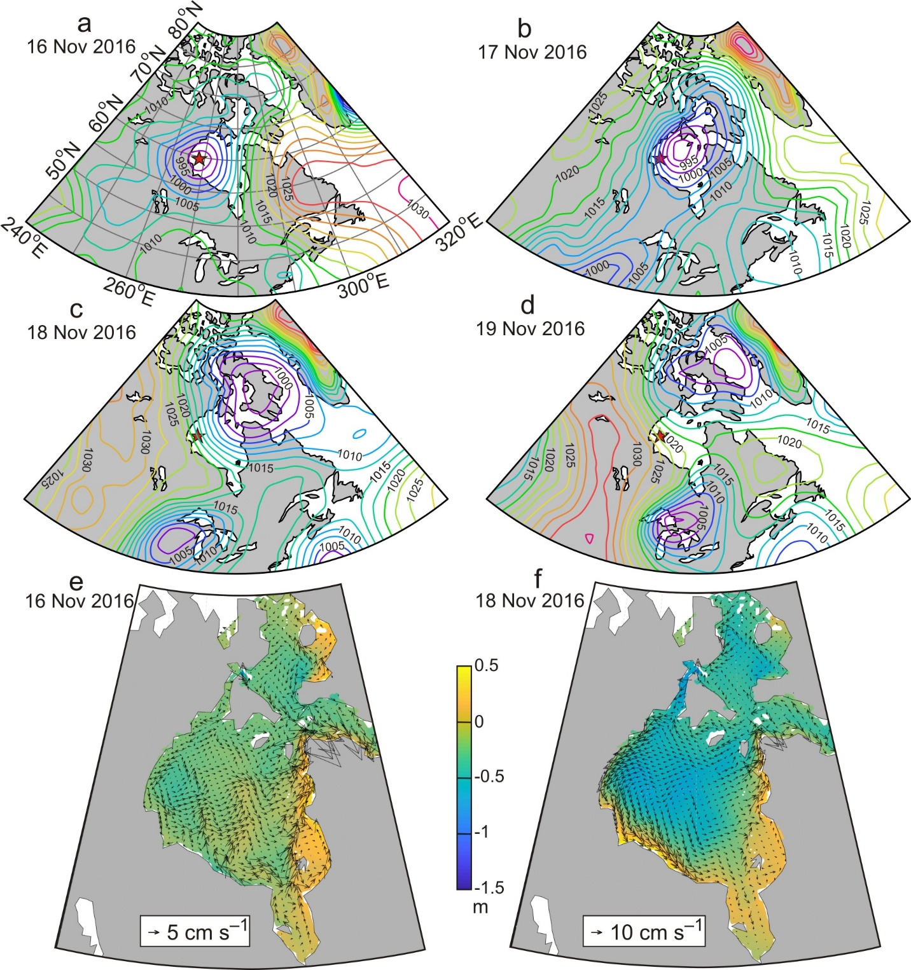
Figure S1. Sea level atmospheric pressure and simulated currents and sea surface heights for storm #1.
(a-d) Sea level atmospheric pressure (hPa) for storm #1 (16-19 November 2016) and simulated top 30 m currents (arrows) and SSH in color shading (e) before and (f) during the storm on 16 November and 18 November 2016, respectively.

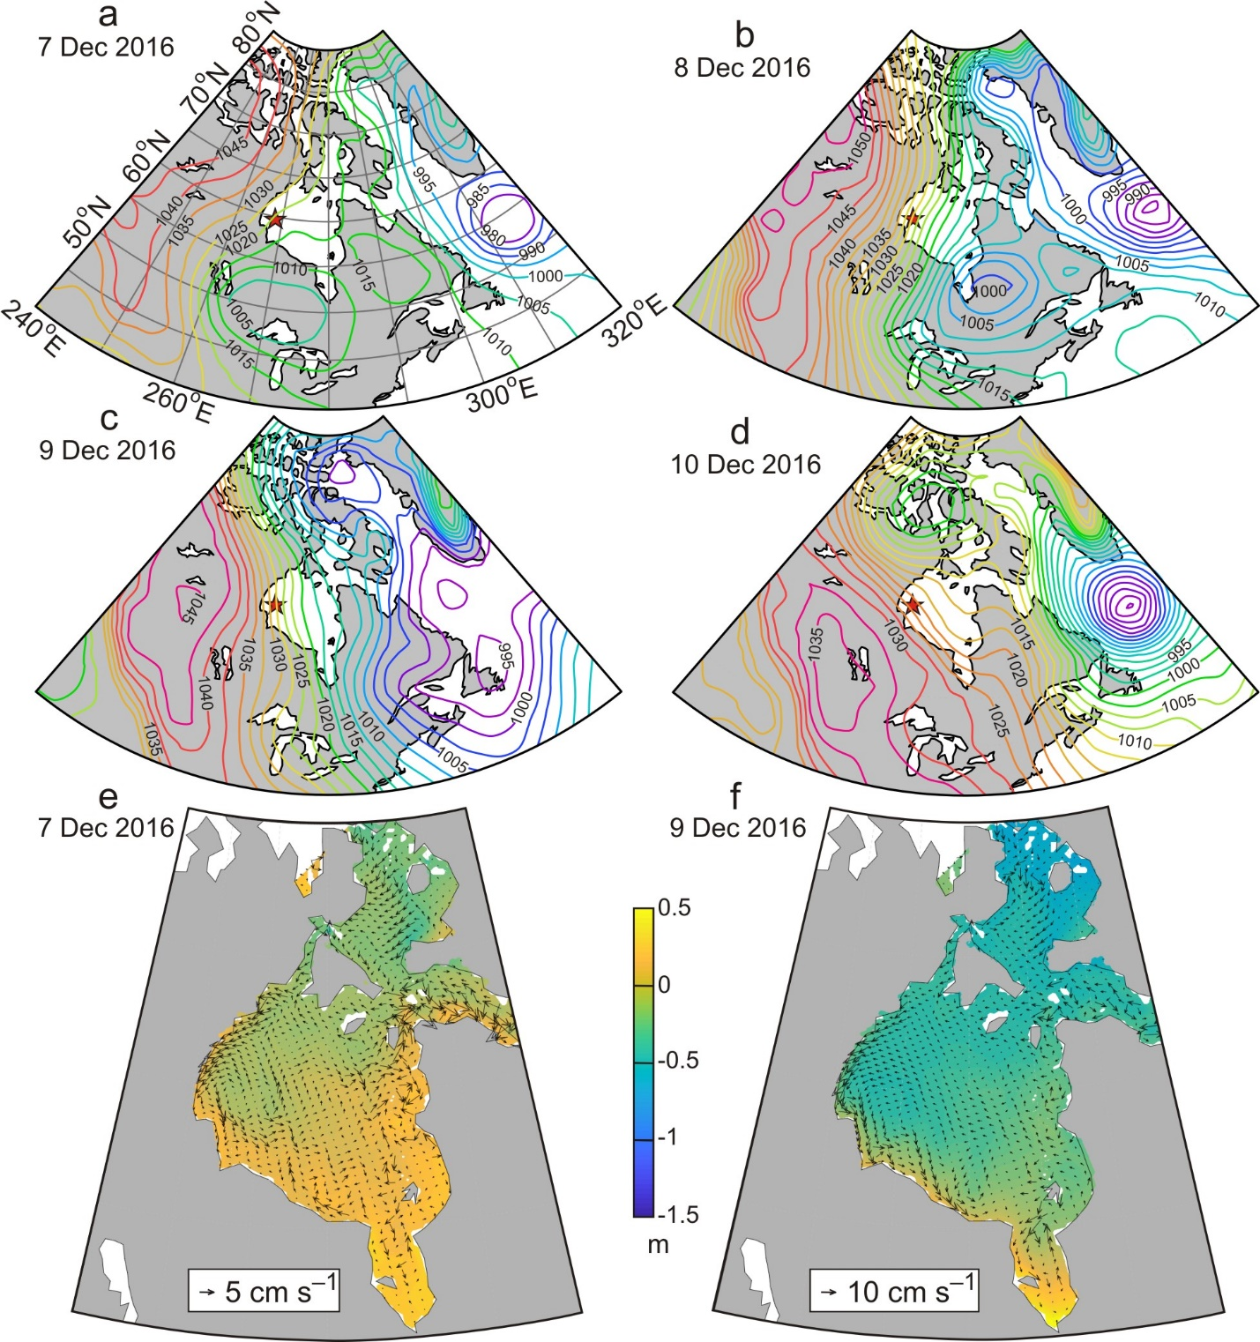
Figure S2. Sea level atmospheric pressure and simulated currents and sea surface heights for storm #2.
(a-d) Sea level atmospheric pressure (hPa) for storm #2 (7-10 December 2016) and simulated top 30 m currents (arrows) and SSH in color shading (e) before and (f) during the storm on 7 December and 9 December 2016, respectively.

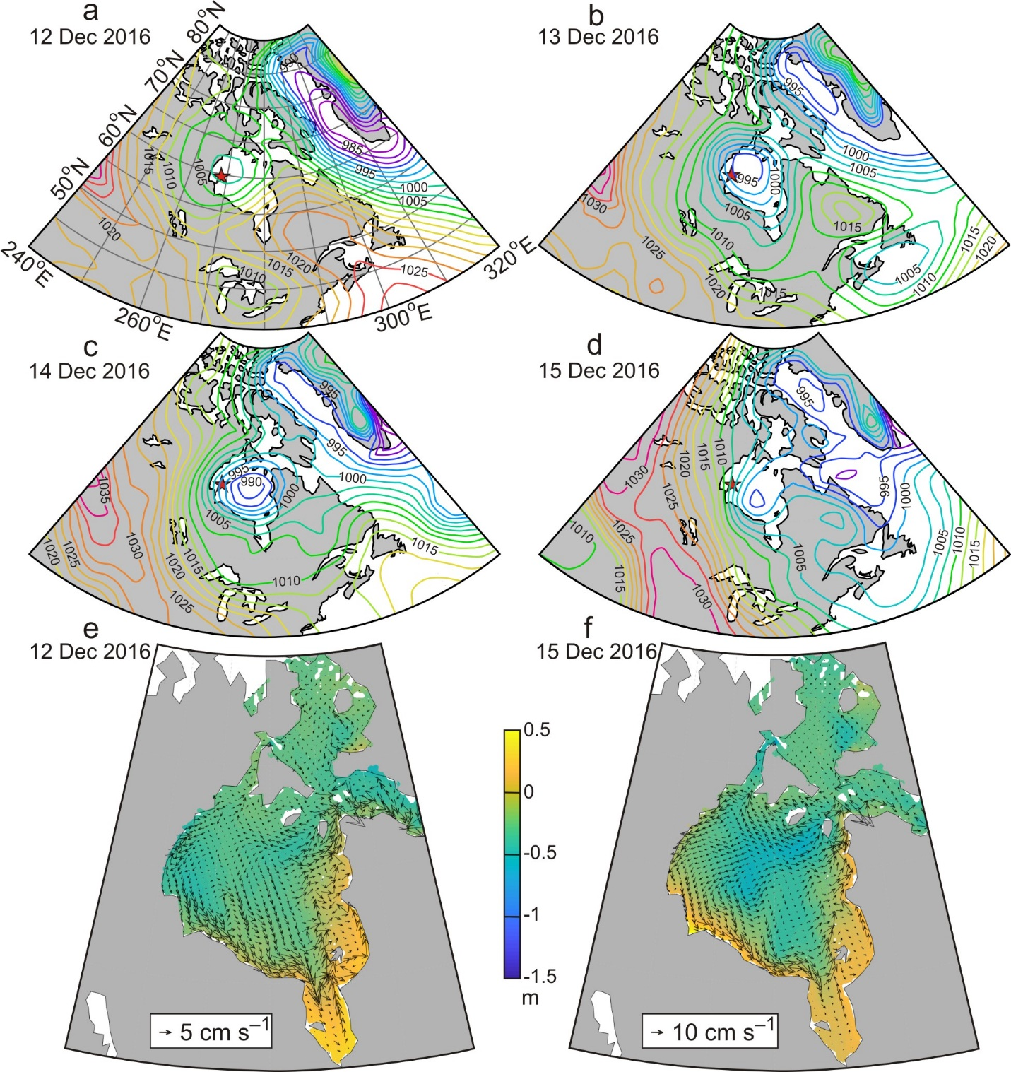
Figure S3. Sea level atmospheric pressure and simulated currents and sea surface heights for storm #3.
(a-d) Sea level atmospheric pressure (hPa) for storm #3 (12-15 December 2016) and simulated top 30 m currents (arrows) and SSH in color shading (e) before and (f) during the storm on 12 December and 15 December 2016, respectively.

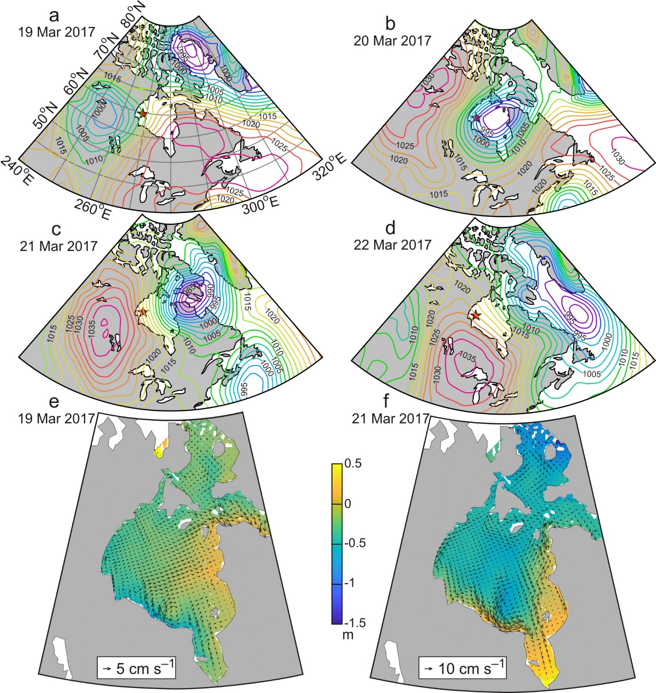
Figure S4. Sea level atmospheric pressure and simulated currents and sea surface heights for storm #5.
(a-d) Sea level atmospheric pressure (hPa) for storm #5 (19-22 March 2017) and simulated top 30 m currents (arrows) and SSH in color shading (e) before and (f) during the storm on 19 March and 21 March 2017, respectively.

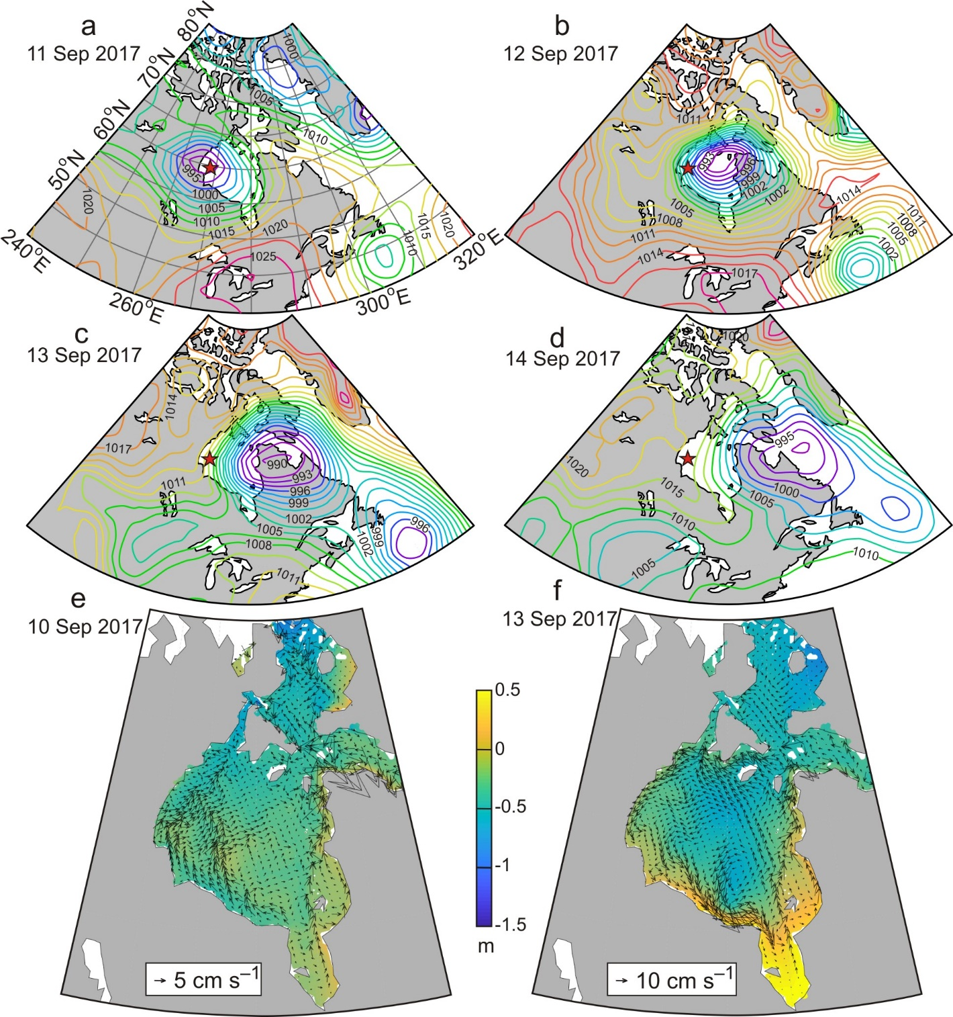
Figure S5. Sea level atmospheric pressure and simulated currents and sea surface heights for storm #7.
(a-d) Sea level atmospheric pressure (hPa) for storm #7 (11-14 September 2017) and simulated top 30 m currents (arrows) and SSH in color shading (e) before and (f) during the storm on 10 September and 13 September 2017, respectively.

