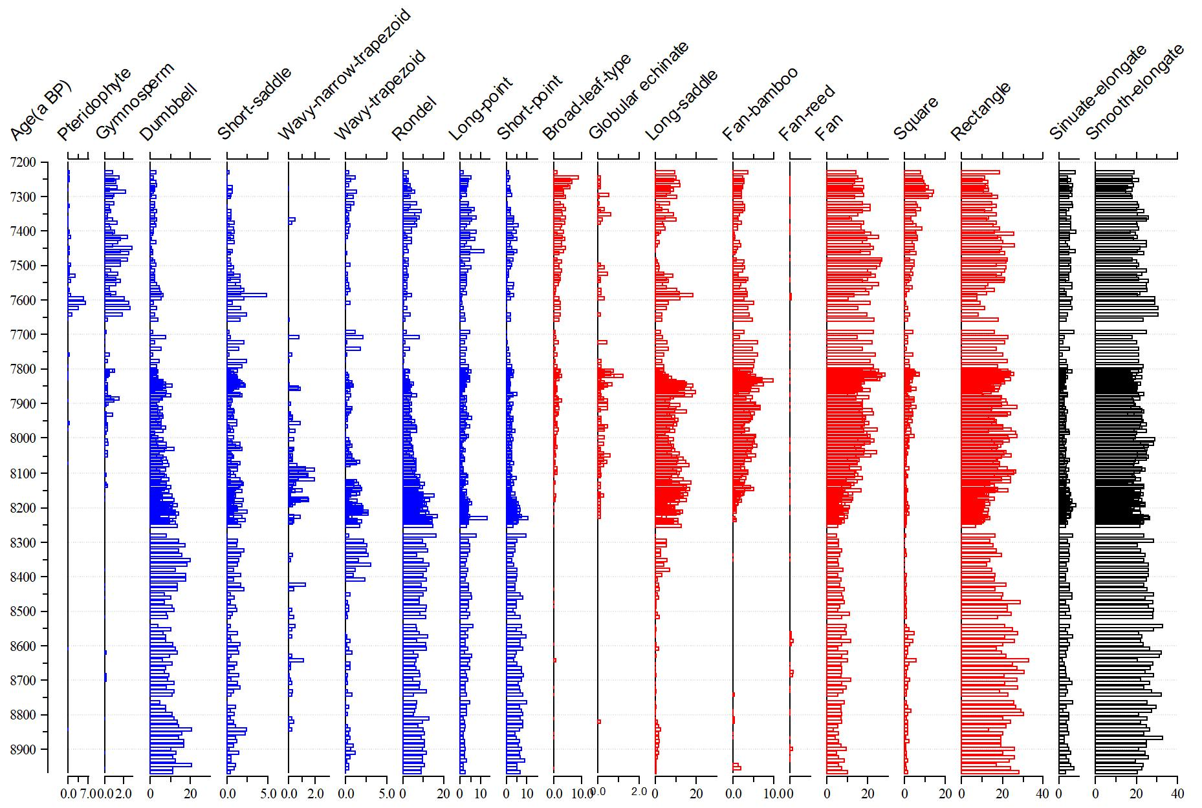
Figure S1 The main phytoliths assemblages from the HG01 core. All phytolith numbers were expressed as percentages of the total phytoliths counted.

