Supplemental material
Underestimation of surface pCO₂ and air-sea CO₂ fluxes due to freshwater stratification in an Arctic shelf sea, Hudson Bay
Mohamed M. M. Ahmed^{1,2*}, Brent G. T. Else¹, David Capelle³, Lisa A. Miller⁴, Tim Papakyriakou³
¹Geography Department, University of Calgary, Calgary, Alberta, Canada
²Geology Department, Faculty of Science, Beni‐Suef University, Beni‐Suef, Egypt
³Centre for Earth Observation Science, Department of Environment and Geography, University of Manitoba, Winnipeg, Manitoba, Canada
⁴Centre for Ocean Climate Chemistry, Institute of Ocean Sciences, Fisheries and Oceans Canada, Sidney, British Columbia, Canada
*Corresponding author: Mohamed Ahmed (email: mohamed.ahmed3@ucalgary.ca)

List of Contents:
Figure S1. Water mass characteristics at each station based on our bottle samples. (a) Surface-water potential temperature versus salinity, color-shaded with pCO₂ values, with isopycnals of density anomaly (σ_{θ}) displayed in dashed lines (blue rectangle indicates samples mainly from Hudson Strait), and (b) oxygen water isotope (δ¹⁸O) versus salinity, shaded with pCO₂ values (the dashed lines represent the mixing lines between the endmembers). SIM, SW, and MW refer to sea-ice melt, seawater, and meteoric water endmembers, respectively.
Figure S2. Vertical gradients of DIC and TA in Hudson Bay. Distributions of DIC (a) and TA (b) as a function of salinity at the surface (red) and at 7-m depth (blue), with the distributions of vertical gradients of DIC (c) and TA (d) versus the vertical gradients of salinity during the study time. The solid black lines in (a,b) show linear regression relationships.
Table S1: Sampling stations with surface and 7-m water samples collected across the study area.

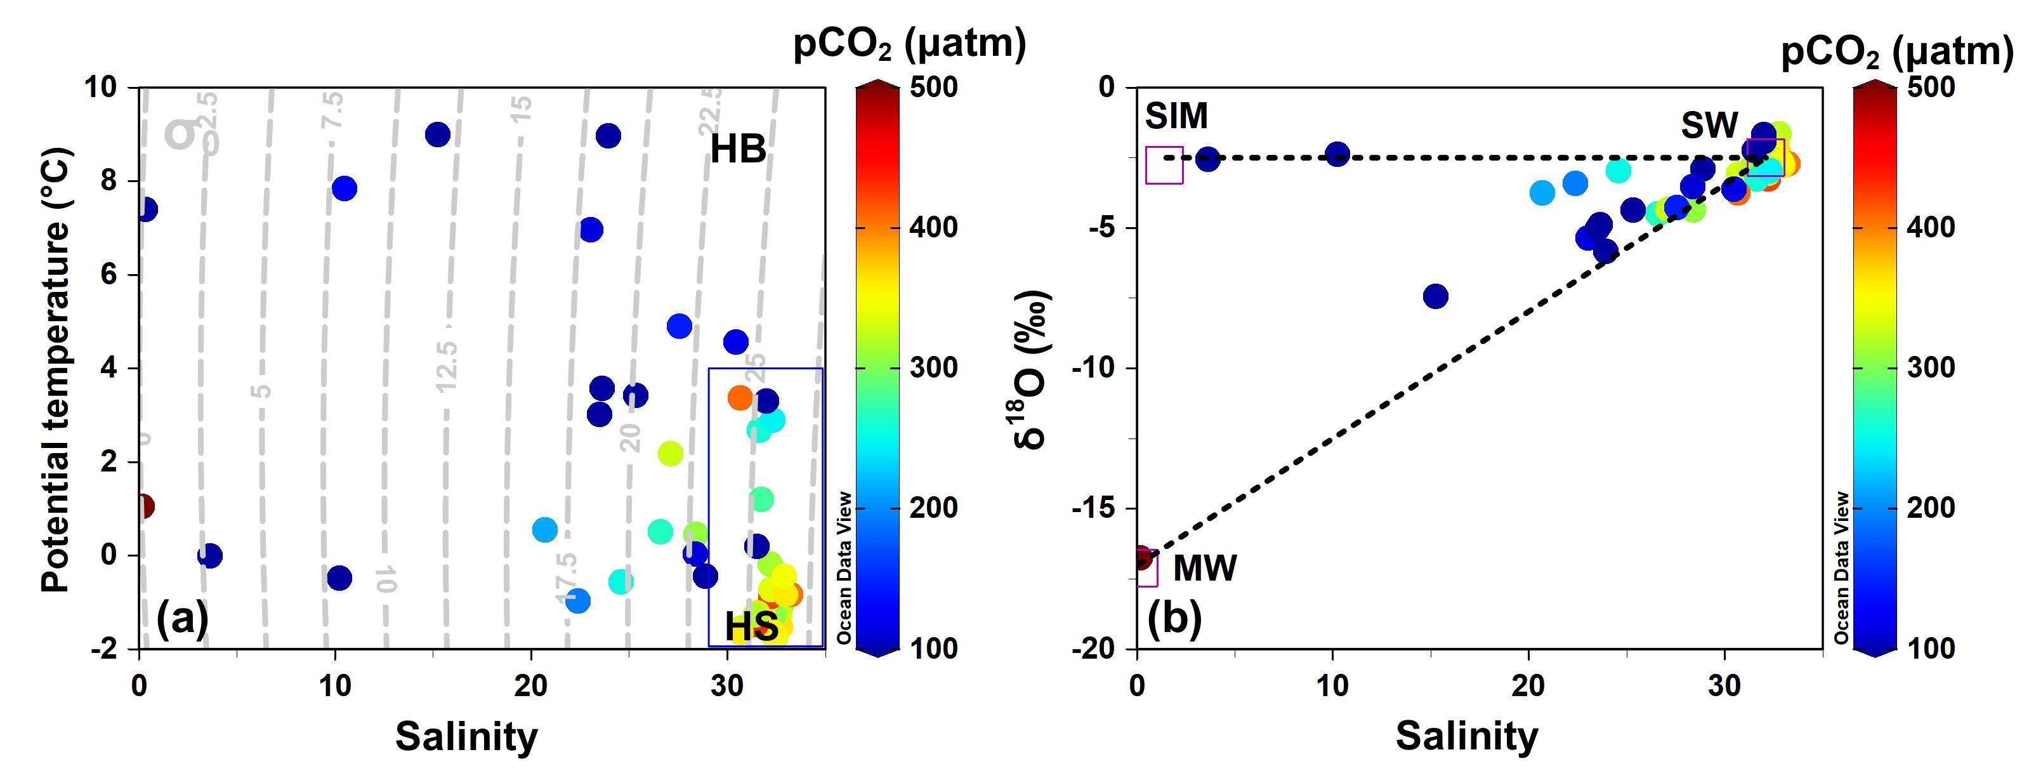
Figure S1. Water mass characteristics at each station based on our bottle samples. (a) Surface water potential temperature versus salinity, color-shaded with pCO₂ values, with isopycnals of density anomaly (σ_{θ}) displayed in dashed lines (blue rectangle indicates samples mainly from Hudson Strait), and (b) oxygen water isotope (δ¹⁸O) versus salinity, shaded with pCO₂ values (the dashed lines represent the mixing lines between the end-members, in red squares). SIM, SW, and MW refer to sea-ice melt, seawater, and meteoric water endmembers, respectively.

Figure S2. Vertical gradients of DIC and TA in Hudson Bay. Distributions of DIC (a) and TA (b) as a function of salinity at the surface (red) and at 7-m depth (blue), with the distributions of vertical gradients of DIC (c) and TA (d) versus the vertical gradients of salinity during the study time. The solid black lines (a,b) show linear regression relationships.

Table S1. Sampling stations with surface and 7-m water samples collected across the study area.
Date (year-month-day) and time (UTC) | Station | Sampling meansª | Latitude | Longitude | Distance^{b} (km) | FD/SB |  | UW^{c}
 |  |  |  |  |  | Surface–0.5 m | 7 m | 7 m
2018-05-31 18:57:11 | 1 | FD | 60.83 | –64.68 | 1.90 | x^{d} | x | x
2018-06-01 00:35:21 | 3 | FD | 61.15 | –64.82 | ―^{e} | x | x | ―
2018-06-01 14:00:28 | 4 | FD | 62.04 | –69.61 | 1.78 | ○^{f} | x | ○
2018-06-02 21:46:50 | 5 | FD | 64.29 | –78.23 | 1.98 | ○ | x | ○
2018-06-03 04:05:55 | 7 | FD | 64.07 | –79.06 | ― | x | x | ―
2018-06-03 20:32:42 | 9 | FD | 63.72 | –79.92 | 0.10 | ○ | x | ○
2018-06-04 02:31:43 | 10 | FD | 63.45 | –79.44 | 0.03 | ○ | x | ○
2018-06-04 19:28:00 | 11 | FD | 62.88 | –78.86 | ― | x | x | ―
2018-06-05 18:01:10 | 15 | SB | 63.18 | –81.86 | 0.02 | ○ | x | ○
2018-06-06 18:53:10 | 16 | SB | 63.00 | –85.88 | 1.50 | ○ | x | ○
2018-06-07 21:44:28 | 17 C | SB | 63.49 | –90.64 | ― | x | ― | ―
2018-06-07 23:06:04 | 17 B | SB | 63.28 | –90.35 | 0.75 | ○ | ― | ○
2018-06-08 00:00:45 | 17 A | SB | 61.18 | –90.06 | ― | x | x
2018-06-08 19:29:59 | 18 | SB | 63.73 | –88.32 | 0.02 | ○ | x | ○
2018-06-09 17:39:35 | 19 C | SB | 62.06 | –92.47 | ― | x | ― | ―
2018-06-09 18:39:35 | 19 B | SB | 61.96 | –92.27 | ― | x | ― | ―
2018-06-09 19:39:35 | 19 A | SB | 61.84 | –92.17 | 0.06 | ○ | x | ○
2018-06-10 13:47:00 | 21 B | SB | 61.05 | –89.37 | ― | x | ― | ―
2018-06-10 14:26:18 | 21 A | SB | 61.14 | –89.37 | ― | x | x | ―
2018-06-11 17:04:32 | 22 C | SB | 60.48 | –94.57 | ― | x | ― | ―
2018-06-11 17:52:39 | 22 B | SB | 60.48 | –94.57 | ― | x | x | ―
2018-06-11 18:52:28 | 22 M | SB | 60.45 | –94.30 | ― | x | ― | ―
2018-06-11 20:12:13 | 22 A | SB | 60.42 | –94.01 | 0.07 | ○ | x | ○
2018-06-12 17:17:49 | 24 | SB | 61.69 | –87.75 | 0.05 | ― | ― | x
2018-06-14 12:13:15 | 26 | FD | 62.20 | –88.38 | 0.03 | ○ | ― | ○
2018-06-15 01:18:38 | 28 | FD | 62.41 | –89.83 | 0.06 | ○ | x | ○
2018-06-18 15:07:38 | 31 | FD | 57.50 | –91.81 | 0.04 | x | x | x
2018-06-19 16:40:22 | 32 B | SB | 56.99 | –88.12 | 0.68 | ― | ― | x
2018-06-19 17:10:00 | 32 A | SB | 56.99 | –88.14 | 0.50 | x | x | x
2018-06-20 23:12:28 | 34 | SB | 56.51 | –86.88 | 0.78 | x | x | x
2018-06-21 13:47:50 | 34B A | SB | 56.50 | –86.86 | 0.80 | x | x | x
2018-06-21 14:11:37 | 34B B | SB | 56.50 | –86.88 | 0.80 | ○ | ― | ○
2018-06-22 03:04:37 | 35 | FD | 57.18 | –86.50 | 0.11 | ― | x | x
2018-06-22 14:46:59 | 36B | SB | 57.77 | –86.03 | 1.24 | ― | ― | x
2018-06-22 14:57:47 | 36A | SB | 57.77 | –86.03 | 1.13 | ― | x | x
2018-06-23 02:54:52 | 37 | FD | 58.47 | –86.23 | ― | x | x | ―
2018-06-23 15:39:00 | 38 B | SB | 58.72 | –86.31 | 0.73 | ― | ― | x
2018-06-23 18:10:49 | 38 A | SB | 58.72 | –86.31 | 0.59 | x | x | x
2018-06-24 06:48:54 | 39 | FD | 58.48 | –87.44 | 0.53 | ― | x | x
2018-06-24 13:49:17 | 40 | SB | 58.24 | –88.58 | 0.08 | ― | x | x
2018-07-04 14:35:57 | Churchill A | SB | 58.76 | –94.20 | ― | ― | x | ―
2018-07-04 15:53:09 | Churchill B | SB | 58.80 | –94.19 | ― | x | ― | ―
2018-07-04 17:40:42 | Churchill C | SB | 58.93 | –93.80 | ― | x | ― | ―
2018-07-08 19:06:04 | 730 | FD | 56.18 | –76.70 | 0.05 | ― | x | x
2018-07-09 10:45:15 | 736 | FD | 58.42 | –78.31 | 0.02 | ― | x | x
2018-07-11 22:26:55 | 689 | FD | 62.34 | –75.53 | 0.04 | ― | x | x
2018-07-12 17:51:04 | 341 | FD | 61.95 | –70.75 | 0.06 | ― | x | x
ªFD indicates sampling from the foredeck; SB, from a small boat.
^{b}Distance refers to the horizontal distance between sampling via Niskin bottle and the closest measurement recorded by the underway pCO₂ system located on the ship (underway observations were recorded only when the distance is < 2 km).
^{c}UW indicates underway pCO₂ measurements.
^{d}Sample was collected.
^{e}No sample was collected.
^{f}Sample was collected and data appear in Figure 10.

