Supplementary Information

Beyond community gardens: A participatory research study evaluating nutrient and lead profiles of urban harvested fruit

Ciaran L. Gallagher, Hannah L. Oettgen, and Dan J. Brabander
Geosciences Department, Wellesley College, Wellesley MA, US

a  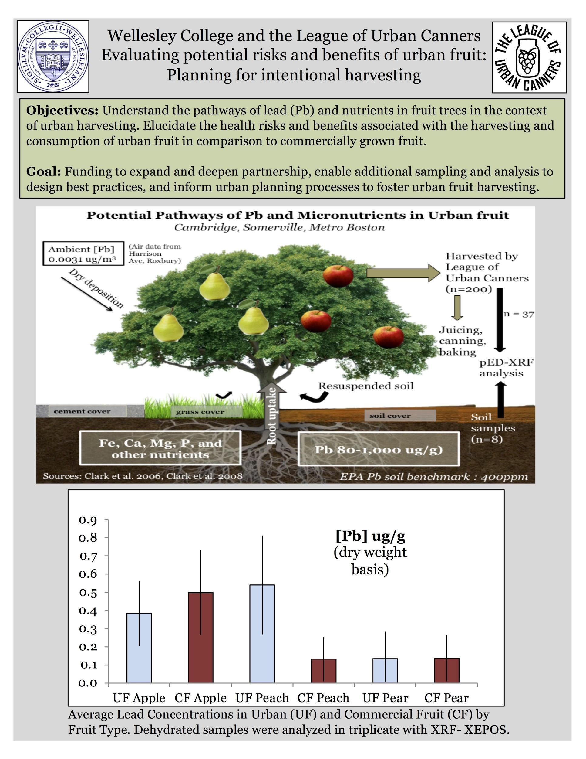 | b  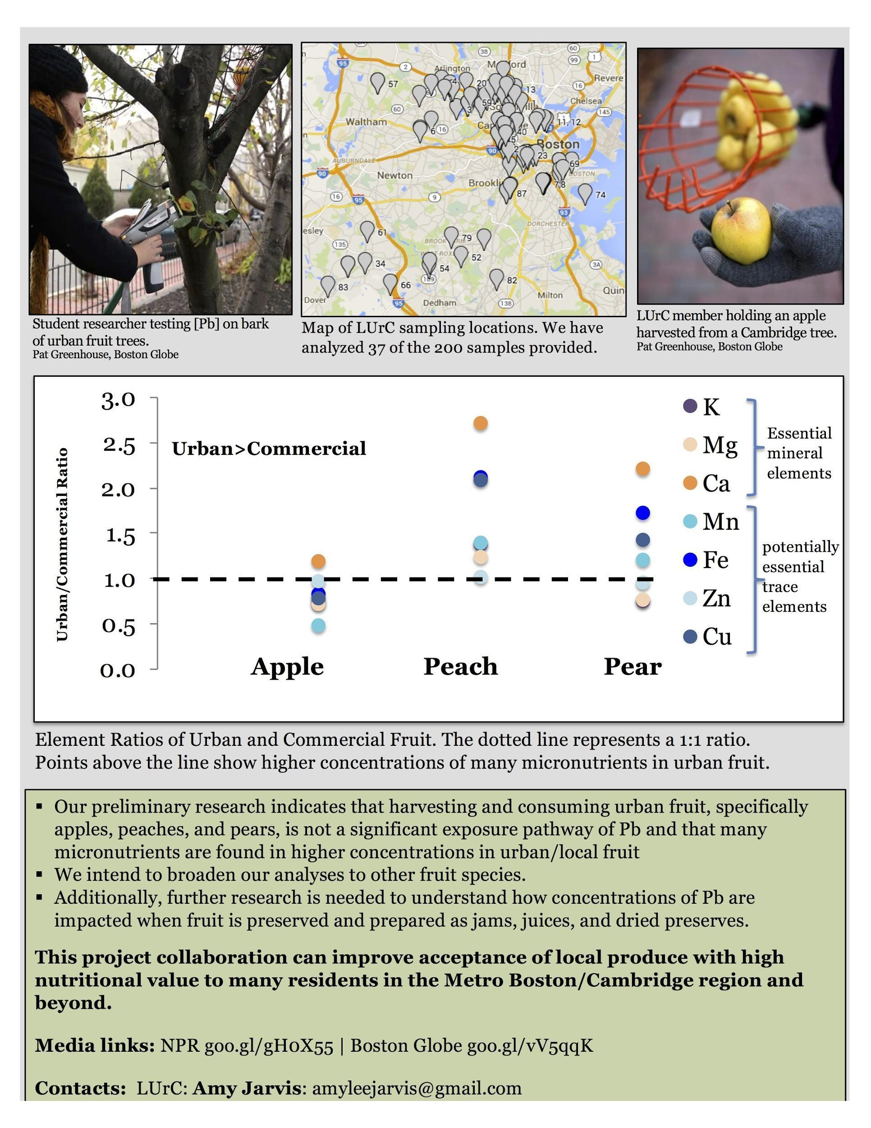
Figure S1 a-b. Front and back of a sample infographic prepared in collaboration with LUrC. This was used to communicate preliminary results and advocate for increasing community involvement with the project.

