Supplemental material

Reliance of deep-sea benthic macrofauna on ice-derived organic matter highlighted by multiple trophic markers in spring, Baffin Bay, Canadian Arctic

Gustavo Yunda-Guarin ^{1*}, Thomas A. Brown ², Loïc N. Michel ³, Blanche Saint-Béat ¹, Rémi Amiraux ¹, Christian Nozais ⁴ and Philippe Archambault ¹

¹ ArcticNet, Québec Océan, Takuvik, Université Laval, (UMI 3376), Québec, Canada
² The Scottish Association for Marine Science (SAMS), Oban, Scotland, UK
³ Institut Français de Recherche pour l'Exploitation de la Mer (Ifremer), Centre de Bretagne, REM/EEP, Laboratoire Environnement Profond, F-29280 Plouzané, France
⁴ Université du Québec à Rimouski, Département de biologie, chimie et géographie, Québec, Canada

Corresponding author: Gustavo Yunda-Guarin (gustavo-adolfo.guarin.1@ulaval.ca)

List of Contents:

Figure S1. Molecular structures of highly branched isoprenoid (HBI) alkenes measured in this study. Top to bottom, sympagic (IP₂₅, Diene II) and phytoplankton-pelagic (Triene III) HBI biomarkers.

Figure S2. Sediment stations showing the spatial distribution and relative percentage of sympagic carbon in Baffin Bay. The percentages of sympagic carbon (SC) found in sediment are shown for each station (n = 17) according to the color bar. Average sea-ice concentrations ranging from 0 to 100% (expressed here between 0 to 1; gray lines), derived from the National Snow and Ice Data Center (https://nsidc.org/data/nsidc-0051), in spring (1 April to 30 June) between 1998 and 2017 in Baffin Bay, Canadian Arctic.

Table S1. Benthic macrofauna measurements from samples collected in Baffin Bay in spring 2016. Mean values of Isotope ratios (δ¹³C, δ¹⁵N) and mean values of sympagic carbon percentages (SC) were measured for each replicate. Total number of species per replicate and the sampling zones (A, B or C) is also shown.
Figure S1. Molecular structures of highly branched isoprenoid (HBI) alkenes measured in this study. Top to bottom, sympagic (IP₂₅, Diene II) and phytoplankton-pelagic (Triene III) HBI biomarkers.

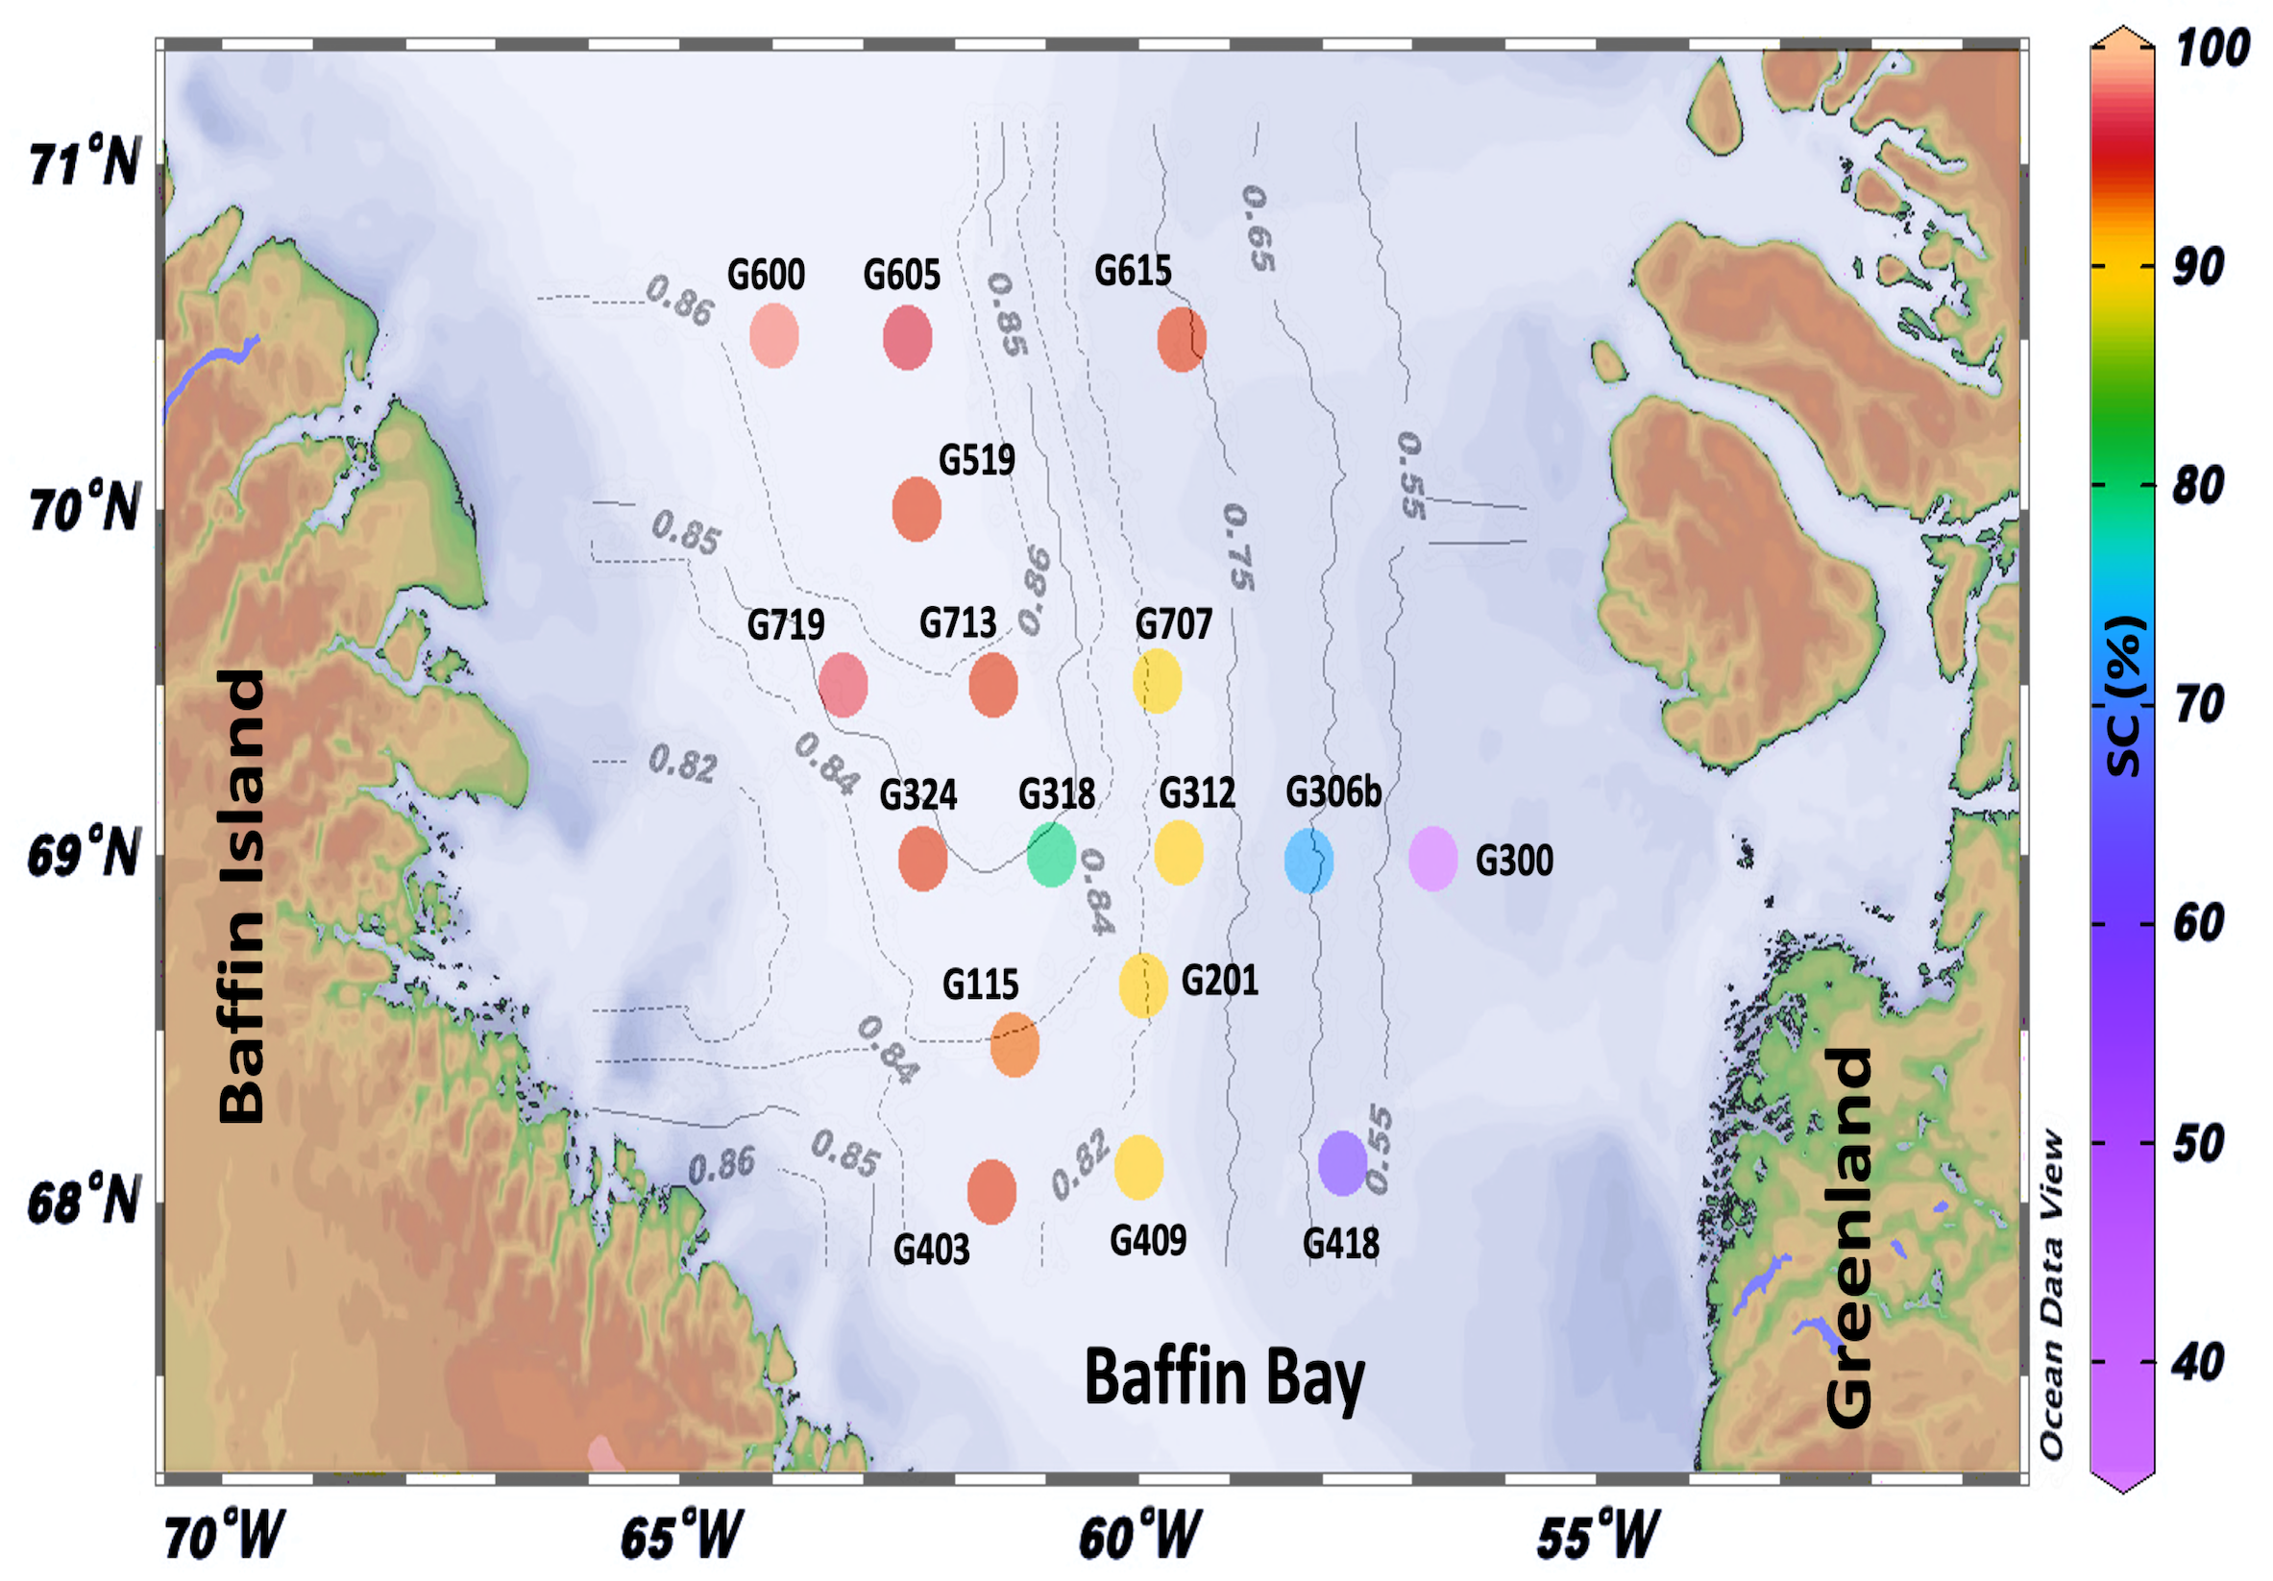
Figure S2. Sediment stations showing the spatial distribution and relative percentage of sympagic carbon in Baffin Bay. The percentages of sympagic carbon (SC) found in sediment are shown for each station (n = 17) according to the color bar. Average sea-ice concentrations ranging from 0 to 100% (expressed here between 0 to 1; gray lines), derived from the National Snow and Ice Data Center (https://nsidc.org/data/nsidc-0051), in spring (1 April to 30 June 30) between 1998 and 2017 in Baffin Bay, Canadian Arctic.
Table S1. Benthic macrofauna measurements from samples collected in Baffin Bay in spring 2016
Taxonomic classification | Zone | nª | n^{b} | δ¹⁵N^{c} (‰) | δ¹³C^{c} (‰) | n^{d} | SC^{c} (%)
Annelida
Class Polychaeta
Aglaophamus malmgreni | C | 12 | 1 | 14.5 | –16.9 | 1 | 89
Jasmineira schaudinni | C | 16 | 6 | 14.3 ± 0.2 | –19.9 ± 0.2 | 6 | 90 ± 5.7
Laetmonice filicornis | C | 1 | 1 | 14.9 | –18.0 | 1 | 99
Polyphysia crassa | C | 5 | 3 | 17.3 ± 0.1 | –15.1 ± 1.2 | 5 | 84 ± 1.3
Arthropoda
Class Malacostraca
Aega psora | A | 2 | 1 | 17.0 | –19.4 | 0 | N/A^{e}
Aegiochus ventrosa | B | 2 | 2 | 16.3 ± 0.4 | –20.6 ± 0.8 | 0 | N/A
Anonyx nugax | B | 5 | 4 | 15.1 ± 0.8 | –19.6 ± 0.3 | 1 | 84
A. nugax | C | 4 | 2 | 16.9 ± 0.7 | –19.1 ± 0.2 | 0 | N/A
Arrhis phyllonyx | C | 5 | 1 | 14.0 | –18.7 | 0 | N/A
Atlantopandalus propinqvus | B | 1 | 1 | 14.4 | –19.7 | 0 | N/A
Boreomysis nobilis | C | 33 | 8 | 11.2 ± 0.3 | –20.1 ± 0.2 | 8 | 97 ± 0.9
Caecognathia stygia | C | 40 | 3 | 17.2 ± 0.1 | –19.3 ± 0.1 | 0 | N/A
Diastylis rathkei | C | 51 | 3 | 6.1 ± 0.3 | –15.8 ± 1.4 | 3 | 85 ± 9.4
Epimeria loricata | B | 1 | 1 | 15.4 | –19.6 | 0 | N/A
Eusirus holmi | C | 1 | 1 | 14.3 | –18.2 | 0 | N/A
Halirages qvadridentatus | B | 3 | 1 | 9.3 | –18.8 | 0 | N/A
Hymenodora glacialis | C | 14 | 7 | 15.2 ± 0.6 | –19.7 ± 0.3 | 7 | 93 ± 2.7
Lebbeus polaris | A | 11 | 5 | 13.4 ± 0.5 | –17.6 ± 0.3 | 5 | 59 ± 33.3
L. polaris | B | 15 | 9 | 13.7 ± 0.8 | –17.9 ± 0.4 | 3 | 79 ± 12.9
Leucothoe uschakovi | B | 18 | 2 | 14.2 ± 0.8 | –17.0 ± 0.0 | 0 | N/A
Lithodes maja | B | 1 | 0 | N/A | N/A | 1 | 69
Pagurus pubescens | A | 1 | 1 | 12.8 | –17.8 | 1 | 25
Pandalus borealis | A | 1 | 1 | 12.1 | –19.2 | 0 | N/A
P. borealis | B | 9 | 9 | 12.7 ± 0.9 | –18.2 ± 0.2 | 2 | 75 ± 17.0
Pandalus montagui | A | 1 | 1 | 13.8 | –19.3 | 0 | N/A
Pontophilus norvegicus | A | 3 | 1 | 14.6 | –17.4 | 0 | N/A
Sabinea sarsii | A | 2 | 2 | 15.4 ± 0.2 | –17.7 ± 0.0 | 0 | N/A
S. sarsii | B | 3 | 2 | 15.1 ± 0.3 | –17.2 ± 0.1 | 1 | 81
Sclerocrangon ferox | B | 1 | 1 | 16.9 | –17.0 | 1 | 69
Spirontocaris liljeborgii | A | 5 | 2 | 12.7 ± 0.0 | –18.7 ± 0.2 | 1 | 27
S. liljeborgii | B | 2 | 2 | 12.9 ± 0.7 | –17.8 ± 0.4 | 1 | 80
Stegocephalus inflatus | C | 1 | 1 | 17.9 | –19.2 | 0 | N/A
Themisto abyssorum | B | 7 | 2 | 11.0 ± 0.3 | –20.4 ± 0.5 | 1 | 91
Tmetonyx sp | C | 14 | 2 | 14.7 ± 0.1 | –17.5 ± 0.1 | 0 | N/A
Chordata
Class Actinopterygii
Cottunculus microps | A | 1 | 1 | 14.4 | –18.3 | 0 | N/A
Hippoglossoides platessoides | A | 1 | 1 | 14.8 | –19.3 | 1 | 32
Lumpenus lampretaeformis | A | 1 | 1 | 14.6 | –18.7 | 1 | 26
Triglops nybelini | A | 2 | 2 | 12.2 ± 0.2 | –20.5 ± 0.1 | 0 | N/A
Lycenchelys paxillus | B | 1 | 1 | 16.4 | –19.7 | 0 | N/A
Triglops nybelini | B | 2 | 2 | 12.7 ± 0.3 | –20.4 ± 0.2 | 0 | N/A
Class Elasmobranchii
Rajella fyllae | C | 1 | 1 | 16.9 | –17.9 | 0 | N/A
Cnidaria
Class Anthozoa
Actinauge cristata | A | 11 | 7 | 11.4 ± 0.9 | –20.8 ± 0.6 | 3 | 62 ± 11.7
A. cristata | B | 2 | 2 | 12.4 ± 0.5 | –20.9 ± 0.2 | 0 | N/A
A. cristata | C | 2 | 2 | 12.1 ± 0.3 | –21.0 ± 0.2 | 1 | 90
Actinostola callosa | A | 1 | 1 | 11.1 | –20.6 | 0 | N/A
A. callosa | C | 2 | 2 | 12.6 ± 0.2 | –20.3 ± 0.5 | 0 | N/A
Anthoptilum grandiflorum | C | 3 | 2 | 12.2 ± 0.2 | –21.2 ± 0.5 | 1 | 87
Bolocera tuediae | A | 5 | 5 | 13.5 ± 1.0 | –19.3 ± 0.2 | 2 | 62 ± 4.3
B. tuediae | B | 1 | 1 | 13.4 | –19.3 | 0 | N/A
Drifa glomerata | B | 2 | 2 | 12.5 ± 0.0 | –19.2 ± 1.1 | 1 | 66
D. glomerata | C | 1 | 1 | 14.3 | –19.2 | 1 | 61
Liponema multicorne | C | 2 | 2 | 15.7 ± 0.2 | –16.7 ± 0.1 | 2 | 90 ± 0.4
Pennatula grandis | A | 4 | 4 | 12.1 ± 1.0 | –19.5 ± 1.8 | 4 | 49 ± 4.6
Echinodermata
Class Asteroidea
Bathybiaster vexillifer | C | 2 | 2 | 15.2 ± 0.6 | –14.7 ± 0.7 | 2 | 90 ± 2.0
Ceramaster granularis | B | 6 | 5 | 17.2 ± 1.5 | –15.5 ± 0.9 | 5 | 76 ± 20.0
Ctenodiscus crispatus | A | 3 | 3 | 13.0 ± 0.7 | –16.2 ± 0.5 | 3 | 86 ± 21.2
C. crispatus | B | 1 | 1 | 12.4 | –17.3 | 1 | 62
Henricia sp | B | 8 | 4 | 19.2 ± 0.8 | –14.8 ± 1.0 | 6 | 70 ± 20.8
Henricia sp | C | 2 | 1 | 17.6 | –15.8 | 1 | 99
Hippasteria phrygiana | A | 2 | 2 | 15.3 ± 1.8 | –16.5 ± 1.5 | 1 | 16
H. phrygiana | B | 1 | 1 | 15.3 | –15.4 | 1 | 54
Hymenaster pellucidus | C | 3 | 1 | 14.0 | –15.8 | 1 | 83
Icasterias panopla | B | 2 | 2 | 16.0 ± 3.9 | –14.2 ± 1.8 | 2 | 57 ± 0.6
Korethraster hispidus | C | 4 | 1 | 20.5 | –14.8 | 1 | 97
Leptychaster arcticus | B | 3 | 2 | 16.2 ± 1.0 | –15.5 ± 0.6 | 1 | 76
Pontaster tenuispinus | C | 5 | 5 | 10.5 ± 0.2 | –17.0 ± 1.2 | 5 | 94 ± 2.4
Pseudarchaster parelii | B | 1 | 1 | 17.2 | –16.8 | 1 | 99
P. parelii | C | 1 | 1 | 17.5 | –16.3 | 1 | 97
Pteraster militaris | C | 1 | 1 | 20.2 | –15.6 | 1 | 98
Stephanasterias albula | B | 16 | 4 | 17.5 ± 3.3 | –15.9 ± 1.1 | 7 | 61 ± 5.1
Tremaster mirabilis | B | 1 | 1 | 19.1 | –15.8 | 1 | 60
Urasterias lincki | A | 1 | 1 | 17.9 | –13.6 | 1 | 39
Class Ophiuroidea
Gorgonocephalus lamarckii | B | 7 | 6 | 11.8 ± 0.8 | –18.4 ± 1.4 | 6 | 68 ± 19.4
Ophiacantha bidentata | B | 12 | 3 | 13.2 ± 0.5 | –16.3 ± 2.3 | 4 | 93 ± 7.6
Ophiacantha spectabilis | B | 6 | 2 | 13.9 ± 0.5 | –17.0 ± 1.5 | 6 | 85 ± 11.3
Ophiopholis aculeata | A | 5 | 3 | 10.7 ± 0.6 | –18.4 ± 0.1 | 3 | 73 ± 34.4
O. aculeata | B | 10 | 4 | 9.7 ± 0.2 | –16.5 ± 1.2 | 3 | 81 ± 15.9
Ophiopleura borealis | C | 4 | 4 | 13.9 ± 1.6 | –16.2 ± 1.7 | 4 | 95 ± 7.4
Ophioscolex glacialis | B | 7 | 1 | 12.2 | –18.8 | 1 | 85
Ophiura sarsii | B | 5 | 3 | 11.0 ± 0.4 | –19.0 ± 0.2 | 3 | 89 ± 3.4
Class Crinoidea
Heliometra glacialis | C | 1 | 1 | 13.4 | –18.2 | 1 | 97
Class Holothuroidea
Molpadia sp | C | 1 | 1 | 17.1 | –15.7 | 1 | 73
Class Echinoidea
Strongylocentrotus sp | B | 2 | 2 | 13.7 ± 1.1 | –15.2 ± 1.5 | 2 | 84 ± 1.0
Mollusca
Class Bivalvia
Astarte crenata | A | 26 | 5 | 13.5 ± 0.5 | –17.5 ± 0.7 | 3 | 44 ± 11.6
A. crenata | C | 6 | 1 | 15.0 | –17.0 | 0 | N/A
Astarte sp | A | 23 | 3 | 13.2 ± 0.6 | –18.6 ± 0.4 | 1 | 77
Bathyarca sp | B | 34 | 1 | 11.0 | –19.5 | 1 | 99
Calliostoma occidentale | A | 5 | 2 | 13.7 ± 0.4 | –18.9 ± 0.0 | 2 | 97 ± 0.0
Cuspidaria glacialis | A | 3 | 1 | 14.1 | –19.3 | 1 | 43
C. glacialis | C | 6 | 1 | 14.7 | –19.1 | 1 | 68
Yoldiella lenticula | C | 24 | 1 | 7.0 | –16.9 | 1 | 95
Class Cephalopoda
Bathypolypus bairdii | B | 1 | 1 | 15.8 | –18.5 | 1 | 57
Rossia megaptera | A | 2 | 2 | 14.1 ± 0.8 | –19.7 ± 0.5 | 2 | 76 ± 10.8
R. megaptera | B | 3 | 3 | 13.5 ± 0.4 | –19.2 ± 0.2 | 2 | 82 ± 4.0
Class Polyplacophora
Hanleya hanleyi | B | 2 | 2 | 13.6 ± 0.4 | –15.7 ± 0.8 | 2 | 55 ± 2.4
Stenosemus albus | B | 9 | 2 | 11.8 ± 0.2 | –17.8 ± 0.2 | 2 | 88 ± 0.1
Class Gastropoda
Boreoscala greenlandica | C | 4 | 1 | 13.5 | –18.1 | 0 | N/A
Marsenina glabra | A | 1 | 1 | 13.8 | –18.8 | 1 | 96
Class Scaphopoda
Siphonodentalium lobatum | C | 32 | 1 | 15.2 | –16.9 | 1 | 99
Nemertea
Nemertina sp | B | 1 | 1 | 15.1 | –16.7 | 1 | 58
Porifera
Class Demospongiae
Geodia barretti | B | 1 | 1 | 8.3 | –18.1 | 0 | N/A
G. barretti | C | 1 | 1 | 8.6 | –18.4 | 0 | N/A
Geodia macandrewii | B | 5 | 5 | 8.8 ± 0.8 | –18.2 ± 0.3 | 2 | 56 ± 2.8
Polymastia hemisphaerica | B | 1 | 1 | 16.9 | –18.6 | 1 | 65
P. hemisphaerica | A | 1 | 1 | 17.0 | –17.9 | 1 | 56
Polymastia sp | A | 2 | 2 | 15.7 ± 2.3 | –17.0 ± 0.5 | 1 | 63
Polymastia sp | C | 1 | 1 | 17.3 | –16.5 | 0 | N/A
Porifera sp | A | 2 | 2 | 14.2 ± 0.2 | –18.5 ± 0.1 | 1 | 66
Porifera sp | B | 1 | 1 | 15.3 | –19.1 | 0 | N/A
Tentorium semisuberites | A | 2 | 1 | 17.4 | –17.9 | 1 | 56
Thenea muricata | A | 1 | 1 | 16.0 | –18.5 | 1 | 59
T. muricata | B | 1 | 1 | 16.4 | –18.4 | 1 | 83

ª Number of total individuals per species and zone used for both stable isotope and HBI lipid biomarkers analyses.
^{b} Number of measurements per zone used in calculating mean value ± standard deviation of stable isotope ratio analyses.
^{c} Mean values ± standard deviation.
^{d} Number of measurements per zone used in calculating HBI biomarkers and mean value ± standard deviation of sympagic carbon.
^{e} N/A indicates data not available.

