Supplemental Material:

Anthropogenic ¹²⁹I in the South China Sea and coastal waters around Taiwan

George S. Burr^{a*}, Hiroyuki Matsuzaki^{b}, Bo-Shian Wang^{c}, Haruka Kusuno^{b}, Hironori Tokuyama^{b}, Takeyasu Yamagata^{b}, Tsai-Luen Yu^{c}, Shing-Lin Wangª, Ching-Chih Chang^{d}, A. J. T. Jull^{d,e} & Ching-Hua Loª

ª Research Center for Future Earth, Department of Geosciences, National Taiwan University, Taipei, Taiwan
^{b} MALT (Micro Analysis Laboratory, Tandem accelerator), The University Museum, The University of Tokyo, Yayoi 2-11-16, Bunkyo-ku, Tokyo 113-0032, Japan
^{c} National Academy of Marine Research (NAMR), Ocean Affairs Council, No. 25, Chenggong 2nd Rd., Qianzhen Dist., Kaohsiung 80661, Taiwan
^{d} Department of Geosciences, University of Arizona, Tucson, AZ 85721 USA
^{e} Isotope Climatology and Environmental Research Centre, Institute for Nuclear Research, 4026 Debrecen, Hungary.

* burr@email.arizona.edu

Figure S1. Coastal sampling sites. Photographs of the three coastal sites studied in this paper: a) National Sun Yat-Sen University, Kaohsiung; b) Yehliu Geopark; c) Zhuwei Fishing Village.

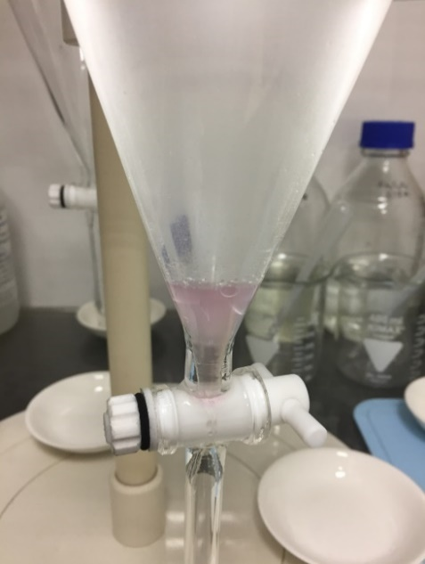

Figure S2. Extraction of iodine from seawater. Immiscible chloroform at the base of a separatory funnel, with artificial seawater above. The purple color is from dissolved iodine from 20 μL methyl iodide dissolved in 1 L of artificial seawater.

Text S1. Iodine extraction reactions

Iodate is reduced to iodide through the reaction:

$$IO_{3}^{-}+3HSO_{3}^{-}→I^{-}+3HSO_{4}^{-}$$

Iodide is oxidized to iodine through the reaction:

$$6I^{-}+2NO_{2}^{-}+8H^{+}→3I_{2}+N_{2}+4H_{2}O$$

Iodine is extracted from methyl iodide (CH₃I) through the reaction:

$${CH}_{3}I+{2NO}_{2}^{-}+H^{+}→{CH}_{3}{NO}_{2}+{HNO}_{2}+\frac{1}{2}I_{2}$$

Figure S3. Plot of ¹²⁹I/¹²⁷I values from open ocean sites in the SCS. The dashed line is the weighted average of these values and the shaded error represents the 2σ uncertainty of the weighted average (49.1 ± 2.4 × 10⁻¹²). All samples overlap with the average, within errors.

Table S1. Chlorophyll a results.
Average depth (m) | Number of observations (n) | Chl a ± 1σ (μg L⁻¹)
1.7 | 497 | 0.007 ± 0.028
2.2 | 500 | 0.004 ± 0.019
6.2 | 500 | 0.010 ± 0.009
11.1 | 500 | 0.026 ± 0.008
11.9 | 500 | 0.028 ± 0.008
12.0 | 500 | 0.025 ± 0.003
11.9 | 500 | 0.022 ± 0.005
12.2 | 500 | 0.023 ± 0.002
18.4 | 500 | 0.030 ± 0.006
26.7 | 500 | 0.044 ± 0.005
33.8 | 500 | 0.084 ± 0.041
40.8 | 500 | 0.086 ± 0.007
47.9 | 500 | 0.100 ± 0.005
59.8 | 500 | 0.185 ± 0.077
77.4 | 500 | 0.316 ± 0.045
95.0 | 500 | 0.210 ± 0.028
112.7 | 500 | 0.117 ± 0.022
130.6 | 500 | 0.062 ± 0.010
148.4 | 500 | 0.043 ± 0.005
166.2 | 500 | 0.036 ± 0.002
184.0 | 500 | 0.035 ± 0.002
201.7 | 500 | 0.035 ± 0.002
219.5 | 500 | 0.035 ± 0.001
237.3 | 500 | 0.036 ± 0.001
255.0 | 500 | 0.038 ± 0.001
272.8 | 500 | 0.039 ± 0.001
290.5 | 500 | 0.038 ± 0.001
308.3 | 500 | 0.039 ± 0.002
326.1 | 500 | 0.039 ± 0.002
343.8 | 500 | 0.040 ± 0.002
361.5 | 500 | 0.040 ± 0.002
379.4 | 500 | 0.040 ± 0.001
397.1 | 500 | 0.040 ± 0.002
414.8 | 500 | 0.040 ± 0.001
432.6 | 500 | 0.040 ± 0.002
450.4 | 500 | 0.039 ± 0.001
468.1 | 500 | 0.040 ± 0.002
485.9 | 500 | 0.039 ± 0.001
503.6 | 500 | 0.039 ± 0.002
521.2 | 500 | 0.040 ± 0.002
538.6 | 500 | 0.038 ± 0.001
556.0 | 500 | 0.039 ± 0.002
573.6 | 500 | 0.040 ± 0.002
591.0 | 500 | 0.039 ± 0.001

