Supplemental Material

Characterization, sources and reactivity of volatile organic compounds (VOCs) in Seoul and surrounding regions during KORUS-AQ

Isobel J. Simpson^{1,*}, Donald R. Blake¹, Nicola J. Blake¹, Simone Meinardi¹, Barbara Barletta¹, Stacey C. Hughes¹, Lauren T. Fleming^{1,11}, James H. Crawford², Glenn S. Diskin², Louisa K. Emmons⁹, Alan Fried³, Hai Guo⁴, David A. Peterson⁵, Armin Wisthaler^{6,7}, Jung-Hun Woo⁸, Jerome Barré^{9,10}, Benjamin Gaubert⁹, Jinseok Kim⁸, Michelle J. Kim¹², Younha Kim⁸, Christoph Knote¹³, Tomas Mikoviny⁶, Sally E. Pusede¹⁴, Jason R. Schroeder^{2,15}, Yu Wang⁴, Paul O. Wennberg¹², Lewei Zeng⁴

1 University of California, Irvine, Irvine, CA, US
2 NASA Langley, Hampton, VA, US
3 University of Colorado, Boulder, CO, US
4 The Hong Kong Polytechnic University, Hong Kong, China
5 Naval Research Laboratory, Monterey, CA, US
6 University of Oslo, Oslo, Norway
7 University of Innsbruck, Innsbruck, Austria
8 Konkuk University, Seoul, South Korea
9 NCAR, Boulder, CO, US
10 European Centre for Medium-Range Weather Forecasts, Reading, United Kingdom
11 University of Leeds, Leeds, United Kingdom
12 California Institute of Technology, Pasadena, CA, US
13 Meteorological Institute, LMU Munich, Munich, Germany
14 University of Virginia, Charlottesville, VA, US
15 California Air Resources Board, Sacramento, CA US

* Corresponding author: isimpson@uci.edu

List of contents:
1. Calibration procedures for major reported species
2. Comparison between WAS and high frequency measurements
3. Enlarged spatial distributions of selected VOCs
4. Selection of Seoul data
5. Abundance of VOCs and OVOCs in Seoul
6. OH reactivity in Seoul
Figures:
Figure S-1. Comparison of toluene measurements during KORUS-AQ using high frequency PTR-ToF-MS (blue) and WAS (red).
Figure S-2. Comparison of (a) toluene measurements made by WAS and PTR-ToF-MS and (b) ethane measurements made by WAS and CAMS.
Figure S-3. Enlarged spatial distributions of selected VOCs during KORUS-AQ.
Figure S-4. Selection of Seoul data during KORUS-AQ using toluene as an example.
Figure S-5. Abundance of (a) WAS VOCs and (b) WAS VOCs + PTR-ToF-MS methanol in air samples collected at low altitude (< 0.5 km) over Seoul (n = 177).
Figure S-6. (a) Twenty most abundant non-methane VOCs measured by WAS at low altitude over Seoul (n = 177; alt. <0.5 km) during KORUS-AQ (not including COS and long-lived halocarbons), together with their (b) rate constants for reaction with OH, and (c) OH reactivity.
Figure S-7. Ozone formation potential for methanol and VOC groups based on (a) OH reactivity and (b) ozone production (P(O₃)) calculations using photochemical box modeling.
Tables:
Table S-1. Details of calibration standards used for major species reported in this paper.
Table S-2. Analytical details and measurement statistics for 82 VOCs measured in whole air samples (WAS) and 11 trace gases measured by fast-response instruments and averaged over the WAS canister fill times.
Table S-3. Percent contribution of each compound to each factor, based on 4-factor and 5-factor PMF solutions for the low-altitude Seoul data during KORUS-AQ (n = 177). “Long.” = long-range transport; “Sol.” = solvents.
1. Calibration procedures for major reported species
Additional details on the calibration procedures for major species reported in this paper are presented below. Table S-1 summarizes the source, mole fraction, and acquisition dates of calibration standards used by different instrument teams.
CAMS uses an Air Liquide standard of 5.4 ppm for formaldehyde and a Scott-Marrin standard of 4.87 ppm for ethane. Before each flight, the concentration of the standards directly flowing into the instrument inlet was measured by direct absorption. For details see Richter et al., 2015 and Fried et al., 2020.
DACOM was calibrated periodically during each flight using three Scott-Marrin cylinders containing low, medium, and high levels of CO (153.9 ppb, 240.4/245.6 ppb, 496.6 ppb), with an additional ultra-high CO cylinder that was used post-campaign (10.05 ppm). The first mid-range standard was used for Flights 1-13, and the second for Flights 14-20. The cylinders were acquired in 2016.
PTR-MS performed in-flight calibration using a flow of VOC-free air that was spiked with ~5 ppbv of the target VOCs. The VOC standard was obtained from Apel-Riemer Environmental in 2016 and is a custom-made 11-component VOC mixture (methanol, acetonitrile, acetaldehyde, acetone, isoprene, methyl ethyl ketone, benzene toluene, m-xylene, 1,3,5-trimethylbenzene, α-pinene).
WAS uses a system of multiple standards including calibrated standards and working standards (Table S-1). The calibrated standards are contained in aluminum cylinders and include an original NBS propane standard of 0.99 ppm obtained in 1978, a 67-VOC mix of 1 ppmv obtained from Scott-Marrin in 2004, and halocarbon standards that were made in-house in the 1970s and 1980s. During KORUS-AQ these calibrated standards were each run once. WAS working standards are pressurized stainless steel pontoons of humidified, spiked whole air that are calibrated in the laboratory. During KORUS-AQ WAS used a working standard made in 2016 based on high-altitude air from the White Mountain Research Center in the Sierra Nevada Mountain Range, California (137.6°N, 118.3°W, 3090 m). To make the working standard, a cylinder was pressurized with White Mountain air (~2000 psi), analyzed five times, and then spiked with the 67-VOC standard. After a week, a portion of this air (~400 psi) was added to an evacuated, humidified pontoon (Pontoon D) and immediately analyzed five times, then five ore times a few weeks later. During KORUS-AQ air from Pontoon D was analyzed every 8 samples, or roughly every 3 hours. When the pontoon needed to be refilled with cylinder air, it was analyzed five times before the transfer and five times immediately after. Three older working standards from the 1990s were also analyzed once a day (Pontoon A from 1991), once a week (Pontoon B from 1996), and at the beginning and end of the mission (Pontoon C from 1999). These standards were made in a way similar to Pontoon D, using NIST and Scott-Marrin standards (Colman et al., 2001).
2. Comparison between WAS and high frequency measurements
During KORUS-AQ several VOCs were measured both by WAS and by fast-response instruments, including toluene (PTR-ToF-MS) and ethane (CAMS). Figure S-1 compares WAS toluene measurements with high frequency toluene measurements made by PTR-ToF-MS. The PTR-ToF-MS data are reported at 1 Hz and the average WAS sampling times were 33-47 s. The samples were collected at low altitude (0.1-2.2 km) as the DC-8 repeated its missed approach maneuver over Seongnam on the morning of June 5, 2016. The higher mixing ratios occurred as the DC-8 descended to 0.1 km (0.4 km during the fifth cycle), and the lower values as the DC-8 ascended above 1 km.
Figure S-2 compares WAS measurements with high frequency toluene and ethane measurements that have been averaged over the fill time of the WAS samples, called the WAS data merge. The data agree well, with a slope of 0.924 ± 0.002 and 0.981 ± 0.004 for toluene and ethane, respectively, and r² values of 0.99 and 0.97, respectively.

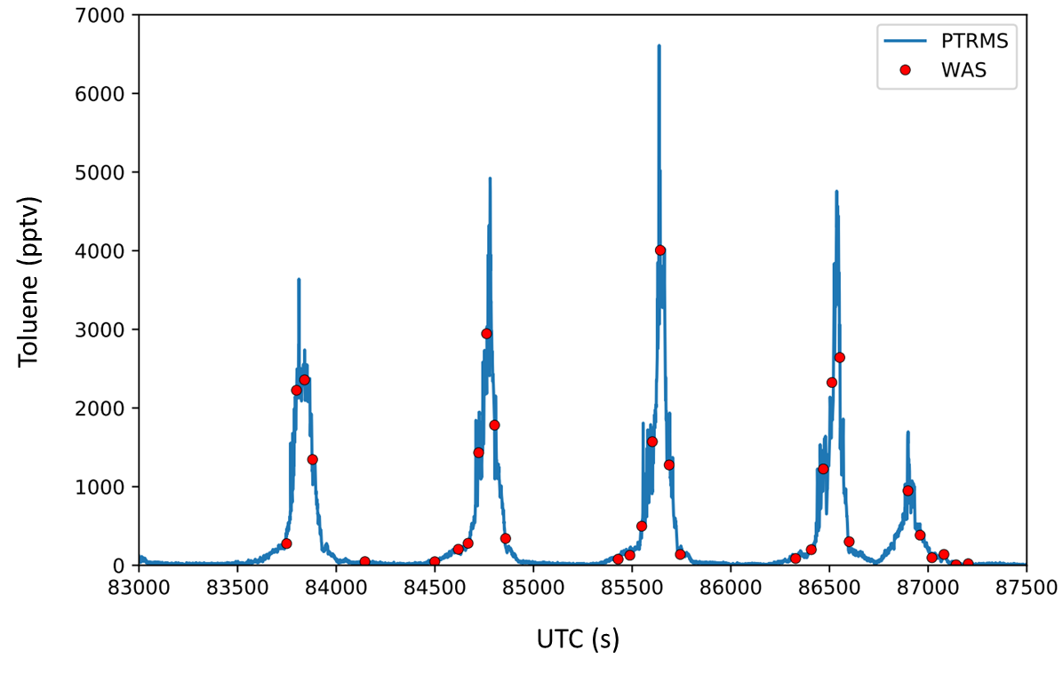
Figure S-1. Comparison of toluene measurements during KORUS-AQ using high frequency PTR-ToF-MS (blue) and WAS (red). The PTR-ToF-MS data are reported at 1 Hz and the WAS data had an average fill time of 38 s. The measurements cover over an hour of time, from approximately 7:30 to 8:50 a.m. on June 5, 2016 during Flight 19.

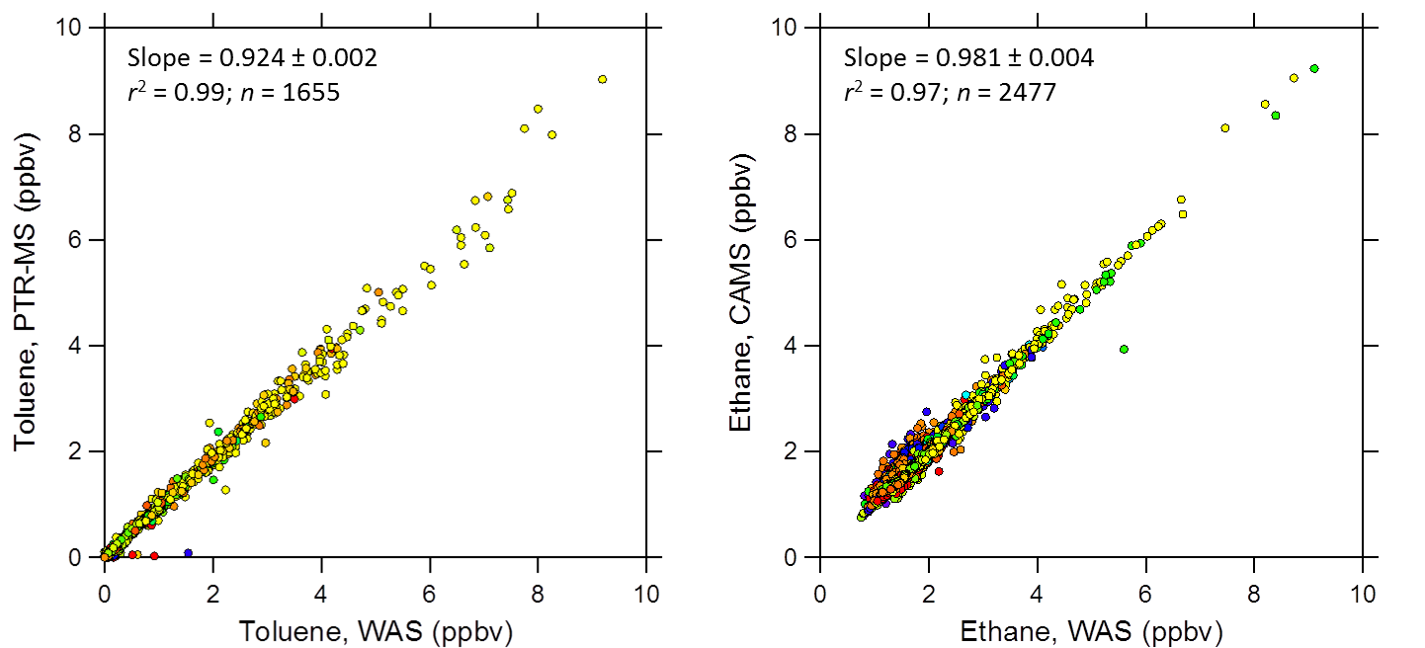

Figure S-2. Comparison of (a) toluene measurements made by WAS and PTR-ToF-MS and (b) ethane measurements made by WAS and CAMS. All measurements are based on the WAS data merge for KORUS-AQ (n = 2554).

3. Enlarged spatial distributions of selected VOCs

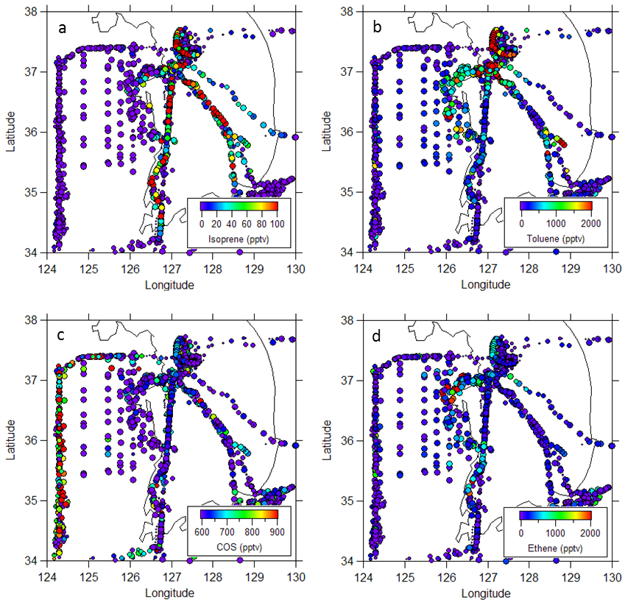
Figure S-3. Enlarged spatial distributions of selected VOCs during KORUS-AQ. (a) Isoprene, a short-lived biogenic tracer, (b) toluene, an urban solvent tracer that was abundant over Seoul, (c) carbonyl sulfide (COS), a tracer of air arriving from China, and (d) ethene, a tracer of the Daesan industrial facility.
4. Selection of Seoul data
As noted in Section 3.2.1, Seoul data were selected based on a geographical box around Seoul (37.3-37.7°N and 126.7-127.3°E) and low altitudes (<0.5 km), for a total of 177 samples (Figure S-4). Altitudes <0.5 km rather than <1 km were selected based on analysis by Lamb et al. (2018), which calculated the relative contributions of different source regions to black carbon (BC) mass loadings by altitude based on BC observations and Hysplit back trajectory analysis for each meteorological period. While surface concentrations of BC were dominated by South Korean sources, air at 900 hPa (~1 km) had 35%, 60%, 100% and 20% contribution from China during the dynamic, stagnant, second dynamic and Rex blocking periods, respectively. The 177 Seoul samples represent data collected during all four meteorological conditions of the 6-week mission (Figure S-4b).

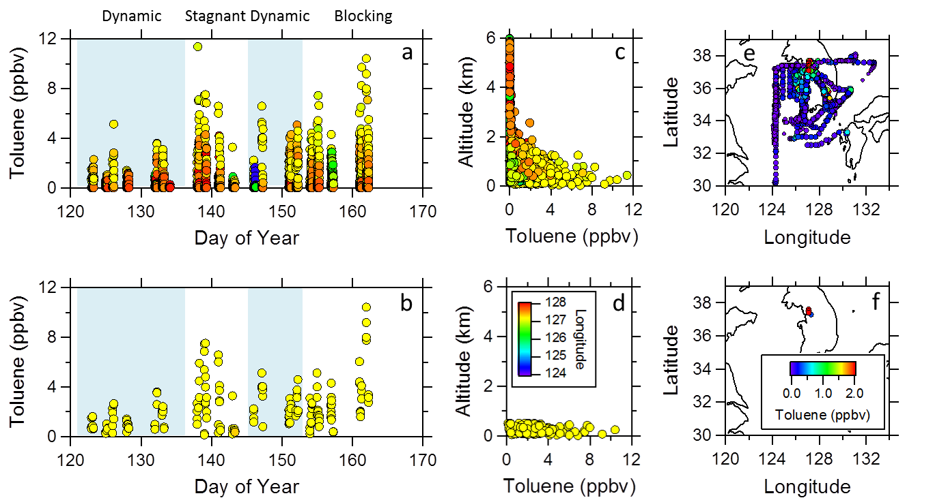

Figure S-4. Selection of Seoul data during KORUS-AQ using toluene as an example. Top panels (a, c, e) show toluene mixing ratios collected during the entire KORUS-AQ mission (n = 2554); bottom panels (b, d, f) show toluene mixing ratios collected at low altitude over Seoul (n = 177; alt. < 0.5 km). (a-b) Time series of toluene, (c-d) altitude profiles of toluene, (e-f) spatial distributions of toluene. Panels (a-d) are colour-coded by longitude (legend shown in panel d) as described in Figure 4 of the main manuscript, and panels (e-f) are colour-coded by toluene (legend shown in panel f). The blue and white shading in panels (a-b) represents dynamic (blue) and stagnant (white) conditions, as described in Figure 5 of the main manuscript.

5. Abundance of VOCs and OVOCs in Seoul
The abundance of VOCs over Seoul was determined using low-altitude measurements from whole air sampling (WAS) (Figure S-5a), and using WAS data together with PTR-ToF-MS methanol based on methanol averages from the WAS data merge (Figure S-5b).

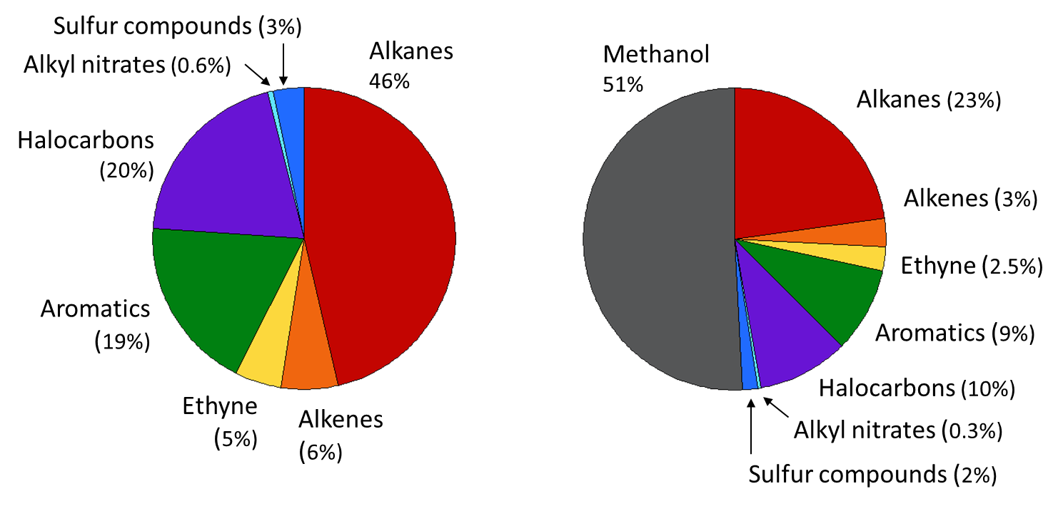

Figure S-5. Abundance of (a) WAS VOCs and (b) WAS VOCs + PTR-ToF-MS methanol in air samples collected at low altitude (< 0.5 km) over Seoul (n = 177). The abundances are based on average mixing ratios.

6. OH reactivity in Seoul
For OH-reactive VOCs, the OH reactivity expresses the product of VOC concentration and rate coefficient for reaction with OH. Therefore VOCs can have a high OH reactivity based primarily on their abundance (e.g., toluene), their OH rate constant (e.g., isoprene), or a combination of both (e.g., m-xylene) (Figure S-6).

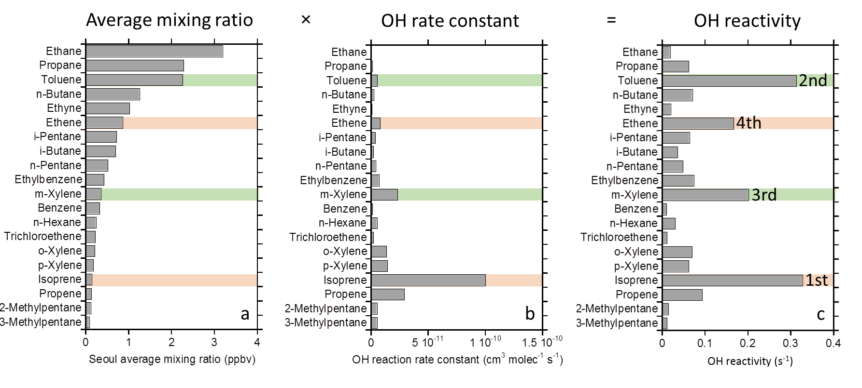
Figure S-6. (a) Twenty most abundant non-methane VOCs measured by WAS at low altitude over Seoul (n = 177; alt. <0.5 km) during KORUS-AQ (not including COS and long-lived halocarbons), together with their (b) rate constants for reaction with OH, and (c) OH reactivity. Selected aromatics are coloured in green and selected alkenes in orange. The OH reactivity rankings are labeled for the first four compounds in panel (c).

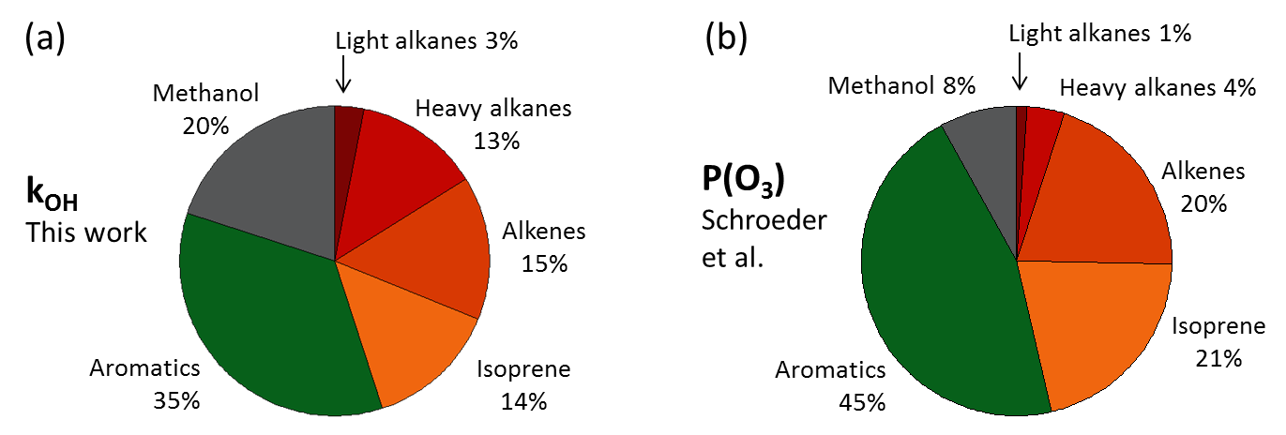

Figure S-7. Ozone formation potential for methanol and VOC groups based on (a) OH reactivity and (b) ozone production (P(O₃)) calculations using photochemical box modeling. ‘Light alkanes’ represent C₂-C₃ and ‘heavy alkanes’ are C₄ and higher.

Table S-1. Details of calibration standards used for major species reported in this paper.

Group | Compound(s) | Standard source | Acquisition date | Mole fraction
CAMS | Formaldehyde | Air Liquide | n/a | 5.4 ppm
CAMS | Ethane | Scott-Marrin | n/a | 4.87 ppm
DACOM | CO (low) | Scott-Marrin | 2016 | 153.9 ppb
DACOM | CO (mid) | Scott-Marrin | 2016 | 240.4 ppb
DACOM | CO (mid) | Scott-Marrin | 2016 | 245.6 ppb
DACOM | CO (high) | Scott-Marrin | 2016 | 496.6 ppb
DACOM | CO (ultra-high) | Scott-Marrin | 2016 | 10.05 ppm
PTR-MS | 11 hydrocarbons | Apel-Reimer | 2016 | 5 ppbv
WAS | Propane | NBS | 1978 | 0.99 ppmv
WAS | 67 VOCs | Scott-Marrin | 2004 | 1 ppmv
WAS | Halocarbons | UCI | 1978-1985 | Varies
WAS (Pontoon A) | Spiked whole air | UCI | 1991 | 0.5-10 ppbv
WAS (Pontoon B) | Spiked whole air | UCI | 1996 | 0.3-8 ppbv
WAS (Pontoon C) | Spiked whole air | UCI | 1999 | 0.2-4 ppbv
WAS (Pontoon D) | Spiked whole air | UCI | 2016 | 0.5-5 ppbv

Table S-2. Analytical details and measurement statistics for 82 VOCs measured in whole air samples (WAS) and 11 trace gases measured by fast-response instruments and averaged over the WAS canister fill times. The measurements were collected during KORUS-AQ aboard the NASA DC-8 aircraft at altitudes < 500 m over Seoul (n = 177) and in air masses arriving from China (n = 68). Units are pptv unless otherwise stated. LOD = limit of detection, Acc. = accuracy. Note that values have not been rounded, but in many cases they are presented beyond their level of significance.
______________________________________________________________________________________________________________________

Compound | LOD | Precision | Acc. | Lifetime | Seoul | Seoul | Seoul | Seoul | Seoul | China | China | China | China | China
 | (pptv) | (%) | (%) |  | Min  (pptv) | Max  (pptv) | Med  (pptv) | Avg  (pptv) | Std  (pptv) | Min  (pptv) | Max  (pptv) | Med  (pptv) | Avg  (pptv) | Std  (pptv)
FAST INSTRUMENTS
Methane, ppbv | n/a | 0.1 | 1 | 9 yr | 1920 | 2518 | 2040 | 2054 | 101 | 1933 | 2138 | 1992 | 2005 | 55
Carbon monoxide, ppbv | n/a | 1 | 2 | 2 mo | 167 | 663 | 320 | 346 | 119 | 206 | 1174 | 354 | 384 | 173
Nitric oxide | 20 | 2 | 10 | 1 day | 64 | 70106 | 4002 | 9009 | 13296 | 10 | 601 | 51 | 94 | 109
Nitrogen dioxide | 30 | 5 | 10 | 1 day | 441 | 64725 | 15570 | 17818 | 12424 | 117 | 2185 | 291 | 474 | 412
Total reactive N (NO_{y}) | 20 | 1 | 10 | n/a | 3625 | 135412 | 29499 | 35206 | 24819 | 2853 | 22765 | 7565 | 7996 | 4256
Ozone, ppbv | 0.04 | 1 | 5 | 8 day | 11 | 145 | 63 | 66 | 30 | 55 | 139 | 91 | 89 | 20
Formaldehyde | 28-80ª | 28-80 pptvª | 4-6 | 3 hrsª | 1237 | 9936 | 3835 | 3988 | 1681 | 885 | 6393 | 1885 | 2173 | 1220
Methanol | 315 | 418 pptv^{b} | 10 | 12 d | 5368 | 68463 | 18928 | 21150 | 10354 | 1181 | 35511 | 11433 | 12171 | 7093
Acetaldehyde | 85 | 122 pptv^{b} | 10 | 1 d | 418 | 5104 | 2114 | 2196 | 999 | 381 | 4460 | 1040 | 1257 | 870
Methyl ethyl ketone | 32 | 87 pptv^{b} | 10 | 10 d | 209 | 6854 | 1143 | 1461 | 1207 | 101 | 2021 | 377 | 459 | 363
Hydrogen cyanide | 15 | 20 pptv | 30 | 5 mo | 388 | 1140 | 593 | 631 | 153 | 189 | 1529 | 898 | 929 | 390
WAS MEASUREMENTS
Alkanes
Ethane | 3 | 1 | 5 | 48 d | 1636 | 8727 | 2790 | 3200 | 1327 | 1078 | 3655 | 2354 | 2337 | 603
Propane | 3 | 2 | 5 | 11 d | 488 | 7683 | 2128 | 2309 | 1425 | 134 | 3701 | 772 | 1097 | 876
i-Butane | 3 | 3 | 5 | 5.5 d | 78 | 2717 | 565 | 702 | 523 | 13 | 1281 | 147 | 254 | 260
n-Butane | 3 | 3 | 5 | 5.0 d | 161 | 4914 | 1009 | 1262 | 949 | 14 | 2135 | 253 | 396 | 413
i-Pentane | 3 | 3 | 5 | 3.2 d | 89 | 3199 | 602 | 727 | 565 | 6 | 1111 | 98 | 195 | 247
n-Pentane | 3 | 3 | 5 | 3.0 d | 55 | 2266 | 401 | 518 | 424 | 5 | 939 | 58 | 131 | 179
n-Hexane | 3 | 3 | 5 | 2.2 d | 25 | 787 | 191 | 239 | 180 | <LOD | 360 | 43 | 75 | 85
Compound | LOD | Precision | Acc. | Lifetime | Seoul | Seoul | Seoul | Seoul | Seoul | China | China | China | China | China
 | (pptv) | (%) | (%) |  | Min  (pptv) | Max  (pptv) | Med  (pptv) | Avg  (pptv) | Std  (pptv) | Min  (pptv) | Max  (pptv) | Med  (pptv) | Avg  (pptv) | Std  (pptv)
n-Heptane | 3 | 3 | 5 | 1.7 d | <LOD | 398 | 62 | 75 | 59 | <LOD | 92 | 7 | 17 | 25
n-Octane | 3 | 3 | 5 | 1.4 d | <LOD | 217 | 35 | 45 | 33 | <LOD | 86 | 5 | 10 | 14
n-Nonane | 3 | 3 | 5 | 1.2 d | <LOD | 176 | 38 | 46 | 34 | <LOD | 38 | <LOD | 6 | 9
n-Decane | 3 | 3 | 5 | 1.1 d | <LOD | 161 | 38 | 45 | 35 | <LOD | 38 | <LOD | 4 | 7
2,3-Dimethylbutane | 3 | 3 | 5 | 2.0 d | <LOD | 113 | 21 | 27 | 21 | <LOD | 39 | <LOD | 6 | 10
2-Methylpentane | 3 | 3 | 5 | 2.2 d | 10 | 475 | 86 | 112 | 90 | <LOD | 209 | 15 | 36 | 52
3-Methylpentane | 3 | 3 | 5 | 2.2 d | 6 | 308 | 65 | 83 | 66 | <LOD | 151 | 9 | 25 | 36
Cycloalkanes
Cyclopentane | 3 | 3 | 5 | 2.3 d | 4 | 370 | 38 | 46 | 40 | <LOD | 65 | 8 | 13 | 14
Methylcyclopentane | 3 | 3 | 5 |  | <LOD | 600 | 102 | 113 | 85 | <LOD | 584 | 59 | 90 | 104
Cyclohexane | 3 | 3 | 5 | 1.7 d | <LOD | 348 | 69 | 82 | 64 | <LOD | 118 | 13 | 22 | 28
Methylcyclohexane | 3 | 3 | 5 | 1.2 d | <LOD | 181 | 35 | 44 | 35 | <LOD | 56 | <LOD | 8 | 15
Alkenes/Alkynes
Ethyne | 3 | 3 | 5 | 15 d | 304 | 2481 | 925 | 1026 | 490 | 264 | 2839 | 974 | 1070 | 603
Ethene | 3 | 3 | 5 | 1.5 d | 42 | 3366 | 714 | 870 | 676 | 7 | 1394 | 115 | 259 | 352
Propene | 3 | 3 | 5 | 10 hr | 5 | 725 | 85 | 133 | 129 | <LOD | 372 | 5 | 32 | 73
1-Butene | 3 | 3 | 5 | 8.8 hr | <LOD | 164 | 17 | 24 | 23 | <LOD | 79 | <LOD | 3 | 10
i-Butene | 3 | 3 | 5 | 5.4 hr | <LOD | 193 | <LOD | 19 | 37 | <LOD | 110 | <LOD | 2 | 13
cis-2-Butene | 3 | 3 | 5 | 4.9 hr | <LOD | 32 | <LOD | 5 | 7 | <LOD | 7 | <LOD | <LOD | n/a
trans-2-Butene | 3 | 3 | 5 | 4.3 hr | <LOD | 46 | 3 | 6 | 9 | <LOD | 11 | <LOD | <LOD | n/a
1,3-butadiene | 3 | 3 | 5 | 4.2 hr | <LOD | 160 | <LOD | 9 | 19 | <LOD | 5 | <LOD | <LOD | n/a
Isoprene | 3 | 3 | 5 | 2.8 hr | <LOD | 897 | 108 | 134 | 115 | <LOD | 12 | <LOD | <LOD | n/a
α-Pinene | 3 | 3 | 5 | 5.2 hr | <LOD | 82 | 8 | 13 | 16 | <LOD | <LOD | <LOD | <LOD | n/a
β-Pinene | 3 | 3 | 5 | 3.7 hr | <LOD | 87 | 6 | 11 | 14 | <LOD | 3 | <LOD | <LOD | n/a
Compound | LOD | Precision | Acc. | Lifetime | Seoul | Seoul | Seoul | Seoul | Seoul | China | China | China | China | China
 | (pptv) | (%) | (%) |  | Min  (pptv) | Max  (pptv) | Med  (pptv) | Avg  (pptv) | Std  (pptv) | Min  (pptv) | Max  (pptv) | Med  (pptv) | Avg  (pptv) | Std  (pptv)
Aromatics
Benzene | 3 | 3 | 5 | 9.5 | 63 | 1007 | 251 | 324 | 196 | 87 | 1350 | 397 | 454 | 298
Toluene | 3 | 3 | 5 | 2.1 d | 117 | 10420 | 1981 | 2284 | 1832 | <LOD | 1645 | 102 | 249 | 359
Ethylbenzene | 3 | 3 | 5 | 1.7 d | 35 | 1691 | 370 | 432 | 352 | <LOD | 528 | 20 | 63 | 121
m,p-Xylene | 3 | 3 | 5 | 12-19 hr | 35 | 3747 | 369 | 538 | 602 | <LOD | 228 | 6 | 30 | 54
o-Xylene | 3 | 3 | 5 | 20 hr | 19 | 1492 | 150 | 212 | 224 | <LOD | 148 | 4 | 17 | 34
Styrene | 3 | 3 | 5 | 4.8 hr | <LOD | 127 | 13 | 20 | 22 | <LOD | 12 | <LOD | <LOD | n/a
i-Propylbenzene | 3 | 3 | 5 | 1.8 d | <LOD | 61 | 8 | 10 | 10 | <LOD | 35 | <LOD | <LOD | n/a
n-Propylbenzene | 3 | 3 | 5 | 2.0 d | <LOD | 46 | 10 | 12 | 9 | <LOD | 14 | <LOD | <LOD | n/a
2-Ethyltoluene | 3 | 3 | 5 | 23 hr | <LOD | 53 | 9 | 12 | 10 | <LOD | 15 | <LOD | <LOD | n/a
3-Ethyltoluene | 3 | 3 | 5 | 15 hr | <LOD | 132 | 17 | 24 | 24 | <LOD | 20 | <LOD | <LOD | n/a
4-Ethyltoluene | 3 | 3 | 5 | 23 hr | <LOD | 88 | 11 | 15 | 14 | <LOD | 15 | <LOD | <LOD | n/a
1,2,3-Trimethylbenzene | 3 | 3 | 5 | 8.5 hr | <LOD | 59 | 8 | 12 | 13 | <LOD | 16 | <LOD | <LOD | n/a
1,2,4-Trimethylbenzene | 3 | 3 | 5 | 8.5 hr | <LOD | 213 | 23 | 36 | 42 | <LOD | 27 | <LOD | <LOD | n/a
1,3,5-Trimethylbenzene | 3 | 3 | 5 | 4.9 hr | <LOD | 51 | 6 | 8 | 10 | <LOD | 11 | <LOD | <LOD | n/a
Halocarbons
CFC-11 | 10 | 1 | 3 | 52 yr | 227 | 362 | 253 | 258 | 23 | 234 | 295 | 251 | 254 | 14
CFC-12 | 10 | 1 | 3 | 102 yr | 508 | 564 | 527 | 528 | 9 | 510 | 555 | 526 | 526 | 8
CFC-112 | 0.1 | 5 | 10 | 59 yr | 0.40 | 0.68 | 0.53 | 0.53 | 0.05 | 0.40 | 0.63 | 0.53 | 0.52 | 0.05
CFC-113 | 5 | 1 | 3 | 93 yr | 71.4 | 80.7 | 74.8 | 75.1 | 2.0 | 72.5 | 128.4 | 75.8 | 80.0 | 10.6
CFC-114 | 1 | 1 | 10 | 189 yr | 15.8 | 17.7 | 16.6 | 16.6 | 0.3 | 16.0 | 25.7 | 16.6 | 17.0 | 1.5
CCl₄ | 1 | 1 | 5 | 32 yr | 80.6 | 102.5 | 86.7 | 87.7 | 4.5 | 83.2 | 149.3 | 92.1 | 97.2 | 12.6
CH₃CCl₃ | 0.1 | 1 | 5 | 5.0 yr | 2.8 | 11.0 | 3.3 | 3.5 | 1.0 | 2.8 | 3.4 | 3.0 | 3.0 | 0.1
H-1211 | 0.1 | 1 | 5 | 16 yr | 3.6 | 17.3 | 4.7 | 5.6 | 2.4 | 3.5 | 6.5 | 3.7 | 3.8 | 0.4
H-1301 | 0.1 | 10 | 10 | 72 yr | 3.3 | 12.2 | 3.8 | 4.1 | 1.0 | 3.3 | 4.8 | 3.5 | 3.5 | 0.3
H-2402 | 0.01 | 1 | 5 | 28 yr | 0.41 | 0.62 | 0.44 | 0.45 | 0.03 | 0.41 | 0.59 | 0.49 | 0.48 | 0.03
HCFC-22 | 2 | 5 | 5 | 12 yr | 281 | 3759 | 742 | 865 | 549 | 259 | 807 | 311 | 358 | 113
HCFC-141b | 0.5 | 3 | 10 | 9.4 yr | 32 | 1629 | 106 | 148 | 183 | 28 | 118 | 37 | 42 | 19
Compound | LOD | Precision | Acc. | Lifetime | Seoul | Seoul | Seoul | Seoul | Seoul | China | China | China | China | China
 | (pptv) | (%) | (%) |  | Min  (pptv) | Max  (pptv) | Med  (pptv) | Avg  (pptv) | Std  (pptv) | Min  (pptv) | Max  (pptv) | Med  (pptv) | Avg  (pptv) | Std  (pptv)
HCFC-142b | 0.5 | 3 | 10 | 18 yr | 26 | 475 | 70 | 101 | 81 | 23 | 124 | 27 | 31 | 13
HFC-134a | 1 | 3 | 10 | 14 yr | 96 | 478 | 179 | 200 | 81 | 95 | 200 | 108 | 111 | 21
HFC-152a | 0.1 | 5 | 10 | 1.6 yr | 10 | 448 | 31 | 56 | 66 | 10 | 127 | 13 | 19 | 17
HFC-227ea | 1 | 5 | 10 | 36 yr | 1.0 | 29.0 | 1.6 | 2.0 | 2.8 | 1.1 | 3.9 | 1.6 | 1.8 | 0.5
HFC-365mfc | 0.2 | 5 | 15 | 8.7 yr | 1.1 | 4.1 | 1.6 | 1.7 | 0.4 | 1.0 | 5.7 | 1.5 | 1.7 | 0.7
CH₃Cl | 50 | 5 | 10 | 0.9 yr | 557 | 1208 | 715 | 752 | 146 | 603 | 2211 | 753 | 919 | 348
CH₃Br | 0.5 | 5 | 10 | 0.8 yr | 6.9 | 103 | 14 | 18 | 13 | 6.6 | 32 | 11 | 13 | 5
CH₃I | 0.005 | 5 | 20 | 4 d | 0.3 | 5.2 | 1.7 | 1.9 | 1.0 | 0.6 | 6.7 | 2.3 | 2.4 | 1.4
CH₂Cl₂ | 1 | 5 | 10 | 4 mo | 81 | 1399 | 404 | 455 | 258 | 88 | 938 | 339 | 365 | 186
CHCl₃ | 0.1 | 5 | 10 | 3.5 mo | 22 | 610 | 77 | 120 | 116 | 34 | 310 | 93 | 126 | 73
C₂HCl₃ | 0.01 | 5 | 10 | 6 d | 3.1 | 1642 | 129 | 226 | 271 | 1 | 180 | 8 | 22 | 36
C₂Cl₄ | 0.01 | 5 | 10 | 2.5 mo | 3.2 | 129 | 17 | 25 | 26 | 4 | 86 | 8 | 14 | 17
CH₂Br₂ | 0.01 | 5 | 20 | 3.5 mo | 0.9 | 4.4 | 1.5 | 1.6 | 0.5 | 1.1 | 4.5 | 1.4 | 1.5 | 0.5
CHBr₃ | 0.01 | 10 | 20 | 24 d | 0.6 | 10.9 | 2.3 | 2.7 | 1.7 | 0.9 | 8.9 | 1.9 | 2.3 | 1.2
CHBrCl₂ | 0.01 | 10 | 50 | 78 d | 0.4 | 13.4 | 1.7 | 2.3 | 1.9 | 0.4 | 1.8 | 0.6 | 0.7 | 0.3
CHBr2Cl | 0.01 | 5 | 50 | 59 d | 0.2 | 3.3 | 0.7 | 0.8 | 0.5 | 0.2 | 1.2 | 0.4 | 0.5 | 0.2
1,2-DCE | 0.1 | 5 | 10 | 65 d | 19 | 397 | 83 | 106 | 82 | 50 | 2517 | 220 | 354 | 423
Organic nitrates
MeONO2 | 0.02 | 5 | 10 | 1 mo | 4.7 | 25 | 11.0 | 11.6 | 3.9 | 6.7 | 19 | 11.0 | 11.2 | 2.7
EtONO2 | 0.02 | 5 | 10 | 2-4 wk | 4.7 | 17 | 9.3 | 9.6 | 2.8 | 5.7 | 22 | 10.1 | 10.5 | 3.3
i-PrONO2 | 0.02 | 5 | 10 | 1-3 wk | 8.6 | 46 | 20.8 | 22.6 | 8.6 | 12.9 | 53 | 21.9 | 24.8 | 9.4
n-PrONO2 | 0.02 | 5 | 10 | 1-2 wk | 1.3 | 9.6 | 3.8 | 4.3 | 1.9 | 2.1 | 11.9 | 3.7 | 4.4 | 2.2
2-BuONO2 | 0.02 | 5 | 10 | 1-2 wk | 8.5 | 82 | 24.9 | 31.2 | 18.1 | 13.9 | 113 | 30.1 | 35.0 | 18.4
2-PeONO2 | 0.02 | 5 | 10 | 4-5 d | 2.4 | 51 | 12.7 | 15.2 | 9.6 | 2.7 | 47 | 10.5 | 13.9 | 9.4
3-PeONO2 | 0.02 | 5 | 10 | 4-5 d | 1.9 | 30 | 8.4 | 9.5 | 5.6 | 2.9 | 30 | 7.4 | 9.1 | 5.5
3-Me-2-BuONO2 | 0.02 | 5 | 10 |  | 1.9 | 30 | 9.4 | 11.4 | 7.1 | 2.5 | 41 | 9.1 | 11.8 | 7.6
Compound | LOD | Precision | Acc. | Lifetime | Seoul | Seoul | Seoul | Seoul | Seoul | China | China | China | China | China
 | (pptv) | (%) | (%) |  | Min  (pptv) | Max  (pptv) | Med  (pptv) | Avg  (pptv) | Std  (pptv) | Min  (pptv) | Max  (pptv) | Med  (pptv) | Avg  (pptv) | Std  (pptv)
Sulfur compounds
COS | 10 | 3 | 10 | 2 yr | 518 | 1082 | 651 | 698 | 138 | 670 | 1512 | 868 | 914 | 196
DMS | 0.1 | 10 | 20 | 1-2 d | 0.1 | 14.8 | 1.4 | 2.0 | 1.9 | 0.1 | 25.8 | 0.2 | 2.4 | 5.7

______________________________________________________________________________________________________________________

ª The CH₂O LOD and precision are given at 1 standard deviation. The lifetime is for mid-day.
^{b} The precision for methanol, acetaldehyde and MEK are reported for a mixing ratio of 3 ppbv.

Table S-3. Percent contribution of each compound to each factor, based on 4-factor and 5-factor PMF solutions for the low-altitude Seoul data during KORUS-AQ (n = 177). “Long.” = long-range transport; “Sol.” = solvents.

--------------------- Four PMF factors ------------------------- ---------------------------------- Five PMF factors -----------------------------

Compound | Factor 1 | Factor 2 | Factor 3 | Factor 4 |  |  | Factor 1 |  | Factor 2 | Factor 3 |  | Factor 4 | Factor 5
 | (Biogenic) | (Long.) | (Traffic) | (Sol./LPG) | (Biogenic) |  |  |  | (Long.) | (Traffic) | (Sol1/LPG) |  | (Sol2/LPG)
CO | 17 | 53 | 18 | 12 |  |  |  | 11 | 51 | 12 | 16 |  | 10
COS | 22 | 67 | 11 | 0 |  |  |  | 16 | 67 | 5 | 11 |  | 2
Ethane | 14 | 46 | 23 | 18 |  |  |  | 8 | 44 | 17 | 31 |  | 0
Ethyne | 13 | 42 | 20 | 25 |  |  |  | 7 | 38 | 15 | 20 |  | 20
Ethene | 6 | 3 | 57 | 35 |  |  |  | 2 | 0 | 52 | 27 |  | 20
Propene | 4 | 0 | 71 | 25 |  |  |  | 0 | 0 | 60 | 40 |  | 0
Propane | 11 | 18 | 36 | 36 |  |  |  | 5 | 14 | 31 | 31 |  | 19
i-Butane | 9 | 11 | 41 | 40 |  |  |  | 3 | 7 | 35 | 36 |  | 19
n-Butane | 10 | 11 | 38 | 41 |  |  |  | 4 | 7 | 33 | 40 |  | 16
i-Pentane | 12 | 8 | 41 | 39 |  |  |  | 6 | 4 | 35 | 43 |  | 12
n-Pentane | 10 | 6 | 47 | 37 |  |  |  | 5 | 4 | 41 | 36 |  | 15
Isoprene | 87 | 0 | 4 | 9 |  |  |  | 84 | 1 | 7 | 8 |  | 0
n-Hexane | 7 | 12 | 33 | 48 |  |  |  | 5 | 4 | 30 | 5 |  | 57
n-Heptane | 11 | 11 | 19 | 58 |  |  |  | 5 | 3 | 15 | 32 |  | 45
2-MePentane | 10 | 8 | 35 | 47 |  |  |  | 5 | 2 | 31 | 30 |  | 32
3-MePentane | 9 | 6 | 37 | 48 |  |  |  | 5 | 1 | 33 | 19 |  | 42
Benzene | 11 | 37 | 36 | 16 |  |  |  | 5 | 30 | 33 | 0 |  | 32
Toluene | 13 | 12 | 7 | 67 |  |  |  | 8 | 2 | 1 | 32 |  | 57
Ethylbenzene | 14 | 13 | 4 | 69 |  |  |  | 5 | 3 | 0 | 56 |  | 35
m/p-Xylene | 9 | 10 | 14 | 66 |  |  |  | 0 | 1 | 9 | 70 |  | 20
o-Xylene | 11 | 12 | 10 | 67 |  |  |  | 2 | 3 | 5 | 65 |  | 25
------------------------------------------------------------------------- ----------------------------------------------------------------------------------------

