**Supplemental Materials**

**Influence of VOCs emitted by oil and natural gas development to the ambient air quality in the Northern Colorado Front Range**

**Samuel Rossabi1, Jacques Hueber1, Wei Wang1, Pam Milmoe2, and Detlev Helmig1,3\***

1Institute of Arctic and Alpine Research, University of Colorado, Boulder, CO, USA

2Environmental Health Division, Boulder County Public Health, Boulder, CO, USA

3now at: Boulder A.I.R. LLC, Boulder, CO, USA

*corresponding author: Detlev Helmig ([dh.bouldair@gmail.com](mailto:detlev.helmig@colorado.edu))

**Elementa – Science of the Anthropocene**

**Revised Version**

**November 17, 2021**

**List of Contents**

**Figure S1**

Sampling schedule at Boulder County Public Health campaign sites. Besides the VOCs sampling into the canisters, indicated by the orange color, the campaign also included ozone monitoring, exploratory sampling with small battery-powered sensors, and sampling of VOCs on adsorbent cartridges (not reported here).

**Figure S2**

(A) Typically field set up for 3-day integrated sampling of air into Summa canisters. The canisters were placed inside a cooler to avoid exposure to direct solar irradiance. In addition, 3-5 1-liter bottles filled with water were placed inside the cooler to dampen diurnal temperature swings. (B) Summa canister with the passive flow controlling device installed.

**Figure S3**

VOC as measured in canisters plotted as elevation gradients on 6 sampling days during the campaign.

**Figure S4**

8-hour HYSPLIT back trajectory for 7/20/14 ending at INSTAAR, CU-Boulder (BO), at 12:00 (MDT) (1600 UTC).

**Figure S5**

8-hour HYSPLIT back trajectory for 7/26/14arriving at INSTAAR, CU-Boulder (BO), at 12:00 (MDT) (1600 UTC).

**Figure S6**

8-hour HYSPLIT back trajectory for 7/31/14 arriving at INSTAAR, CU-Boulder (BO) at 04:00 (MDT) (1000 UTC).

**Figure S7**

Diurnal cycles on four days at the Lost Angels Road (LA) site (elevation = 2392 m). These samples were collected via PFP. Sample times are reported in MDT 24 hour format. Note that the scale of the left y-axis (mixing ratios) varies by plot, but the right y-axis ((i/n) pentane ratio) is identical in all plots.

**Table S1**

Components, mole fraction, and tolerances of standard mixtures used to calibrate the GC/MS/FID. Four multicomponent standards were used: (a) Apel-Riemer multicomponent standard, (b) National Physical Laboratory multicomponent standard, (c) Apel-Reimer oxygenated VOC standard, (d) National Institute of Technology standard.

**Table S2**

Detection limits for the canister and PFP gas chromatography determination of volatile organic compounds.

**Table S3**

Comparison of Canister and PFP Measurements at the Lost Angels site. % differences were calculated by dividing the absolute value of the difference of the measurements by the average mole fraction of the measurements and converting to a percentage.

**Table S4**

VOCs to ethane relationship in monitoring data from the Boulder Reservoir [*Boulder_AIR*, 2021]*.

**Figure S1**

Sampling schedule at Boulder County Public Health campaign sites. Besides the VOCs sampling into the canisters, indicated by the orange color, the campaign also included ozone monitoring, exploratory sampling with small battery-powered (Pod) sensors, and VOCs sampling on adsorbent cartridges (not reported here).

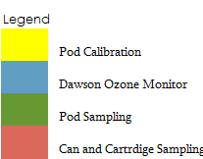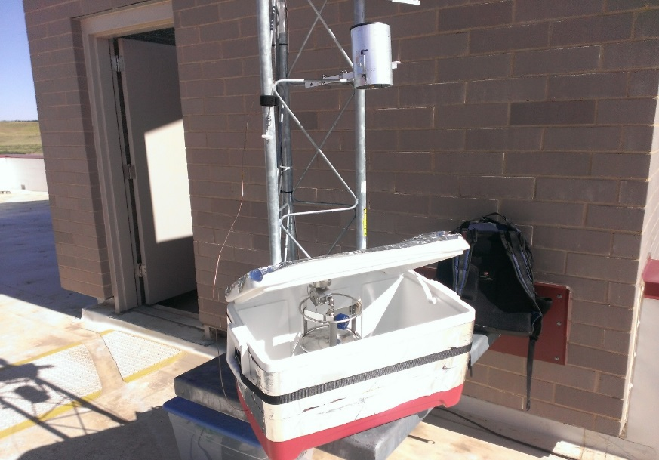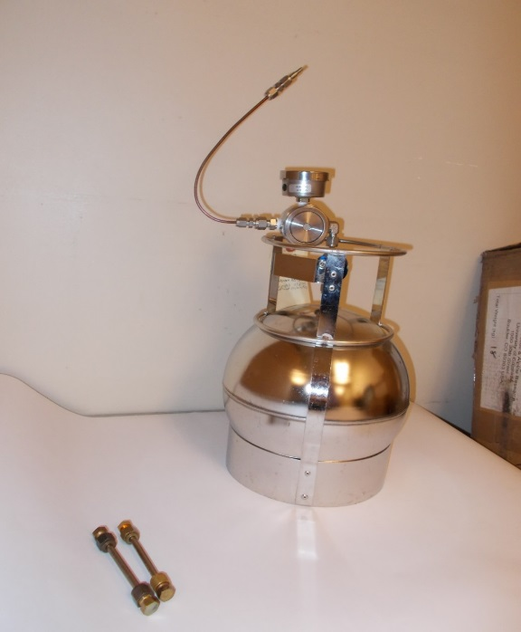

**Figure S2**

(A) Typically field set up for 3-day integrated sampling of air into Summa canisters. The canisters were placed inside a cooler to avoid exposure to direct solar irradiance. In addition, 3-5 1-liter bottles filled with water were placed inside the cooler to dampen diurnal temperature swings. (B) Summa canister with the passive flow controlling device installed.

**A**

**B**

**Figure S3**

VOC as measured in canisters plotted as elevation gradients on seven sampling days during the campaign.

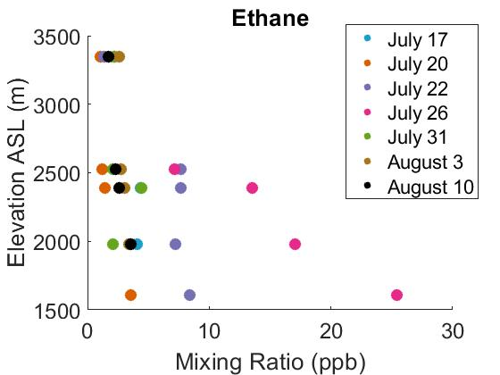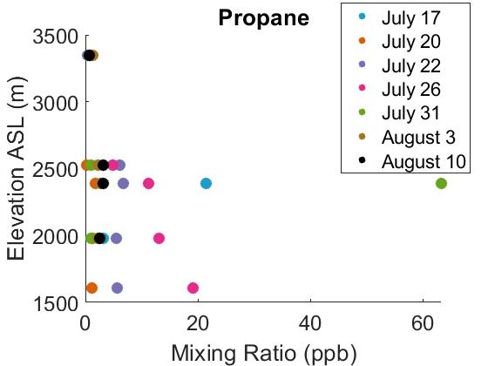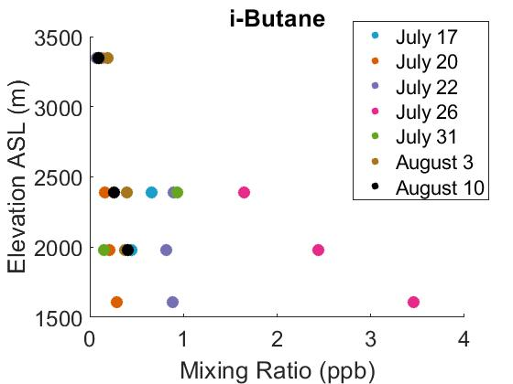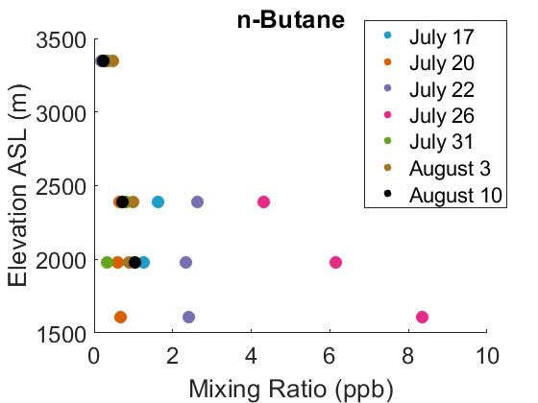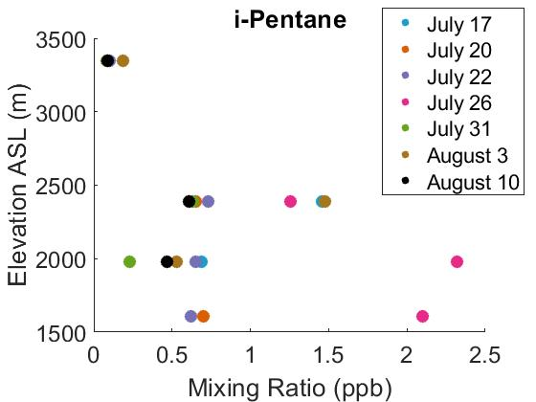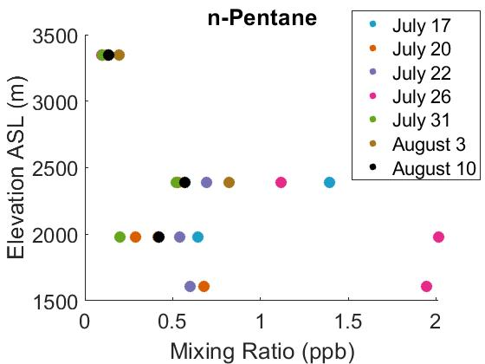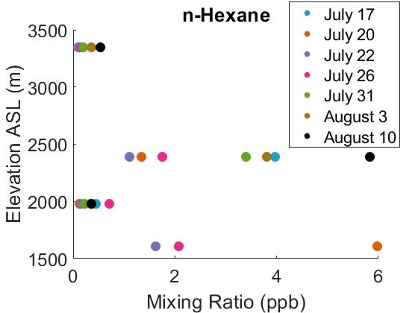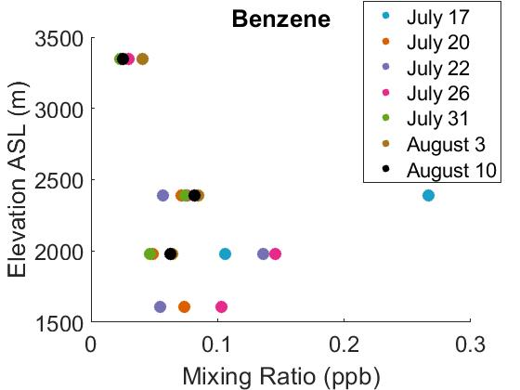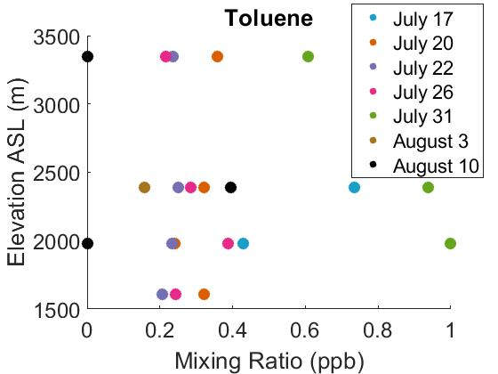

**Figure S4**

8-hour HYSPLIT back trajectory for 7/20/14 ending at INSTAAR, CU-Boulder (BO), at 12:00 (MDT) (19:00 UTC).

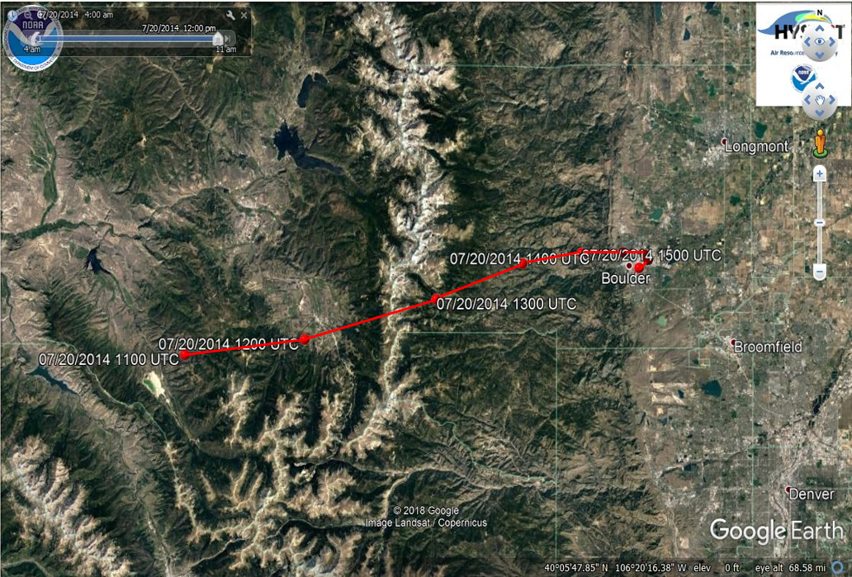

**Figure S5**

8-hour HYSPLIT back trajectory for 7/26/14 arriving at INSTAAR, CU-Boulder (BO), at 12:00 (MDT) (19:00 UTC).

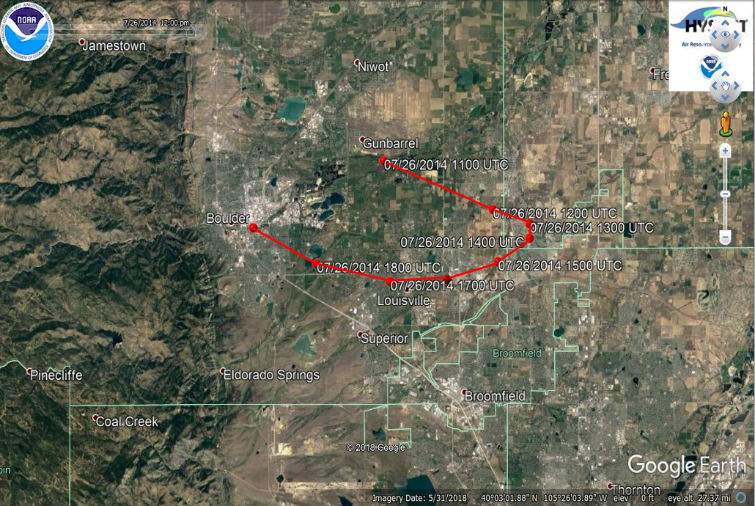

**Figure S6**

8-hour HYSPLIT back trajectory for 7/31/14 arriving at INSTAAR, CU-Boulder (BO) at 04:00 (MDT) (11:00 UTC).

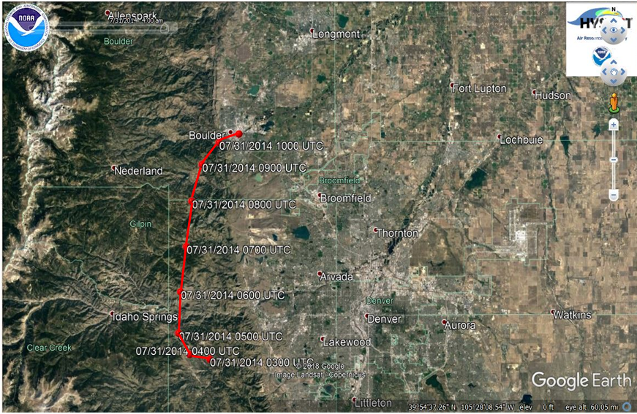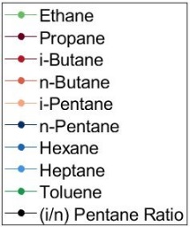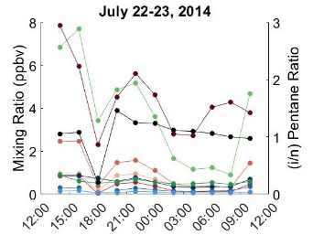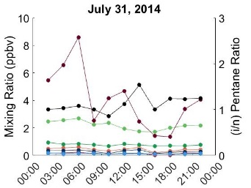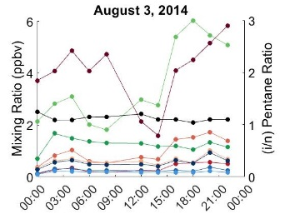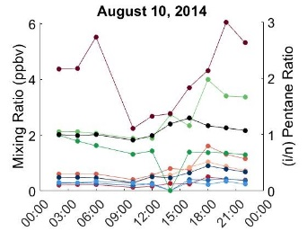

**Figure S7**

Diurnal cycles on four days at the Lost Angels Road (LA) site (elevation = 2392 m). These samples were collected via PFP. Sample times are reported in MDT 24 hour format. Note that the scale of the left y-axis (mixing ratios) varies by plot, but the right y-axis ((i/n) pentane ratio) is identical in all plots.

**Table S1**

Components, mole fraction, and tolerances of standard mixtures used to calibrate the GC/MS/FID. Four multicomponent standards were used: (a) Apel-Riemer multicomponent standard, (b) National Physical Laboratory multicomponent standard, (c) Apel-Reimer oxygenated VOC standard, (d) National Institute of Technology standard.

1. Apel-Riemer Environmental, Inc. multicomponent standard, Broomfield, CO, USA, prepared summer 2014.

|  |  |  |
| --- | --- | --- |
| Component | Mole fraction (nmol mol-1) | Tolerance (%) |
| Ethene | 4.93 | 5 |
| Acetlyene | 5.73 | 5 |
| Ethane | 9.72 | 5 |
| Propene | 1.89 | 5 |
| Propane | 9.16 | 5 |
| Propyne | 4.53 | 5 |
| i-Butane | 4.07 | 5 |
| i-Butene | 2.72 | 5 |
| 1-Butene | 2.12 | 5 |
| 1,3-Butadiene | 1.99 | 5 |
| Butane | 7.84 | 5 |
| t-2-Butene | 0.94 | 5 |
| c-2-Butene | 1.99 | 5 |
| 1,2-Butadiene | 4.79 | 5 |
| i-Pentane | 5.97 | 5 |
| 1-Pentene | 0.97 | 5 |
| 2-Methyl-butene | 0.99 | 5 |
| Pentane | 7.09 | 5 |
| Isoprene | 3.88 | 5 |
| t-2-Pentene | 0.77 | 5 |
| c-2-Pentene | 1.86 | 5 |
| 2-Methyl-2-butene | 0.81 | 5 |
| 2,2-Dimethylbutane | 1.86 | 5 |
| Cyclopentene | 0.79 | 5 |
| Cyclopentane | 0.97 | 5 |
| 2,3-Dimethylbutane | 1.46 | 5 |
| 2-Methylpentane | 0.80 | 5 |
| 3-Methylpentane | 0.99 | 5 |
| 2-Methyl-1-pentene | 0.75 | 5 |
| Hexane | 2.50 | 5 |
| t-2-Hexene | 0.41 | 5 |
| c-2-Hexene | 0.78 | 5 |
| Methylcyclopentane | 0.79 | 5 |
| 2,4-Dimethylpentane | 0.79 | 5 |
| Benzene | 1.62 | 5 |
| Cylcohexane | 0.44 | 5 |
| 2-Methylhexane | 0.81 | 5 |
| 2,3-Dimethylpentane | 0.37 | 5 |
| Cyclohexene | 0.73 | 5 |
| 3-Methylhexane | 0.74 | 5 |
| 1-Heptene | 1.91 | 5 |
| Heptane | 3.55 | 5 |
| Methylcyclohexane | 0.82 | 5 |
| 2,3,4-Trimethylpentane | 0.40 | 5 |
| Toluene | 2.26 | 5 |
| 2-Methylheptane | 0.41 | 5 |
| 4-Methylheptane | 0.98 | 5 |
| 3-Methylheptane | 0.77 | 5 |
| Octane | 0.41 | 5 |
| Ethylbenzene | 0.70 | 5 |
| m-Xylene | 1.10 | 5 |
| p-Xylene | 0.36 | 5 |
| Styrene | 0.35 | 5 |
| o-Xylene | 0.38 | 5 |

1. National Physical Laboratory multicomponent standard, London, UK, prepared December 16, 2015.

|  |  |  |
| --- | --- | --- |
| Component | Mole fraction (nmol mol-1) | Tolerance (± nmol mol-1) |
| Ethane | 4.06 | 0.08 |
| Ethene | 3.91 | 0.08 |
| Propane | 4.09 | 0.08 |
| Propene | 4.02 | 0.08 |
| 2-Methylpropane | 4.20 | 0.11 |
| Butane | 3.98 | 0.08 |
| Ethyne | 4.13 | 0.21 |
| t-But-2-ene | 3.97 | 0.08 |
| But-1-ene | 3.98 | 0.08 |
| c-But-2-ene | 4.02 | 0.08 |
| 2-Methylbutane | 4.05 | 0.08 |
| Pentane | 4.05 | 0.08 |
| 1,3-butadiene | 3.97 | 0.08 |
| t-Pent-2-ene | 3.97 | 0.08 |
| Pent-1-ene | 3.98 | 0.08 |
| 2-Methylpentane | 4.06 | 0.08 |
| Hexane | 3.99 | 0.08 |
| Isoprene | 4.03 | 0.09 |
| Heptane | 4.02 | 0.08 |
| Benzene | 4.00 | 0.08 |
| 2,2,4-Trimethylpentane | 3.99 | 0.08 |
| Octane | 4.03 | 0.08 |
| Toluene | 4.00 | 0.10 |
| Ethylbenzene | 4.00 | 0.10 |
| m-Xylene + p-Xylene | 8.04 | 0.21 |
| o-Xylene | 4.00 | 0.10 |
| 1,3,5-Trimethylbenzene | 4.01 | 0.11 |
| 1,2,4-Trimethylbenzene | 4.03 | 0.11 |
| 1,2,3-Trimethylbenzene | 4.04 | 0.11 |

1. Apel-Riemer Environmental, Inc. oxygenated VOC standard, Broomfield, CO, USA, prepared April 2010.

|  |  |  |
| --- | --- | --- |
| Component | Mole fraction (nmol mol-1) | Tolerance (%) |
| Methanol | 540 | 5 |
| Acetone | 538 | 5 |
| Methyl Vinyl Ketone | 506 | 5 |
| Methacrolein | 542 | 5 |
| Isoprene | 519 | 5 |

1. National Institute of Standards and Technology, USA, standard, prepared 2008.

|  |  |  |
| --- | --- | --- |
| Component | Mole fraction (nmol mol-1) | Tolerance (%) |
| |  | | --- | | Ethane | | propane | | propene | | i-butane | | n-butane | | i-butene | | i-pentane | | n-pentane | | 1-pentene | | hexane | | heptane | | benzene | | i-octane | | octane | | toluene | | nonane | | o-xylene | | decane | | |  | | --- | | 0.4979 | | 0.5223 | | 0.4950 | | 0.5215 | | 0.5084 | | 0.5195 | | 0.4791 | | 0.4874 | | 0.4801 | | 0.4859 | | 0.4981 | | 0.4987 | | 0.4849 | | 0.4799 | | 0.4841 | | 0.4731 | | 0.4915 | | 0.4899 | | 2.0  2.4  2.0  1.4  2.0  1.6  1.2  1.2  2.0  2.4  2.2  1.5  2.4  3.2  2.6  3.7  1.6  5.4 |
|  |  |  |

**Table S2**

Detection limits for the canister and PFP gas chromatography determination of volatile organic compounds.

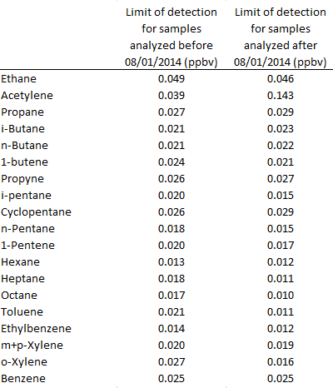

**Table S3**

Comparison of the noon – 3 p.m. canister and the average of 12 PFP diurnal cycle measurements at the Lost Angels site. % differences were calculated by dividing the absolute value of the difference of the measurements by the average mole fraction of the measurements and converting to a percentage.

|  |  |  |  |  |  |  |  |  |  |  |
| --- | --- | --- | --- | --- | --- | --- | --- | --- | --- | --- |
| Canister vs. PFP Measurements at Lost Angels Site | | | | | | | | | | |
|  |  |  | | | | | | | | |
| Sampling Date | Sampling Method & Comparison | Ethane | Propane | i-Butane | n-Butane | i-Pentane | n-Pentane | n- Hexane | n-Heptane | Toluene |
| 7/22/2014 | PFP avg. (ppb) | 3.75 | 4.41 | 0.37 | 1.13 | 0.61 | 0.59 | 0.22 | 0.09 | 0.58 |
| PFP std. dev. (ppb) | 2.35 | 1.62 | 0.29 | 0.82 | 0.30 | 0.22 | 0.08 | 0.04 | 0.12 |
| Canister (ppb) | 7.68 | 6.81 | 0.90 | 2.63 | 0.73 | 0.69 | 1.11 | 0.06 | 0.22 |
| Difference (%) | 69 | 43 | 84 | 80 | 19 | 17 | 135 | 48 | 91 |
| 7/31/2014 | PFP avg. (ppb) | 2.18 | 4.06 | 0.14 | 0.42 | 0.33 | 0.28 | 0.14 | 0.10 | 0.76 |
| PFP std. dev. (ppb) | 0.32 | 2.21 | 0.07 | 0.12 | 0.14 | 0.10 | 0.03 | 0.02 | 0.08 |
| Canister (ppb) | 4.45 |  | 0.94 | 0.82 | 0.64 | 0.52 | 3.39 | 0.07 | 0.43 |
| Difference (%) | 68 |  | 149 | 64 | 64 | 59 | 184 | 28 | 55 |
| 8/3/2014 | PFP avg. (ppb) | 3.60 | 4.07 | 0.33 | 0.99 | 0.61 | 0.55 | 0.25 | 0.18 | 1.24 |
| PFP std. dev. (ppb) | 1.57 | 1.24 | 0.16 | 0.46 | 0.17 | 0.16 | 0.06 | 0.04 | 0.25 |
| Canister (ppb) | 3.06 | 2.68 | 0.40 | 0.99 | 1.47 | 0.82 | 3.80 | 0.08 | 0.42 |
| Difference (%) | 16 | 41 | 17 | 0.78 | 83 | 40 | 175 | 70 | 99 |
| 8/10/2014 | PFP avg. (ppb) | 2.59 | 4.14 | 0.27 | 0.84 | 0.63 | 0.57 | 0.29 | 0.26 | 1.36 |
| PFP std. dev. (ppb) | 0.75 | 1.29 | 0.12 | 0.39 | 0.24 | 0.18 | 0.12 | 0.10 | 0.53 |
| Canister (ppb) | 2.63 | 3.20 | 0.26 | 0.73 | 0.61 | 0.57 | 5.83 | 0.08 | 0.46 |
| Difference (%) | 1.4 | 26 | 6.0 | 14 | 2.8 | 0.88 | 181 | 104 | 100 |

**Table S4**

VOCs to ethane relationship in monitoring data from the Boulder Reservoir [*Boulder_AIR*, 2021]*.



*These results rely on in-situ monitoring data from the Boulder Reservoir VOCs monitoring between April 5, 2017 and October 4, 2021. Altogether, some 25,000 individual gas chromatography (GC) sample analyses were considered. VOCs quantification results for the listed VOCs were plotted against the ethane mole fraction in the sample and a best linear regression fit through all data was determined. Columns two and three represent the slope and intercept results of the analysis. The slope values were then multiplied by the number of carbon (column 5) in each analyte to allow for a relative weighing of the contribution of each VOCs species to the total volatile VOCs carbon in the sample (column 6). Isoprene was the only VOCs among the quantified species that was excluded. The relative contribution of minor compounds was estimated by selecting the nine highest ethane samples of the record and determining the mean relative ratio of the peak area of integrated, but non-speciated GC peaks versus the total peak area of the identified compounds listed in the table. The contribution of each individual VOC to the total VOCs volatile carbon was then determined considering the 6.5% contribution of these non-speciated VOCs (column 7).