Supplemental Material

Investigating methane emissions from geologic microseepage in Western New York State, USA: Supplemental Material
Roxana Kazemi ¹ * , William Schlageter ¹ , Benjamin Hmiel ^{1 †} , Thomas S. Weber ¹, Lee T. Murray ¹, Vasilii V. Petrenko ¹
¹ Department of Earth and Environmental Sciences, University of Rochester, Rochester, New York, United States
† now at Environmental Defense Fund, New York, NY, United States
*Corresponding author: rkazemi@u.rochester.edu
April 24, 2021

List of Contents:
Figure S1: Map of the area of interest in Western New York State. Oil and gas wells (ESOGIS, 2019) with a 1km-radius buffer.

Table S1: Overview of selected sample areas.

Table S2: Field measurements and calculated flux values of every sample taken over the course of this study.
Figure S2. The sampling system set up in the field on November 17th, 2019 at Chestnut Ridge Park.
Text S1: Flux Chamber Testing.

Table S3: Flux chamber volume calibration results.
Figure S3. A schematic of the design for the flux calibration testing. The standard gas tank was switched from a high [CH₄] standard to ultrapure air between positive and negative flux simulations.

Table S4: Flux detection test results.

Figure S4. [CH₄] over the 2.5 hour blank test for a sealed intact chamber.
Figure S5. CH₄ concentration over the course of the outdoor blank test (above) and indoor blank test (below).
Figure S6. CH₄ concentration over the course of the breath test (above) and high CH₄ concentration standard gas test (below).

Figure S7. [CH₄] over time for a typical flux chamber sample measurement. This measurement is i-1 at Watkins Glen State Park on January 9th, 2020 (Table S2).
Text S2: Problems encountered during field measurements.

Table S5: Results of a test of the effects of loose quick-connect fitting.
Figure S8. First sample with a time-variable CH₄ trend. [CO₂] (red), [CH₄] (green), and [H₂O] (blue) during sample e-1 at Chestnut Ridge Park on November 17th, 2019.
Figure S9. Second sample with a time-variable CH₄ trend. [CO₂] (red), [CH₄] (green), and [H₂O] (blue) during sample e-8 at Chestnut Ridge Park on November 24th, 2019.
Figure S10. Third sample with a time-variable CH₄ trend. [CO₂] (red), [CH₄] (green), and [H₂O] (blue) during sample c-7 at Hemlock Canadice State Forest on January 6th, 2020.
Figure S11. Bar charts of the results. The top left, top right, and bottom right panels compare average fluxes for sampled areas (areas indicated by letters as in Figure 2 and Table S1) to Etiope et al. 2019 estimates, with each panel presenting results for a different microseepage emission Level as per Etiope et al. (2019) classification. The bottom-left panel compares average fluxes of each cell Level.
Text S3. Statistical Sensitivity Testing.
Figure S12. Method for generating synthetic microseepage datasets.
Figure S13. Modes of temporal variability. Timeseries of microseepage emissions from two distant locations within the same synthetic dataset, for cases with (a) asynchronous temporal variability and (b) synchronous temporal variability.
Text S4. Comparison with satellite data from the TROPOMI instrument.
Figure S14. Maps of TROPOMI time-averaged column CH₄ around Etiope et al. (2019) Level 4 cells in Western New York State.

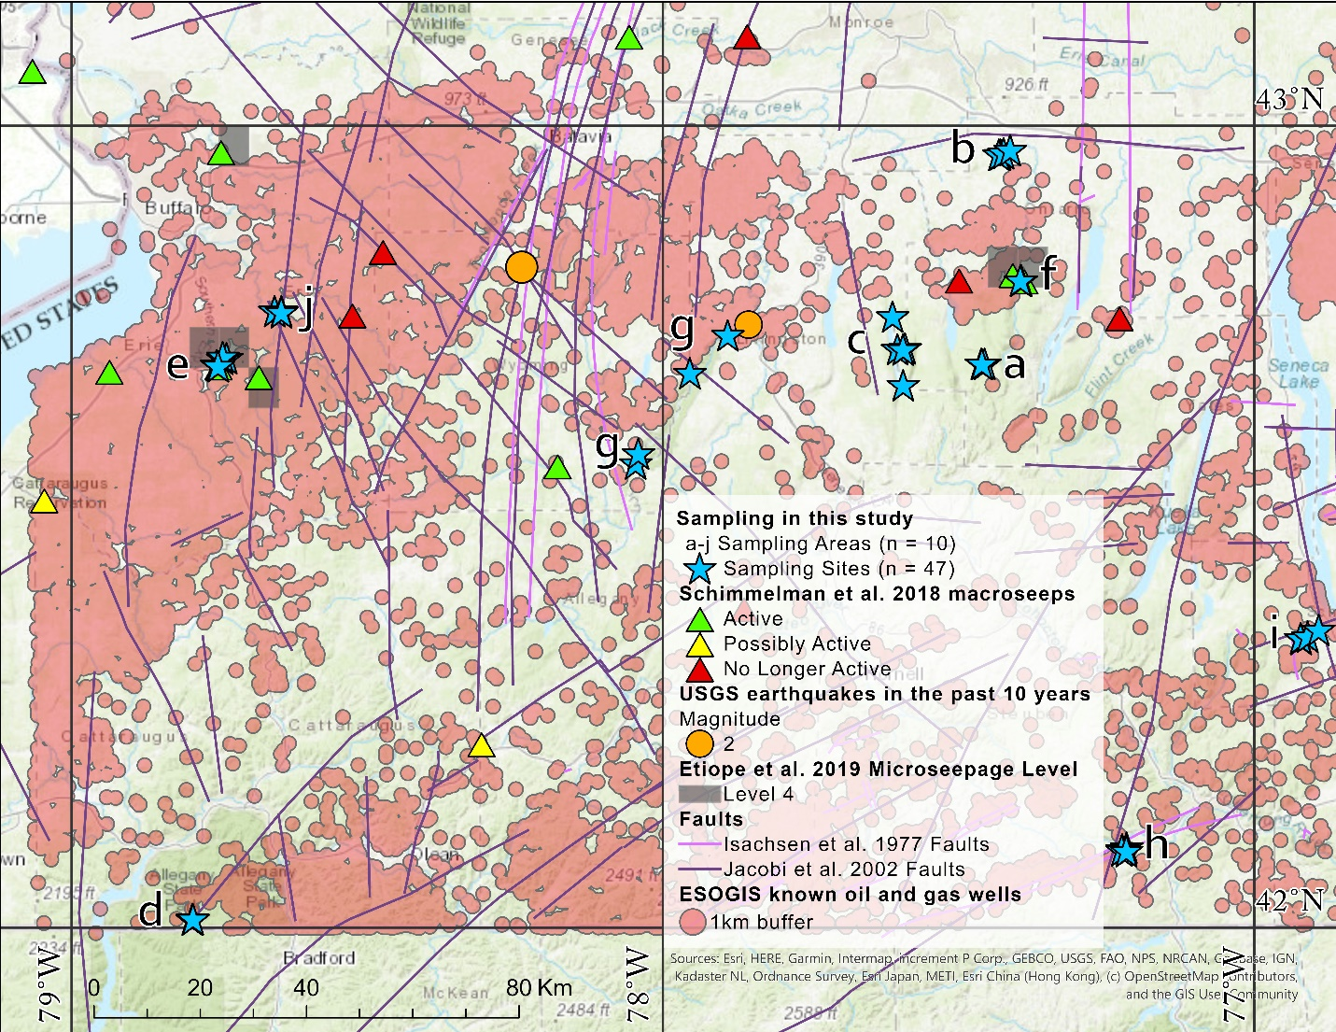Figure S1. Map of the area of interest in Western New York State. Oil and gas wells (ESOGIS, 2019) with a 1km-radius buffer.

Table S1: Overview of selected sample areas.
Area figure key | Sampling Area Name | Nearby indicators predictive of microseepage | Assigned seepage Level in Etiope et al. (2019) | Corrected seepage Level | Total number of samples (n) | Sampling date #1 | Sampling date #2
a | Cumming Nature Center | none | Level 1 | Level 1 | 6 | 9/20/2019 | 1/12/2020
b | Ganondagan State Historic Site | topographic lows | Level 1 | Level 1 | 4 | 10/4/2019 | N/A
c | Hemlock Canadice State Forest | topographic lows | Level 1 | Level 1 | 7 | 10/11/2019 | 1/6/2020
d | Allegany State Park | faulting, topographic lows | Level 1 | Level 2 | 4 | 10/18/2019 | N/A
e | Chestnut Ridge Park | topographic lows, macro-seeps | Level 4 | Level 4 | 8 | 11/17/2019 | 11/24/2019
f | Levi Corser Memorial Park | macro-seeps | Level 4 | Level 4 | 3 | 1/5/2020 | N/A
g | Letchworth State Park | faulting, topographic lows, recent seismic events | Level 0 and Level 1 | Level 2 | 4 | 1/7/2020 | N/A
h | Pinnacle State Park | faulting, topographic lows | Level 1 | Level 2 | 4 | 1/8/2020 | N/A
i | Watkins Glen State Park | faulting, topographic lows | Level 1 | Level 2 | 4 | 1/9/2020 | N/A
j | Knox Farm State Park | faulting | Level 0 | Level 2 | 3 | 1/14/2020 | N/A
Totals | 10 areas |  |  |  | 47 samples

Table S2: Field measurements and calculated flux values of every sample taken over the course of this study.
Site key ª | Assigned seepage Level in Etiope et al. (2019) | Date | Latitude | Longitude | Altitude above sea level (ft) | Soil Temperature (°C) | Chamber Temperature (°C) | Calculated Flux (mg CH₄ m⁻² day⁻¹)^{b}
a-1^{c} | Level 1 | 9/20/2019 | 42.70472 | -77.45585 | 1700 | ND ^{h} | 20.8 | -3.58 ± 0.322
a-2^{c} | Level 1 | 9/20/2019 | 42.70450 | -77.46043 | 1665 | 16.7 | 22.2 | -3.02 ± 0.258
a-3^{c} | Level 1 | 9/20/2019 | 42.70468 | -77.46160 | 1695 | ND | 21.1 | -2.78 ± 0.218
a-4^{c} | Level 1 | 1/12/2020 | 42.28300 | -77.45585 | 1700 | 8.6 | 3.25 | -0.216 ± 0.266
a-5^{c} | Level 1 | 1/12/2020 | 42.28100 | -77.46160 | 1695 | 5.9 | 1.75 | -0.329 ± 0.166
a-6 | Level 1 | 1/12/2020 | 42.28100 | -77.46160 | 1695 | 5.9 | 1.75 | -0.343 ± 0.0527
a-7^{c} | Level 1 | 1/12/2020 | 42.27000 | -77.46043 | 1665 | 5.2 | 1 | -0.905 ± 0.133
b-1 | Level 1 | 10/4/2019 | 42.96457 | -77.42928 | 716 | 10.6 | 10.6 | -0.212 ± 0.0272
b-2 | Level 1 | 10/4/2019 | 42.96408 | -77.43180 | 798 | 12.6 | 10.9 | -3.45 ± 0.175
b-3 | Level 1 | 10/4/2019 | 42.96597 | -77.42385 | 662 | 15.3 | 9.8 | -0.0526 ± 0.0195
b-4 | Level 1 | 10/4/2019 | 42.96973 | -77.41262 | 696 | 14.6 | 12.35 | -0.244 ± 0.0394
c-1^{c, g} | Level 1 | 10/11/2019 | 42.72393 | -77.59050 | 1400 | 12.1 | 11.9 | 0.116 ± 0.0306
c-2^{c} | Level 1 | 10/11/2019 | 42.72250 | -77.59383 | 1347 | 12.3 | 16.65 | -1.29 ± 0.0776
c-3 | Level 1 | 10/11/2019 | 42.72288 | -77.60332 | 993 | 12.2 | 14.7 | -1.57 ± 0.113
Site key ª | Assigned seepage Level in Etiope et al. (2019) | Date | Latitude | Longitude | Altitude above sea level (ft) | Soil Temperature (°C) | Chamber Temperature (°C) | Calculated Flux (mg CH₄ m⁻² day⁻¹)^{b}
c-4 ^{c} | Level 1 | 1/6/2020 | 42.72393 | -77.59050 | 1400 | 3 | 1.2 | -0.0900 ± 0.0422
c-5^{c} | Level 1 | 1/6/2020 | 42.72250 | -77.59383 | 1347 | 2.8 | 1.1 | 0.0254 ± 0.0300
c-6 | Level 1 | 1/6/2020 | 42.67815 | -77.59363 | 1007 | 3.4 | 3 | -0.0861 ± 0.0423
c-7 ^{d} | Level 1 | 1/6/2020 | 42.76343 | -77.61157 | 991 | 3.6 | 3.05 | 1.27 ± 1.59
d-1 | Level 1 | 10/18/2019 | 42.00997 | -78.79560 | 1641 | 10 | 9.8 | -0.192 ± 0.0864
d-2 | Level 1 | 10/18/2019 | 42.01108 | -78.79540 | 1660 | 9.2 | 8.75 | -2.67 ± 0.151
d-3 | Level 1 | 10/18/2019 | 42.01103 | -78.79482 | 1688 | 9.4 | 8.3 | -0.695 ± 0.0644
d-4 | Level 1 | 10/18/2019 | 42.01057 | -78.79433 | 1697 | 8.5 | 8.5 | -0.872 ± 0.0725
e-1^{c, d, f} | Level 4 | 11/17/2019 | 42.70173 | -78.75170 | 999 | ND | 7.8 | 0.306 ± 0.346
e-2 ^{f} | Level 4 | 11/17/2019 | 42.70193 | -78.75197 | 1028 | ND | 1.7 | -0.0720 ± 0.0378
e-3 ^{f} | Level 4 | 11/17/2019 | 42.70197 | -78.75260 | 1039 | ND | 1 | -1.19 ± 0.0663
e-4 | Level 4 | 11/17/2019 | 42.70323 | -78.75433 | 1051 | ND | 0.35 | -0.102 ± 0.0350
e-5 | Level 4 | 11/24/2019 | 42.71172 | -78.73760 | 1550 | 5.7 | 4.5 | -0.0102 ± 0.0473
e-6 | Level 4 | 11/24/2019 | 42.71098 | -78.74432 | 1513 | 4.2 | 4.4 | -0.183 ± 0.147
e-7 | Level 4 | 11/24/2019 | 42.71323 | -78.74412 | 1440 | 5.9 | 7.2 | -0.272 ± 0.0315
Site key ª | Assigned seepage Level in Etiope et al. (2019) | Date | Latitude | Longitude | Altitude above sea level (ft) | Soil Temperature (°C) | Chamber Temperature (°C) | Calculated Flux (mg CH₄ m⁻² day⁻¹)^{b}
e-8 ^{c, d, f} | Level 4 | 11/24/2019 | 42.70178 | -78.75198 | 1323 | ND | 4.6 | -2.03 ± 6.88
f-1 e | Level 4 | 1/5/2020 | 42.80812 | -77.39380 | 900 | 3.25 | 0.8 | -0.0503 ± 0.0354
f-2 ^{e} | Level 4 | 1/5/2020 | 42.80815 | -77.39463 | 905 | 3 | 1.1 | -0.0242 ± 0.0353
f-3 ^{e} | Level 4 | 1/5/2020 | 42.80808 | -77.39543 | 903 | 3.9 | 1.2 | 0.00194 ± 0.0282
g-1 | Level 1 | 1/7/2020 | 42.58065 | -78.04617 | 1120 | 3.35 | 4.9 | -0.0312 ± 0.0531
g-2 | Level 1 | 1/7/2020 | 42.59317 | -78.04142 | 1352 | 3.5 | 11.2 | -0.149 ± 0.0477
g-3 | Level 1 | 1/7/2020 | 42.69323 | -77.95437 | 865 | 3.15 | 2.8 | -0.463 ± 0.0651
g-4 ^{f} | Level 1 | 1/7/2020 | 42.74018 | -77.89025 | 660 | 2.85 | 3.65 | -0.579 ± 0.0539
h-1 ^{f} | Level 1 | 1/8/2020 | 42.10058 | -77.21580 | 1445 | 4.25 | 1 | -1.75 ± 0.100
h-2 | Level 1 | 1/8/2020 | 42.09820 | -77.21732 | 1506 | 1.55 | 0.05 | 0.0238 ± 0.0256
h-3 | Level 1 | 1/8/2020 | 42.09692 | -77.21740 | 1570 | 1.35 | 1.5 | 0.0239 ± 0.0442
h-4 ^{f} | Level 1 | 1/8/2020 | 42.09605 | -77.21622 | 1644 | 2.3 | -2.15 | -0.0307 ± 0.0362
i-1 | Level 1 | 1/9/2020 | 42.36170 | -76.92077 | 980 | 3.15 | -1.05 | -1.14 ± 0.0695
i-2 | Level 1 | 1/9/2020 | 42.36260 | -76.91717 | 990 | 1.9 | -1.25 | -0.00694 ± 0.147
i-3 | Level 1 | 1/9/2020 | 42.36482 | -76.90967 | 1001 | 1.55 | -1.7 | -0.385 ± 0.0686
Site key ª | Assigned seepage Level in Etiope et al. (2019) | Date | Latitude | Longitude | Altitude above sea level (ft) | Soil Temperature (°C) | Chamber Temperature (°C) | Calculated Flux (mg CH₄ m⁻² day⁻¹)^{b}
i-4 | Level 1 | 1/9/2020 | 42.37308 | -76.89102 | 1005 | 1.8 | -3.25 | -0.259 ± 0.0396
j-1 ^{f, g} | Level 0 | 1/14/2020 | 42.77022 | -78.65073 | 931 | 7.65 | 12.4 | 0.122 ± 0.0355
j-2 | Level 0 | 1/14/2020 | 42.77022 | -78.64487 | 963 | 5.25 | 14.9 | -0.0326 ± 0.0455
j-3 | Level 0 | 1/14/2020 | 42.76867 | -78.64498 | 936 | 4.9 | 12.65 | -0.113 ± 0.0523
ª Site key combines the area figure key and sample number (i.e. sampling area letter - sample number)
^{b} Fluxes are shown with 2σ uncertainties.
^{c} These sampling sites were sampled on two separate dates.
^{d} Excluded from further analysis due to low confidence in the calculated flux for reasons described in Text S2.
^{e} Avoiding areas that appeared to be walked on was not possible for these samples as the entire area of the relatively small park was used for picnic tables and sporting fields.
^{f} Sites which are located within the 1km buffer zone of a known oil or gas well.
^{g} The two small significantly positive fluxes we detected.
^{h} No direct data measurement was recorded (ND).

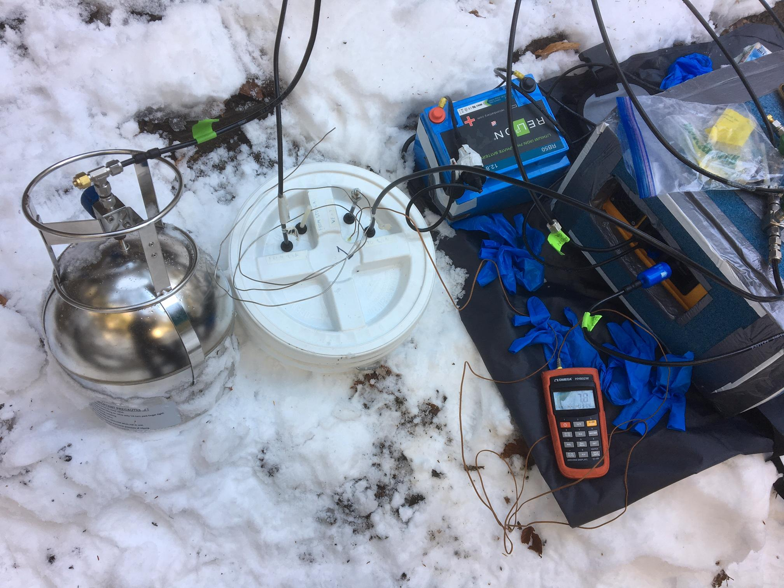Figure S2. The sampling system set up in the field on November 17th, 2019 at Chestnut Ridge Park.

Text S1. Flux Chamber Testing

LGR Gas Analyzer detection limit
The LGR Gas Analyzer has a 1σ precision of 0.3 nmol mol⁻¹ over a 100 second measurement interval. We assume that this would enable robust detection of a 1.8 nmol mol⁻¹ (6σ) change in [CH₄] between the start and end of the 10-minute sample measurement. This translates into d[CH₄]/dt = 0.18 nmol mol⁻¹ min⁻¹, or 0.023 mg CH₄ m⁻² day⁻¹ in terms of flux.

Volume Calibration
To calculate the methane flux for each sample, it is essential to have a reliable measurement of the chamber volume. To calibrate the chamber volume, the empty chamber was weighed, inverted, and filled with DI water up to the level corresponding to the typical soil-air boundary when the chamber is pushed into the ground and weighed once again. The volume was determined using the difference in mass and density of pure water.

Table S3: Flux chamber volume calibration results.
Flux Chamber ª | Calibrated Volume (L) | Measurement Uncertainty (L)
Shorter (cut-off) chamber | 7.27 | 0.32
Taller (intact) Chamber | 19.31 | 0.32
ª Initial blank and flux detection tests were conducted with the taller chamber, while all the field measurements (Table S2), later blank tests, and high [CH₄] intrusion tests were conducted with the shorter chamber to increase flux detection sensitivity.

Flux Detection Tests
To verify that the system can accurately detect CH₄ fluxes, an additional auxiliary port was installed in the top of a sealed, intact flux chamber and connected through a mass flow controller (MFC) to a known standard gas (Figure S3). To simulate a positive flux, a standard gas with [CH₄] of 29,580 ± 2% nmol mol⁻¹ was introduced at rates of 20, 10, 2, and 1 sccm, and to simulate a negative flux, ultrapure air with < 10 nmol mol⁻¹ of [CH₄] (assumed 5 ± 5 nmol mol⁻¹) was introduced at rates of 45, 30, 15, and 5 sccm. As shown in Table S4, the measured and expected fluxes were in good agreement, with an average ratio of 1.00 ± 0.07 (one standard deviation); the largest disagreement (14%) was observed for the lowest negative flux test.

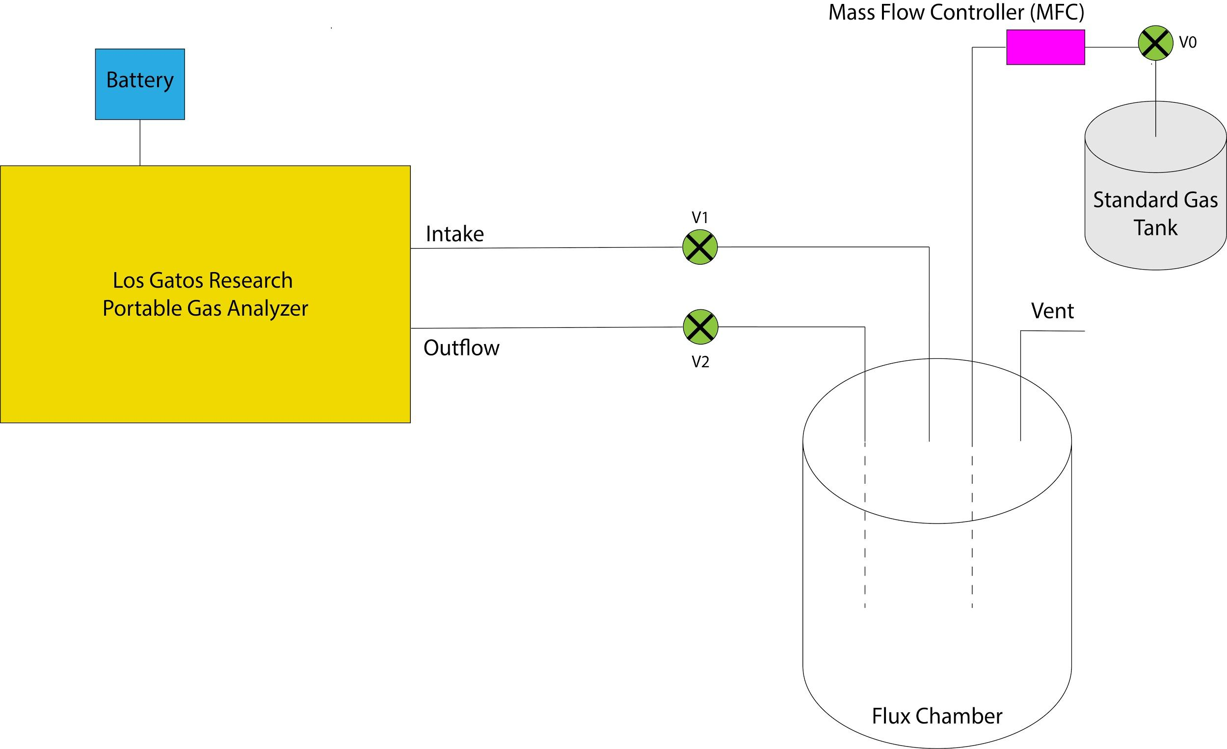Figure S3. A schematic of the design for the flux calibration testing. The standard gas tank was switched from a high [CH₄] standard to ultrapure air between positive and negative flux simulations.

Table S4: Flux detection test results.
Standard Gas CH₄ mole fraction (nmol mol⁻¹) | Flow rate (sccm) | Predicted d[CH₄]/dt using MFC flow rate (nmol mol⁻¹ min⁻¹) | Measured d[CH₄]/dt (nmol mol⁻¹ min⁻¹) ª | CH₄ Flux using MFC flow rate (mg CH₄ m⁻² day⁻¹) | Measured CH₄ Flux (mg CH₄ m⁻² day⁻¹) ª | Measured flux as % of expected flux
29580 | 20 | 30.2 | 31.3 ± 2.0 | 9.37 | 9.72 ± 0.352 | 104
29580 | 10 | 15.1 | 16.2 ± 0.5 | 4.70 | 5.02 ± 0.115 | 107
29580 | 2 | 3.0 | 3.0 ± 0.32 | 0.94 | 0.93 ± 0.051 | 99
29580 | 1 | 1.5 | 1.5 ± 0.22 | 0.47 | 0.47 ± 0.034 | 100
5 | 5 | -0.7 | -0.6 ± 0.24 | -0.22 | -0.19 ± 0.037 | 86
5 | 15 | -2.2 | -2.3 ± 0.42 | -0.67 | -0.73 ± 0.066 | 109
5 | 30 | -4.3 | -4.2 ± 0.46 | -1.32 | -1.30 ± 0.075 | 98
5 | 45 | -6.3 | -6.4 ± 0.48 | -1.96 | -1.98 ± 0.082 | 101
 |  |  |  |  | Average | 100 ± 7.03 ^{b}
ª Measured d[CH₄]/dt and fluxes are shown with 2σ uncertainties
^{b} The uncertainty shown for the average measured flux as % of expected represents one standard deviation.

System blank testing
In order to ensure the system components do not alter CH₄ via production or removal, before cutting the bottom of the chamber off, we conducted a blank test of the sealed chamber. In preparation, the chamber was cleaned with soap and water, ethanol, milli-Q water, blow-dried, and then had all auxillary ports plugged. The air inside the chamber was circulated through the LGR analyzer for 2.5 hours, 15 times the length of a typical sample measurement. This resulted in a calculated total “flux” of only 0.001 ± 0.0066 mg CH₄ m⁻² day⁻¹ which is three orders of magnitude smaller than the anticipated flux for a Level 1 area. For this test, the [CH₄] oscillated on the order of 3 nmol mol⁻¹ rather than increasing or decreasing linearly; this most likely represents instrument drift in the LGR gas analyzer over time rather than CH₄ production or removal in the system (Figure S4).

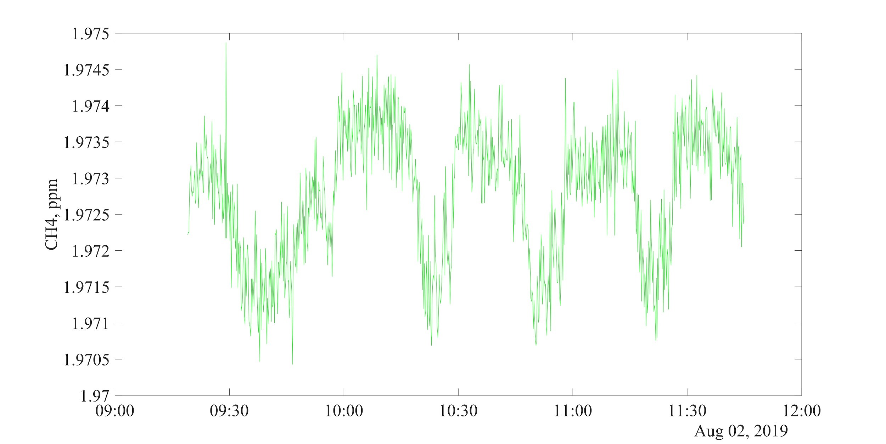

Figure S4. [CH₄] over the 2.5 hour blank test for a sealed intact chamber.

A secondary set of blank tests was conducted several months later. For these later tests, the chamber was the same as during field measurements (lower part of the HDPE bucket cut off, shorter chamber), and it was pushed into a tray of clean sand intended to simulate the field soil without the potential for CH₄ alteration by microbes. The sand was sterilized by heating for 2 hours at 232˚C and then left to cool for eight hours before being transferred to the sterilized tray. An indoor and an outdoor blank test were conducted. For the indoor blank test, air was circulated in the chamber for 45 minutes in an empty room. This test showed [CH₄] fluctuations of up to 10 nmol mol⁻¹ (Figure S5) and is most likely a result of fluctuations of [CH₄] in the surrounding air in combination with the imperfect seal formed by the relatively permeable sand.
For the outdoor blank test, the test setup was brought into the middle of a low-traffic greenspace on the University of Rochester campus and air was allowed to circulate for 25 minutes. The test showed a small decrease in [CH₄] on the order of 10 nmol mol⁻¹, followed by stable values; also likely due to small changes to [CH₄] in the surrounding air (figure S5). Overall, the tests indicate no significant [CH₄] blank from our sampling system, similar to the tests with a fully-sealed larger chamber.

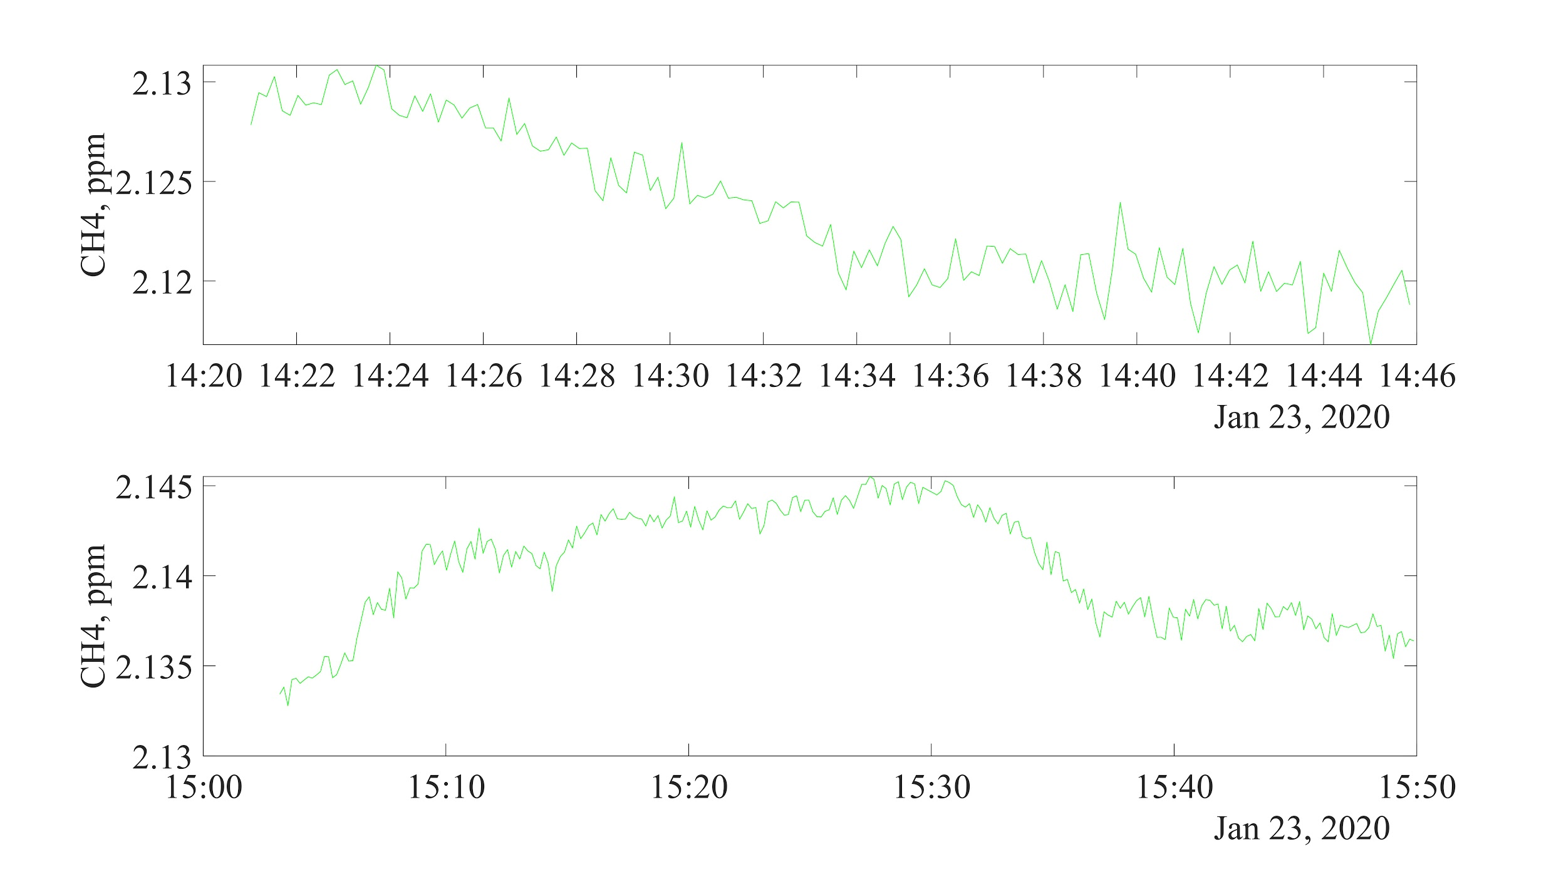Figure S5. CH₄ concentration over the course of the outdoor blank test (above) and indoor blank test (below).

High [CH₄] intrusion tests
To investigate possible intrusion of extraneous [CH₄] from ambient sources, two additional tests were conducted with the shorter, cut-off chamber and sterilized sand. The first test investigated the influence of CH₄ being breathed onto the sampling system. Some people naturally breathe out small amounts of CH₄, including one of the authors (Keppler et al., 2016). For this test, the CH₄ breather breathed onto the sand surrounding the chamber for about 30 seconds, and then allowed the chamber to equilibrate for 8 minutes. There was a small positive flux (0.375 nmol mol⁻¹ min⁻¹, Figure S6), which translates to 0.04 mg CH₄ m⁻² day⁻¹ flux; this is an order of magnitude lower than most fluxes we measured in the field. During sampling in the field, the methane breathing author was careful to keep at least a few meters away during the measurement, we therefore don’t anticipate any interference from methane breathing in our measurements. The second test was designed to investigate the intrusion of high-[CH₄] ambient air, especially in areas with CH₄ macroseeps nearby. For this test, a standard gas with a [CH₄] of 29,580 nmol mol⁻¹ was sprayed around the chamber onto the surface of the sand at a rate of about 20 sccm for 30 seconds; the chamber was then left to equilibrate for 15 minutes. The standard gas was then applied again for 15 seconds and the chamber was left to equilibrate for another 15 minutes. This did result in significant fluxes, equivalent to 1.22 and 0.55 mg CH₄ m⁻² day⁻¹ respectively (Figure S6). While the permeability of the sand is likely higher than that of the soils we sampled, it may be possible that samples collected near strong CH₄ sources (e.g. near a macroseep) would be affected significantly. This is suspected for two samples that are discussed in Text S2.

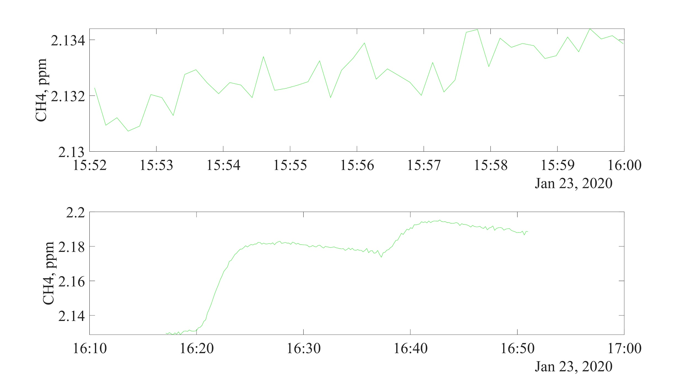Figure S6. CH₄ concentration over the course of the breath test (above) and high CH₄ concentration standard gas test (below).

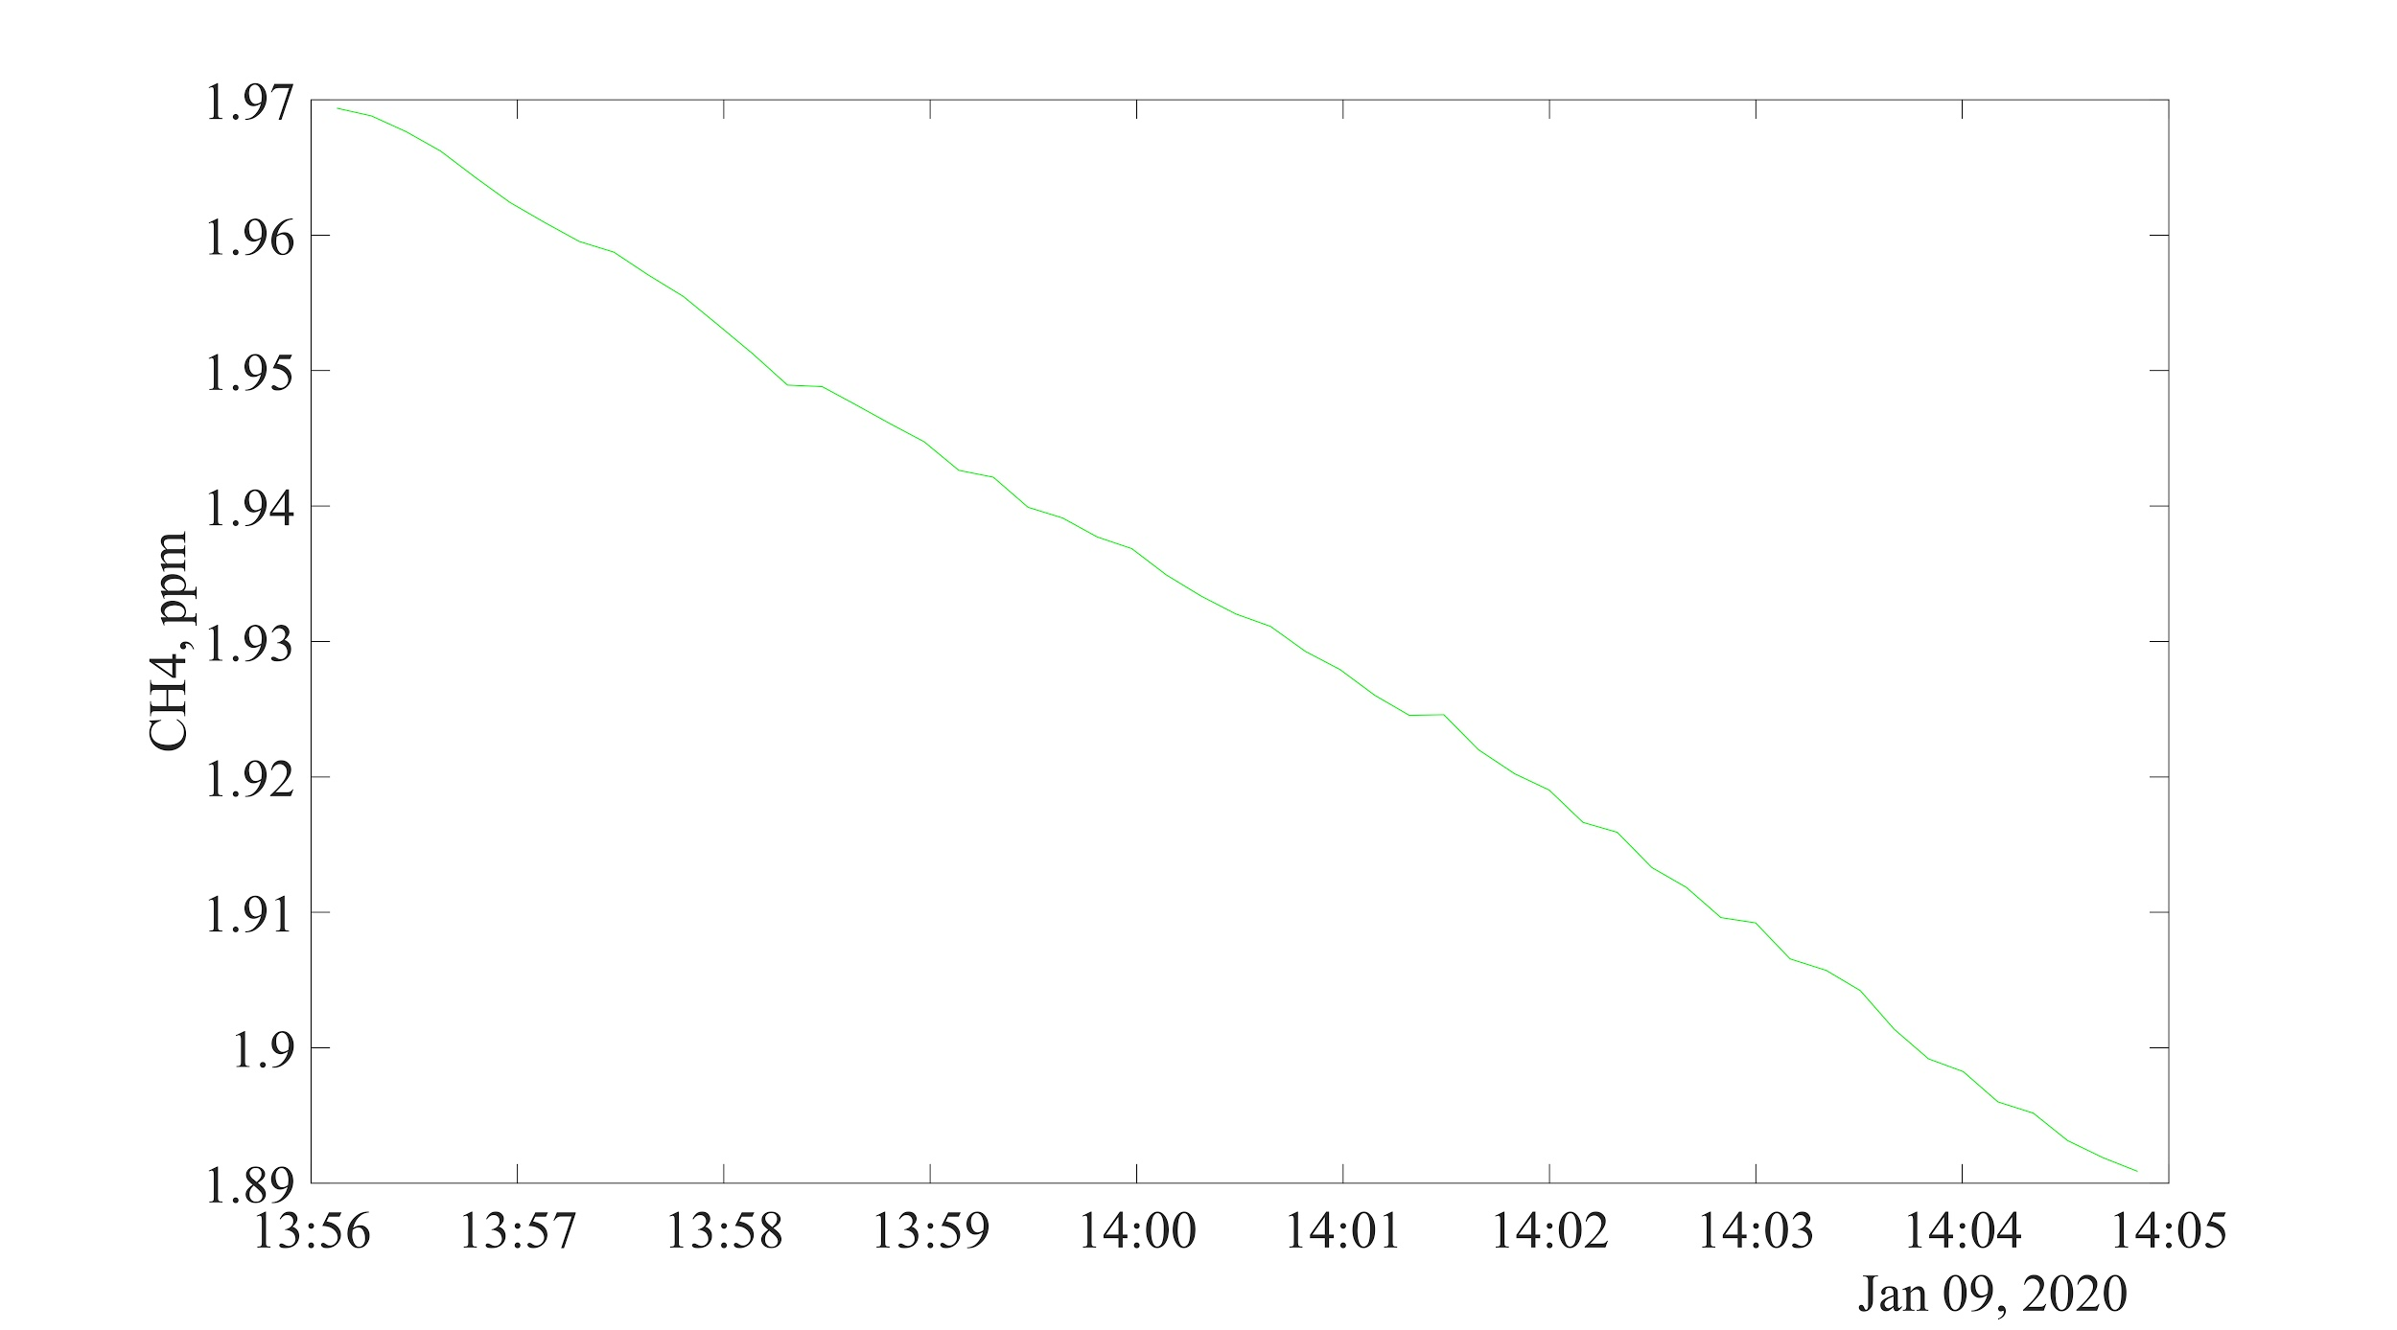Figure S7. [CH₄] over time for a typical flux chamber sample measurement. This measurement is i-1 at Watkins Glen State Park on January 9th, 2020 (Table S2).

Text S2. Problems Encountered During Field Measurements

Flux chamber seal to the ground
We encountered difficulty sealing the flux chamber to the ground for samples adjacent to the Eternal Flame macroseep in Chestnut Ridge Park (e-1 & e-8 in Table S2). Normally the chamber is pushed about ∼2 cm into the soil during sampling, but at this location the surface was too rocky to truly seal the chamber, so a snow pack was applied around the chamber’s edge instead for the first sample, and no additional sealing was attempted for the second sample. This may have allowed for ambient air intrusion (including elevated CH₄ from the nearby macroseep) during sampling.

Loose Fittings on the flux chamber
After the second sample at Letchworth State Park on January 7th, 2020 (g-2 in Table S2), we discovered that two quick-connect fittings on the flux chamber (these bulkhead fittings seal to the chamber with o-rings when properly tightened) were loose, potentially allowing for intrusion of ambient air. These fittings were immediately tightened to reseal the chamber. While we are uncertain of how many previous samples were taken with loose fittings, the synflex lines are disconnected and reconnected for every sample, and it is likely that a loose fitting would have been noticed relatively quickly. We conducted a test of the effects of loose fittings at Cumming Nature Center on January 12th, 2020. The first sample in this test was a normal flux measurement with the fittings fully tightened and the second sample was a repeat of this measurement but with the quick-connect fitting loosened to mimic the observed problem (a-5 and a-6 in Table S2). The results of this test in Table S5 show that the difference in detected flux is within the 2σ uncertainty range. Thus, it appears that this issue is unlikely to have significantly affected measurements with small fluxes. All measured fluxes during the week preceding the detection of this problem were small, and the data were thus included in our analysis. One exception was Hemlock-Canadice State Forest Sample 7 (c-7), which is discussed in a subsection below.

Table S5: Results of a test of the effects of loose quick-connect fitting.
 | Flux (mg CH₄ m⁻² day⁻¹) ª
Fully Sealed | -0.329 ± 0.166
Loosened fittings | -0.343 ± 0.053
ª Shown flux uncertainties are 2σ.

Standard Gas Measurement
Under normal operating conditions, the LGR Gas analyzer cavity pressure fluctuates by ≤ 100 millitorr, and cavity temperature drifts slowly depending on the difference between the internal and external temperatures. For each sample, we examined the cavity pressure and cavity temperature during measurement. There was no indication of instrument measurement problems for any of the samples based on these parameters.
The standard gas measurements at the beginning and end of each sampling day serve as a check on possible instrument drift. For each 3-minute standard gas measurement, average CH₄ and standard deviation are calculated. We expect this value to be within ~15 nmol mol⁻¹ of the known standard gas CH₄ concentration, allowing for some instrument drift between days.
All standard gas measurements made on October 18th, 2019 and one standard gas measurement made on January 7th, 2020 yielded anomalous values with 2σ flux uncertainties corresponding to > 1 mg CH₄ m⁻² day⁻¹. For the October 18th measurements, it was determined that the standard gas flask had not been refilled (refilling the standard gas flask prior to a day of sampling is the normal procedure). The anomalous [CH₄] values on that day were a result of the anomalously low pressure in the standard gas flask, and the resulting anomalously low pressures in the LGR analyzer cavity. The analyzer parameters at all other times and [CH₄] from ambient air measurements on that day all looked normal, however, so the sample flux measurements from that day were retained in the analysis.
For the anomalous standard gas measurement at the start of sampling on January 7, it was determined that the LGR analyzer cavity pressure was anomalously high during the measurement. The analyzer parameters at all other times, [CH₄] from ambient air measurements as well as the second standard gas measurement on that day all looked normal, however, so the sample flux measurements from that day were retained in the analysis.

Measurements not included in the analysis
For three samples noted in Table S2, we could not accurately characterize the [CH₄] behavior with a linear slope due to a variable [CH₄] trend (Figures S9-S11). One possible explanation for this behavior is high [CH₄] ambient air intrusion into the flux chamber. Two of the samples with this behavior were adjacent to Eternal Flame macroseep at Chestnut Ridge Park, where we were unable to properly seal the flux chamber to the ground due to the rocky surface. For sample e-1, we created a snow-pack around the base of the flux chamber. The [CH₄] at first decreased linearly, then increased linearly, then decreased linearly again, while the [CO₂] consistently demonstrated a linear decrease (Figure S8). For sample e-8, in the same location one week later, no snow was available to attempt a seal around the chamber. In this case, the [CO₂] and [CH₄] trends varied widely, but shared similar peaks and troughs (Figure S9). The inability to seal the flux chamber may have allowed for the intrusion of air with variable ambient [CH₄] due to the presence of the macroseep, particularly with sample e-8. It is also in principle possible that we detected intermittent microseepage. The third of these samples was in Hemlock Canadice State Forest on January 6, 2020 on the shore of Hemlock Lake (c-7, Figure S10). In this case, the chamber was properly sealed, but the similarity of the [CO₂] and [CH₄] trends are not compatible with an influx of natural gas, so the [CH₄] may be biogenic due to the proximity to Hemlock Lake.
These samples were excluded from further analyses due to their anomalous behavior. If a linear d[CH₄]/dt slope is assumed for these samples, e-1 and e-8 present CH₄ flux values of 0.306 ± 0.346 and -2.02 ± 6.88 mg CH₄ m⁻² day⁻¹ respectively, which are still two orders of magnitude less than the Etiope et al. (2019) estimate for Level 4 cells (493.54 mg CH₄ m⁻² day⁻¹). For sample c-7, however, the flux value of 1.27 ± 1.59 mg CH₄ m⁻² day⁻¹ exceeds the averaged estimate for Level 0/ Level 1 cells (0.598 mg CH₄ m⁻² day⁻¹), but as noted above, it is unclear whether this is a geologic CH₄ flux. Including these samples in the analysis does not change the overall conclusion of significant overestimation of Western New York State microseepage by the Etiope et al. 2019 model (Figure S11).

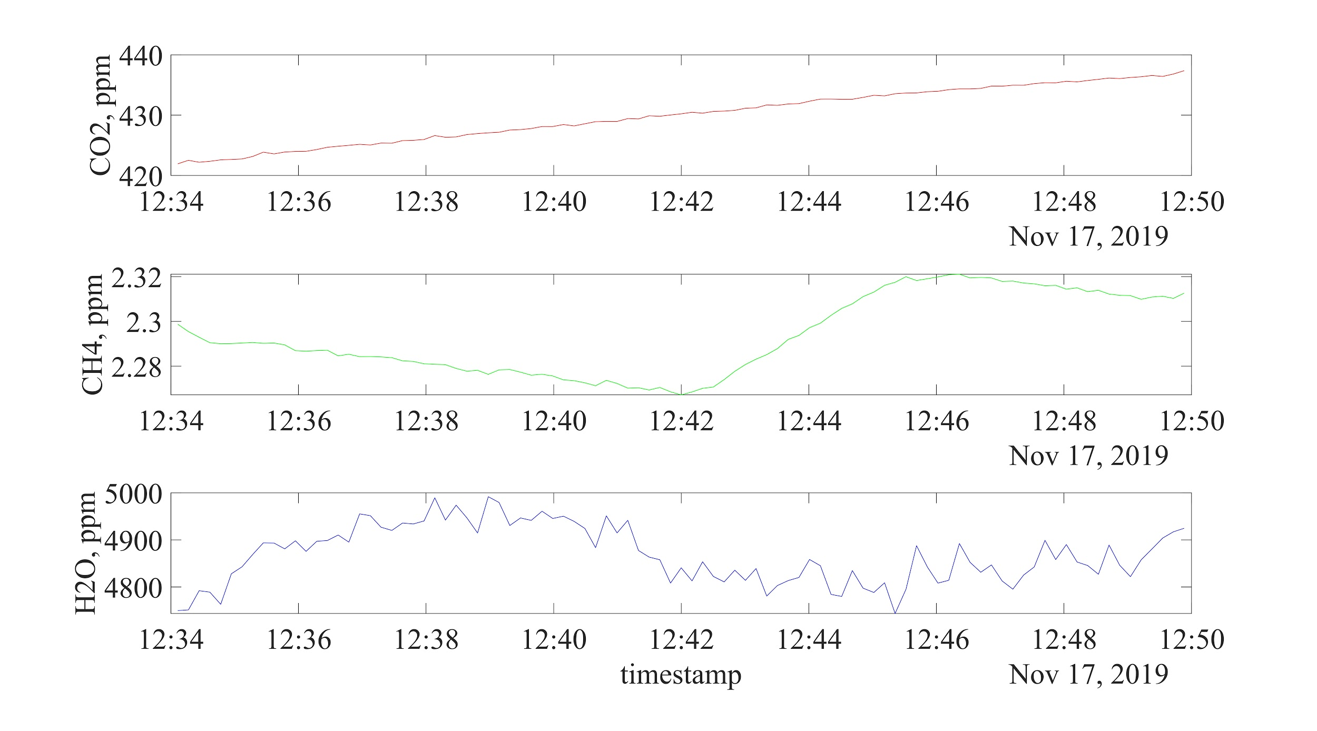Figure S8. First sample with a time-variable CH₄ trend. [CO₂] (red), [CH₄] (green), and [H₂O] (blue) during sample e-1 at Chestnut Ridge Park on November 17th, 2019.

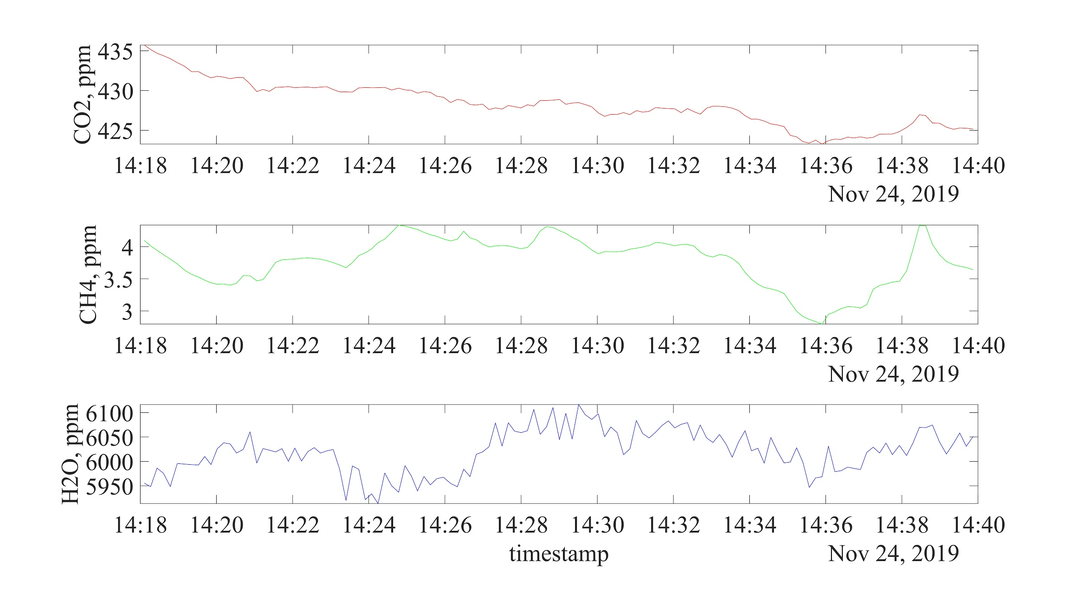Figure S9. Second sample with a time-variable CH₄ trend. [CO₂] (red), [CH₄] (green), and [H₂O] (blue) during sample e-8 at Chestnut Ridge Park on November 24th, 2019.

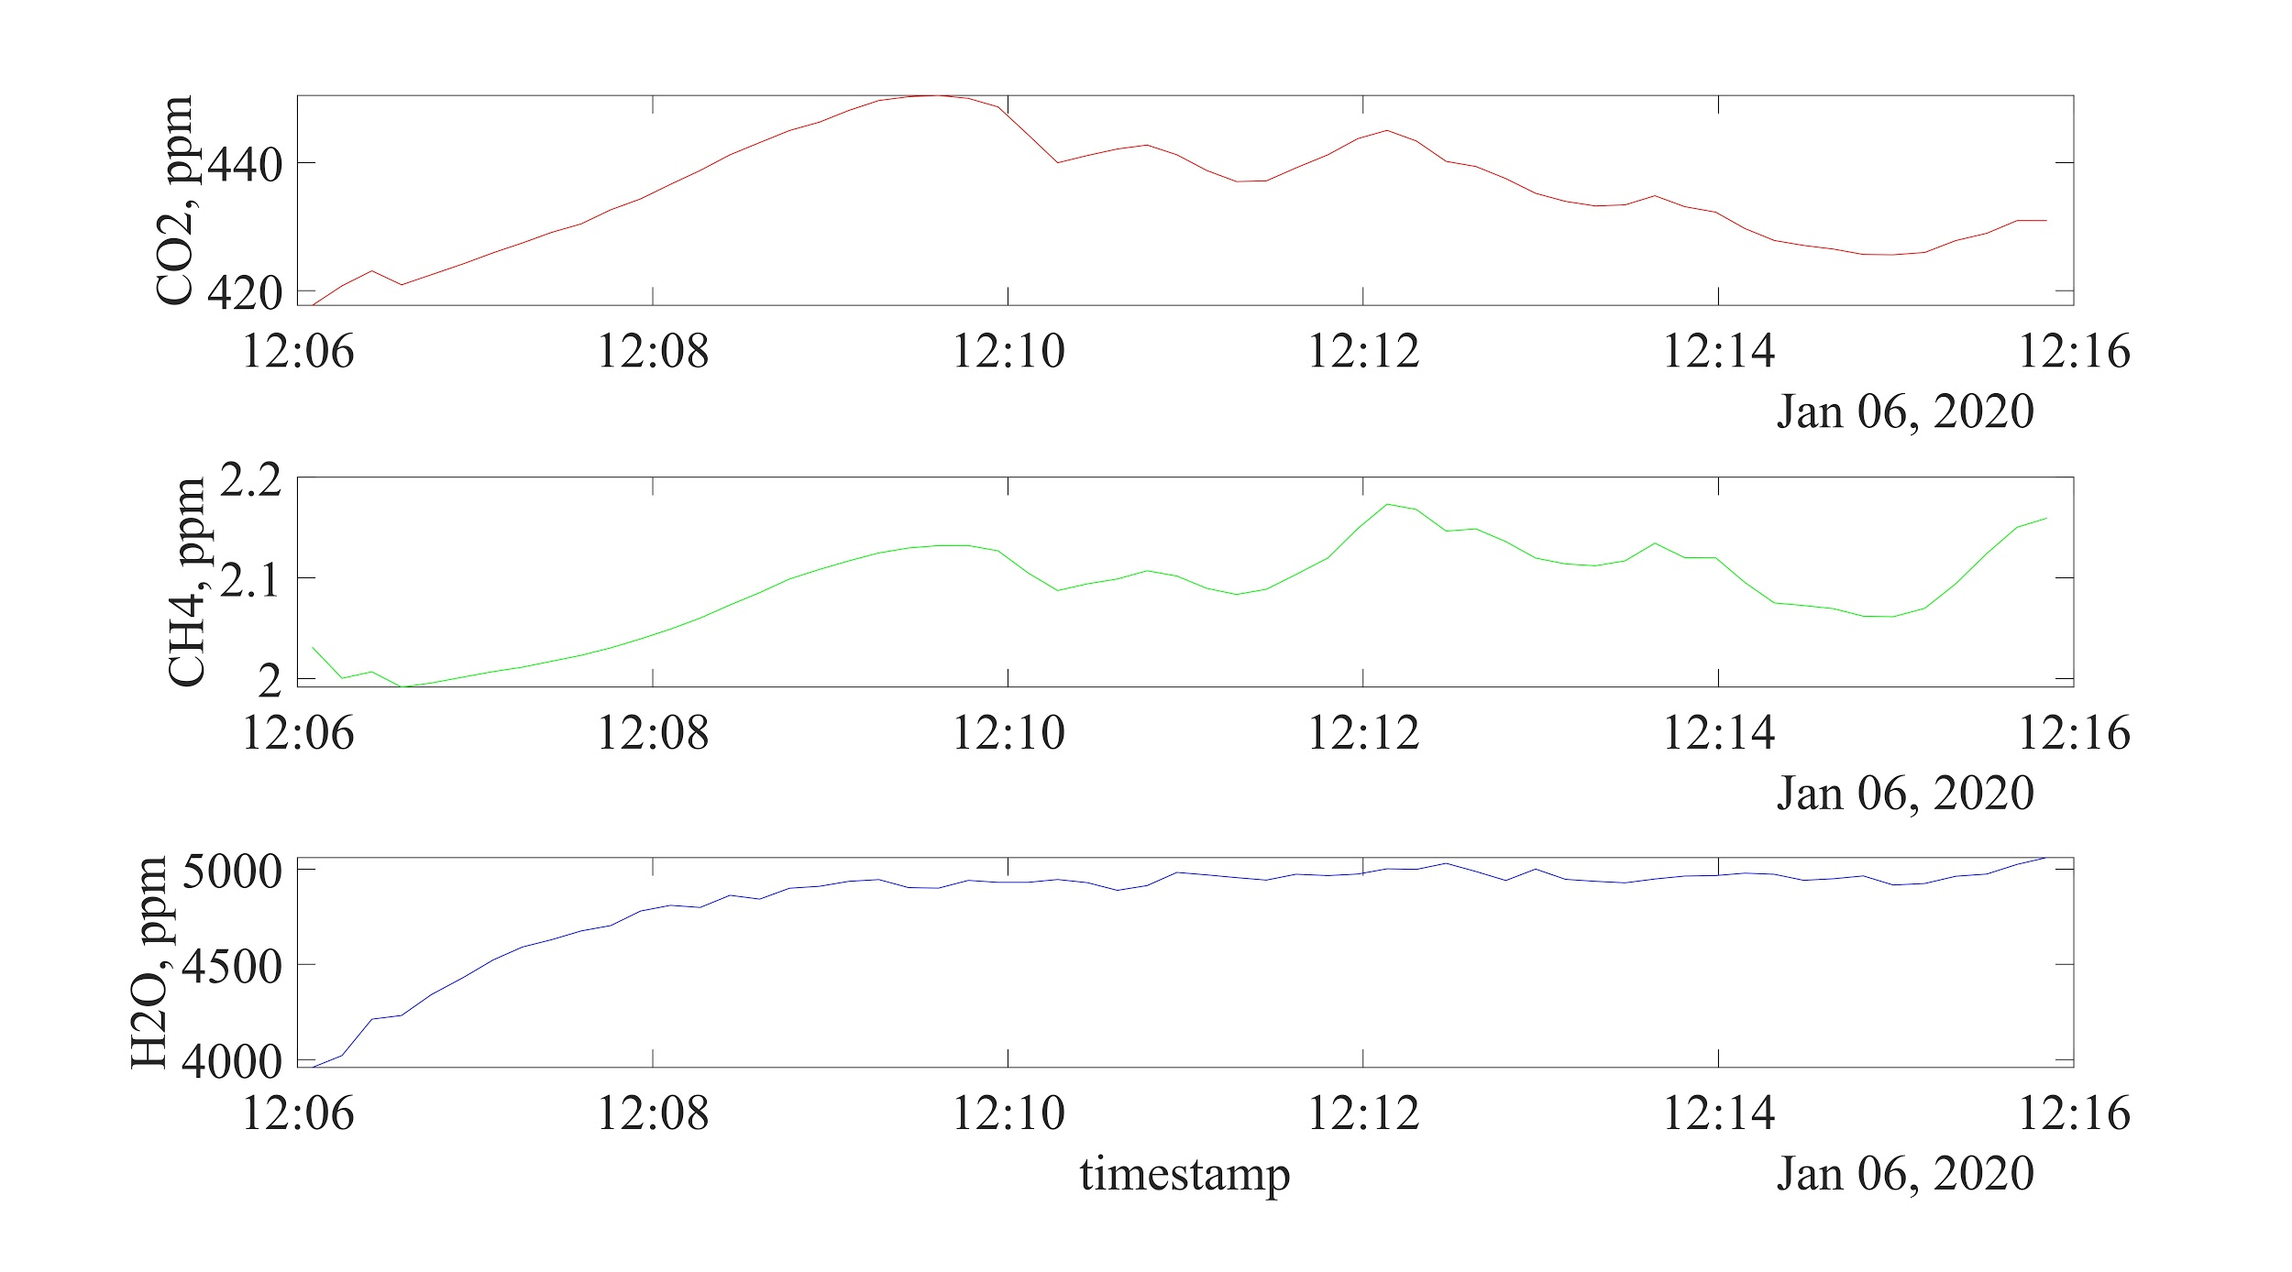Figure S10. Third sample with a time-variable CH₄ trend. [CO₂] (red), [CH₄] (green), and [H₂O] (blue) during sample c-7 at Hemlock Canadice State Forest on January 6th, 2020.

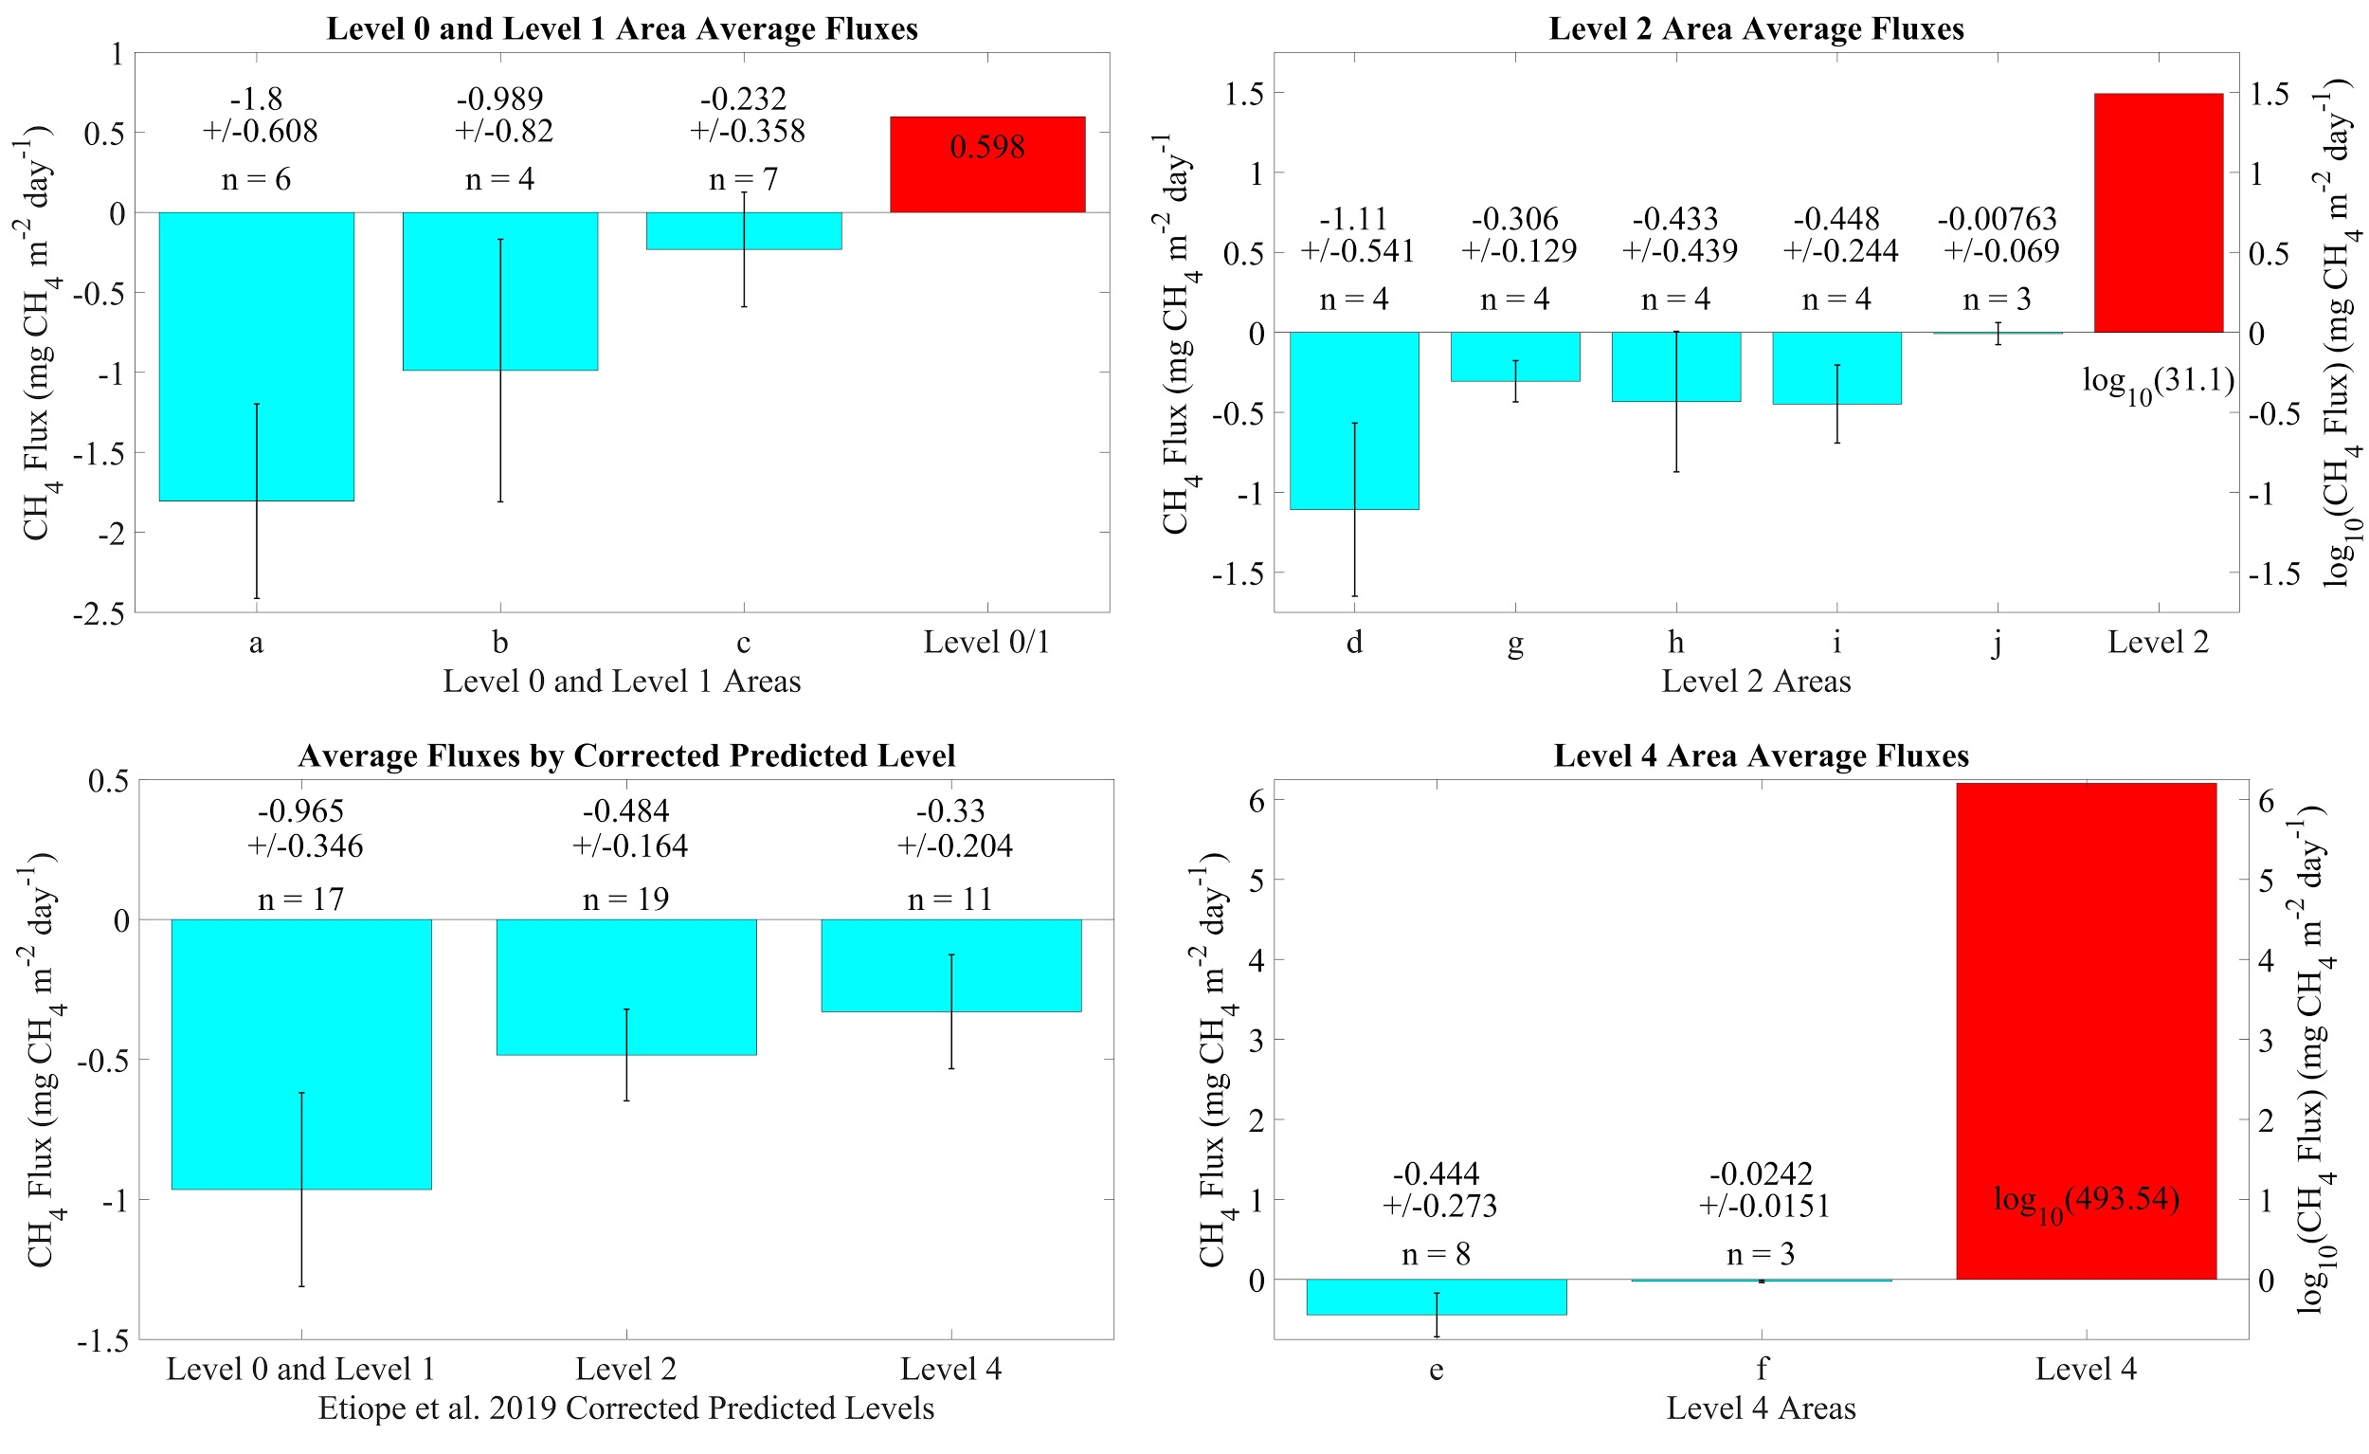Figure S11. Bar charts of the results.The top left, top right, and bottom right panels compare average fluxes for sampled areas (areas indicated by letters as in Figure 2 and Table S1) to Etiope et al. 2019 estimates, with each panel presenting results for a different microseepage emission Level as per Etiope et al. (2019) classification. The bottom-left panel compares average fluxes of each cell Level. Cyan bars represent average flux values of measurements from this study, red bars represent Etiope et al. estimated microseepage fluxes for Level 0/1 cells (averaged together), Level 2 cells, and Level 4 cells, error bars represent the standard error of the mean, n values indicate the number of flux measurements for each area. Note that the log₁₀ of the predicted Etiope et al. (2019) fluxes are plotted for Level 2 and Level 4 to allow the bars to fit on the plot. All samples (including ones with time-variable d[CH₄]/dt discussed above) have been included.

Text S3. Statistical Sensitivity Testing
We designed a statistical analysis to assess how confidently we can conclude that the global model of Etiope et al. (2019) overestimated microseepage in our sampling region, given that we collected sparse measurements of a process that is potentially extremely patchy in space and time. Because we found no strong relationships between microseepage rates and “predictive” factors such as proximity to faults and macroseeps, our goal here is to test whether the existence of random variability, unrelated to these factors, could render our sampling strategy unsuitable.
A Monte Carlo analysis was conducted in which hundreds of thousands of synthetic microseepage distributions were generated for the region between 79-77°W and 42-43°N, each with different patchy emission patterns that average to the same mean rate as predicted by Etiope et al. (2019) for this region (≈ 4 mg CH₄ m⁻² d⁻¹). These synthetic distributions were then “sampled” at the locations where our measurements were made to address the following questions:
- Does the mean of these synthetic samples accurately reflect the true mean emission rate in the synthetic distribution? This allows us to assess the representativeness of our sampling strategy.
- What is the probability of collecting our measurements (with a mean+S.E. of -0.47 mg CH₄ m⁻² d⁻¹), if the regional mean predicted by Etiope et al. (2019) is correct? This allows us to assess whether we can confidently reject the model prediction, based on our measurements.

To generate synthetic microseepage datasets, a statistical distribution for emissions within our region must first be assumed, which we defined based on the 1509 previous microseepage measurements compiled by Etiope et al. (2019) (Fig. S12a). Following Inverse-Hyperbolic-Sine (IHS) transformation (similar to the log transform, but applicable to datasets with negative values), these data are well fit by a Generalized Extreme Value (GEV) distribution, with a peak at ≈ 0.1 mg CH₄ m⁻² d⁻¹, a short left tail towards weakly negative values, and a long right tail towards high very fluxes (red line in Fig. S12a). We assumed the same general shape of emissions distribution applies within our Western New York State region, but scaled the distribution to ensure it yields a mean emissions rate of ≈ 4 mg CH₄ m⁻² d⁻¹, as predicted by Etiope et al. (2019) for this region (original distribution mean is ≈ 50 mg CH₄ m⁻² d⁻¹). The scaling was undertaken by re-fitting the GEV distribution to a modified dataset, in which very high rate measurements >500 mg CH₄ m⁻² d⁻¹ (71 datapoints) were discarded, and the remaining measurements were normalized to have a mean value of 4 mg CH₄ m⁻² d⁻¹. The resulting distribution (yellow line in Fig. S12a) maintains the shape of the original emissions distribution, but with slightly lower probabilities assigned to very high emissions rates, higher probabilities assigned to weakly positive rates, and similar probabilities assigned to negative rates.
With the emissions probability distribution defined, synthetic datasets were generated by assembling random draws from the distribution onto a discretized grid, with prescribed spatial and temporal scales of “patchiness”. We first describe the method for scenarios with no temporal variability, then extend the method to account for two different modes of temporal variability. Our process is adapted from methods used previously to propagate spatially correlated noise into tracer distributions and flux calculations in ocean biogeochemistry studies (DeVries and Primeau, 2011; Weber et al., 2016), and comprises two stages. In the first stage, a “sorting pattern” of spatially smoothed random noise (values between 0 and 1) is created by generating random numbers on our spatial grid and applying two-dimensional smoothing using a Hamming filter window with a specified width (5km in the example in Fig. S12b). The grid resolution is chosen to be at least 10 times smaller than smoothing scale, to ensure that the spatial pattern is well resolved.
In the second stage, a number of random samples are drawn from the emissions probability distribution (Fig. S12a) equal to the total number of pixels on the grid. The samples are then sorted and assembled onto the grid in the order prescribed by the sorting pattern – the highest rate drawn from the emissions distribution is assigned to the pixel with the highest sorting value (closest to 1), and so on until the lowest emissions rate is assigned to the pixel with the lowest sorting value (closest to zero). The resulting emissions pattern (Fig. S12c) has the exact same statistical characteristics as the assumed emissions probability distribution (Fig. S12a), but with high and low rates clustered into features with the prescribed characteristic scale (5 km in this example). Given the shape of the emissions distribution, the spatial emissions pattern has the appearance of “hotspots” of high emissions surrounded by a background of weakly positive and weakly negative rates (Fig. S12c).
The synthetic emissions pattern was then interpolated to the exact locations where our measurements were collected (43 measurements within the 2°x1° region), to generate a set of synthetic samples. The entire process of assembling and sampling a synthetic emissions pattern was then repeated 10,000 times, to build a probability distribution for the synthetic sample mean (Fig. S12d), which can then be compared to the true synthetic regional mean and our measurement mean to address questions (i) and (ii) outlined above. In each iteration, a different emissions pattern is produced, but with the same prescribed scale of spatial patchiness.
In this example, with a patchiness scale of 5km, the synthetic sample mean is lower than the true synthetic regional mean (4 mg CH₄ m⁻² d⁻¹) ≈70% of the time, and higher than the synthetic regional mean ≈30% of the time. It is therefore more likely than not that our sampling strategy underestimates the regional mean of the patchy emissions pattern. This is because our samples are not widely distributed and numerous enough to ensure that emissions hotspots are sufficiently sampled to account for their contribution to the regional mean. However, 95% of the time the synthetic sample mean lies between 0-15mg/m²/yr, which does not overlap our measurement mean+S.E. of -0.47mg/m²/day. In fact, there is only a 2% probability of finding a synthetic sample mean <-0.47mg/m²/day, meaning it is very improbable that our set of fluxes could have been measured in a region whose true mean microseepage flux is 4 mg CH₄ m⁻² d⁻¹. This is because it is unlikely that we could have exclusively sampled within patches of weakly negative fluxes, given the prevalence of positive fluxes in the synthetic distribution.
Given that the true spatial scale of variability in microseepage emissions is not known, we repeated the analysis described above for “patchiness” scales ranging from 1 km to 100 km, and our findings are summarized in the main text and Fig. 4 a-b.
We also explored the additional uncertainties introduced by temporal variability in microseepage emissions, by generating synthetic datasets that vary in time as well as space. We considered two different modes of temporal variability: (i) asynchronous variability, in which emissions are randomly distributed in space and time, with characteristic spatial and temporal scales of patchiness; (ii) synchronous variability, in which emissions have a fixed spatial pattern that is scaled up and down in synchrony, with a characteristic timescale of variability. In practice, generating these two types of synthetic datasets differs only in how the three-dimensional “sorting pattern” is produced. Once the sorting pattern has been defined, a three-dimensional (longitude x latitude x time) grid is filled with random draws from the emissions probability distribution exactly as described above.
In the case of asynchronous temporal variability, the sorting pattern is created by generating three-dimensional random noise and smoothing with a 3-d Hamming filter window with a specified width in space and time. The resulting emissions pattern comprises high emissions “events” with the specified spatial and temporal scale, surrounded by a three-dimensional background of weakly positive and negative emissions, and temporal variations at two distant points are uncorrelated with one another (Fig. S13a). In the case of synchronous temporal variability, the sorting pattern is generated by multiplying a fixed two-dimensional pattern of smoothed noise by a timeseries of smoothed noise. Periods of higher-than-average and lower-than-average emissions therefore occur synchronously through the domain, and the temporal variations at any two points on the grid are correlated with one another (Fig. S13b). We note that these cases represent two extremes, and that real microseepage emissions may exhibit temporal synchrony on spatial scales smaller than the entire 2°x1° domain.
The spatially and temporally varying synthetic datasets were interpolated to the locations and times of our measurements to generate synthetic sets, and the process was repeated 10,000 to build a probability distribution for the synthetic sample mean as before. The analysis was conducted using a fixed spatial patchiness scale of 5km, and temporal patchiness scales ranging from 1 day to half a year, and our findings are summarized in the main text and Fig. 4c-d.

Figure S12. Method for generating synthetic microseepage datasets.
a, Probability distribution of microseepage rates. A Generalized Extreme Value (GEV) distribution (red line) is fit to the data compilation of Etiope et al. (2019) (blue bars), then scaled to generate a distribution with the same shape but a mean value of 4 mg CH₄ m⁻² d⁻¹ (yellow line). b, Sorting pattern created by smoothing two-dimensional random noise with a 5 km Hamming filter window. c, Synthetic emissions dataset generated by drawing random samples from the emissions distribution (yellow line in a) and assembling them onto our grid in the order prescribed by the sorting pattern (b). Our sampling locations are shown as red crosses. d, Probability distribution for the mean of samples taken from 10,000 different synthetic datasets at our sampling locations. 95% of the time, the mean falls within the grey shaded interval, which does not overlap with the mean+S.E. of our measurements.
Figure S13. Modes of temporal variability. Timeseries of microseepage emissions from two distant locations within the same synthetic dataset, for cases with (a) asynchronous temporal variability and (b) synchronous temporal variability.

Text S4. Comparison with satellite data from the TROPOMI instrument
We used a simple atmospheric column model to examine whether microseepage emissions in the study region could in principle be detectable in the TROPOMI column CH₄ data (TROPOMI; Hu et al., 2018; Copernicus Sentinel-5P, 2019). In this approach, the change in the column mean CH₄ mole fraction as the air column passes over a grid cell is given by:
$$∆{CH}_{4}= \frac{E\frac{L}{v}}{\frac{P_{s}}{Mg}}$$
Where ΔCH₄ is the change in the CH₄ mole fraction (mol mol⁻¹), E is the microseepage CH₄ emission rate in mol CH₄ m⁻² s⁻¹, L is the path length over the grid cell in m, v is the mean near-surface wind speed in m s⁻¹, P_{s} is the surface pressure in Pa, M is the molecular weight of air (0.029 kg mol⁻¹), and g is acceleration due to gravity (9.82 m s⁻²).

If we consider the 8 x 8 km grid cells in the time-averaged TROPOMI data and use 8000 m for the path length and 4.33 m s⁻¹ for the wind speed (climatological average for Rochester, NY, USA), as well as emissions corresponding to Level 4 in Etiope et al 2019 classification (494 mg CH4 m⁻² day⁻¹) then ∆CH₄ = 1.9 nmol mol⁻¹, slightly below the TROPOMI precision of 3 nmol mol⁻¹. However, as can be seen in Figure S14, Etiope et al. (2019) predicted clusters of two or three Level 4 grid cells, and the maximum path length over these clusters may be slightly larger; it is also possible that the mean wind speed over these locations may be slightly lower than at nearby regional weather stations; this could potentially allow for ∆CH₄ values to reach the 3 nmol mol⁻¹ precision of TROPOMI data.

As can be seen in Figure S14, the examined 8 x 8 km TROPOMI data grid cells that contain Level 4 microseepage emission cells do not appear to be anomalous in their column-average CH₄ mole fraction as compared to immediately adjacent grid cells. We note that based on this simple calculation, TROPOMI data may be useful for identifying possible high-microseepage areas to guide future sampling. However, caution must be used as satellite retrievals are of course influenced by total emissions, including all anthropogenic and other natural CH₄ sources in a given location.

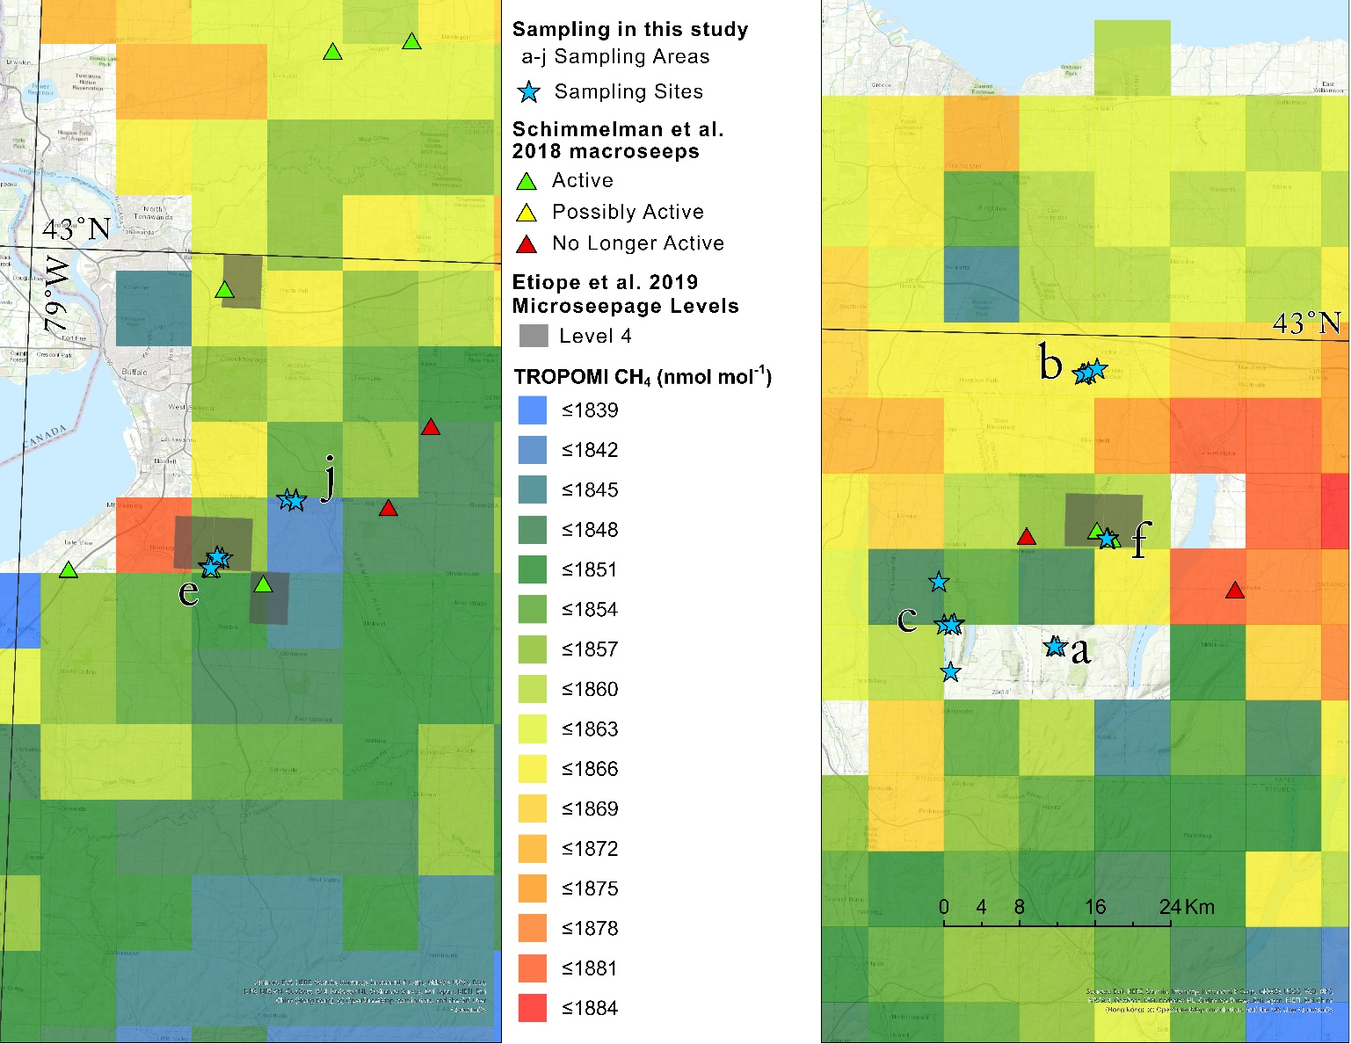
Figure S14. Maps of TROPOMI time-averaged column CH₄ around Etiope et al. (2019) Level 4 cells in Western New York State.
The left map focuses on four of the more western Level 4 cells, where sampling was conducted at Chestnut Ridge Park (our sampling area e). No CH₄ enhancements are apparent as compared to adjacent grid cells. Slightly enhanced CH₄ is seen in the TROPOMI grid cell just to the west of the Level 4 cells associated with Chestnut Ridge Park, but that grid cell is generally upwind of the Level 4 cells. The grid cell also encompasses a heavily developed area. For these reasons, it is unlikely that the CH₄ enhancement in this particular grid cell is due to microseepage emissions. The right map focuses on the other two, more eastern Level 4 cells, where sampling was conducted at Levi Corser Memorial Park (our sampling area f). There are no apparent CH₄ enhancements in these Level 4 cells as compared to adjacent grid cells.

References
Copernicus Sentinel-5P (processed by ESA), 2019, TROPOMI Level 2 Methane Total Column products. Version 01. European Space Agency. DOI: 10.5270/S5P-3p6lnwd
DeVries, T. and Primeau, F., 2011. Dynamically and observationally constrained estimates of water-mass distributions and ages in the global ocean. Journal of Physical Oceanography, 41(12), pp.2381-2401. DOI: 10.1175/JPO-D-10-05011.1
Empire State Organized Geologic Information System (ESOGIS). New York State Museum, Available at: https://esogis.nysm.nysed.gov/. Accessed 2019 August 21.
Etiope, G., Ciotoli, G., Schwietzke, S. and Schoell, M., 2019. Gridded maps of geological methane emissions and their isotopic signature. Earth System Science Data , 11, pp.1-22. DOI: 10.5194/essd-11-1-2019
Hu, H., Landgraf, J., Detmers, R., Borsdorff, T., Aan de Brugh, J., Aben, I., Butz, A. and Hasekamp, O., 2018. Toward global mapping of methane with TROPOMI: First results and intersatellite comparison to GOSAT. Geophysical Research Letters, 45(8), pp.3682-3689. DOI: 10.1002/2018GL077259
Isachsen, Y.W. and McKendree, W.G., 1977. Preliminary brittle structure map of New York, scale 1: 250,000. NY State Museum Science Service Map Chart Series, 31. Available at: http://www.nysm.nysed.gov/research-collections/geology/gis. Accessed 2019 August 21.
Jacobi, R.D., 2002. Basement faults and seismicity in the Appalachian Basin of New York State. Tectonophysics, 353(1-4), pp.75-113. DOI: 10.1016/S0040-1951(02)00278-0
Keppler, F., Schiller, A., Ehehalt, R., Greule, M., Hartmann, J. and Polag, D., 2016. Stable isotope and high precision concentration measurements confirm that all humans produce and exhale methane. Journal of breath research, 10(1), p.016003. DOI: 10.1088/1752-7155/10/1/016003
Schimmelmann, A., Ensminger, S.A., Drobniak, A., Mastalerz, M., Etiope, G., Jacobi, R.D. and Frankenberg, C., 2018. Natural geological seepage of hydrocarbon gas in the Appalachian Basin and Midwest USA in relation to shale tectonic fracturing and past industrial hydrocarbon production. Science of the total environment, 644, pp.982-993. DOI: 10.1016/j.scitotenv.2018.06.374
United States Geological Survey (USGS), NEIC PDE catalog, National Earthquake Information Center. Available at: https://www.usgs.gov/natural-hazards/earthquake-hazards/earthquakes. Accessed 2019 August 21.
Weber, T., Cram, J.A., Leung, S.W., DeVries, T. and Deutsch, C., 2016. Deep ocean nutrients imply large latitudinal variation in particle transfer efficiency. Proceedings of the National Academy of Sciences, 113(31), pp.8606-8611. DOI: 10.1073/pnas.1604414113

