Confidential paper ELEMENTA-D-20-00098.R2: Science of the Anthropocene Special Issue for BaySys
Supplemental Material

Changing freshwater contributions to the Arctic: a 90-year trend analysis (1981–2070)
Tricia A. Stadnyk^{a,b}; Tefs, A.ª, Broesky, M.^{b}, Déry, S. J.^{c}, , Myers, P. G.^{d} ,Ridenour, N.A.^{d}, Koenig, K.^{e}, Vonderbank, L.^{f}, Gustafsson, D.^{g}

ªDepartment of Geography University of Calgary, Calgary, AB, Canada, T2N 1N4
^{b}University of Manitoba, Dept. Civil Engineering, Winnipeg MB, R3T 5V6
^{c}Environmental Science and Engineering Program, University of Northern British Columbia, Prince George, British Columbia, Canada, V2N 4Z9
^{d}Department of Earth and Atmospheric Sciences, University of Alberta, Edmonton, Alberta, Canada, T6G2 E3
^{e}Manitoba Hydro, Hydrologic and Hydroclimatic Studies Section , Winnipeg, MB, Canada
^{f}Department of Civil Engineering, University of Calgary, Calgary, Alberta, Canada, T2N 1N4
^{g}Hydrology Research Unit, Swedish Meteorological and Hydrological Institute, Norrköping, Folkborgsvägen, Sweden

List of Contents
Table S1. Validation results for all pan-Arctic rivers, summarized by region (bolded), as simulated by the revised A-HYPE model. Observed mean monthly discharge (1981–2010) is shown, along with percent of total freshwater discharge to the full Arctic domain. No performance statistics are available for the full Arctic region, as no useable period exists with data for all gauges presented.
Table S2. Correlation (R²) between computed spectral power (2 to 365 days) and fitted spectral power curve (y = Ax^{B}) where power exponent by river and period is presented in Figure 7b.
Table S3. Change in winter temperature and precipitation in near and far future periods for Hudson Bay subregions. Subregions defined by M Braun (submitted); mean ensemble change in maximum (TXx), minimum (TNn), and mean (Tmean) temperature and mean precipitation change (mm) are presented, followed by the standard deviation of the ensemble in square brackets.
Figure S1. Modeled performance of monthly discharge of 74 pan-Arctic gauges. Model validation metrics by major Arctic drainage basin outlet (n = 79, monthly discharge, 1971–2013; gauged stations listed in Table S1) for (a) Nash-Sutcliffe efficiency (NSE), (b) correlation of mean monthly discharge, (c) mean bias of monthly discharge, and (d) standard deviation of bias of monthly discharge. Scale by upstream area (in million km²); shape indicates observed data source.
Figure S2. Modeled pan-Arctic annual discharge ensemble, ensemble mean, and Mann-Kendall trend and significance. Annual discharge for 12 largest Arctic rivers (by mean annual discharge) with Mann-Kendall trend analysis for all pan-Arctic rivers (1981–2070; red line), pre-whitened by removing 1-year lag autocorrelation prior to computing Mann-Kendall significance. Dark blue line represents the ensemble mean; light blue shading represents the ensemble range projected from hydrologic simulation of five different climate input from CMIP5.
Figure S3. Ensemble mean of trend differences [|Renaturalized|-|Regulated|]. Mean of 30-year periods for (a) historic period, n = 7, and (b) future period, n = 19, of differences in the trends between naturalized and regulated simulations for the most intensely regulated rivers in the HBC. Above the red line indicates higher, more significant trends are detected in the naturalized flow record.
Figure S4. Average annual daily discharge and flow probability for the period 1981–2070. Simulated ensemble mean (a, c) day-of-year average annual discharge by 30-year period and (b, d) empirically sorted flow duration curves by 30-year period (n = 10,957) for the (a, b) regulated and (c, d) non-regulated rivers draining to the HBC.
Figure S5. Trends by time period and GCM for regulated and renaturalized configurations. Thirty-year moving window analysis of trends by GCM simulation and time period for (i) regulated model, (ii) renaturalized model, and (iii) [|Renaturalized|-|Regulated|] for the three most intensely regulated and largest volume contributing systems to the HBC (a) Nelson River, (b) Churchill River, and (c) La Grande Rivière. Trends computed as Sen’s slope of Mann-Kendall trend analysis (as percent of period mean); * in (i) and (ii) represent significant trends. Blank cells in (iii) represent agreement in trend direction and significance between renaturalized and regulated; ^, increasing trend slope under regulation (relative to renaturalized); v, decreasing trend slope under regulation; and x, disagreement in trend direction where one or both trends were significant.

Table S1. Validation results for all pan-Arctic rivers, summarized by region (bolded), as simulated by the revised A-HYPE model.
Location name | Data source | Latitude (º) | Longitude (º) | AHYPE drainage area (km²) | Nash Sutcliffe efficiency | Kling Gupta efficiency | Pearson correlation | Relative error of mean (%) | Relative error of standard deviation (%) | Observed mean discharge (m³ s^{–1})ª | Simulated contribution to full Arctic domain (%)^{b}
Hudson Bay Complex (regulation) | DERY | n.a.^{c} | n.a. | 1890477 | 0.46 | 0.71 | 0.72 | –2.0 | –6.5 | 11313 | n.a.
Nelson River outlet | DERY | 56.9061 | –93.2289 | 1111890 | 0.11 | 0.41 | 0.46 | –2.5 | –23.6 | 3343 | 1.6
Chruchill River outlet | DERY | 58.3992 | –94.2430 | 295121 | 0.31 | 0.28 | 0.66 | –36.0 | –52.3 | 356 | 0.1
Albany River outlet | DERY | 52.1817 | –81.7365 | 137035 | 0.08 | 0.40 | 0.74 | 54.1 | 4.1 | 1009 | 0.8
Rivière Koksoak outlet | DERY | 57.9503 | –69.0149 | 136262 | 0.63 | 0.66 | 0.80 | –12.0 | –24.9 | 1458 | 0.6
Moose River outlet | DERY | 51.3130 | –80.8665 | 109440 | 0.67 | 0.66 | 0.85 | 19.4 | –23.6 | 1182 | 0.7
La Grande Rivière outlet | DERY | 53.8194 | –78.7421 | 100729 | –0.39 | 0.43 | 0.47 | –19.5 | –10.5 | 3039 | 1.2
Rivière Eastmain outlet | DERY | 52.1942 | –78.2816 | 46930 | –0.18 | 0.06 | 0.38 | 46.9 | –53.1 | 108 | 0.1
Rivière Rupert outlet | DERY | 51.4452 | –78.6174 | 46003 | –1.85 | 0.29 | 0.72 | –51.2 | –39.7 | 818 | 0.2
Hudson Bay Complex (no regulation) | DERY | n.a. | n.a. | 977214 | 0.59 | 0.63 | 0.78 | –4.4 | –29.7 | 9315 | n.a.
Thelon and Kazan Rivers outlet | DERY | 63.9982 | –94.2106 | 246371 | –0.86 | –0.29 | 0.01 | –64.6 | –51.8 | 1354 | 0.2
Hayes River outlet | DERY | 56.8909 | –92.7484 | 105042 | 0.20 | 0.50 | 0.80 | 44.4 | –8.4 | 611 | 0.4
Severn River outlet | DERY | 55.9435 | –87.7767 | 99222 | –1.02 | 0.23 | 0.52 | 39.7 | 45.1 | 672 | 0.5
Winisk River outlet | DERY | 55.1388 | –85.2410 | 71066 | –0.63 | 0.21 | 0.65 | 59.4 | 38.0 | 470 | 0.4
Rivière Nottaway outlet | DERY | 51.0861 | –78.8282 | 67383 | 0.04 | 0.23 | 0.35 | 10.4 | –40.1 | 988 | 0.5
Thlewiaza and Tha–anne Rivers outlet | DERY | 60.5878 | –95.0423 | 49599 | –12.92 | –1.88 | 0.21 | –22.8 | 276.3 | 220 | 0.1
Seal River outlet | DERY | 59.0106 | –95.4294 | 49263 | 0.09 | 0.33 | 0.54 | –33.2 | –34.7 | 371 | 0.1
Attawapiskat River outlet | DERY | 52.9606 | –82.7564 | 47168 | –0.75 | 0.14 | 0.55 | 71.7 | 15.2 | 348 | 0.3
Rivière Arnaud outlet | DERY | 60.0450 | –70.9953 | 44486 | 0.40 | 0.33 | 0.75 | –26.7 | –56.4 | 365 | 0.1
Grande Rivière de la Baleine outlet | DERY | 55.2806 | –7.5323 | 41219 | –0.02 | 0.42 | 0.72 | –42.8 | –27.3 | 663 | 0.2
Rivière George outlet | DERY | 58.2801 | –65.5367 | 39364 | 0.46 | 0.39 | 0.78 | –32.6 | –47.4 | 734 | 0.2
Rivière aux Feuilles outlet | DERY | 58.7952 | –70.4840 | 38684 | –0.27 | –0.11 | 0.37 | –61.1 | –67.4 | 548 | 0.1
Rivière Harricana outlet | DERY | 51.1417 | –79.2827 | 33873 | –192.47 | –8.91 | 0.61 | 887.6 | 440.1 | 57 | 0.3
Rivière a la Baleine outlet | DERY | 57.9376 | –67.6645 | 31788 | 0.55 | 0.49 | 0.79 | –21.1 | –41.9 | 486 | 0.2
Quoich River outlet | DERY | 64.2370 | –93.9427 | 29883 | –0.13 | –0.27 | 0.55 | –80.7 | –87.8 | 213 | 0.0
Ekwan River outlet | DERY | 53.3262 | –82.3654 | 21546 | –6.66 | –1.46 | 0.41 | 192.5 | 141.2 | 83 | 0.1
Rivière Broadback outlet | DERY | 51.2862 | –78.7060 | 20189 | 0.41 | 0.61 | 0.67 | 6.6 | –20.0 | 309 | 0.2
Petite Rivière de la Baleine outlet | DERY | 55.8618 | –76.4413 | 15750 | –1.84 | 0.01 | 0.62 | 60.1 | 68.4 | 101 | 0.1
Fergusson River outlet | DERY | 62.1479 | –93.5213 | 15556 | –0.34 | –0.42 | 0.17 | –73.8 | –87.7 | 83 | 0.0
Rivière Innuksuac outlet | DERY | 58.5765 | –76.9350 | 12727 | 0.02 | 0.32 | 0.67 | –41.0 | –42.4 | 104 | 0.0
Rivière Nastapoka outlet | DERY | 56.9035 | –76.3638 | 12417 | –1.80 | –0.06 | 0.26 | –62.1 | –41.9 | 257 | 0.0
Rivière a l'Eau Claire outlet | DERY | 56.2488 | –76.2797 | 12388 | –11.12 | –1.49 | 0.17 | 29.4 | 232.2 | 90 | 0.1
Lorillard River outlet | DERY | 64.2049 | –90.4072 | 11432 | 0.03 | –0.17 | 0.64 | –75.3 | –82.3 | 89 | 0.0
Rivière Pontax outlet | DERY | 51.6244 | –78.6983 | 3020 | –0.16 | –0.04 | 0.68 | –46.5 | –87.2 | 99 | 0.0
Arctic Ocean rivers | GRDC & HYCOS | n.a. | n.a. | n.a. | n.a. | n.a. | n.a. | n.a. | n.a. | 102986 | n.a.
Ob At Salekhard | GRDC | 66.7045 | 66.5912 | 2917508 | –0.86 | 0.05 | 0.74 | 61.6 | 66.9 | 12889 | 11.0
Yenisey At Igarka | GRDC | 67.2418 | 86.5527 | 2442735 | 0.79 | 0.73 | 0.90 | –0.4 | –24.9 | 19499 | 10.4
Lena at Kusur | HYCOS | 70.7433 | 127.3350 | 2418974 | 0.88 | 0.91 | 0.94 | 7.1 | 0.2 | 17773 | 9.5
Mackenzie River at Arctic Red River | GRDC | 67.5238 | –133.6766 | 1717754 | 0.38 | 0.48 | 0.91 | 32.8 | 39.1 | 9211 | 5.7
Lena At Tabaga | GRDC | 61.7974 | 129.6286 | 895724 | 0.79 | 0.89 | 0.89 | –2.8 | 0.3 | 7303 | 3.7
Yukon River at Pilot Station Alaska | HYCOS | 61.9617 | –162.8544 | 820856 | n.a. | n.a. | n.a. | n.a. | n.a. | 6576 | 3.4
Kolyma at Kolymskaya | HYCOS | 68.8187 | 158.5510 | 533013 | 0.81 | 0.85 | 0.92 | 0.4 | 13.3 | 3234 | 1.7
Yukon River near Stevens Village Alaska | HYCOS | 65.8750 | –149.4486 | 498171 | 0.23 | 0.45 | 0.83 | 21.5 | 47.5 | 3373 | 2.1
Kolyma At Srednekolymsk | GRDC | 67.3126 | 153.4898 | 368441 | 0.55 | 0.58 | 0.89 | 14.2 | 38.2 | 2121 | 1.3
Severnaya Dvina At Ust'–Pinega | GRDC | 64.0459 | 41.6449 | 350496 | 0.53 | 0.38 | 0.94 | 50.9 | 34.4 | 3416 | 2.6
Pechora At Oksino | GRDC | 67.5595 | 52.3886 | 312041 | 0.89 | 0.90 | 0.94 | –4.8 | –6.9 | 4823 | 2.3
Indigirka at Vorontsovo | HYCOS | 69.5577 | 147.4290 | 302800 | 0.64 | 0.62 | 0.82 | –22.0 | –25.5 | 1712 | 0.7
Khatanga at Khatanga | HYCOS | 72.1080 | 102.6981 | 264999 | –0.09 | 0.27 | 0.77 | –51.2 | –46.1 | 6757 | 0.8
Yana at Ubileynaya | HYCOS | 70.7231 | 136.1203 | 223083 | 0.67 | 0.75 | 0.82 | –7.8 | –15.6 | 1145 | 0.5
Olenek At 7.5 km down of Buur's mouth | GRDC | 71.8621 | 123.6247 | 196702 | 0.66 | 0.52 | 0.86 | –24.1 | –39.1 | 1269 | 0.6
Taz at Sidorovsk | HYCOS | 65.9138 | 82.2080 | 97481 | 0.20 | 0.35 | 0.87 | 32.3 | 54.9 | 1097 | 0.7
Back River above Hermann River | GRDC | 66.0445 | –96.5344 | 88092 | –0.07 | –0.16 | 0.60 | –57.0 | –93.0 | 489 | 0.1
Indigirka At Indigirskiy | GRDC | 64.6031 | 142.9383 | 83512 | 0.64 | 0.73 | 0.81 | –13.8 | –12.5 | 420 | 0.2
Pur At Urengoy | GRDC | 65.8356 | 78.7207 | 80514 | 0.28 | 0.31 | 0.91 | 50.3 | 46.3 | 627 | 0.6
Anabar At Saskulakh | GRDC | 71.8838 | 114.2083 | 78822 | 0.55 | 0.29 | 0.86 | –47.1 | –50.4 | 490 | 0.2
Peel River above Fort Mcpherson | GRDC | 67.1355 | –135.0008 | 69174 | 0.10 | 0.54 | 0.70 | –15.7 | 32.0 | 683 | 0.2
Anderson River below Carnwath River | GRDC | 68.5445 | –128.5132 | 60204 | 0.26 | 0.22 | 0.65 | 60.7 | –33.1 | 172 | 0.1
Onega At Porog | GRDC | 63.5864 | 38.9099 | 56678 | 0.61 | 0.62 | 0.83 | 30.0 | –16.0 | 547 | 0.4
Mezen' At Malonisogorskaya | GRDC | 64.9653 | 45.5343 | 56401 | 0.62 | 0.51 | 0.92 | 40.9 | 26.3 | 639 | 0.4
Bolsh'oy Anuy at Konstantinovo | HYCOS | 68.0557 | 161.2823 | 49494 | 0.60 | 0.74 | 0.81 | –17.4 | –1.4 | 263 | 0.1
Nadym At Nadym | GRDC | 65.5183 | 72.6525 | 48317 | –0.61 | 0.02 | 0.80 | 58.4 | 76.6 | 440 | 0.4
Coppermine River above Copper Creek | GRDC | 67.2290 | –116.1515 | 45600 | –0.34 | –0.10 | 0.71 | –63.6 | –84.4 | 253 | 0.1
Khantaika at Shnezhnogorsk | HYCOS | 68.0386 | 87.3368 | 29814 | –9.30 | –3.24 | 0.34 | 405.8 | 104.9 | 74 | 0.2
Kovda At Knyazhegubskaya GES | HYCOS | 66.6862 | 32.0364 | 25540 | 0.01 | 0.21 | 0.31 | –0.3 | –39.2 | 288 | 0.1
Kobuk River near Kiana Alaska | GRDC | 66.9910 | –159.9862 | 24587 | 0.41 | 0.28 | 0.84 | –52.7 | –46.3 | 426 | 0.1
Arctic Red River near the mouth | GRDC | 66.8285 | –132.9984 | 19999 | 0.50 | 0.70 | 0.78 | –19.0 | 5.8 | 156 | 0.1
Tuloma At Verkhne–Tulomskaya GES | GRDC | 68.5746 | 31.1080 | 17458 | –3.77 | –0.39 | 0.16 | –6.4 | 109.7 | 202 | 0.1
Burnside River near the mouth | GRDC | 66.5772 | –109.2395 | 17210 | –0.17 | –0.32 | 0.30 | –70.5 | –86.8 | 144 | 0.0
Ellice River near the mouth | GRDC | 67.2214 | –104.1440 | 16739 | –0.02 | –0.21 | 0.36 | –65.0 | –80.2 | 88 | 0.0
Alazeya At Argakhtakh | GRDC | 68.4702 | 153.2817 | 15800 | 0.56 | 0.64 | 0.77 | 20.8 | –17.6 | 40 | 0.0
Paatsjoki at Kaitakoski | GRDC | 68.9203 | 28.4066 | 14718 | 0.22 | 0.31 | 0.58 | –12.4 | –53.1 | 164 | 0.1
Ponoy At Kanevka | GRDC | 67.1661 | 38.6613 | 10431 | 0.79 | 0.87 | 0.90 | 4.8 | 7.3 | 122 | 0.1
Kuparuk River near Deadhorse Alaska | GRDC | 70.2737 | –149.0836 | 8885 | 0.42 | 0.31 | 0.72 | –37.3 | –50.5 | 75 | 0.0
Voron'ya At Serebryanskaya GES 1 | GRDC | 68.5598 | 35.3968 | 8514 | –0.22 | 0.43 | 0.45 | –16.3 | –0.3 | 110 | 0.0
Tree River near the mouth | GRDC | 67.2764 | –112.6274 | 6067 | –0.20 | –0.21 | 0.36 | –56.4 | –85.9 | 38 | 0.0
Firth River near the mouth | GRDC | 69.1776 | –139.8116 | 5686 | –0.37 | 0.34 | 0.65 | –19.9 | 52.7 | 44 | 0.0
Oelfusa at Selfoss | GRDC | 63.9537 | –20.9563 | 5674 | –3.40 | 0.42 | 0.71 | –48.6 | –11.2 | 369 | 0.1
ªObserved mean monthly discharge (1981–2010)
^{b}Percent of total freshwater discharge to the full Arctic domain; no performance statistics are available for the full Arctic region, as no useable period exists with data for all gauges presented.
^{c}Not applicable or not available.

Table S2. Fitted spectral power correlation (R²) between computed spectral power (2 to 365 days) and fitted spectral power curve (y = Ax^{B}), where power exponent by river and period is presented in Figure 7b.
Period | Region or river
 | Arctic | Kolyma | Lena | Khatanga | Yenisei | Ob | Pechora | Dvina | Koksoak | La Grande | Nelson | Mackenzie | Yukon | HBC regulated | HBC no regulation
1981 to 2010 | 0.921 | 0.953 | 0.948 | 0.945 | 0.964 | 0.929 | 0.958 | 0.956 | 0.904 | 0.698 | 0.889 | 0.937 | 0.938 | 0.826 | 0.875
1991 to 2020 | 0.921 | 0.944 | 0.945 | 0.948 | 0.964 | 0.930 | 0.947 | 0.948 | 0.903 | 0.696 | 0.886 | 0.938 | 0.937 | 0.821 | 0.884
2001 to 2030 | 0.916 | 0.948 | 0.945 | 0.943 | 0.932 | 0.928 | 0.934 | 0.938 | 0.903 | 0.676 | 0.886 | 0.958 | 0.937 | 0.806 | 0.878
2011 to 2040 | 0.917 | 0.948 | 0.953 | 0.949 | 0.932 | 0.926 | 0.941 | 0.948 | 0.905 | 0.675 | 0.888 | 0.935 | 0.931 | 0.810 | 0.883
2021 to 2050 | 0.914 | 0.952 | 0.947 | 0.948 | 0.932 | 0.925 | 0.941 | 0.951 | 0.909 | 0.674 | 0.890 | 0.934 | 0.943 | 0.797 | 0.882
2031 to 2060 | 0.914 | 0.941 | 0.947 | 0.948 | 0.932 | 0.925 | 0.949 | 0.954 | 0.902 | 0.677 | 0.893 | 0.936 | 0.931 | 0.799 | 0.883
2041 to 2070 | 0.917 | 0.955 | 0.940 | 0.947 | 0.934 | 0.928 | 0.936 | 0.940 | 0.901 | 0.671 | 0.890 | 0.936 | 0.943 | 0.797 | 0.880

Table S3. Mean ensemble change in maximum (TXx), minimum (TNn), and mean (Tmean) winter temperature and precipitation (mm) in near and far future periods for Hudson Bay subregions.
Locationª | TXx (°C)^{b} |  | TNn (°C)^{b} |  | Tmean (°C)^{b} |  | PRCPTOT (mm)^{b}
 | Delta 1 | Delta 2 | Delta 1 | Delta 2 | Delta 1 | Delta 2 | Delta 1 | Delta 2
Foxe Basin | 2.57  [2.13]^{b} | 3.70  [2.22] | 3.15  [2.01] | 5.60  [2.74] | 2.63  [1.84] | 4.32  [2.26] | 27.56  [26.40] | 65.91  [41.89]
Northwestern Hudson Bay | 1.65  [1.63] | 2.49  [1.90] | 2.75  [1.31] | 4.60  [1.76] | 2.36  [1.38] | 3.68  [1.60] | 23.94  [11.44] | 60.40  [7.15]
Hudson Lowlands/West James Bay | 1.60  [1.22] | 2.56  [1.80] | 3.39  [1.40] | 5.41  [1.70] | 1.97  [1.02] | 3.14  [1.29] | 44.39  [20.61] | 78.58  [22.54]
East James Bay | 1.54  [1.37] | 2.59  [1.94] | 3.50  [1.56] | 6.04  [2.15] | 1.91  [0.94] | 3.09  [1.21] | 60.37  [14.17] | 106.62  [33.37]
East Hudson Bay/Ungava Bay | 1.71  [1.52] | 2.32  [2.03] | 3.77  [2.02] | 6.58  [3.13] | 2.23  [1.48] | 3.59  [1.77] | 52.90  [31.44] | 89.73  [47.20]
Nelson Basin | 1.59  [0.97] | 2.60  [1.59] | 2.84  [1.40] | 4.25  [1.51] | 1.77  [0.81] | 2.68  [1.07] | 34.01  [12.47] | 48.47  [37.84]
Churchill Basin | 1.54  [1.06] | 2.46  [1.97] | 3.06  [1.38] | 4.76  [1.71] | 1.87  [0.88] | 2.83  [1.11] | 32.56  [15.53] | 52.64  [23.87]
ªSubregions defined by Braun et al. (submitted)
^{b}Near future (Delta1): 2021–2050; far future (Delta2): 2041–2070 evaluated relative to the historical period (1981–2010); standard deviation of the ensemble: [in brackets]

Figure S1. Modeled performance of monthly discharge of 74 pan-Arctic gauges. Model validation metrics by major Arctic drainage basin outlet (n = 79, monthly discharge, 1971–2013; gauged stations listed in Table S1) for (a) Nash-Sutcliffe efficiency (NSE), (b) correlation of mean monthly discharge, (c) mean bias of monthly discharge, and (d) standard deviation of bias of monthly discharge. Scale by upstream area (in million km²); shape indicates observed data source.

Figure S2. Modeled pan-Arctic annual discharge ensemble, ensemble mean, and Mann-Kendall trend and significance. Annual discharge for 12 largest Arctic rivers (by mean annual discharge) with Mann-Kendall trend analysis for all pan-Arctic rivers (1981–2070; red line), pre-whitened by removing 1-year lag autocorrelation prior to computing Mann-Kendall significance. Dark blue line represents the ensemble mean; light blue shading represents the ensemble range projected from hydrologic simulation of five different climate input from CMIP5.

(a)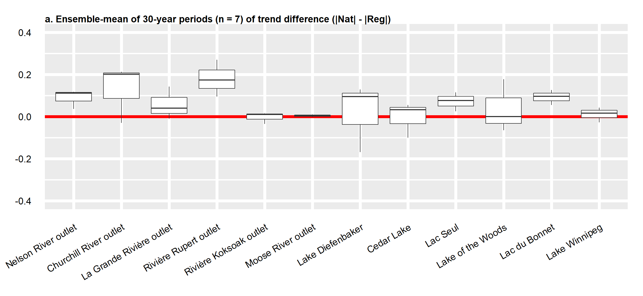
(b)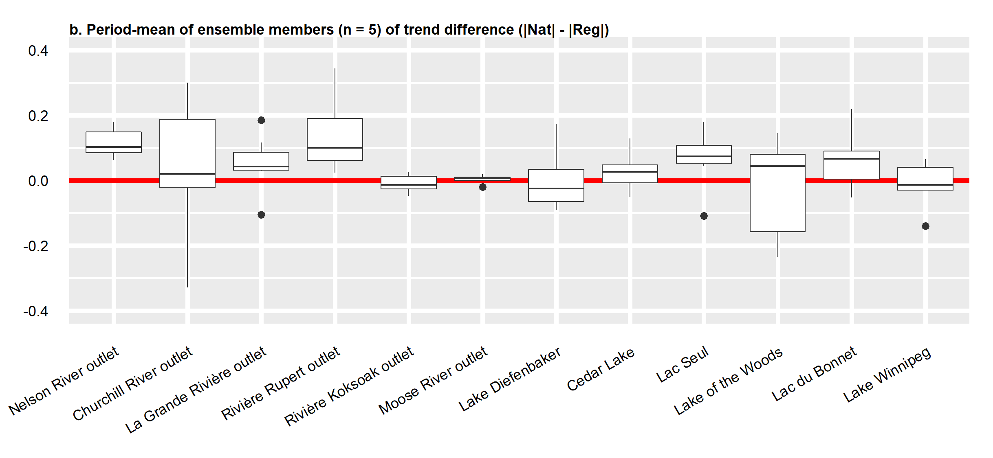
Figure S3. Ensemble mean of trend differences [|Renaturalized|-|Regulated|]. Mean of 30-year periods for (a) historic period, n = 7, and (b) future period, n = 19, of differences in the trends between naturalized and regulated simulations for the most intensely regulated rivers in the HBC. Above the red line indicates higher, more significant trends are detected in the naturalized flow record.

Figure S4. Average annual daily discharge and flow probability for the period 1981–2070. Simulated ensemble mean (a, c) day-of-year average annual discharge by 30-year period and (b, d) empirically sorted flow duration curves by 30-year period (n = 10,957) for the (a, b) regulated and (c, d) non-regulated rivers draining to the HBC.

(a)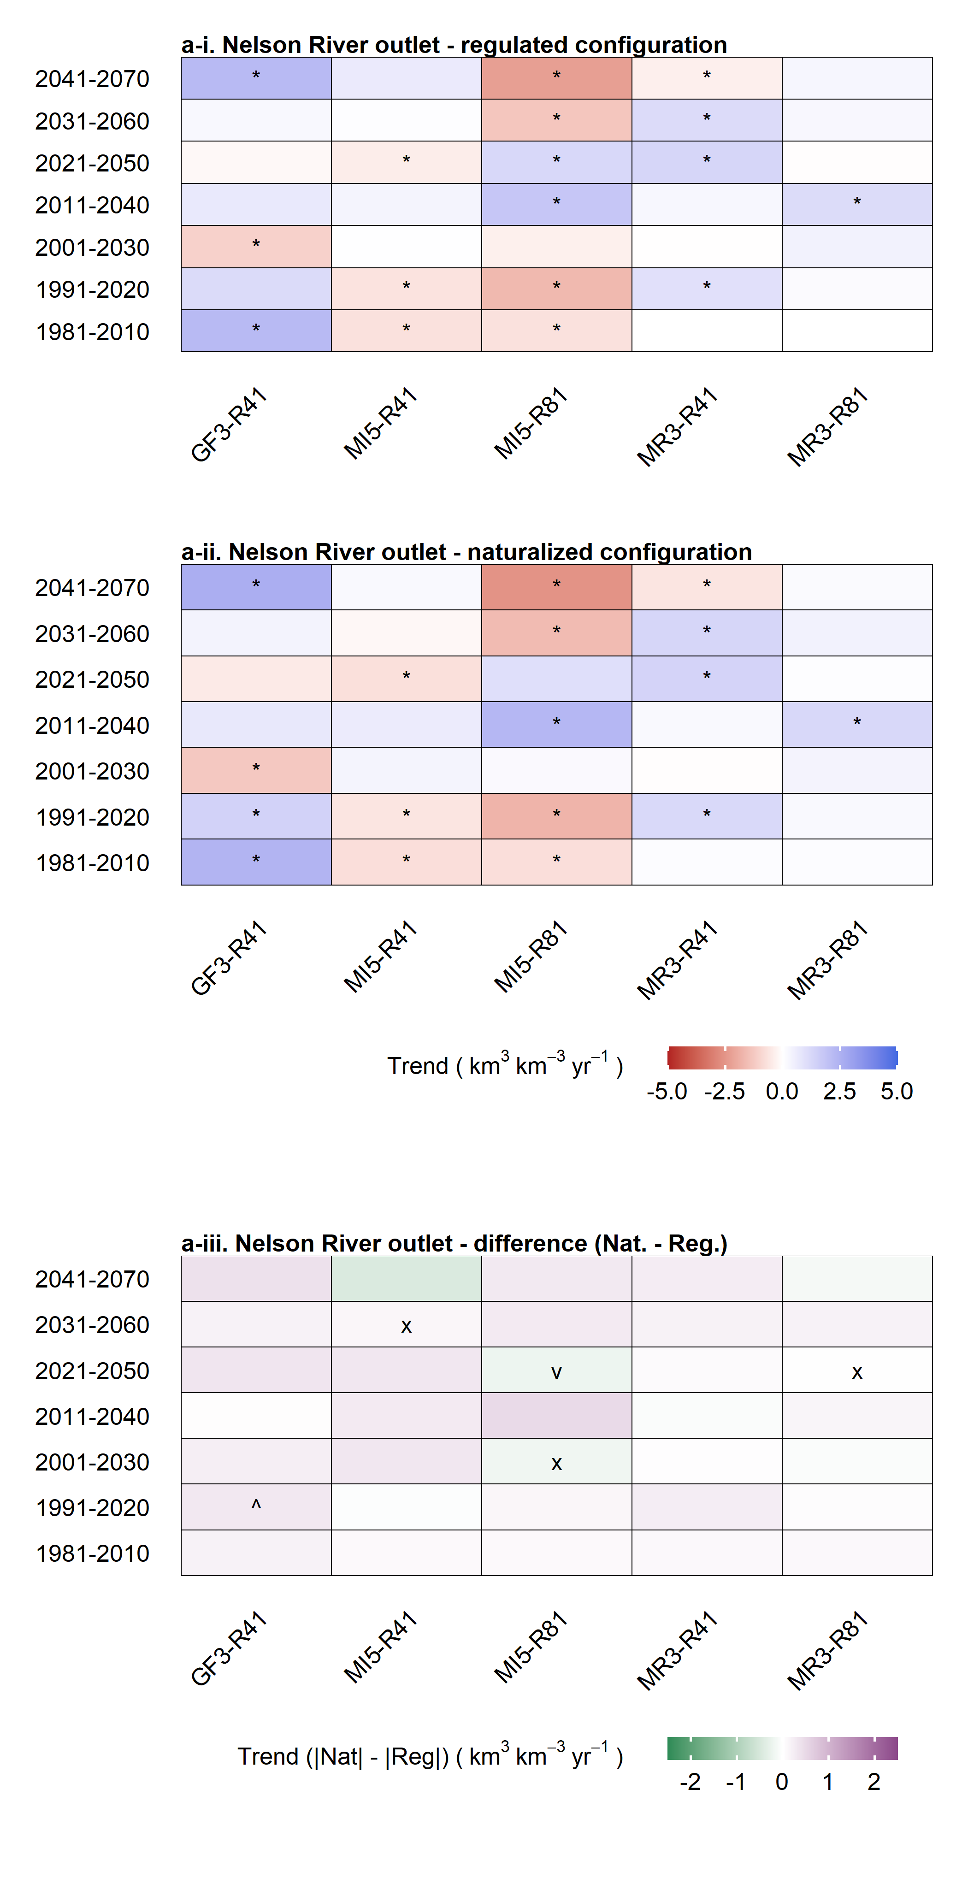(b)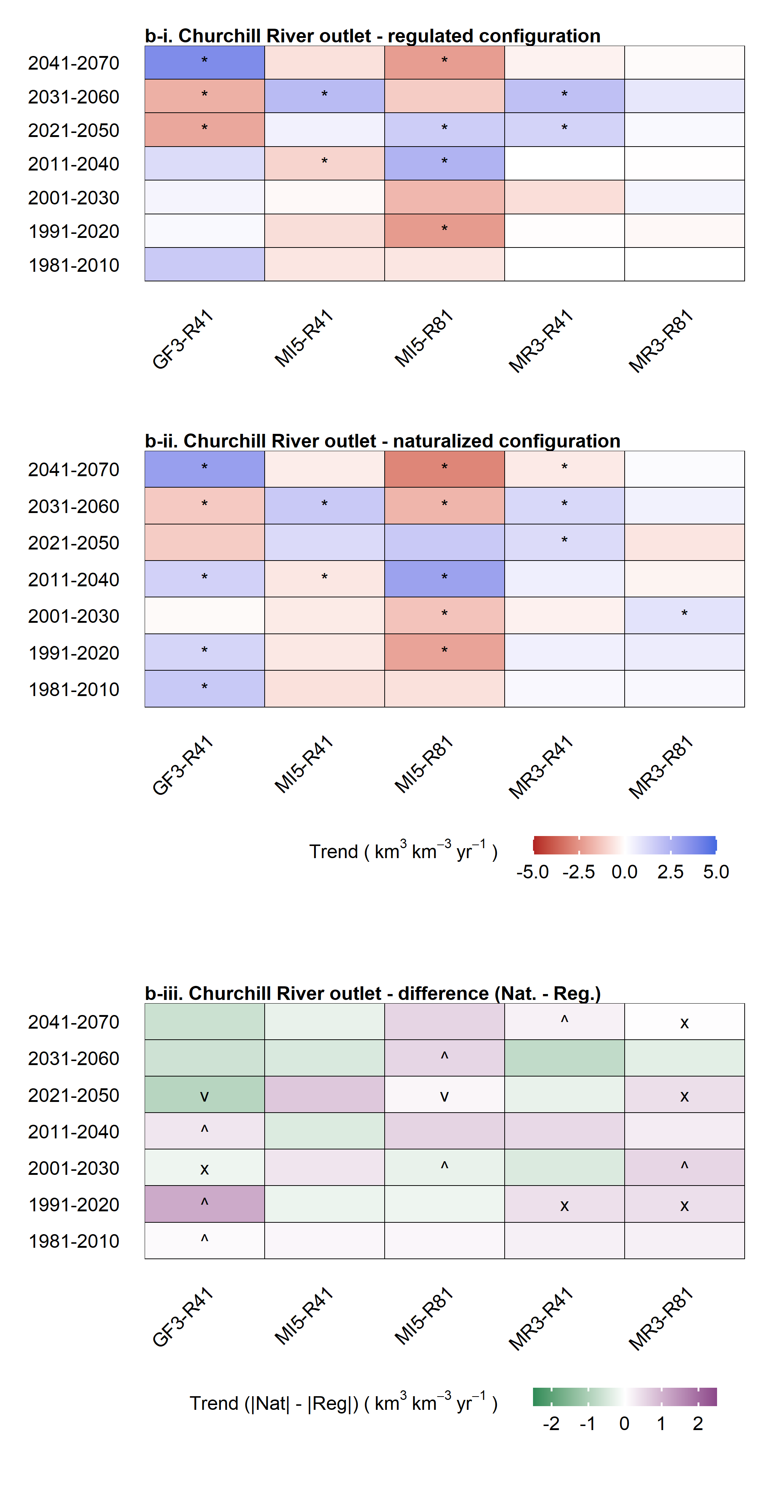(c)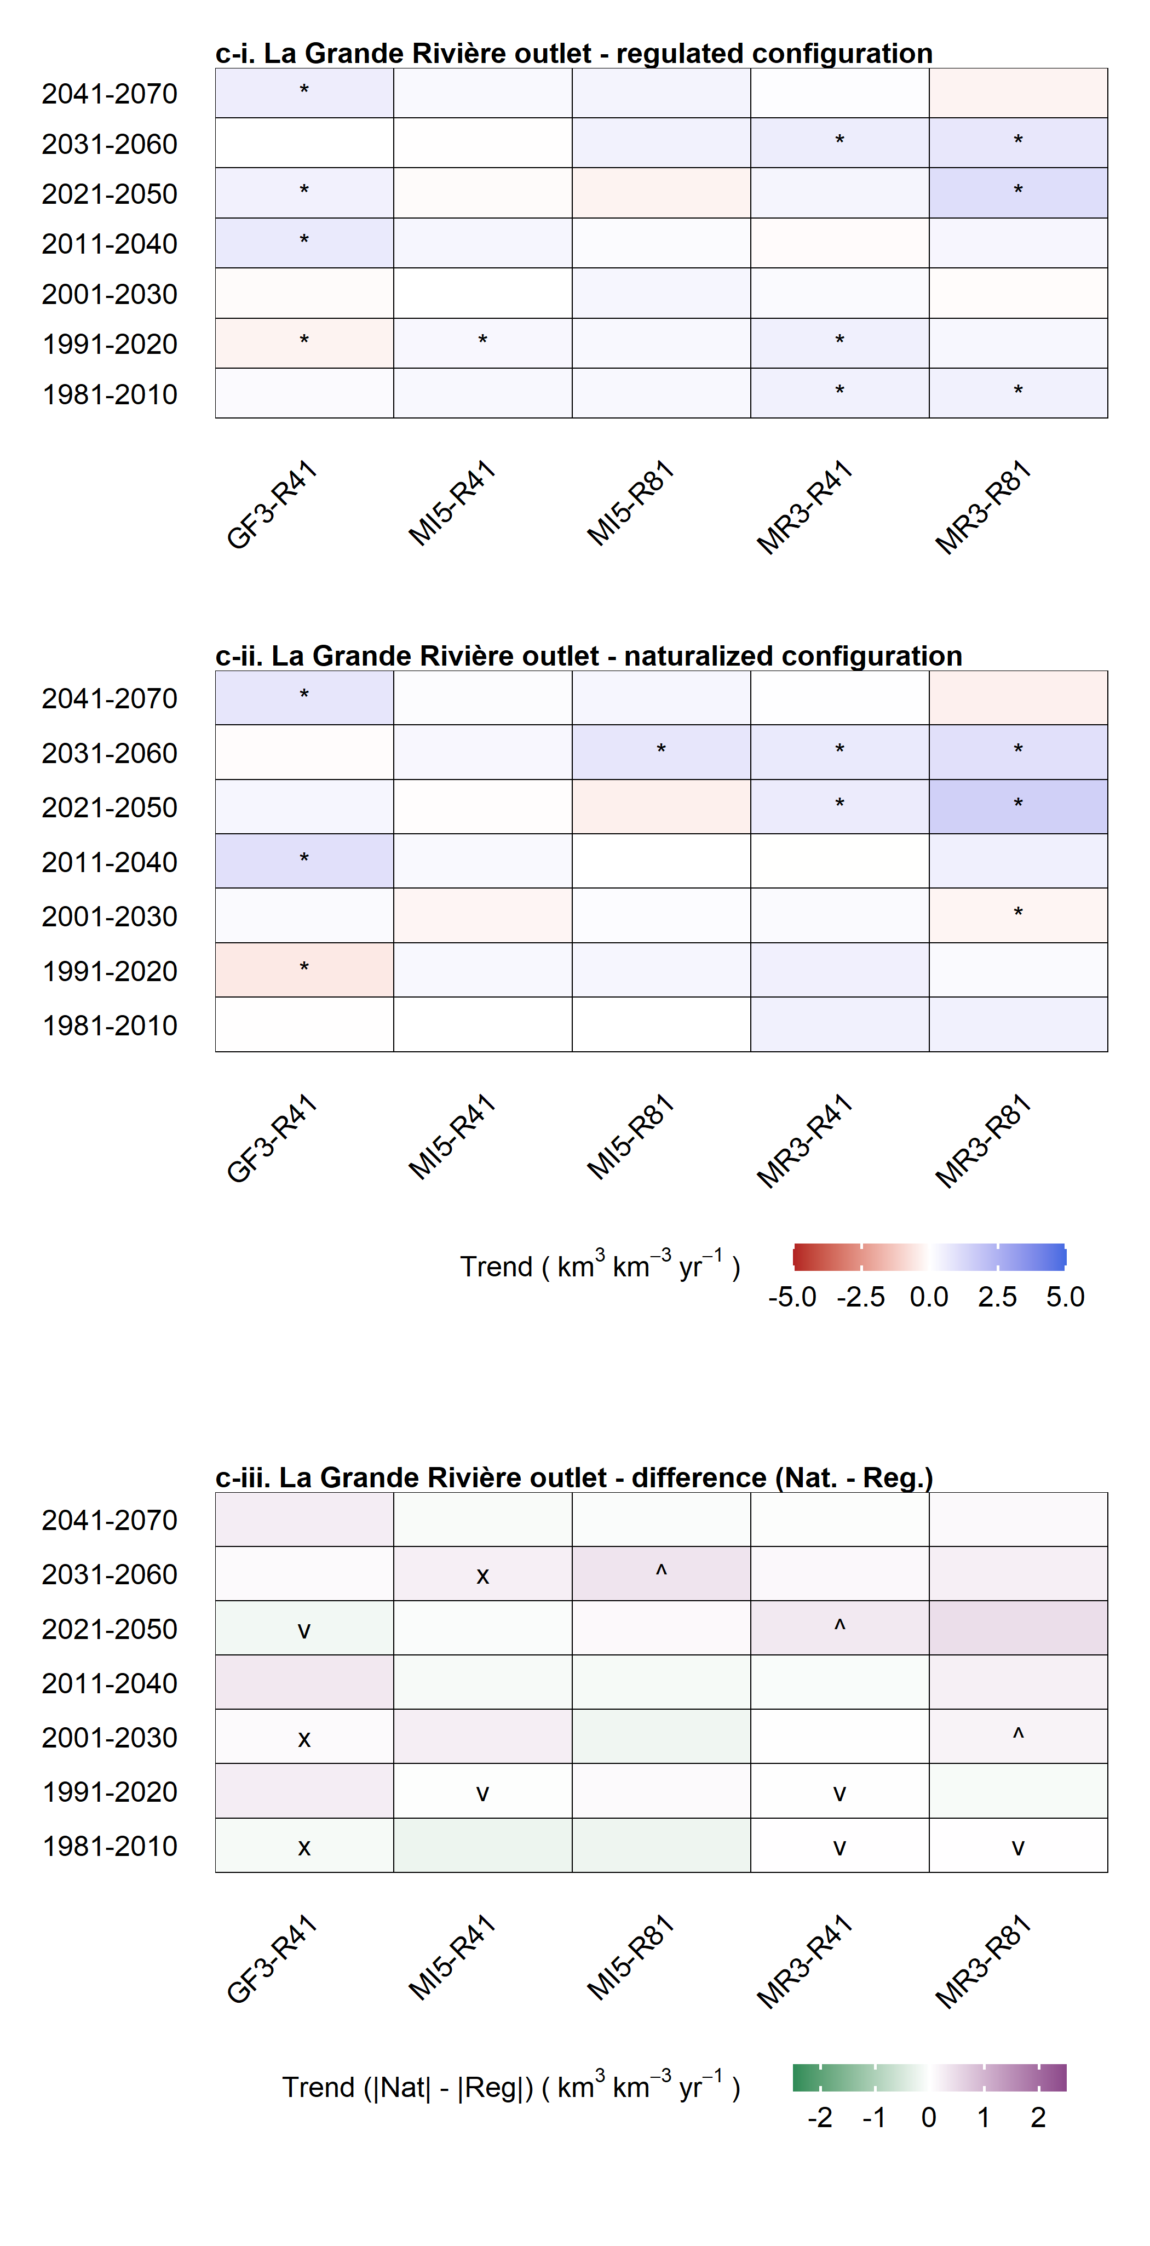
Figure S5. Trends by time period and GCM for regulated and renaturalized configurations. Thirty-year moving window analysis of trends by GCM simulation and time period for (i) regulated model, (ii) renaturalized model, and (iii) [|Renaturalized|-|Regulated|] for the three most intensely regulated and largest volume contributing systems to the HBC: (a) Nelson River, (b) Churchill River, and (c) La Grande Rivière. Trends computed as Sen’s slope of Mann-Kendall trend analysis (as percent of period mean); * in (i) and (ii) represent significant trends. Blank cells in (iii) represent agreement in trend direction and significance between renaturalized and regulated; ^, increasing trend slope under regulation (relative to renaturalized); v, decreasing trend slope under regulation; and x, disagreement in trend direction where one or both trends were significant.

