Supplemental Material

Spatial patterns in summertime surface ozone in the southern Front Range of the Rocky Mountains, USA
Margot T. Flynn¹, Erick J. Mattson², Daniel A. Jaffe³, Lynne E. Gratz^{1*}
¹Colorado College, Environmental Studies Program, Colorado Springs, Colorado, United States
²Colorado Department of Public Health and Environment, Air Pollution Control Division, Glendale, Colorado, United States
³University of Washington-Bothell, Physical Sciences Division, Bothell, Washington, United States and University of Washington-Seattle, Department of Atmospheric Sciences, Seattle, Washington, United States
*Corresponding author: lgratz@coloradocollege.edu

List of Contents:

Figure S1. Time series of continuous hourly ozone observations, and boxplot distributions of summertime hourly ozone at permanent Colorado Springs ozone monitoring stations.
A) Time series of continuous hourly ozone observations at AFA (left). Boxplot distributions of summertime (June-July-August) hourly ozone by year at AFA (right). B) Time series of continuous hourly ozone observations at MAN (left). Boxplot distributions of summertime hourly ozone by year at MAN (right). Boxplots were generated using R Studio. The center line represents the median ozone mole fraction, the box represents the interquartile range, and upper/lower whiskers are either maximum/minimum value or the upper/lower quartile value plus/minus 1.5 times the interquartile range. Data after 10/31/2020 is considered preliminary and may be flagged or removed before being certified.
Figure S2. Distributions for hourly ozone frequency by site from June – September 2018.
Histogram distributions for hourly ozone mole fractions at each site with permanent sites marked in red. All sites except MON and AFA have normal distributions. Table S2 displays descriptive statistics for the hourly ozone measurements for each site.

Figure S3. Wind roses for ozone frequencies.
Ozone frequencies by direction for the 0:00, 4:00, 8:00, 12:00, 16:00, and 20:00 hours of the day at the MON (NNW of city center), BLF (NNE of city center), NAV (E of city center), and CAS (W of city center) sites during the summer 2018 ozone study (see Figure 2 for map). Ozone measurements are plotted only for each labeled hour (e.g. ozone measurements at hours 1:00-3:00, 5:00-7:00, 9:00-11:00, 17:00-19:00, and 21:00-23:00 and corresponding wind direction are not shown).
Figure S4. NOAA HMS active fires (red triangles), smoke product (gray shading), and surface 8-hr ozone observations on 6/12/2018 with 72-hour HYSPLIT back trajectory and ozone time series.
A) Map of fires burning and NOAA HMS smoke product for near peak ozone hour on 6/12/2018 and B) the 72-hour HYSPLIT back-trajectory for 6/12/2018 at peak ozone hour (1800 UTC) for 500, 1000, and 1500 m AGL. C) Time series plot of hourly ozone at eight sites in Colorado Springs during the high ozone event.

Figure S5. NOAA HMS active fires (red triangles), smoke product (gray shading), and surface 8-hr ozone observations on 7/6/2018 with 72-hour HYSPLIT back trajectory and ozone time series.
A) Map of fires burning and NOAA HMS smoke product for near peak ozone hour on 7/6/2018 and B) the 72-hour HYSPLIT back-trajectory for 7/6/2018 at peak ozone hour (2100 UTC) for 500, 1000, and 1500 m AGL. C) Time series plot of hourly ozone at eight sites in Colorado Springs during the high ozone event.

Figure S6. NOAA HMS active fires (red triangles), smoke product (gray shading), and surface 8-hr ozone observations on 7/14/2018 with 72-hour HYSPLIT back trajectory and ozone time series.
A) Map of fires burning and NOAA HMS smoke product for near peak ozone hour on 7/14/2018 and B) the 72-hour HYSPLIT back-trajectory for 7/14/2018 at peak ozone hour (2100 UTC) for 500, 1000, and 1500 m AGL. C) Time series plot of hourly ozone at eight sites in Colorado Springs during the high ozone event.

Figure S7. NOAA HMS active fires (red triangles), smoke product (gray shading), and surface 8-hr ozone observations on 7/18/2018 with 72-hour HYSPLIT back trajectory and ozone time series.
A) Map of fires burning and NOAA HMS smoke product for near peak ozone hour on 7/18/2018 and B) the 72-hour HYSPLIT back-trajectory for 7/18/2018 at peak ozone hour (2200 UTC) for 500, 1000, and 1500 m AGL. C) Time series plot of hourly ozone at eight sites in Colorado Springs during the high ozone event.

Figure S8. NOAA HMS active fires (red triangles), smoke product (gray shading), and surface 8-hr ozone observations on 7/31/2018 – 8/2/2018 with 72-hour HYSPLIT back trajectory and ozone time series.
A) Maps of fires burning and NOAA HMS smoke product for near peak ozone hour on 7/31/2018, 8/1/2018, and 8/2/2018 and B) the 72-hour HYSPLIT back-trajectories for 7/31/2018 – 8/2/2018 at peak ozone hour (1800 – 2200 UTC) for 500, 1000, and 1500 m AGL. C) Time series plot of hourly ozone at eight sites in Colorado Springs during the high ozone event.

Table S1. A summary of results from A) nightly baseline checks at temporary sites that used the 2BTech model 205 and B) audits of temporary sites by a CDPHE independent QA team at three ozone levels during the 2018 Colorado Springs ozone study^{a,b,c}
Table S2. Summary statistics for ozone mole fractions (ppb) during the June – September 2018 special ozone study

Table S3. Variables used in the GAMs for both MAN and AFA sitesª
Table S4. Training and cross-validation results for MDA8 values at MAN
Table S5. GAM count and residuals (ppb) for non-smoke and smoke days for MANª
Table S6. Training and cross-validation results for MDA8 values at AFA
Table S7. GAM count and residuals (ppb) for non-smoke and smoke days for AFAª
Table S8. High ozone event dates, durations, and peak ozone during the 2018 ozone study

Data S1. Hourly ozone data collected for the 2018 CDPHE special study of the Pikes Peak region

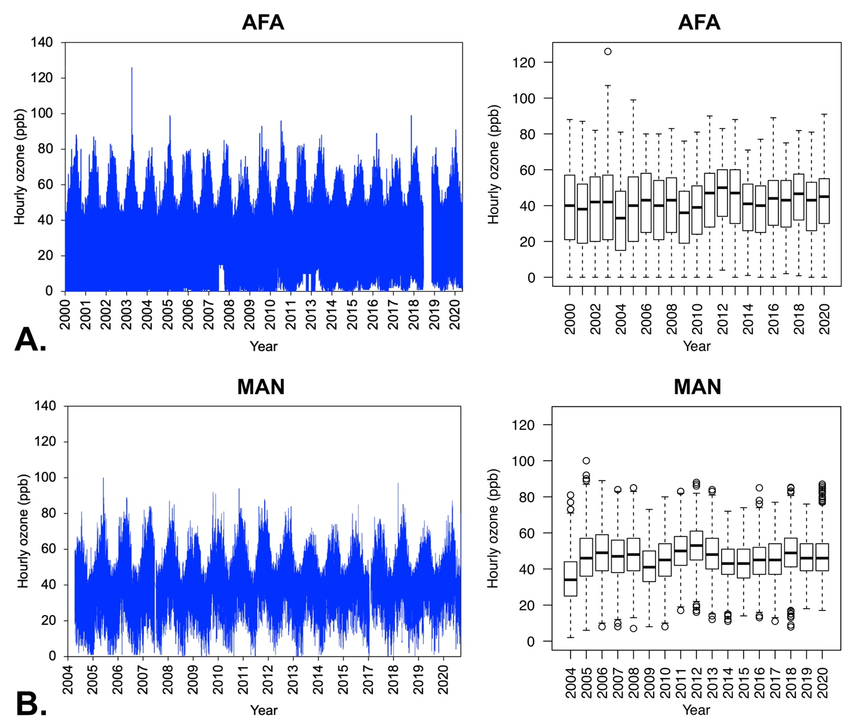
Figure S1. Time series of continuous hourly ozone observations, and boxplot distributions of summertime hourly ozone at permanent Colorado Springs ozone monitoring stations.
A) Time series of continuous hourly ozone observations at AFA (left). Boxplot distributions of summertime (June-July-August) hourly ozone by year at AFA (right). B) Time series of continuous hourly ozone observations at MAN (left). Boxplot distributions of summertime hourly ozone by year at MAN (right). Boxplots were generated using R Studio. The center line represents the median ozone mole fraction, the box represents the interquartile range, and upper/lower whiskers are either maximum/minimum value or the upper/lower quartile value plus/minus 1.5 times the interquartile range. Data after 10/31/2020 is considered preliminary and may be flagged or removed before being certified.

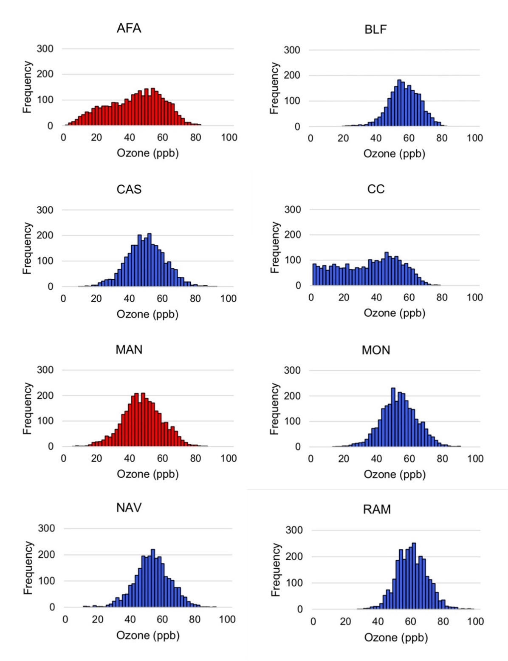

Figure S2. Distributions for hourly ozone frequency by site from June – September 2018.

Histogram distributions for hourly ozone mole fractions at each site with permanent sites marked in red. All sites except MON and AFA have normal distributions. Table S2 displays descriptive statistics for the hourly ozone measurements for each site.

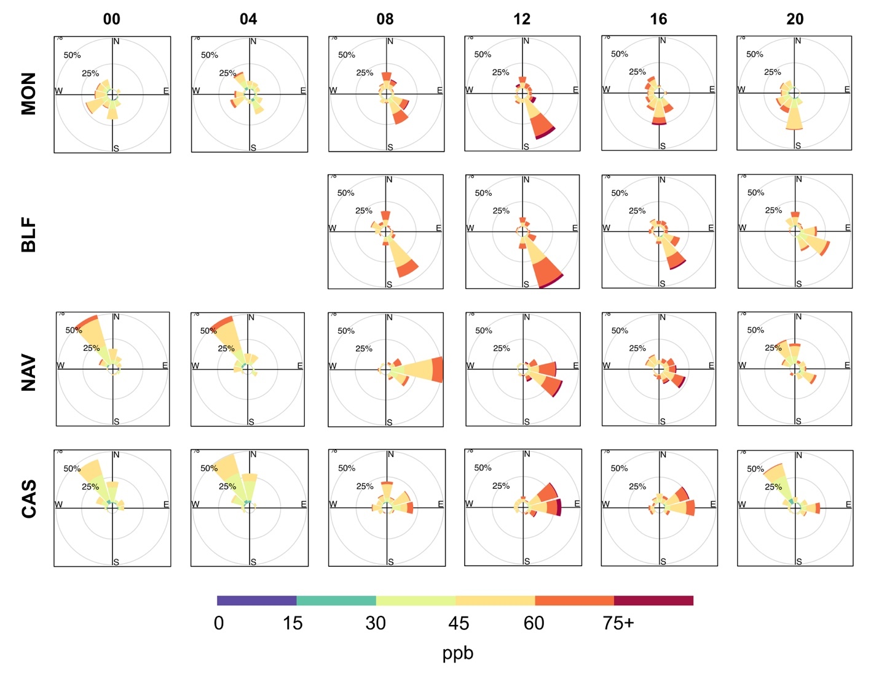
Figure S3. Wind roses for ozone frequencies.
Ozone frequencies by direction for the 0:00, 4:00, 8:00, 12:00, 16:00, and 20:00 hours of the day at the MON (NNW of city center), BLF (NNE of city center), NAV (E of city center), and CAS (W of city center) sites during the summer 2018 ozone study (see Figure 2 for map). Ozone measurements are plotted only for each labeled hour (e.g. ozone measurements at hours 1:00-3:00, 5:00-7:00, 9:00-11:00, 17:00-19:00, and 21:00-23:00 and corresponding wind direction are not shown).

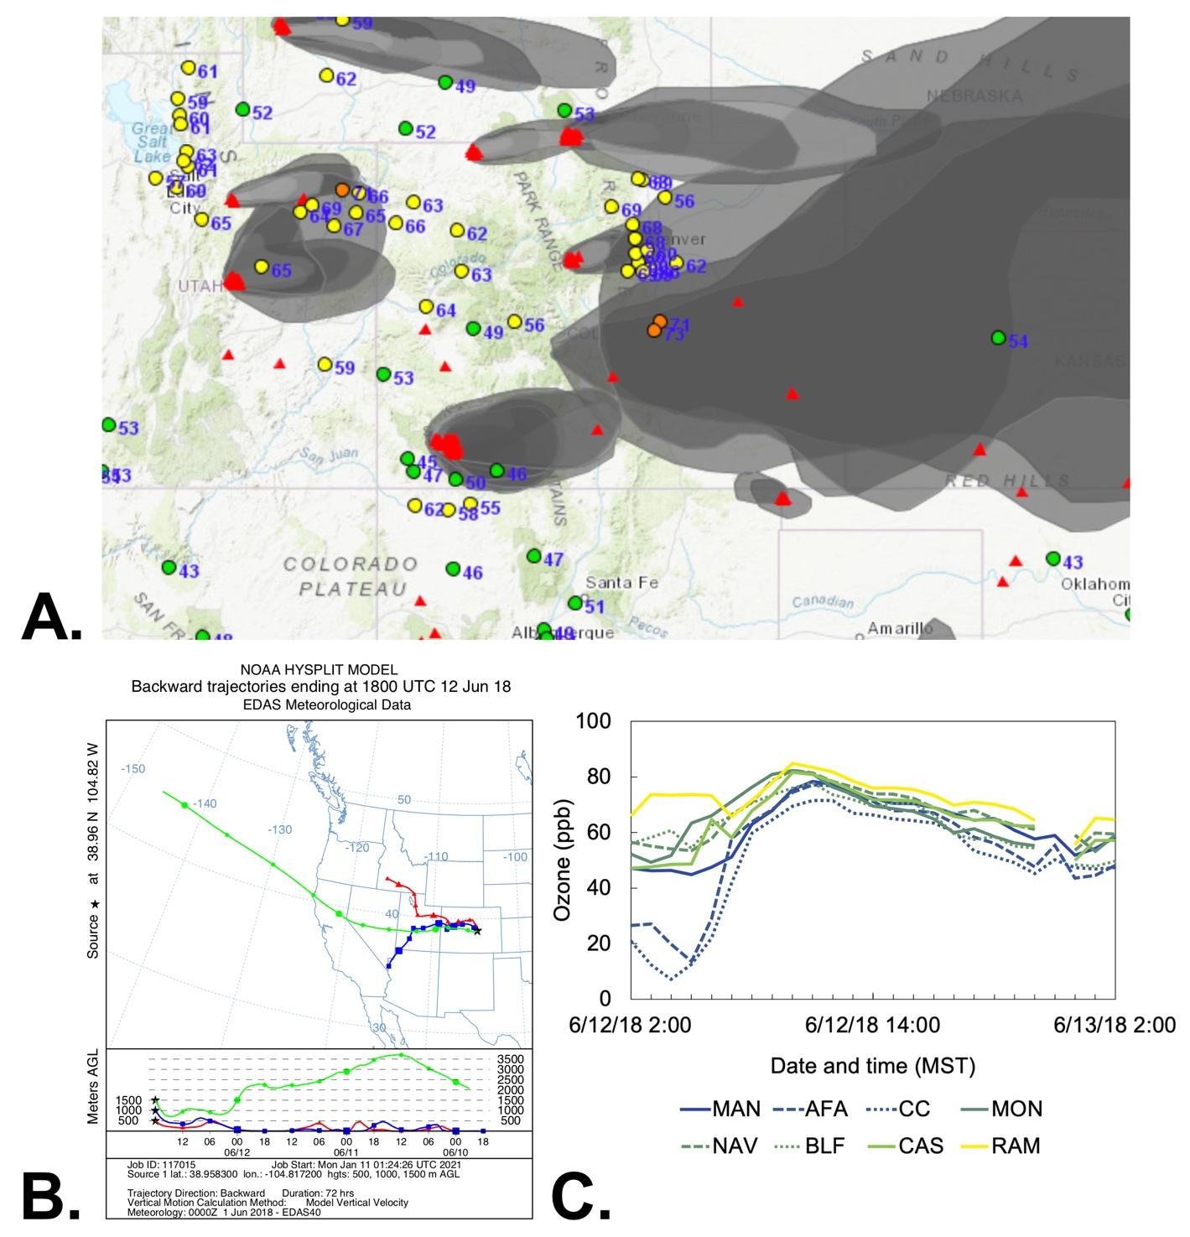

Figure S4. NOAA HMS active fires (red triangles), smoke product (gray shading), and surface 8-hr ozone observations on 6/12/2018 with 72-hour HYSPLIT back trajectory and ozone time series.

A) Map of fires burning and NOAA HMS smoke product for near peak ozone hour on 6/12/2018 and B) the 72-hour HYSPLIT back-trajectory for 6/12/2018 at peak ozone hour (1800 UTC) for 500, 1000, and 1500 m AGL. C) Time series plot of hourly ozone at eight sites in Colorado Springs during the high ozone event.
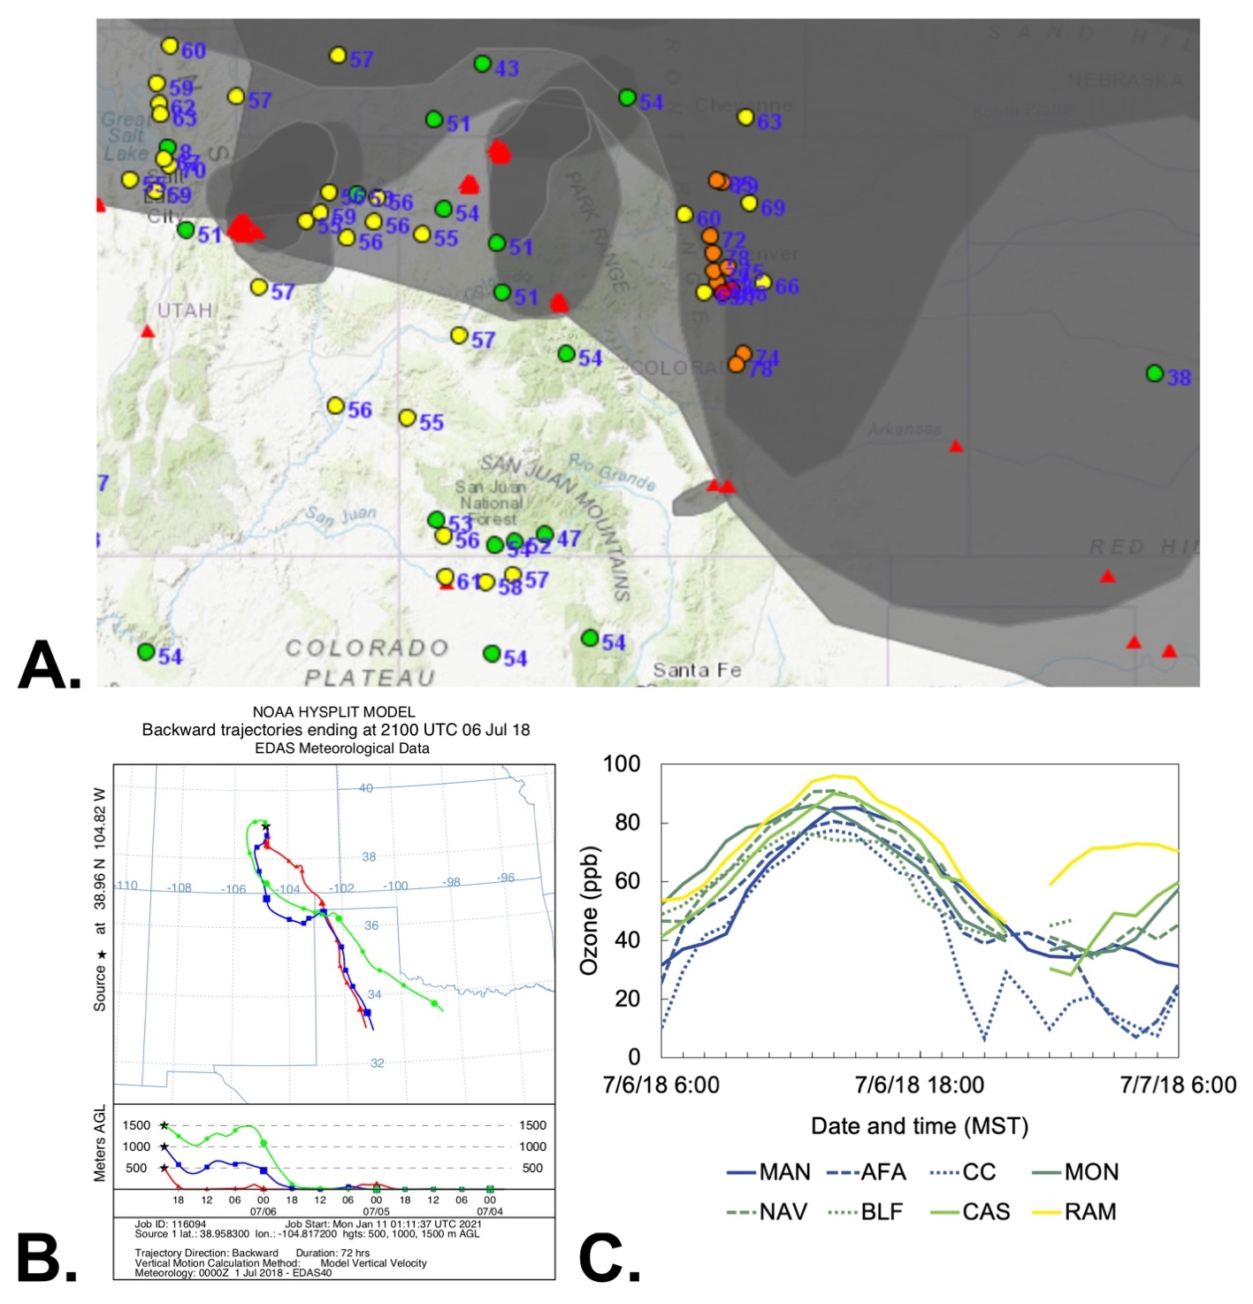

Figure S5. NOAA HMS active fires (red triangles), smoke product (gray shading), and surface 8-hr ozone observations on 7/6/2018 with 72-hour HYSPLIT back trajectory and ozone time series.

A) Map of fires burning and NOAA HMS smoke product for near peak ozone hour on 7/6/2018 and B) the 72-hour HYSPLIT back-trajectory for 7/6/2018 at peak ozone hour (2100 UTC) for 500, 1000, and 1500 m AGL. C) Time series plot of hourly ozone at eight sites in Colorado Springs during the high ozone event.

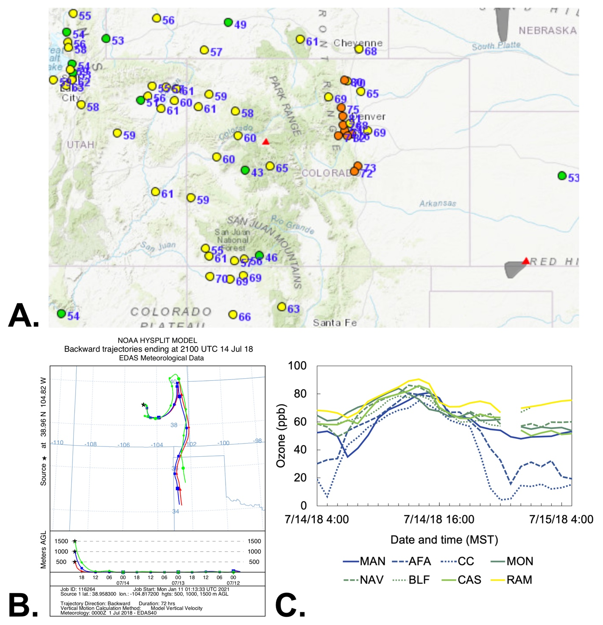

Figure S6. NOAA HMS active fires (red triangles), smoke product (gray shading), and surface 8-hr ozone observations on 7/14/2018 with 72-hour HYSPLIT back trajectory and ozone time series.

A) Map of fires burning and NOAA HMS smoke product for near peak ozone hour on 7/14/2018 and B) the 72-hour HYSPLIT back-trajectory for 7/14/2018 at peak ozone hour (2100 UTC) for 500, 1000, and 1500 m AGL. C) Time series plot of hourly ozone at eight sites in Colorado Springs during the high ozone event.

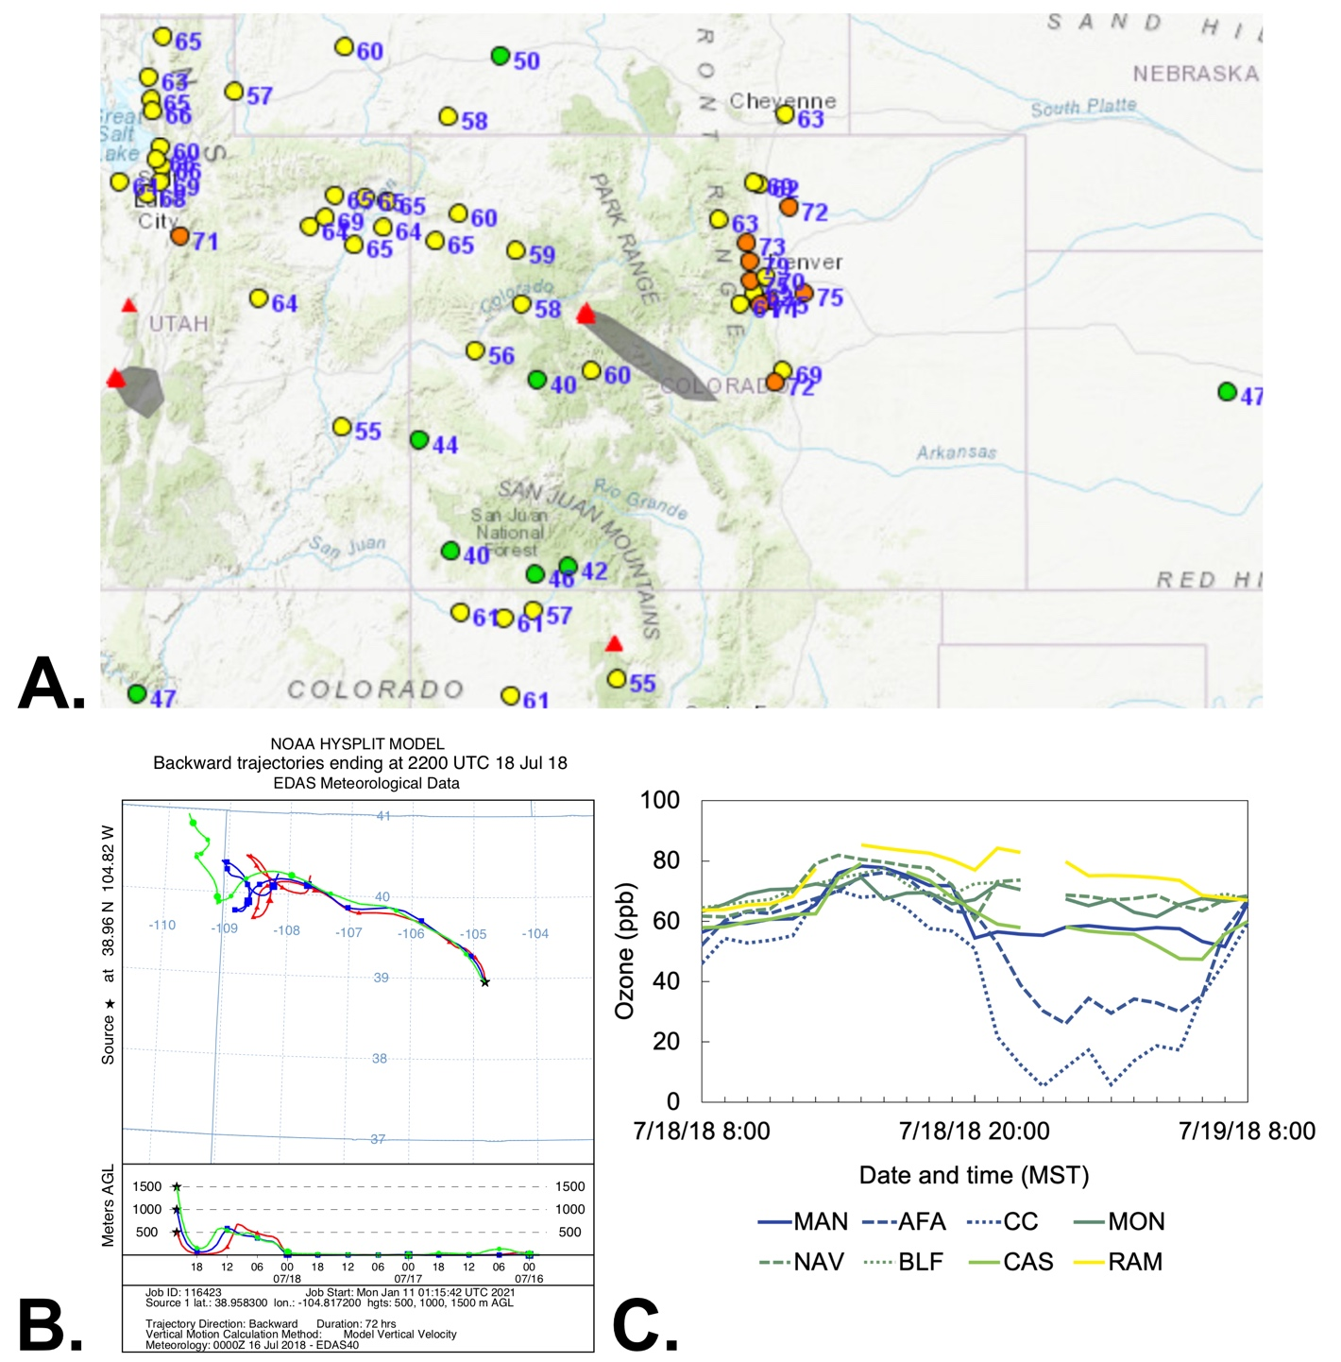

Figure S7. NOAA HMS active fires (red triangles), smoke product (gray shading), and surface 8-hr ozone observations on 7/18/2018 with 72-hour HYSPLIT back trajectory and ozone time series.

A) Map of fires burning and NOAA HMS smoke product for near peak ozone hour on 7/18/2018 and B) the 72-hour HYSPLIT back-trajectory for 7/18/2018 at peak ozone hour (2200 UTC) for 500, 1000, and 1500 m AGL. C) Time series plot of hourly ozone at eight sites in Colorado Springs during the high ozone event.

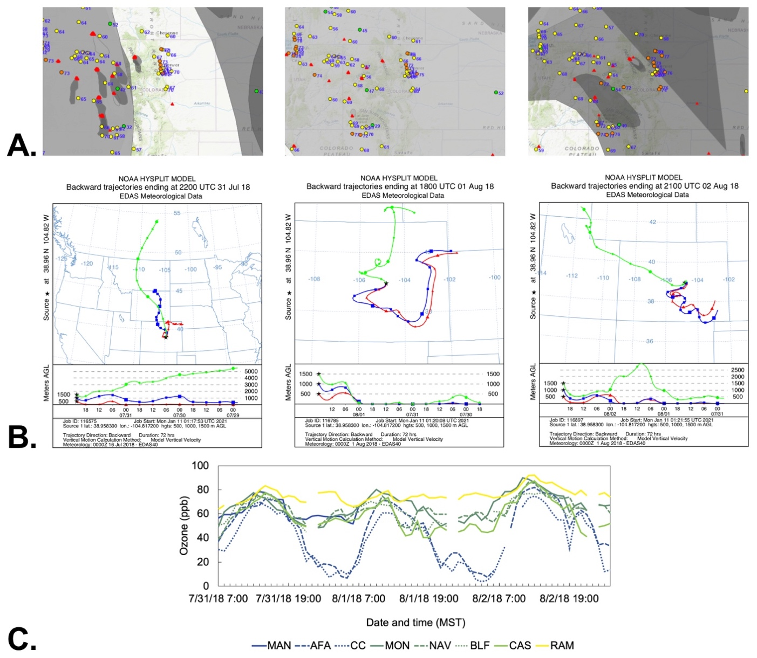

Figure S8. NOAA HMS active fires (red triangles), smoke product (gray shading), and surface 8-hr ozone observations on 7/31/2018 – 8/2/2018 with 72-hour HYSPLIT back trajectory and ozone time series.

A) Maps of fires burning and NOAA HMS smoke product for near peak ozone hour on 7/31/2018, 8/1/2018, and 8/2/2018 and B) the 72-hour HYSPLIT back-trajectories for 7/31/2018 – 8/2/2018 at peak ozone hour (1800 – 2200 UTC) for 500, 1000, and 1500 m AGL. C) Time series plot of hourly ozone at eight sites in Colorado Springs during the high ozone event.

Table S1. A summary of results from A) nightly baseline checks at temporary sites that used the 2BTech model 205, and B) audits of temporary sites by a CDPHE independent QA team at three ozone levels during the 2018 Colorado Springs ozone study^{a,b,c}
A.
 | BLF | CAS | MON | NAV | RAM
Std. Dev. | 0.44 | 0.33 | 0.42 | 0.50 | 0.44
Drift | 0.20 | 0.27 | 0.61 | -1.0 | -0.81
B.
Target | BLF | CAS | CC | MON | NAV | RAM
125ppb | -1.6% | 2.8% | -7.5% | -0.6% | 0.6% | 4.3%
75ppb | -2.3% | 0.5% | -7.6% | -0.1% | 0.0% | 3.5%
35ppb | -7.8% | -5.2% | -9.7% | 0.6% | -0.5% | 2.4%
ª Positive values indicate the analyzer responded higher than the target
^{b} Percentages are an average of six points per target
^{c} Criteria for auditing was 15%, the same for all regulatory equipment

Table S2. Summary statistics for ozone mole fractions (ppb) during the June – September 2018 special ozone study

Site | n | Minimum | Maximum | Mean | Std. Dev. | Std. Error | Variance
ACA | 2921 | 1 | 82 | 42 | 17 | 0.3 | 283
BLF | 2006 | 19 | 80 | 56 | 9 | 0.2 | 87
CAS | 2761 | 9 | 90 | 49 | 12 | 0.2 | 136
CC | 2791 | 0 | 78 | 34 | 19 | 0.4 | 343
MAN | 2914 | 5 | 85 | 47 | 12 | 0.2 | 145
MON | 2737 | 13 | 90 | 53 | 11 | 0.2 | 120
NAV | 2642 | 11 | 90 | 53 | 11 | 0.2 | 122
RAM | 2766 | 28 | 96 | 60 | 9 | 0.2 | 88

Table S3. Variables used in the GAMs for both MAN and AFA sitesª
Variable
Daily mean relative humidity
Daily maximum temperature
Geopotential height at 500 hPa
Wind quadrant (NE, SE, SW, NW) based on local winds
Month
ª In each GAM, all variables above have p-values of < 0.1, except for wind quadrant at AFA, which had a p-value of 0.14.
Table S4. Training and cross-validation results for MDA8 values at MAN
 | N | Avg Residual (ppb) | R²
Training data | 667 | -7.1 x 10⁻¹⁵ | 0.45
Cross validation data | 72 | -1.8 x 10⁻¹ | 0.51
All data | 739 | 3.4 x 10⁻¹³ | 0.45

Table S5. GAM count and residuals (ppb) for non-smoke and smoke days for MANª
 | 2014 | 2015 | 2016 | 2017 | 2018 | 2019 | 2020 | Total
Non-smoke days: Count | 10 | 31 | 94 | 96 | 80 | 105 | 84 | 500
Non-smoke days: Mean residual (ppb) | -1.1 | -1.8 | -2.7 | 1.6 | 1.6 | -0.4 | -2.1 | -0.5
Smoke days: Count | 0 | 5 | 12 | 22 | 33 | 0 | 36 | 108
Smoke days: Mean residual (ppb) | ND | 1.8 | -0.2 | 3.0 | 4.6 | ND | 6.8 | 4.3
ª Note that 131 days could not be classified as smoke or non-smoke due to missing HMS or PM_{2.5} data. From 2014 until 6/24/2016, PM_{2.5} data is only available is every three days, but starting on 6/24/2016, the data are available nearly every day. Thus for 2014 and 2015 the number of days that can be identified as smoke or non-smoke are very limited
Table S6. Training and cross-validation results for MDA8 values at AFA
 | N | Avg Residual (ppb) | R²
Training data | 671 | 4.4 x 10⁻¹³ | 0.40
Cross-validation data | 75 | 0.56 | 0.51
All data | 746 | 1.9 x 10⁻¹³ | 0.42

Table S7. GAM count and residuals (ppb) for non-smoke and smoke days for AFAª
 | 2014 | 2015 | 2016 | 2017 | 2018 | 2019 | 2020 | Total
No smoke days: Count | 10 | 32 | 93 | 98 | 83 | 104 | 85 | 505
No smoke days: Mean residual (ppb) | -2.7 | -1.8 | -1.3 | 0.8 | 0.9 | -1.1 | -1.5 | -0.6
Smoke days: Count | 0 | 5 | 12 | 22 | 35 | 0 | 36 | 110
Smoke days: Mean residual (ppb) | ND | 1.4 | 1.6 | 2.4 | 4.6 | ND | 7.6 | 4.7
ª Note that 131 days could not be classified as smoke or non-smoke due to missing HMS or PM_{2.5} data. From 2014 until 6/24/2016, PM_{2.5} data is only available is every three days, but starting on 6/24/2016, the data are available nearly every day. Thus for 2014 and 2015 the number of days that can be identified as smoke or non-smoke are very limited.

Table S8. High ozone event dates, durations, and peak ozone during the 2018 ozone study

Date | Duration | Peak 1-hr Ozone (ppb)
June 12, 2018 | 2:00-16:00 (14 hours) | 85
July 6, 2018 | 6:00-15:00 (9 hours) | 96
July 14, 2018 – July 15, 2018 | 4:00-5:00 (25 hours) | 90
July 18, 2018 – July 19, 2018 | 8:00-2:00 (18 hours) | 85
July 31, 2018 – August 3, 2018 | 7:00-2:00 (67 hours) | 92

Data S1. Hourly ozone data collected for the 2018 CDPHE special study of the Pikes Peak region

