Supplemental Material

Article title: DMS Emissions from the Arctic Marginal Ice Zone
Martí Galí^{1,2*}, Martine Lizotte¹, David J. Kieber³, Achim Randelhoff¹, Rachel Hussherr¹, Lei Xue³, Julie Dinasquet^{4,5}, Marcel Babin¹, Eric Rehm¹, Maurice Levasseur¹
¹ Takuvik International Research Laboratory, Laval University (Canada), CNRS, FR; Département de biologie et Québec-Océan, Université Laval, Québec, CA
² Barcelona Supercomputing Center
³ Department of Chemistry, College of Environmental Science and Forestry, State University of New York, 1 Forestry Drive, Syracuse, New York 13210, United States
⁴ Marine Biology Research Division, Scripps Institution of Oceanography, La Jolla, USA
⁵ Sorbonne Université, Laboratoire d’Océanographie Microbienne, Banyuls-sur-Mer, France
* Corresponding author: marti.gali.tapias@gmail.com

List of Contents

Texts
Text S1. DMS analysis
Text S2. DMSP analysis
Text S3. Particulate DMSP partitioning
Text S4. Multivariate analysis
4.1 Redundancy analysis (RDA) and variance partitioning
4.2 Stepwise multiple linear regression
Text S5. Order-of-magnitude DMS cycling estimates

Tables
Table S1. DMS (DMSP_{t}) data counts by ice cover categories and depth horizons.
Table S2. Parameters used to compute the particulate DMSP concentration bound to different phytoplankton groups and detrital particles.
Table S3. Stepwise multiple linear regression (sMLR) models linking DMSP_{t} or DMS and phytoplankton pigments.

Figures
Figure S1. Boxplots of phytoplankton abundances in the near-surface and SCM layers.
Figure S2. Bacterial abundance and activity.
Figure S3. Estimates of particulate DMSP bound to different phytoplankton groups.
Figure S4. Scatterplots of (a) DMSP_{t} and (b) DMS vs. TChl a.
Figure S5. Spearman correlation (r_{S}) between salinity and sulfur/phytoplankton stocks in different layers.

Text S1. DMS analysis
From 10-20 mL of unfiltered seawater was drawn from the vials, spiked with deuterated DMS internal standards (DMS-d₃ and DMS-d₆ (99 atom %), at 0.54 and 4.5 nM final concentration) and injected into the sparge chamber of a purge-and-trap device (pre-rinsed with MilliQ (MQ) water) using an inline syringe fitted with a 25-mm diameter GF/F filter. Samples were sparged with ultra-high purity (UHP) helium for 5 min to strip the DMS from the seawater and trap it on a glass tube containing Tenax-TA that was placed downstream of the sparge chamber (Gourdal et al. 2018). The Tenax-filled glass tube was placed over a vessel filled with liquid nitrogen to maintain it below –10°C. After sparging, the glass tube was removed from the cryogenic trap and immediately stored at –80°C until analysis or, most frequently, placed in the injector chamber of the gas chromatograph-mass spectrometer (GC-MS; GC: Agilent 7890A; MS: Agilent 5975C) for analysis.
The GC-MS was calibrated at the beginning of each transect and at the end of the last transect (every four days). Four to six standard solutions were prepared by diluting DMS-d₃ and DMS-d₆ in Milli-Q (MQ) water at four to six different concentrations between 0.5 and 45 nM. The R² of the log-log linear calibration equation was generally > 0.99 and the mean slope (± std dev) was 0.978 (± 0.018). We determined the DMS concentration using a fixed mean calibration curve throughout the cruise for better temporal consistency. The coefficient of variation (CV) between concentrations determined using the fixed calibration and those determined with the time-varying calibration was ± 7%.
The DMS peak area, with a mass-to-charge ratio (m/z) of 62, and those of the internal standards (DMS-d₃, m/z = 65; DMS-d₆, m/z = 68) were determined using the MassHunter workstation software. Initial concentrations were obtained by applying the calibration equation to blank-corrected peak areas (blank signals were generally less than 10% of the smallest peak areas detected in samples). The initial values for endogenous DMS (mDMS) were subsequently corrected using the DMS-d₆ internal standard according to the equation:
DMS = mDMS · eDMS-d₆ / mDMS-d₆ (Equation S1)
where eDMS-d₆ is the expected (known) concentration of DMS-d₆ internal standard (4.5 nM) and mDMS-d₆ is the initially measured concentration. This procedure corrects for errors associated with sample handling, inefficiencies of the purge-and-trap system or instrument drift. The mean propagated uncertainty of DMS measurements was estimated at 10%, which results from adding in quadrature the mean range of 6.5% obtained for a subset of samples analyzed in duplicate (n = 16) and the 7% uncertainty (CV) due to the calibration equation. No analytical replicates were performed for the majority of samples.
The 10% propagated uncertainty quoted above does not take into account errors associated with sample pre-screening (del Valle et al., 2009). Two different mesh sizes (100 and 5 µm) were compared to quantify potential filtration artifacts, and we obtained a mean (median) concentration ratio of 1.19 (1.19) between samples pre-screened with the 100-µm mesh and their 5 µm-screened counterparts. However, the test was statistically inconclusive because the ratio of the concentrations obtained with the two procedures ranged between 0.60 and 1.9 (n = 19), with interquartile range of 0.93–1.46. Using bootstrapping (n = 10000), we obtained a 95% confidence interval for the ratio of concentrations that was only marginally different from 1 (1.02–1.36 for the untransformed ratio and 0.93–1.36 for the log10 transformed ratio). Our results are consistent with those from del Valle et al. (2009) during a Phaeocystis bloom in the Ross Sea (Antarctica), who observed a mean (median) ratio of 1.67 (1.70) between unscreened samples and their 20 µm-screened counterparts (samples were GF/F-filtered upon injection, as in our study). Despite the different mesh sizes used, these results clearly point to the importance of pre-screening particles of the size of Phaeocystis colonies (>100 µm) and even solitary Phaeocystis cells (~ 5 µm diameter) from samples to avoid DMS measurement artifacts.

Text S2. DMSP analysis
Processed DMSP samples were stored in the dark at 4°C and analyzed at Laval University (UL, Québec City) and at the State University of New York, College of Environmental Science and Forestry (SUNY-ESF, Syracuse, NY) within 30 months of collection. These circumstances prompted us to perform storage tests and interlab comparisons. Standards of known DMSP concentration were prepared on the ship by diluting a 20-µM stock solution of DMSP·HCl (Sigma-Aldrich; solution in MQ water kept frozen) in GF/F-filtered 1900 m-depth seawater, and subsequently processed as regular samples. Additional aliquots of some samples were also analyzed on the ship within a few days of collection using standard base cleavage procedures (see below) to allow for later comparisons. We obtained 100.0 ± 1.5% recovery of DMSP standards prepared on the ship (triplicates at 25, 100 and 400 nM) and 95.1 ± 5.9% recovery for surface seawater samples that had been analyzed on the ship (n = 4 duplicates, 18–123 nM concentration range). Regarding interlab comparisons, we obtained a mean difference of 1.2 ± 10% between UL and SUNY for a subset of samples that were sent to both labs (n = 4 duplicates, 2.5–126 nM concentration range). In summary, our tests indicated that no DMSP loss occurred during the storage period and confirmed the accuracy and consistency of the analytical methods described below.
At UL, stoichiometric conversion of DMSP to DMS was achieved by adding 3 mL of 5 M NaOH to 5 mL of sample or standard in a 40-mL gas-tight glass vial. Vials were then promptly placed in a rack and subsampled automatically via a Teledyne Tekmar Atomx XYZ system fitted with a pneumatic syringe, injected into a calibrated glass vessel, heated at 40ºC, and sparged with UHP helium at a flow rate of 40 mL min^{–1} for 11 min to allow complete adsorption of the stripped DMS on a U-shaped proprietary trap. Following full extraction of DMS, the U-shaped trap was heated to 250ºC to allow elution of the gas onto a Gas Chromatograph (GC, model Intuvo 9000, Agilent, oven: 60ºC, capillary column: DB-5ms, 30 m x 250 µm x 0.25 µm, He: 1.0 mL min^{–1}) at a flow rate of 300 mL min^{–1}. After chromatographic separation, the GC effluent was carried through to a Mass Spectrometer (MS, model 5977B, Agilent), where the peak area of the ionized DMS (m/z = 62) was determined with the MassHunter workstation software and converted to a concentration using a 7-point calibration of a diluted DMSP standard solution (Research Plus Inc. 100 nM DMSP solution acidified with 10% H₂SO₄ and diluted with MQ water). Calibrations were performed on a weekly basis with an average R² regression coefficient of 0.99. The mean standard error of the internal standard was on average of 0.21 nmol L^{–1}. The working detection limit of the instrument was 1.1 nM and was calculated as the addition of the mean blank concentration and 3 times its standard deviation.
At SUNY-ESF, DMSP was quantified following the procedure outlined in Kinsey and Kieber (2016). Briefly, 200 µL of 5 M NaOH solution was added to 1 mL of a DMSP standard or microwaved and acidified seawater sample in a precleaned 10-mL borosilicate serum vial. Following the addition of base, each serum vial was immediately capped with a Teflon-lined butyl rubber stopper and sealed with an aluminum crimp cap. Basified samples were stored for 24 h in the dark at room temperature prior to analysis. The DMS was quantified in the standards and samples using a cryogenic purge-and-trap system (sparging time, 4 min) and a Shimadzu GC-14A with flame photometric detector (temperature, 225°C). Separation of DMS from other volatile sulfur compounds was achieved isothermally at 60°C using a Chromosil 330 column (3.2 mm i.d. × 2.4 m long, Supelco Inc.) with UHP helium as the carrier gas (Kinsey and Kieber, 2016).

Text S3. Particulate DMSP partitioning
Particulate DMSP (DMSP_{p}) was estimated from the abundance of phyto- and bacterioplankton using conversion factors. For phytoplankton, counts were converted to carbon biomass and then multiplied by the proportion of DMSP-carbon biomass for each group (b_{DMSP}). The carbon biomass of diatoms was kindly provided by Lafond et al. (2019). For the other groups, carbon biomass was estimated from the product of cell abundance and mean cell biovolume, using the allometric relationships of Menden-Deuer and Lessard (2000). The mean cell biovolume was estimated by assigning each taxonomic group a mean equivalent spherical diameter (ESD) to calculate the corresponding volume of a sphere. For Phaeocystis, an ESD of 5 µm was taken from the literature (Schoemann et al., 2005). For picoeukaryotes counted by flow cytometry, we assumed an ESD of 2 µm. For the other taxonomic groups, ESD was calculated as the abundance-weighted mean of the different size intervals for which cell counts were available within a given group. The values of the parameters used to compute the DMSP_{p} bound to each phytoplankton group are compiled in Table S1.
Estimates of DMSP_{p} based on the sum of DMSP_{p} for the different phytoplankton groups were compared to measurements, assuming that DMSP_{p} represented 90% of total DMSP (DMSP_{t}). This value is in good accordance with the literature (Kiene and Slezak, 2006) and with our measurements at stations 713 and 719, where the mean DMSP_{d}/DMSP_{t} fraction was 10 ± 6% (n = 7) for sampling depths between the surface and the SCM. Proportions of DMSP-carbon, b_{DMSP}, in each group were initially taken from Table 1 in Stefels et al. (2007). The p of the most abundant groups were subsequently modified to better fit observations. With the values taken from Stefels et al. (2007), our calculations could account on average for 34% and 67% of DMSP_{p} in the near-surface and SCM layers, respectively. With the final adjusted values suggested in Table S1, we could account on average for 49% and 89% of DMSP_{p} in the near-surface and SCM layers.
Estimates of DMSP_{p} were sensitive to the b_{DMSP} assigned to Phaeocystis, dinoflagellates and diatoms. Assigning solitary Phaeocystis a b_{DMSP} = 0.05 produced reasonable results, but b_{DMSP} of around 0.10 are probably realistic (Sheehan et al., 2020). The b_{DMSP} of dinoflagellates was probably around 0.10, consistent with reported values for the Gymnodiniales (Gymnodinium, Gyrodinium) (Caruana and Malin 2015) that dominated dinoflagellates assemblages during Green Edge. Assigning diatoms a b_{DMSP} lower than 0.01 (e.g. the value of 0.004 suggested by Stefels et al., 2007) results in an underestimation of DMSP_{p} in diatom-dominated stations. A b_{DMSP} between 0.01 and 0.02 better fit observations, especially in the surface layer, and is consistent with upregulated DMSP synthesis in the face of nutrient scarcity and light stress (Sunda et al., 2002; McParland and Levine, 2019). The cell size of solitary Phaeocystis cells was another source of uncertainty in DMSP_{p} estimates, as their size may vary between 4 and 8 µm (Schoemann et al., 2005; Wassmann et al., 2005). Increasing the mean diameter from 5 to 7 µm would double cell biovolume and thus the DMSP_{p} bound to single-celled Phaeocystis.
The revised values of b_{DMSP}p allowed for a large contribution of Phaeocystis colonies and detrital aggregates to the DMSP_{p} pool at some stations, even if the cell diameter of solitary Phaeocystis cells was doubled. Thus, we attempted to estimate the DMSP bound to Phaeocystis colonies and detrital aggregates using measurements of their biovolume from the Imaging FlowCytobot (IFCB). Procedures used to operate the IFCB are described elsewhere (Grondin, 2019). Only particles displaying Chl-like fluorescence were imaged, so that non-fluorescing detritus were not included.
Phaeocystis pouchetii colonies can be either spherical (< 100 µm) or cloud-like (up to 2 mm), and cells are located at the surface (in the curves of the lobes) and bound together by mucilage, i.e., an extracellular polysaccharide matrix. Measurements of the biovolume of Phaeocystis colonies is extremely challenging because they easily disintegrate when preserved in Lugol’s solution (the conventional method for traditional microscopic counting) or upon mechanical stress (Schoemann et al., 2005), e.g., potentially when flowing through the IFCB chamber. According to the available measurements, colonial Phaeocystis biomass would account for up to 11% of the total POC (calculated from c_{p} as described in the main text, Section 4.2), with an average of 1%. However, assigning Phaeocystis colonies the same b_{DMSP} = 0.10 used for solitary cells would overestimate DMSP_{p} at some stations, and up to 25-fold at station 707. Available measurements of colonial Phaeocystis biovolume would be compatible with DMSP_{p} measurements if, for example, we assumed a b_{DMSP} = 0.05 and that 2% of the biovolume of the colonies contained DMSP.
Vertical differences in the vertical distribution of DMSP_{p} bound to Phaeocystis colonies can also be estimated from the comparison between pigments and cell abundance. As described at the end of Section 4.3 in the main text, Phaeocystis diagnostic pigment concentrations (which should account for colonial biomass) decreased less steeply than single-cell counts from the near-surface to the SCM. This comparison suggests total (colonial + single-celled) Phaeocystis biomass could be 7-fold higher than deduced from cell counts in the near-surface, increasing the average fraction of surface DMSP_{p} accounted for from 52 to 75% in the “optimized p” scenario.
Non-fluorescing detrital particles accounted for a median 3%, mean 8% and maximum 47% of the POC according to our estimates based on the combination of IFCB data and c_{p}-derived POC. Assuming b_{DMSP} = 0.01, these particles would contribute up to 30% of the DMSP_{p} (station 703), with a median 6% and mean 7%. At some stations, Melosira resting spores represented a sizable POC pool. Assigning them a b_{DMSP} of 0.004 as for active diatoms (Stefels et al., 2007), this would translate into a 3–9% of the DMSP_{p} at 3 stations, but 71% of the DMSP_{p} in another station, causing large DMSP_{p} overestimation suggesting their DMSP content was lower.
Although these calculations suggest that the fraction of DMSP_{p} bound to detrital matter and Phaeocystis colonies was substantial at some stations, they are nonetheless highly uncertain. Examination of the partitioning of DMSP_{p} in the SCM at station 512 further illustrates this point. Microscopy data indicated that there was a co-dominance of Phaeocystis and diatoms in this sample. In accordance, the DMSP_{t}:c_{p} ratio was lower than at station 615 SCM (Figure 5a), a station dominated by Phaeocystis cells whose abundance accounted for all of the measured DMSP_{p}. At station 512, however, as much as 30% of the DMSP_{p} pool (472 nM) was unaccounted for even under the least conservative assumptions about the biomass and DMSP content of detrital matter and Phaeocystis colonies. This further suggests our estimates failed to take into account the DMSP bound to zooplankton and/or non-fluorescing detrital particles.
We made order-of-magnitude estimates of the potential contribution of bacterial DMSP synthesis to the total DMSP concentration. For our calculations we made the following assumptions: (1) bacterial protein content of 21.6·10^{–9} µg protein cell^{–1}, corresponding to an average bacterium with cell diameter of 0.5 µm (cell volume of 0.07 µm³) (Simon and Azam, 1989; Table 5); (2) bacterial DMSP content of 40 pmol DMSP (µg protein)^{–1} (Figure 3 in Curson et al., 2017). This is an upper bound for N-limited bacteria (more representative of bacteria in the surface layer). Multiplying the bacterial abundance (cells mL^{–1}) by these two factors, we obtain the DMSP concentration attributed to bacteria. Under these assumptions, bacteria-synthesized DMSP could have reached a maximum of about 2 nM, and the mean (maximum) bacterial contribution to DMSP_{t} would be 2.4% (4.6%). These estimates are upper bounds due to the conversion factors chosen. In addition, only 0.5% of marine bacterial metagenomes had the dsyB gene that encodes for DMSP synthesis in the TARA Oceans global database, suggesting that the bacterial contribution was likely smaller (less than 0.023%). On the other hand, one might argue that if bacterial growth rates were higher than those of phytoplankton, their relative contribution to the DMSP production flux would be higher. However, the compilation made by Kirchman (2016) indicates that the average growth rates of the bacterial community are lower than those of phytoplankton, especially during blooms. Beyond uncertainties in the biomass, growth rates and DMSP content of DMSP-producing bacteria, our calculations suggest these organisms made a negligible contribution to DMSP stocks and fluxes during the Green Edge cruise.

Text S4. Multivariate analysis

4.1 Redundancy analysis (RDA) and variance partitioning
We performed a redundancy analysis (RDA) to analyze the relationship between sulfur compounds (DMSP_{t} and DMS, matrix Y) and two sets of predictors: physical variables (matrix X) and phytoplankton pigments (matrix W). In a first step, we used variance partitioning (Borcard et al., 2011; R package vegan) to assess the fraction of variance in Y explained by X and W. This analysis showed the dominant explanatory power of phytoplankton pigments. We subsequently analyzed the correlation structure between dimethylated sulfur compounds (Y) and the variables in each set of predictors. The relationships between sulfur compounds and physical variables were consistent with the description provided in the main text and figures and are not analyzed further. The relationships between sulfur compounds and phytoplankton pigments were used to identify pigments that were more closely associated to either DMSP_{t} or DMS in the correlation table (Table 2). The latter results indicated high redundancy (multicollinearity) between some pigments, which was used as the basis to exclude some pigments from the stepwise multiple linear regression.

4.2 Stepwise multiple linear regression (sMLR)
Stepwise multiple regression was performed using the function stepAIC in R (MASS package), which uses the Akaike information criterion to select significant model terms. Only first-order linear models were evaluated. For this analysis, either DMSP_{t} or DMS were regressed against phytoplankton pigments analyzed by HPLC. The predictor matrix was standardized by calculating the z-score, whereas DMSP_{t} and DMS were not standardized. Thus, the y-intercepts represent the mean concentration of DMSP_{t} or DMS observed in the water column in each data subset, whereas the regression coefficients of the different pigments can be compared among them and indicate their relative influence on a given predictand. Given that some diagnostic pigments were not detected in all samples (Table 2), we conducted two analyses for each sulfur compound: one where only pigments detected in the majority of samples were included in the initial predictor matrix, and another where the 19’-butanoyloxyfucoxanthin-like pigment (putative Phaeocystis proxy) was included in the initial predictor matrix, which decreased the number of cases (rows) by about one third. Results of this analysis are shown in Table S3.
An optimal model including Chl c2, fucoxanthin, β carotene, TChl a, hex-fuco and Chl b explained 80% of the DMSP_{t} variance in linear space. To interpret the sMLR results one must keep in mind that, although all pigments were positively correlated with DMSPt (Table 2) and among themselves (Figure 5), they entered the sMLR model with positive or negative coefficients depending on their ability to explain residual DMSP_{t} variance. Chl c2 (present in both low- and high-DMSP taxa, Table 2; see also Figure 7i) and β carotene (photoprotective) entered the model with highly significant positive coefficients (p < 10^{–10}); by contrast, fucoxanthin entered with a highly significant negative coefficient that possibly accounted for the “dilution effect” of diatoms on DMSP_{t} due to their low DMSP content. In summary, the sMLR reflected the abundance of different taxonomic groups, their DMSP content, their photoacclimation state, and the co-occurrence patterns of these factors. Interestingly, this regression model could not be improved by adding the Phaeocystis diagnostics, Chl c3 and but-fuco-like, and the dinoflagellate diagnostic, peridinin, suggesting that their role as high DMSP producers was better captured by less specific pigments, or that sample size was insufficient. Similar interpretations can be made for the DMS sMLR model, with the difference of the predictive power added by but-fuco-like (see main article, Section 3.4).

Text S5. Order-of-magnitude estimates of diapycnal DMS transport
Vertical DMS transport by turbulent diffusion can be computed as the product of the vertical DMS concentration gradient (ΔDMS/Δz) and the turbulent diapycnal diffusivity (K_{z}). Performing accurate calculations of physical DMS transport is beyond the scope of this study and would possibly require a 3-dimensional biogeochemical model. Thus, here we will provide only order-of-magnitude estimates. Randelhoff et al. (2019) showed that, during Green Edge, the average K_{z} between 5 and 25 m typically ranged between 10^{–5} and 10^{–3} m² s^{–1}, and generally increased as the equivalent mixed layer depth (h_{BD}) deepened. Here we will use a value of 5·10^{–5} m² s^{–1}, which is representative of the typical K_{z} (Figure 10 in Randelhoff et al., 2019) for an h_{BD} between 15 and 20 m (Table 1). The vertical DMS gradient recorded during Green Edge in the top 20 m of the water column was typically (IQR) between –0.175 and 0.023 µmol m^{–4}, where positive sign represents an increase in concentration with depth and therefore an upward DMS flux. Multiplying the vertical DMS gradient by a constant K_{z} of 5·10^{–5} m² s^{–1} gives an IQR of between –0.76 and 0.10 µmol m^{–2} d^{–1} for the vertical DMS transport.
The maximum vertical DMS gradient was recorded at station 512, and averaged 4.3 µmol m^{–4} between the near-surface (DMS of 12 nM, equal to 12 µmol m^{–3}) and the SCM (DMS of 74 nM). The corresponding h_{BD} was 11.3 m at this station. Using a value of K_{z} equal to 2·10^{–5} multiplied by the vertical DMS gradient yielded an upward DMS transport of 7.4 µmol m^{–2} d^{–1},which is comparable to sea–air DMS flux at this station, estimated at 12 µmol m^{–2} d^{–1}. Dividing this flux by h_{BD} we obtained a volumetric rate of upward DMS transport of 0.66 µmol m^{–3} d^{–1}. Further dividing this volumetric rate by the mean DMS concentration between the surface and the h_{BD}, estimated at 22 nM, yielded a turnover rate constant due to upwards DMS transport of 0.03 d^{–1}. This value likely represents an upper bound for diapycnal DMS transport during Green Edge and, despite being extremely high, it is one to two orders of magnitude smaller than the DMS turnover rate constants due to biological and photochemical processes reported in the Arctic (Galí and Simó, 2010; Taalba et al., 2013). Similar findings were reported for the coastal Antarctic Peninsula (Herrmann et al., 2012). Therefore, diapycnal DMS transport likely made a negligible contribution to the DMS budget equation at most stations.

References
(only those that do not appear in the main text)
Herrmann M, Najjar RG, Neeley AR, Vila-Costa M, Dacey JW, DiTullio GR, Kieber DJ, Kiene RP, Matrai PA, Simó R, Vernet M. 2012. Diagnostic modeling of dimethylsulfide production in coastal water west of the Antarctic Peninsula. Cont Shelf Res 32: 96–109.
Kirchman DL. 2016. Growth rates of microbes in the oceans. Ann Rev Mar Sci 8: 285–309.
Taalba A, Xie H., Scarratt, M. G., Bélanger, S., Levasseur, M. 2013. Photooxidation of dimethylsulfide (DMS) in the Canadian Arctic. Biogeosciences 10(11): 6793–6806.

Tables
Table S1. DMS (DMSP_{t}) data counts by ice cover categories and depth horizons.
Depth | ICE | MIZ | OW
0 < z ≤ 9 | 16 (16) | 30 (21) | 20 (12)
9 < z ≤ 21 | 19 (11) | 29 (23) | 14 (13)
21 < z ≤ 41 | 12 (10) | 11 (11) | 25 (14)
41 < z ≤ 81 | 4 (4) | 10 (10) | 11 (12)

Table S2. Parameters used to compute the particulate DMSP concentration bound to different phytoplankton groups and detrital particles.
Phytoplankton species or group | ESDª (µm) | Proportion DMSP-carbon (b_{DMSP})
Phytoplankton species or group | ESDª (µm) | Initial (Stefels et al. 2007) | Adjusted
Diatoms | not used | 0.004 | 0.02
Phaeocystis pouchetii | 5 | 0.05 | 0.10
Unidentified flagellates | 5 | 0.05 | 0.05
Thecate dinoflagellates | 15 | 0.11 | 0.11
Athecate dinoflagellates | 15 | 0.11 | 0.11
Chrysophytes | 10 | 0.094 | 0.10
Cryptophytes | 5 | 0.02 | 0.02
Pyramymonas (prasinophyte) | 14 | 0.025 | 0.025
Picoeukaryotes^{b} | 2 | 0.025 | 0.025
Average % (range) of DMSP_{p} accounted for
Surface |  | 37 (16–128) | 52 (19–150)
SCM |  | 77 (32–140) | 99 (45–147)
ª ESD: equivalent spherical diameter.
^{b} Likely pico-sized prasinophytes, perhaps including some haptophytes and pelagophytes. Here we assumed, for simplicity, they corresponded mostly to the prasinophyte Micromonas sp.
Table S3. Stepwise multiple linear regression models linking DMSP_{t} or DMS and phytoplankton pigments. Significance levels: p ≥ 0.05 is non-significant (marked with n.s. only if the pigment was in the initial predictor matrix); 0.05 > p ≥ 0.01 is marginally significant (marked in italics); p < 10^{–10} is extremely significant (marked in bold). For each compound, the left column includes all available samples and the right column the sample subset where the 19’-butanoyloxyfucoxanthin-like pigment was detected. Chl c3 gave marginally significant coefficients in just one case and was excluded from all initial predictor matrices (with no effect on adjusted R²).
Fit statistics | Predicted variables
Fit statistics | DMSPt |  | DMS
n | 89 | 58 | 103 | 69
Adjusted R² | 0.80 | 0.82 | 0.81 | 0.94
MLR equation terms (coefficient ± standard error)
Intercept | 59.2 ± 3.6 | 60.6 ± 5.0 | 6.7 ± 0.4 | 6.6 ± 0.3
Total chlorophyll a | –167 ± 39 | –212 ± 45 | n.s. | 18.4 ± 1.7
Chlorophyll b | –13.4 ± 6.6 | n.s. | –4.7 ± 0.7 | –3.5 ± 0.5
Chlorophyll c2 | 312 ± 37 | 356 ± 52 | 24.3 ± 1.9 | n.s.
Fucoxanthin | –135 ± 16 | –116 ± 28 | –17.8 ± 1.9 | –11.1 ± 1.5
19’-hexanoyloxyfucoxanthin | –24.2 ± 4.7 | –32.8 ± 7.0 | –4.8 ± 0.6 | –3.9 ± 0.4
β carotene | 80.8 ± 9.6 | 85.5 ± 11.5 | 5.6 ± 0.8 | 1.7 ± 0.6
19’-butanoyloxyfucoxanthin-like | - | n.s. | - | 4.8 ± 0.5

Figures

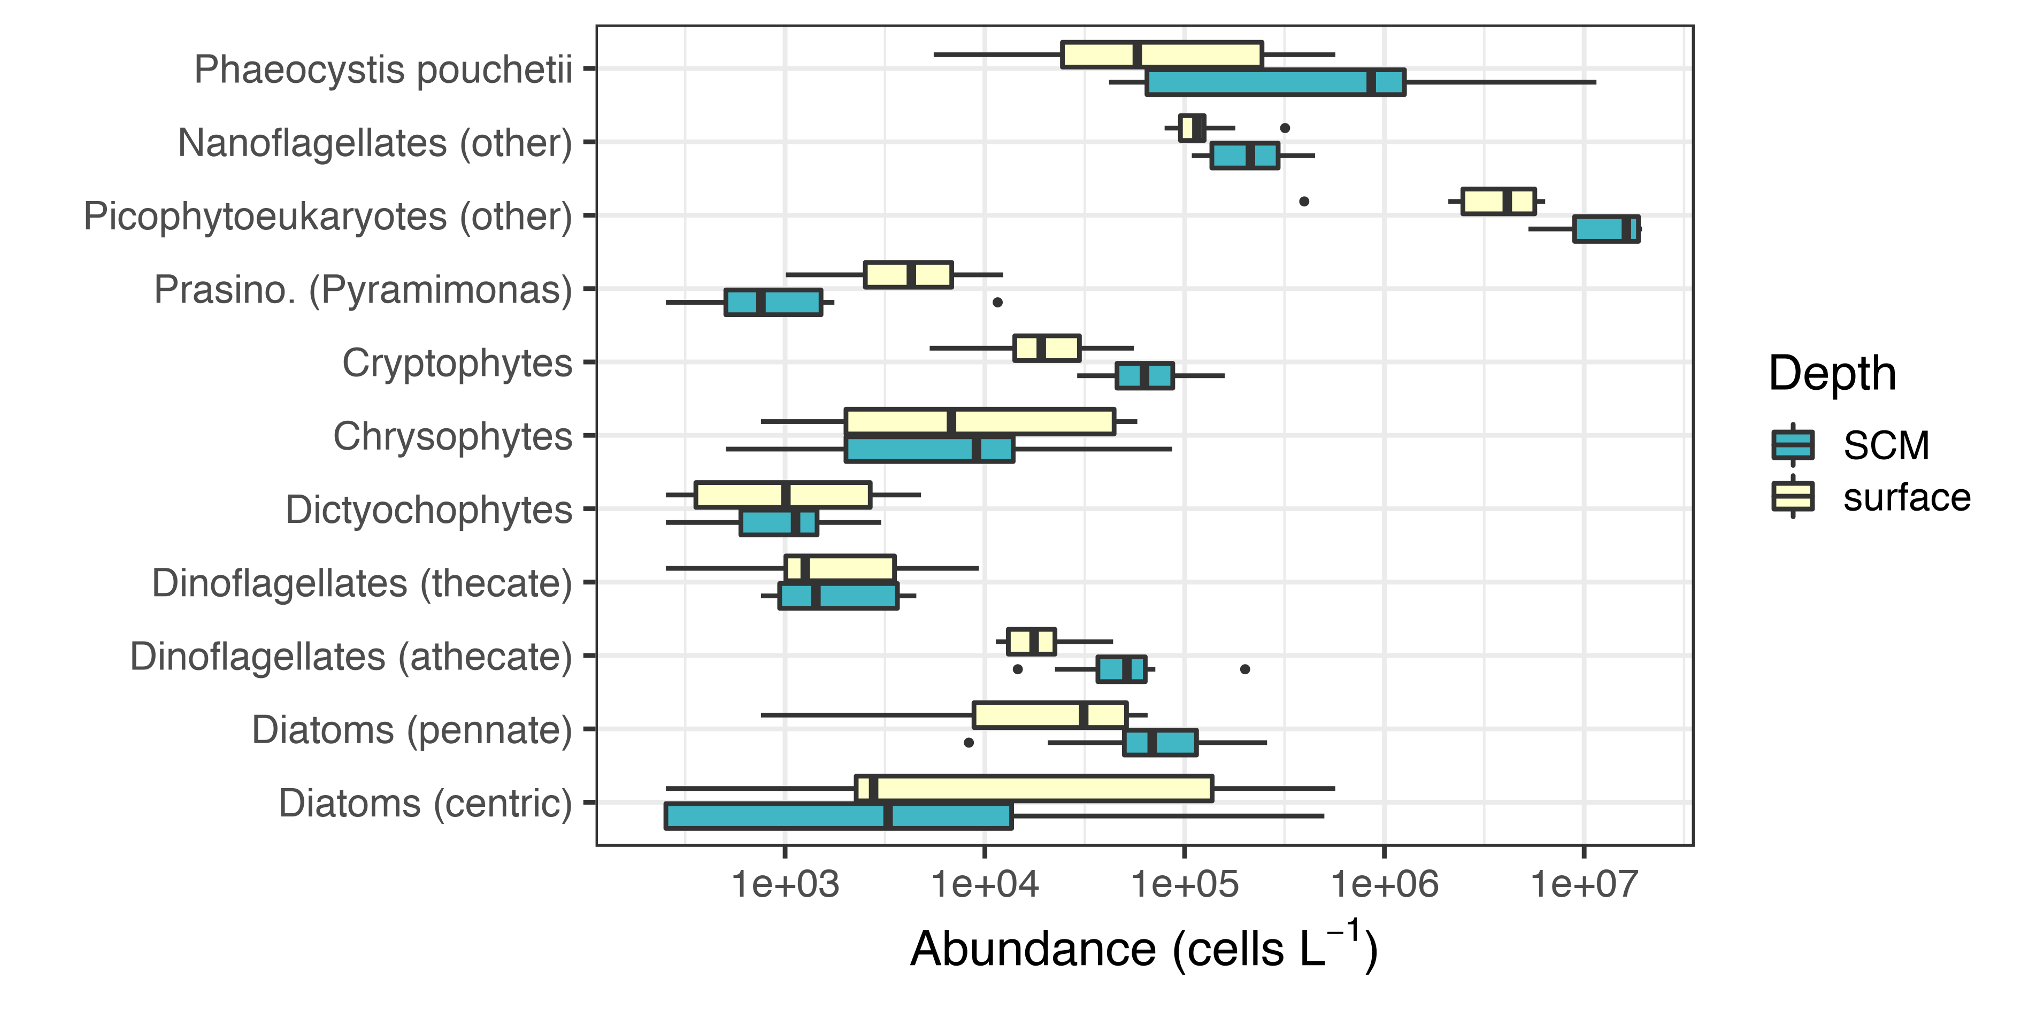
Figure S1. Boxplots of phytoplankton abundances in the near-surface and SCM layers.
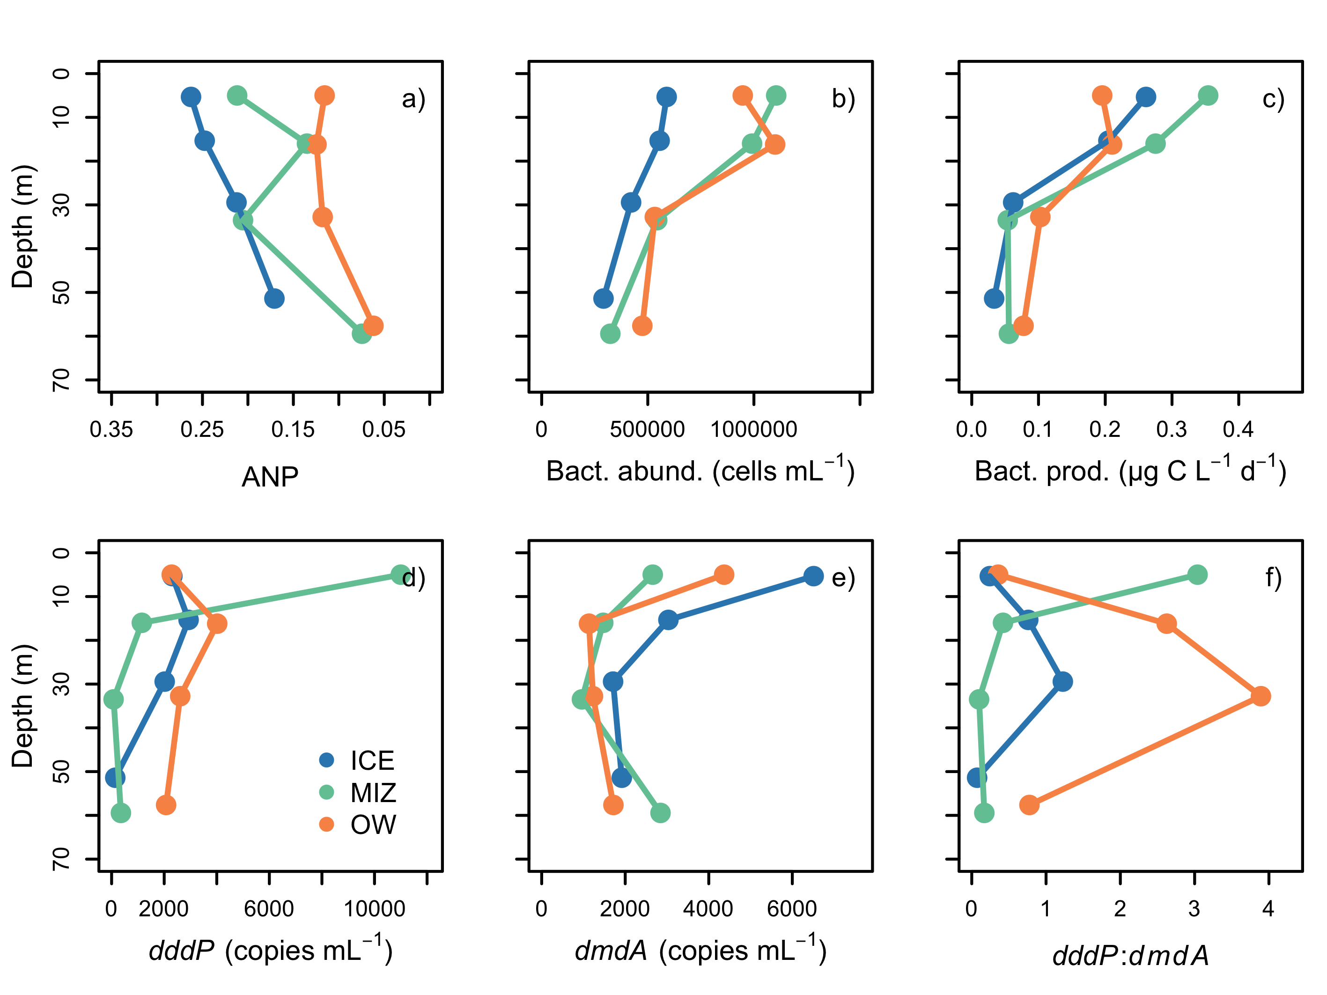
Figure S2. Bacterial abundances and activities. Data correspond to the entire Green Edge dataset. Abundance of the dddP and dmdA genes was measured mostly in leg 1a, transect T1 to T3, with the exception of stations 507 and 519 shown in Figure 9 of the main text.

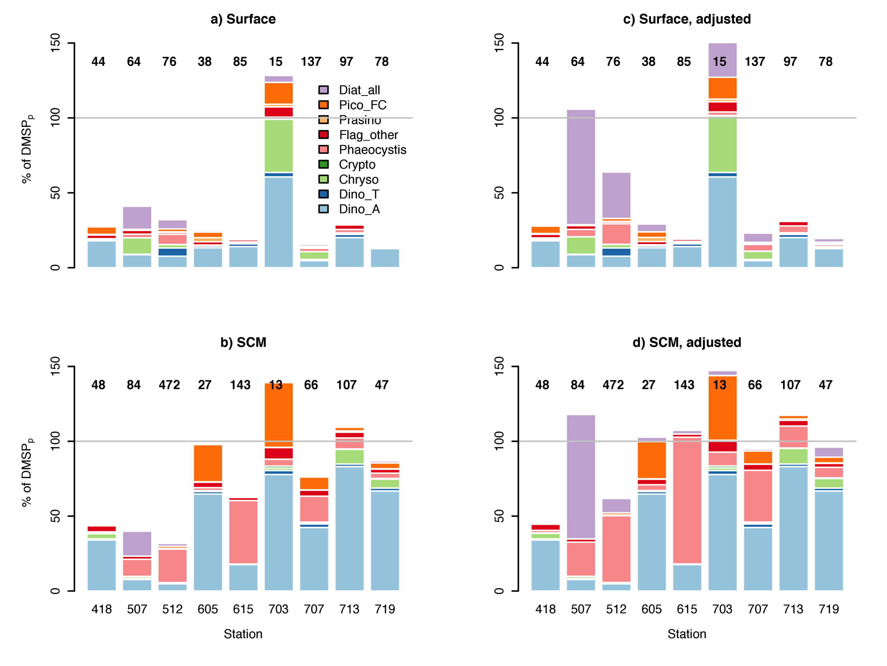
Figure S3. Estimates of particulate DMSP bound to different phytoplankton groups. (a) Surface, (b) SCM, (c) adjusted surface and (d) adjusted SCM. Numbers above each bar represent the particulate DMSP concentration in each sample.

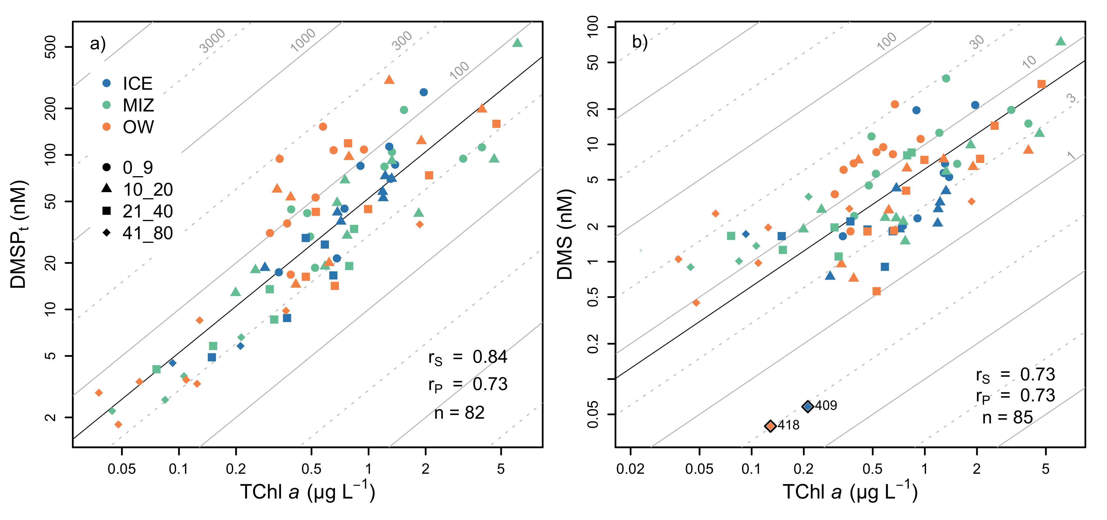
Figure S4. Scatterplots of (a) DMSP_{t} and (b) DMS vs. TChl a.
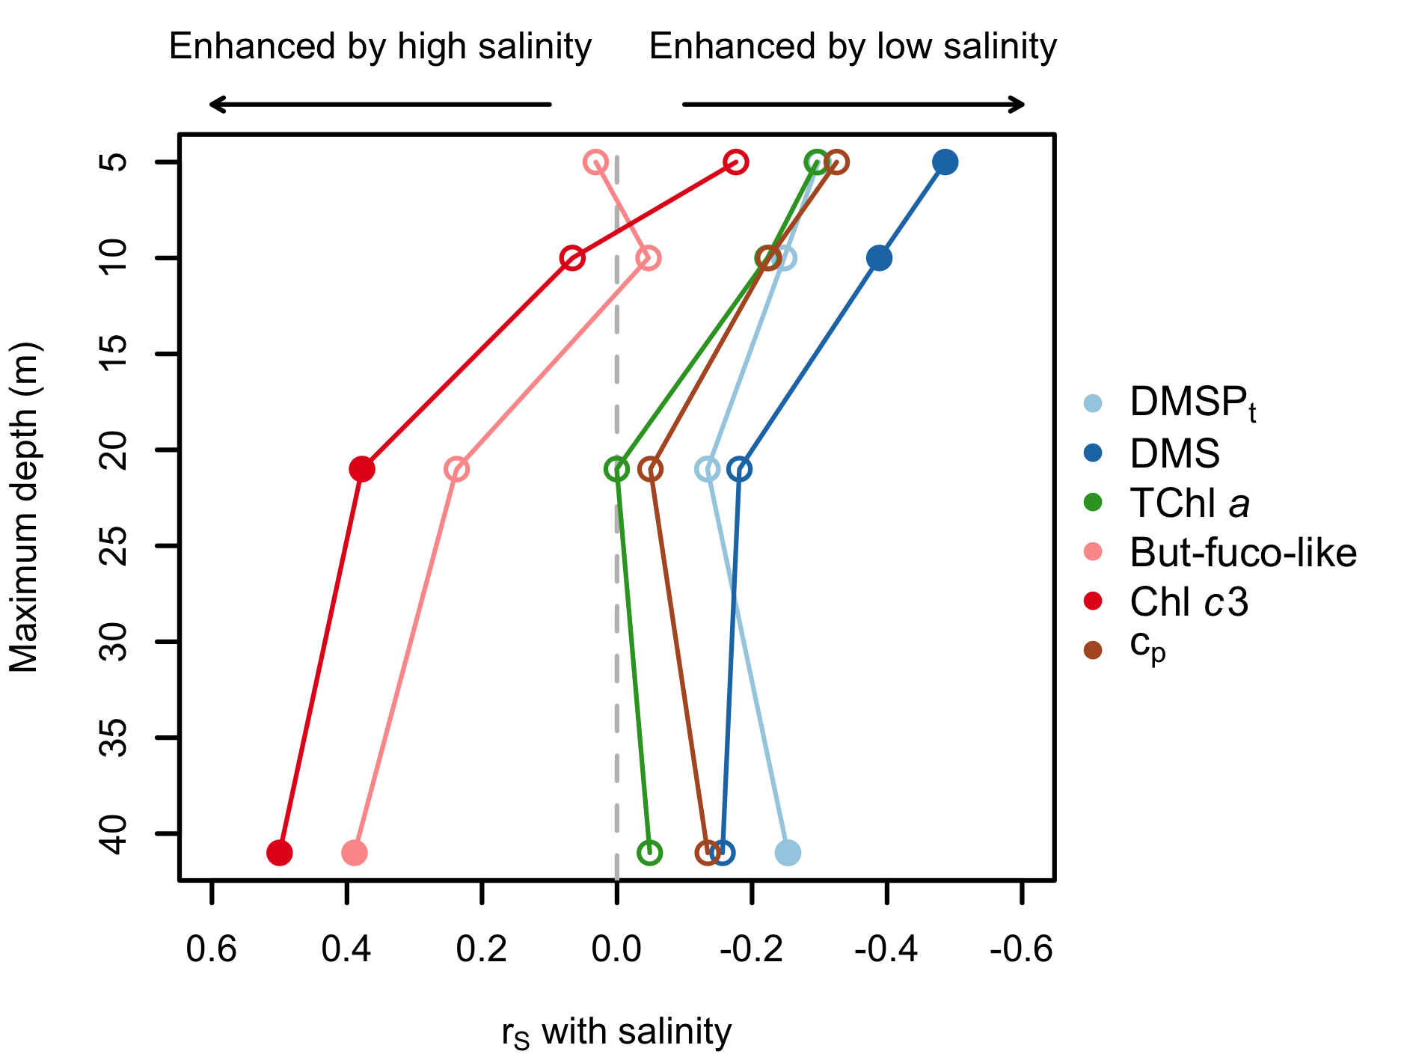
Figure S5. Spearman correlation (r_{S}) between salinity and sulfur/phytoplankton stocks in different layers. Shown are the correlation coefficients between salinity and the six variables listed in the legend. Correlations were computed for different layers extending between the sea surface and variable maximum depths of 5, 10, 21 and 41 m. Filled symbols mark significance at p < 0.05.

