Supplemental Material

A baseline evaluation of oceanographic and sea ice conditions in the Hudson Bay Complex during 2016–2018

J. V. Lukovich¹, Shabnam Jafarikhasragh¹, A. Tefs², Paul G. Myers³, K. Sydor⁴, K. Wong⁴, Julienne C. Stroeve^{1,5,6}, T.A. Stadnyk⁴, D. Babb¹, D.G. Barber¹

¹ Centre for Earth Observation Science, University of Manitoba, Winnipeg, MB, Canada
² Department of Geography, University of Calgary, Calgary, AB, Canada
³ Department of Earth and Atmospheric Sciences, University of Alberta, Edmonton, AB, Canada
⁴ Manitoba Hydro, Winnipeg, Manitoba, Canada
⁵ Centre for Polar Observation and Modelling, Earth Sciences, University College London, London, UK
⁶ National Snow and Ice Data Centre, University of Colorado, Boulder, CO, USA

List of contents:

Figure S1A–D. Monthly sea surface temperature (SST) standardized anomalies relative to the 1982-2010 climatology over the Hudson Bay Complex (HBC) for 2016 (Figure S1A), 2017 (Figure S1B), and 2018 (Figure S1C). The monthly SST standard deviations (°C) for the 1982-2010 climatology are also shown (Figure S1D).

Figures S2A–D. Monthly Sea Ice Concentration (SIC) standardized anomalies relative to the 1982-2010 climatology over the Hudson Bay Complex (HBC) for 2016 (Figure S1A), 2017 (Figure S1B), and 2018 (Figure S1C). The monthly SIC standard deviations (%) for the 1981-2010 climatology are also shown (Figure S1D).

Figure S3. Day of retreat as defined in Table S1 computed using NOAA/NSIDC Climate Data Record of Passive Microwave Sea Ice Concentration, Version 3 for 1982-2010 climatology and 2016-2018 baseline years.

Figure S4. Day of closing as defined in Table S1 in Part II of the baseline evaluation, presented at the end of this document.

Figure S5A–S5D. Maps of monthly mean sea ice drift speed standardized anomalies for 2016 (Figure S5A), 2017 (Figure S5B), and 2018 (Figure S5C) with high(low) ice drift speed regimes depicted by red(blue) shading. The monthly sea ice drift standard deviations (cm/s) for the 1981-2010 climatology are also shown (Figure S5D).

Figure S6A–D. Standardized anomaly maps for absolute value of monthly meridional circulation index (MCI) for 2016 (Figure S6A), 2017 (Figure S6B), and 2018 (Figure S6C). Negative (blue) values indicate reduced meridional or enhanced zonal sea ice drift, while positive (red) values indicate enhanced meridional drift. The monthly MCI standard deviations for the 1981-2010 climatology are also shown (Figure S6D).

Equations

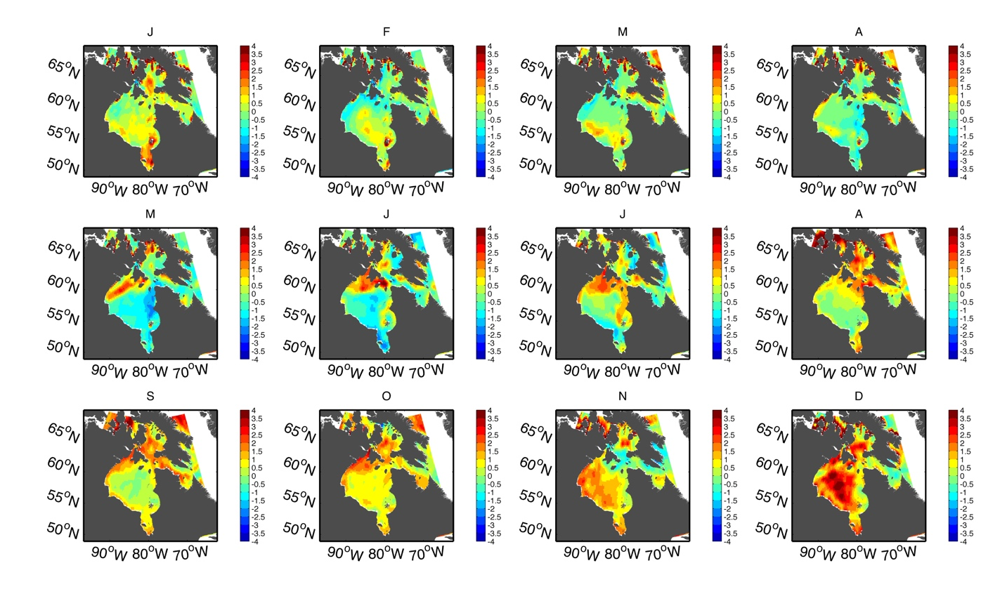

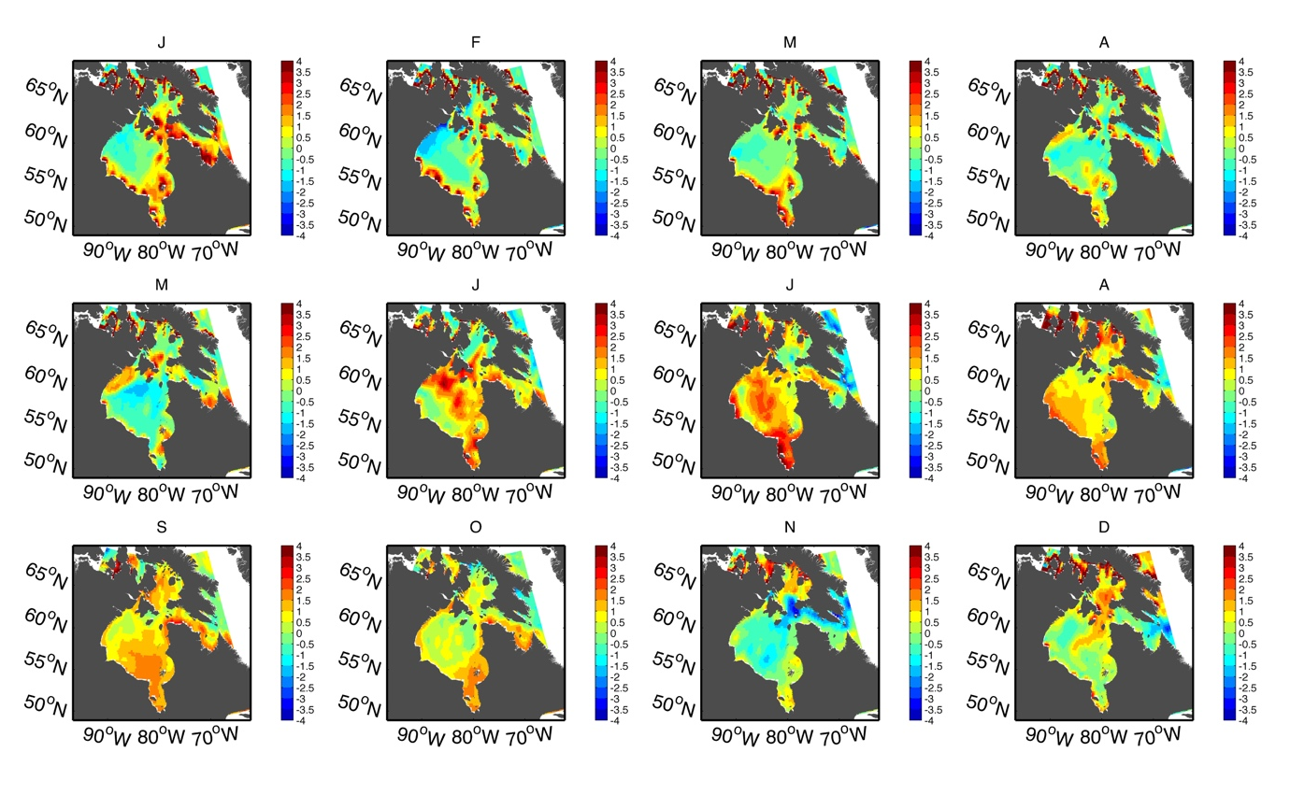
Figure S1A. Maps of monthly sea surface temperature standardized anomalies for 2016. Monthly sea surface temperature (SST) standardized anomalies relative to the 1982-2010 climatology for 2016, with high (low) sea surface temperature regimes depicted by red (blue) shading.

Figure S1B. Maps of monthly sea surface temperature standardized anomalies for 2017. Monthly sea surface temperature (SST) standardized anomalies for 2017, with high (low) sea surface temperature regimes depicted by red (blue) shading.

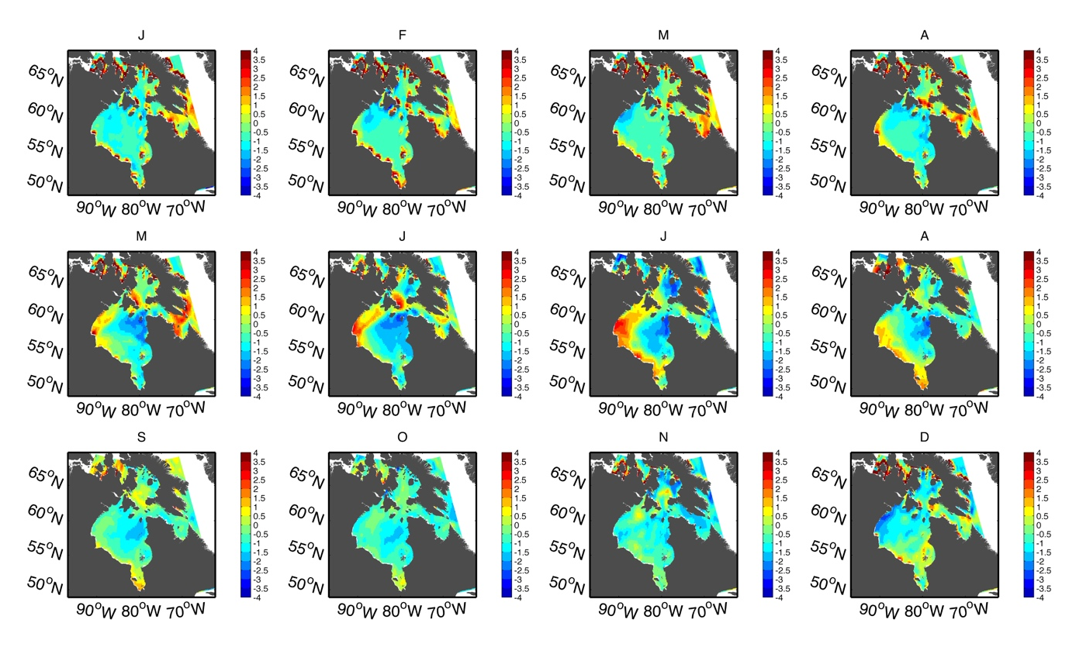

.

Figure S1C. Maps of monthly sea surface temperature standardized anomalies for 2018. Monthly sea surface temperature (SST) standardized anomalies for 2018, with high (low) sea surface temperature regimes depicted by red (blue) shading.
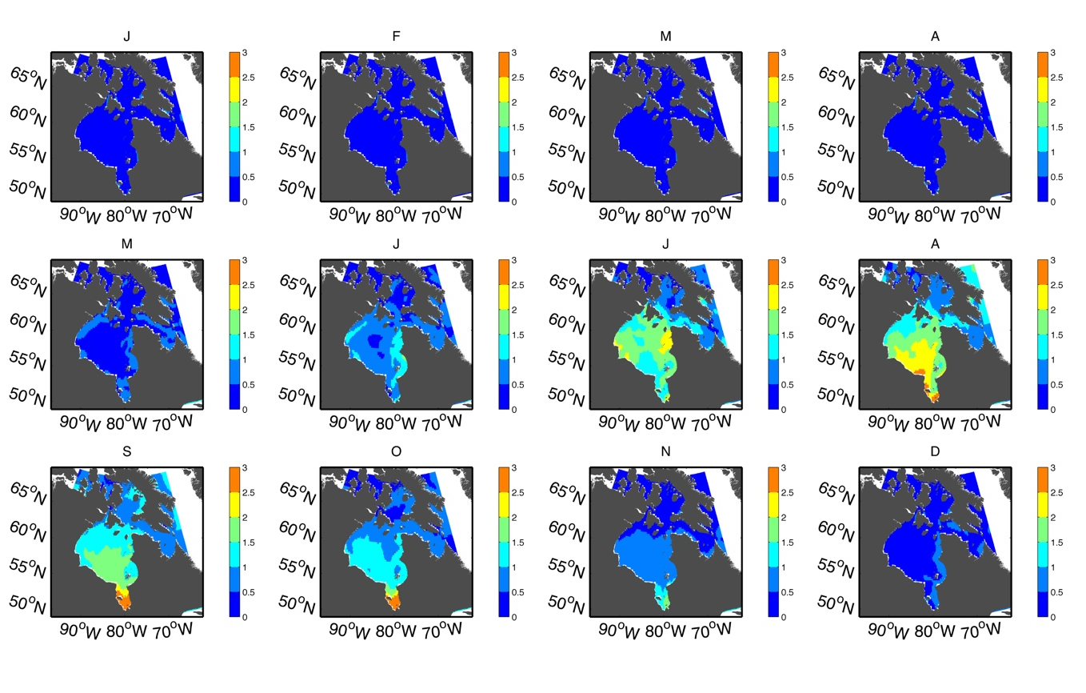

Figure S1D. Maps of standard deviations for monthly sea surface temperature. Standard deviation for SST for 1982-2010 timeframe. It is clear that the SST in warmer months (June, August, September) deviate more from their average value. Units are in [°C].

Figure S2A. Maps of monthly sea ice concentration standardized anomalies for 2016. Depicted are monthly mean sea ice concentration (SIC) standardized anomalies for 2016, with high (low) SIC regimes depicted by red (blue) shading. Black stippling indicates ice-covered (ice-free) regions for 1981-2010 climatology (2016), while red stippling indicates ice-covered (ice-free) regions for 2016 (1981-2010 climatology).

Figure S2B. Maps of monthly sea ice concentration standardized anomalies for 2017. Depicted are monthly mean sea ice concentration (SIC) standardized anomalies for 2017, with high (low) SIC regimes depicted by red (blue) shading. Black stippling indicates ice-covered (ice-free) regions for 1981-2010 climatology (2016), while red stippling indicates ice-covered (ice-free) regions for 2016 (1981-2010 climatology).

Figure S2C. Maps of monthly sea ice concentration standardized anomalies for 2018. Depicted are monthly mean sea ice concentration (SIC) standardized anomalies for 2018, with high (low) SIC regimes depicted by red (blue) shading. Black stippling indicates ice-covered (ice-free) regions for 1981-2010 climatology (2016), while red stippling indicates ice-covered (ice-free) regions for 2016 (1981-2010 climatology).

Figure S2D. Maps of standard deviations for monthly sea ice concentration. NSIDC sea ice concentration standard deviation maps for 1981-2010 climatology. Units are in [%].
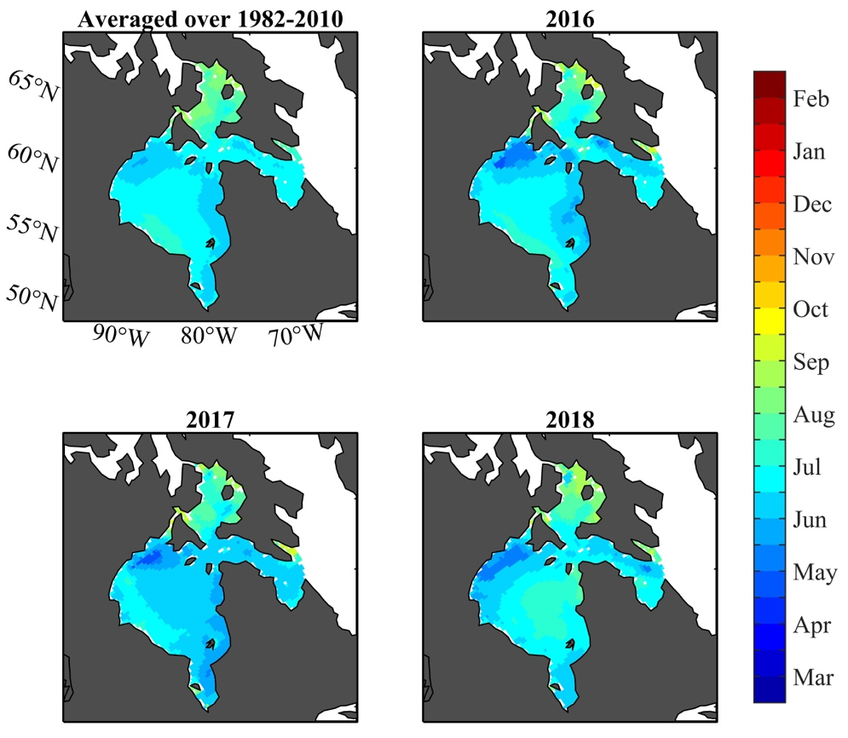
1

Figure S3. Day of retreat for 1981–2010 climatology and 2016–2018 baseline years in the Hudson Bay Complex. Day of retreat computed using NOAA/NSIDC Climate Data Record of Passive Microwave Sea Ice Concentration, Version 3 for 1981-2010 climatology and 2016-2018 baseline years.
1
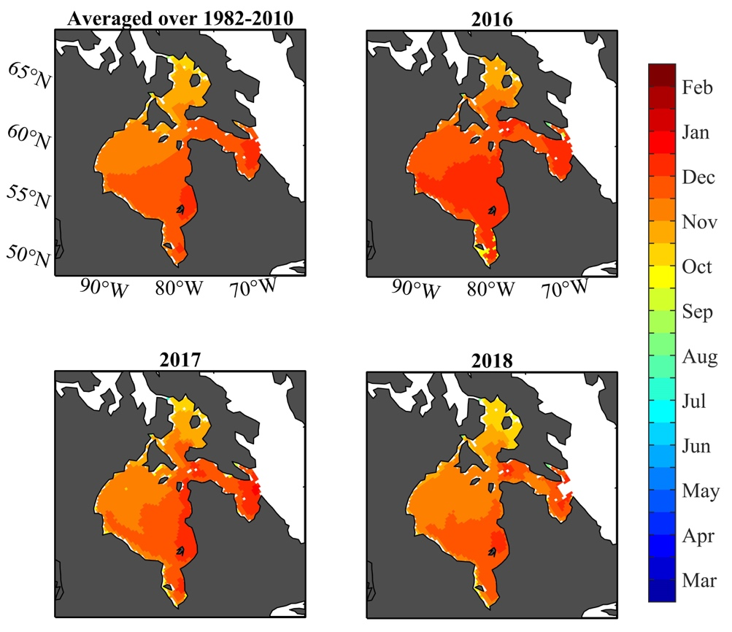

Figure S4. Day of closing for 1981–2010 climatology and 2016–2018 baseline years in the Hudson Bay Complex. Day of closing using NOAA/NSIDC Climate Data Record of Passive Microwave Sea Ice Concentration, Version 3 for 1981-2010 climatology and 2016-2018 baseline years.

Figure S5A. Maps of monthly sea ice drift speed standardized anomalies for 2016. Depicted are monthly mean sea ice drift speed standardized anomalies for 2016, with high(low) ice drift speed regimes depicted by red(blue) shading.

Figure S5B. Maps of monthly sea ice concentration standardized anomalies for 2017. Depicted are monthly mean sea ice drift speed standardized anomalies for 2017, with high(low) ice drift speed regimes depicted by red(blue) shading.

Figure S5C. Maps of monthly sea ice concentration standardized anomalies for 2018. Depicted are monthly mean sea ice drift speed standardized anomalies for 2018, with high(low) ice drift speed regimes depicted by red(blue) shading.

Figure S5D. Maps of standard deviations for monthly sea ice drift speed. NSIDC sea ice drift speed standard deviation maps for 1981-2010 climatology. Units are in [cm/s].

Figure S6A. Maps of monthly meridional circulation index anomalies for 2016. Standardized anomaly maps for absolute value of monthly meridional circulation index in 2016. Negative (blue) values indicate reduced meridional or enhanced zonal sea ice drift, while positive (red) values indicate enhanced meridional drift.

Figure S6B. Maps of monthly meridional circulation index anomalies for 2017. Standardized anomaly maps for absolute value of monthly meridional circulation index in 2017. Negative (blue) values indicate reduced meridional or enhanced zonal sea ice drift, while positive (red) values indicate enhanced meridional drift.

Figure S6C. Maps of monthly meridional circulation index anomalies for 2018. Standardized anomaly maps for absolute value of monthly meridional circulation index in 2018. Negative (blue) values indicate reduced meridional or enhanced zonal sea ice drift, while positive (red) values indicate enhanced meridional drift.

Figure S6D. Maps of standard deviations for monthly meridional circulation index. NSIDC meridional circulation index standard deviation maps for 1981-2010 climatology.

Equations

Spatially discretized maps
$a_{m,y,i}= \frac{\left(x_{m,y,i} - μ_{m,ref,i}\right)}{σ_{m,ref,i}}$ (Eq. 1)

$a_{m,y}$ vector of standard anomalies of variable x, month m, years y, for every grid i (subfigures A-C in Figures S1-S2; Equation 1)
$x_{m,y}$ vector of variable x, month m, year y, for every grid i
$μ_{m,ref}$ vector of averages of variable x, month m, years 1981-2010, for every grid i

Spatially averaged timeseries
$υ_{m,y}= \frac{\sum_{i=1}^{n}{\left(x_{m,y,i} × A_{i}\right)}}{\sum_{i}^{n}{A_{i}}}$ (Eq. 2)
$ν_{m,ref}= \frac{\sum_{i=1}^{n}{\left(μ_{m,ref,i} × A_{i}\right)}}{\sum_{i}^{n}{A_{i}}}$ (Eq. 3)
${IQR}_{m,y}= \left|{p75}_{m,y}- {p25}_{m,y}\right|$ (Eq. 4)
$a_{m,y}= \frac{\sum_{i=1}^{n}{\left(a_{m,y,i} × A_{i}\right)}}{\sum_{i}^{n}{A_{i}}}$ (Eq. 5)

$ν_{m,y}$ mean of variable x, averaged spatially (area-weighted), month m, year y (solid lines in subfigure A in Figures 2, 10-12; Equation 2).
$A$ vector of grid (or sub-basin) areas A, for every grid i
$υ_{m,ref}$ grid averages over years 1981-2010 of variable x, averaged spatially, month m, (dashed line in subfigure A in Figures 2, 10-12; Equation 3)
${IQR}_{m,y}$ absolute difference of 25th and 75th spatial percentile for month m, year y (shaded ranges in subfigure A in Figures 11 and 12; Equation 4)
${pXX}_{m,y}$ spatial percentile XX of empirical CDF of variable x constructed from all grids i, for month m, year y
$a_{m,y}$ anomaly of variable a, averaged spatially (area-weighted), month m, year y (solid lines in subfigure B in Figures 2, 10-12 and values in Figures 1-4; Equation 5)

