Water allocation under climate change: a diagnosis of the Chilean system
Pilar Barría^{1,2}, Ignacio Barría Sandoval³, Carlos Guzman⁴, Cristián Chadwick², Camila Alvarez-Garreton^{5,6}, Raúl Díaz-Vasconcellos², Anahí Ocampo-Melgar², Rodrigo Fuster⁷
¹Departamento de Ciencias de la Ingeniería, Universidad de Los Lagos, Puerto Montt, Chile.
²Facultad de Ciencias Forestales y de la Conservación de la Naturaleza, Universidad de Chile, Santiago, Chile.
³Centro de Investigación GAIA Antártica, Universidad de Magallanes, Punta Arenas, Chile.
⁴Departamento de Ingeniería Hidráulica y Ambiental, Pontificia Universidad Católica de Chile, Santiago, Chile.
⁵Center for Climate and Resilience Research (CR2, FONDAP 15110009), Santiago, Chile.
⁶Department of Civil Engineering, Universidad de La Frontera, Temuco, Chile.
⁷Departamento de Ciencias Ambientales y Recursos Naturales Renovables, Facultad de Ciencias Agronómicas, Universidad de Chile, Santiago, Chile
*pilar.barria@ulagos.cl

List of Contents
Table S1 List of studied basins
Id gauge CAMELS-CL catchments | Name of the catchment | Surface (km²) | Elevation (masl) | Annual precip. 1979-2005 (mm) | Annual precip. 1994-2019 (mm)
4537001 | Río Guatulamé en el Tomé | 2462.8 | 1226 | 279.0 | 248.5
4558001 | Río Limarí en Panamericana | 11422.6 | 1362 | 263.2 | 236.0
5101001 | Río Pedernal en Tejada | 81.1 | 2474 | 412.0 | 370.1
5411001 | Estero Pocuro En El Sifon | 181.0 | 1929 | 514.7 | 470.7
5716001 | Río Angostura en Valdivia de Paine | 1480.8 | 737 | 784.0 | 712.3
5741001 | Estero Puangue En Boqueron | 144.2 | 1062 | 556.8 | 498.9
5746001 | Estero Puangue en Ruta 78 | 1713.4 | 380 | 477.0 | 428.0
5748001 | Rio Maipo En Cabimbao | 14914.8 | 1186 | 667.4 | 604.1
6027001 | Rio Claro En El Valle | 349.4 | 1608 | 1512.5 | 1384.0
6043001 | Estero Alhué en Quilamuta | 801.8 | 702 | 731.3 | 661.2
7116001 | Estero Upeo En Upeo | 367.2 | 1139 | 1566.3 | 1443.3
7123001 | Río Mataquito en Licantén | 5699.9 | 1027 | 1370.4 | 1258.9
7330001 | Rio Perquilauquen En San Manuel | 502.4 | 1129 | 2090.1 | 1967.7
7332001 | Rio Perquilauquen En Gniquen | 1209.0 | 437 | 1660.8 | 1562.8
7335001 | Rio Perquilauquen En Quella | 1686.8 | 276 | 1459.2 | 1372.8
7336001 | Rio Cauquenes En El Arrayan | 622.1 | 283 | 1016.6 | 958.7
7339001 | Río Cauquenes en Desembocadura | 1637.5 | 216 | 945.9 | 888.2
7341001 | Rio Purapel En Nirivilo | 262.8 | 310 | 963.9 | 892.1
7343001 | Rio Purapel En Sauzal | 404.3 | 274 | 911.7 | 844.1
7350001 | Rio Longavi En La Quiriquina | 668.9 | 1400 | 2070.8 | 1941.8
7350003 | Rio Longavi En El Castillo | 466.9 | 1562 | 2109.3 | 1976.0
7354002 | Río Achibueno en La Recova | 894.3 | 1273 | 2043.6 | 1909.0
7357002 | Rio Loncomilla En Bodega | 7078.8 | 201 | 1184.7 | 1110.5
7359001 | Rio Loncomilla En Las Brisas | 9923.7 | 224 | 1279.7 | 1197.2
7372001 | Rio Claro En Camarico | 703.0 | 854 | 1522.0 | 1408.4
7383001 | Río Maule en Forel | 20514.6 | 404 | 1353.6 | 1258.8
8114001 | Rio Cato En Puente Cato | 970.1 | 515 | 1836.8 | 1736.1
8117005 | Río Chillán en Camino a Confluencia | 798.5 | 266 | 1611.4 | 1526.1
8123001 | Rio Itata En Cholguan | 860.1 | 731 | 1848.3 | 1761.8
8124001 | Rio Itata En General Cruz | 1661.9 | 454 | 1669.0 | 1589.9
8124002 | Rio Itata En Trilaleo | 1148.2 | 609 | 1790.0 | 1706.0
8130001 | Rio Renegado En Invernada | 128.6 | 1553 | 2649.7 | 2509.2
8130002 | Rio Diguillin En San Lorenzo (Atacalco) | 204.4 | 1468 | 2507.0 | 2375.6
8132001 | Rio Diguillin En Longitudinal | 1300.5 | 610 | 1943.5 | 1845.3
8134003 | Río Larqui en Santa Cruz de Cuca | 636.1 | 119 | 1172.4 | 1113.1
8135002 | Rio Itata En Balsa Nueva Aldea | 4510.0 | 286 | 1566.3 | 1489.4
8141001 | Río Itata en Coelemu | 10405.2 | 297 | 1579.1 | 1494.7
8220001 | Rio Andalien Camino A Penco | 750.3 | 217 | 1160.3 | 1103.5
8304001 | Río Lonquimay Antes Junta Río Bio Bio | 466.7 | 1372 | 2416.3 | 2338.5
8317001 | Rio Biobio En Rucalhue | 7252.5 | 1389 | 2152.5 | 2069.5
8317002 | Rio Lirquen En Cerro El Padre | 103.4 | 610 | 2377.3 | 2285.4
8323001 | Río Duqueco en Cerrillos | 1339.5 | 551 | 1897.5 | 1815.6
8323002 | Rio Duqueco En Villucura | 817.7 | 942 | 2099.1 | 2011.0
8330001 | Río Mulchén en Mulchén | 428.1 | 390 | 2108.9 | 2027.1
8332001 | Río Bureo en Mulchén | 540.8 | 581 | 2361.3 | 2269.4
8334001 | Río Bio Bio en Coihue | 11147.8 | 1162 | 2045.4 | 1964.2
8342001 | Rio Renaico En Longitudinal | 688.2 | 814 | 2527.0 | 2437.4
8343001 | Rio Mininco En Longitudinal | 440.2 | 427 | 1939.4 | 1868.5
8351001 | Rio Malleco En Collipulli | 415.1 | 796 | 2399.2 | 2319.2
8358001 | Rio Vergara En Tijeral | 2537.0 | 242 | 1484.7 | 1431.7
8383001 | Rio Laja En Puente Perales | 3428.2 | 1443 | 1932.2 | 1834.7
8394001 | Rio Biobio En Desembocadura | 24269.9 | 600 | 1818.8 | 1743.0
8821002 | Río Elicura en Puente Elicura | 123.1 | 731 | 1748.9 | 1690.2
8910001 | Rio Lleu-Lleu En Desague Lago Lleu-Lleu | 580.2 | 297 | 1379.9 | 1339.5
9102001 | Rio Lumaco En Lumaco | 853.1 | 260 | 1178.7 | 1141.9
9104001 | Rio Traiguen En Victoria | 93.8 | 498 | 1795.7 | 1736.0
9104002 | Río Dumo en Santa Ana | 393.1 | 450 | 1741.0 | 1682.9
9106001 | Rio Quino En Longitudinal | 276.7 | 514 | 1892.0 | 1833.1
9113001 | Rio Quillen En Galvarino | 710.0 | 242 | 1321.4 | 1284.7
9116001 | Rio Cholchol En Cholchol | 5047.6 | 293 | 1340.4 | 1301.4
9123001 | Rio Cautin En Rari-Ruca | 1306.1 | 1098 | 2748.0 | 2667.9
9127001 | Rio Muco En Puente Muco | 650.3 | 469 | 1977.3 | 1928.4
9129002 | Rio Cautin En Cajon | 2755.6 | 635 | 2215.8 | 2154.1
9131001 | Rio Quepe En Vilcun | 379.0 | 876 | 2556.2 | 2495.9
9134001 | Río Huichahue en Faja | 348.0 | 556 | 2171.3 | 2121.4
9135001 | Rio Quepe En Quepe | 1665.6 | 379 | 1994.0 | 1948.6
9140001 | Rio Cautin En Almagro | 5547.3 | 385 | 1969.0 | 1918.4
9404001 | Rio Allipen En Los Laureles | 1675.1 | 1054 | 2340.4 | 2282.4
9412001 | Rio Trancura En Curarrehue | 356.9 | 1203 | 3243.0 | 3197.0
9414001 | Rio Trancura Antes Rio Llafenco | 1379.4 | 1171 | 2846.7 | 2799.4
9416001 | Rio Liucura En Liucura | 349.0 | 1076 | 2676.7 | 2629.5
9420001 | Rio Tolten En Villarica | 2933.6 | 995 | 2783.2 | 2737.2
9433001 | Rio Puyehue En Quitratue | 153.5 | 171 | 1870.9 | 1834.6
9434001 | Rio Donguil En Gorbea | 769.7 | 199 | 1874.2 | 1837.5
9436001 | Río Mahuidanche en Santa Ana | 383.9 | 174 | 1807.6 | 1773.9
10102001 | Río Liquine en Liquine | 367.9 | 1150 | 3172.6 | 3132.6
10111001 | Río San Pedro en Desagüe Lago Riñihue | 4385.5 | 901 | 2850.7 | 2814.9
10121001 | Río Collileufú een Los Lagos | 626.2 | 170 | 1600.0 | 1575.6
10134001 | Rio Cruces En Rucaco | 1802.6 | 251 | 2115.5 | 2079.2
10137001 | Río Inaque en Mafil | 539.0 | 166 | 1793.0 | 1766.6
10304001 | Río Calcurrupe en Desembocadura | 1725.8 | 982 | 3062.3 | 3026.8
10306001 | Río Nilahue en Mayay | 308.6 | 868 | 3400.4 | 3373.6
10328001 | Rio Pilmaiquen En San Pablo | 2473.2 | 337 | 2778.2 | 2752.0
10340001 | Río Rahue en Desagüe Lago Rupanco | 1001.3 | 351 | 2807.8 | 2783.4
10356001 | Río Negro en Chahuilco | 2279.7 | 136 | 1562.9 | 1540.3
10362001 | Río Damas en Tacamó | 466.8 | 122 | 1619.6 | 1600.8
10364001 | Río Rahue en Forrahue | 5603.0 | 140 | 1858.4 | 1836.1

Table S2 List of CMIP5 models used to obtain climate and runoff projections
N° | GCM | Climate modelling centre and location | Ensemble member | Resolution | Reference
1 | ACCESS1-0 | Centre for Australian Weather and Climate Research, Australia | r1i1p1 | Atmospheric: 1.875°x1.25°, Ocean: 1°x1° | Dix et al. (2013)
2 | ACCESS1-3 | Centre for Australian Weather and Climate Research, Australia | r1i1p1 | Atmospheric: 1.875°x1.25°, Ocean: 1°x1° | Dix et al. (2013)
3 | BNU-ESM | College of Global Change and Earth System Science, Beijing Normal University, China | r1i1p1 | Atmospheric: 2.7906°x2.8125°, Ocean: 1°x1° | Ji et al. (2014)
4 | CCSM4 | National Centre for Atmospheric Research, USA | r1i1p1, r2i1p1, r3i1p1, r4i1p1, r5i1p1, r6i1p1 | Atmospheric: 0.9424°x1.25°, Ocean: 1°x1° | Meehl et al. (2012)
5 | CESM1-BGC | Community Earth System Model Contributors | r1i1p1 | Atmospheric: 0.9424°x1.25°, Ocean: 1°x1° | Gent et al. (2011)
6 | CESM1-CAM5 | Community Earth System Model Contributors | r1i1p1, r2i1p1, r3i1p1 | Atmospheric: 0.9424°x1.25°, Ocean: 1°x1° | Gent et al. (2011)
7 | CMCC-CMS | Centro Euro-Mediterraneo per I Cambiamenti Climatici, Italy | r1i1p1 | Atmospheric:3.7111°x3.75° | Vichi et al. (2011)
8 | CMCC-CM | Centro Euro-Mediterraneo per I Cambiamenti Climatici, Italy | r1i1p1 | Atmospheric: 0.7484°x0.75° | Vichi et al. (2011)
9 | CNRM-CM5 | Centre National de Recherches Meteorologiques, France | r1i1p1 | Atmospheric: 1.4008°x1.40625°, Ocean: 1°x1° | Voldoire et al. (2013)
10 | CSIRO-Mk3-6-0 | Commonwealth Scientific and Industrial Research Organization in collaboration with Queensland Climate Change Centre of Excellence, Australia | r1i1p1, r2i1p1, r3i1p1, r4i1p1, r5i1p1, r6i1p1, r7i1p1, r8i1p1, r9i1p1, r10i1p1 | Atmospheric: 1.8653°x1.875°, Ocean: 1.875°x1.875° | Rotstayn et al. (2012)
11 | CanESM2 | Canadian Centre for Climate Modelling and Analysis, Canada | r1i1p1, r2i1p1, r3i1p1, r4i1p1, r5i1p1 | Atmospheric: 2.7906°x2.8125°, Ocean: 0.9303°x1.1407° | Arora et al. (2011)
12 | EC-EARTH | EC-EARTH consortium, Europe | r2i1p1, r8i1p1, r9i1p1, r12i1p1 | Atmospheric: 1.1215°x1.125° | Hazeleger et al. (2011)
13 | FGOALS-g2 | LASG, Institute of Atmospheric Physics, Chinese Academy of Sciences and CESS, Tsinghua University, China | r1i1p1 | Atmospheric: 2.7906°x2.8125°, Ocean: 1°x1° | Li et al. (2013)
14 | FGOALS-s2 | LASG, Institute of Atmospheric Physics, Chinese Academy of Sciences, China, The First Institute of Oceanography, SOA, China | r1i1p1 | Atmospheric: 1.6590°x2.8125°, Ocean: 1°x1° | Bao et al. (2013)
15 | FIO-ESM | The First Institute of Oceanography, SOA, China | r1i1p1, r2i1p1, r3i1p1 | Atmospheric: 2°x2° | Qiao et al. (2013)
16 | GFDL-CM3 | NOAA Geophysical Fluid Dynamics Laboratory, USA | r1i1p1 | Atmospheric: 2°x2.5°, Ocean: 0.3344°x1° | Donner et al. (2011)
17 | GFDL-ESM2G | NOAA Geophysical Fluid Dynamics Laboratory, USA | r1i1p1 | Atmospheric: 2.0225°x2°, Ocean: 0.375°x1° | Dunne et al. (2012)
18 | GFDL-ESM2M | NOAA Geophysical Fluid Dynamics Laboratory, USA | r1i1p1 | Atmospheric: 2.0225°x2.5°, Ocean: 0.3344°x1° | Dunne et al. (2012)
19 | GISS-E2-H-CC | NASA Goddard Institute for Space Studies, USA | r1i1p1 | Atmospheric: 2°x2.5°, Ocean: 1°x1° | Schmidt et al. (2006)
20 | GISS-E2-H-p1 | NASA Goddard Institute for Space Studies, USA | r1i1p1, r2i1p1, r3i1p1, r4i1p1, r5i1p1 | Atmospheric: 2°x2.5°, Ocean: 1°x1° | Schmidt et al. (2006)
21 | GISS-E2-H-p2 and GISS-E2-H-p3 | NASA Goddard Institute for Space Studies, USA | r1i1p2, r1i1p3, r2i1p2, r2i1p3, r3i1p2, r3i1p3, r4i1p2, r4i1p3, r5i1p2, r5i1p3 | Atmospheric: 2°x2.5°, Ocean: 1°x1° | Schmidt et al. (2006)
22 | GISS-E2-R-CC | NASA Goddard Institute for Space Studies, USA | r1i1p1 | Atmospheric: 2°x2.5°, Ocean: 1°x1.25° | Schmidt et al. (2006)
23 | GISS-E2-R-p1 | NASA Goddard Institute for Space Studies, USA | r1i1p1, r2i1p1, r3i1p1, r4i1p1, r5i1p1, r6i1p1 | Atmospheric: 2°x2.5°, Ocean: 1°x1.25° | Schmidt et al. (2006)
24 | GISS-E2-R-p2 and GISS-E2-R-p3 | NASA Goddard Institute for Space Studies, USA | r1i1p2, r1i1p3, r2i1p2, r2i1p3, r3i1p2, r3i1p3, r4i1p2, r4i1p3, r5i1p2, r5i1p3, r6i1p3 | Atmospheric: 2°x2.5°, Ocean: 1°x1.25° | Schmidt et al. (2006)
25 | HadGEM2-AO | National Institute of Meteorological Research, Korea Meteorological Administration, Korea | r1i1p1 | Atmospheric: 1.25°x1.875°, Ocean: 1°x1° | Martin et al. (2011)
26 | HadGEM2-CC | Met Office Hadley Centre, UK | r1i1p1 | Atmospheric: 1.25°x1.875°, Ocean: 1°x1° | Martin et al. (2011)
27 | HadGEM2-ES | Met Office Hadley Centre, UK | r1i1p1, r2i1p1, r3i1p1, r4i1p1 | Atmospheric: 1.25°x1.875°, Ocean: 1°x1° | Collins et al. (2011)
28 | IPSL-CM5A-LR | Institut Pierre Simon Laplace, France | r1i1p1, r2i1p1, r3i1p1, r4i1p1 | Atmospheric: 1.8947°x3.75°, Ocean: 2°x2° | Dufresne et al. (2013)
29 | IPSL-CM5A-MR | Institut Pierre Simon Laplace, France | r1i1p1 | Atmospheric: 1.2676°x2.5°, Ocean: 2°x2° | Dufresne et al. (2013)
30 | IPSL-CM5B-LR | Institut Pierre Simon Laplace, France | r1i1p1 | Atmospheric: 1.8947°x3.75°, Ocean: 2°x2° | Dufresne et al. (2013)
31 | MIROC-ESM-CHEM | Japan Agency for Marine-Earth Science and Technology, Atmosphere and Ocean Research Institute (The University of Tokyo), and National Institute for Environmental Studies, Japan | r1i1p1 | Atmospheric: 2.7906°x2.8125°, Ocean: 0.5582°x1.40625° | Watanabe et al. (2011)
32 | MIROC-ESM | Japan Agency for Marine-Earth Science and Technology, Atmosphere and Ocean Research Institute (The University of Tokyo), and National Institute for Environmental Studies, Japan | r1i1p1 | Atmospheric: 2.7906°x2.8125°, Ocean: 0.5582°x1.40625° | Watanabe et al. (2011)
33 | MIROC5 | Japan Agency for Marine-Earth Science and Technology, Atmosphere and Ocean | r1i1p1, r2i1p1, r3i1p1 | Atmospheric:1.4008°x1.40625°, Ocean: 0.5°x1.40625° | Watanabe et al. (2011)
34 | MPI-ESM-LR | Max Planck Institute for Meteorology, Germany | r1i1p1, r2i1p1, r3i1p1 | Atmospheric:1.8653°x1.875° | Giorgetta et al. (2013)
35 | MPI-ESM-MR | Max Planck Institute for Meteorology, Germany | r1i1p1, r2i1p1, r3i1p1 | Atmospheric:1.8653°x1.875° | Giorgetta et al. (2013)
36 | MRI-CGCM3 | Meteorological Research Institute, Japan | r1i1p1 | Atmospheric:1.8653°x1.875° | Yukimoto et al. (2012)
37 | NorESM1-ME | Norwegian Climate Centre, Norway | r1i1p1 | Atmospheric:1.8947°x2.5° | Iversen et al. (2013)
38 | NorESM1-M | Norwegian Climate Centre, Norway | r1i1p1 | Atmospheric:1.8947°x2.5° | Iversen et al. (2013)
39 | bcc-csm1-1-m | Beijing Climate Center, China Meteorological Administration, China | r1i1p1 | Atmospheric:2.7906°x2.8125°, Ocean: 1°x1° | Wu (2012)
40 | bcc-csm1-1 | Beijing Climate Center, China Meteorological Administration, China | r1i1p1 | Atmospheric:2.7906°x2.8125°, Ocean: 1°x1° | Wu (2012)
41 | inmcm4 | Russian Institute for Numerical Mathematics, Russia | r1i1p1 | Atmospheric:1.5°x2°, Ocean: 0.5°x1° | Volodin et al. (2010)

Text S1
The information on granted water use rights (WURs) used for this study was obtained from a consultation to the Chilean Water Directorate (in spanish DGA), under the Transparency Law website (https://www.portaltransparencia.cl/PortalPdT/web/guest/ley-de-transparencia), which aims to provide public access to information produced by governmental offices. Although there is a public granted WURs database published in the DGA website (https://dga.mop.gob.cl/productosyservicios/derechos_historicos/Paginas/default.aspx), the several shortcomings that affect that information prevented this study to considered it for the analyses. As the aim of the public granted WURs database is to provide traceability of all the administrative processes that have affected WURs historically, there are several duplicates WURs, which are not identified in the database. These studies also indicated that there are a number of WURs with non-volumetric information (water shares), with mistaken coordinates, and old WURs which have not been normalized, nor included in the DGA database. To estimate the actual Chilean water demand, the DGA generated debugged WURs reports, which are the official information internally used to estimate water availability and grant new WURs. The debugged DGA WURs reports deleted the duplicates WURs, systematize the non-volumetric WURs transforming them from water shares to l/s, and corrected their coordinates. However, the WURs granted before the WC81 are not included in that database, thus it is still an underestimation of the total water demand. This official debugged WURs database (hereafter the DGA WURs database) was used in this assessment to calculate que Indices of Anthropic Intervention (IAI).
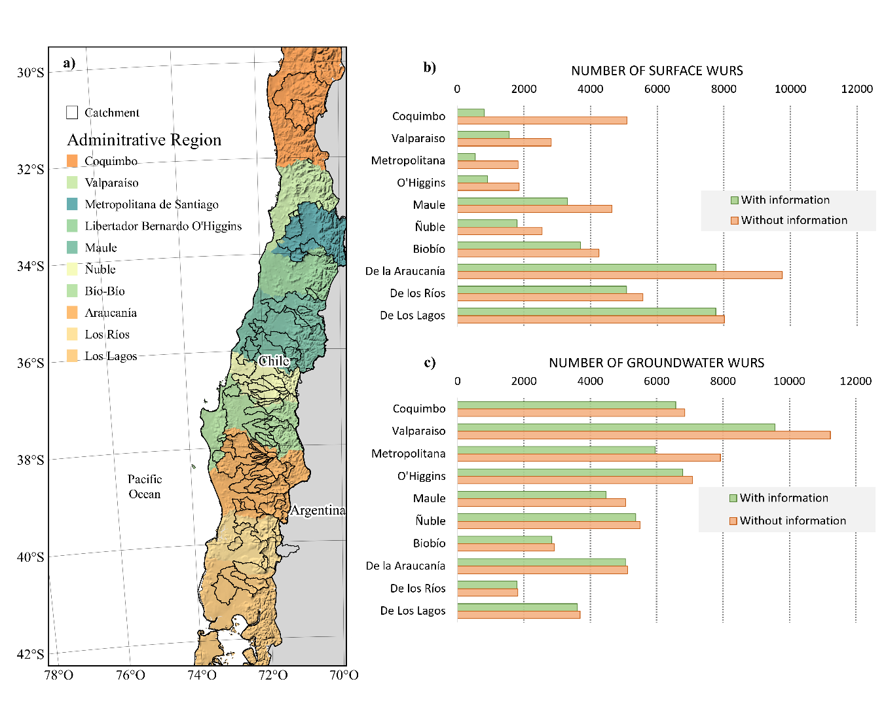
Figure S1. Distribution of the Public DGA WURs database within the administrative regions of the study zone. a) Map indicating the location of basins and administrative regions of the study zone, b) Comparison of surface WURs with and without coordinates information, c) Comparison of groundwater WURs with and without coordinates information

Figure S2. Evaluation of the GR2M model in the 87 catchments using the NSE and R2 coefficients

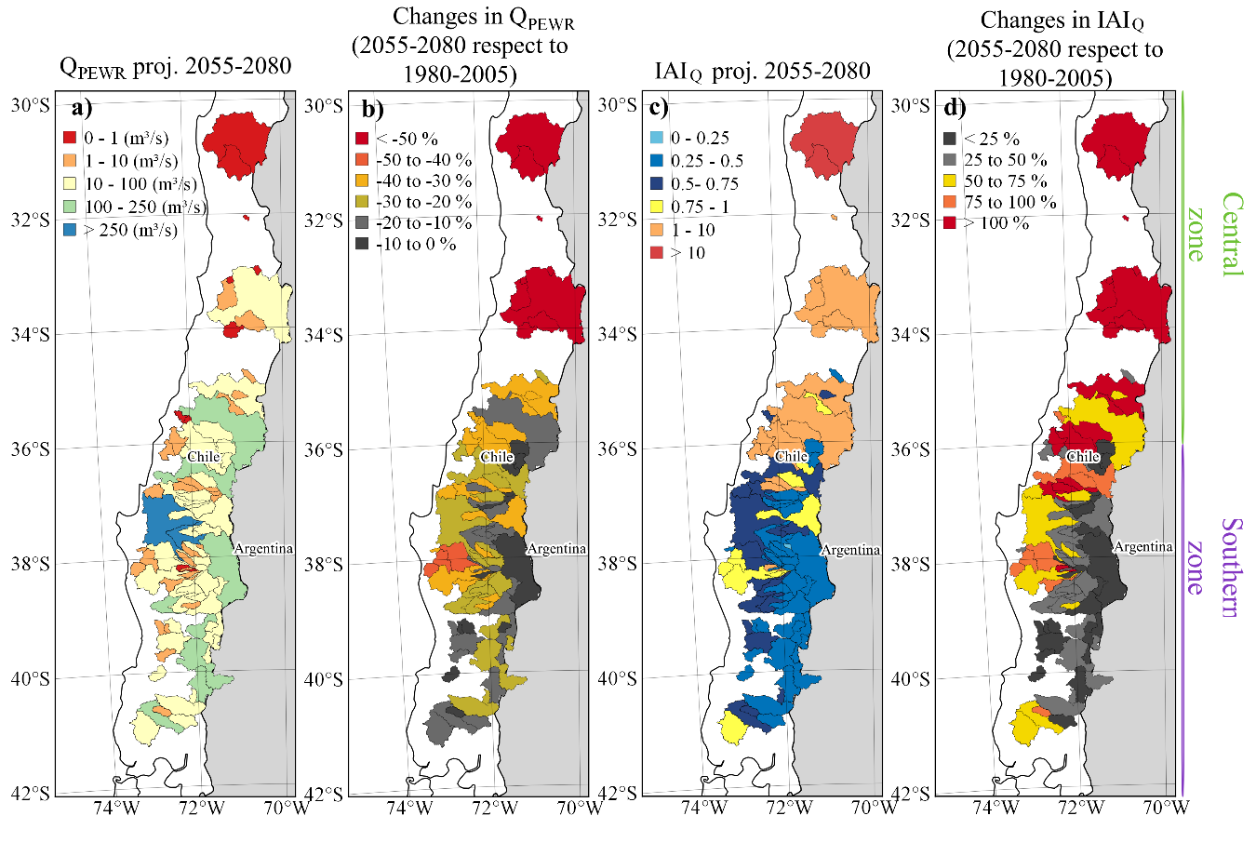
Figure S3 Water availability under the RCP4.5 scenario for granting permanently exercisable water use rights (Q_{PEWR}) and indices of anthropic intervention (IAI_{Q}). The indices were calculated from model-based annual runoff projections considering: a) Q_{PEWR} for the 2055-2080 period, b) Changes in the Q_{PEWR} between the 2055-2080 and 1980-2005 periods, c) IAI_{Q} for the 2055-2080 period and d) Changes in the IAI_{Q} between the 2055-2080 and the 1980-2005 periods.

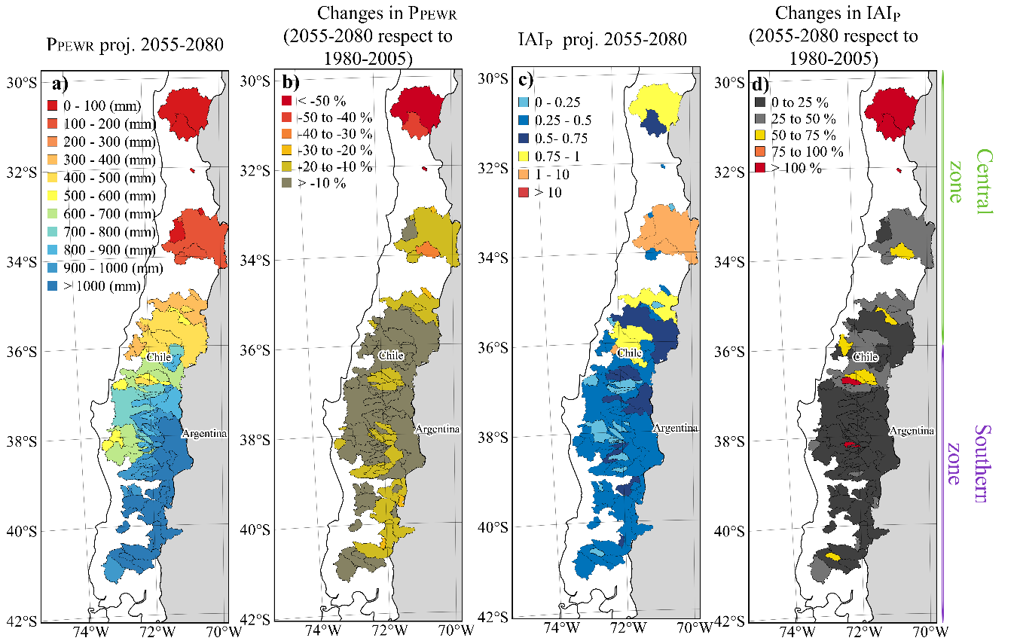
Figure S4 Rainfall available under the RCP4.5 scenario for granting permanently exercisable water rights (P_{EWR}) and indices of anthropic intervention (IAIP). The indices were calculated using projected annual rainfall considering: a) P_{EWR} for the 2055-2080 period, b) Changes in the PEWR between the 2055-2080 and 1980-2005 period, c) IAI_{P} for the 2055-2080 period and d) Changes in the IAI_{P} between the 2055-2080 and the 1980-2005 period.
Figure S5. Calculations of number of overallocated basins. The overallocated obtained using the debugged and the official WURs database considering the a) IAIQ and the b) IAIP indices.

