Supplemental Material
Atmospheric oil and natural gas hydrocarbon trends in the Northern Colorado Front Range are notably smaller than inventory emissions reductions

Samuel J. Oltmans^{1*}, Lucy C. Cheadle², Detlev Helmig³, Hélène Angot⁴, Gabrielle Pétron^{5,1}, Stephen A. Montzka¹, Edward J. Dlugokencky¹, Benjamin Miller^{5,1}, Bradley Hall¹, Russell C. Schnell^{5,1}, Jonathan Kofler^{5,1}, Sonja Wolter^{5,1}, Molly Crotwell^{5,1}, Carolina Siso^{5,1}, Pieter Tans¹, Arlyn Andrews¹
¹ NOAA/ESRL Global Monitoring Laboratory, Boulder, Colorado USA
² P.O. Box 2815, Sacramento, California USA
³ Boulder AIR, Boulder, Colorado, USA
⁴ INSTAAR, University of Colorado, Boulder, Colorado USA
⁵ CIRES, University of Colorado, Boulder, Colorado USA

*Corresponding author: ¹ samuel.j.oltmans@noaa.gov
List of Contents
Figures
Figure S1: Monthly propane mole fractions at NWR for 2012-2017. The horizontal red line in each box is the median, the box spans the 25th and 75th percentiles, the vertical bars the 5th and 95th percentiles, the red pluses values >95th percentile, and the green dots are the mean. N = the number of flask sample observations.

Figure S2: PSCF for the ratio of i-pentane/n-pentane <1 for 2007-2016 (all seasons; n = 2520) in flasks collected during daytime hours at BAO (black dot).

Figure S3: Monthly mole fractions of methane at BAO and NWR for 2008-2015. The box whisker format is the same as in Fig. S1.

Figure S4: Correlation between BAO residual methane (ppm) and propane (ppb) for samples with wind directions from the NE quadrant for 2007-2012 (top left panel) and 2013-2016 (top right panel), and for all daytime samples for 2007-2012 (bottom left panel) and 2013-2016 (bottom right panel).

Figure S5: Photochemical season (May-Sept) mole fractions of methane at NWR (left panel) and BAO (right panel) for 2008-2015 for all daytime samples. The box whisker format is as in Fig. S1.

Figure S6: Ratio of the monthly median mole fractions of methane at BAO and NWR for 2008-2016 for all daytime samples. For each year, there are twelve monthly values (except 2016 where only January-June had samples), and the plotted symbols represent the variability of the twelve-monthly values, but do not include the variability of individual samples within the month. The box whisker format is the same as in Fig. S1.

Figure S7: i-pentane as a function of n-pentane at BAO for photochemical season daytime samples, color-coded for the concurrent propane mole fraction in the sample.
Figure S8: Ratio of the mole fractions of i-pentane to n-pentane at BAO for the years 2008-2015 for the full year (left panel) and photochemical season (right panel) for all daytime samples. The box whisker format is the same as in Fig. S1.

Figure S9: Mole fractions of acetylene at BAO for the years 2008-2015 for the full year (left panel) and photochemical season (right panel). Note the different y-axis scale on the two panels. The box whisker format is the same as in Fig. S1.

Figure S10: Ratio of acetylene/i-pentane (left panel) and acetylene/propane (right panel) mole fractions for samples with wind directions from the south sector. Note the different y-axis scale on the two panels. The box whisker format is as in Fig. S1.

Tables
Table S1: Number of flask samples collected each year at the BAO tower. The number of days on which samples were collected is also shown. During certain periods (primarily 2008-2012), samples were collected in pairs so that the number of days with samples is less than the total number of samples.

Table S2: Trend statistics for propane mole fractions at BAO for 2008-2015 for daytime samples with wind directions from the south sector.

Table S3: Trend statistics for methane mole fractions at NWR for 2008-2015 using all daytime samples.

Table S4a: Trend statistics for methane mole fractions at BAO for 2008-2015 using all daytime samples.

Table S4b: Trend statistics for methane mole fractions at BAO for 2008-2015 using daytime samples with wind directions from the NE quadrant.

Table S5: Trend statistics for the ratio of BAO to NWR methane mole fractions for 2008-2016 using all BAO daytime samples and NWR monthly medians.

Table S6: Trend statistics for the ratio of i-pentane to n-pentane at BAO for 2008-2015 for samples with wind directions from the south sector.

Table S7a: Trend statistics for acetylene mole fractions at BAO for 2008-2015 using daytime samples with wind directions from the NE quadrant.

Table S7b: Trend statistics for acetylene mole fractions at BAO for 2008-2015 for samples with wind directions from the south sector.

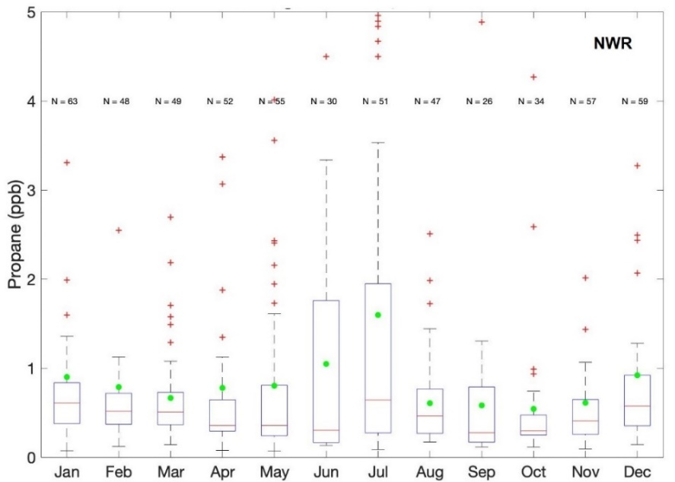

Figure S1: Monthly propane mole fractions at NWR for 2012-2017. The horizontal red line in each box is the median, the bottom and top of the box are the 25th and 75th percentiles, the vertical bars are the 5th and 95th percentiles, the red pluses values are >95th percentile, and the green dots are the mean. N = the total number of samples.

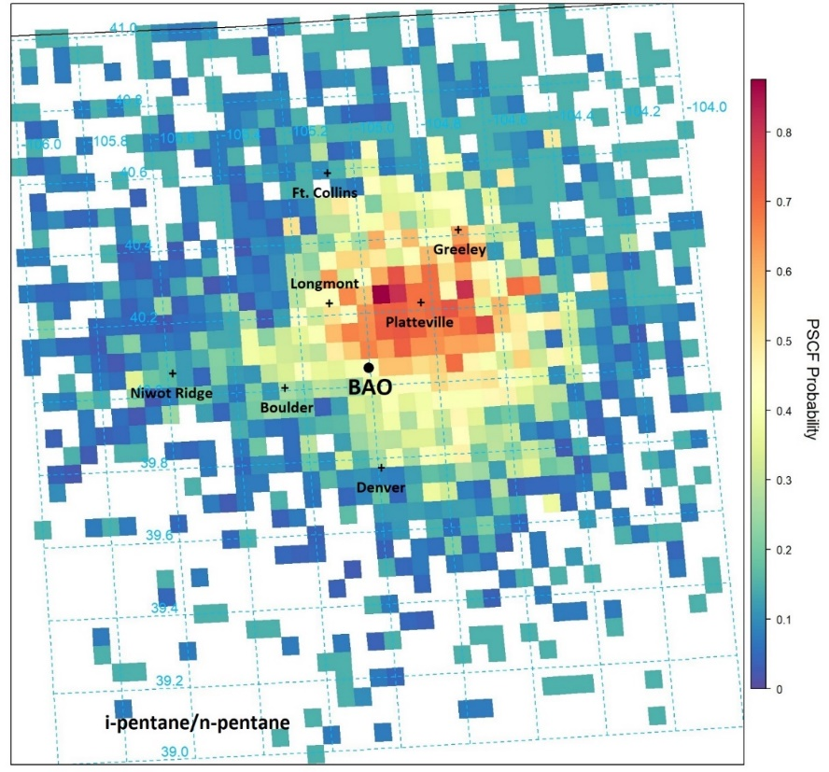

Figure S2: PSCF for the ratio of i-pentane/n-pentane <1 for 2007-2016 (all seasons; n = 2520) in flasks collected during daytime hours at BAO (black dot).

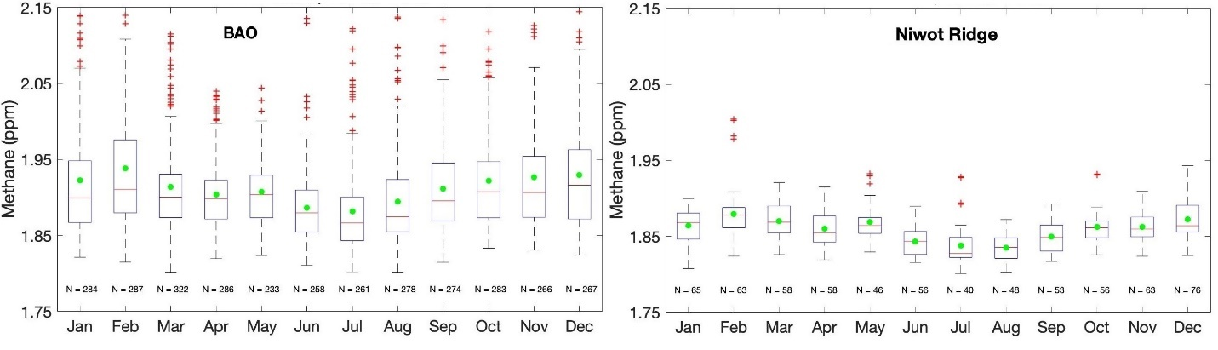
Figure S3: Monthly mole fractions of methane at BAO and NWR for 2008-2015. The box whisker format is the same as in Fig. S1.

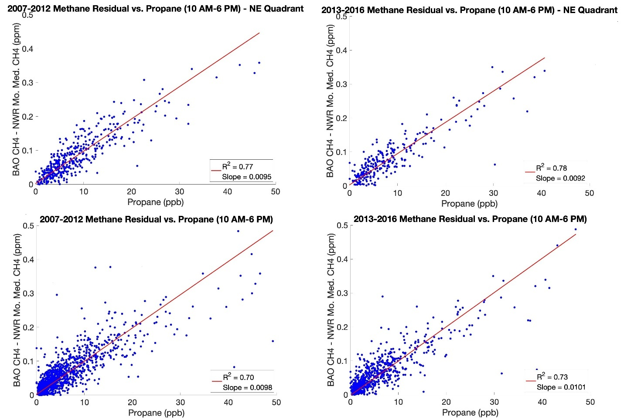
Figure S4: Correlation between BAO residual methane (ppm) and propane (ppb) for samples with wind directions from the NE quadrant for 2007-2012 (top left panel) and 2013-2016 (top right panel), and for all daytime samples for 2007-2012 (bottom left panel) and 2013-2016 (bottom right panel).

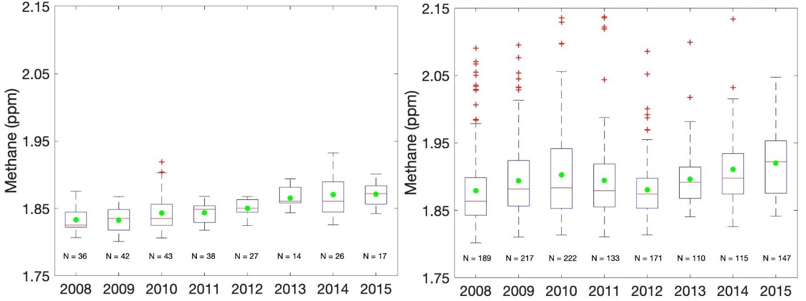
Figure S5: Photochemical season (May-Sept) mole fractions of methane at NWR (left panel) and BAO (right panel) for 2008-2015 for all daytime samples. The box whisker format is as in Fig. S1.

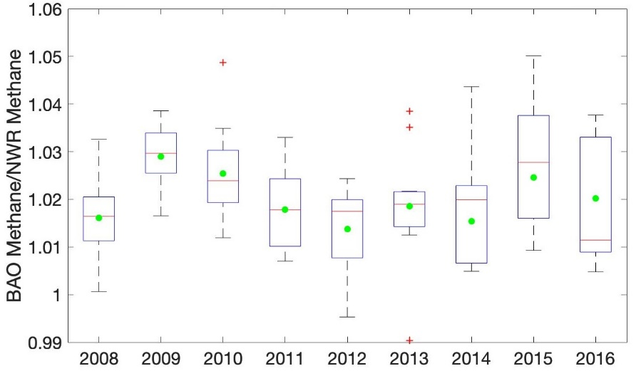

Figure S6: Ratio of the monthly median mole fractions of methane at BAO over NWR for 2008-2016 for all daytime samples. For each year there are twelve monthly values (except 2016 when only January-June had samples) and the plotted symbols represent the variability of the twelve monthly values but do not include the variability of individual samples within the month. The box whisker format is as in Fig. S1.

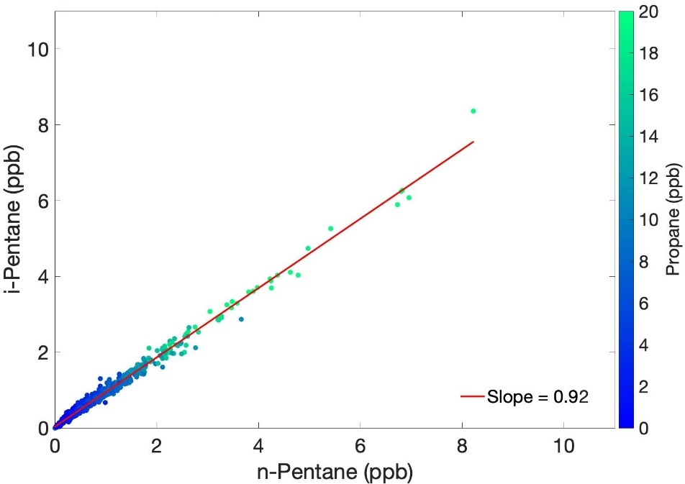
Figure S7: i-pentane as a function of n-pentane at BAO for photochemical season daytime samples color coded for the concurrent propane mole fraction in the sample for samples with wind directions from the NE quadrant

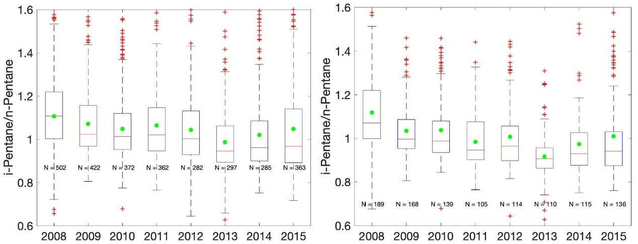
Figure S8: Ratio of the mole fractions of i-pentane to n-pentane at BAO for the years 2008-2015 for the full year (left panel) and photochemical season (right panel) and for all daytime samples. The box whisker format is as in Fig. S1.

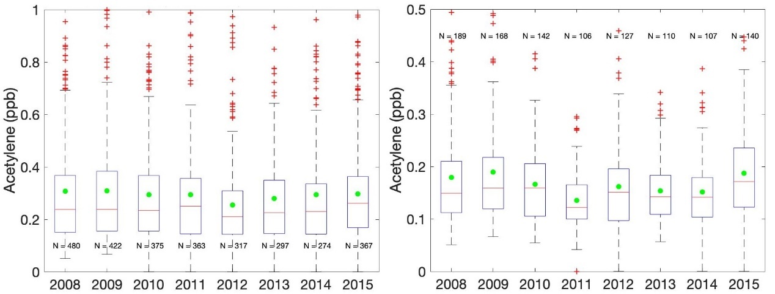
Figure S9: Mole fractions of acetylene at BAO for the years 2008-2015 for the full year (left panel) and photochemical season (right panel) for all daytime samples. Note the different y-axis scale on the two panels. The box whisker format is as in Fig. S1.

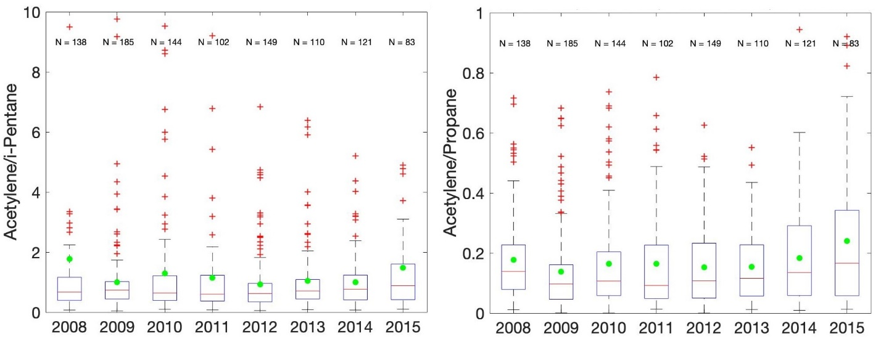
Figure S10: Ratio of acetylene/i-pentane (left panel) and acetylene/propane (right panel) mole fractions for samples with wind directions from the south sector. Note the different y-axis scale on the two panels. The box whisker format is as in Fig. S1.

Table S1: Number of flask samples collected each year at the BAO tower. The number of days on which samples were collected is also shown. During certain periods (primarily 2008-2012) samples were collected in pairs so that the number of days with samples is less than the total number of samples.

Year | Daytime  Samples | Days with  Samples
2007 (Aug-Dec) | 144 | 94
2008 | 529 | 325
2009 | 504 | 263
2010 | 503 | 322
2011 | 399 | 202
2012 | 407 | 263
2013 | 298 | 298
2014 | 285 | 285
2015 | 374 | 254
2016 (Jan-Jul) | 144 | 137

Table S2: Trend statistics for propane mole fractions at BAO for 2008-2015 for daytime samples with wind directions from the south sector.
Propane | Full Year |  |  |  | Photochemical Season (May-Sept)
 | Value (ppb) | Slope  (ppb yr⁻¹) | 2 Sigma Standard Deviation (ppb yr⁻¹) | P-Value | Value (ppb) | Slope  (ppb yr⁻¹) | 2 Sigma Standard Deviation (ppb yr⁻¹) | P-Value
Mean | 8.151 | -1.663 | 8.317 | 0.301 | 2.809 | -0.118 | 0.281 | 0.055
Median | 2.318 | -0.118 | 0.283 | 0.056 | 1.755 | -0.029 | 0.357 | 0.662
5th %ile | 0.428 | -0.024 | 0.073 | 0.117 | 0.397 | -0.023 | 0.165 | 0.457
25th %ile | 1.072 | -0.060 | 0.170 | 0.094 | 0.940 | -0.045 | 0.216 | 0.288
75th %ile | 4.664 | -0.109 | 0.674 | 0.395 | 3.644 | -0.057 | 0.866 | 0.721
95th %ile | 14.922 | -10.685 | 56.498 | 0.326 | 8.854 | -0.518 | 0.872 | 0.015

Table S3: Trend statistics for methane mole fractions at NWR for 2008-2015 using all daytime samples.

Methane |  | Full Year |  |  |  | Photochemical Season (May-Sept)
 |  | Value (ppm) | Slope  (ppm yr⁻¹) | 2 Sigma Standard Deviation (ppm yr⁻¹) | P-Value | Value (ppm) | Slope  (ppm yr⁻¹) | 2 Sigma Standard Deviation  (ppm yr⁻¹) | P-Value
Mean | 1.860 |  | 0.007 | 0.003 | 0.000 | 1.847 | 0.006 | 0.004 | 0.000
Median | 1.859 |  | 0.007 | 0.002 | 0.000 | 1.845 | 0.006 | 0.003 | 0.000
5th %ile | 1.820 |  | 0.005 | 0.006 | 0.003 | 1.813 | 0.005 | 0.007 | 0.004
25th %ile | 1.841 |  | 0.007 | 0.003 | 0.000 | 1.828 | 0.006 | 0.006 | 0.002
75th %ile | 1.875 |  | 0.007 | 0.005 | 0.000 | 1.861 | 0.007 | 0.005 | 0.000
95th %ile | 1.908 |  | 0.006 | 0.011 | 0.020 | 1.896 | 0.006 | 0.019 | 0.132

Table S4a: Trend statistics for methane mole fractions at BAO for 2008-2015 using all daytime samples.

Methane | Full Year |  |  |  | Photochemical Season (May-Sept)
 | Value (ppm) | Slope  (ppm yr⁻¹) | 2 Sigma Standard Deviation (ppm yr⁻¹) | P-Value | Value (ppm) | Slope  (ppm yr⁻¹) | 2 Sigma Standard Deviation (ppm yr⁻¹) | P-Value
Mean | 1.912 | 0.005 | 0.010 | 0.029 | 1.896 | 0.004 | 0.009 | 0.050
Median | 1.896 | 0.005 | 0.008 | 0.014 | 1.883 | 0.006 | 0.009 | 0.009
5th %ile | 1.836 | 0.006 | 0.004 | 0.000 | 1.828 | 0.006 | 0.005 | 0.001
25th %ile | 1.867 | 0.006 | 0.005 | 0.001 | 1.857 | 0.004 | 0.004 | 0.002
75th %ile | 1.938 | 0.005 | 0.012 | 0.056 | 1.924 | 0.004 | 0.016 | 0.219
95th %ile | 2.036 | 0.005 | 0.027 | 0.314 | 1.996 | -0.007 | 0.019 | 0.078

Table S4b: Trend statistics for methane mole fractions at BAO for 2008-2015 using daytime samples with wind directions from the northeast quadrant.
Methane | Full Year |  |  |  | Photochemical Season (May-Sept)
 | Value (ppm) | Slope  (ppm yr⁻¹) | 2 Sigma Standard Deviation (ppm yr⁻¹) | P-Value | Value (ppm) | Slope  (ppm yr⁻¹) | 2 Sigma Standard Deviation (ppm yr⁻¹) | P-Value
Mean | 1.940 | 0.005 | 0.015 | 0.095 | 1.917 | 0.004 | 0.011 | 0.089
Median | 1.924 | 0.004 | 0.011 | 0.088 | 1.904 | 0.005 | 0.014 | 0.098
5th %ile | 1.854 | 0.006 | 0.005 | 0.001 | 1.845 | 0.006 | 0.004 | 0.000
25th %ile | 1.888 | 0.006 | 0.008 | 0.005 | 1.876 | 0.007 | 0.008 | 0.003
75th %ile | 1.968 | 0.002 | 0.019 | 0.499 | 1.941 | 0.002 | 0.015 | 0.431
95th %ile | 2.077 | 0.011 | 0.043 | 0.198 | 2.029 | -0.002 | 0.030 | 0.775

Table S5: Trend statistics for the ratio of BAO to NWR methane mole fractions for 2008-2016 using all BAO daytime samples and NWR monthly medians.
Methane | Full Year |  |  | Photochemical Season (May-Sept)
 | Slope  (yr⁻¹) | 2 Sigma Standard Deviation (yr⁻¹) | P-Value | Slope  (yr⁻¹) | 2 Sigma  Standard Deviation (yr⁻¹) | P-Value
Mean | -0.001 | 0.005 | 0.300 | -0.001 | 0.005 | 0.340
Median | -0.001 | 0.004 | 0.237 | 0.000 | 0.005 | 0.999
5th %ile | -0.001 | 0.003 | 0.209 | 0.000 | 0.007 | 0.699
25th %ile | 0.000 | 0.003 | 0.668 | 0.000 | 0.004 | 0.844
75th %ile | -0.001 | 0.006 | 0.318 | -0.001 | 0.008 | 0.522
95th %ile | -0.002 | 0.015 | 0.489 | -0.005 | 0.011 | 0.019

Table S6: Trend statistics for the ratio of i-pentane to n-pentane at BAO for 2008-2015 for samples with wind directions from the south sector.
i-pentane/  n-pentane | Full Year |  |  | Photochemical Season (May-Sept)
 | Slope  (yr⁻¹) | 2 Sigma Standard Deviation (yr⁻⁻¹) | P-Value | Slope  (yr⁻¹) | 2 Sigma  Standard Deviation (yr⁻¹) | P-Value
Mean | -0.002 | 0.029 | 0.651 | -0.010 | 0.059 | 0.399
Median | -0.012 | 0.032 | 0.079 | -0.022 | 0.045 | 0.035
5th %ile | -0.009 | 0.028 | 0.100 | -0.012 | 0.045 | 0.166
25th %ile | -0.012 | 0.017 | 0.006 | -0.015 | 0.025 | 0.014
75th %ile | -0.002 | 0.056 | 0.882 | -0.003 | 0.105 | 0.877
95th %ile | 0.015 | 0.069 | 0.275 | 0.016 | 0.100 | 0.394

Table S7a: Trend statistics for acetylene mole fractions at BAO for 2008-2015 using daytime samples with wind directions from the NE quadrant.
Acetylene | Full Year |  |  |  | Photochemical Season (May-Sept)
 | Value (ppb) | Slope  (ppb yr⁻¹) | 2 Sigma Standard Deviation (ppb yr⁻¹) | P-Value | Value (ppb) | Slope  (ppb yr⁻¹) | 2 Sigma Standard Deviation (ppb yr⁻¹) | P-Value
Mean | 0.276 | 0.000 | 0.023 | 0.974 | 0.180 | -0.003 | 0.019 | 0.486
Median | 0.232 | 0.005 | 0.022 | 0.208 | 0.158 | -0.000 | 0.020 | 0.915
5th %ile | 0.089 | -0.001 | 0.009 | 0.529 | 0.081 | -0.001 | 0.009 | 0.534
25th %ile | 0.152 | 0.001 | 0.018 | 0.795 | 0.117 | 0.002 | 0.013 | 0.538
75th %ile | 0.352 | -0.003 | 0.022 | 0.447 | 0.206 | -0.003 | 0.018 | 0.349
95th %ile | 0.590 | -0.011 | 0.059 | 0.322 | 0.383 | -0.012 | 0.067 | 0.335

Table 7b: Trend statistics for acetylene mole fractions at BAO for 2008-2015 using daytime samples with wind directions from the south.
Acetylene | Full Year |  |  |  | Photochemical Season (May-Sept)
 | Value (ppb) | Slope  (ppb yr⁻¹) | 2 Sigma Standard Deviation (ppb yr⁻¹) | P-Value | Value (ppb) | Slope  (ppb yr⁻¹) | 2 Sigma Standard Deviation (ppb yr⁻¹) | P-Value
Mean | 0.331 | -0.001 | 0.025 | 0.768 | 0.169 | -0.003 | 0.019 | 0.432
Median | 0.250 | 0.001 | 0.025 | 0.873 | 0.150 | 0.000 | 0.015 | 0.972
5th %ile | 0.091 | -0.001 | 0.008 | 0.454 | 0.082 | -0.001 | 0.010 | 0.594
25th %ile | 0.153 | 0.002 | 0.012 | 0.423 | 0.111 | -0.001 | 0.006 | 0.325
75th %ile | 0.406 | -0.004 | 0.033 | 0.510 | 0.200 | -0.003 | 0.020 | 0.438
95th %ile | 0.878 | -0.010 | 0.120 | 0.660 | 0.312 | -0.009 | 0.069 | 0.466

