Supplementary Materials

High-resolution records of anthropogenic activity and geohazards from the reservoir of Sun-Moon Lake, Central Taiwan

Huei-Fen Chen^{a,b*}, Kuo-Yen Wei^{c*}, Jyh-Jaan Steven Huang^{c,d}, Chi-Cheng Linª, Chih-Chieh Su^{e}, Gwo-Shyh Song^{e}, Hong-Chun Li^{c}, Teh-Quei Lee^{f}, Shen-Rong Song^{c}, Hui-Juan Panª

ª Institute of Earth Sciences, National Taiwan Ocean University, Keelung, Taiwan, ROC
^{b} Center of Excellence for Oceans, National Taiwan Ocean University, Keelung, Taiwan, ROC
^{c} Department of Geosciences, National Taiwan University, Taipei, Taiwan, ROC
^{d} Institute of Geology, University of Innsbruck, Innsbruck, Austria
^{e} Institute of Oceanography, National Taiwan University, Taipei 10617, Taiwan, ROC
^{f} Institute of Earth Sciences, Academia Sinica, Taipei 11529, Taiwan, ROC

Corresponding author: HFC, diopside0412@yahoo.com.tw
Co-corresponding author: KYW, weiky@ntu.edu.tw

Table S1. The variance explained, PC correlation coefficient of each element with PCs of core Sun 2-1. The dominant elements with their strong correlation are marked with bold-face numbers.

Sun 2-1 upper part (after 1934 CE)
PC1 PC2 PC3 PC4 PC5
Variance explained 51.2% 14.9% 10.7% 7.6% 5.5%
Loadings
Si -0.157 -0.889 0.290 0.061 0.087
Ar 0.033 0.174 -0.237 -0.195 -0397
K -0.240 -0.751 0.146 0.060 0.134
Ca 0.990 0.061 0.121 -0.014 -0.005
Ti -0.144 -0.757 0.113 -0.004 0.114
Mn 0.129 0.204 -0.210 0.860 0.311
Fe -0.467 -0.401 -0.065 -0.005 -0.005
Ni -0.253 0.480 -0.358 -0.063 -0.300
Cu -0.026 0.274 -0.289 -0.533 0.733
Zn -0.083 0.007 -0.238 -0.243 0.044
Rb -0.2429 0.348 -0.290 -0.100 -0.379
Sr 0.283 0.347 -0.156 -0.121 -0.239
Ba -0.177 -0.231 -0.107 0.154 0.110
Pb -0.560 0.449 0.691 0.033 0.064
Mo inc -0.274 0.656 -0.387 -0.035 -0.343
Mo coh -0.250 0.634 -0.403 -0.176 -0.421

Sun 2-1 lower part (before 1934 CE)
PC1 PC2 PC3 PC4
Variance explained 46.6% 22.5% 11.1% 6.5%
Loadings
Si -0.046 -0.414 0.234 0.548
Ar -0.526 0.545 0.205 0.317
K -0.210 -0.608 0.202 0.063
Ca 0.158 0.907 -0.059 -0.274
Ti -0.356 -0.512 0.186 0.055
Mn 0.992 -0.025 0.027 0.115
Fe 0.610 0.384 -0.022 -0.478
Ni -0.372 0.748 0.133 0.444
Cu -0.358 0.558 0.153 0.408
Zn -0.228 0.347 0.192 0.471
Rb -0.544 -0.253 0.175 0.309
Sr -0.510 0.356 0.100 -0.038
Ba -0.285 -0.699 0.249 -0.012
Pb -0.096 -0.107 -0.959 0.172
Mo inc -0.353 0.769 0.130 0.435
Mo coh -0.344 0.759 0.156 0.451

Table S2. The variance explained, PC loadings of each element on PCs of principal analyses of core SM 16 4-3. The dominant elements with their heavy loadings are marked with bold-face numbers.

SM 16 4-3 upper part (after 1934 CE)

PC1 PC2 PC3 PC4 PC5
Variance explained 42.2% 20.9% 11.4% 7.2% 4.3%
Loadings

Si 0.603 -0.159 -0.708 -0.005 -0.174 K 0.552 -0.382 -0.572 0.201 -0.04 Ca 0.804 0.579 0.117 0.043 0.007 Ti -0.114 -0.272 -0.533 0.443 0.006
Mn -0.189 0.132 0.271 -0.613 0.422
Fe -0.485 -0.259 -0.210 -0.088 0.346
Ni -0.009 -0.380 0.507 0.210 0.009
Cu 0.224 0.169 0.553 0.064 0.655
Zn -0.385 -0.196 0.298 -0.226 -0.069
Rb 0.101 -0.482 0.184 0.678 0.130
Sr 0.137 0.190 0.434 0.279 0.181
Pb -0.814 0.545 -0.143 0.128 -0.015
Mo inc -0.146 -0.406 0.607 0.105 0.078
Mo coh 0.040 -0.209 0.391 0.673 0.266

SM16 4-3 lower part (before 1934 CE)
PC1 PC2 PC3 PC4 PC5
Variance explained 42.7% 19.1% 14.1% 7.1% 5.1%
Loadings
Si -0.225 -0.816 -0.186 -0.339 0.289
Ar 0.149 0.547 0.033 0.249 -0.186
K -0.446 -0.722 0.049 -0.266 0.150
Ca -0154 0.208 -0.958 0.097 -0.041
Ti 0.053 -0716 0.164 -0.287 0.070
Mn -0.317 -0.175 -0.254 -0.198 0.029
Fe 0.416 -0.331 0.241 -0.175 -0.195
Ni -0.553 0295 0.218 -0.145 -0.094
Cu -0.232 0.536 0.206 0.394 0.675
Zn -0.151 -0215 0.387 -0.031 -0.068
Rb -0.498 0.282 0.503 -0.185 -0.210
Sr -0.150 0.541 0.198 -0.149 -0.323
Zr 0.070 0.382 0.260 -0.100 -0.281
Ba -0.0074 -0.737 0.124 0.624 -0.183
Pb 0.997 0.014 -0.010 -0.025 0.023
Mo inc -0.644 0.485 0.250 -0.227 -0.162
Mo coh -0.550 0.572 0.329 -0.237 -0.253

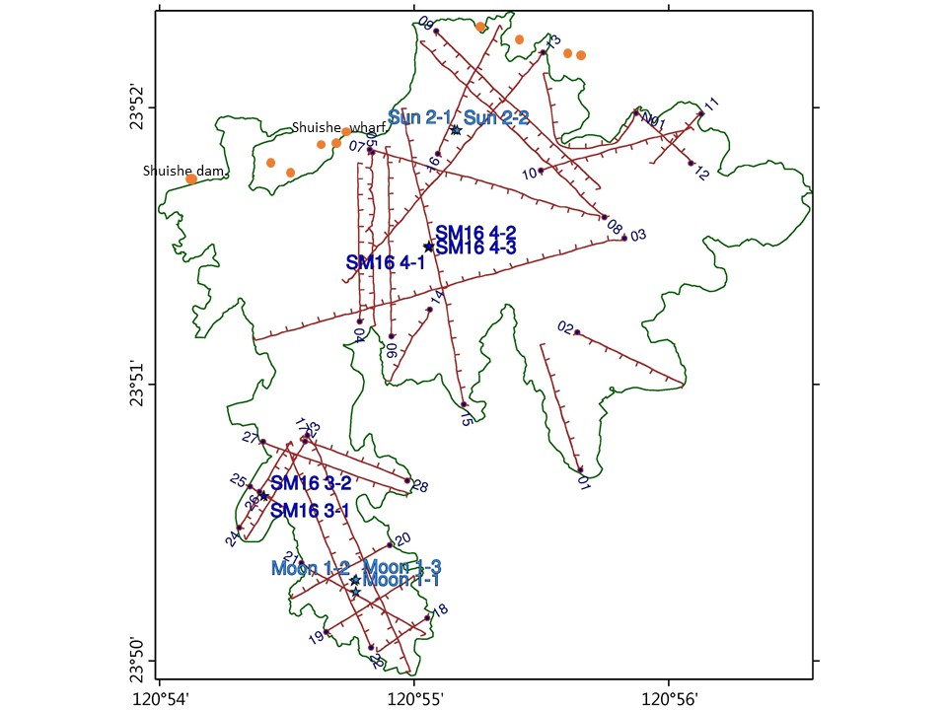
Fig. S1. Paths of bottom profiling of the Sun and Moon Lakes. The red lines represent the surveying paths and the blue stars mark the coring sites. The orange circles mean collapse of big hotels, and damages of Shuishe dam and Shuishe wharf in the northern of Sun Lake. After 1999 Chi-Chi earthquake, many public facilities, houses and hotels were rebuilt in this region for long times.

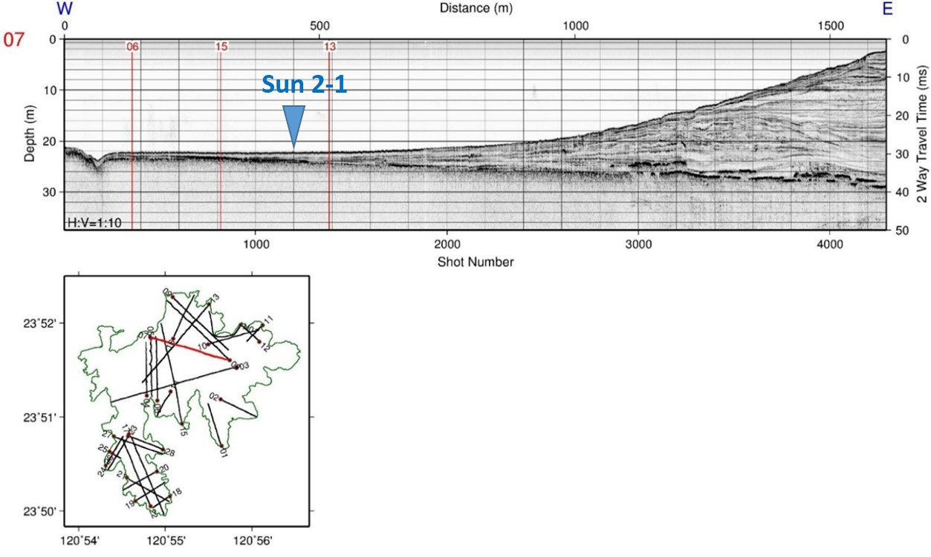
Figure S2. Seismic profile of line 07 in Sun-Moon Lake.
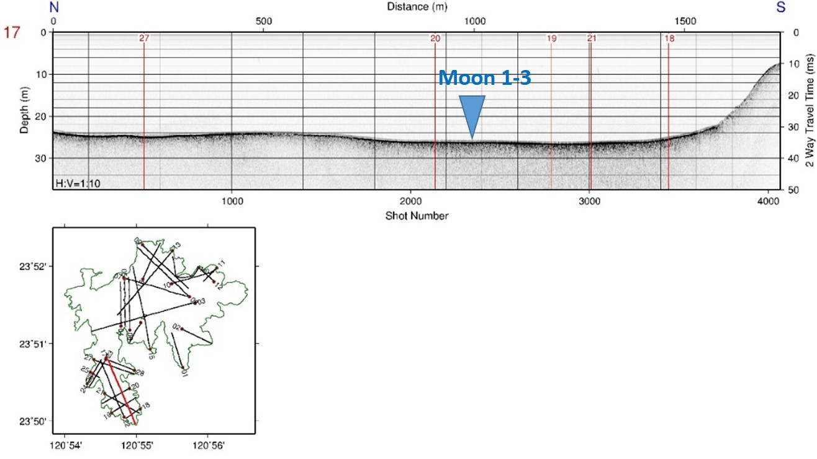
Figure S3. Seismic profile of line 17 in Sun-Moon Lake
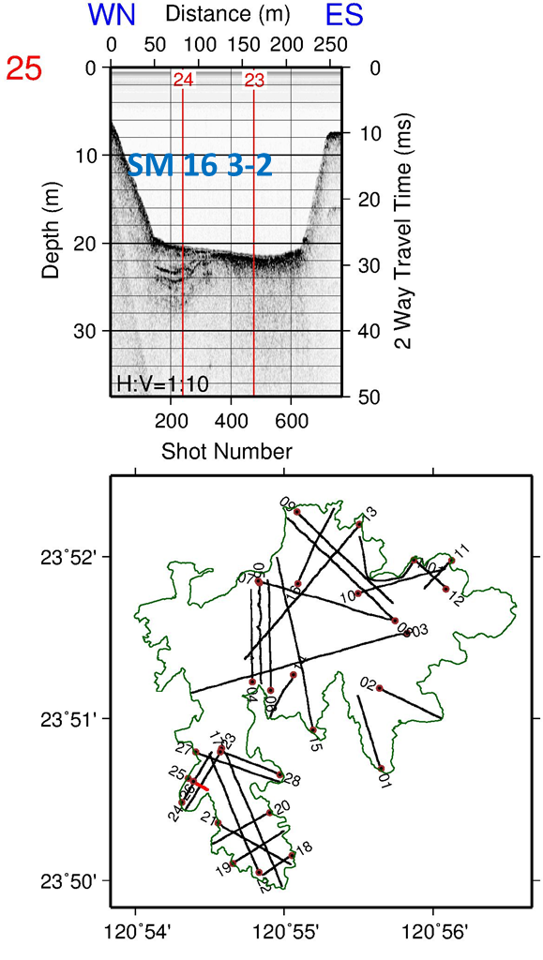
Figure S4. Seismic profile of line 25 in Sun-Moon Lake
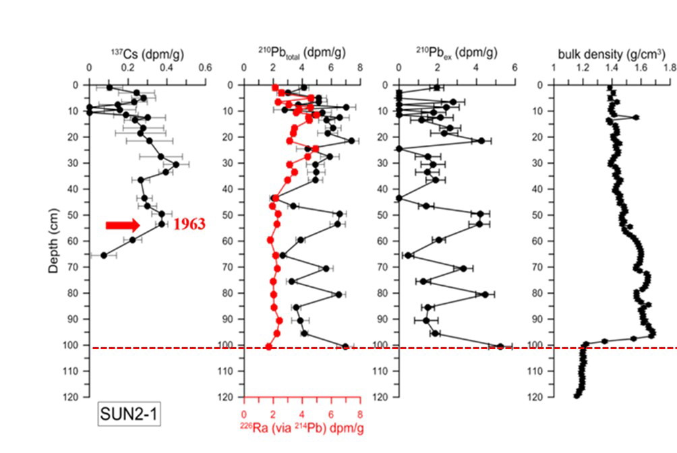
Fig. S5. ²¹⁰Pb and¹³⁷Cs dating results of core Sun 2-1 from Sun Lake. The red arrow shows the peak of global nuclear testing events in 1963 CE and the red dotted line indicates the dam construction in 1934 CE.
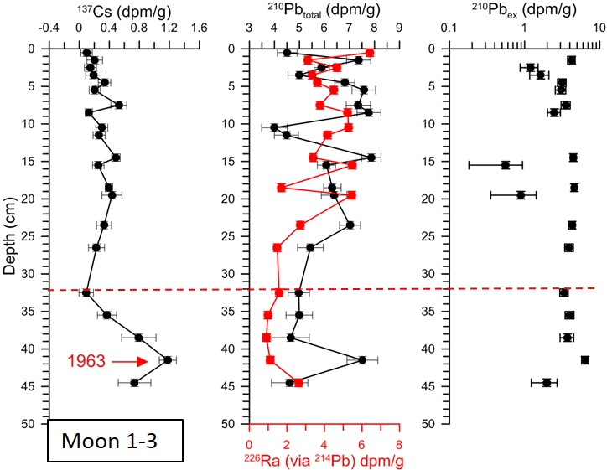
Fig. S6 ²¹⁰Pb and¹³⁷Cs dating results of core Moon 1-3 from Moon Lake. The red arrow shows the peak of global nuclear testing events in 1963 CE and the red dotted line indicates the dam construction in 1934 CE. This reversed age is unreasonable.

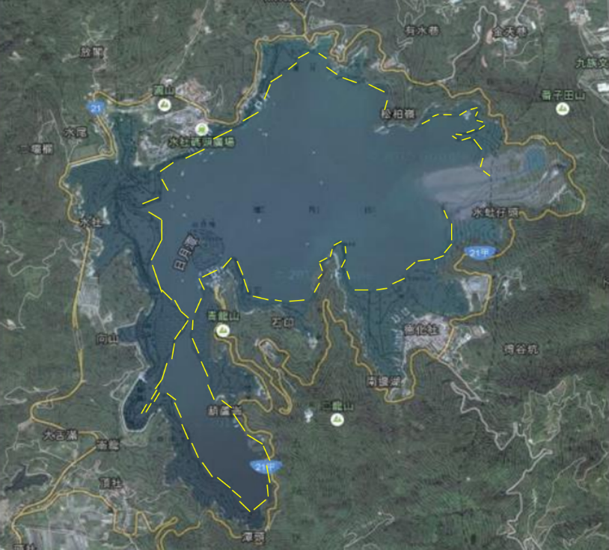
Figure S7. Ancient (yellow dotted line) and resent shorelines of Sun-Moon Lake revised from Old Map of Taiwan 1898. (Leung, 2015)

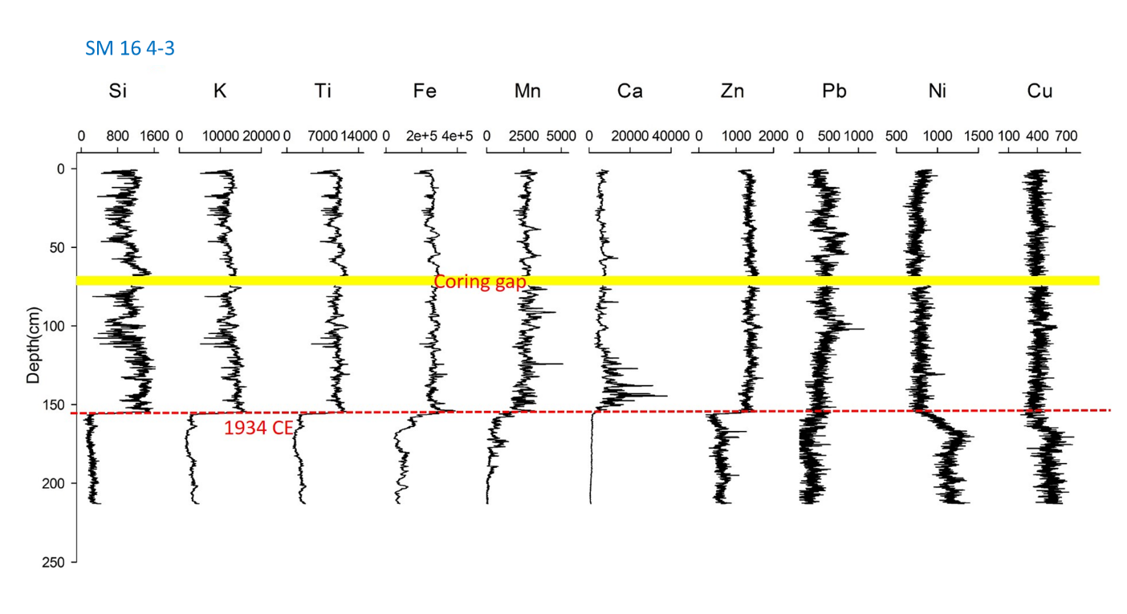
Figure S8. The XRF results of core SM 16 4-3. Most terrestrial elements Si, K, Ti, Fe, Mn raise in the upper core (post 1934 CE), but only Ni and Cu enrich in the lower core (prior to 1934 CE). Element Ca from cement source also increases after 1934 CE.
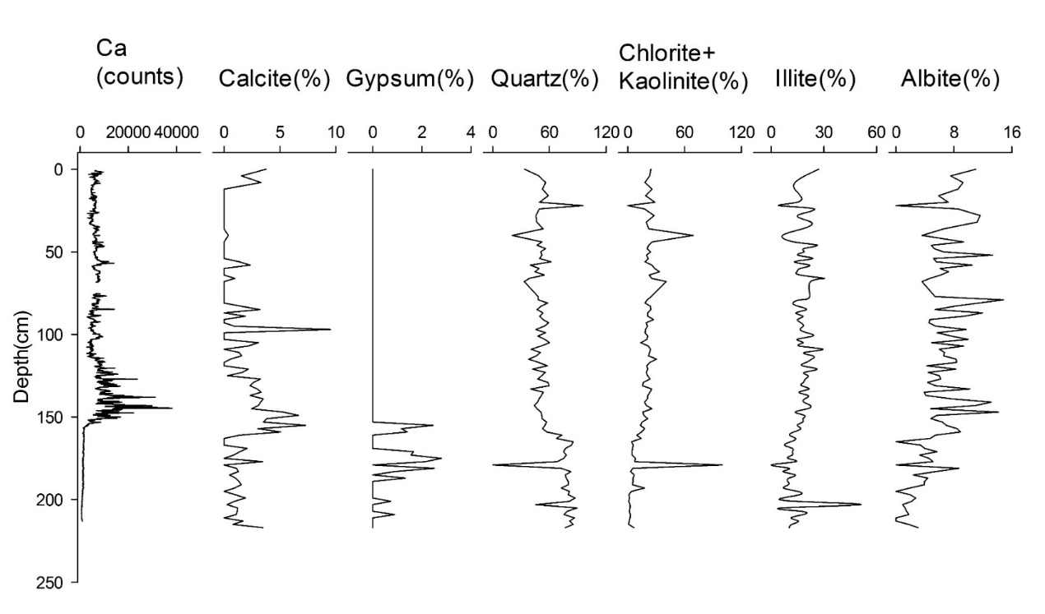
Figure S9. The semiquantiative results of mineral content by XRD for core SM 16 4-3. Its Ca content corresponds to the calcite content from cement source.
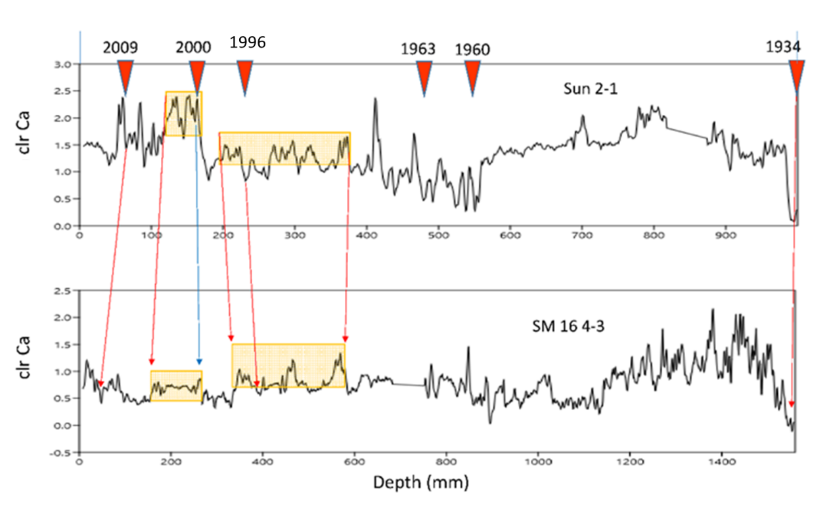
Figure S10. Correlation between cores Sun 2-1 and SM 16 4-3 by using the sigmnals of clr Ca.

