**Supplemental material for:**

**Concentrations, ratios, and sinking fluxes of major bioelements at Ocean Station Papa**

Montserrat Roca-Martí, Claudia R. Benitez-Nelson, Blaire P. Umhau, Abigale M. Wyatt, Samantha J. Clevenger, Steven Pike, Tristan J. Horner, Margaret L. Estapa, Laure Resplandy, Ken O. Buesseler

Contents:

1. Figure S1. Total particulate phosphorus intercomparison.
2. Figure S2. Particulate inorganic carbon (PIC)/thorium-234 (234Th) ratios in different particle classes.
3. Figure S3. Time-series satellite particulate inorganic carbon (PIC) concentration around Station P.
4. Table S1. In situ pump casts near Station P during the EXport Processes in the Ocean from RemoTe Sensing field campaign.
5. Table S2. Subsample to subsample variability on quartz microfiber filters.
6. Table S3. Thorium-234 (234Th), particulate organic carbon (POC), particulate nitrogen (PN), total particulate phosphorus (TPP), biogenic silica (bSi), and particulate inorganic carbon (PIC) fluxes for each cast and depth. *(Separate file)*

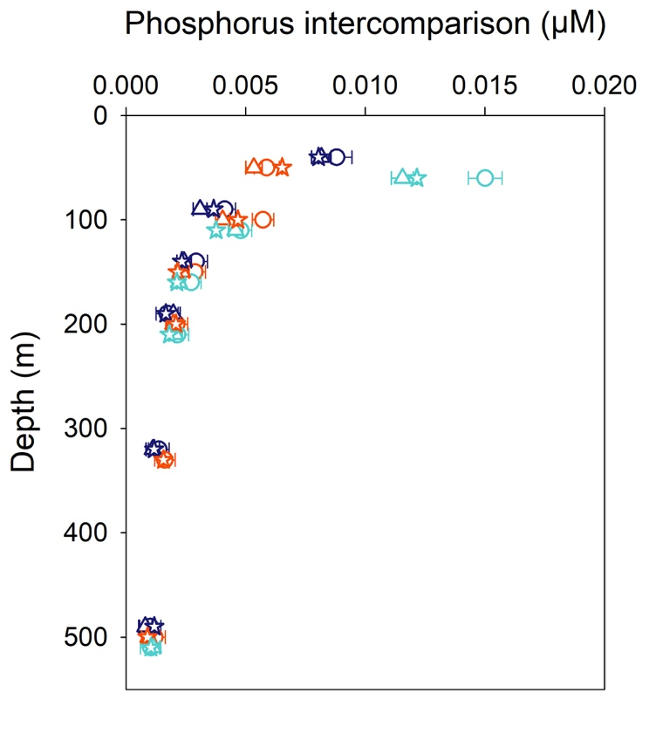

**Figure S1.** Total particulate phosphorus intercomparison based on three subsets of quartz microfiber filter punches (1–5 μm fraction) preserved differently: dried at sea (circles), frozen at –20ºC (triangles) and at room temperature (stars). Dried and frozen punches were analyzed at the University of South Carolina, while those stored at room temperature were processed at the Woods Hole Oceanographic Institution following the methods described in the manuscript. Samples were collected using in situ pumps at 50, 100, 150, 200, 330 and 500 m at three stations (once per epoch: Epoch 1 = dark blue; Epoch 2 = red; Epoch 3 = turquoise). Data from each epoch are offset by 10 m to facilitate visualization.

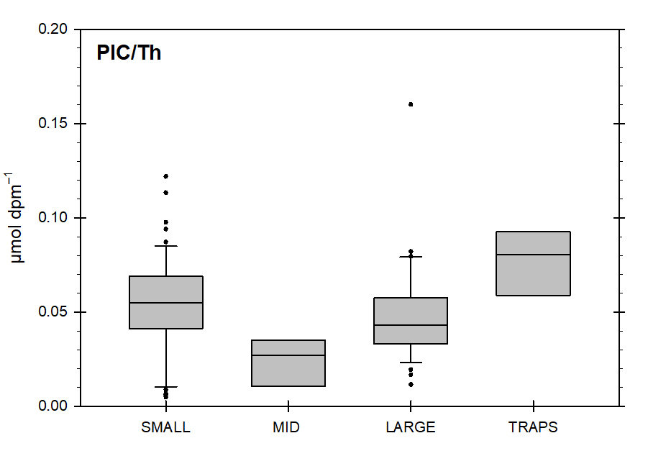

**Figure S2.** Particulate inorganic carbon (PIC)/thorium-234 (234Th) ratios in small (1–5 μm), mid-sized (5–51 μm), large (>51 μm) and trap (Estapa et al., 2021) particles combining samples from 100 to 500 m. The base of the boxes indicates the 25th percentile, the line within the boxes marks the median, and the top of the boxes indicates the 75th percentile. Error bars above and below the boxes indicate the 90th and 10th percentiles. Black dots show the data points outside the 10–90th percentile range.



**Figure S3.** Monthly satellite-derived particulate inorganic carbon (PIC) concentration around Station P from 2002 to 2018 (± 2 degrees). Orange dots show the monthly average concentrations in August and September and the orange dotted line represents the average PIC concentration in August and September during this 17-year time period. Data courtesy of NASA Goddard Space Flight Center, Ocean Ecology Laboratory, 2018.

**Table S1. In situ pump casts near Station P during the EXport Processes in the Ocean from RemoTe Sensing field campaign**

|  |  |  |  |  |  |  |
| --- | --- | --- | --- | --- | --- | --- |
| Pump cast # | Station # | Epoch # | Latitude (ºN) | Longitude (ºE) | Pumping start (UTC) | Duration (h) |
| 1 | SS7 | 1 | 50.14 | –145.07 | 15-Aug-18 8:15 | 4 |
| 2 | SS12 | 1 | 50.11 | –144.97 | 16-Aug-18 6:59 | 4 |
| 3 | SS11 | 1 | 50.05 | –145.03 | 17-Aug-18 8:08 | 5 |
| 4 | SS8 | 1 | 50.08 | –145.13 | 18-Aug-18 7:06 | 4 |
| 5 | LS3 | 2 | 50.23 | –145.50 | 22-Aug-18 9:37 | 4 |
| 6 | LS9 | 2 | 50.10 | –144.94 | 23-Aug-18 6:17 | 4 |
| 7 | LS18 | 2 | 50.46 | –144.74 | 25-Aug-18 4:55 | 4 |
| 8 | LS12 | 2 | 50.59 | –145.30 | 26-Aug-18 7:19 | 5 |
| 9 | SS8 | 3 | 50.59 | –144.95 | 1-Sep-18 6:34 | 4 |
| 10 | SS7 | 3 | 50.65 | –144.87 | 2-Sep-18 6:05 | 4 |
| 11 | SS12 | 3 | 50.59 | –144.79 | 3-Sep-18 6:08 | 4 |
| 12 | SS11 | 3 | 50.54 | –144.87 | 4-Sep-18 7:52 | 5 |

**Table S2. Subsample to subsample variability on quartz microfiber filtersa**

|  |  |  |  |  |  |  |  |  |
| --- | --- | --- | --- | --- | --- | --- | --- | --- |
| Parameter | 50 m | | | | 500 m | | | |
| Punch 1 (μmol) | Punch 2 (μmol) | Punch 3 (μmol) | RSD (%)b | Punch 1 (μmol) | Punch 2 (μmol) | Punch 3 (μmol) | RSD (%)b |
| Particulate carbon | 33.9 | 34.9 | 34.5 | 1 | 5.08 | 4.68 | 4.62 | 5 |
| Particulate nitrogen | 5.66 | 5.32 | 6.02 | 6 | 0.831 | 0.732 | 0.727 | 8 |
| Total particulate phosphorus | 0.359 | 0.351 | 0.365 | 2 | 0.102 | 0.098 | 0.100 | 2 |
| Particulate inorganic carbon | 0.281 | 0.280 | 0.257 | 5 | 0.469 | 0.506 | 0.480 | 4 |

aMeasurements on triplicate quartz microfiber filter punches (21 mm) from two samples collected at 50 and 500 m (station LS9)

bRSD = relative standard deviation