Supplemental material
Sources and sinks of methane in sea ice: insights from stable isotopes
Caroline Jacques^{1*}, Célia J. Sapart^{1,2}, François Fripiat¹, Gauthier Carnat¹, Jiayun Zhou^{1,3}, Bruno Delille³, Thomas Röckmann², Carina van der Veen², Helge Niemann^{4,5,6}, Tim Haskell⁷ and Jean-Louis Tison¹

¹ Laboratoire de Glaciologie, Université libre de Bruxelles, Bruxelles, Belgium
² Institute for Marine and Atmospheric research Utrecht (IMAU), Utrecht University, Utrecht, The Netherlands
³ Unité d’Océanographie Chimique, Université de Liège, Liège, Belgium
⁴ Department of Marine Microbiology and Biogeochemistry, Royal Netherlands Institute for Sea Research (NIOZ), The Netherlands
⁵ Department of Earth Sciences, Faculty of Geosciences, Utrecht University, The Netherlands
⁶ CAGE – Centre for Arctic Gas Hydrate, Environment and Climate, Department of Geosciences, UiT The Arctic University of Norway, Tromsø, Norway
⁷Callaghan Innovation, Wellington, new Zealand
*corresponding author: Jean-Louis.Tison@ulb.be

Table S1. Summary of the sensitivity parameters tested with the one-box model, considering an initial CH₄ concentration in bulk ice of 9.1 nM, characterized by a δ¹³C value of –68.5 ‰ and a δD value of –239 ‰.
δ¹³C-CH_{4 MOg} (‰ vs VPDB) | MOg rate/MOx rate | ε_{C MOx} | Figure
–66 | 0.33 | 13 | Fig. S1
 | 0.66
 | 1
 | 0.33 | 30
 | 0.66
 | 1
–40 | 0.33 | 13 | Fig. S2
 | 0.66
 | 1
 | 0.33 | 30
 | 0.66
 | 1
δ¹³C-CH_{4 S} (‰ vs VPDB) | S rate/MOx rate | ε_{C MOx} | Figure
–66 | 0.33 | 13 | Fig. S3
 | 0.66
 | 1
 | 0.33 | 30
 | 0.66
 | 1
δD-CH_{4 MOg} (‰ vs VSMOW) | MOg rate/MOx rate | ε_{D MOx} | Figure
–239 | 0.33 | 97 | Fig. S4
 | 0.66
 | 1
 | 0.33 | 350
 | 0.66
 | 1
–100 | 0.33 | 97 | Fig. S5
 | 0.66
 | 1
 | 0.33 | 350
 | 0.66
 | 1
δD-CH_{4 S} (‰ vs VSMOW) | S rate/MOx rate | ε_{D MOx} | Figure
–250 | 0.33 | 97 | Fig. S6
 | 0.66
 | 1
 | 0.33 | 350
 | 0.66
 | 1

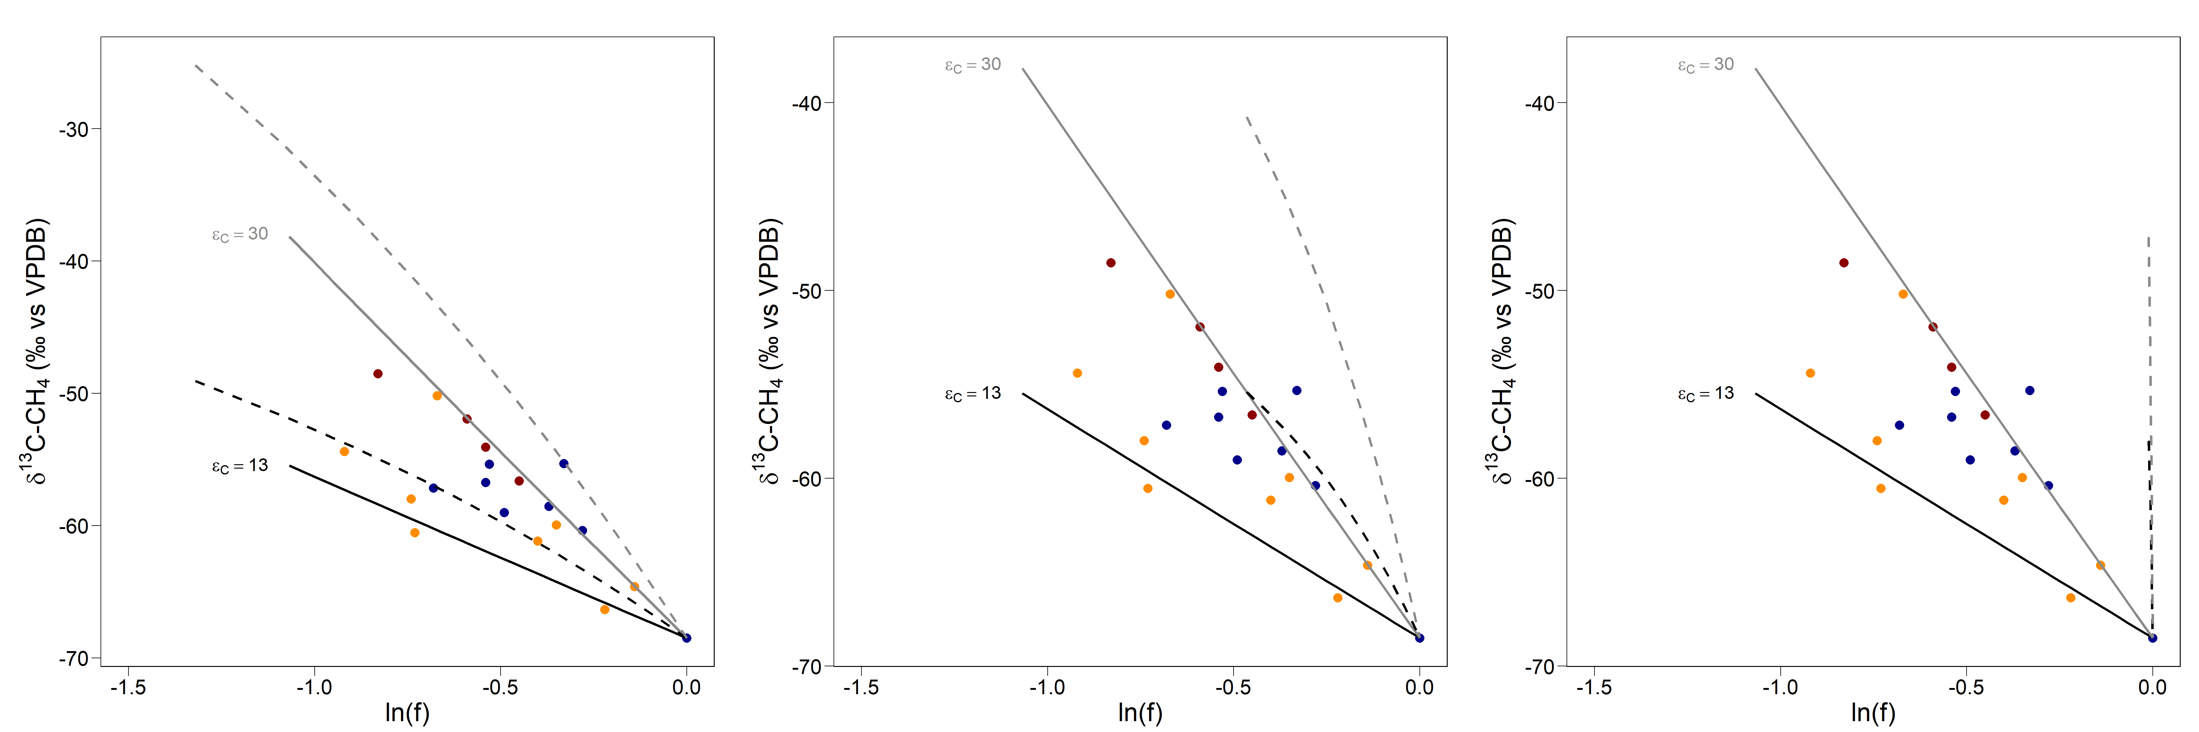
Figure S1. δ¹³C-CH₄ signatures (‰ vs VPDB) as a function of ln(f) (where f is the remaining fraction of CH_{4 ice}), measured in Barrow sea-ice cores collected on the April 3 (blue), May 8 (orange) and June 5 (red). We tested the impact of in situ CH₄ production with a δ¹³C value of 66 ‰, typical of methanogenesis (dotted lines), on the trend imposed by microbial oxidation (solid lines) with an isotopic fractionation ε_{c} = 13 (black) or ε_{c} = 30 (grey), with increasing microbial production-to-oxidation ratios (MOg/MOx) from the left to the right panel (1/3, 2/3 and 1, respectively).
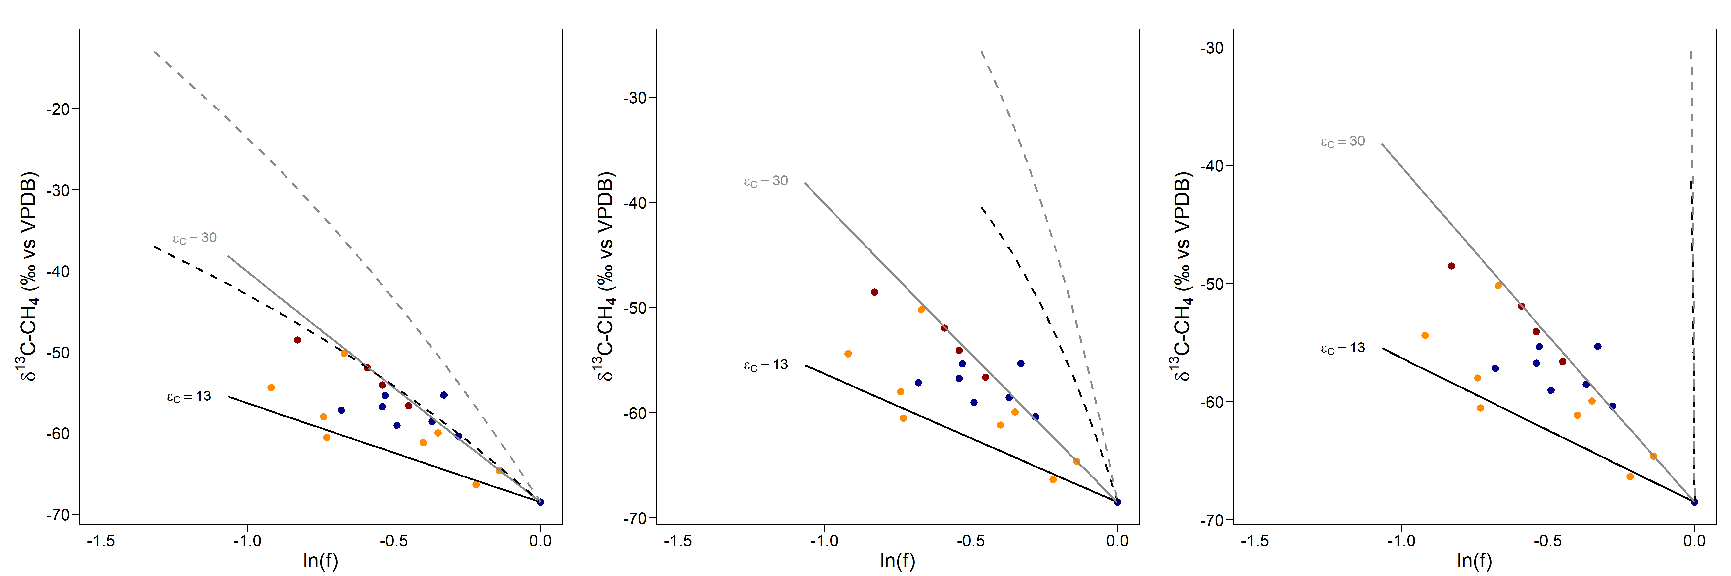
Figure S2. δ¹³C-CH₄ signatures (‰ vs VPDB) as a function of ln(f) (where f is the remaining fraction of CH_{4 ice}), measured in Barrow sea-ice cores collected on April 3 (blue), May 8 (orange) and June 5 (red). We tested the impact of in situ CH₄ production with an atypically high δ¹³C value of 40 ‰ (dotted lines), on the trend imposed by microbial oxidation (solid lines) with an isotopic fractionation ε_{c} = 13 (black) or ε_{c} = 30 (grey), with increasing microbial production-to-oxidation ratios (MOg/MOx) from the left to the right panel (1/3, 2/3 and 1, respectively).
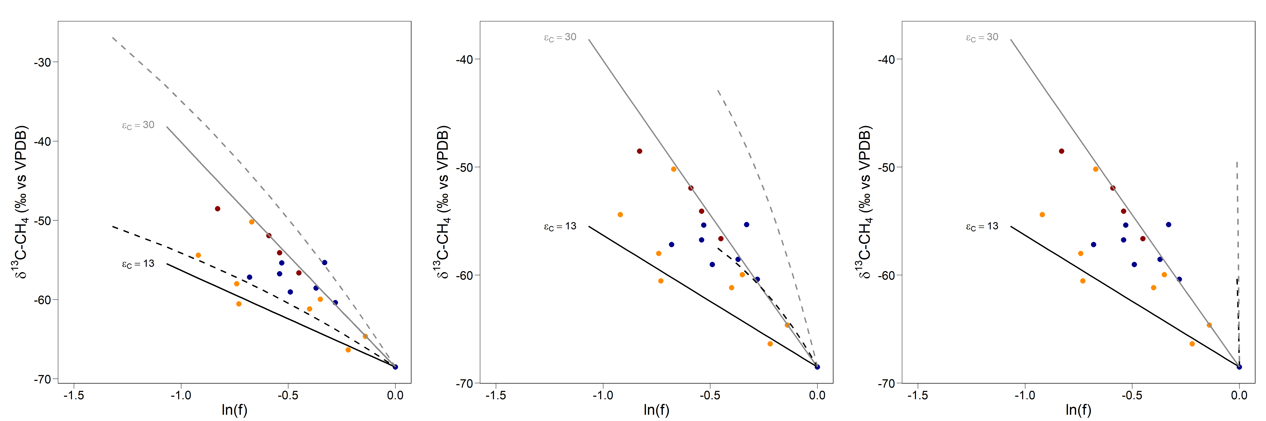
Figure S3. δ¹³C-CH₄ signatures (‰ vs VPDB) as a function of ln(f) (where f is the remaining fraction of CH_{4 ice}), measured in Barrow sea-ice cores collected on April 3 (blue), May 8 (orange) and June 5 (red). We tested the impact of CH₄ supply via bubbles or diffusive exchange from underlying seawater with a δ¹³C value of 66 ‰ (dotted lines), on the trend imposed by microbial oxidation (solid lines) with an isotopic fractionation ε_{c} = 13 (black) or ε_{c} = 30 (grey), with increasing supply-to-microbial oxidation ratios (S/MOx) from the left to the right panel (1/3, 2/3 and 1, respectively).

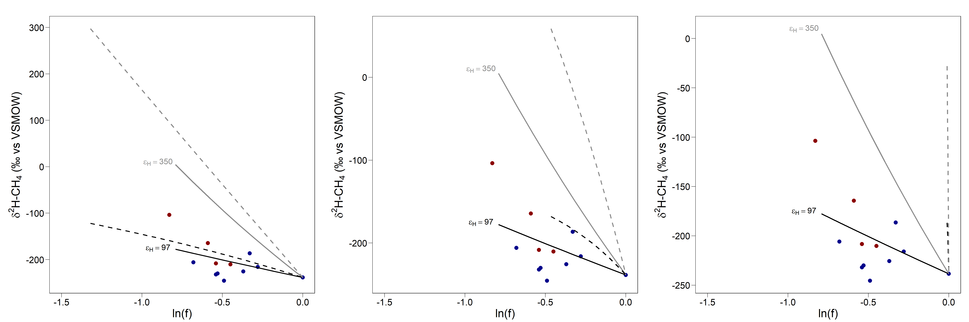
Figure S4. δ²H-CH₄ signatures (‰ vs VSMOW) as a function of ln(f) (where f is the remaining fraction of CH_{4 ice}), measured in Barrow sea-ice cores collected on April 3 (blue), May 8 (orange) and June 5 (red). We tested the impact of in situ CH₄ production with a δ²H value of 239 ‰, typical of methanogenesis (dotted lines), on the trend imposed by microbial oxidation (solid lines) with an isotopic fractionation ε_{H} = 97 (black) or ε_{H} = 350 (grey), with increasing microbial production-to-oxidation ratios (MOg/MOx) from the left to the right panel (1/3, 2/3 and 1, respectively).

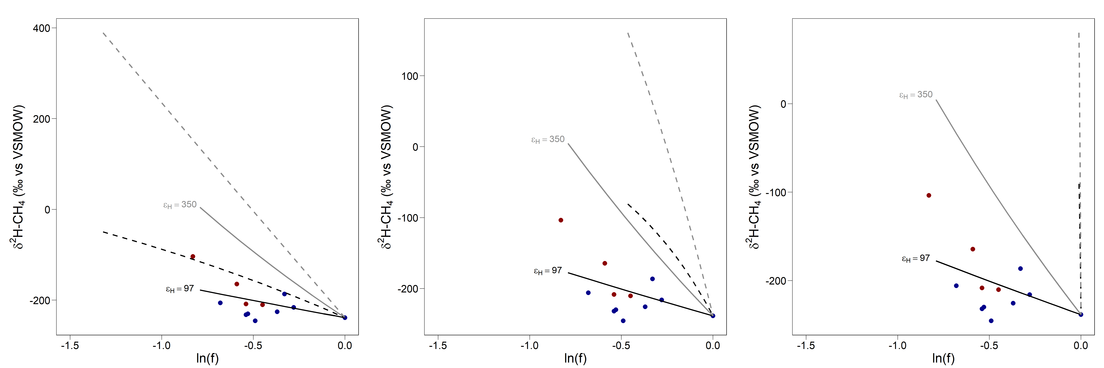
Figure S5. δ²H-CH₄ signatures (‰ vs VSMOW) as a function of ln(f) (where f is the remaining fraction of CH_{4 ice}), measured in Barrow sea-ice cores collected on April 3 (blue), May 8 (orange) and June 5 (red). We tested the impact of in situ CH₄ production with an atypically high δ²H value of 100 ‰ (dotted lines), on the trend imposed by microbial oxidation (solid lines) with an isotopic fractionation ε_{H} = 97 (black) or ε_{H} = 350 (grey), with increasing microbial production-to-oxidation ratios (MOg/MOx) from the left to the right panel (1/3, 2/3 and 1, respectively).

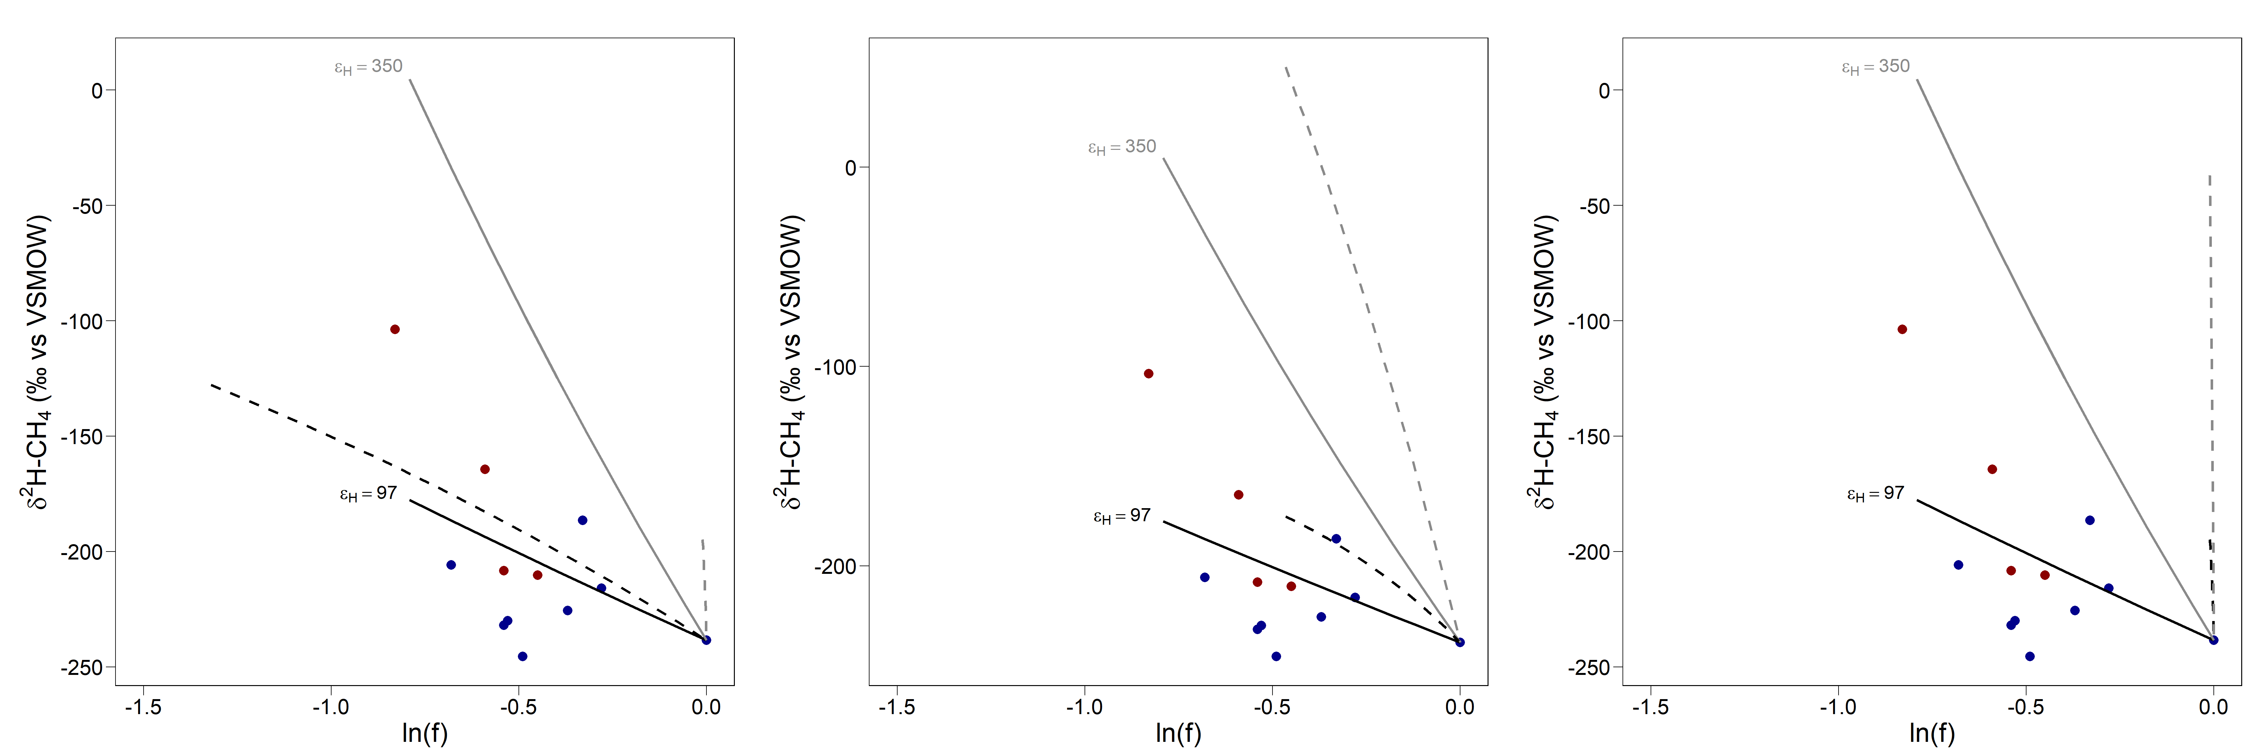
Figure S6. δ²H-CH₄ signatures (‰ vs VSMOW) as a function of ln(f) (where f is the remaining fraction of CH_{4 ice}), measured in Barrow sea-ice cores collected on April 3 (blue), May 8 (orange) and June 5 (red). We tested the impact of CH₄ supply via bubbles or diffusive exchange from underlying seawater with a δ²H value of 250 ‰ (dotted lines), on the trend imposed by microbial oxidation (solid lines) with an isotopic fractionation ε_{H} = 97 (black) or ε_{H} = 350 (grey), with increasing supply-to-microbial oxidation ratios (S/MOx) from the left to the right panel (1/3, 2/3 and 1, respectively).

