Supplemental Material

Comprehensive Evaluation of the Copernicus Atmosphere Monitoring Service (CAMS) Reanalysis against Independent Observations: Reactive Gases

Annette Wagner¹*, Y. Bennouna², A.-M. Blechschmidt³, G. Brasseur¹, S. Chabrillat⁴, Y. Christophe⁴, Q. Errera⁴, H. Eskes⁵, J. Flemming⁶, K. M. Hansen⁷, A. Inness⁶, J. Kapsomenakis⁸, B. Langerock⁴, A. Richter³, N. Sudarchikova¹, V. Thouret², C. Zerefos^{8,9}

¹Max Planck Institute for Meteorology, Hamburg, 20146, Germany
²Laboratoire d’Aérologie, Université de Toulouse, CNRS-UPS, UMR 5560, Toulouse, France
³Institute of Environmental Physics, University of Bremen, Bremen, Germany
⁴Royal Belgian Institute for Space Aeronomy, BIRA-IASB, Uccle, 1180, Belgium
⁵Royal Netherlands Meteorological Institute, De Bilt, the Netherlands
⁶European Centre for Medium-Range Weather Forecasts, Reading, UK
⁷Aarhus University, Roskilde, 4000, Denmark
⁸Academy of Athens, Athens, Greece
⁹Greece Navarino Environmental Observatory (N.E.O.), Messinia, Greece

*Annette.wagner@mpimet.mpg.de

Add DOI here after acceptance of manuscript.
March 23, 2021
List of Contents:
Section S-1: Description of data and methods
Section S-1.1: O₃ observations by limb scanning satellite instruments
Section S-1.2: O₃ and CO partial columns from NDACC
Section S-1.3: CO total columns from MOPITT and IASI satellite observations
Section S-1.4: NO₂ and HCHO from satellite data
Section S-1.5: IAGOS aircraft data
Section S-1.6: O₃ profiles from sonde data of different networks
Section S-1.7: Surface O₃ and CO from GAW, EMEP and IASOA observations
Figure S-1: Time periods of the satellite data sets assimilated in the CAMS reanalysis
Figure S-2: Monthly climatologies of the normalized mean bias (NMB) (model-obs)/obs (%) shown in Figure 1. Each climatology is averaged over the available period of observations: MIPAS (green, 2003/01 to 2012/04), MLS (red, 2004/08 to 2018/12 against CAMS, 2004/08 to 2012/12 against MACC) and ACE-FTS (blue, 2004/02 to 2018/12 against CAMS, 2004/02 to 2012/12 against MACC).
Figure S-3: Correlation coefficient (top row) and Fractional Gross Error (bottom row) globally averaged over the common comparison period. CAMS reanalysis (red) and MACC reanalysis (green) versus satellite observations, from left to right: MIPAS, MLS and ACE-FTS.
Figure S-4: Inter-annual seasonal time-series of monthly Modified Normalised Mean Biases (MNMB, %) from the validation with ozone sondes in the stratosphere over Antarctica between 2003 and 2018. Top left: DJF, top right: MAM, bottom left: JJA, bottom right: SON. CAMS reanalysis in red, Control run in blue.
Figure S-5: Inter-annual seasonal time-series of monthly Modified Normalised Mean Biases (MNMB, %) from the validation with ozone sondes in the stratosphere over the Arctic between 2003 and 2018. Top left: DJF, top right: MAM, bottom left: JJA, bottom right: SON. CAMS reanalysis in red, Control run in blue.
Figure S-6: Inter-annual seasonal time-series of monthly Modified Normalised Mean Biases (MNMB, %) from the validation with ozone sondes in the stratosphere over the Northern midlatitudes between 2003 and 2018. Top left: DJF, top right: MAM, bottom left: JJA, bottom right: SON. CAMS reanalysis in red, Control run in blue.
Figure S-7: Inter-annual seasonal time-series of monthly Modified Normalised Mean Biases (MNMB, %) from the validation with ozone sondes in the stratosphere over the Tropics between 2003 and 2018. Top left: DJF, top right: MAM, bottom left: JJA, bottom right: SON. CAMS reanalysis in red, Control run in blue.
Figure S-8: Time series of seasonal biases (DJF, MAM, JJA, SON) for each NDACC FTIR site. Top is CAMS control run, middle is CAMS reanalysis, bottom MACC reanalysis- sorted by decreasing latitude for the time period 2003 – 2018. The plot shows relative differences of the models compared to FTIR partial columns of stratospheric ozone between the tropopause and 60 km.
Figure S-9: Inter-annual seasonal time-series of O₃ monthly Modified Normalised Mean Biases (MNMB, %) from the validation with ozone sondes in the free troposphere for the Arctic between 2003 and 2018. Top left: DJF, top right: MAM, bottom left: JJA, bottom right: SON. CAMS reanalysis in red, Control run in blue.
Figure S-10: Inter-annual seasonal time-series of monthly Modified Normalised Mean Biases (MNMB, %) from the validation with ozone sondes in the free troposphere over the Northern midlatitudes between 2003 and 2018. Top left: DJF, top right: MAM, bottom left: JJA, bottom right: SON. CAMS reanalysis in red, Control run in blue.
Figure S-11: Inter-annual seasonal time-series of monthly Modified Normalised Mean Biases (MNMB, %) from the validation with ozone sondes in the free troposphere over the Tropics between 2003 and 2018. . Top left: DJF, top right: MAM, bottom left: JJA, bottom right: SON. CAMS reanalysis in red, Control run in blue.
Figure S-12: Inter-annual seasonal time-series of monthly Modified Normalised Mean Biases (MNMB, %) for free tropospheric ozone from the comparison with IAGOS aircraft data, for North America between 2003 and 2018. Top left: DJF, top right: MAM, bottom left: JJA, bottom right: SON. CAMS reanalysis in red, Control run in blue.
Figure S-13: Inter-annual seasonal time-series of monthly Modified Normalised Mean Biases (MNMB, %) for free tropospheric ozone from the comparison with IAGOS aircraft data, for Europe between 2003 and 2018. Top left: DJF, top right: MAM, bottom left: JJA, bottom right: SON. CAMS reanalysis in red, Control run in blue.
Figure S-14: Inter-annual seasonal time-series of monthly Modified Normalised Mean Bias (MNMB, %) for free tropospheric ozone from the comparison with IAGOS aircraft data, for East Asia between 2003 and 2018. Top left: DJF, top right: MAM, bottom left: JJA, bottom right: SON. CAMS reanalysis in red, Control run in blue.
Figure S-15: Inter-annual seasonal time-series of monthly Modified Normalised Mean Biases (MNMB, %) for free tropospheric ozone from the comparison with IAGOS aircraft data, for India between 2003 and 2018. Top left: DJF, top right: MAM, bottom left: JJA, bottom right: SON. CAMS reanalysis in red, Control run in blue.
Figure S-16: Mean seasonal variability of monthly MNMB for the CAMS reanalysis (red), Control run (blue) and MACC reanalysis from the evaluation with IAGOS O₃ aircraft data in the free troposphere over different regions. Top left: North America, top right: Europe, bottom left: East Asia, bottom right: India). Monthly MNMB values are averaged for the years between 2003 and 2018 for CAMS reanalysis and Control run, and between 2003 and 2012 for MACC reanalysis.
Figure S-17: Time-series of O₃ Modified Normalised Mean Bias (MNMB) from the comparison with IAOSA surface observations. Left panel: High Arctic sites (Alert, Barrow and Villum Research Station). Right panel: European Arctic sites (Esrange, Karasjok, Oulanka, Pallas, Tustervatn). CAMS reanalysis (red) and control run (blue).
Figure S-18: Time-series of O₃ Modified Normalised Mean Bias (MNMB) from the comparison of the CAMS reanalysis (red) and the control run (blue) and MACC reanalysis (green) with EMEP observations. The data is averaged over European latitudinal zones of 50N-70N (a), 40N-50N (b) and 30N-40N (c) as well as for the group containing stations above 1000m (d).
Figure S-19: Time-series of monthly Modified Normalised Mean Bias (MNMB, %) from the comparison against IAGOS O₃ aircraft data in the surface for the period 2003-2018. Top left: North America, top right: Europe, bottom left: East Asia, bottom right: India. The plots show averages over various airports in the surface layer (> 950 hPa), for the CAMS reanalysis (red), Control run (blue) and MACC reanalysis (green).
Figure S-20: Inter-annual seasonal time-series of O₃ Modified monthly Normalised Mean Biases (MNMB, %) from the validation with GAW O₃ surface observations for the Arctic between 2003 and 2018. Top left: DJF, top right: MAM, bottom left: JJA, bottom right: SON. CAMS reanalysis in red, Control run in blue.
Figure S-21: Inter-annual seasonal time-series of monthly Modified Normalised Mean Bias (MNMB, %) for surface O₃ from the comparison with IAGOS aircraft data, for Europe between 2003 and 2018. Top left: DJF, top right: MAM, bottom left: JJA, bottom right: SON. CAMS reanalysis in red, Control run in blue.
Figure S-22: Inter-annual seasonal time-series of O₃ Modified monthly Normalised Mean Bias (MNMB, %) from the validation with GAW O₃ surface observations for the Tropics between 2003 and 2018. Top left: DJF, top right: MAM, bottom left: JJA, bottom right: SON. CAMS reanalysis in red, Control run in blue.
Figure S-23: CO total columns for satellite retrievals MOPITT V7, IASI (black), CAMS reanalysis data (red) and Control run (blue) over selected regions for the period 2003-2018. From left to right: first row for US and Europe, second row: East Asia and South Asia, third row for North Africa and South Africa, last row for Alaska Fire region and Siberia Fire region.
Figure S-24: Time –series of CO Modified Normalised Mean Bias (MNMB, %) from the validation with IASI CO total columns over selected regions for the years from 2008 to 2018.
First row left: US, first row right: Europe, second row left: East Asia, second row right: South Asia, third row left: North Africa, third row right: South Africa, last row left: Alaska fire region, last row left: Siberian fire region. CAMS reanalysis (red), control run (blue). Lower MNMBs of both runs during 2014/2015 originate likely from the change of IASI data versions on 10/2014.
Figure S-25: Trend estimates for the relative bias of the CAMS reanalysis for southern hemispheric NDACC FTIR Stations Wollongong (upper panel) and Arrival heights (lower panel). Trend estimates for the relative bias of the CAMS reanalysis for southern hemispheric NDACC FTIR Stations Wollongong (upper panel) and Arrival heights (lower panel).
Figure S-26: Time-series of monthly Modified Normalised Mean Bias (MNMB, %) from the comparison against IAGOS CO aircraft data at the surface for the period 2003-2018. Top left: North America, top right: Europe, bottom left: East Asia, bottom right: India. The plots show averages over various airports in the surface layer (> 950 hPa), for the CAMS reanalysis (red), Control run (blue) and MACC reanalysis (green).
Figure S-27: Mean seasonal variability of monthly MNMB for the CAMS reanalysis (red, Control run (blue) and MACC reanalysis from the evaluation with IAGOS CO aircraft data in the free troposphere over different regions. Top left: North America, top right: Europe, bottom left: Eastern Asia, bottom right: India. Monthly MNMB values are averaged for the years between 2003 and 2018 for CAMS reanalysis and Control run, and between 2003 and 2012 for MACC reanalysis.
Figure S-28: Inter-annual seasonal time-series of monthly Modified Normalised Mean Bias (MNMB, %) from the validation with GAW CO surface data for North America between 2003 and 2018. Top left: DJF, top right: MAM, bottom left: JJA, bottom right: SON. CAMS reanalysis in red, Control run in blue.
Figure S-29: Inter-annual seasonal time-series of monthly Modified Normalised Mean Bias (MNMB) from the validation with GAW CO surface data for Europe between 2003 and 2018. Top left: DJF, top right: MAM, bottom left: JJA, bottom right: SON. CAMS reanalysis in red, Control run in blue.
Figure S-30: Climatological monthly mean of the Modified Normalized Mean Bias from the comparison of time series of tropospheric NO₂ columns from SCIAMACHY and GOME-2 to model results. MNMBs are derived from daily averages over a specific region. Negative daily averages of the retrievals have been flagged in the calculation of the MNMB only. The x-axis lists the months (Jan-Dec). Error bars show the standard deviation.
Figure S-31: Climatological monthly mean of the Modified Normalized Mean Bias from the comparison of time series of tropospheric HCHO columns from SCIAMACHY and GOME-2 to model results. Negative daily averages of the retrievals have been flagged in the calculation of the MNMB only. The x-axis lists the months (Jan-Dec). Error bars show the standard deviation.
Table S-1: Comparison of the set-up of CAMS and MACC reanalysis
Table S-2: Multi-annual monthly MNMBs (and associated SD) for the MACC and CAMS reanalysis, calculated from the comparison with ozone soundings for different regions in the stratosphere. Values cover the time period 2003-2012 and values in brackets the time period 2003- 2018.
Table S-3: Relative differences, correlation coefficients and standard deviations w.r.t. O3 NDACC FTIR observations in the stratosphere for the period 2003-2018 (2003-2012 for the MACC reanalysis). Missing data values are denoted as “NaN”.
Table S-4: Multi-annual monthly MNMBs (and associated SD) for the MACC and CAMS reanalysis, calculated from the comparison with ozone soundings for different regions in the free troposphere. Values cover the time period 2003-2012 and values in brackets the time period 2003- 2018.
Table S-5: Multi-annual monthly MNMBs (and associated SD) for the MACC and CAMS reanalysis, calculated from the comparison with IAGOS free tropospheric ozone observations for different regions. Values cover the time period 2003-2012 and values in brackets the time period 2003- 2018.
Table S-6: Multi-annual monthly MNMBs (and associated SD) calculated from 3-hourly observations for Arctic regions from the validation with IAOSA O₃ surface data Monthly MNMBs for the CAMS reanalysis, calculated from the comparison with IAOSA O₃ surface data for 2 Arctic regions for the period 2003-2018.
Table S7: Multi-annual monthly MNMBs (and associated SD) for the MACC and CAMS reanalysis, calculated from the comparison with IAGOS surface ozone observations for different regions. Values cover the time period 2003-2012 and values in brackets the time period 2003- 2018.
Table S8: Multi-annual monthly MNMBs (and associated SD) for the MACC and CAMS reanalysis, calculated from the comparison with 3-hourly O₃ GAW surface observations for different regions. Values cover the time period 2003-2012 and values in brackets the time period 2003- 2018.
Table S9: Relative differences, correlation coefficients and standard deviations for the CAMS reanalysis and the MACC reanalysis run w.r.t. CO NDACC observations in the free troposphere for different FTIR locations for the period 2003-2018 (2003-2012 for the MACC reanalysis). Missing data values are denoted as “NaN”.
Table S10: Monthly MNMBs for the MACC and CAMS reanalysis, calculated from the comparison with IAGOS free tropospheric CO observations for different regions. Values cover the time period 2003-2012 and values in brackets the time period 2003- 2018.
Table S11: Monthly MNMBs for the MACC and CAMS reanalysis, calculated from the comparison with IAGOS surface CO observations for different regions. Values cover the time period 2003-2012 and values in brackets the time period 2003- 2018.
Table S12: Monthly MNMBs for the MACC and CAMS reanalysis, calculated from the comparison with 3-hourly GAW surface CO observations for different regions. Values cover the time period 2003-2012 and values in brackets the time period 2003- 2018.
S-1. Validation Data and Methods

S-1.1 O₃ observations by limb scanning satellite instruments
For the validation of stratospheric O₃, we use data sets from 3 different satellite instruments for validation: AURA-MLS (Microwave Limb Sounder), MIPAS (Michelson Interferometer for Passive Atmospheric Sounding), and ACE-FTS (Atmospheric Chemistry Experiment Fourier Transform Spectrometer). The satellite observations are affected by biases, which depend on latitude range and altitude, and may have long-term stability problems (Hubert et al. 2016). According to this study, AURA-MLS is among the most stable and accurate instruments for O₃ above the UTLS and has a large coverage between 82° South an 82° North. MIPAS has also a good coverage, but some stability issues and tends to globally overestimate O₃ concentrations. Both instruments are in the list of assimilated data of the CAMS reanalysis and as such should not be considered as fully independent observations. A fully independent dataset consists in ACE-FTS (version 3.5) observations from solar occultation (Walker et al. 2017; Sheese et al. 2017). The first step of the validation procedure consists in mapping the model dataset to the observation space. The model dataset is converted to volume mixing ratio, and interpolated along the time dimension. These interpolated 3-D fields are mapped to the observation space by bilinear interpolation for the horizontal dimension and a vertical interpolation on the observations vertical grid. The interpolated model datasets are saved for further processing, along with indicators of observation quality. The second step of the validation selects observations according to the quality and usability criteria, which are defined in the technical documentation accompanying each dataset. The third and final step builds statistics, on the observation datasets, the interpolated model datasets and their differences in different latitude bands.

S-1.2 O₃ and CO partial columns from NDACC
NDACC is a cross-border international research network of remote sounding stations. At present time it includes more than 70 high-quality, remote-sensing research sites distributed worldwide for (i) observing and understanding the physical/chemical state of the stratosphere and troposphere, and (ii) assessing the impact of stratospheric changes on the underlying troposphere and on global climate.
The NDACC network data used for the CAMS model validation includes O₃ data from observations of 24 stations. In this study, we use Fourier Transform InfraRed (FTIR) partial columns for O₃ (surface to ±60km) and CO (surface to ±25km). The FTIR data report averaging kernels for each measurement. The validation routines use the standard smoothing equation on the model profile, which is brought to the NDACC instrument vertical grid by means of a mass conserved re-gridding algorithm (see Langerock et al. 2015). FTIR measurements measure direct sun light and the geo-location of the probed air mass can differ significantly from the sites location when the sun stands at high solar zenith angle. To remove this comparison error from the validation results, a vertical model profile is extracted along the line of sight of FTIR measurements.
A detailed description of the NDACC measurement technique, retrieval methods, reported uncertainties, data processing and filtering is found in the NORS (Demonstration Network Of ground-based Remote Sensing Observations) data user guide deliverable.

S-1.3 CO total columns from MOPITT and IASI satellite observations
The CO total columns from the MOPITT instrument on-board the NASA Earth Observation System EOS Terra satellite (Deeter et al., 2010) was used for the model comparison. At nadir view, the MOPITT instrument has a horizontal resolution of 22 x 22 km² and allows for global coverage within three days. Only daytime CO total columns from the MOPITT version 7 (V7) were used for the comparison. Validation results for V7 CO products indicate generally smaller retrieval biases and reduced bias variability compared to previous data version. MOPITT V7 CO bias is typically less than 10 % (Deeter M. et al., 2017).
The modelled data are re-gridded to the same grid as used for the satellite gridded data (1x1TM5), with conserved mass. The modelled CO profiles (X) are transformed by applying the satellite averaging kernels (A) and the a priori CO profile (X_{a}) according to the following equation (Rodgers, 2000) to create the profiles X* appropriate for comparison with satellite data:
$$X^{}=X_{a}+A\left(X-X_{A}\right)$$
The averaging kernels indicate the sensitivity of the satellite measurement and retrieval system to the true CO profile, with the remainder of the information set by the a priori profile and retrieval constraints (Emmons et al., 2009; Deeter et al., 2010). The model CO total columns, used in the comparison with satellite observations, have been calculated using the profiles X* which have the same vertical resolution and a-priori dependence as the satellite retrievals.
The averaging kernels indicate low sensitivity near the surface and maximum sensitivity in the low troposphere (4–6 km), where MOPITT shows slightly higher sensitivity compared to Infrared Atmospheric Sounding Interferometer (IASI) (George et al., 2009). It should be noted that CO total columns are MOPITT V7 data is also assimilated in the CAMS reanalysis, but until the end of 2016 from a different retrieval product (NCAR, V6) than the retrievals used for model evaluation in this manuscript. From Jan 2017 onwards, however, MOPITT V7 data are also assimilated in the model.
CO total columns from the IASI thermal infrared sounder instruments on-board the satellite MetOp-A were used in our comparisons. MetOp-A IASI provides global Earth coverage twice a day, with a horizontal resolution of 12 km diameter footprint on the ground at nadir (Clerbaux et al., 2009). We use MetOp-A CO total column data, version v20100815 from 1st October 2007 to 29th September 2014 and version v20140922 from 30 th September 2014. This data was processed at Laboratoire Atmosphères, Observations Spatiales (LATMOS).
Following the recommendations of Hurtmans et al., (2012) we filter the data with bias values lower/higher than -0.15/0.25 x 10-9 W/(cm² cm⁻¹ sr) and an Root Mean Square (RMS) larger than 2.7 x 10-9 W/(cm² cm⁻¹ sr). We filter the data with CO total column > 20 x 1018 molec/cm². Only data with “super” quality flag equal to 0 were used. The estimated bias of the IASI CO data is about 7% in the Northern Hemisphere and equatorial region and 11% in the Southern Hemisphere. In case of high CO concentrations, such as during fire events, the bias can reach up to 17% (George et al., 2009).

S-1.4 NO₂ and HCHO from satellite data
Model columns of tropospheric NO₂ and HCHO are compared to SCIAMACHY/Envisat NO₂ satellite retrievals IUP-UB v0.7, IUP-UB v1.0, respectively) (Richter et al., 2005, Wittrock et al., 2006) for model data until March 2012, and to GOME-2/MetOp-A NO₂ satellite retrievals (IUP-UB v1.0) (Richter et al., 2011,Vrekoussis et al., 2010) from April 2012 onwards. This satellite data provides excellent coverage in space and time and very good statistics. However, only integrated tropospheric columns are available and the satellite data is always taken at the same local time, roughly 10:00 LT for SCIAMACHY and 09:30 LT for GOME-2, and at clear sky only. Therefore, model data are vertically integrated, interpolated in time and then sampled to match the satellite data. GOME-2 data were gridded to the resolution of the CAMS reanalysis (i.e. 0.75° deg x 0.75° deg). Model data of NO₂ were treated with the same reference sector subtraction approach as the satellite data. Uncertainties in NO₂ satellite retrievals are large and depend on the region and season. Winter values in mid and high latitudes are usually associated with larger error margins. As a rough estimate, systematic uncertainties in regions with significant pollution are on the order of 20% – 30%. The uncertainty of monthly mean HCHO columns is relatively large (20% – 40%), as the retrieval is performed in the UV part of the spectrum where less light is available and the HCHO absorption signal is smaller than that of NO₂, and both noise and systematic offsets have an influence on the results. However, absolute values and seasonality are retrieved more accurately over HCHO hotspots.
Note that SCIAMACHY and GOME-2 NO₂ observations are assimilated in the CAMS reanalysis, but from a different retrieval product than the retrievals by IUP-UB used for model evaluation in this manuscript.

S-1.5 IAGOS aircraft data
The IAGOS (In-service aircraft for a global observing system) programme uses sensors mounted on commercial aircraft to obtain in situ measurements of various chemical species in the atmosphere (Petzold et al, 2015; IAGOS web page). All IAGOS-CORE aircraft are equipped with a package which provides volume mixing ratios of the trace gases O₃, CO, and water vapour, as well as cloud particle number concentration, and meteorological measurements including temperature, pressure and winds. Further details on O₃ and CO instruments and their operation can be found in Nédélec et al. (2015). Data are stored every 4s throughout the flight, and are used either as tropospheric profiles taken during landing and take-off or as horizontal trajectories in the upper troposphere-lower stratosphere (UTLS) obtained during the cruise part of the flight. More details on the frequency of the airports visited by IAGOS are available on the IAGOS web page.
A mean profile is calculated from the observations, which is the average of all the take-offs and landings at that airport for that day. Collocated profiles are extracted from the model grid-box containing the airport using the values closest to the model time step. Like for the observations, these individual IAGOS-collocated profiles are used to calculate a daily mean profile from the model. These daily profiles are then used to derive the scores of the model analysis, which are computed on a monthly basis for five different atmospheric layers. The surface layer (SL) extends up to 950 hPa, and the free troposphere from 850hPa to the upper troposphere (UT). The height of the tropopause (if encountered) is determined from the IAGOS temperature profiles and the upper troposphere (UT) and is defined as being 1km below the tropopause If the tropopause cannot be determined, 350 hPa is used as a default value.

S-1.6 O₃ profiles from sonde data of different networks
Sonde data from the Norwegian Institute for Air Research (NILU), the World Ozone and Ultraviolet Radiation Data Centre (WOUDC), the Network for the Detection of Atmospheric Composition Change (NDACC) and the Southern Hemisphere ADditional OZonesondes (SHADOZ) database were used to validate O₃ in the stratosphere and free troposphere. For the validation, the sonde profiles are compared to the model data closest in time. The gridded three hourly (0:00, 3:00, 6:00, 09:00, 12:00, 15:00, 18:00 UTC) analysis model data are linearly interpolated to the latitude and longitude of the stations’ location and converted into partial pressure. In the vertical, the ozone sonde data are resampled at the altitude closest to the model level. The horizontal drift during ascend of the sonde is considered negligible in comparison with the model resolution. For all individual launches the differences between observation and model are calculated and aggregated to monthly means over specific regions (Arctic, Antarctica, Northern midlatitudes and Tropics) and altitude ranges, namely free troposphere, and stratosphere. Here, the free troposphere is defined between 750 and 200 hPa in the tropics and between 750 and 300 hPa elsewhere. The stratosphere is defined between 60 and 10 hPa in the tropics and between 90 and 10 hPa elsewhere.

S-1.7 Surface O₃ and CO from GAW, EMEP and IASOA observations
For the validation of surface O₃ and carbon monoxide, we use data from the Global Atmosphere Watch (GAW) programme, from the EMEP (European Monitoring and Evaluation Programme) network and from the International Arctic Systems for Observing the Atmosphere (IASOA) for the Arctic regions.
For the validation, 3-hourly values (0:00, 3:00, 6:00, 09:00, 12:00, 15:00, 18:00 UTC) of the analysis model are extracted from the model and are matched with hourly observational station data. Model mixing ratios at the stations’ locations are linearly interpolated from the model data in the horizontal. In the vertical, modelled gas mixing ratios are extracted at the model level, which is closest to the stations’ real altitude. For stations in complex terrain, extra adjustments have been made. Validation metrics are calculated for each station on a monthly and/or yearly basis (2003-2018).
Figure S-1: Time periods of the satellite data sets assimilated in the CAMS reanalysis

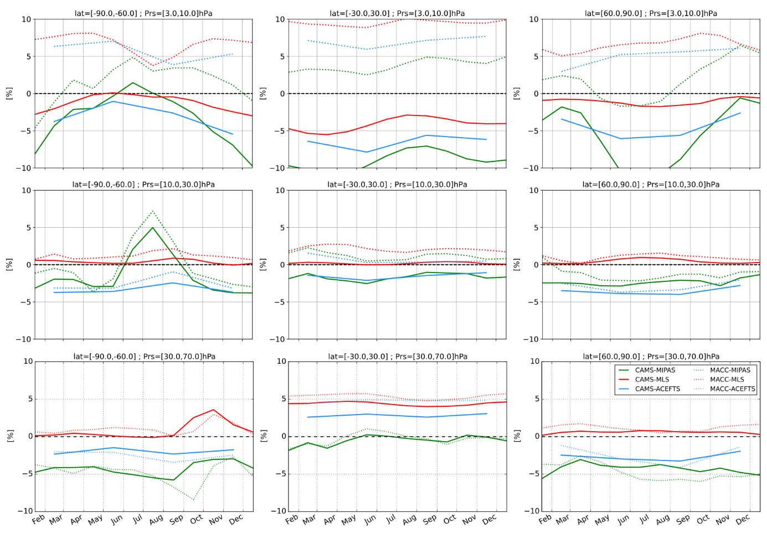
Figure S-2: Monthly climatologies of the Modified Normalised Mean Bias (MNMB, %) shown in Figure 1. Each climatology is averaged over the available period of observations: MIPAS (green, 2003/01 to 2012/04), MLS (red, 2004/08 to 2018/12 against CAMS, 2004/08 to 2012/12 against MACC) and ACE-FTS (blue, 2004/02 to 2018/12 against CAMS, 2004/02 to 2012/12 against MACC).

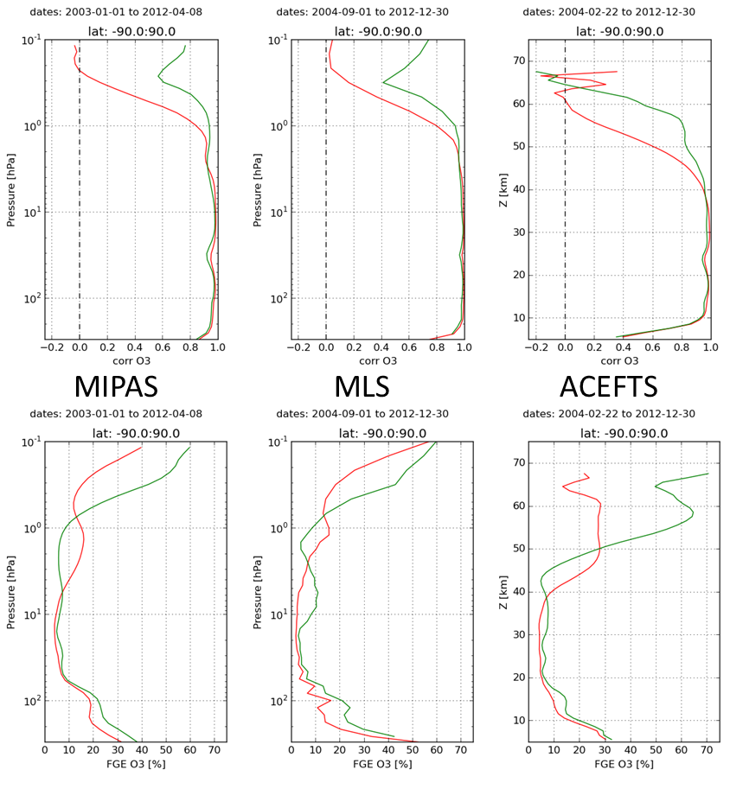
Figure S-3: Correlation coefficient (top row) and Fractional Gross Error (bottom row) globally averaged over the common comparison period. CAMS reanalysis (red) and MACC reanalysis (green) versus satellite observations, from left to right: MIPAS, MLS and ACE-FTS.
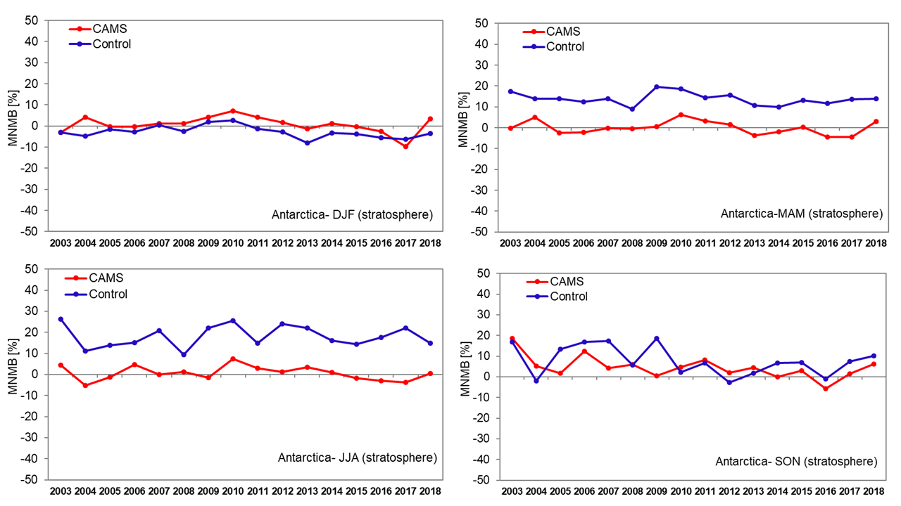
Figure S-4: Inter-annual time-series of seasonal Modified Normalised Mean Biases (MNMB, %) from the validation with ozone sondes in the stratosphere over Antarctica between 2003 and 2018. Top left: DJF, top right: MAM, bottom left: JJA, bottom right: SON. CAMS reanalysis in red, Control run in blue.
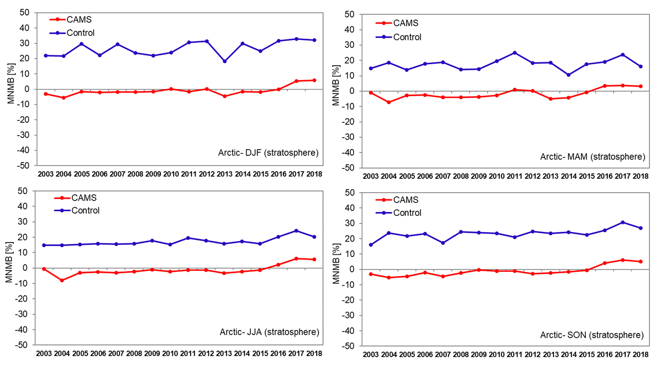
Figure S-5: Inter-annual time-series of seasonal Modified Normalised Mean Biases (MNMB, %) from the validation with ozone sondes in the stratosphere over the Arctic between 2003 and 2018. Top left: DJF, top right: MAM, bottom left: JJA, bottom right: SON. CAMS reanalysis in red, Control run in blue.

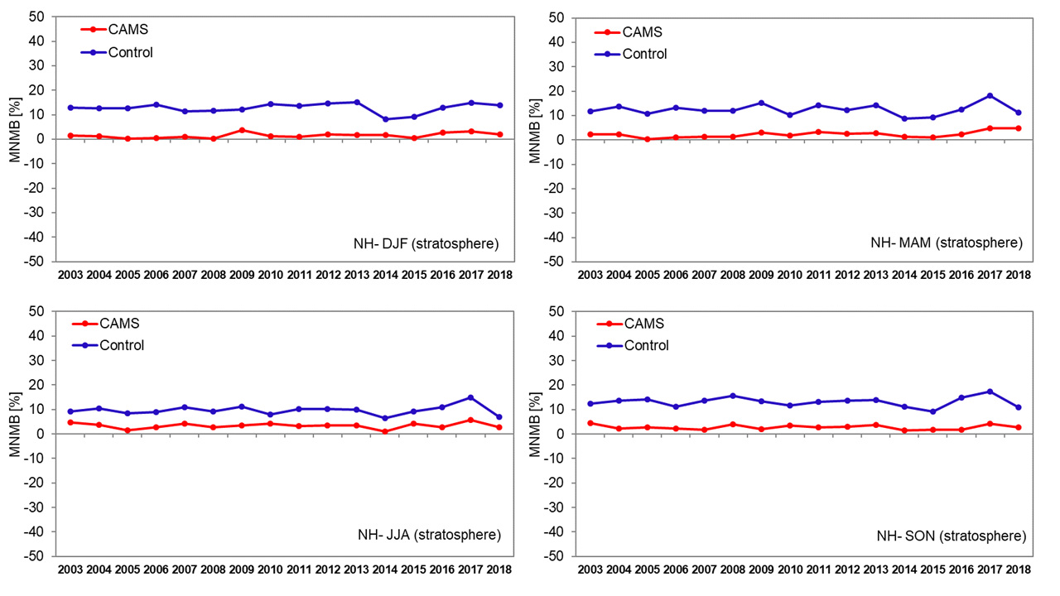
Figure S-6: Inter-annual time-series of seasonal Modified Normalised Mean Biases (MNMB, %) from the validation with ozone sondes in the stratosphere over the Northern mid-latitudes between 2003 and 2018. Top left: DJF, top right: MAM, bottom left: JJA, bottom right: SON. CAMS reanalysis in red, Control run in blue.
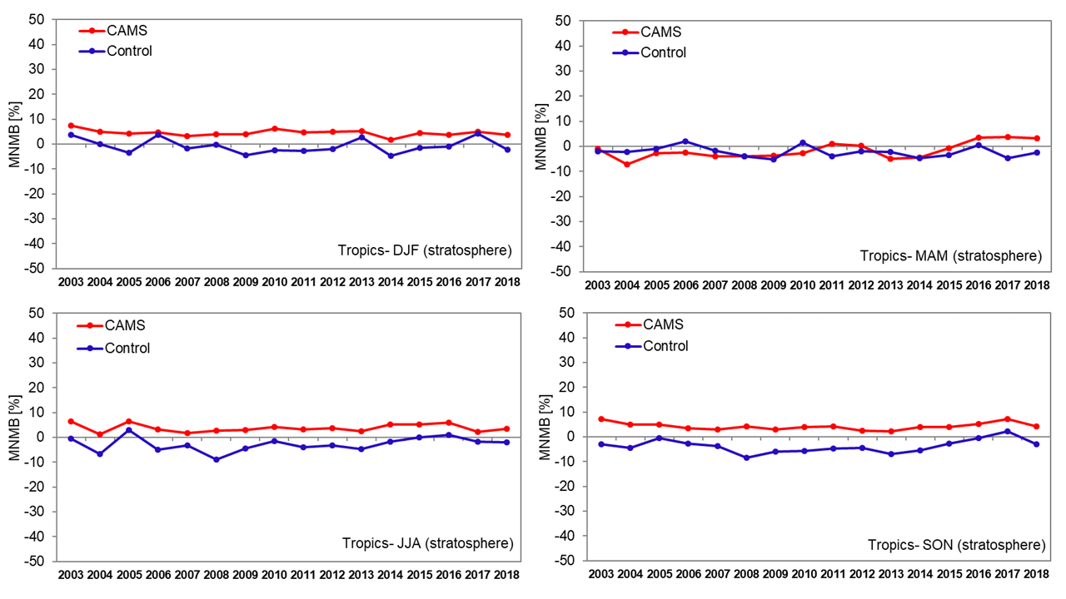
Figure S-7: Inter-annual time-series of seasonal Modified Normalised Mean Biases (MNMB, %) from the validation with ozone sondes in the stratosphere over the Tropics between 2003 and 2018. Top left: DJF, top right: MAM, bottom left: JJA, bottom right: SON. CAMS reanalysis in red, Control run in blue.
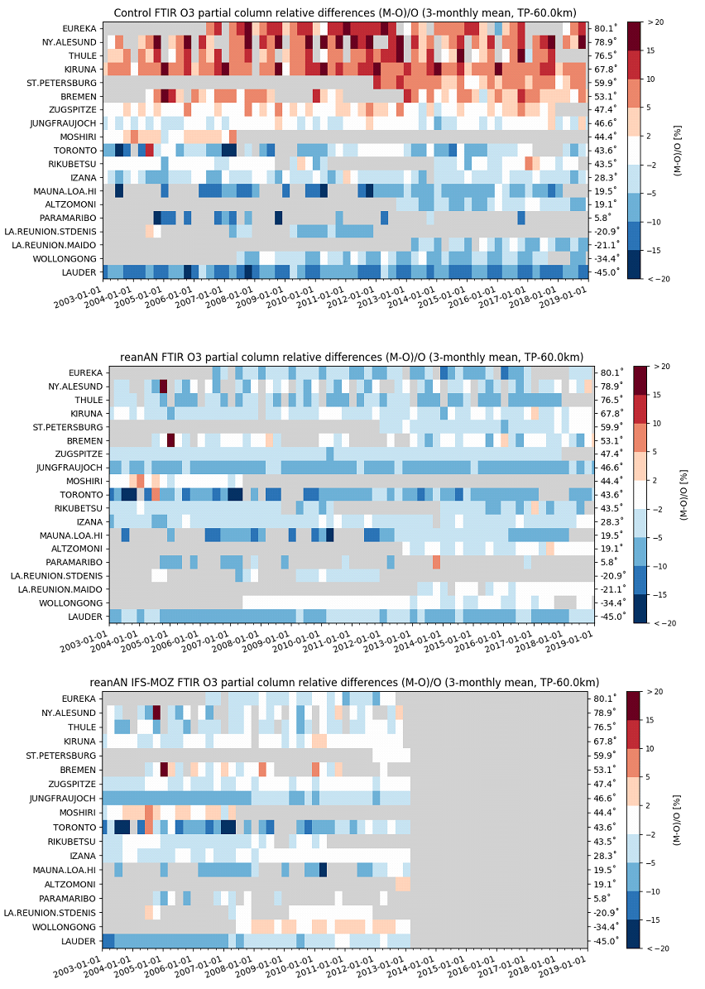
Figure S-8: Time series of seasonal biases (DJF, MAM, JJA, SON) for each NDACC FTIR site.
Top is CAMS control run, middle is CAMS reanalysis, bottom MACC reanalysis- sorted by decreasing latitude for the time period 2003 – 2018. The plot shows relative differences of the models compared to FTIR partial columns of stratospheric O₃ between the tropopause and 60 km.

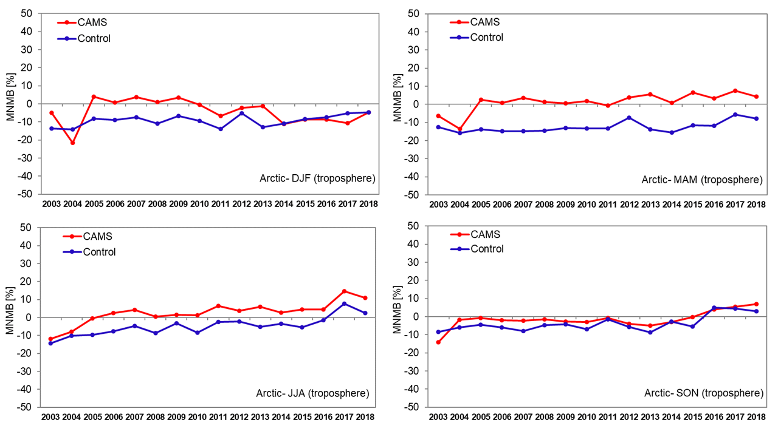
Figure S-9: Inter-annual time-series of seasonal Modified Normalised Mean Biases (MNMB, %) from the validation with ozone sondes in the free troposphere for the Arctic between 2003 and 2018. Top left: DJF, top right: MAM, bottom left: JJA, bottom right: SON. CAMS reanalysis in red, Control run in blue.

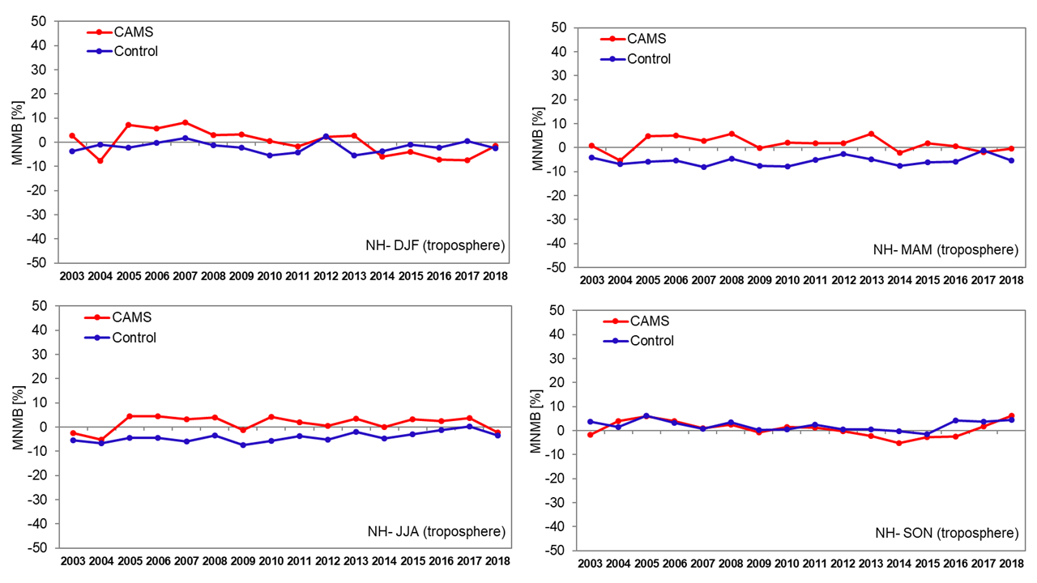
Figure S-10: Inter-annual time-series of seasonal Modified Normalised Mean Biases (MNMB, %) from the validation with ozone sondes in the free troposphere over the Northern mid-latitudes between 2003 and 2018. Top left: DJF, top right: MAM, bottom left: JJA, bottom right: SON. CAMS reanalysis in red, Control run in blue.

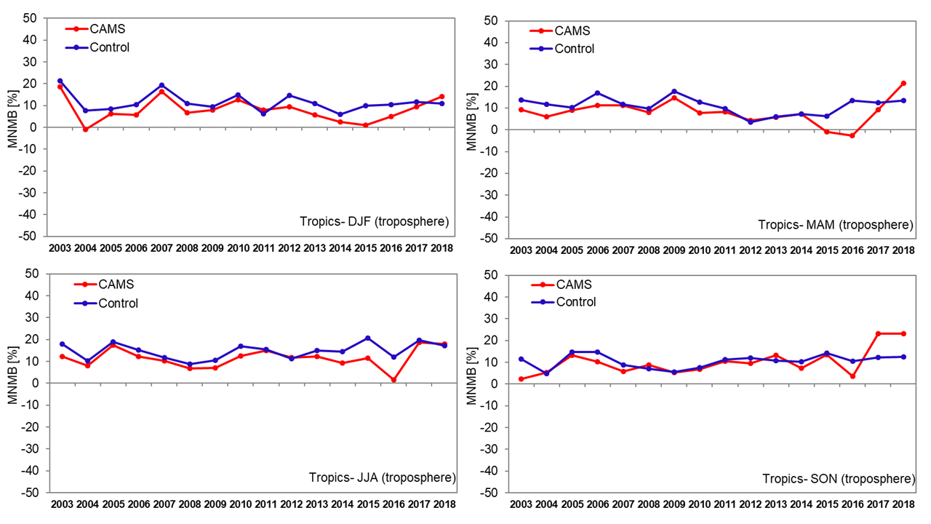
Figure S-11: Inter-annual time-series of seasonal Modified Normalised Mean Biases (MNMB, %) from the validation with ozone sondes in the free troposphere over the Tropics between 2003 and 2018. Top left: DJF, top right: MAM, bottom left: JJA, bottom right: SON. CAMS reanalysis in red, Control run in blue.

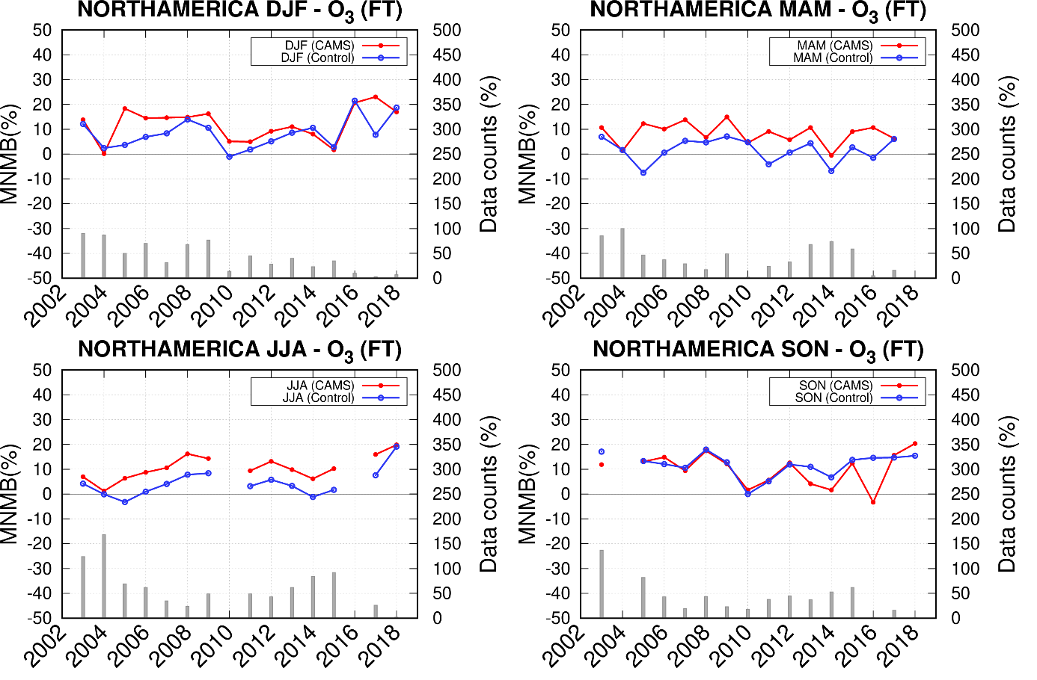
Figure S-12: Inter-annual time-series of seasonal Modified Normalised Mean Biases (MNMB, %) for free tropospheric O₃ from the comparison with IAGOS aircraft data, for North America between 2003 and 2018. Top left: DJF, top right: MAM, bottom left: JJA, bottom right: SON. CAMS reanalysis in red, Control run in blue.

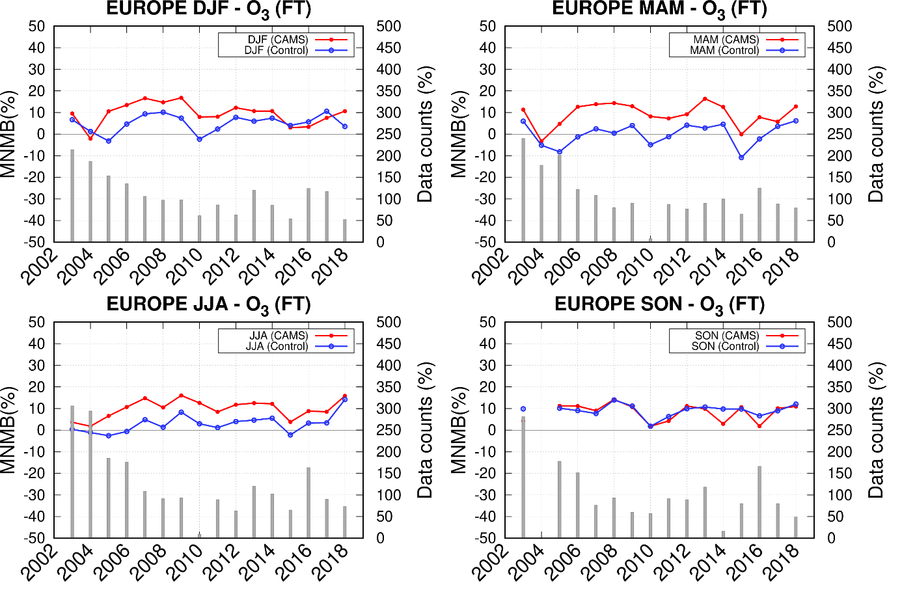
Figure S-13: Inter-annual time-series of seasonal Modified Normalised Mean Biases (MNMB, %) for free tropospheric O₃ from the comparison with IAGOS aircraft data, for Europe between 2003 and 2018. Top left: DJF, top right: MAM, bottom left: JJA, bottom right: SON. CAMS reanalysis in red, Control run in blue.
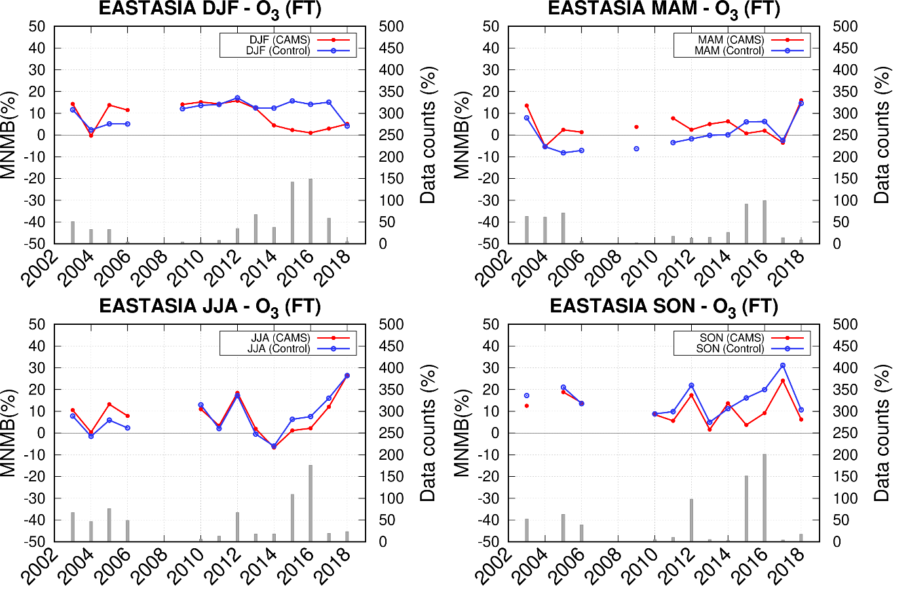
Figure S-14: Inter-annual time-series of seasonal Modified Normalised Mean Bias (MNMB, %) for free tropospheric O₃ from the comparison with IAGOS aircraft data, for East Asia between 2003 and 2018. Top left: DJF, top right: MAM, bottom left: JJA, bottom right: SON. CAMS reanalysis in red, Control run in blue.

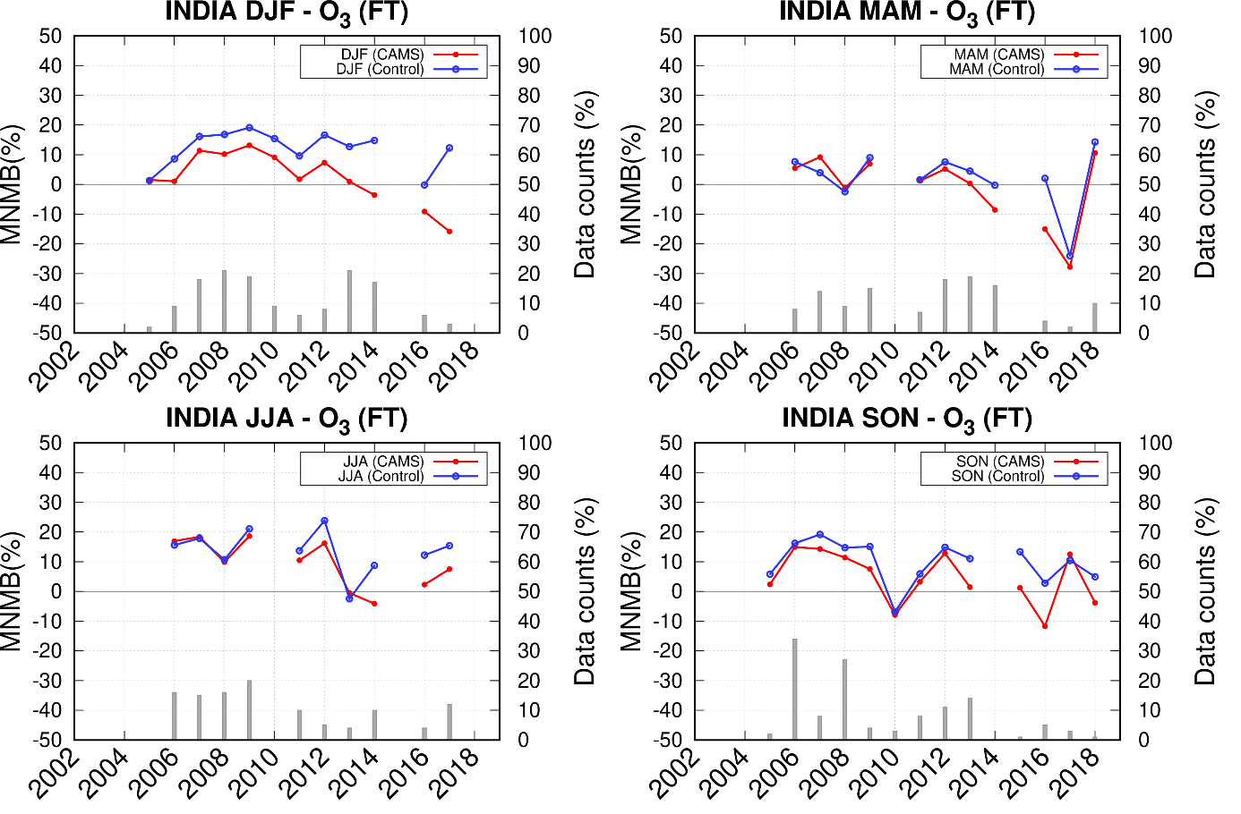
Figure S-15: Inter-annual time-series of seasonal Modified Normalised Mean Biases (MNMB, %) for free tropospheric O₃ from the comparison with IAGOS aircraft data, for India between 2003 and 2018. Top left: DJF, top right: MAM, bottom left: JJA, bottom right: SON. CAMS reanalysis in red, Control run in blue.
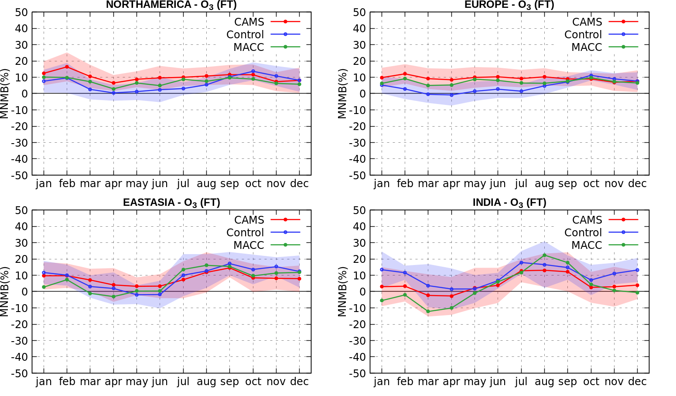
Figure S-16: Mean seasonal variability of monthly MNMB for the CAMS reanalysis (red), Control run (blue) and MACC reanalysis from the evaluation with IAGOS O₃ aircraft data in the free troposphere over different regions. Top left: North America, top right: Europe, bottom left: East Asia, bottom right: India). Monthly MNMB values are averaged for the years between 2003 and 2018 for CAMS reanalysis and Control run, and between 2003 and 2012 for MACC reanalysis.

Figure S-17: Time-series of O₃ Modified Normalised Mean Bias (MNMB) from the comparison with IAOSA surface observations. Left panel: High Arctic sites (Alert, Barrow and Villum Research Station). Right panel: European Arctic sites (Esrange, Karasjok, Oulanka, Pallas, Tustervatn). CAMS reanalysis (red) and control run (blue).

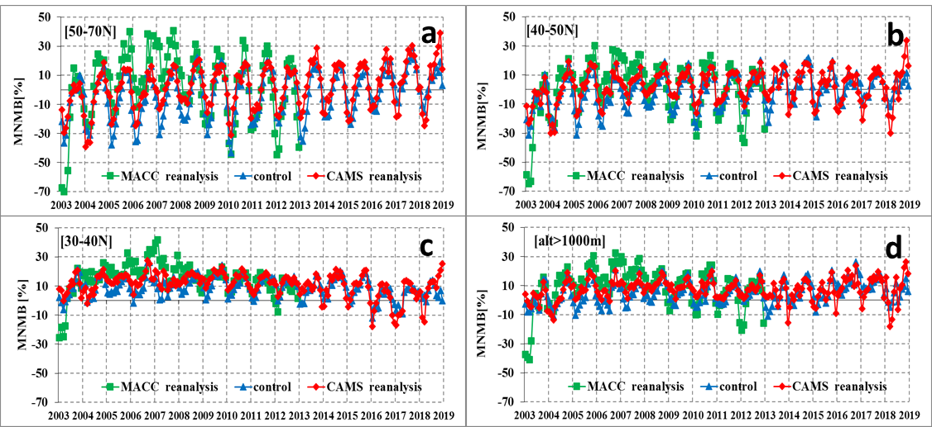
Figure S-18: Time-series of O₃ Modified Normalised Mean Bias (MNMB) from the comparison of the CAMS reanalysis (red) and the control run (blue) and MACC reanalysis (green) with EMEP observations. The data is averaged over European latitudinal zones of 50N-70N (a), 40N-50N (b) and 30N-40N (c) as well as for the group containing stations above 1000m (d).

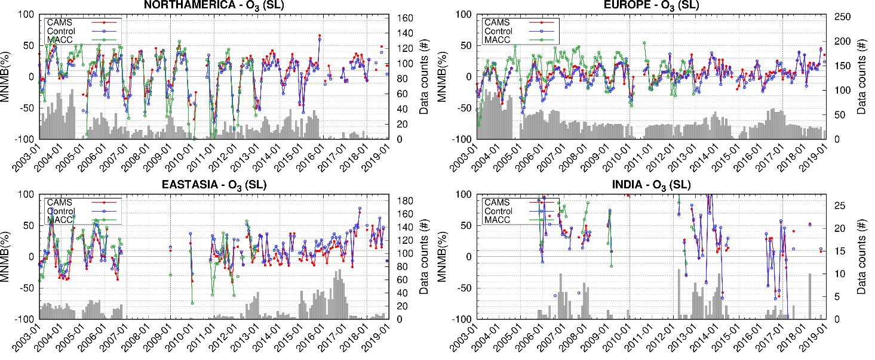
Figure S-19: Time-series of monthly Modified Normalised Mean Bias (MNMB, %) from the comparison against IAGOS O₃ aircraft data in the surface for the period 2003-2018. Top left: North America, top right: Europe, bottom left: East Asia, bottom right: India. The plots show averages over various airports in the surface layer (> 950 hPa), for the CAMS reanalysis (red), Control run (blue) and MACC reanalysis (green).
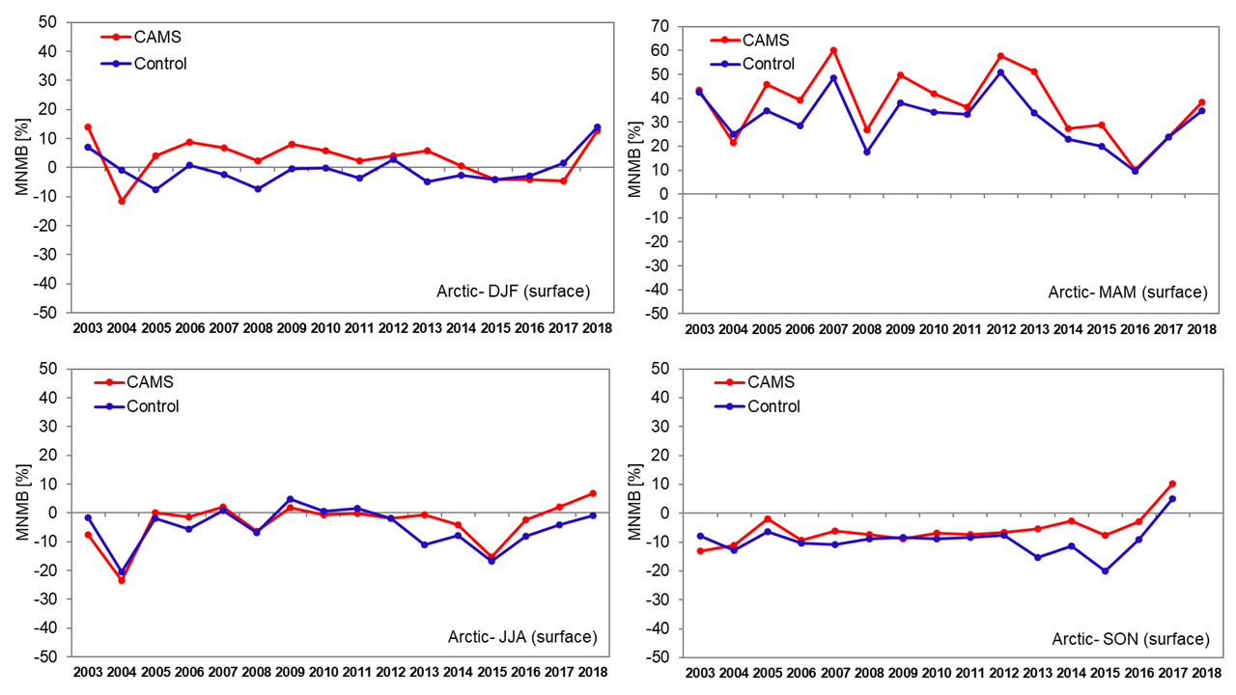
Figure S-20: Inter-annual time-series of seasonal Modified monthly Normalised Mean Biases (MNMB, %) from the validation with GAW O₃ surface observations for the Arctic between 2003 and 2018. Top left: DJF, top right: MAM, bottom left: JJA, bottom right: SON. CAMS reanalysis in red, Control run in blue.

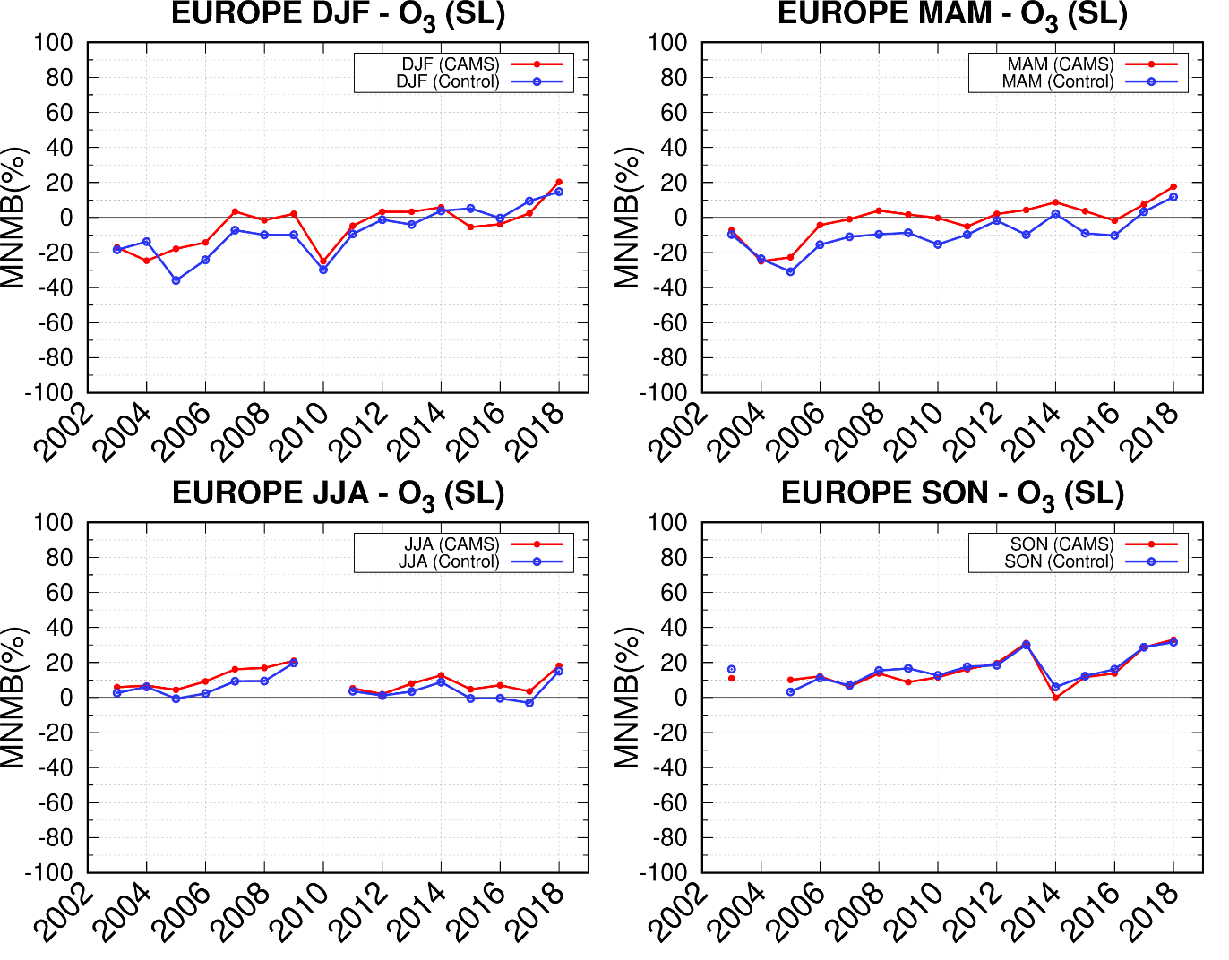
Figure S-21: Inter-annual time-series of seasonal Modified Normalised Mean Bias (MNMB, %) for surface O₃ from the comparison with IAGOS aircraft data, for Europe between 2003 and 2018. Top left: DJF, top right: MAM, bottom left: JJA, bottom right: SON. CAMS reanalysis in red, Control run in blue.
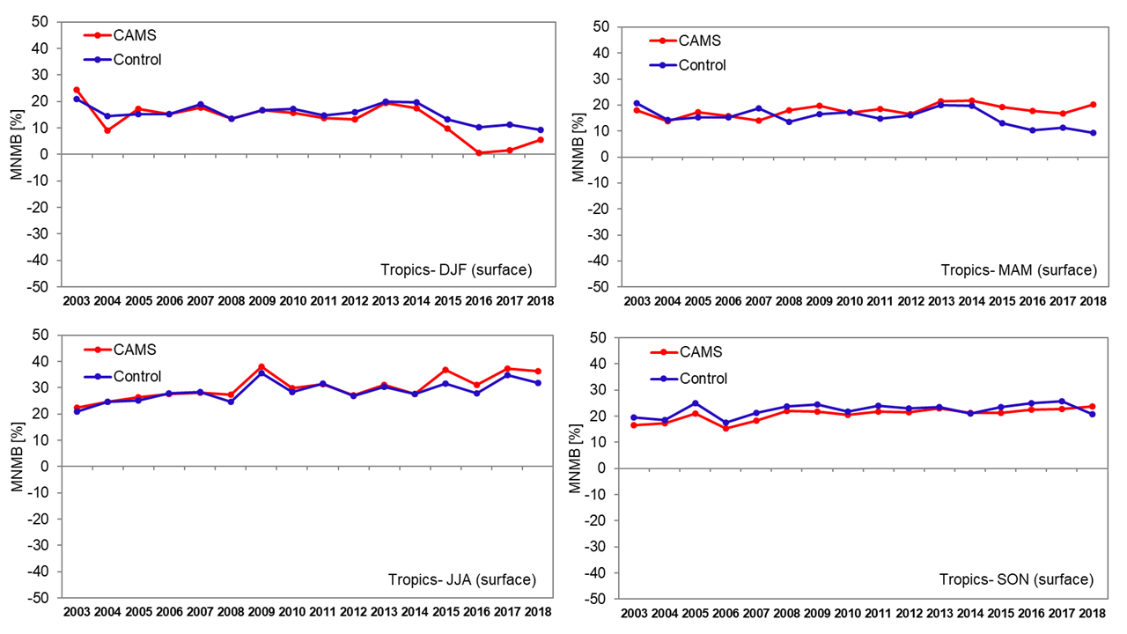
Figure S-22: Inter-annual time-series of seasonal Modified monthly Normalised Mean Bias (MNMB, %) from the validation with GAW O₃ surface observations for the Tropics between 2003 and 2018. Top left: DJF, top right: MAM, bottom left: JJA, bottom right: SON. CAMS reanalysis in red, Control run in blue.
Figure S-23: CO total columns for satellite retrievals MOPITT V7, IASI (black), CAMS reanalysis data (red) and Control run (blue) over selected regions for the period 2003-2018. From left to right: first row for US and Europe, second row: East Asia and South Asia, third row for North Africa and South Africa, last row for Alaska Fire region and Siberia Fire region.
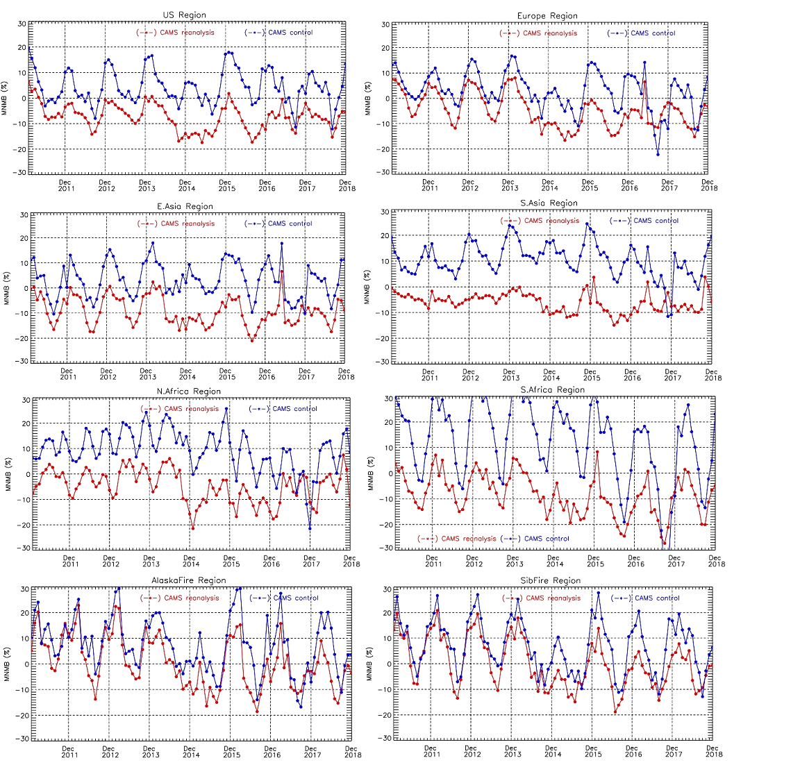
Figure S-24: Time –series of CO Modified Normalised Mean Bias (MNMB, %) from the validation with IASI CO total columns over selected regions for the years from 2008 to 2018.
First row left: US, first row right: Europe, second row left: East Asia, second row right: South Asia, third row left: North Africa, third row right: South Africa, last row left: Alaska fire region, last row left: Siberian fire region. CAMS reanalysis (red), control run (blue). Lower MNMBs of both runs during 2014/2015 originate likely from the change of IASI data versions on 10/2014.

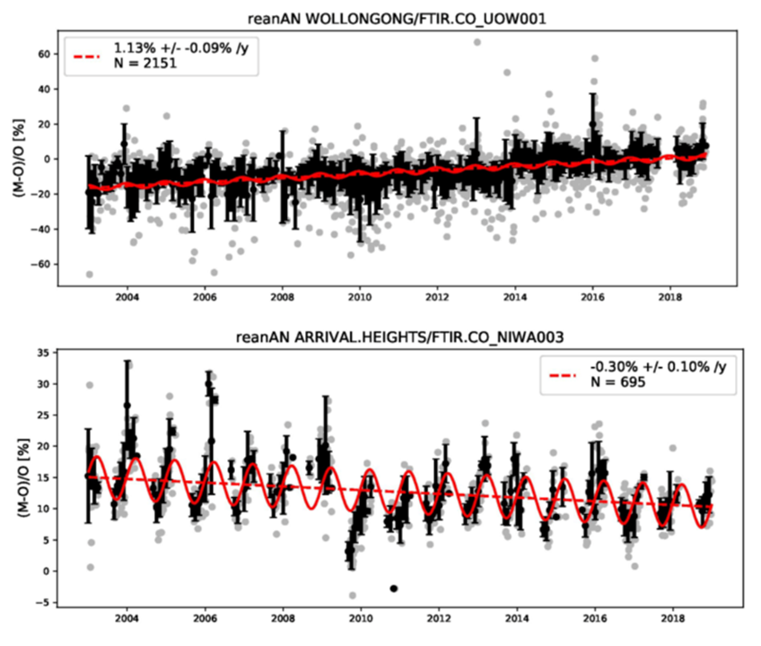
Figure S-25: Trend estimates for the relative bias of the CAMS reanalysis for southern hemispheric NDACC FTIR Stations Wollongong (upper panel) and Arrival heights (lower panel).

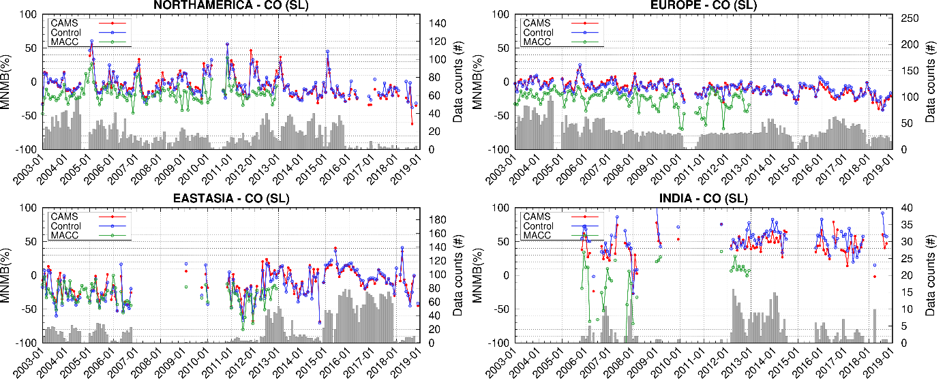
Figure S-26: Time-series of monthly Modified Normalised Mean Bias (MNMB, %) from the comparison against IAGOS CO aircraft data at the surface for the period 2003-2018. Top left: North America, top right: Europe, bottom left: East Asia, bottom right: India. The plots show averages over various airports in the surface layer (> 950 hPa), for the CAMS reanalysis (red), Control run (blue) and MACC reanalysis (green).

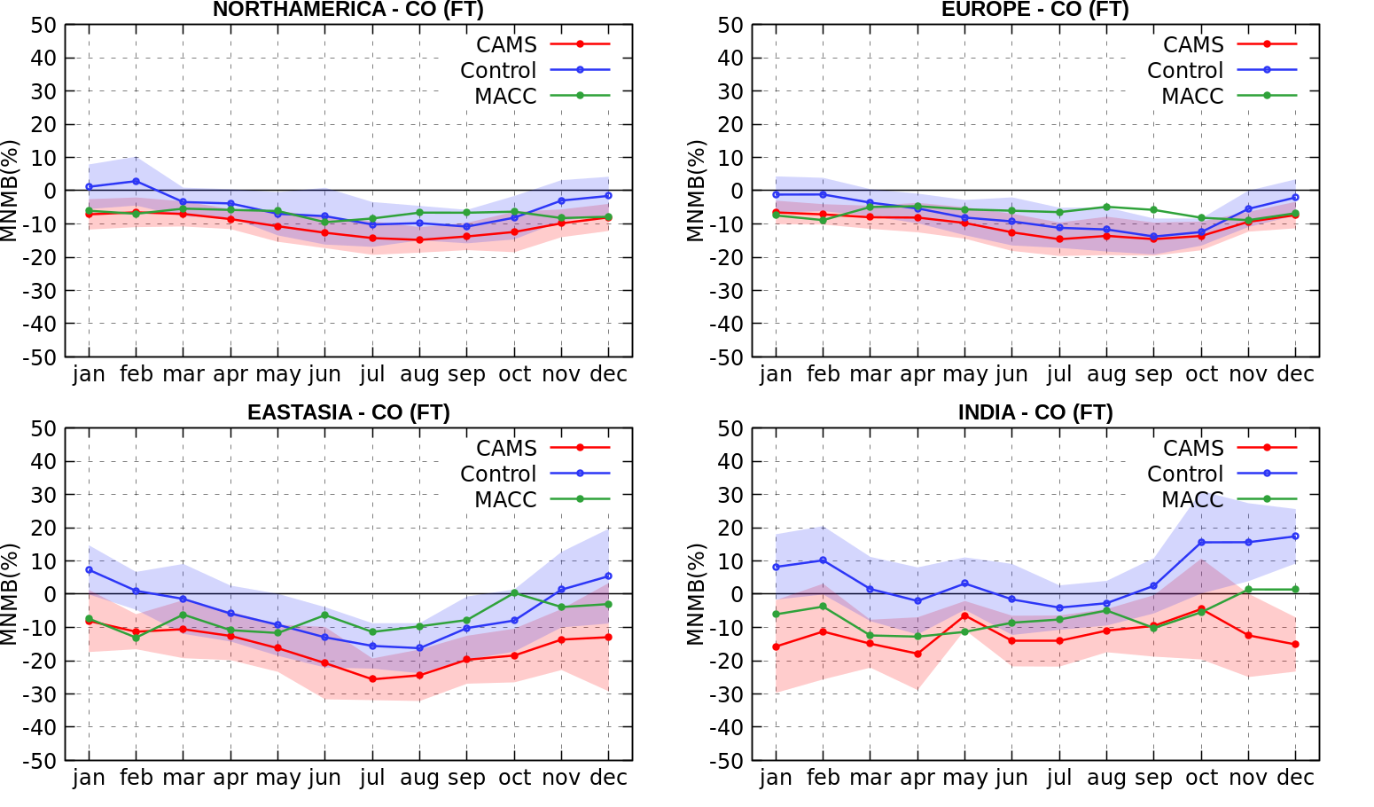
Figure S-27: Mean seasonal variability of monthly MNMB for the CAMS reanalysis (red, Control run (blue) and MACC reanalysis from the evaluation with IAGOS CO aircraft data in the free troposphere over different regions. Top left: North America, top right: Europe, bottom left: Eastern Asia, bottom right: India. Monthly MNMB values are averaged for the years between 2003 and 2018 for CAMS reanalysis and Control run, and between 2003 and 2012 for MACC reanalysis.

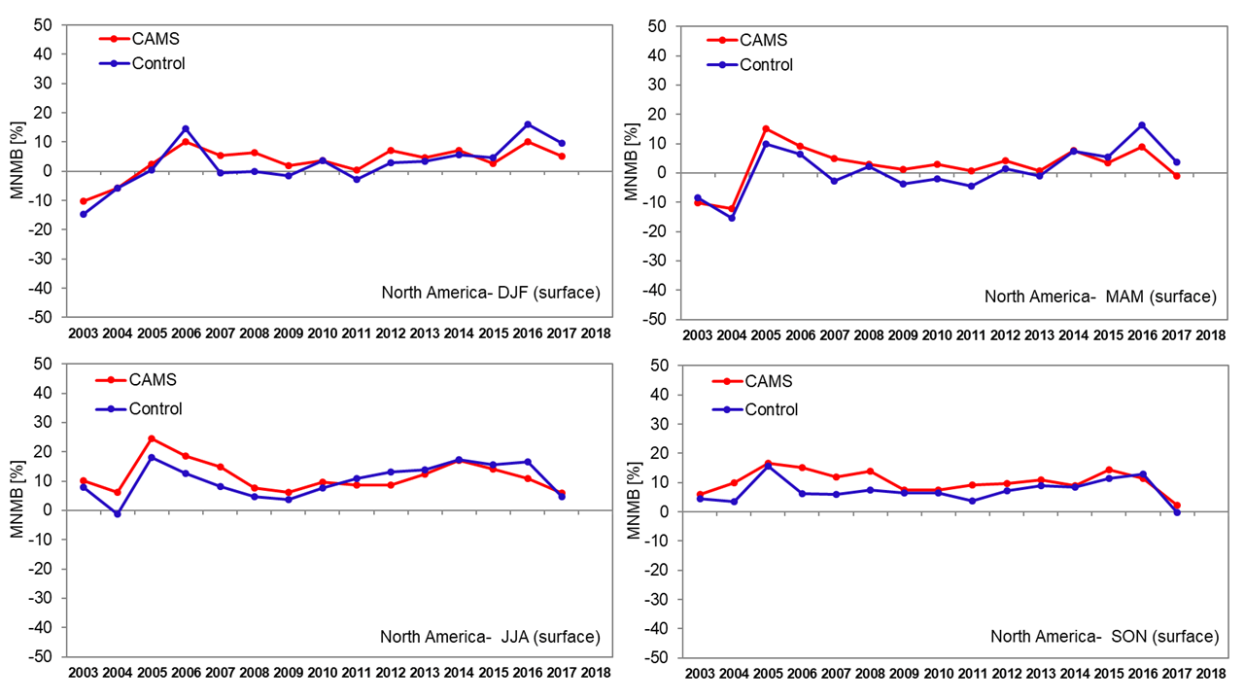
Figure S-28: Inter-annual time-series of seasonal Modified Normalised Mean Bias (MNMB, %) from the validation with GAW CO surface data for North America between 2003 and 2018. Top left: DJF, top right: MAM, bottom left: JJA, bottom right: SON. CAMS reanalysis in red, Control run in blue.

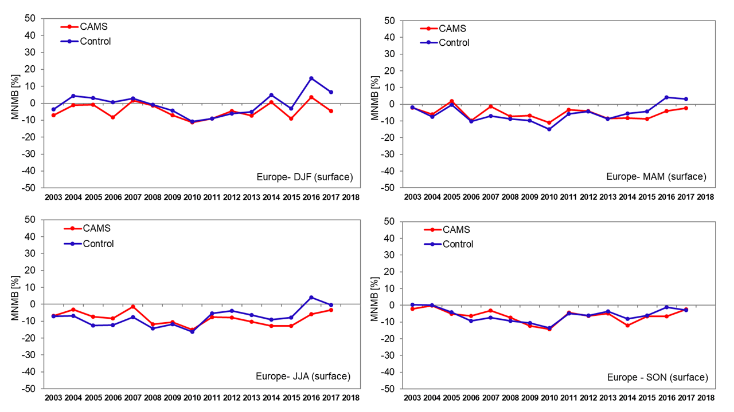
Figure S-29: Inter-annual time-series of seasonal Modified Normalised Mean Bias (MNMB) from the validation with GAW CO surface data for Europe between 2003 and 2018. Top left: DJF, top right: MAM, bottom left: JJA, bottom right: SON. CAMS reanalysis in red, Control run in blue.

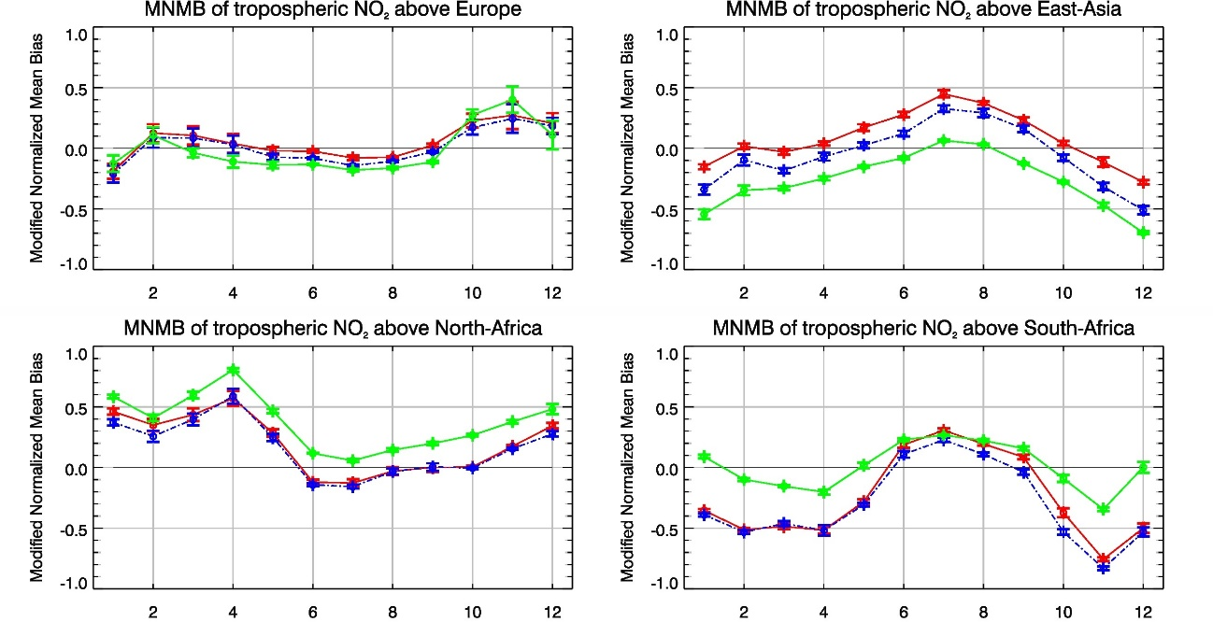
Figure S-30: Climatological monthly mean of the Modified Normalized Mean Bias from the comparison of time series of tropospheric NO₂ columns from SCIAMACHY and GOME-2 to model results. MNMBs are derived from daily averages over a specific region. Negative daily averages of the retrievals have been flagged in the calculation of the MNMB only. The x-axis lists the months (Jan-Dec). Error bars show the standard deviation.
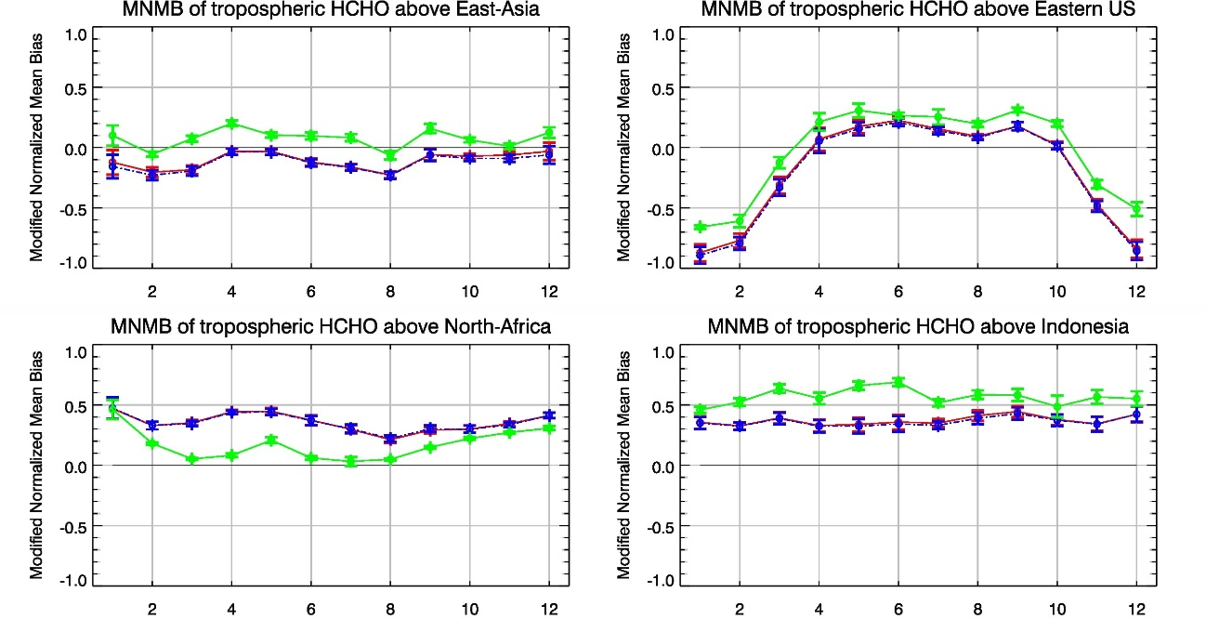
Figure S-31: Climatological monthly mean of the Modified Normalized Mean Bias from the comparison of time series of tropospheric HCHO columns from SCIAMACHY and GOME-2 to model results. Negative daily averages of the retrievals have been flagged in the calculation of the MNMB only. The x-axis lists the months (Jan-Dec). Error bars show the standard deviation.

Model | MACC reanalysis | CAMS reanalysis
Period covered | 2003 -2012 | 2003 - present
Assimilation system | IFS Cycle 36r1 4D-Var | IFS Cycle 42r1 4D-Var
Spatial resolution | 80 km globally (T255), 60 levels to 0.1 hPa | 80 km globally (T255), 60 levels to 0.1 hPa
Temporal resolution | 6-hourly analysis fields, 3-hourly forecast fields | 3-hourly analysis fields, 3-hourly forecast fields
Anthropogenic missions | Chemistry species: MACCity (trend: ACCMIP + RCP8.5)  Aerosols: AEROCOM | MACCity (trend: ACCMIP + RCP8.5) & CO emission upgrade Stein et al. (2014)
Biomass burning emissions | GFED (2003–2008) and GFAS v0 (2009–2012 ) | GFAS v 1.2
Biogenic emissions | Monthly mean VOC emissions for the year 2003 calculated by the MEGAN2.1 model (Guenther et al., 2006) used for the whole period. No inter-annual variability. | Monthly mean VOC emissions calculated by the MEGAN model using MERRA reanalysed meteorology (Sindelarova et al., 2014) for the whole period.
Chemistry modules | CTM MOZART3 coupled to the IFS (see Flemming et al. 2009) | IFS CB05 (Flemming et al. 2015, with updates as given in CAMS Reanalysis data documentation) & Cariolle O₃ parametrisation in stratosphere
Aerosol modules | Mocrette et al. (2009) | Mocrette et al. (2009) with changes, see Inness et al. (2019)
Aerosol used in radiation scheme | Tegen climatology | Interactive active aerosols, i.e. aerosol fields from eac4 used in radiation scheme
Stratospheric chemistry | Yes | No, but Cariolle ozone parametrization in stratosphere and stratospheric O₃ available.
Technical documentation | ECMWF MACC confluence page | CAMS confluence web page
Table S-1: Comparison of the set-up of CAMS and MACC reanalysis

 | MACC (Antarctica) | CAMS (Antarctica) | MACC (Arctic) | CAMS (Arctic) | MACC (NH) | CAMS (NH) | MACC (Tropics) | CAMS (Tropics)
Month/ MNMBs [%] | MNMB±SD | MNMB± SD | MNMB± SD | MNMB± SD | MNMB±SD | MNMB± SD | MNMB± SD | MNMB ± SD
Jan | 2.83±5.18 | 1.57±4.90  (-0.01±5.08) | 2.17±6.60 | -1.60±2.13  (-0.54±3.81) | 2.61±3.15 | 0.71±0.97  (1.04±1.13) | 5.67±2.09 | 4.57±1.53  (4.05±1.48)
Feb | 1.87±3.80 | 1.31±3.20  (0.65±4.12) | -0.73±2.35 | -1.90±2.23  (-1.23±3.07) | 1.81±2.04 | 1.16±2.22  (1.56±2.09) | 6.03±1.83 | 5.02±1.19  (4.57±1.85)
Mar | 0.63±3.44 | 0.59±3.06  (-0.77±3.34) | -0.91±3.27 | -2.30±1.92  (-1.88±2.69) | 2.21±2.82 | 1.25±1.60  (1.53±1.65) | 6.43±1.72 | 5.02±1.18  (4.55±2.01)
Apr | -0.3±1.69 | -0.09±2.18  (-0.60±2.48) | -1.84±4.65 | -2.21±3.03  (-1.26±3.70) | 1.97±2.50 | 1.63±0.99  (2.02±1.51) | 6.33±2.74 | 4.80±1.95  (4.68±1.75)
May | 1.84±5.68 | 2.69±4.30  (1.25±4.42) | -3.40±3.32 | -3.59±2.41  (-1.91±3.75) | 3.30±1.90 | 2.85±0.77  (3.19±1.40) | 5.68±1.88 | 4.02±1.31  (4.00±2.43)
Jun | -0.11±0.73 | 2.04±5.30  (0.72±4.75) | -3.00±3.10 | -2.90±2.00  (-1.54±3.52) | 3.63±2.26 | 3.11±1.39  (3.12±1.40) | 5.27±1.82 | 3.44±1.74  (3.70±1.80)
Jul | 0.49±7.93 | 0.39±5.29  (1.06±2.84) | -2.78±4.06 | -2.39±2.71  (-0.91±3.66) | 4.03±1.69 | 3.59±1.78  (3.53±1.73) | 4.73±2.80 | 3.43±2.63  (3.48±2.40)
Aug | 2.2±2.90 | 1.69±2.28  (1.06±2.84 ) | -2.38±2.69 | -2.40±2.18  (-1.06±3.20) | 3.85±1.71 | 3.45±1.32  (3.46±2.18) | 5.07±2.21 | 3.90±1.70  (4.05±1.61)
Sep | 0.22±9.64 | 6.67±3.42  (5.09±4.25) | -2.64±2.50 | -3.13±2.24  (-1.09±3.93) | 3.60±1.30 | 3.03±1.08  (2.94±1.68) | 4.11±1.14 | 3.28±0.93  (2.96±1.16)
Oct | 0.32±7.09 | 5.95±8.27  (4.75±7.09) | -1.66±1.45 | -2.52±1.47  (-1.20±3.10) | 3.36±1.43 | 3.08±1.35  (3.02±1.49) | 4.66±1.83 | 3.75±1.87  (4.40±2.01)
Nov | 7.14±6.60 | 6.38±6.87  (3.81±7.04) | -1.75±2.71 | -2.42±2.27  (-0.70±3.52) | 2.80±1.51 | 2.43±1.42  (2.32±1.23) | 6.11±2.27 | 5.27±2.29  (5.39±2.62)
Dec | 3.89±4.17 | 3.35±4.04  (1.61±5.18) | -1.32±2.23 | -2.10±1.80  (-0.51±3.81) | 2.62±1.48 | 2.06±1.25  (2.04±1.27) | 5.62±2.01 | 4.67±1.82  (4.68±1.82)
Table S-2: Multi-annual monthly MNMBs (and associated SD) for the MACC and CAMS reanalysis, calculated from the comparison with ozone soundings for different regions in the stratosphere. Values cover the time period 2003-2012 and values in brackets the time period 2003- 2018.

 | MACC Reanalysis |  |  |  |  |  | CAMS Reanalysis
FTIR site | Lat | # | Std | R | Rel. diff. bias  (%) | Rel. diff. std  (%) | # | Std | R | Rel. diff. bias  (%) | Rel. diff. std  (%)
EUREKA | 80.1 | 494 | 1 | 0.99 | -2.2 | 2.06 | 756 | 1.1 | 0.99 | -4.73 | 1.91
NYALESUND | 78.9 | 192 | 1 | 0.98 | -2.29 | 4.28 | 357 | 1 | 0.99 | -3.83 | 3.13
THULE | 76.5 | 703 | 1 | 0.99 | -3.16 | 2.58 | 996 | 1.1 | 0.99 | -5.15 | 2.18
KIRUNA | 67.8 | 677 | 1 | 0.99 | -1.41 | 2.7 | 1097 | 1 | 0.99 | -2.63 | 2.31
ST.PETERSBURG | 59.9 | 74 | 1 | 1 | -0.78 | 1.64 | 505 | 1 | 0.99 | -2.91 | 2.17
BREMEN | 53.1 | 166 | 1 | 0.93 | 0.49 | 6.19 | 371 | 1 | 0.96 | -1.89 | 4.69
ZUGSPITZE | 47.4 | 1215 | 1.1 | 0.98 | -1.68 | 2.3 | 1784 | 1.1 | 0.99 | -3.61 | 1.99
JUNGFRAUJOCH | 46.6 | 1052 | 1.1 | 0.99 | -5.35 | 2.05 | 1615 | 1.1 | 0.99 | -5.36 | 1.63
MOSHIRI | 44.4 | 344 | 1.1 | 0.98 | 1.96 | 4.14 | 344 | 1.1 | 0.98 | 0.38 | 3.72
TORONTO | 43.6 | 459 | 1.2 | 0.83 | -5.98 | 7.5 | 1043 | 1.2 | 0.91 | -7.99 | 5.7
RIKUBETSU | 43.5 | 313 | 1.1 | 0.99 | -2.26 | 2.32 | 424 | 1 | 0.99 | -3.64 | 2.24
IZANA | 28.3 | 994 | 1.1 | 0.89 | -1.39 | 2.48 | 1540 | 1.1 | 0.93 | -3.06 | 1.91
MAUNA LOA | 19.5 | 263 | 1.1 | 0.82 | -4.83 | 4.42 | 1319 | 1.2 | 0.89 | -4.68 | 2.97
ALTZOMONI | 19.1 | 15 | 1.3 | 0.84 | 4.51 | 1.01 | 483 | 1 | 0.95 | -2.06 | 1.89
PARAMARIBO | 5.8 | 75 | 1.2 | 0.84 | -3.14 | 2.12 | 81 | 1.1 | 0.8 | -5.69 | 2.47
LA REUNION  ST DENIS | -20.9 | 469 | 1 | 0.91 | 0.44 | 1.79 | 469 | 1 | 0.9 | -2.6 | 1.82
LA REUNION  MAIDO | -21.1 | 0 | NaN | NaN | NaN | NaN | 823 | 0.9 | 0.94 | -1.11 | 1.65
WOLLONGONG | -34.4 | 394 | 1.1 | 0.99 | 2.53 | 1.92 | 776 | 1 | 0.99 | -0.93 | 1.86
LAUDER | -45 | 681 | 1.1 | 0.97 | -5.07 | 3.32 | 1459 | 1 | 0.99 | -5.23 | 1.85
MEAN |  |  | 1.1 | 0.94 | -1.64 | 3.05 |  | 1.1 | 0.96 | -3.51 | 2.53
Table S-3: Relative differences, correlation coefficients (R) and standard deviations w.r.t. O₃ NDACC FTIR observations in the stratosphere for the period 2003-2018 (2003-2012 for the MACC reanalysis). Missing data values are denoted as “NaN”.

 | MACC (Antarctica) | CAMS (Antarctica) | MACC (Arctic) | CAMS (Arctic) | MACC (NH) | CAMS (NH) | MACC (Tropics) | CAMS (Tropics)
Month/ MNMBs [%] | MNMB±SD | MNMB± SD | MNMB± SD | MNMB± SD | MNMB± SD | MNMB± SD | MNMB± SD | MNMB ± SD
Jan | 5.28±22.50 | 1.48±8.35  (12.58±15.58) | -10.3±21.31 | -2.43±7.30  (-5.23±7.37) | -2.50±16.52 | 2.18±4.51  (-1.00±6.14) | -8.13±5.99 | 11.93±7.42  (-1.00±6.14)
Feb | -2.72±26.47 | -2.79±12.21  (7.28±16.44) | -6.04±18.11 | 0.63±7.71  (-0.71±6.67) | 0.32± 12.94 | 3.89±4.21  (2.04±5.24) | -12.26±7.11 | 7.37±6.46  (2.04±5.24)
Mar | 6.62±19.96 | -2.21±11.99  (2.98±12.05) | -3.86±16.63 | 0.28±6.15  (0.86±5.09) | -1.78±13.32 | 1.42±3.51  (0.93±3.70) | -8.35±5.15 | 10.42±4.82  (0.93±3.70)
Apr | -2.76±15.78 | -4.64±9.84  (-2.39±9.35) | -5.71±14.51 | -1.38±4.84  (1.45±5.87) | -2.69±11.56 | 0.56±2.88  (0.45±2.63) | -9.99±4.88 | 6.31±3.18  (0.45±2.63)
May | -12.7±23.83 | -7.12±5.36  (-6.23±5.50) | -5.15±10.99 | -0.82±6.22  (1.77± 6.21) | 0.96±7.19 | 3.74±3.39  (2.85± 3.99) | -4.74±6.57 | 10.20±4.20  (2.85±3.99)
Jun | -11.2±22.25 | -8.54±6.18  (-9.35±5.59) | -4.21±8.89 | 0.53±7.51  (4.50±8.28) | -1.87±3.89 | 0.99±3.49  (1.34±3.97) | -4.33±5.67 | 12.42±2.32  (1.34±3.97)
Jul | -7.75±24.33 | -3.02±8.25  (-5.66±7.80) | -2.06±6.07 | 1.34±5.53  (1.95±5.38) | -2.13±2.80 | 1.03±3.85  (0.4±3.54) | -7.98±7.68 | 10.22±6.34  (0.4±3.54)
Aug | -0.26±25.87 | 4.51±9.48  (2.64±8.03) | -2.48±6.08 | -1.89±4.37  (1.66±6.80) | -0.54±3.88 | 2.23±3.95  (2.95±3.49) | -6.45±5.30 | 11.35±2.85  (2.95±3.49)
Sep | 9.41±23.75 | 9.32±8.52  (5.78±9.24) | 2.35±7.51 | -0.91±2.84  (0.68±3.93) | 1.12±3.41 | 2.37±2.62  (1.67±3.05) | -10.04±5.32 | 9.13±2.64  (1.67±3.05)
Oct | -0.32±22.47 | 4.40±6.55  (1.89±7.57) | -1.35±11.69 | -2.91±4.05  (-0.85±5.19) | 2.73±6.40 | 1.78±2.55  (1.08±2.79) | -12.36±5.93 | 7.17±4.27  (1.08±2.79)
Nov | 2.39±20.42 | 3.33±5.18  (6.11±8.12) | -6.81±16.11 | -5.93±6.01  (-4.38±6.31) | -0.82±8.13 | 0.98±3.56  (-0.49±4.90) | -11.17±8.72 | 7.11±4.57  (-0.49±4.90)
Dec | 3.09±14.80 | 5.03±11.34  (12.16±11.3) | -9.58±17.78 | -5.12±7.44  (-5.64±8.28) | -1.36±12.73 | 0.54±5.28  (-0.26±5.94) | -11.11±7.41 | 6.52±6.30  (-0.26±5.94)
Table S-4: Multi-annual monthly MNMBs (and associated SD) for the MACC and CAMS reanalysis, calculated from the comparison with ozone soundings for different regions in the free troposphere. Values cover the time period 2003-2012 and values in brackets the time period 2003- 2018.

 | MACC  (N-AMERICA) | CAMS  (N-AMERICA) | MACC  (EUROPE) | CAMS  (EUROPE) | MACC  (EASTASIA) | CAMS  (EASTASIA) | MACC  (INDIA) | CAMS  (INDIA)
Month/ MNMBs [%] | MNMB±SD | MNMB±SD | MNMB±SD | MNMB±SD | MNMB±SD | MNMB±SD | MNMB±SD | MNMB±SD
Jan | 10.12±13.35 | 11.19±7.08 | 6.23±15.47 | 11.75±6.17 | 2.72±10.96 | 12.99±7.83 | -5.52±11.33 | 8.26±10.66
 |  | (12.44±7.30) |  | (9.78±6.01) |  | (9.68±8.37) |  | 3.00±11.98
Feb | 9.86±13.80 | 15.12±7.69 | 9.14±11.98 | 12.77±6.35 | 7.29±7.46 | 12.21±7.98 | -2.05±8.90 | 7.22±5.81
 |  | (16.37±8.85) |  | (12.09±5.93) |  | (9.72±7.45) |  | 3.28±9.36
Mar | 7.28±12.45 | 11.29±7.20 | 4.99±15.66 | 9.32±6.57 | -1.08±11.00 | 7.25±9.75 | -12.21±7.34 | 2.24±4.06
 |  | (10.50±7.11) |  | (9.14±6.35) |  | (7.08±6.89) |  | -2.36±12.93
Apr | 2.91±8.55 | 7.45±4.85 | 5.26±12.88 | 7.71±5.96 | -3.08±4.36 | 2.07±7.90 | -10.07±7.44 | 1.71±8.52
 |  | (6.47±4.92) |  | (8.45±6.74) |  | (4.07±10.35) |  | -2.68±11.58
May | 6.49±5.34 | 8.86±4.96 | 8.78±5.66 | 10.33±6.25 | 0.29±3.62 | 3.69±5.07 | -1.00±7.51 | 8.27±7.46
 |  | (8.79±4.88) |  | (9.90±6.36) |  | (3.22±5.47) |  | 2.18±12.37
Jun | 4.88±3.23 | 7.57±5.05 | 8.05±4.11 | 10.13±4.92 | 0.34±7.69 | 2.75±5.26 | 5.98±7.80 | 10.59±6.43
 |  | (9.61±7.32) |  | (10.28±5.63) |  | (3.34±7.36) |  | 3.80±10.77
Jul | 8.69±5.46 | 10.39±5.39 | 6.46±3.99 | 9.72±6.65 | 13.58±7.20 | 6.51±8.38 | 11.69±8.14 | 15.81±5.89
 |  | (9.99±5.39) |  | (9.21±5.38) |  | (7.26±11.33) |  | 12.76±7.01
Aug | 7.53±5.68 | 10.46±6.35 | 6.32±5.13 | 9.22±4.85 | 16.09±6.47 | 16.31±12.10 | 22.35±6.64 | 17.95±4.63
 |  | (10.76±5.54) |  | (10.26±5.29) |  | (11.78±12.31) |  | 13.08±10.19
Sep | 9.68±5.49 | 12.20±4.74 | 7.59±4.91 | 9.07±4.55 | 15.40±8.47 | 15.55±5.70 | 17.73±12.66 | 15.13±7.70
 |  | (11.62±5.97) |  | (8.82±4.29) |  | (14.52±5.82) |  | 12.12±12.01
Oct | 8.87±7.90 | 11.85±6.40 | 9.72±6.08 | 8.86±3.82 | 9.62±9.05 | 12.53±5.96 | 4.36±10.63 | 6.93±10.14
 |  | (11.54±6.32) |  | (8.81±3.89) |  | (8.43±8.57) |  | 2.62±9.44
Nov | 6.23±8.89 | 8.83±4.27 | 7.34±9.82 | 7.99±4.71 | 11.36±12.92 | 9.60±7.98 | 0.69±10.27 | 6.82±7.61
 |  | (7.28±5.82) |  | (6.91±5.31) |  | (8.10±6.91) |  | 2.96±12.23
Dec | 5.74±12.90 | 8.94±5.52 | 6.48±13.63 | 8.92±6.84 | 11.74±9.55 | 12.91±6.82 | -0.59±9.24 | 6.90±6.68
 |  | (8.11±7.76) |  | (7.58±6.68) |  | (7.95±8.00) |  | 3.97±8.57
Table S-5: Multi-annual monthly MNMBs (and associated SD) for the MACC and CAMS reanalysis, calculated from the comparison with IAGOS free tropospheric observations for different regions. Values cover the time period 2003-2012 and values in brackets the time period 2003- 2018.

 | CAMS Reanalysis  (High Arctic) | CAMS Reanalysis (European Arctic)
MNMBs [%] | MNMB ± SD | MNMB ± SD
Jan | 4.4±8.7 | -13.1±8.9
Feb | 15.6±7.9 | -14.9±9.0
Mar | 46.3±13.5 | -8.7±10.7
Apr | 61.6±19.5 | -3.2±8.5
May | 48.7±20.8 | 11.3±7.9
Jun | 9.8±20.0 | 22.7±9.1
Jul | 3.2±17.3 | 30.1±7.1
Aug | -5.5±17.9 | 31.8±5.3
Sep | -13.2±14.6 | 24.1±6.7
Oct | 1.0±8.3 | 16.0±7.5
Nov | 3.6±7.5 | 4.6±7.8
Dec | 3.5±8.0 | -10.3±8.1
Table S-6: Multi-annual monthly MNMBs (and associated SD) calculated from 3-hourly observations for Arctic regions from the validation with IAOSA O₃ surface data Monthly MNMBs for the CAMS reanalysis, calculated from the comparison with IAOSA O₃ surface data for 2 Arctic regions for the period 2003-2018.

 | MACC  (N-AMERICA) | CAMS  (N-AMERICA) | MACC  (EUROPE) | CAMS  (EUROPE) | MACC  (EASTASIA) | CAMS  (EASTASIA) | MACC  (INDIA) | CAMS  (INDIA)
Month/ MNMBs [%] | MNMB±SD | MNMB±SD | MNMB±SD | MNMB±SD | MNMB±SD | MNMB±SD | MNMB±SD | MNMB±SD
Jan | -20.63±41.92 | -19.14±30.77 | -11.06±26.36 | -9.51±15.56 | -21.47±36.72 | -4.32±24.66 | 49.32±31.17 | 37.12±19.64
 |  | -14.98±26.39 |  | -4.95±16.84 |  | 0.84±22.26 |  | 27.01±20.63
Feb | -45.62±38.56 | -25.81±23.95 | -21.23±28.88 | -16.53±13.36 | -4.80±31.07 | 4.05±26.00 | 73.56±11.51 | 57.28±31.29
 |  | -21.25±25.56 |  | -9.78±16.49 |  | 7.42±22.07 |  | 42.57±29.35
Mar | -21.54±31.66 | -6.18±14.16 | -15.86±25.97 | -12.36±17.21 | -14.35±13.14 | -13.91±13.97 | -15.00±0.00 | 26.80±16.37
 |  | -6.14±12.54 |  | -6.66±16.56 |  | 1.27±19.91 |  | 15.55±22.96
Apr | 7.07±20.72 | 14.88±11.23 | -3.23±17.41 | -7.10±8.37 | -1.92±10.32 | -6.26±18.01 | 58.42±39.47 | 50.57±26.22
 |  | 14.97±11.06 |  | -0.31±12.97 |  | 6.24±22.89 |  | 11.59±67.20
May | 28.78±13.43 | 24.96±13.58 | 13.29±10.20 | 1.60±8.91 | 8.24±7.24 | -10.65±12.41 | 167.58±0.00 | 90.82±63.11
 |  | 21.18±12.90 |  | 3.86±7.85 |  | -4.98±16.18 |  | 47.48±76.75
Jun | 30.86±13.83 | 26.01±12.05 | 24.97±12.07 | 6.25±9.17 | 24.28±13.37 | -1.14±9.16 | NaN | NaN
 |  | 25.11±11.01 |  | 8.28±9.30 |  | 7.90±17.74 |  | 19.78±13.64
Jul | 29.91±10.80 | 28.53±6.43 | 25.16±10.52 | 10.53±6.60 | 34.32±29.34 | 10.29±26.53 | 9.51±0.00 | 27.07±0.00
 |  | 27.47±6.84 |  | 8.49±6.36 |  | 14.50±23.38 |  | 14.65±31.43
Aug | 32.93±11.61 | 30.63±8.89 | 28.50±16.25 | 12.45±9.15 | 41.04±30.19 | 26.69±33.17 | -10.55±0.00 | -67.01±51.82
 |  | 30.86±8.43 |  | 11.82±7.54 |  | 21.38±29.44 |  | -4.08±90.50
Sep | 40.90±13.87 | 34.92±9.09 | 27.90±14.03 | 11.74±7.10 | 30.61±18.60 | 8.92±17.32 | NaN | 31.02±0.00
 |  | 32.37±12.24 |  | 12.39±9.45 |  | 19.41±23.22 |  | 15.93±64.67
Oct | 30.40±14.46 | 27.68±12.46 | 19.00±13.12 | 7.27±10.88 | 12.60±25.05 | -3.82±19.06 | 86.09±0.00 | 68.04±0.00
 |  | 28.02±11.09 |  | 16.20±16.55 |  | 5.94±21.58 |  | 64.61±54.93
Nov | -35.77±46.68 | -21.68±21.74 | 21.71±11.55 | 17.37±10.51 | 10.18±27.57 | -7.26±19.66 | 67.31±31.89 | 60.91±30.44
 |  | -4.58±32.31 |  | 18.12±9.64 |  | -2.46±16.39 |  | 37.11±55.02
Dec | -26.25±47.28 | -26.26±30.96 | 1.47±24.41 | -0.30±10.43 | -6.83±39.86 | 5.53±20.65 | 48.65±23.44 | 49.40±30.44
 |  | (-15.97±32.33) |  | (2.70±14.01) |  | (2.08±16.11) |  | (49.13±25.12)
Table S-7: Multi-annual monthly MNMBs (and associated SD) for the MACC and CAMS reanalysis, calculated from the comparison with IAGOS surface observations for different regions. Values cover the time period 2003-2012 and values in brackets the time period 2003- 2018.

 | MACC (Antarctica) | CAMS (Antarctica) | MACC (Arctic) | CAMS (Arctic) | MACC (NH) | CAMS (NH) | MACC (Tropics) | CAMS (Tropics)
Month/ MNMBs [%] | MNMB± SD | MNMB± SD | MNMB± SD | MNMB± SD | MNMB±SD | MNMB± SD | MNMB± SD | MNMB± SD
Jan | -48.9±31.54 | -14.97±10.09  (-7.46±13.88) | -73.5±34.77 | 2.18± 7.41  (-0.55±8.04) | -23.4±22.13 | -13.0±10.04  (-12.4±8.26) | 11.86±9.49 | 15.68±4.37  (12.64±6.80)
Feb | -60.8±37.76 | -21.31±8.34  (-13.4±12.87) | -66.4±33.22 | 10.87±5.29  (11.58±6.4) | -25.9±21.35 | -19.17±8.84  (-15.5±9.38) | 12.71±8.86 | 16.49±3.69  (15.37±6.46)
Mar | -49.7±24.12 | -8.89±10.91  (-2.75±12.69) | -27.6±24.46 | 39.49±6.53  (38.7±9.09) | -24.6±16.57 | -16.42±7.56  (-13.0±8.37) | 14.85±7.54 | 14.57±2.48  (15.15±4.99)
Apr | -63.6±21.35 | -5.95±10.51  (-1.85±10.65) | -6.91±32.38 | 51.45±14.5  (45.5±16.3) | -18.08±9.42 | -11.59±4.51  (-7.69±6.66) | 18.21±6.26 | 16.15±2.48  (16.73±2.46)
May | -72.8±32.84 | -9.59±6.53  (-5.78± 8.15) | -0.39±22.81 | 35.82±19.93  (28.6±18.1) | -4.01±5.71 | -2.94±4.89  (-0.56±5.72) | 20.20±6.57 | 19.75±4.42  (21.61± 5.21)
Jun | -75.9±34.76 | -10.90±4.73  (-9.56±4.94) | -39.1±15.65 | 4.95±9.96  (5.07±8.76) | 5.39±4.29 | 1.32±5.16  (4.15±6.30) | 25.99±6.92 | 25.52±4.31  (27.21±4.78)
Jul | -75.3±27.86 | -5.66±5.51  (-6.03±4.96) | -60.3±16.08 | -5.00±7.38  (-4.55±7.66) | 10.62±6.54 | 6.42±6.50  (7.73±6.64) | 32.06±6.55 | 30.41±3.63  (31.47±4.95)
Aug | -57.6±31.47 | 8.78±7.72  (8.42±6.48) | -52.5±11.84 | -11.1±5.84  (-11.2±8.18) | 15.02±6.98 | 10.78±5.02  (12.3±6.19) | 28.84±5.62 | 28.76±5.26  (31.79±6.89)
Sep | -39.6±28.82 | 17.76±9.57  (16.21±9.78) | -42.3±16.44 | -15.8±4.31  (-13.0±7.67) | 11.96±6.36 | 12.32±4.90  (13.9±6.32) | 26.0±3.76 | 25.67±4.67  (28.59±5.95)
Oct | -49.4±24.11 | 13.17±8.03  (11.08±9.83) | -40.5±22.70 | -5.16± 4.70  (-3.32±6.07) | 9.56±5.93 | 15.26±2.84  (14.6±3.46) | 17.80±5.70 | 18.54±2.96  (19.82±3.67)
Nov | -59.4±22.66 | -7.97±6.42  (-1.75±11.38) | -61.7±28.21 | -2.52±4.83  (-1.06±5.74) | 3.63±12.79 | 8.77±3.40  (9.50±5.19) | 13.18±7.26 | 14.55±3.05  (13.48±4.05)
Dec | -57.8±17.26 | -18.25±9.67  (-8.57±16.66) | -71.7±29.00 | -1.32±6.11  (-2.54±6.26) | -12.0±19.28 | -3.9±6.99  (-4.55±7.78) | 13.93±8.25 | 13.72±3.02  (9.55±6.87)
Table S-8: Multi-annual monthly MNMBs (and associated SD) for the MACC and CAMS reanalysis, calculated from the comparison with 3-hourly O₃ GAW surface observations for different regions. Values cover the time period 2003-2012 and values in brackets the time period 2003- 2018.

 | MACC reanalysis |  |  |  |  |  | CAMS reanalysis
FTIR site | Lat | # | Std | R | Rel. diff. bias  (%) | Rel. diff. std  (%) | # | Std | R | Rel. diff. bias  (%) | Rel. diff. std  (%)
EUREKA | 80.1 | 508 | 1 | 0.84 | -11.04 | 8.3 | 825 | 1.1 | 0.9 | -2.62 | 6.66
NYALESUND | 78.9 | 212 | 1.1 | 0.75 | -14.54 | 11.93 | 371 | 1.3 | 0.93 | -5.3 | 7.18
THULE | 76.5 | 698 | 0.9 | 0.88 | -10.88 | 7.95 | 981 | 1.1 | 0.93 | -6.12 | 5.54
KIRUNA | 67.8 | 558 | 1.1 | 0.9 | -5.23 | 6.84 | 812 | 1.1 | 0.96 | -7.44 | 4.38
ST.PETERSBURG | 59.9 | 238 | 1.2 | 0.87 | 0.66 | 7.28 | 686 | 1.1 | 0.95 | -4.7 | 4.12
ZUGSPITZE | 47.4 | 1165 | 1 | 0.91 | -1.76 | 5.89 | 1810 | 1 | 0.95 | -6.62 | 4.41
JUNGFRAUJOCH | 46.6 | 1025 | 0.9 | 0.9 | 2.72 | 6.01 | 1504 | 1 | 0.94 | -5.53 | 4.55
TORONTO | 43.6 | 770 | 1.1 | 0.78 | 3.78 | 9.05 | 1529 | 1 | 0.84 | -1.5 | 7.73
RIKUBETSU | 43.5 | 310 | 1.2 | 0.86 | -0.85 | 7.61 | 435 | 0.8 | 0.79 | -5.67 | 10.84
IZANA | 28.3 | 969 | 1 | 0.85 | -0.5 | 7.14 | 1515 | 1.1 | 0.95 | -8.06 | 3.79
MAUNA LOA | 19.5 | 412 | 1 | 0.85 | 2.57 | 10.56 | 1493 | 1.1 | 0.96 | -7.96 | 4.88
ALTZOMONI | 19.1 | 27 | 0.9 | 0.79 | 12.59 | 5.01 | 634 | 1.1 | 0.86 | -9.58 | 6.34
LA REUNION  ST DENIS | -20.9 | 464 | 1.1 | 0.96 | 5.66 | 6.06 | 564 | 1.2 | 0.96 | -1.18 | 5.46
LA REUNION  MAIDO | -21.1 | 0 | NaN | NaN | NaN | NaN | 1010 | 1.1 | 0.94 | -0.86 | 6.38
LAUDER | -45 | 809 | 1 | 0.93 | 9.23 | 7.43 | 1645 | 1 | 0.95 | 4.39 | 5.48
MEAN |  |  | 1 | 0.86 | -0.54 | 7.65 |  | 1.1 | 0.92 | -4.58 | 5.85
Table S-9: Relative differences, correlation coefficients and standard deviations for the CAMS reanalysis and the MACC reanalysis run w.r.t. CO NDACC observations in the free troposphere for different FTIR locations for the period 2003-2018 (2003-2012 for the MACC reanalysis). Missing data values are denoted as “NaN”.

 | MACC  (N-AMERICA) | CAMS  (N-AMERICA) | MACC  (EUROPE) | CAMS  (EUROPE) | MACC  (EASTASIA) | CAMS  (EASTASIA) | MACC  (INDIA) | CAMS  (INDIA)
Month/  MNMB  [%] | MNMB±SD | MNMB±SD | MNMB±SD | MNMB±SD | MNMB±SD | MNMB±SD | MNMB±SD | MNMB±SD
Jan | -6.04±7.14 | -6.79±3.76 | -7.44±7.37 | -7.09±3.84 | -7.34±12.48 | -4.14±7.22 | -6.06±14.87 | -14.18±11.28
 |  | (-7.11±4.58) |  | (-6.55±3.55) |  | (-8.05±9.35) |  | (-15.74±13.95)
Feb | -6.95±6.19 | -7.10±4.46 | -8.85±6.47 | -7.87±3.24 | -13.06±14.45 | -9.09±4.26 | -3.72±13.11 | -5.20±14.96
 |  | (-6.50±4.47) |  | (-7.13±3.06) |  | (-11.29±5.27) |  | (-11.24±14.40)
Mar | -5.40±4.12 | -6.89±4.24 | -4.91±3.66 | -6.67±2.52 | -6.13±10.20 | -6.77±8.84 | -12.40±11.09 | -14.67±8.15
 |  | (-6.99±3.78) |  | (-7.99±3.48) |  | (-10.52±8.73) |  | (-14.88±7.20)
Apr | -5.78±4.09 | -8.70±2.73 | -4.66±5.94 | -6.82±4.01 | -10.83±4.49 | -12.48±4.38 | -12.76±6.67 | -11.99±9.01
 |  | (-8.54±3.02) |  | (-8.09±4.43) |  | (-12.55±7.30) |  | (-17.89±10.95)
May | -6.12±4.23 | -10.95±3.92 | -5.62±4.17 | -8.22±3.58 | -11.67±7.58 | -14.41±7.46 | -11.33±4.42 | -6.01±5.10
 |  | (-10.70±4.69) |  | (-9.71±4.73) |  | (-16.24±7.11) |  | (-6.41±4.36)
Jun | -9.48±5.87 | -13.59±4.97 | -6.02±7.12 | -11.78±3.56 | -6.28±17.79 | -16.17±11.34 | -8.57±11.00 | -11.68±6.86
 |  | (-12.65±4.64) |  | (-12.53±5.60) |  | (-20.7±10.88) |  | (-14.09±7.62)
Jul | -8.35±5.81 | -13.12±3.76 | -6.45±6.13 | -12.13±3.28 | -11.36±10.86 | -21.85±2.90 | -7.61±7.39 | -11.97±6.18
 |  | (-14.25±5.04) |  | (-14.60±5.03) |  | (-25.59±6.27) |  | (-14.09±7.70)
Aug | -6.59±6.28 | -13.20±3.44 | -4.84±6.05 | -10.74±3.37 | -9.66±11.23 | -19.92±4.47 | -4.91±7.67 | -9.68±5.40
 |  | (-14.79±3.85) |  | (-13.60±5.78) |  | (-24.38±7.75) |  | (-10.96±6.51)
Sep | -6.62±5.64 | -14.38±4.68 | -5.78±3.28 | -12.04±3.44 | -7.77±11.66 | -17.38±5.62 | -10.17±8.76 | -8.32±9.93
 |  | (-13.76±4.12) |  | (-14.57±4.97) |  | (-19.71±7.21) |  | (-9.53±9.26)
Oct | -6.31±5.57 | -14.16±4.16 | -8.13±4.57 | -12.01±4.20 | 0.39±14.09 | -15.94±8.03 | -5.43±5.32 | -10.86±15.17
 |  | (-12.41±6.10) |  | (-13.60±4.33) |  | (-18.44±8.07) |  | (-4.46±15.16)
Nov | -8.23±4.33 | -8.45±3.73 | -8.84±3.90 | -9.21±2.40 | -3.86±9.05 | -6.50±4.26 | 1.42±9.01 | -10.82±7.53
 |  | (-9.80±4.18) |  | (-9.34±2.98) |  | (-13.64±9.16) |  | (-12.40±12.53)
Dec | -7.84±3.88 | -7.27±4.26 | -6.77±4.60 | -6.34±3.45 | -2.97±13.78 | -7.13±15.31 | 1.41±12.58 | -14.09±6.03
 |  | (-8.03±4.08) |  | (-7.33±3.98) |  | (-12.9±16.30) |  | (-15.13±8.13)
Table S-10: Monthly MNMBs for the MACC and CAMS reanalysis, calculated from the comparison with IAGOS free tropospheric CO observations for different regions. Values cover the time period 2003-2012 and values in brackets the time period 2003- 2018.

 | MACC  (N-AMERICA) | CAMS  (N-AMERICA) | MACC  (EUROPE) | CAMS  (EUROPE) | MACC  (EASTASIA) | CAMS  (EASTASIA) | MACC  (INDIA) | CAMS  (INDIA)
Month/MNMB[%] | MNMB±SD | MNMB±SD | MNMB±SD | MNMB±SD | MNMB±SD | MNMB±SD | MNMB±SD | MNMB±SD
Jan | -15.15±18.97 | 9.09±21.83 | -35.24±17.09 | -4.54±6.40 | -27.92±17.25 | -27.24±14.77 | -11.01±41.57 | 32.60±45.65
 |  | (1.16±22.14) |  | (-6.21±7.72) |  | (-13.80±19.21) |  | (39.90±32.32)
Feb | -10.42±17.88 | 18.23±18.95 | -37.64±18.62 | -8.08±11.17 | -16.43±9.16 | -12.38±15.63 | 8.81±15.56 | 38.36±11.47
 |  | (12.38±22.24) |  | (-9.39±9.42) |  | (-7.87±16.82) |  | (37.96±13.65)
Mar | -12.47±13.87 | 6.17±12.34 | -27.48±9.54 | -6.00±8.64 | -25.79±13.39 | -27.84±13.48 | -16.63±42.25 | 31.69±20.32
 |  | (5.67±12.18) |  | (-8.79±9.22) |  | (-12.92±20.58) |  | (36.08±14.89)
Apr | -17.13±4.90 | -9.03±6.88 | -19.78±10.48 | -0.48±5.84 | -24.04±11.57 | -11.31±17.72 | 17.12±7.46 | 40.96±12.29
 |  | (-11.34±6.61 |  | (-4.09±6.95) |  | (-1.39±20.04) |  | (38.35±19.56)
May | -18.30±6.39 | -7.36±7.80 | -17.42±4.31 | -3.30±2.47 | -29.78±7.29 | -7.03±19.06 | 27.93±0.00 | 32.76±50.46
 |  | -10.96±9.04) |  | (-7.87±7.92) |  | (-3.83±15.32) |  | (34.24±30.92)
Jun | -24.19±5.65 | -11.01±6.96 | -18.86±3.56 | -7.90±3.36 | -47.13±9.61 | -36.74±9.39 | 8.22±0.00 | 36.99±0.00
 |  | (-13.42±7.53) |  | (-14.0±10.33) |  | (-17.36±26.05) |  | (48.98±15.43)
Jul | -22.74±6.24 | -6.50±6.97 | -20.88±4.39 | -8.25±6.15 | -41.35±20.03 | -28.55±28.43 | -25.95±55.73 | 57.37±0.00
 |  | (-10.57±9.07) |  | (-13.20±9.02) |  | (-15.70±25.52) |  | (59.97±13.41)
Aug | -21.05±6.91 | -6.69±5.37 | -16.87±4.70 | -2.58±5.57 | -38.49±15.68 | (-23.65±21.88 | 8.03±0.00 | 46.31±0.00
 |  | (-10.40±8.00 |  | (-9.57±12.19) |  | (-18.86±17.64) |  | (50.47±10.80
Sep | -19.44±7.76 | -11.20±5.51 | -19.65±11.53 | -1.72±10.13 | -25.29±11.95 | -17.49±16.95 | -53.71±84.81 | 47.75±4.63
 |  | (-17.71±14.65 |  | (-7.57±11.68) |  | (-12.68±15.44) |  | (49.76±9.55
Oct | -20.23±8.27 | -12.12±10.85 | -27.67±11.79 | -4.36±12.23 | -27.16±11.46 | -11.14±15.60 | -13.27±41.59 | 46.37±21.91
 |  | (-12.61±9.46 |  | (-10.3±12.23) |  | (-14.31±20.96) |  | (46.13±15.23
Nov | -7.86±23.82 | 17.21±21.90 | -34.00±15.03 | -8.38±12.04 | -23.13±11.61 | -15.13±17.34 | -7.93±12.68 | 39.19±2.49
 |  | (-0.59±28.25 |  | (-12.49±11.0) |  | (-12.26±17.44) |  | (41.09±4.66
Dec | -13.89±11.82 | 11.12±10.35 | -30.29±11.52 | -4.23±7.73 | -27.59±20.60 | -17.81±28.08 | 9.81±18.97 | 45.60±16.26
 |  | (2.27±17.83) |  | (-7.61±9.74) |  | (-17.03±23.44) |  | (46.69±14.62)
Table S-11: Monthly MNMBs for the MACC and CAMS reanalysis, calculated from the comparison with IAGOS surface CO observations for different regions. Values cover the time period 2003-2012 and values in brackets the time period 2003- 2018.

 | MACC (Europe) | CAMS (Europe) | MACC  (North America) | CAMS (North America) | MACC (Asia) | CAMS (Asia)
Month/ MNMBs [%] | MNMB±SD | MNMB ± SD | MNMB± SD | MNMB ± SD | MNMB±SD | MNMB ± SD
Jan | -18.57±8.40 | -2.00±4.31  (-1.10±4.91) | -7.59±15.49 | 1.76±6.40  (2.94±5.96) | -2.9±5.79 | -4.13±5.70  (-4.70±4.98)
Feb | -23.47±9.54 | -8.74±4.39  (-8.17±4.97) | -11.13±16.72 | 0.60±6.5  ( 1.35±5.92) | -4.16±5.88 | -4.13±5.70  (-4.70±4.98)
Mar | -18.57±6.35 | -6.07±3.83  (-6.61±3.79) | -14.38±16.77 | 1.07±7.38  (1.31±6.20) | -2.43±4.64 | -4.13±5.70  (-4.70±4.98)
Apr | -15.45±5.64 | -4.50±3.22  (-4.81±3.37) | -15.87±13.36 | -0.47±7.86  (0.03±6.73) | -3.20±5.42 | -4.13±5.70  (-4.70±4.98)
May | -12.64±6.62 | -4.29±5.40  (-4.85±4.57) | -13.63±12.72 | 5.03±8.08  (6.33±7.88 ) | -4.29±6.96 | -4.13±5.70  (-4.70±4.98)
Jun | -11.07±4.91 | -7.32±4.12  (-8.04±4.11) | -5.92±11.49 | 12.91±7.22  (12.37±6.52) | -0.75±7.05 | -4.13±5.70  (-4.70±4.98)
Jul | -11.23±8.36 | -8.77±4.40  (-9.15±4.58) | -5.21±11.85 | 11.20±7.44  (12.66±7.49) | 5.20±4.55 | -4.13±5.70  (-4.70±4.98)
Aug | -11.42±4.43 | -7.74±4.91  (-7.71±4.53) | -7.02±10.33 | 10.42±4.16  (10.09±4.21) | 1.93±7.98 | -4.13±5.70  (-4.70±4.98)
Sep | -11.68±8.23 | -7.06±4.22  (-7.22±4.48) | -5.73±9.86 | 7.94±4.26  (7.51±3.78) | 4.16±5.45 | -4.13±5.70  (-4.70±4.98)
Oct | -14.37±7.37 | -6.03±6.35  (-6.48±5.76) | -4.12±10.85 | 12.17±3.79  (10.77±4.58) | 2.13±5.21 | -4.13±5.70  (-4.70±4.98)
Nov | -17.30±6.20 | -5.30±4.14  (-5.05±3.88) | -3.40±11.72 | 12.09±4.24  (12.77±6.22) | -0.70±5.31 | -4.13±5.70  (-4.70±4.98)
Dec | -15.09±8.40 | -3.89±5.06  (-3.26±5.03) | -5.80±18.18 | 6.00±3.17  (6.59±3.97) | -0.57±6.65 | -4.13±5.70  (-4.70±4.98)
Table S-12: Monthly MNMBs for the MACC and CAMS reanalysis, calculated from the comparison with 3-hourly GAW surface CO observations for different regions. Values cover the time period 2003-2012 and values in brackets the time period 2003- 2018.

References
Clerbaux, C, Boynard, A, Clarisse, L, George, MJ, Hadji-Lazaro, J, Herbin, H., Hurtmans, D, Pommier, M, Razavi, A, Turquety, S, Wespes, C, Coheur, P-F. 2009. Monitoring of atmospheric composition using the thermal infrared IASI/MetOp sounder. Atmospheric Chemistry and Physics 16: 6041–6054.
Deeter, MN, Edwards, DP, Gille, CG, Emmons, LK, Francis, G, Ho, SP, Mao, D, Masters, D, Worden, H, Drummond, JR, Novelli, PC. 2010. The MOPITT Version 4 CO product: Algorithm enhancements, validation, and long-term stability. Journal of Geophysical Research 115: D07306. DOI: http://dx.doi.org/10.1029/2009JD013005.
ECMWF MACC Confluence. Available at https://confluence.ecmwf.int/pages/viewpage.action?pageId=81010554. Accessed November 2020.
Emmons, LK, Edwards, DP, Deeter, MN, Gille, JC, Campos, T, Nédélec, P, Novelli, P, Sachse, G. 2009. Measurements of Pollution in the Troposphere (MOPITT) validation through 2006. Atmospheric Chemistry and Physics 9: 1795–1803.
Hubert, D, Lambert, J-C, Verhoelst, T, Granville, J, Keppens, A, Baray, J-L, Bourassa, AE, Cortesi, U, Degenstein, DA, Froidevaux, L, Godin-Beekmann, S, Hoppel, KW, Johnson, BJ, Kyrölä, E, Leblanc, T, Lichtenberg, G, Marchand, M, McElroy, CT, Murtagh, D, Nakane, H, Portafaix, T, Querel, R, Russell III, JM, Salvador, J, Smit, HGJ, Stebel, K, Steinbrecht, W, Strawbridge, KB, Stübi, R, Swart, DPJ, Taha, G, Tarasick, DW, Thompson, AM, Urban, J, van Gijsel, JAE, Van Malderen, R, von der Gathen, P, Walker, KA, Wolfram, E, Zawodny, JM. 2016. Ground-based assessment of the bias and long-term stability of 14 limb and occultation ozone profile data records. Atmospheric Measurement Techniques 9: 2497–2534. DOI: http://dx.doi.org/10.5194/amt-9-2497-2016.
Hurtmans, D, Coheur, P-F, Wespes, C, Clarisse, L, Scharf, O, Clerbaux, C, Hadji-Lazaro, J, George M, Turquety, S. 2012. FORLI radiative transfer and retrieval code for IASI. Quantitative Spectroscopy and Radiative Transfer 113: 11.
Langerock, B, De Mazière, M, Hendrick, F, Vigouroux, C, Desmet, F, Dils, B, Niemeijer, S. 2015. Description of algorithms for co-locating and comparing gridded model data with remote-sensing observations. Geoscientific Model Development 8: 911–921. DOI: http://dx.doi.org/10.5194/gmd-8-911-2015.
Walker, K, Jones, S, Sheese, P, Boone, C, Bernath, P. 2017. ACE–FTS atmospheric chemistry experiment. Data usage guide and file format description for ACE-FTS Level 2 Data Version 3.5/3.6 ASCII format. Doc. ACE-SOC 0030. Available at https://databace.scisat.ca/level2/ace_v3.5_v3.6/ACE-SOC-0030-1A-ACE-FTS_ascii_data_usage_and_fileformat_for_v3.5-3.6-16Jan2017.pdf. Accessed 4 May 2021

