Supplementary materials for:
Projecting regions of North Atlantic right whale, Eubalaena glacialis, habitat suitability in the Gulf of Maine for the year 2050
Camille H. Ross^{1,2}, Daniel E. Pendleton³, Benjamin Tupper¹, David Brickman⁴, Monica A. Zani³, Charles A. Mayo⁵, Nicholas R. Record^{1*}
¹Bigelow Laboratory for Ocean Sciences, East Boothbay, ME, USA
²Colby College, Waterville, ME, USA
³Anderson Cabot Center for Ocean Life, New England Aquarium, Boston, MA, USA
⁴Bedford Institute of Oceanography, Fisheries and Oceans Canada, Dartmouth, NS,
Canada
⁵Center for Coastal Studies, Provincetown, MA, USA
*Corresponding author email: nrecord@bigelow.org

List of contents
Table S1. Number of presences and absences used in monthly models of E. glacialis habitat suitability
Table S2. Correlation coefficients between environmental covariates
Figure S1. Density plots of present and year-2050 environmental covariates.
Figure S2. Evaluation score for each model algorithm for each month using TSS.
Figure S3. Response curves for the 10 cross-validation runs of the ANN models.
Figure S4. Response curves for the 10 cross-validation runs of the GAM models.

Table S1. Number of presences and absences used in monthly models of E. glacialis habitat suitability. Presence-absence data were drawn from the years 1993 and 2009. Duplicate records for the same day and location were discarded.
Month | Presences | Absences
January | 92 | 5,902
February | 273 | 9,805
March | 556 | 13,379
April | 685 | 21,476
May | 500 | 25,153
June | 299 | 19,817
July | 435 | 13,527
August | 1,371 | 12,863
September | 1,031 | 10,225
October | 160 | 7,065
November | 60 | 6,612
December | 59 | 3,930

Table S2. Correlation coefficients between each environmental covariate.
Covariate | SST | BTM_TEMP | BAT | CAL | CHLOR
SST | 1.00 | 0.95 | 0.76 | 0.62 | –0.033
BTM_TEMP | 0.95 | 1.00 | 0.81 | 0.72 | –0.11
BAT | 0.76 | 0.81 | 1.00 | 0.73967 | –0.22
CAL | 0.62 | 0.72 | 0.74 | 1.00 | –0.43
CHLOR | –0.033 | –0.11 | –0.22 | –0.43 | 1.00

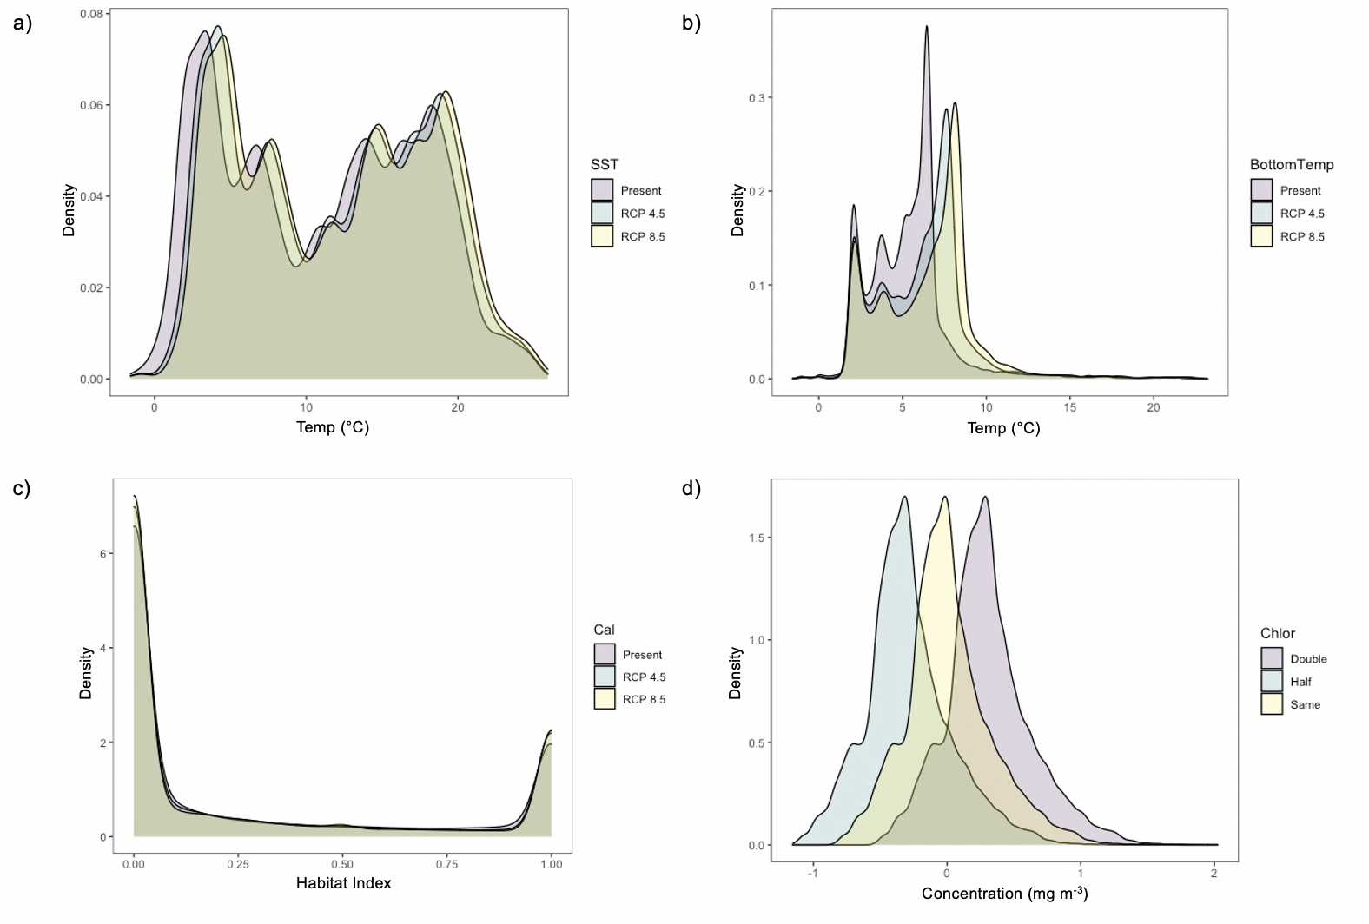
Figure S1. Density plots of present and year-2050 environmental covariates. Density plots comparing present climatological conditions to projected year-2050 climatological conditions for RCP 4.5 and 8.5 for a) sea surface temperature, b) bottom temperature, c) C. finmarchicus habitat index, and d) varying logged chlorophyll concentrations.

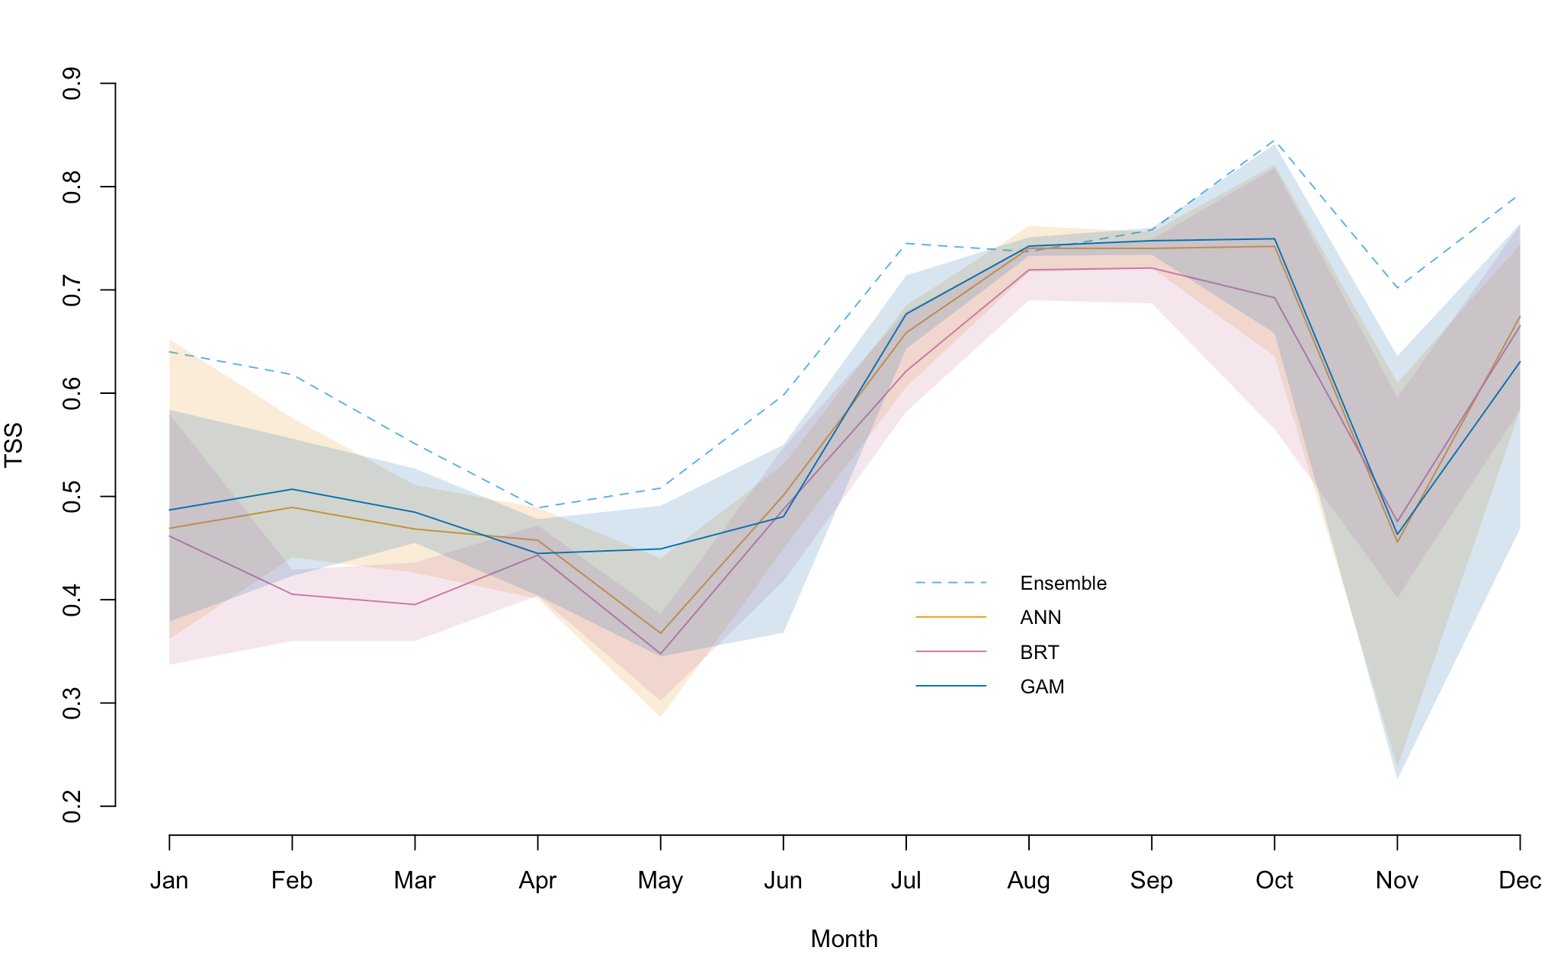
Figure S2. Monthly evaluation true skill statistic (TSS) scores of the individual models and the ensemble. Evaluation score for each model algorithm for each month using TSS. The lines represent the mean evaluation score over the 10 cross-validation runs. Ranges for individual models are represented by the shaded areas.

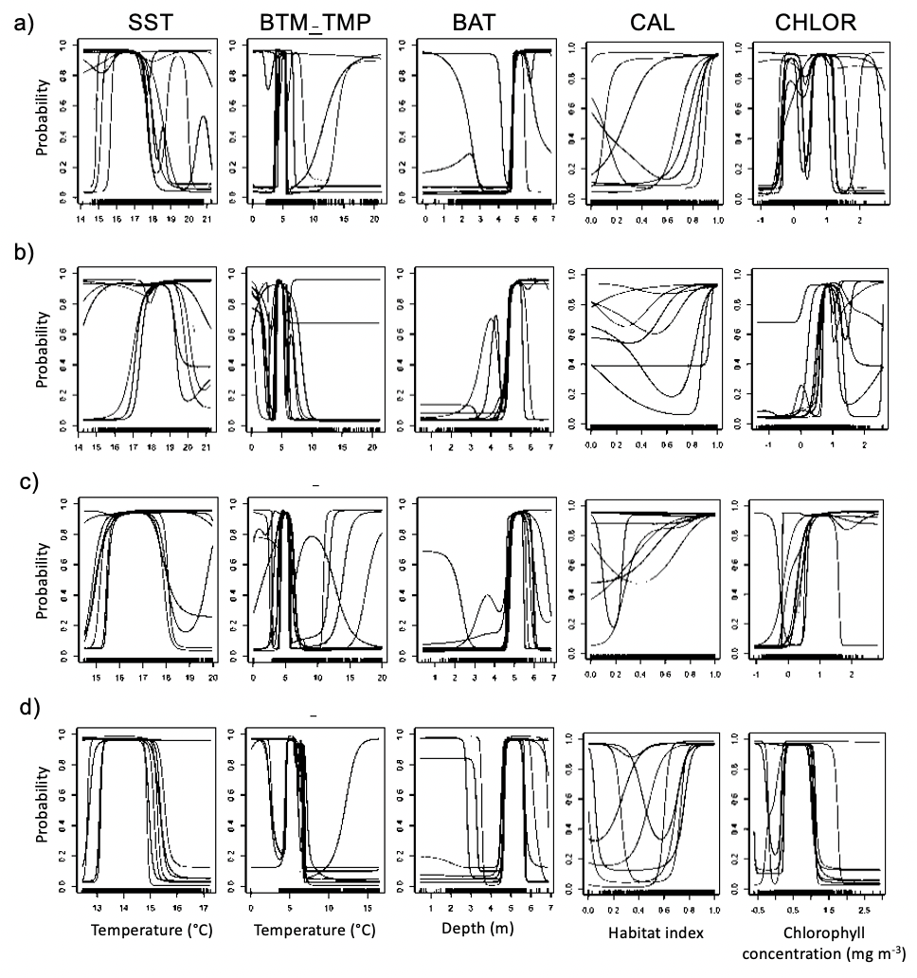
Figure S3. Artificial neural network response curves. Response curves for the 10 cross-validation runs of the ANN, or artificial neural network, models in a) July, b) August, c) September, and d) October. Covariates: sea surface temperature (SST), bottom temperature (BTM_TMP), bathymetry (BAT), Calanus finmarchicus habitat index (CAL), and chlorophyll concentration (CHLOR). The y-axes represent the probability of habitat suitability. The x-axes represent the values of the covariates; scales for depth and chlorophyll concentration are logarithmic.

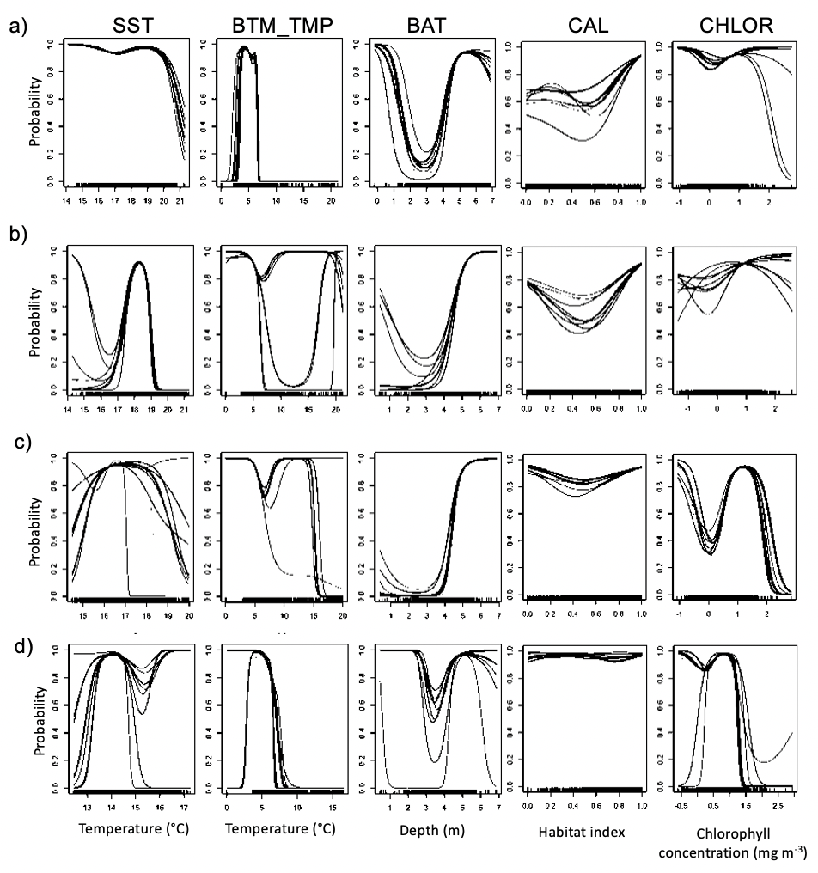
Figure S4. Generalized additive model response curves. Response curves for the 10 cross-validation runs of the GAMs, in a) July, b) August, c) September, and d) October. Covariates: sea surface temperature (SST), bottom temperature (BTM_TMP), bathymetry (BAT), Calanus finmarchicus habitat index (CAL), and chlorophyll concentration (CHLOR). The y-axes represent the probability of habitat suitability. The x-axes represent the values of the covariates; scales for depth and chlorophyll concentration are logarithmic.
.

