Supplementary Information
Global emissions of VOCs from compressed aerosol products

Amber M Yeoman¹ and Alastair C Lewis^{2 *}
[1] Wolfson Atmospheric Chemistry Laboratories, University of York, Heslington, York YO10 5DD United Kingdom
[2] National Centre for Atmospheric Science, University of York, Heslington, York YO10 5DD, United Kingdom

*ally.lewis@ncas.ac.uk

List of contents:
Figure S1: European aerosol production breakdown
For the years 2016-2018, using data provided by the European Aerosol Federation (FEA).
File Type: PNG Document (.png)

Table S1: Economic classifications according to The World Bank
Data determined using the World Bank Atlas method.
File type: Microsoft Word (.doc)

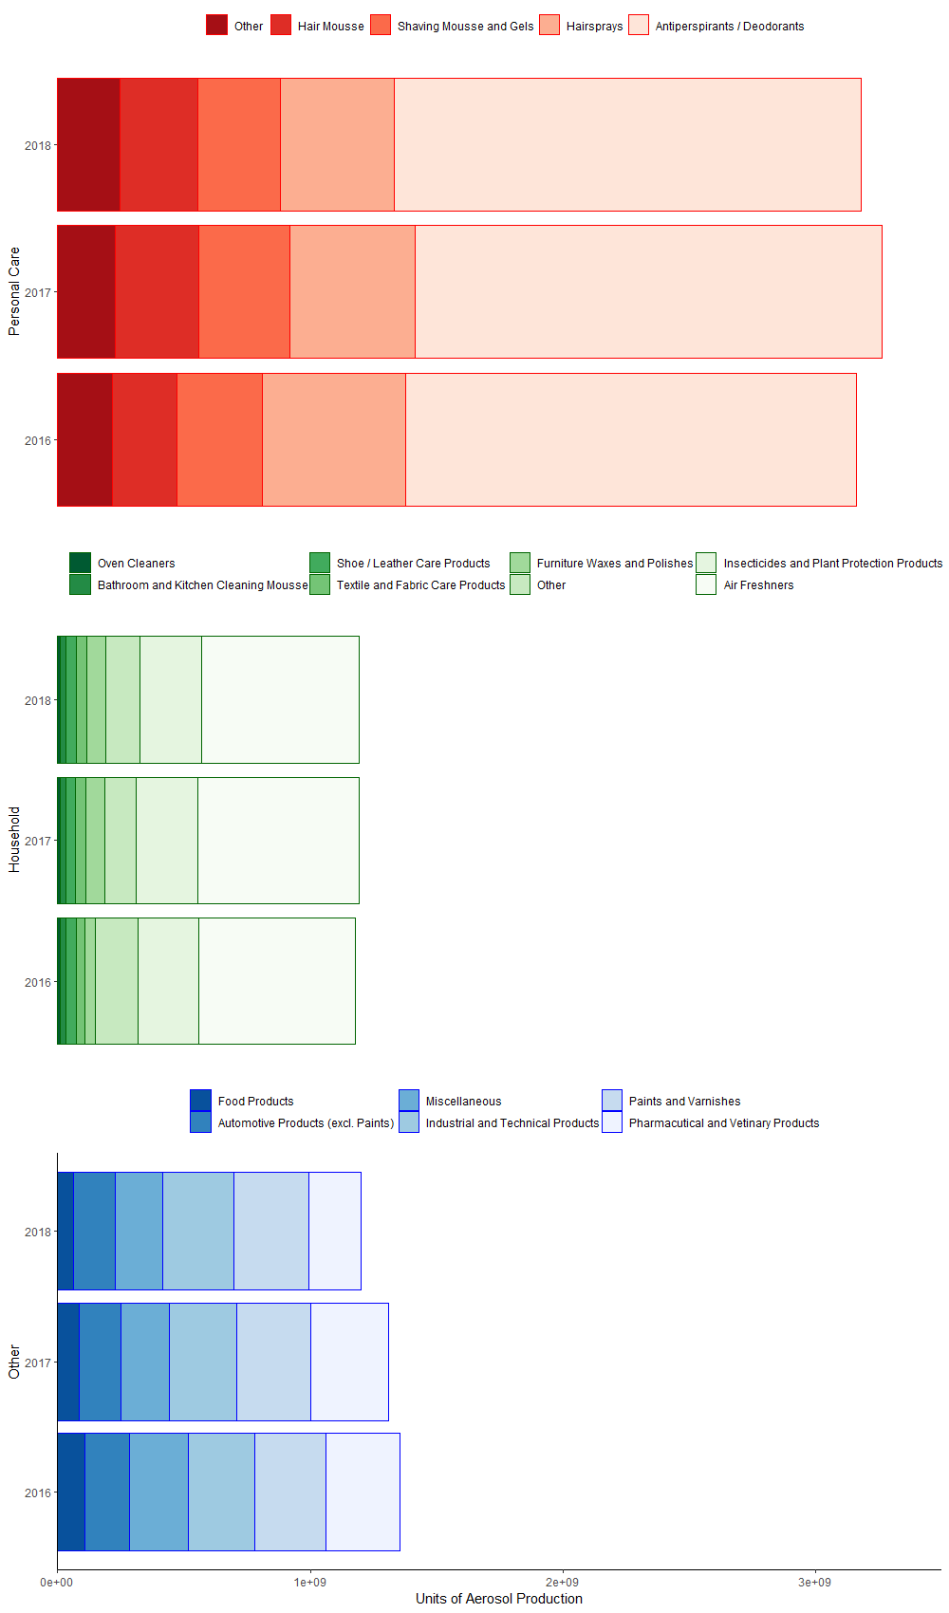

Figure S1: European aerosol production breakdown
For the years 2016-2018, using data provided by the European Aerosol Federation (FEA).
Table S1: Economic classifications according to The World Bank
Data determined using the World Bank Atlas method.
Low | Lower Middle | Upper Middle | High
Afghanistan | Angola | Albania ª | Andorra ª
Burkina Faso | Algeria | American Samoa | Antigua and Barbuda
Burundi | Bangladesh | Argentina | Aruba
Central African Republic | Benin | Armenia | Australia
Chad | Bhutan | Azerbaijan | The Bahamas
DR Congo | Bolivia | Belarus ª | Bahrain
Eritrea | Cabo Verde | Bosnia and Herzegovina ª | Barbados
Ethiopia | Cambodia | Botswana | Belgium ª
Gambia | Cameroon | Brazil | Bermuda
Guinea | Comoros | Bulgaria ª | British Virgin Islands
Guinea-Bissau | Rep Congo | China | Brunei Darussalam
Haiti | Cote d'Ivoire | Colombia | Canada
PDR Korea | Djibouti | Costa Rica | Cayman Islands
Liberia | AR Egypt | Cuba | Channel Islands ª
Madagascar | El Salvador | Dominica | Chile
Malawi | Eswatini | Dominican Republic | Croatia ª
Mali | Ghana | Equatorial Guinea | Curacao
Mozambique | Honduras | Ecuador | Cyprus ª
Niger | India | Fiji | Czech Republic ª
Rwanda | Kenya | Gabon | Denmark ª
Sierra Leone | Kiribati | Georgia | Estonia ª
Somalia | Kyrgyz Rep | Guatemala | Faroe Islands ª
South Sudan | Lao PDR | Guyana | Finland ª
Sudan | Lesotho | Indonesia | France ª
Syrian AR | Mauritania | Iran Islamic Rep | French Polynesia
Tajikistan | Micronesia Def Sts | Iraq | Germany ª
Togo | Moldova ª | Jamaica | Gibraltar ª
Uganda | Mongolia | Jordan | Greece ª
Yemen | Morocco | Kazakhstan | Greenland ª
 | Myanmar | Kosovo ª | Guam
 | Nepal | Lebanon | Hong Kong SAR ^{b}
 | Nicaragua | Libya | Hungary ª
 | Nigeria | Malaysia | Iceland ª
 | Pakistan | Maldives | Ireland ª
 | Papua New Guinea | Marshall Islands | Isle of Man ª
 | Philippines | Mexico | Israel
 | Sao Tome and Principe | Montenegro ª | Italy ª
 | Senegal | Namibia | Japan
 | Solomon Islands | North Macedonia ª | Korea Rep
 | Sri Lanka | Paraguay | Kuwait
 | Tanzania | Peru | Latvia ª
 | Timor-Leste | Russian Federation ª | Liechtenstein ª
 | Tunisia | Samoa | Lithuania ª
 | Ukraine ª | Serbia ª | Luxembourg ª
 | Uzbekistan | South Africa | Macao SAR ^{b}
 | Vanuatu | St. Lucia | Malta ª
 | Vietnam | St. Vincent and the Grenadines | Mauritius
 | West Bank and Gaza | Suriname | Monaco ª
 | Zambia | Thailand | Nauru
 | Zimbabwe | Tonga | Netherlands ª
 |  | Turkey ª | New Caledonia
 |  | Turkmenistan | New Zealand
 |  | Tuvalu | Northern Mariana Islands
 |  | Venezuela RB | Norway ª
 |  |  | Oman
 |  |  | Palau
 |  |  | Panama
 |  |  | Poland ª
 |  |  | Portugal ª
 |  |  | Puerto Rico
 |  |  | Romania ª
 |  |  | Qatar
 |  |  | San Marino ª
 |  |  | Saudi Arabia
 |  |  | Seychelles
 |  |  | Singapore
 |  |  | Sint Maarten
 |  |  | Slovak Republic ª
 |  |  | Slovenia ª
 |  |  | Spain ª
 |  |  | St. Kitts and Nevis
 |  |  | St. Martin
 |  |  | Sweden ª
 |  |  | Switzerland ª
 |  |  | Taiwan ^{b}
 |  |  | Trinidad and Tobago
 |  |  | Turks and Caicos Islands
 |  |  | United Arab Emirates
 |  |  | United Kingdom ª
 |  |  | United States
 |  |  | Uruguay
 |  |  | Virgin Islands (U.S)
ª Included within the grouping of Europe
^{b} Included in China’s total

