Supplementary Information

The impact of COVID-19 induced lockdown on nitrogen dioxide levels over major American counties

James Poetzscher¹, Rima J. Isaifan^{2*}

¹European Environmental Bureau, Rue des Deux Eglises 14, 1000 Brussels, Belgium
²Division of Sustainable Development (DSD), College of Science and Engineering (CSE), Hamad Bin Khalifa University (HBKU) / Qatar Foundation (QF), P.O. Box 5825, Doha, Qatar

*Corresponding author’s Email: risaifan@hbku.edu.qa.

List of Contents:

Expanded description of technique used in processing TROPOMI NO₂.

Figure S1. Location and geographic boundaries of San Francisco County, Santa Clara County, and Los Angeles County.

Figure S2. Location and geographic boundaries of New York City, Philadelphia County, Allegheny County, and Washington DC

Figure S3. Location and geographic boundaries of Denver County, Cook County, Wayne Count, Harris County, and Fulton County.

Figure S4. Visualized NO₂ levels in each county over analyzed time periods.

Table S1. Supplementary NO₂ data used in calculations

Table S2. Raw meteorological data for temperature, wind speed, wind direction, and relative humidity during 2019 and 2020.

Table S3. Raw meteorological data and percentage shift for temperature, wind speed, wind direction, and relative humidity during 2015-2018 baseline, 2019, and 2020.

Discussion of County Ordinances Informing Our Selection of Peak Lockdown Period.

Expanded description of technique used in processing TROPOMI NO₂.
TROPOMI data used in this study is accessed through Google Earth Engine. We first aim to calculate average NO2 levels for each day of interest between the 2020 pre lockdown period, beginning on February 1st 2020, and the end of the 2020 loosening lockdown period for each county, as well as the corresponding time frames in 2019. First, we begin by selecting the Offline NO2 TROPOMI data which automatically has a filter requiring a qa_value greater than 75 applied. We then use the reduce region function to isolate data for our county of interest. Next, we create a time series for 2020 and 2019 before merging the two time series together. Finally, we output a downloadable chart displaying the average value of NO2 within the county boundaries for each day of the year within our specified time frame during both 2020 and 2019. Certain days have no data in either 2020 or 2019 and in such a case, the day of year simply is excluded from the chart. There are a significant number of days with no data for at least one of 2020 or 2019 given the small size of many of the counties and the strict filter of qa_value greater than 75. Counties with smaller areas have fewer pixels and are therefore generally more likely to have days with no data. Once we calculate the average NO2 level within each county for each day of interest, we average these values over the 6 time periods we’re analyzing: 2020 and 2019 pre, peak and loosening lockdown. Earth Engine code is available upon request.

Figure S1. Location and geographic boundaries of San Francisco County, Santa Clara County, and Los Angeles County.
Figure S2. Location and geographic boundaries of New York City, Philadelphia County, Allegheny County, and Washington DC.
Figure S3. Location and geographic boundaries of Denver County, Cook County, Wayne Count, Harris County, and Fulton County.

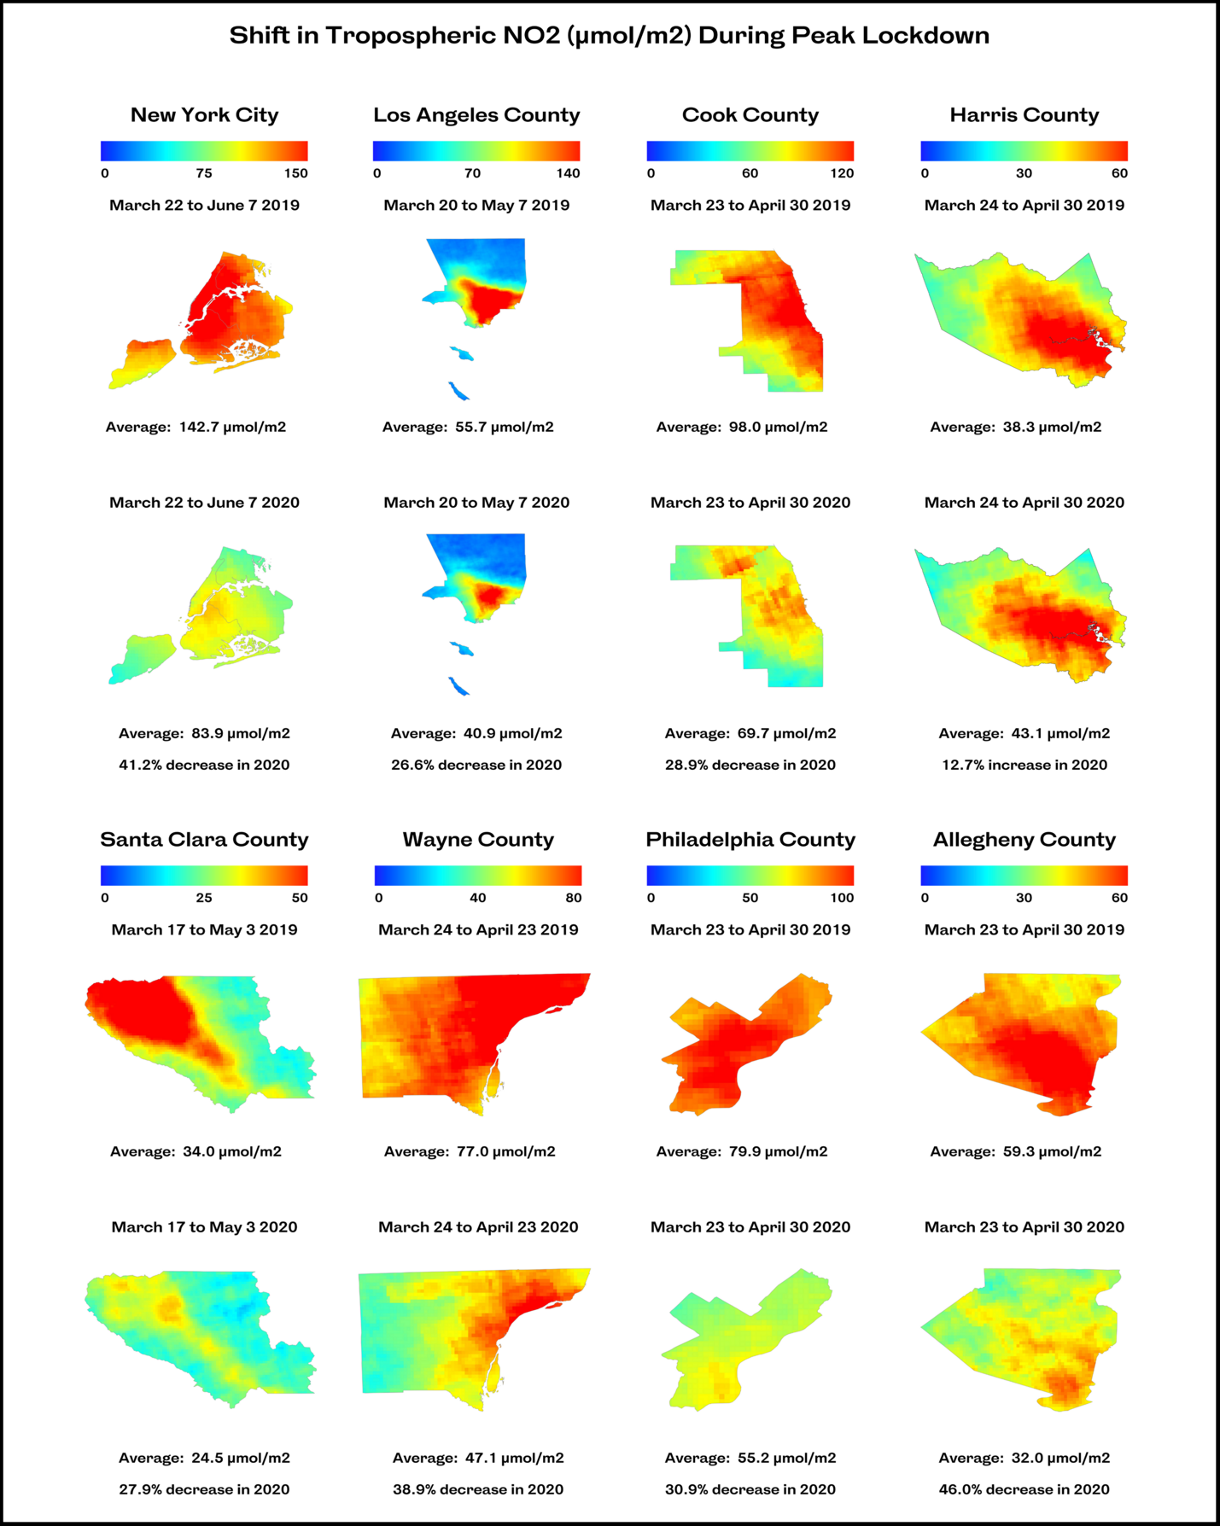
Figure S4. Tropospheric NO₂ levels (μmol/m²) in 8 of the 12 analyzed counties during the peak lockdown period in 2020 and 2019.
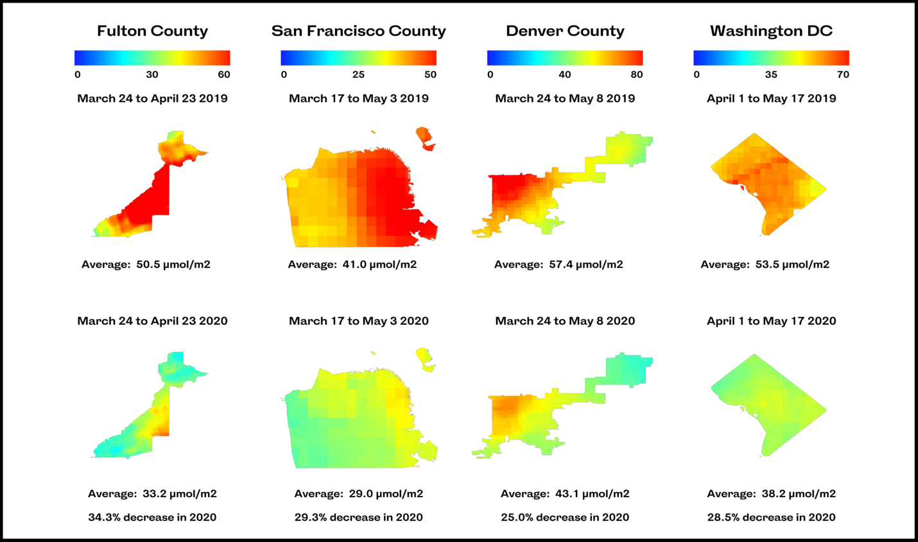
Figure S4 (continued). Tropospheric NO₂ levels (μmol/m²) in the remaining 4 of the 12 analyzed counties during the peak lockdown period in 2020 and 2019.

Table S1. Summary of county-level tropospheric NO₂ column values during the 6 periods analyzed: 2020 and 2019 pre, peak, and loosening lockdown.

Table S2. Summary of county-level data for temperature (°F), wind speed (m/s), wind direction (°), and relative humidity (RH) (%) during the 2019 and 2020 peak and loosening lockdown periods.
 | County | 2019 Peak Lockdown | 2020 Peak Lockdown | 2019 Loosening Lockdown | 2020 Loosening Lockdown
T (°F) | New York City | 55.6 | 53.6 | 72.1 | 72.5
 | Los Angeles | 61.0 | 62.5 | 61.6 | 64.6
 | Cook | 46.4 | 46.6 | 56.8 | 59.9
 | Harris | 68.6 | 71.3 | 77.4 | 76.8
 | Santa Clara | 59.0 | 56.7 | 59.3 | 65.9
 | Wayne | 46.0 | 43.5 | 53.8 | 53.5
 | Philadelphia | 56.8 | 50.5 | 63.9 | 61.5
 | Allegheny | 51.6 | 48.2 | 63.7 | 58.3
 | Fulton | 62.7 | 62.8 | 72.5 | 65.7
 | San Francisco | 56.8 | 55.5 | 57.4 | 61.1
 | Denver | 46.7 | 45.8 | 53.7 | 63.6
 | Washington DC | 63.0 | 56.5 | 73.8 | 72.0
 | Mean | 56.2 | 54.4 | 63.8 | 64.6
WS (m/s) | New York City | 11.8 | 12.4 | 9.8 | 9.6
 | Los Angeles | 8.5 | 7.8 | 8.6 | 8.5
 | Cook | 11.5 | 9.9 | 9.6 | 9.5
 | Harris | 9.6 | 8.5 | 10.4 | 8.9
 | Santa Clara | 7.1 | 6.4 | 7.6 | 7.9
 | Wayne | 10.6 | 9.2 | 9.0 | 8.9
 | Philadelphia | 10.2 | 10.8 | 9.0 | 9.2
 | Allegheny | 8.2 | 9.1 | 7.6 | 8.4
 | Fulton | 8.5 | 9.0 | 7.1 | 8.4
 | San Francisco | 10.5 | 11.1 | 12.2 | 12.1
 | Denver | 10.6 | 10.4 | 10.1 | 11.2
 | Washington DC | 8.8 | 9.8 | 9.6 | 9.4
 | Mean | 9.7 | 9.5 | 9.2 | 9.3
WD (°) | New York City | 177.9 | 183.8 | 175.9 | 167.5
 | Los Angeles | 207.8 | 181.9 | 210.8 | 207.9
 | Cook | 151.1 | 168.2 | 143.0 | 147.8
 | Harris | 154.9 | 156.6 | 144.4 | 150.2
 | Santa Clara | 200.4 | 204.2 | 219.1 | 219.4
 | Wayne | 178.9 | 181.4 | 147.5 | 155.2
 | Philadelphia | 184.0 | 176.6 | 158.5 | 168.2
 | Allegheny | 179.8 | 202.7 | 203.6 | 176.9
 | Fulton | 190.6 | 225.9 | 195.5 | 207.1
 | San Francisco | 209.5 | 227.0 | 240.9 | 230.5
 | Denver | 159.6 | 159.4 | 178.5 | 173.0
 | Washington DC | 156.8 | 200.0 | 186.9 | 160.8
 | Mean | 179.3 | 189.0 | 183.7 | 180.4
RH (%) | New York City | 79.1 | 72.3 | 79.1 | 73.7
 | Los Angeles | 71.2 | 68.0 | 73.9 | 73.4
 | Cook | 68.0 | 69.1 | 75.0 | 68.5
 | Harris | 78.0 | 73.5 | 82.3 | 70.7
 | Santa Clara | 70.7 | 67.7 | 78.8 | 56.8
 | Wayne | 62.6 | 69.3 | 68.6 | 65.0
 | Philadelphia | 60.4 | 66.9 | 73.5 | 65.2
 | Allegheny | 65.0 | 66.5 | 75.9 | 65.1
 | Fulton | 62.9 | 62.2 | 64.5 | 62.4
 | San Francisco | 72.4 | 70.8 | 73.3 | 68.8
 | Denver | 63.9 | 55.8 | 65.2 | 51.3
 | Washington DC | 66.9 | 64.1 | 63.8 | 67.3
 | Mean | 68.4 | 67.2 | 72.8 | 65.7

Table S3. Summary of county-level data for temperature (°F), wind speed (m/s), wind direction (°), and relative humidity (RH) (%) during the 2015-2018 baseline, 2019, and 2020 peak and loosening lockdown periods. % change from 2019 and 2020 peak and loosening lockdown compared to the 2015-2018 baseline is also displayed.
 | County | 2015 - 2018  Peak | 2019 Peak  (% change) | 2020 Peak  (% change) | 2015 - 2018  Loosening | 2019 Loosening  (% change) | 2020 Loosening  (% change)
T (°F) | New York City | 55.4 | 55.6 | 53.6 | 73.2 | 72.1 | 72.5
 |  |  | 0.3% | -3.3% |  | -1.5% | -1.0%
 | Los Angeles | 61.4 | 61.0 | 62.5 | 62.0 | 61.6 | 64.6
 |  |  | -0.7% | 1.7% |  | -0.6% | 4.2%
 | Cook | 45.6 | 46.4 | 46.6 | 60.1 | 56.8 | 59.9
 |  |  | 1.7% | 2.1% |  | -5.5% | -0.4%
 | Harris | 69.7 | 68.6 | 71.3 | 75.9 | 77.4 | 76.8
 |  |  | -1.6% | 2.3% |  | 2.0% | 1.2%
 | Santa Clara | 59.2 | 59.0 | 56.7 | 61.7 | 59.3 | 65.9
 |  |  | -0.3% | -4.2% |  | -3.9% | 6.8%
 | Wayne | 45.4 | 46.0 | 43.5 | 57.5 | 53.8 | 53.5
 |  |  | 1.2% | -4.2% |  | -6.4% | -6.9%
 | Philadelphia | 52.6 | 56.8 | 50.5 | 64.5 | 63.9 | 61.5
 |  |  | 8.0% | -4.1% |  | -0.9% | -4.6%
 | Allegheny | 50.5 | 51.6 | 48.2 | 63.9 | 63.7 | 58.3
 |  |  | 2.2% | -4.7% |  | -0.3% | -8.7%
 | Fulton | 62.6 | 62.7 | 62.8 | 69.9 | 72.5 | 65.7
 |  |  | 0.1% | 0.2% |  | 3.7% | -6.0%
 | San Francisco | 57.7 | 56.8 | 55.5 | 58.5 | 57.4 | 61.1
 |  |  | -1.6% | -3.9% |  | -2.0% | 4.4%
 | Denver | 46.9 | 46.7 | 45.8 | 57.7 | 53.7 | 63.6
 |  |  | -0.4% | -2.5% |  | -7.0% | 10.2%
 | Washington DC | 60.9 | 63.0 | 56.5 | 72.2 | 73.8 | 72.0
 |  |  | 3.4% | -7.2% |  | 2.2% | -0.3%
 | Mean | 55.7 | 56.2 | 54.4 | 64.7 | 63.8 | 64.6
 |  |  | 0.9% | -2.2% |  | -1.4% | -0.2%
WS (m/s) | New York City | 11.1 | 11.8 | 12.4 | 10.3 | 9.8 | 9.6
 |  |  | 5.8% | 11.8% |  | -5.5% | -7.2%
 | Los Angeles | 8.2 | 8.5 | 7.8 | 8.1 | 8.6 | 8.5
 |  |  | 2.8% | -5.6% |  | 6.5% | 4.6%
 | Cook | 11.2 | 11.5 | 9.9 | 9.9 | 9.6 | 9.5
 |  |  | 2.6% | -11.6% |  | -3.0% | -4.1%
 | Harris | 8.7 | 9.6 | 8.5 | 8.6 | 10.4 | 8.9
 |  |  | 10.0% | -2.7% |  | 21.6% | 3.4%
 | Santa Clara | 7.1 | 7.1 | 6.4 | 7.7 | 7.6 | 7.9
 |  |  | -0.1% | -10.6% |  | -1.6% | 2.5%
 | Wayne | 9.9 | 10.6 | 9.2 | 8.4 | 9.0 | 8.9
 |  |  | 7.3% | -6.6% |  | 7.0% | 6.4%
 | Philadelphia | 10.3 | 10.2 | 10.8 | 8.5 | 9.0 | 9.2
 |  |  | -1.2% | 5.2% |  | 4.9% | 7.6%
 | Allegheny | 8.9 | 8.2 | 9.1 | 7.1 | 7.6 | 8.4
 |  |  | -8.0% | 2.4% |  | 6.9% | 19.2%
 | Fulton | 9.0 | 8.5 | 9.0 | 7.8 | 7.1 | 8.4
 |  |  | -5.4% | 0.1% |  | -8.6% | 8.1%
 | San Francisco | 11.7 | 10.5 | 11.1 | 13.4 | 12.2 | 12.1
 |  |  | -10.2% | -5.3% |  | -9.4% | -10.0%
 | Denver | 11.5 | 10.6 | 10.4 | 10.1 | 10.1 | 11.2
 |  |  | -7.6% | -9.4% |  | -0.4% | 10.2%
 | Washington DC | 9.4 | 8.8 | 9.8 | 8.4 | 9.6 | 9.4
 |  |  | -6.7% | 4.0% |  | 14.5% | 12.7%
 | Mean | 9.8 | 9.7 | 9.5 | 9.0 | 9.2 | 9.3
 |  |  | -1.1% | -2.3% |  | 2.0% | 3.4%
WD (°) | New York City | 171.4 | 177.9 | 183.8 | 184.5 | 175.9 | 167.5
 |  |  | 3.8% | 7.3% |  | -4.6% | -9.2%
 | Los Angeles | 192.0 | 207.8 | 181.9 | 212.0 | 210.8 | 207.9
 |  |  | 8.3% | -5.2% |  | -0.6% | -1.9%
 | Cook | 150.8 | 151.1 | 168.2 | 145.1 | 143.0 | 147.8
 |  |  | 0.2% | 11.5% |  | -1.4% | 1.9%
 | Harris | 152.8 | 154.9 | 156.6 | 142.6 | 144.4 | 150.2
 |  |  | 1.4% | 2.5% |  | 1.3% | 5.4%
 | Santa Clara | 196.1 | 200.4 | 204.2 | 227.0 | 219.1 | 219.4
 |  |  | 2.2% | 4.1% |  | -3.5% | -3.3%
 | Wayne | 170.4 | 178.9 | 181.4 | 155.7 | 147.5 | 155.2
 |  |  | 5.0% | 6.5% |  | -5.2% | -0.3%
 | Philadelphia | 180.0 | 184.0 | 176.6 | 157.8 | 158.5 | 168.2
 |  |  | 2.2% | -1.9% |  | 0.5% | 6.6%
 | Allegheny | 191.0 | 179.8 | 202.7 | 173.8 | 203.6 | 176.9
 |  |  | -5.9% | 6.1% |  | 17.1% | 1.8%
 | Fulton | 185.7 | 190.6 | 225.9 | 197.6 | 195.5 | 207.1
 |  |  | 2.6% | 21.6% |  | -1.1% | 4.8%
 | San Francisco | 224.6 | 209.5 | 227.0 | 247.9 | 240.9 | 230.5
 |  |  | -6.7% | 1.1% |  | -2.8% | -7.0%
 | Denver | 176.6 | 159.6 | 159.4 | 169.9 | 178.5 | 173.0
 |  |  | -9.7% | -9.8% |  | 5.1% | 1.8%
 | Washington DC | 169.1 | 156.8 | 200.0 | 162.2 | 186.9 | 160.8
 |  |  | -7.2% | 18.3% |  | 15.2% | -0.8%
 | Mean | 180.0 | 179.3 | 189.0 | 181.3 | 183.7 | 180.4
 |  |  | -0.4% | 5.0% |  | 1.3% | -0.5%
RH (%) | New York City | 69.9 | 79.1 | 72.3 | 70.1 | 79.1 | 73.7
 |  |  | 13.3% | 3.5% |  | 12.9% | 5.2%
 | Los Angeles | 70.4 | 71.2 | 68.0 | 77.3 | 73.9 | 73.4
 |  |  | 1.2% | -3.3% |  | -4.3% | -5.0%
 | Cook | 67.9 | 68.0 | 69.1 | 69.0 | 75.0 | 68.5
 |  |  | 0.2% | 1.8% |  | 8.7% | -0.7%
 | Harris | 75.9 | 78.0 | 73.5 | 77.2 | 82.3 | 70.7
 |  |  | 2.8% | -3.2% |  | 6.6% | -8.4%
 | Santa Clara | 64.6 | 70.7 | 67.7 | 66.1 | 78.8 | 56.8
 |  |  | 9.5% | 4.8% |  | 19.2% | -14.0%
 | Wayne | 67.2 | 62.6 | 69.3 | 65.2 | 68.6 | 65.0
 |  |  | -6.8% | 3.2% |  | 5.3% | -0.2%
 | Philadelphia | 62.5 | 60.4 | 66.9 | 69.4 | 73.5 | 65.2
 |  |  | -3.3% | 7.1% |  | 5.9% | -6.1%
 | Allegheny | 62.7 | 65.0 | 66.5 | 68.4 | 75.9 | 65.1
 |  |  | 3.6% | 6.0% |  | 11.0% | -4.7%
 | Fulton | 66.5 | 62.9 | 62.2 | 66.9 | 64.5 | 62.4
 |  |  | -5.4% | -6.5% |  | -3.5% | -6.7%
 | San Francisco | 71.2 | 72.4 | 70.8 | 71.6 | 73.3 | 68.8
 |  |  | 1.6% | -0.6% |  | 2.4% | -3.9%
 | Denver | 60.6 | 63.9 | 55.8 | 63.2 | 65.2 | 51.3
 |  |  | 5.4% | -7.9% |  | 3.1% | -18.8%
 | Washington DC | 64.3 | 66.9 | 64.1 | 71.6 | 63.8 | 67.3
 |  |  | 4.1% | -0.4% |  | -10.9% | -6.0%
 | Mean | 67.0 | 68.4 | 67.2 | 69.7 | 72.8 | 65.7
 |  |  | 2.2% | 0.3% |  | 4.6% | -5.7%

Discussion of County Ordinances Informing Our Selection of Peak Lockdown Period.

New York City
In New York City, shelter in place was enforced starting on March 22nd and continued unchanged through June 7th. On June 8th, New York City began reopening, loosening many lockdown measures including allowing construction to resume and allowing non-essential shops to reopen for curbside pickup (Evelyn, 2020; Danner et al., 2020).

Los Angeles County
In Los Angeles County, shelter in place was enforced on March 20th and continued unchanged through May 7th. On May 8th, Los Angeles County began reopening by allowing a variety of non-essential shops to reopen for curbside pickup including florists, clothing stores, toy stores and bookstores (Kandel, 2020; Wick, 2020).

Cook County (Chicago)
In Cook County, the county home to the city of Chicago, shelter in place was enforced beginning on March 21st and continued unchanged through April 30th. On May 1st, Cook County began loosening lockdown restrictions by allowing a variety of non-essential shops to reopen for curbside pickup, reopening golf courses and state parks, and allowing elective health procedures to take place (Petrella et al., 2020; Price, 2020).

Harris County (Houston)
In Harris County, the county home to the city of Houston, shelter in place was ordered on March 24th and continued unchanged through April 30th. On May 1st, Texas Governor, Greg Abbott, announced a statewide loosening of lockdown restrictions, including in Harris County. Beginning on May 1st, restaurants, retail stores, and movie theaters were allowed to reopen at 25% of their capacity. Places of worship were also allowed to reopen, and licensed health professionals were allowed to return to work (McGuinness, 2020; Bentio, 2020).

Santa Clara County
In Santa Clara County, the county home to Santa Clara and San Jose, shelter in place was enforced starting on March 17th and continued unchanged through May 3rd. On May 4th, Santa Clara County extended the stay-at-home guidelines but loosened previous restrictions. Businesses that primarily operate outdoors such as car washes were allowed to reopen, construction was allowed to resume, some outdoor recreational facilities such as skate parks were allowed to reopen, and employees of businesses that were allowed to operate could access permitted childcare programs (Allday, 2020; Nguyen and Martichoux, 2020).

Wayne County (Detroit)
In Wayne County, the county home to the city of Detroit, shelter in place was enforced beginning on March 24th and continued unchanged through April 23rd. On April 24th, Wayne County loosened restrictions by allowing a variety of outdoor activities to resume and businesses linked to these outdoor activities to reopen. Other non-essential businesses were allowed to reopen for curbside pickup (Miller and Feuer, 2020; Hutchinson, 2020).

Philadelphia County
In Philadelphia County, shelter in place was enforced beginning on March 23rd and continued unchanged through April 30th. On May 1st, Philadelphia County loosened restrictions for the first time, primarily by allowing construction to resume and reopening some golf courses (Marroni, 2020; Read and Meyer, 2020).

Allegheny County (Pittsburgh)
In Allegheny County, the county which contains the city of Pittsburgh, shelter in place was enforced starting on March 23rd and continued unchanged through April 30th. On May 1st, Allegheny County first loosened restrictions, primarily by allowing construction to resume and golf courses to reopen (Mervosh et al., 2020; Pickel, 2020).

Fulton County (Atlanta)
In Fulton County, the county home to the city of Atlanta, shelter in place was enforced beginning on March 24th and continued unchanged through April 23rd. On April 24th, Georgia governor Brian Kemp took significant steps to loosen restrictions statewide, including in Fulton County. Beginning on April 24th, Fulton County gyms, barbers, nail salons and more non-essential businesses reopened (Keenan, 2020; Rojas and Cooper, 2020; Shah, 2020).

San Francisco County
In San Francisco County, California, shelter in place was enforced starting on March 17th and continued unchanged through May 3rd. On May 4th, San Francisco County extended the stay-at-home guidelines but loosened previous restrictions. Businesses that primarily operate outdoors such as car washes were allowed to reopen, construction was allowed to resume, some outdoor recreational facilities such as skate parks were allowed to reopen, and employees of businesses that were allowed to operate could access permitted childcare programs (Waldrop and Martin, 2020; Fracassa, 2020).

Denver County
In Denver County, shelter in place was enforced beginning on March 24th and continued unchanged through May 8th. On May 9th, Denver County began reopening by allowing a variety of non-essential businesses including barbers, nail-salons and retail stores to reopen (Oravetz, 2020; Swanson, 2020).

Washington D.C.
In Washington D.C., shelter in place was enforced starting on April 1st and continued unchanged through May 17th. On May 18th, Washington D.C. began to loosen lockdown restrictions as they reopened a few locally owned shops for curbside pickup (Mervosh et al., 2020; Barnes, 2020; Grablick, 2020).

References
Allday E. 2020 Mar 19. Bay Area orders “shelter in place,” only essential businesses open in 6 counties. Available at https://www.sfchronicle.com/local-politics/article/Bay-Area-must-shelter-in-place-Only-15135014.php. Accessed 2021 Mar 16.
Barnes S. 2020 May 14. DC Extends Stay-at-Home Order Through June 8 – NBC4 Washington. Available at https://www.nbcwashington.com/news/dc-mayor-exected-to-extend-stay-at-home-order/2301329/. Accessed 2021 Mar 16.
Bentio M. 2020 Jun 26. Texas reopening plan timeline: What led up to pause | khou.com. Available at https://www.khou.com/article/news/health/coronavirus/timeline-what-led-up-to-pause-in-texas-reopening-plan-surge-in-covid-19-cases/285-598205d0-9b31-4b39-a3ec-a0c32bb7a14f. Accessed 2021 Mar 16.
Danner C, Stieb M, Raymond A. 2020 Aug 17. When Will New York Reopen? Phases and Full Plan, Explained. Available at https://nymag.com/intelligencer/2020/08/when-will-new-york-reopen-phases-and-full-plan-explained.html. Accessed 2021 Mar 16.
Evelyn K. 2020 Mar 20. Here’s what a “stay home” order means for New York | New York | The Guardian. Available at https://www.theguardian.com/us-news/2020/mar/20/new-york-90-day-stay-home-order-what-it-means. Accessed 2021 Mar 16.
Fracassa D. 2020 Apr 27. Bay Area shelter-in-place orders will be extended to end of May. Available at https://www.sfchronicle.com/bayarea/article/Bay-Area-counties-extend-coronavirus-stay-at-home-15229291.php. Accessed 2021 Mar 16.
Grablick C. 2020 May 18. Update: Beauty Supply Shops, Florists Permitted To Operate Curbside And Sidewalk Services Under Pilot Program | DCist. Available at https://dcist.com/story/20/05/18/some-nonessential-d-c-stores-can-offer-curbside-delivery-and-sidewalk-pick-up-under-new-pilot-program/. Accessed 2021 Mar 16.
Hutchinson D. 2020 Apr 24. Here’s what was reopened in Michigan Gov. Gretchen Whitmer’s revised stay-at-home order. Available at https://www.clickondetroit.com/news/local/2020/04/24/heres-what-was-reopened-in-michigan-gov-gretchen-whitmers-revised-stay-at-home-order/. Accessed 2021 Mar 16.
Kandel J. 2020 Mar 23. Timeline: Covid-19 Pandemic Events and Milestones in California – NBC Los Angeles. Available at https://www.nbclosangeles.com/news/coronavirus/california-coronavirus-pandemic-timeline-key-events/2334100/. Accessed 2021 Mar 16.
Keenan S. 2020 Mar 24. Amid coronavirus, how Atlanta’s new ‘stay at home’ rules will—and won’t—affect your life - Curbed Atlanta. Available at https://atlanta.curbed.com/2020/3/24/21191649/coronavirus-atlanta-stay-home-covid-19-mayor-keisha-lance-bottoms. Accessed 2021 Mar 16.
Marroni S. 2020 Mar 22. Philadelphia mayor issues stay-at-home order starting Monday - pennlive.com. Available at https://www.pennlive.com/news/2020/03/philadelphia-mayor-issues-stay-at-home-order.html. Accessed 2021 Mar 16.
McGuinness D. 2020 Mar 24. Read Harris County’s stay-home order here. Available at https://www.houstonchronicle.com/news/houston-texas/houston/article/Read-Harris-County-s-stay-home-order-here-15154443.php. Accessed 2021 Mar 16.
Mervosh S, Lu D, Swales V. 2020 Apr 20. See Which States and Cities Have Told Residents to Stay at Home - The New York Times. Available at https://www.nytimes.com/interactive/2020/us/coronavirus-stay-at-home-order.html. Accessed 2021 Mar 16.
Miller H, Feuer W. 2020 Mar 23. Coronavirus updates: Here are the states urging residents to stay home. Available at https://www.cnbc.com/2020/03/23/massachusetts-under-stay-at-home-order-until-april-7-gov-baker-announces.html. Accessed 2021 Mar 16.
Nguyen C, Martichoux A. 2020 Apr 30. Coronavirus California: 6 Bay Area counties relax some shelter-in-place restrictions; here are changes starting May 4 - ABC7 San Francisco. Available at https://abc7news.com/bay-area-counties-extend-shelter-in-place-city-of-berkeley-sf-dates/6137439/. Accessed 2021 Mar 16.
Oravetz J. 2020 May 6. Denver Colorado stay-at-home order ends Friday, May 8 | 9news.com. Available at https://www.9news.com/article/news/health/coronavirus/denver-mayor-update-tuesday-stay-at-home-order-set-to-expire/73-f4f24467-743b-4beb-89cb-e9eb2e537434. Accessed 2021 Mar 16.
Petrella D, St. Clair S, Johnson S, Pratt G. 2020 Mar 20. Illinois “stay at home” order: Pritzker directive starts Saturday - Chicago Tribune. Available at https://www.chicagotribune.com/coronavirus/ct-coronavirus-illinois-shelter-in-place-lockdown-order-20200320-teedakbfw5gvdgmnaxlel54hau-story.html. Accessed 2021 Mar 16.
Pickel G. 2020 Apr 23. Yes, all construction can start in Pa. on May 1, but strict guidelines will need to be followed - pennlive.com. Available at https://www.pennlive.com/news/2020/04/yes-all-construction-can-start-in-pa-on-may-1-but-strict-guidelines-will-need-to-be-followed.html. Accessed 2021 Mar 16.
Price S. 2020 Apr 29. What will reopen in Illinois under modified stay-at-home order May 1 - Chicago Sun-Times. Available at https://chicago.suntimes.com/coronavirus/2020/4/29/21241316/illinois-state-at-home-order-may-rules-golf-state-parks. Accessed 2021 Mar 16.
Read Z, Meyer K. 2020 Apr 29. Coronavirus update: Philadelphia to lift some restrictions Friday - WHYY. Available at https://whyy.org/articles/coronavirus-update-mayor-kenney-announces-first-steps-for-reopening-philadelphia/. Accessed 2021 Mar 16.
Rojas R, Cooper M. 2020 Apr 20. Georgia, Tennessee and South Carolina Move to Reopen as Hot Spots Emerge - The New York Times. Available at https://www.nytimes.com/2020/04/20/us/coronavirus-us-hot-spots-reopening.html. Accessed 2021 Mar 16.
Shah K. 2020 Apr 20. Atlanta Rages as Georgia Gov. Kemp Eases COVID-19 Lockdown. Available at https://www.thedailybeast.com/atlanta-rages-as-georgia-gov-kemp-eases-covid-19-lockdown. Accessed 2021 Mar 16.
Swanson C. 2020 May 7. Denver orders residents to stay home as coronavirus spreads: “We will enforce when and where necessary.” Available at https://www.denverpost.com/2020/03/23/denver-stay-home-order-coronavirus/. Accessed 2021 Mar 16.
Waldrop T, Martin A. 2020 Mar 17. San Francisco on first day of Coronavirus lockdown - CNN. Available at https://www.cnn.com/2020/03/17/us/us-coronavirus-san-francisco-lockdown/index.html. Accessed 2021 Mar 16.
Wick J. 2020 May 8. Essential California: Welcome to Stage 2 - Los Angeles Times. Available at https://www.latimes.com/california/newsletter/2020-05-08/reopening-newsom-coronavirus-stage-2-essential-california. Accessed 2021 Mar 16.

