Supplementary Materials

Table S1. ANOVA outputs for fungal biomass. Fungal biomass (nmol PLFA g⁻¹ dry soil) and arbuscular mycorrhizal fungal biomass (nmol NLFA g⁻¹ dry soil) were based on phospholipid fatty acid (PLFA) and neutral lipid fatty acid (NLFA) analysis. The degrees of freedom for each factor is 1 and the total degrees of freedom for each model is 19.

 | Sum of Sq | F-value | P-value
Fungal biomass (organic)
(Intercept) | 15181.5 | 30.9429 | 4.29E-05
Heated | 120.6 | 0.2457 | 0.6268
Nitrogen | 58.8 | 0.1199 | 0.7336
Heated × Nitrogen | 275.6 | 0.5617 | 0.4645
Fungal biomass (mineral)
(Intercept) | 524.42 | 16.1668 | 0.0009879
Heated | 46.46 | 1.4324 | 0.248804
Nitrogen | 6.13 | 0.1891 | 0.6694642
Heated × Nitrogen | 0.3 | 0.0093 | 0.9242527
AMF biomass (organic)
(Intercept) | 365320 | 19.4436 | 0.0004385
Heated | 8916 | 0.4745 | 0.5007821
Nitrogen | 909 | 0.0484 | 0.8287299
Heated × Nitrogen | 4836 | 0.2574 | 0.6188281
AMF biomass (mineral)
(Intercept) | 16260.1 | 8.2962 | 0.01088
Heated | 211 | 0.1077 | 0.74706
Nitrogen | 1115.8 | 0.5693 | 0.4615
Heated × Nitrogen | 861.5 | 0.4395 | 0.51678

Table S2. Permutational analysis of variance (PERMANOVA) table summarizing changes in fungal community composition across the treatments. Significant differences (P ≤ 0.05) are bolded. The degrees of freedom for each factor is 1 and the total degrees of freedom for each model is 19. Abbreviations: AMF = arbuscular mycorrhizal fungi; EMF = ectomycorrhizal fungi, Sap = saprotrophic fungi; Paths = pathotrophic fungi; Sq = squares.

 | Sums of Sq. | F-value | R² | P-value
Total fungi (organic)
Heating (H) | 0.56 | 1.45 | 0.07 | 0.028
Nitrogen (N) | 0.5 | 1.28 | 0.06 | 0.08
H x N | 0.46 | 1.18 | 0.06 | 0.16
Total fungi (mineral)
Heating | 0.5 | 1.28 | 0.7 | 0.19
Nitrogen | 0.26 | 0.67 | 0.04 | 0.84
H x N | 0.26 | 0.64 | 0.03 | 0.87
AMF (organic)
Heating | 0.33 | 2.32 | 0.12 | 0.026
Nitrogen | 0.16 | 1.16 | 0.06 | 0.30
H x N | 0.22 | 1.53 | 0.08 | 0.15
AMF (mineral)
Heating | 0.23 | 1.19 | 0.07 | 0.28
Nitrogen | 0.26 | 1.31 | 0.08 | 0.21
H x N | 0.24 | 1.22 | 0.07 | 0.27
EMF (organic)
Heating | 0.58 | 1.42 | 0.07 | 0.047
Nitrogen | 0.53 | 1.31 | 0.07 | 0.11
H x N | 0.43 | 1.05 | 0.05 | 0.42
EMF (mineral)
Heating | 0.50 | 1.23 | 0.07 | 0.24
Nitrogen | 0.28 | 0.66 | 0.04 | 0.8
H x N | 0.26 | 0.64 | 0.3 | 0.83
Sap (organic)
Heating | 0.61 | 1.85 | 0.09 | 0.01
Nitrogen | 0.42 | 1.25 | 0.06 | 0.143
H x N | 0.53 | 1.6 | 0.08 | 0.019
Sap (mineral)
Heating | 0.52 | 1.4 | 0.07 | 0.04
Nitrogen | 0.39 | 1.05 | 0.05 | 0.38
H x N | 0.37 | 0.99 | 0.05 | 0.47
Paths (organic)
Heating | 0.34 | 0.93 | 0.05 | 0.6
Nitrogen | 0.34 | 0.92 | 0.05 | 0.58
H x N | 0.48 | 1.31 | 0.07 | 0.14
Paths (mineral)
Heating | 0.31 | 0.77 | 0.04 | 0.8
Nitrogen | 0.48 | 1.11 | 0.06 | 0.29
H x N | 0.53 | 1.31 | 0.07 | 0.12

Table S3. ANOVA summary tables outlining fungal alpha diversity (richness and diversity) responses to the treatments. Significant values are in bold (P ≤ 0.05). The degrees of freedom for each factor is 1 and the total degrees of freedom for each model is 19. Abbreviations: AMF = arbuscular mycorrhizal fungi; EMF = ectomycorrhizal fungi, Sap = saprotrophic fungi; Paths = pathotrophic fungi; Sq = squares.

 |  | Sum of Sq | F-value | P-value
Richness | Total fungi (organic)
 | Heated | 774 | 0.7 | 0.42
 | Nitrogen | 2890 | 2.58 | 0.13
 | Heated × N | 994 | 0.89 | 0.36
Shannon | Heated | 1.64 | 4.97 | 0.04
 | Nitrogen | 2 | 6.06 | 0.025
 | Heated × N | 1.3 | 3.94 | 0.06
Richness | Total fungi (mineral)
 | Heated | 1369 | 2.7 | 0.12
 | Nitrogen | 32 | 0.06 | 0.80
 | Heated × N | 708 | 1.39 | 0.25
Shannon | Heated | 0.002 | 0.007 | 0.93
 | Nitrogen | 0.000 | 0.0001 | 0.99
 | Heated × N | 0.03 | 0.09 | 0.77
Richness | AMF (organic)
 | Heated | 18 | 0.28 | 0.59
 | Nitrogen | 72.2 | 1.13 | 0.29
 | Heated × N | 11.1 | 0.17 | 0.68
Shannon | Heated | 1.15 | 7.77 | 0.009
 | Nitrogen | 0.1 | 0.64 | 0.43
 | Heated × N | 0.36 | 2.4 | 0.13
Richness | AMF (mineral)
 | Heated | 0.1 | 0.002 | 0.96
 | Nitrogen | 32.1 | 0.80 | 0.38
 | Heated × N | 56.6 | 1.41 | 0.24
Shannon | Heated | 0.54 | 3.51 | 0.07
 | Nitrogen | 0.01 | 0.08 | 0.78
 | Heated × N | 0.008 | 0.05 | 0.82
Richness | EMF (organic)
 | Heated | 193.6 | 4.55 | 0.048
 | Nitrogen | 62.5 | 1.47 | 0.24
 | Heated × N | 105.8 | 2.49 | 0.13
Shannon | Heated | 1.74 | 12.16 | 0.003
 | Nitrogen | 1.32 | 9.22 | 0.008
 | Heated × N | 1.53 | 10.67 | 0.005
Richness | EMF (mineral)
 | Heated | 1.6 | 0.06 | 0.82
 | Nitrogen | 0.0 | 0.03 | 0.86
 | Heated × N | 7.2 | 0.25 | 0.62
Shannon | Heated | 0.006 | 0.02 | 0.89
 | Nitrogen | 0.000 | 0.00 | 1
 | Heated × N | 0.000 | 0.0001 | 0.99
Richness | Sap (organic)
 | Heated | 52.9 | 0.64 | 0.44
 | Nitrogen | 160 | 1.93 | 0.18
 | Heated × N | 64.8 | 0.78 | 0.39
Shannon | Heated | 0.03 | 0.21 | 0.65
 | Nitrogen | 0.06 | 0.42 | 0.53
 | Heated × N | 0.04 | 0.3 | 0.59
Richness | Sap (mineral)
 | Heated | 240 | 5.7 | 0.03
 | Nitrogen | 19.6 | 0.47 | 0.5
 | Heated × N | 19.6 | 5.35 | 0.03
Shannon | Heated | 1.52 | 4.37 | 0.053
 | Nitrogen | 0.57 | 1.65 | 0.22
 | Heated × N | 0.66 | 1.89 | 0.19
Richness | Paths (organic)
 | Heated (H) | 4.9 | 0.56 | 0.47
 | Heated | 57.6 | 6.6 | 0.02
 | Nitrogen | 0.2 | 0.03 | 0.88
Shannon | Heated × N | 0.07 | 0.3 | 0.6
 | Heated | 0.76 | 3 | 0.1
 | Nitrogen | 0.1 | 0.4 | 0.54
Richness | Paths (mineral)
 | Heated | 12.1 | 2.06 | 0.17
 | Nitrogen | 0.4 | 0.07 | 0.8
 | Heated × N | 24.2 | 4.1 | 0.06
Shannon | Heated | 0.93 | 5.58 | 0.03
 | Nitrogen | 0.25 | 1.46 | 0.24
 | Heated × N | 2.15 | 12.82 | 0.002

Table S4. ANOVA output summarizing treatment effects on fungal community evenness in the organic horizon for general fungi, ectomycorrhizal fungi (EMF), and arbuscular mycorrhizal fungi (AMF). The degrees of freedom for each factor is 1 and the total degrees of freedom for each model is 19. Significant values are in bold (P ≤ 0.05).

 | Sum of Sq | F-value | P-value
Fungi (organic)
(Intercept) | 2.21506 | 214.0164 | 1.11E-10
Heated | 0.0563 | 5.4392 | 0.03308
Nitrogen | 0.05782 | 5.586 | 0.03109
Heated × N | 0.0411 | 3.9707 | 0.06364
EMF (organic)
(Intercept) | 1.88318 | 148.3006 | 1.66E-09
Heated | 0.10022 | 7.8921 | 0.012597
Nitrogen | 0.09841 | 7.7496 | 0.013277
Heated × N | 0.11118 | 8.7555 | 0.009236
AMF (organic)
(Intercept) | 2.99064 | 387.38 | 2.20E-16
Heated | 0.07323 | 9.485 | 0.004016
Nitrogen | 0.00259 | 0.336 | 0.565877
Heated × N | 0.0204 | 2.642 | 0.113045

Table S5. ANOVA outputs summarizing treatment effects on the relative abundances of ectomycorrhizal fungi (EMF), saprotrophs, and pathotrophs . The degrees of freedom for each factor is 1 and the total degrees of freedom for each model is 19.

 | Sum of Sq | F-value | P-value
EMF (organic)
(Intercept) | 2.54504 | 89.2864 | 6.01E-08
Heated | 0.02687 | 0.9428 | 0.346
Nitrogen | 0.00345 | 0.1209 | 0.7326
Heated × N | 0.00789 | 0.2766 | 0.6061
Saprotrophs (organic)
(Intercept) | 0.033207 | 22.5844 | 0.0002164
Heated | 0.0001 | 0.068 | 0.7976654
Nitrogen | 0.000414 | 0.2818 | 0.602823
Heated × N | 0.000951 | 0.647 | 0.4329903
Pathotrophs (organic)
(Intercept) | 0.0005 | 4.4022 | 0.05213
Heated | 0.00019583 | 1.7242 | 0.20768
Nitrogen | 0.00000119 | 0.0105 | 0.91978
Heated × N | 0.00023387 | 2.059 | 0.17056
EMF (mineral)
(Intercept) | 2.80647 | 89.2431 | 6.03E-08
Heated | 0.03121 | 0.9923 | 0.334
Nitrogen | 0.00822 | 0.2615 | 0.6161
Heated × N | 0.01086 | 0.3454 | 0.5649
Saprotrophs (mineral)
(Intercept) | 0.031633 | 2.0888 | 0.1677
Heated | 0.023584 | 1.5573 | 0.23
Nitrogen | 0.000036 | 0.0024 | 0.9617
Heated × N | 0.019549 | 1.2908 | 0.2726
Pathotrophs (mineral)
(Intercept) | 0.00011653 | 3.4236 | 0.08283
Heated | 0.00006107 | 1.7943 | 0.19912
Nitrogen | 0.00002233 | 0.656 | 0.42986
Heated × N | 0.00004639 | 1.3629 | 0.26013

Table S6. The results of similarity percentage analysis showing OTUs significantly contributing to the dissimilarity between treatment versus control plots. For a link to the taxonomy of the most influential OTUs (Top 10) see Table S6.

Treatment | OTU |  | Simper value |  | P-value
Heated |  | OTU113 |  | 0.084804596 |  | 0.018
Heated |  | OTU130 |  | 0.016609195 |  | 0.001
Heated |  | OTU18 |  | 0.016149425 |  | 0.018
Heated |  | OTU352 |  | 0.005114942 |  | 0.003
Heated |  | OTU143 |  | 0.005068965 |  | 0.018
Heated |  | OTU171 |  | 0.004770115 |  | 0.034
Heated |  | OTU11 |  | 0.00316092 |  | 0.046
Heated |  | OTU14 |  | 0.002747126 |  | 0.003
Heated |  | OTU1565 |  | 0.002413793 |  | 0.01
Heated |  | OTU174 |  | 0.002356322 |  | 0.034
Heated |  | OTU639 |  | 0.001954023 |  | 0.017
Heated |  | OTU13 |  | 0.001712644 |  | 0.032
Heated |  | OTU247 |  | 0.001252874 |  | 0.014
Heated |  | OTU43 |  | 0.001149425 |  | 0.011
Heated |  | OTU189 |  | 0.000804598 |  | 0.014
Heated |  | OTU250 |  | 0.000712644 |  | 0.04
Heated |  | OTU273 |  | 0.000678161 |  | 0.041
Heated |  | OTU373 |  | 0.000632184 |  | 0.028
Heated |  | OTU42 |  | 0.000586207 |  | 0.011
Heated |  | OTU255 |  | 0.000574713 |  | 0.019
Heated |  | OTU437 |  | 0.000528736 |  | 0.028
Heated |  | OTU272 |  | 0.00045977 |  | 0.002
Heated |  | OTU405 |  | 0.000448276 |  | 0.046
Heated |  | OTU550 |  | 0.000402299 |  | 0.019
Heated |  | OTU27 |  | 0.000344828 |  | 0.005
Heated |  | OTU370 |  | 0.000344828 |  | 0.008
Heated |  | OTU452 |  | 0.000344828 |  | 0.019
Heated |  | OTU181 |  | 0.000287356 |  | 0.015
Heated |  | OTU80 |  | 0.000229885 |  | 0.034
Heated |  | OTU162 |  | 0.000229885 |  | 0.036
Heated |  | OTU382 |  | 0.000172414 |  | 0.044
Heated x N |  | OTU185 |  | 0.02991954 |  | 0.015
Heated x N |  | OTU18 |  | 0.016149425 |  | 0.019
Heated x N |  | OTU130 |  | 0.015862069 |  | 0.001
Heated x N |  | OTU143 |  | 0.00491954 |  | 0.026
Heated x N |  | OTU171 |  | 0.004873563 |  | 0.029
Heated x N |  | OTU11 |  | 0.003218391 |  | 0.037
Heated x N |  | OTU234 |  | 0.002816092 |  | 0.004
Heated x N |  | OTU376 |  | 0.002655172 |  | 0.007
Heated x N |  | OTU14 |  | 0.002574713 |  | 0.007
Heated x N |  | OTU174 |  | 0.00245977 |  | 0.016
Heated x N |  | OTU1565 |  | 0.002356322 |  | 0.023
Heated x N |  | OTU269 |  | 0.002356322 |  | 0.025
Heated x N |  | OTU639 |  | 0.001954023 |  | 0.022
Heated x N |  | OTU225 |  | 0.001896552 |  | 0.002
Heated x N |  | OTU23 |  | 0.001735632 |  | 0.048
Heated x N |  | OTU803 |  | 0.001724138 |  | 0.024
Heated x N |  | OTU13 |  | 0.001678161 |  | 0.04
Heated x N |  | OTU212 |  | 0.00137931 |  | 0.004
Heated x N |  | OTU289 |  | 0.001264368 |  | 0.002
Heated x N |  | OTU247 |  | 0.001264368 |  | 0.012
Heated x N |  | OTU161 |  | 0.001229885 |  | 0.029
Heated x N |  | OTU43 |  | 0.001137931 |  | 0.022
Heated x N |  | OTU64 |  | 0.000747126 |  | 0.033
Heated x N |  | OTU6 |  | 0.000747126 |  | 0.008
Heated x N |  | OTU1855 |  | 0.000632184 |  | 0.021
Heated x N |  | OTU373 |  | 0.00062069 |  | 0.031
Heated x N |  | OTU272 |  | 0.00045977 |  | 0.002
Heated x N |  | OTU405 |  | 0.000448276 |  | 0.043
Heated x N |  | OTU148 |  | 0.000448276 |  | 0.019
Heated x N |  | OTU370 |  | 0.000402299 |  | 0.001
Heated x N |  | OTU71 |  | 0.000402299 |  | 0.041
Heated x N |  | OTU27 |  | 0.000344828 |  | 0.004
Heated x N |  | OTU452 |  | 0.000344828 |  | 0.018
Heated x N |  | OTU181 |  | 0.000287356 |  | 0.009
Heated x N |  | OTU336 |  | 0.000287356 |  | 0.024
Heated x N |  | OTU343 |  | 0.000229885 |  | 0.041
Heated x N |  | OTU286 |  | 0.000229885 |  | 0.04
Heated x N |  | OTU162 |  | 0.000229885 |  | 0.038
Heated x N |  | OTU26 |  | 0.000172414 |  | 0.049
Heated x N |  | OTU382 |  | 0.000172414 |  | 0.049
Nitrogen |  | OTU50 |  | 0.115022986 |  | 0.013
Nitrogen |  | OTU18 |  | 0.016149425 |  | 0.022
Nitrogen |  | OTU130 |  | 0.015517241 |  | 0.006
Nitrogen |  | OTU143 |  | 0.005172414 |  | 0.018
Nitrogen |  | OTU171 |  | 0.004735632 |  | 0.042
Nitrogen |  | OTU174 |  | 0.002425287 |  | 0.017
Nitrogen |  | OTU539 |  | 0.002425287 |  | 0.048
Nitrogen |  | OTU14 |  | 0.002402299 |  | 0.021
Nitrogen |  | OTU1565 |  | 0.002367816 |  | 0.021
Nitrogen |  | OTU639 |  | 0.001954023 |  | 0.018
Nitrogen |  | OTU247 |  | 0.001241379 |  | 0.017
Nitrogen |  | OTU161 |  | 0.001195402 |  | 0.041
Nitrogen |  | OTU43 |  | 0.001149425 |  | 0.017
Nitrogen |  | OTU373 |  | 0.000632184 |  | 0.021
Nitrogen |  | OTU405 |  | 0.00045977 |  | 0.023
Nitrogen |  | OTU272 |  | 0.00045977 |  | 0.002
Nitrogen |  | OTU370 |  | 0.000402299 |  | 0.003
Nitrogen |  | OTU71 |  | 0.000402299 |  | 0.046
Nitrogen |  | OTU452 |  | 0.000344828 |  | 0.018
Nitrogen |  | OTU27 |  | 0.000287356 |  | 0.012
Nitrogen |  | OTU80 |  | 0.000229885 |  | 0.037
Nitrogen |  | OTU1413 |  | 0.000229885 |  | 0.034
Nitrogen |  | OTU162 |  | 0.000218391 |  | 0.047
Nitrogen |  | OTU26 |  | 0.000172414 |  | 0.041

Table S7. The main taxa driving changes in community composition in the treatment plots. Summaries of the relative abundances of the top ten OTUs with taxonomic assignments driving dissimilarity in community composition between treatment versus control plots identified via similarity percentage analysis (see Table S5 for complete list of OTUs).

OTU | Taxonomy | Control | Heated | Ratio (Trt-Control)
OTU113 | Russula laurocerasi | 0.00137931 | 0.169885058 | 0.168505747
OTU1223 | Russula sp. 1223 | 0.00045977 | 0.043793104 | 0.043333333
OTU130 | Amanita fulva | 0.033333333 | 0.000114943 | -0.033218391
OTU18 | Eurotiales sp. 18 | 0.032298851 | 0 | -0.032298851
OTU352 | Mortierella gemmifera | 0 | 0.010229885 | 0.010229885
OTU143 | Herpotrichiellaceae sp. 143 | 0.010344828 | 0.001034483 | -0.009310345
OTU171 | Cortinarus sp. 171 | 0.00954023 | 0 | -0.00954023
OTU11 | Saccharomycetales sp. 11 | 0.006321839 | 0 | -0.006321839
OTU14 | Mortierella pulchella | 0.005632184 | 0.000229885 | -0.005402299
OTU1565 | Cortinarius sp. 1565 | 0.004827586 | 0 | -0.004827586
 |  | Control | Heated x N | Ratio (Trt-Control)
OTU185 | Boletus rubropunctus | 0.00045977 | 0.060114942 | 0.059655172
OTU18 | Eurotiales sp. 18 | 0.032298851 | 0 | -0.032298851
OTU130 | Amanita fulva | 0.033333333 | 0.001609195 | -0.031724138
OTU143 | Herpotrichiellaceae sp. 143 | 0.010344828 | 0.002528736 | -0.007816092
OTU171 | Cortinarus sp. 171 | 0.00954023 | 0.003563218 | -0.005977011
OTU11 | Saccharomycetales sp. 11 | 0.006321839 | 0.003333333 | -0.002988506
OTU234 | Cladophialophora sp 234 | 0 | 0.005632184 | 0.005632184
OTU376 | Herpotrichiellaceae sp. 376 | 0.000344828 | 0.005517241 | 0.005172414
OTU14 | Mortierella pulchella | 0.005632184 | 0.000804598 | -0.004827586
OTU1565 | Cortinarius sp. 1565 | 0.004827586 | 0.000574713 | -0.004252874
 |  | Control | Nitrogen | Ratio (Trt-Control)
OTU50 | Russula subsulphurea | 0.022873563 | 0.234942529 | 0.212068965
OTU18 | Eurotiales sp. 18 | 0.032298851 | 0 | -0.032298851
OTU130 | Amanita fulva | 0.033333333 | 0.004597701 | -0.028735632
OTU143 | Herpotrichiellaceae sp. 143 | 0.010344828 | 0 | -0.010344828
OTU171 | Cortinarus sp. 171 | 0.00954023 | 0.000114943 | -0.009425287
OTU14 | Mortierella pulchella | 0.005632184 | 0.00137931 | -0.004252874
OTU1565 | Cortinarius sp. 1565 | 0.004827586 | 0.000229885 | -0.004597701
OTU639 | Clitocybe subditopoda | 0.003908046 | 0 | -0.003908046
OTU247 | Trechispora sp. 247 | 0.002528736 | 0.000229885 | -0.002298851
OTU161 | Chaetothyriales sp. 161 | 0.002528736 | 0.000689655 | -0.00183908

Table S8. ANOVA output summarizing treatment effects on fungal functional gene relative abundances. Only functional genes where significant effects were identified are displayed. Significant effects are in bold (P ≤ 0.05).

 | Sum of Sq | F-value | P-value
Cellobiohydrolase
(Intercept) | 1.94E-07 | 20.4265 | 0.0004071
Heated | 1.06E-10 | 0.0112 | 0.9172974
Nitrogen | 5.49E-08 | 5.7731 | 0.0296662
Heated × N | 2.39E-08 | 2.5129 | 0.1337699
Total hydrolytic enzymes
(Intercept) | 6.85E-07 | 9.8716 | 0.006717
Heated | 3.12E-07 | 4.4982 | 0.05101
Nitrogen | 4.62E-08 | 0.6651 | 0.42754
Heated × N | 1.11E-08 | 0.16 | 0.69483
Manganese peroxidase
(Intercept) | 2.66E-06 | 20.7564 | 0.0003787
Heated | 1.05E-06 | 8.1941 | 0.0118617
Nitrogen | 6.12E-08 | 0.4776 | 0.5000715
Heated × N | 1.84E-07 | 1.4344 | 0.2496317

Table S9. Correlations between soil organic matter composition and soil fungal characteristics and soil organic carbon. Statistics show the correlation and P-values determined from vector fitting using the envfit function. Due to autocorrelation among the vectors, we could not include all potential predictor variables and therefore selected the most ecologically relevant variables.

 | r² | P-value
Total soil organic carbon | 0.7246 | 0.001
Fungal hydrolytic enzyme genes | 0.4566 | 0.009
Negative co-occurrence probability | 0.2964 | 0.051
Saprotrophic composition (NMDS1) | 0.2862 | 0.063
Fungal cellobiohydrolase enzyme genes | 0.2633 | 0.083
EMF composition (NMDS1) | 0.2437 | 0.087
Fungal manganese peroxidase genes | 0.2648 | 0.092
Fungal composition (NMDS1) | 0.1168 | 0.366
EMF Shannon diversity | 0.0466 | 0.701
Saprotrophic Shannon diversity | 0.0266 | 0.817
Fungal Shannon diversity | 0.0074 | 0.953

Table S10. . The main AMF taxa driving changes in community composition in the treatment plots. The results of similarity percentage analysis showing arbuscular mycorrhizal fungal OTUs significantly contributing to the dissimilarity between treatment versus control plots. The virtual taxon (VT) number is also shown where a significant alignment was made.

Taxonomy | species | Treatment | Average | P-value
Glomus sp 3 | OTU3 | C vs. Heated | 0.13976661 | 0.042
Glomus sp 2 | OTU2 | C vs. Heated | 0.05486551 | 0.025
Glomus sp 15 | OTU15 | C vs. Heated | 0.04620253 | 0.001
Glomus sp VT00149 | OTU21 | C vs. Heated | 0.0160087 | 0.04
Glomus sp. 49 | OTU49 | C vs. Heated | 0.00428797 | 0.048
Glomus VT00194 | OTU37 | C vs. Heated | 0.00261076 | 0.049
Unknown | OTU63 | C vs. Heated | 0.00245253 | 0.026
Glomus sp. 65 | OTU65 | C vs. Heated | 0.00173259 | 0.008
Glomus sp. 93 | OTU93 | C vs. Heated | 0.00145174 | 0.041
Unknown sp. 106 | OTU106 | C vs. Heated | 0.00094146 | 0.027
Glomus VT00149 iso 2 | OTU108 | C vs. Heated | 0.00079114 | 0.011
Glomus VT00194 iso 3 | OTU88 | C vs. Heated | 0.00057358 | 0.016
Archaeospora sp VT00009 | OTU94 | C vs. Heated | 0.00053797 | 0.044
Glomus sp 61 | OTU61 | C vs. Heated | 0.00023734 | 0.045
Glomus sp 2 | OTU2 | C. vs. HN | 0.05934039 | 0.015
Glomus sp. 49 | OTU49 | C. vs. HN | 0.00456388 | 0.047
Glomus VT00219 | OTU51 | C. vs. HN | 0.0033129 | 0.038
Acaulospora VT00024 | OTU28 | C. vs. HN | 0.00276899 | 0.045
Glomus sp. 65 | OTU65 | C. vs. HN | 0.00170589 | 0.05
Archaeospora VT00004 | OTU14 | C. vs. HN | 0.00165645 | 0.009
Glomus sp 93 | OTU93 | C. vs. HN | 0.00158228 | 0.031
Paraglomus sp 58 | OTU58 | C. vs. HN | 0.00078619 | 0.007
Glomus VT00151 | OTU33 | C. vs. HN | 0.00069225 | 0.01
Glomus VT00194 iso 3 | OTU88 | C. vs. HN | 0.00057358 | 0.044
Glomus sp 2 | OTU2 | C vs. N | 0.05566456 | 0.017
Glomus sp 23 | OTU23 | C vs. N | 0.04084652 | 0.032
Scutellospora sp. 48 | OTU48 | C vs. N | 0.0141693 | 0.033
Glomus VT00194 | OTU37 | C vs. N | 0.00262658 | 0.044
Glomus sp. 65 | OTU65 | C vs. N | 0.00173259 | 0.008
Glomus sp. 93 | OTU93 | C vs. N | 0.00142801 | 0.048
Glomus sp. 92 | OTU92 | C vs. N | 0.00116297 | 0.037
Unknown sp. 106 | OTU106 | C vs. N | 0.00096915 | 0.008
Glomus VT00360 | OTU96 | C vs. N | 0.00093354 | 0.028
Glomus VT00194 iso 3 | OTU88 | C vs. N | 0.00057358 | 0.02
Figure S1. The relative abundance of ectomycorrhizal fungi (EMF) across the treatments. There were no significant differences across the treatment plots. The dashed line shows the median relative abundance of EMF across all samples (median = 70%).

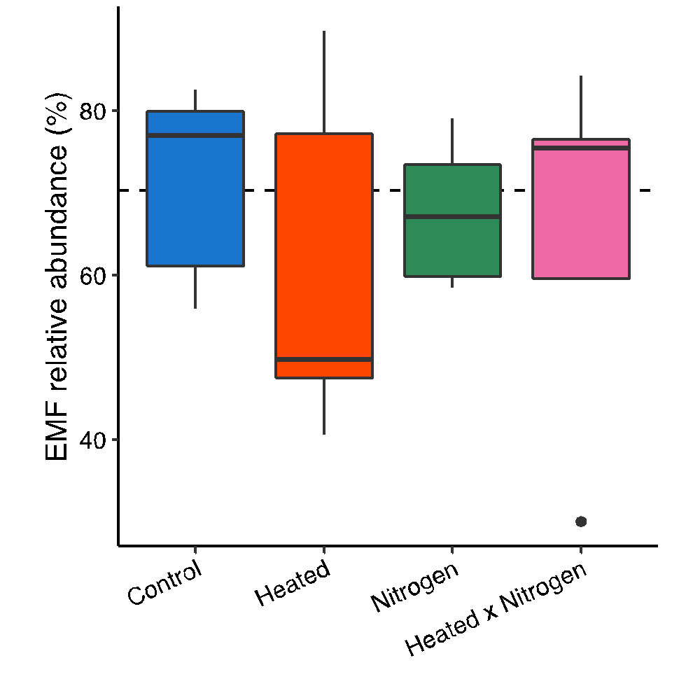

Figure S2. The relative abundance of fungal cellobiohydrolase genes across the treatments. Significant differences are indicated using different lower-case letters (P ≤ 0.05).

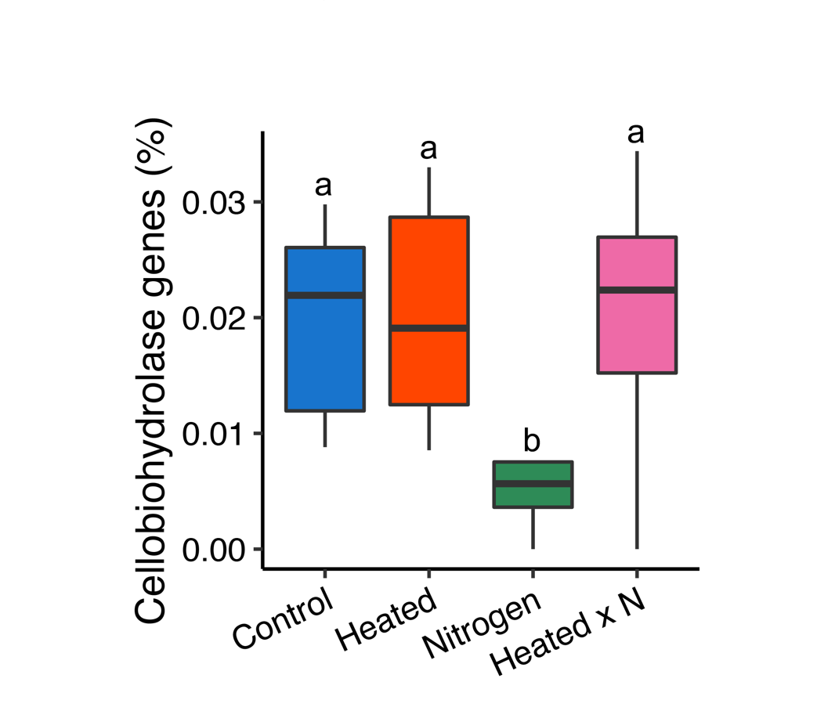

Figure S3. The correlation between suberin- and cutin-derived compound concentrations and fungal negative co-occurrence probability. Different color points show the treatment effects. Blue, orange, green, and pink points show the control, heated, N addition, and heated × N addition plots, respectively.

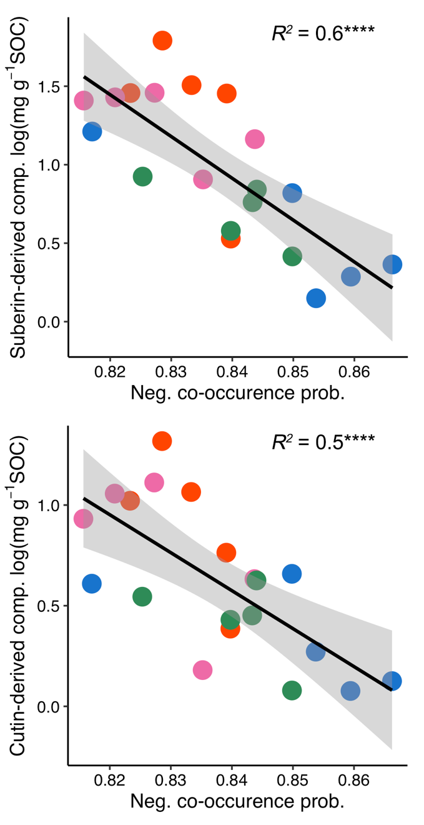

Figure S4. The relative abundance of AMF taxa identified via similarity percentage analysis contributing significantly to variation between treatment and control plot AMF community compositions. Values shown the mean (n = 5) and error bars are the standard error.

