Supplemental Material
Representing climate evolution in ensembles of GCM simulations for the Hudson Bay System
Marco Braun^{1,*}, Alida N. Thiombiano³, Michael J.F. Vieira², Tricia A. Stadnyk³
¹Ouranos Consortium, Montreal, Quebec, Canada
²Manitoba Hydro, Winnipeg, Manitoba, Canada
³University of Calgary, Department of Geography, Calgary, Alberta, Canada
*Braun.Marco@ouranos.ca
List of Contents
Figure S1. The 10th percentile-based thresholds derived from the 1981-2010 base period.
The 10th percentile gridded thresholds generated from the daily minimum temperature (TN) are presented for the calendar day January 1st.
Figure S2. The 10th percentile-based thresholds derived from the 1981-2010 base period.
The 10th percentile gridded thresholds generated from the daily minimum temperature (TN) are presented for the calendar day July 1st.
Figure S3. The 90th percentile-based thresholds derived from the 1981-2010 base period.
The 90th percentile gridded thresholds generated from the daily maximum temperature (TX) are presented for the calendar day January 1st.
Figure S4. The 90th percentile-based thresholds derived from the 1981-2010 base period.
The 90th percentile gridded thresholds generated from the daily maximum temperature (TX) are presented for the calendar day July 1st.
Figure S5. Trend in ENS and SUB TXx annual means time series over the period 1981-2070.
The non-linear blue and red lines represent ENS and SUB means respectively; the solid linear blue and red lines show ENS and SUB Mann-Kendall significant trends respectively; the light blue and red shading highlight respectively ENS and SUB simulations data range.
Figure S6. Trend in ENS and SUB TNn annual means time series over the period 1981-2070.
The non-linear blue and red lines represent ENS and SUB means respectively; the solid linear blue and red lines show ENS and SUB Mann-Kendall significant trends respectively; the light blue and red shading highlight respectively ENS and SUB simulations data range.
Figure S7. Trend in ENS and SUB TX90p annual means time series over the period 1981-2070.
The non-linear blue and red lines represent ENS and SUB means respectively; the solid linear blue and red lines show ENS and SUB Mann-Kendall significant trends respectively; the light blue and red shading highlight respectively ENS and SUB simulations data range.
Figure S8. Trend in ENS and SUB TN10p annual means time series over the period 1981-2070.
The non-linear blue and red lines represent ENS and SUB means respectively; the solid linear blue and red lines show ENS and SUB Mann-Kendall significant trends respectively; the light blue and red shading highlight respectively ENS and SUB simulations data range.
Figure S9. Trend in ENS and SUB FD annual means time series over the period 1981-2070.
The non-linear blue and red lines represent ENS and SUB means respectively; the solid linear blue and red lines show ENS and SUB Mann-Kendall significant trends respectively; the light blue and red shading highlight respectively ENS and SUB simulations data range.
Figure S10. Trend in ENS and SUB ID annual means time series over the period 1981-2070.
The non-linear blue and red lines represent ENS and SUB means respectively; the solid linear blue and red lines show ENS and SUB Mann-Kendall significant trends respectively; the light blue and red shading highlight respectively ENS and SUB simulations data range.
Figure S11. Trend in ENS and SUB PRCPTOT annual means time series over the period 1981-2070.
The non-linear blue and red lines represent ENS and SUB means respectively; the solid linear blue and red lines show ENS and SUB Mann-Kendall significant trends respectively; the light blue and red shading highlight respectively ENS and SUB simulations data range.
Figure S12. Trend in ENS and SUB RX5day annual means time series over the period 1981-2070.
The non-linear blue and red lines represent ENS and SUB means respectively; the solid linear blue and red lines show ENS and SUB Mann-Kendall significant trends respectively; the light blue and red shading highlight respectively ENS and SUB simulations data range.
Figure S13. Trend in ENS and SUB SDII annual means time series over the period 1981-2070.
The non-linear blue and red lines represent ENS and SUB means respectively; the solid linear blue and red lines show ENS and SUB Mann-Kendall significant trends respectively; the light blue and red shading highlight respectively ENS and SUB simulations data range.

Figure S14. Trend in ENS and SUB CDD annual means time series over the period 1981-2070.
The non-linear blue and red lines represent ENS and SUB means respectively; the solid linear blue and red lines show ENS and SUB Mann-Kendall significant trends respectively; the light blue and red shading highlight respectively ENS and SUB simulations data range.

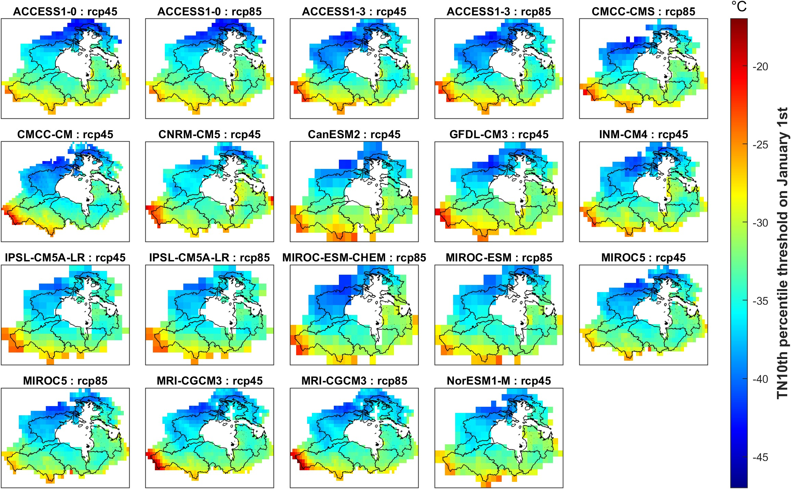
Figure S1. The 10th percentile-based thresholds derived from the 1981-2010 base period.
The 10th percentile gridded thresholds generated from the daily minimum temperature (TN) are presented for the calendar day January 1st.

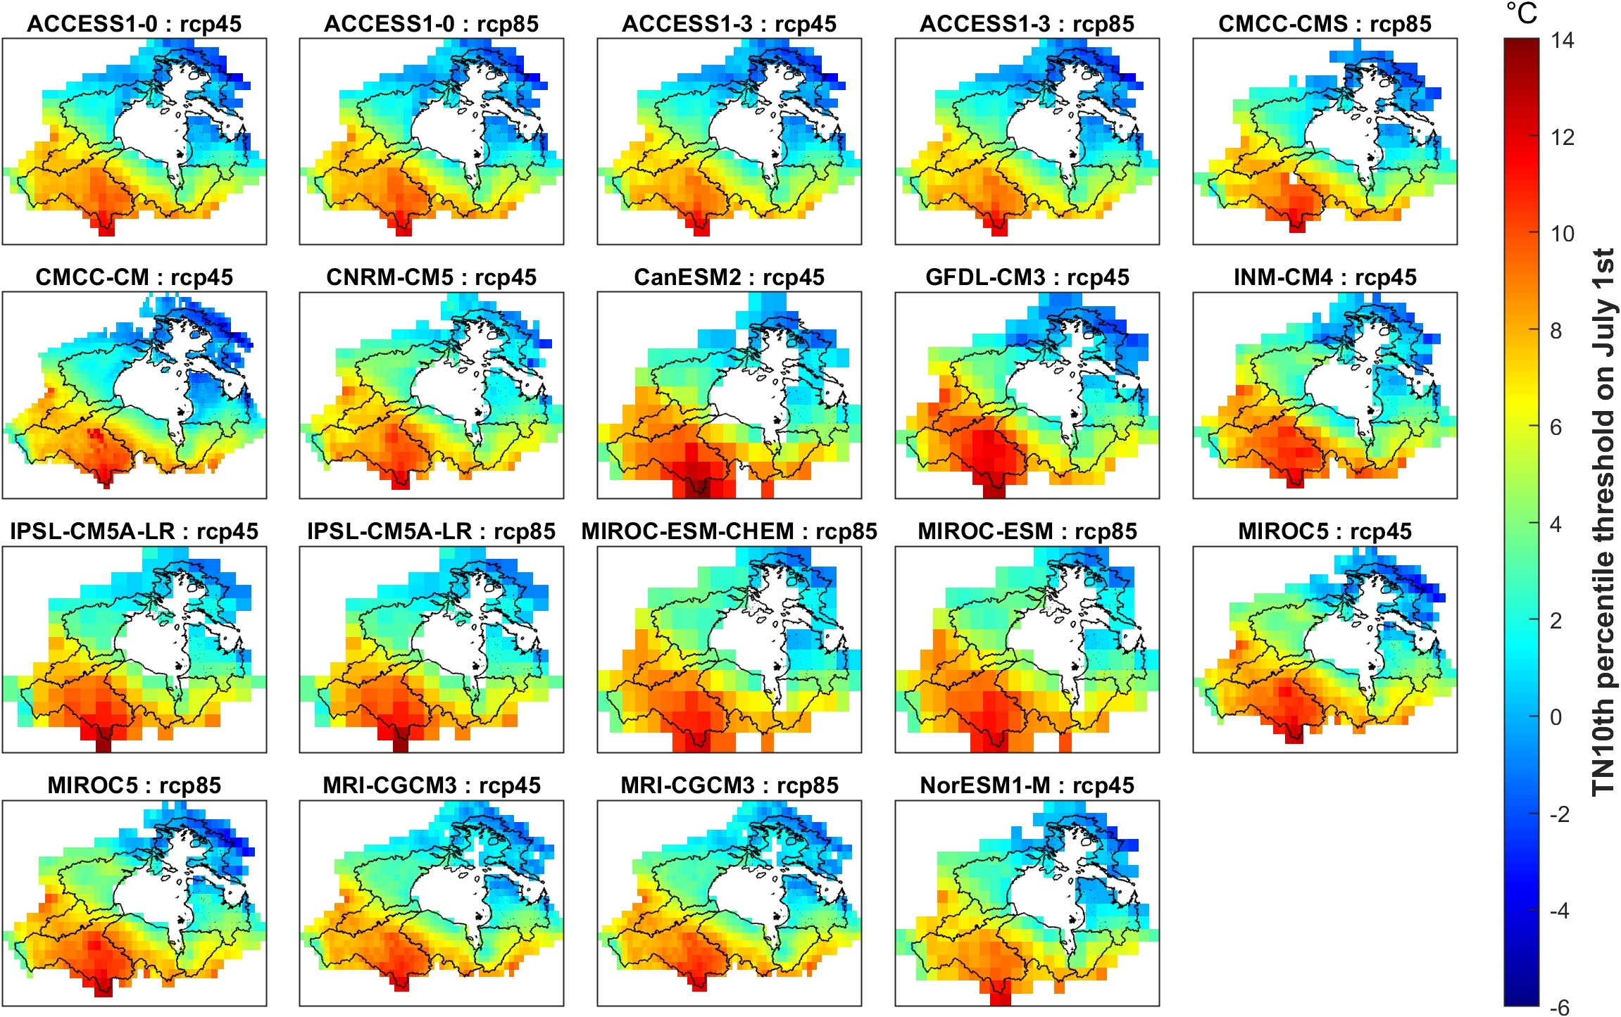
Figure S2. The 10th percentile-based thresholds derived from the 1981-2010 base period.
The 10th percentile gridded thresholds generated from the daily minimum temperature (TN) are presented for the calendar day July 1st.

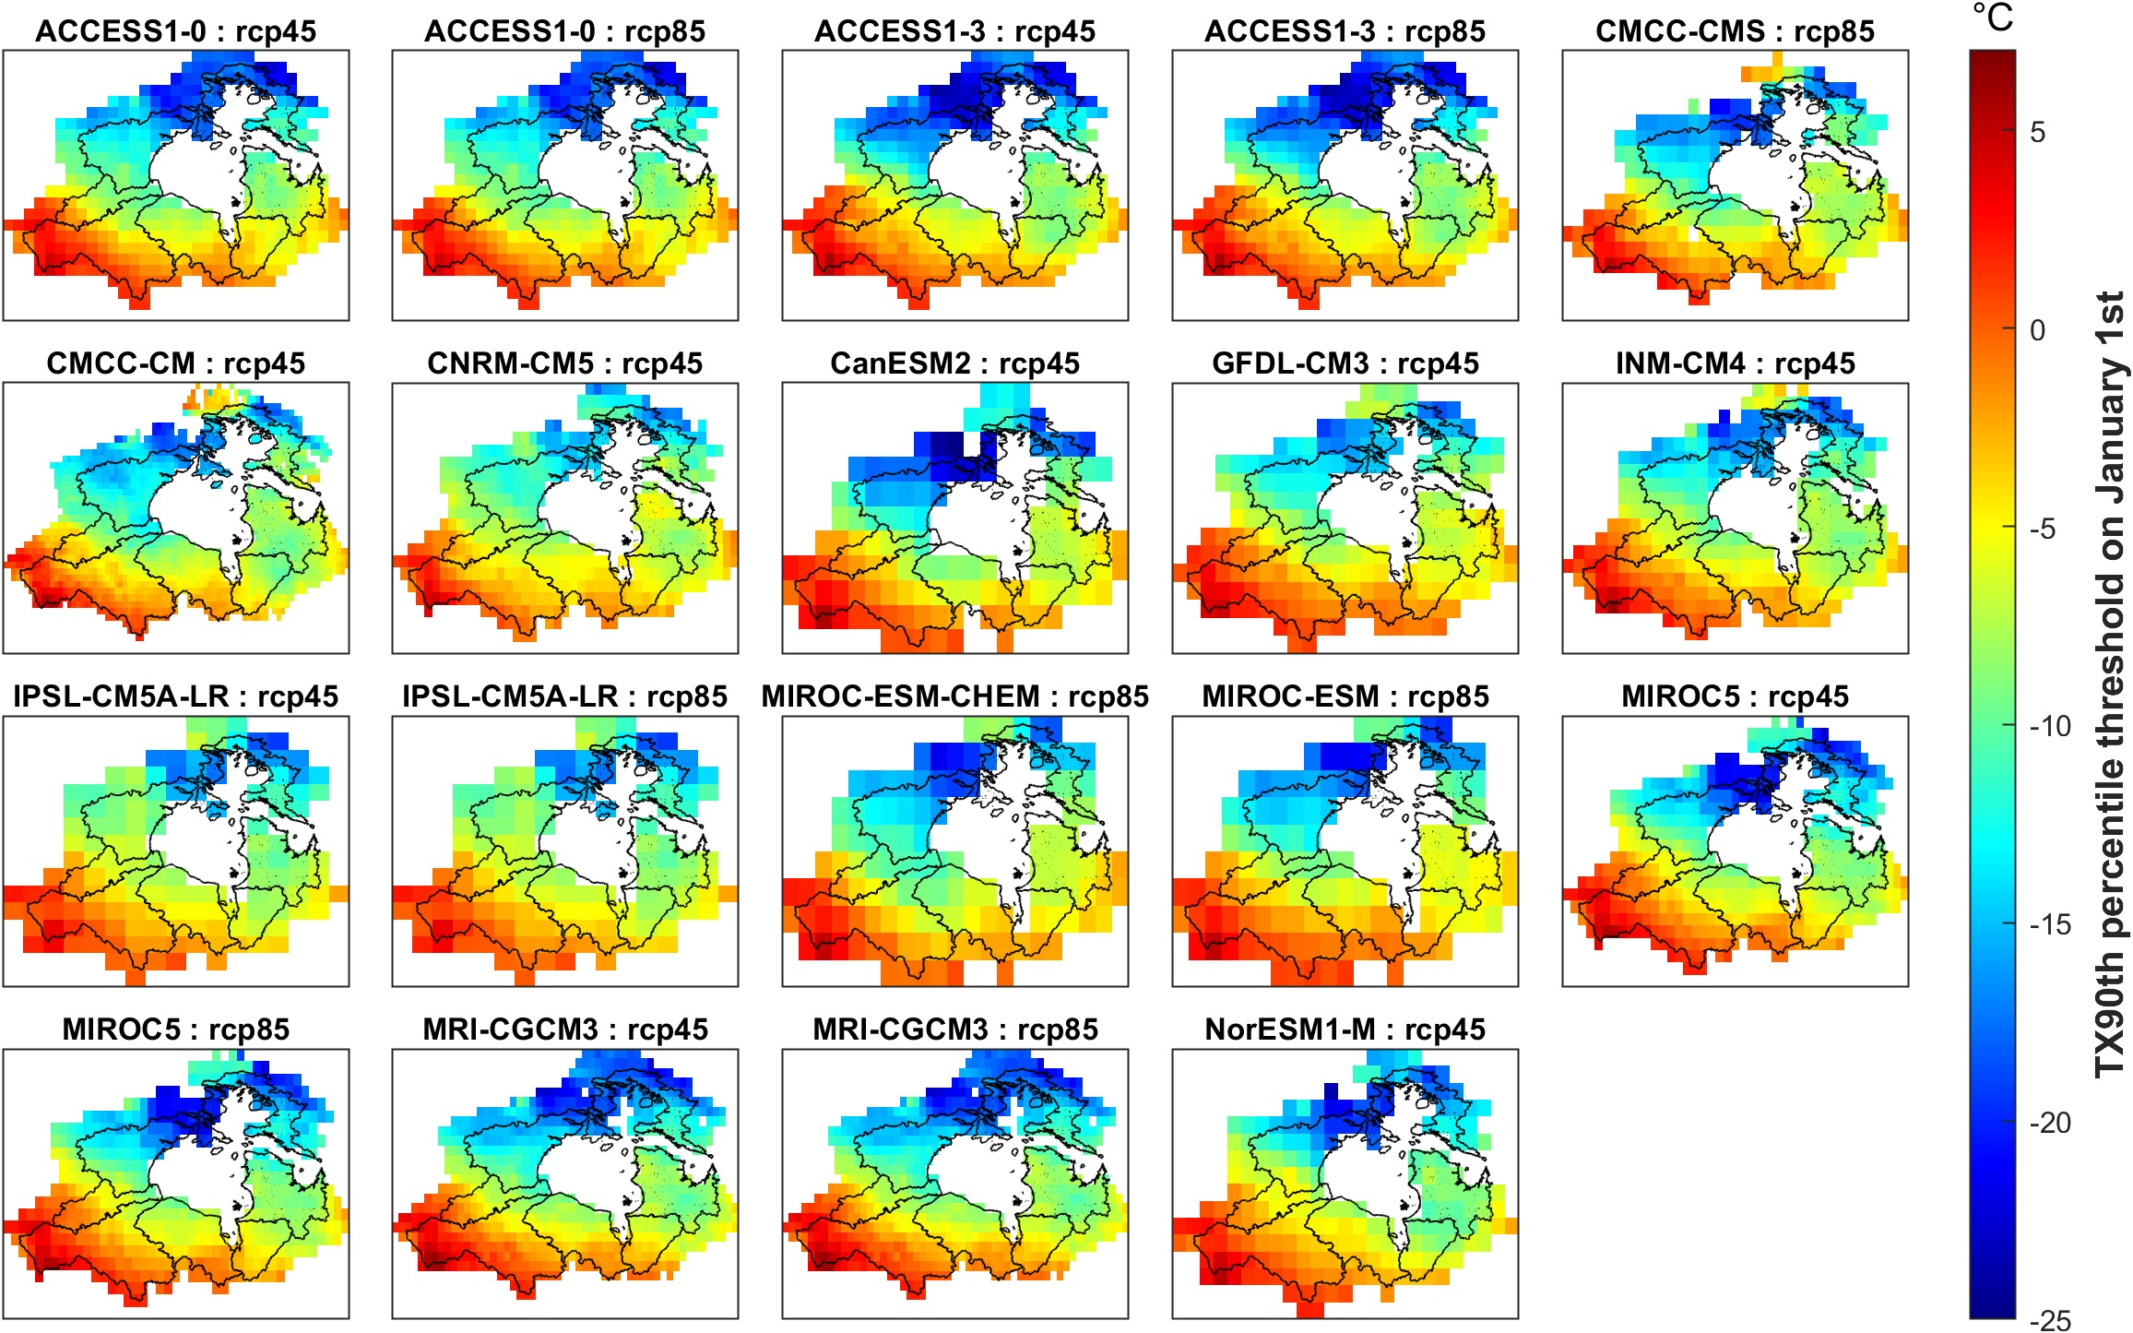
Figure S3. The 90th percentile-based thresholds derived from the 1981-2010 base period.
The 90th percentile gridded thresholds generated from the daily maximum temperature (TX) are presented for the calendar day January 1st.

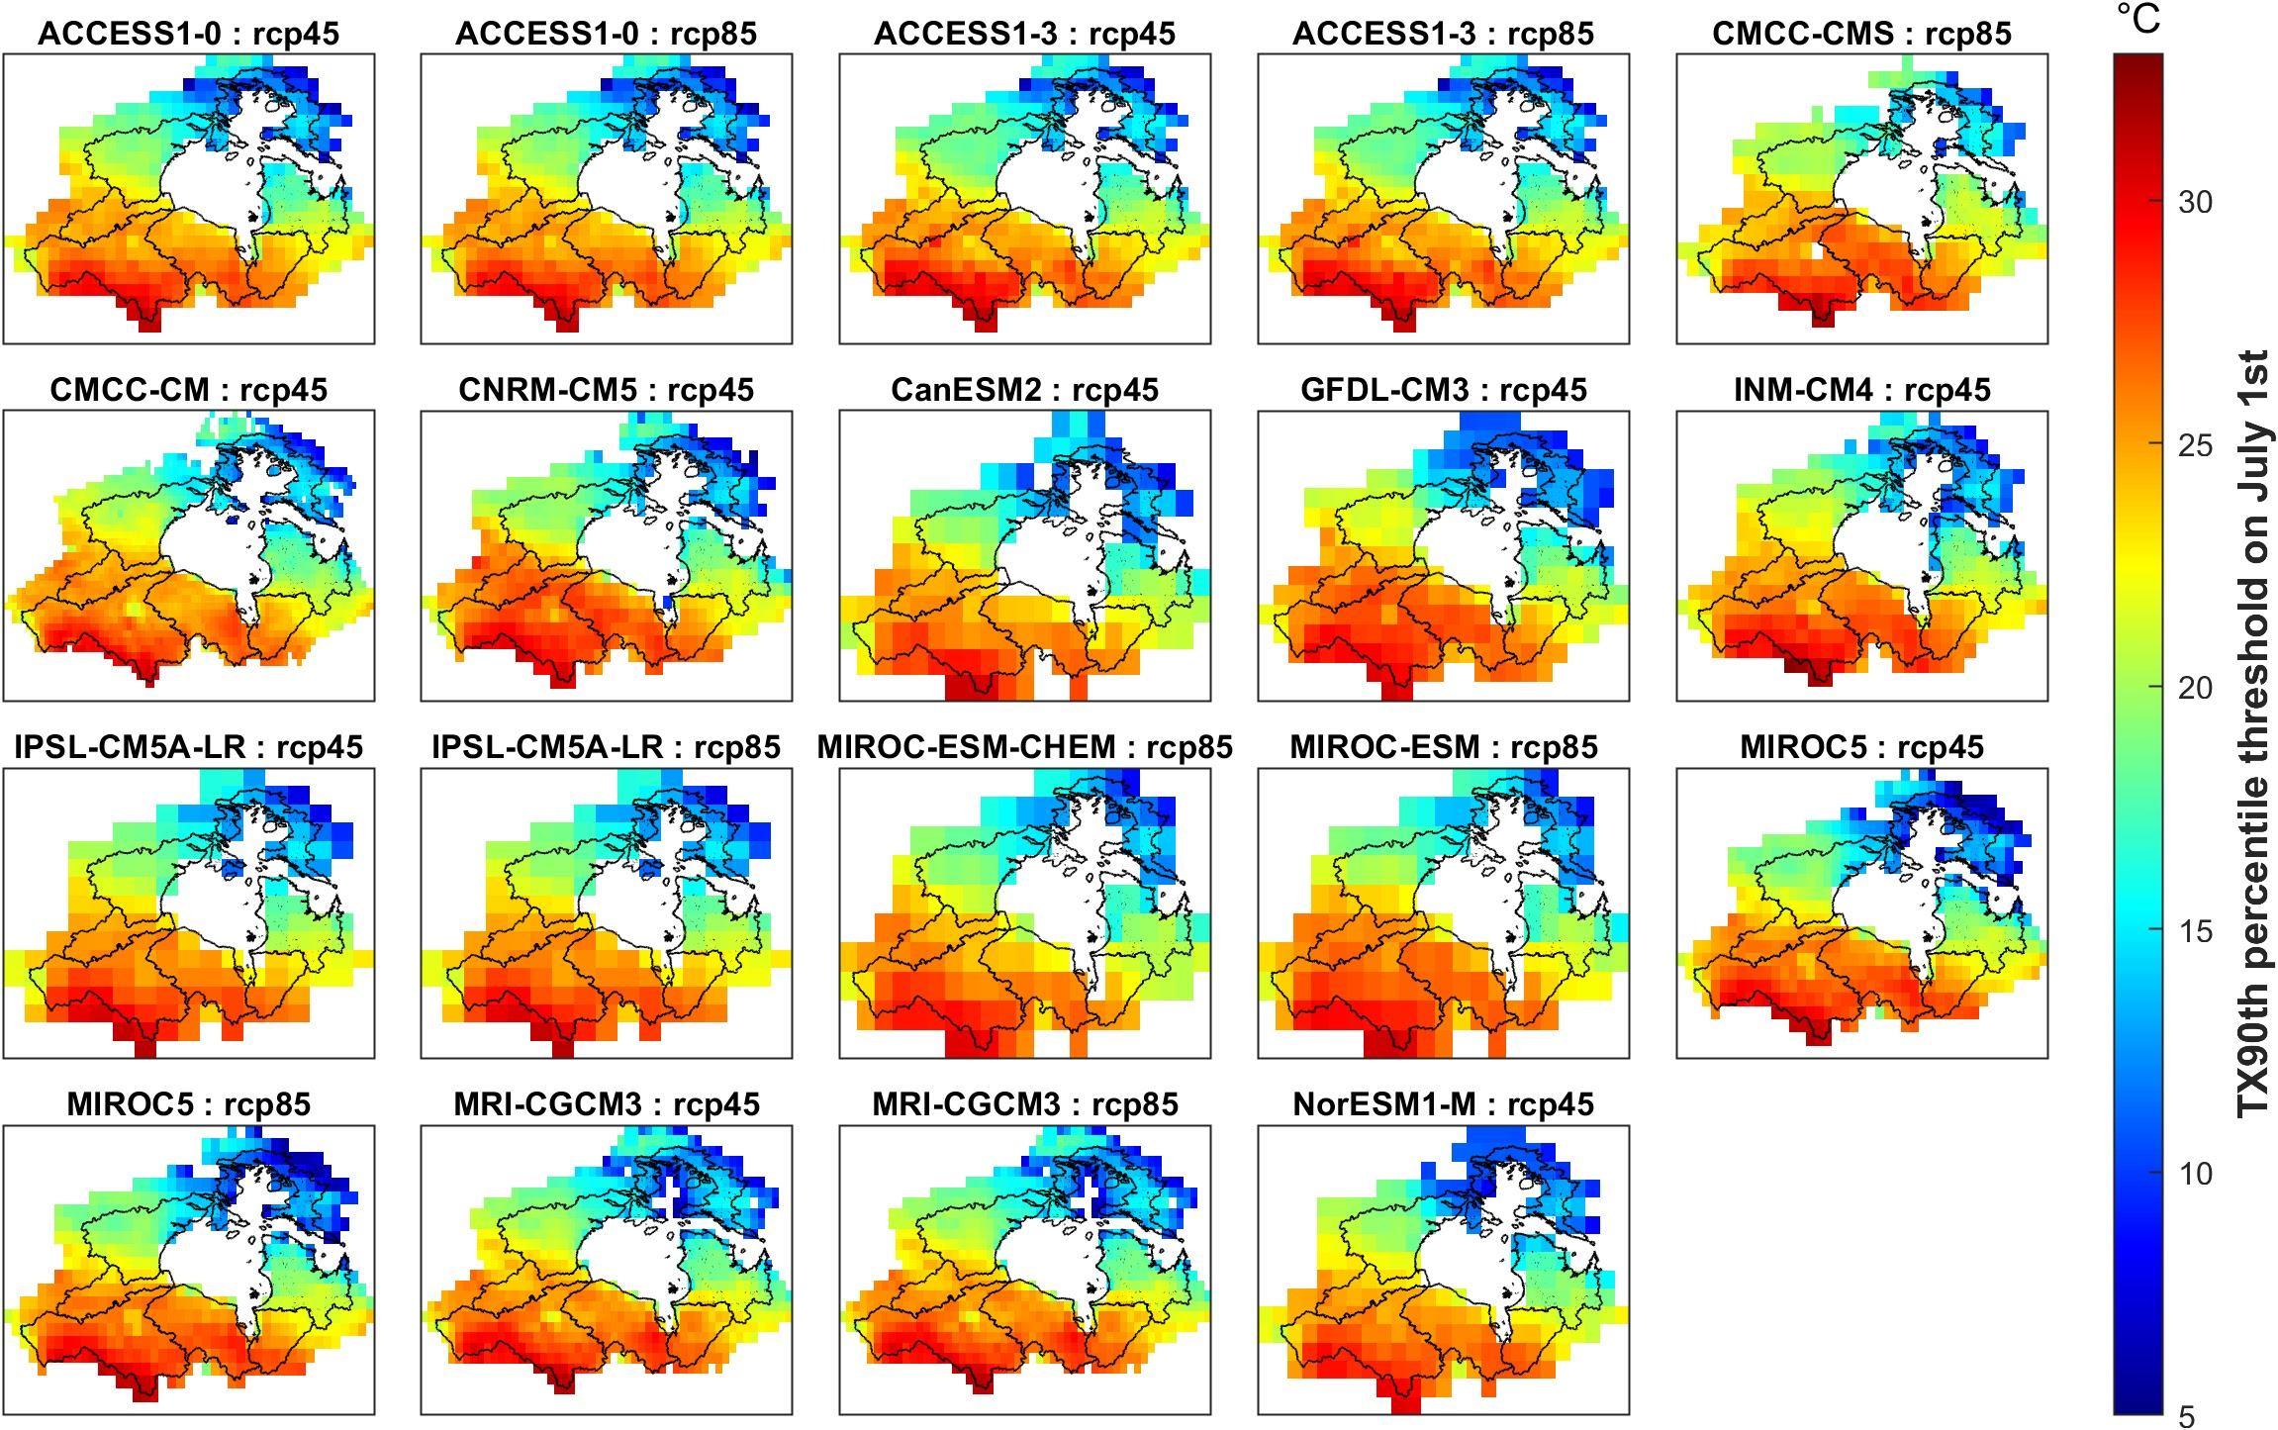
Figure S4. The 90th percentile-based thresholds derived from the 1981-2010 base period.
The 90th percentile gridded thresholds generated from the daily maximum temperature (TX) are presented for the calendar day July 1st.

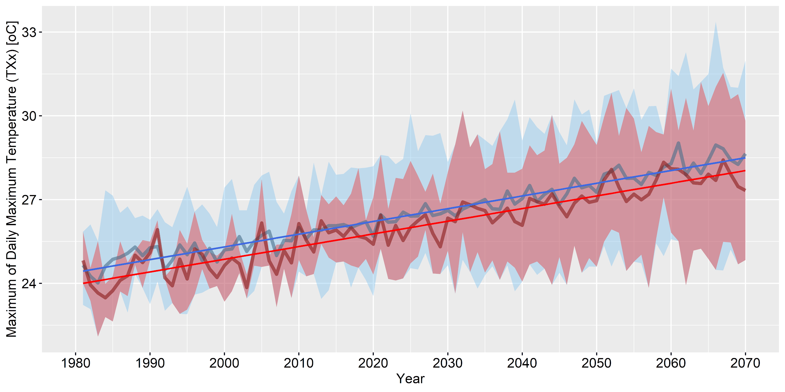
Figure S5. Trend in ENS and SUB TXx annual means time series over the period 1981-2070.
The non-linear blue and red lines represent ENS and SUB means respectively; the solid linear blue and red lines show ENS and SUB Mann-Kendall significant trends respectively; the light blue and red shading highlight respectively ENS and SUB simulations data range.

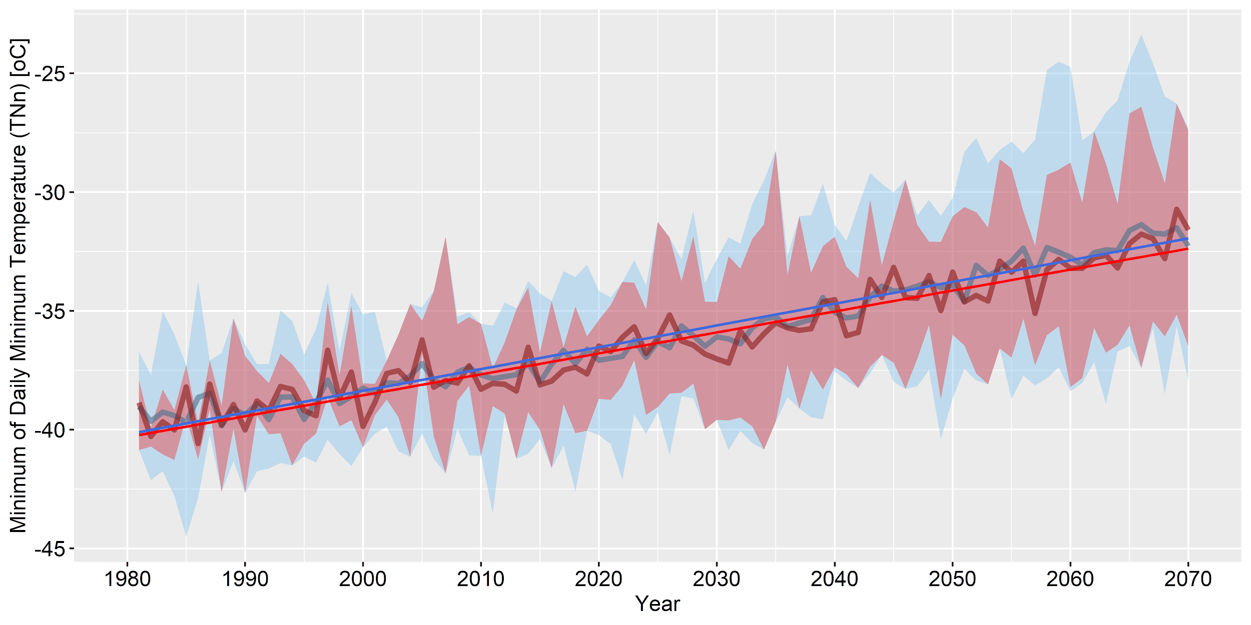
Figure S6. Trend in ENS and SUB TNn annual means time series over the period 1981-2070.
The non-linear blue and red lines represent ENS and SUB means respectively; the solid linear blue and red lines show ENS and SUB Mann-Kendall significant trends respectively; the light blue and red shading highlight respectively ENS and SUB simulations data range.

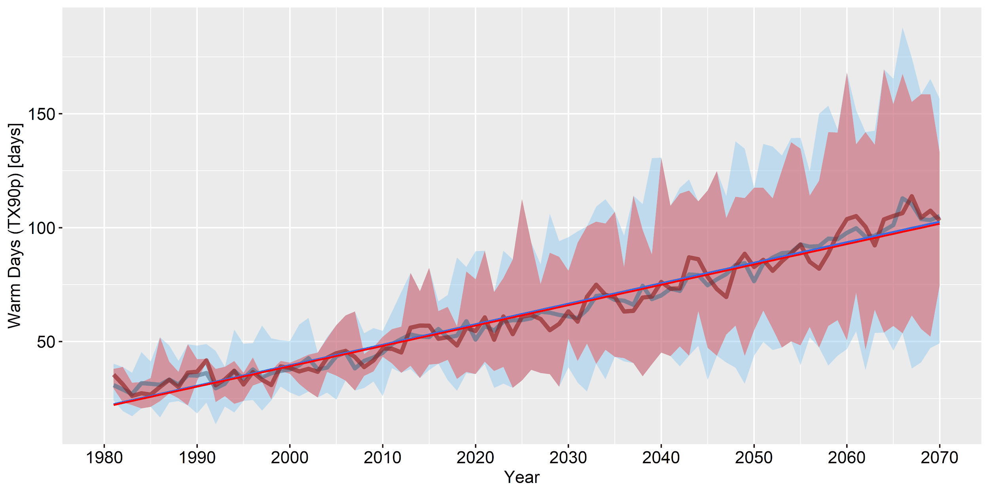
Figure S7. Trend in ENS and SUB TX90p annual means time series over the period 1981-2070.
The non-linear blue and red lines represent ENS and SUB means respectively; the solid linear blue and red lines show ENS and SUB Mann-Kendall significant trends respectively; the light blue and red shading highlight respectively ENS and SUB simulations data range.

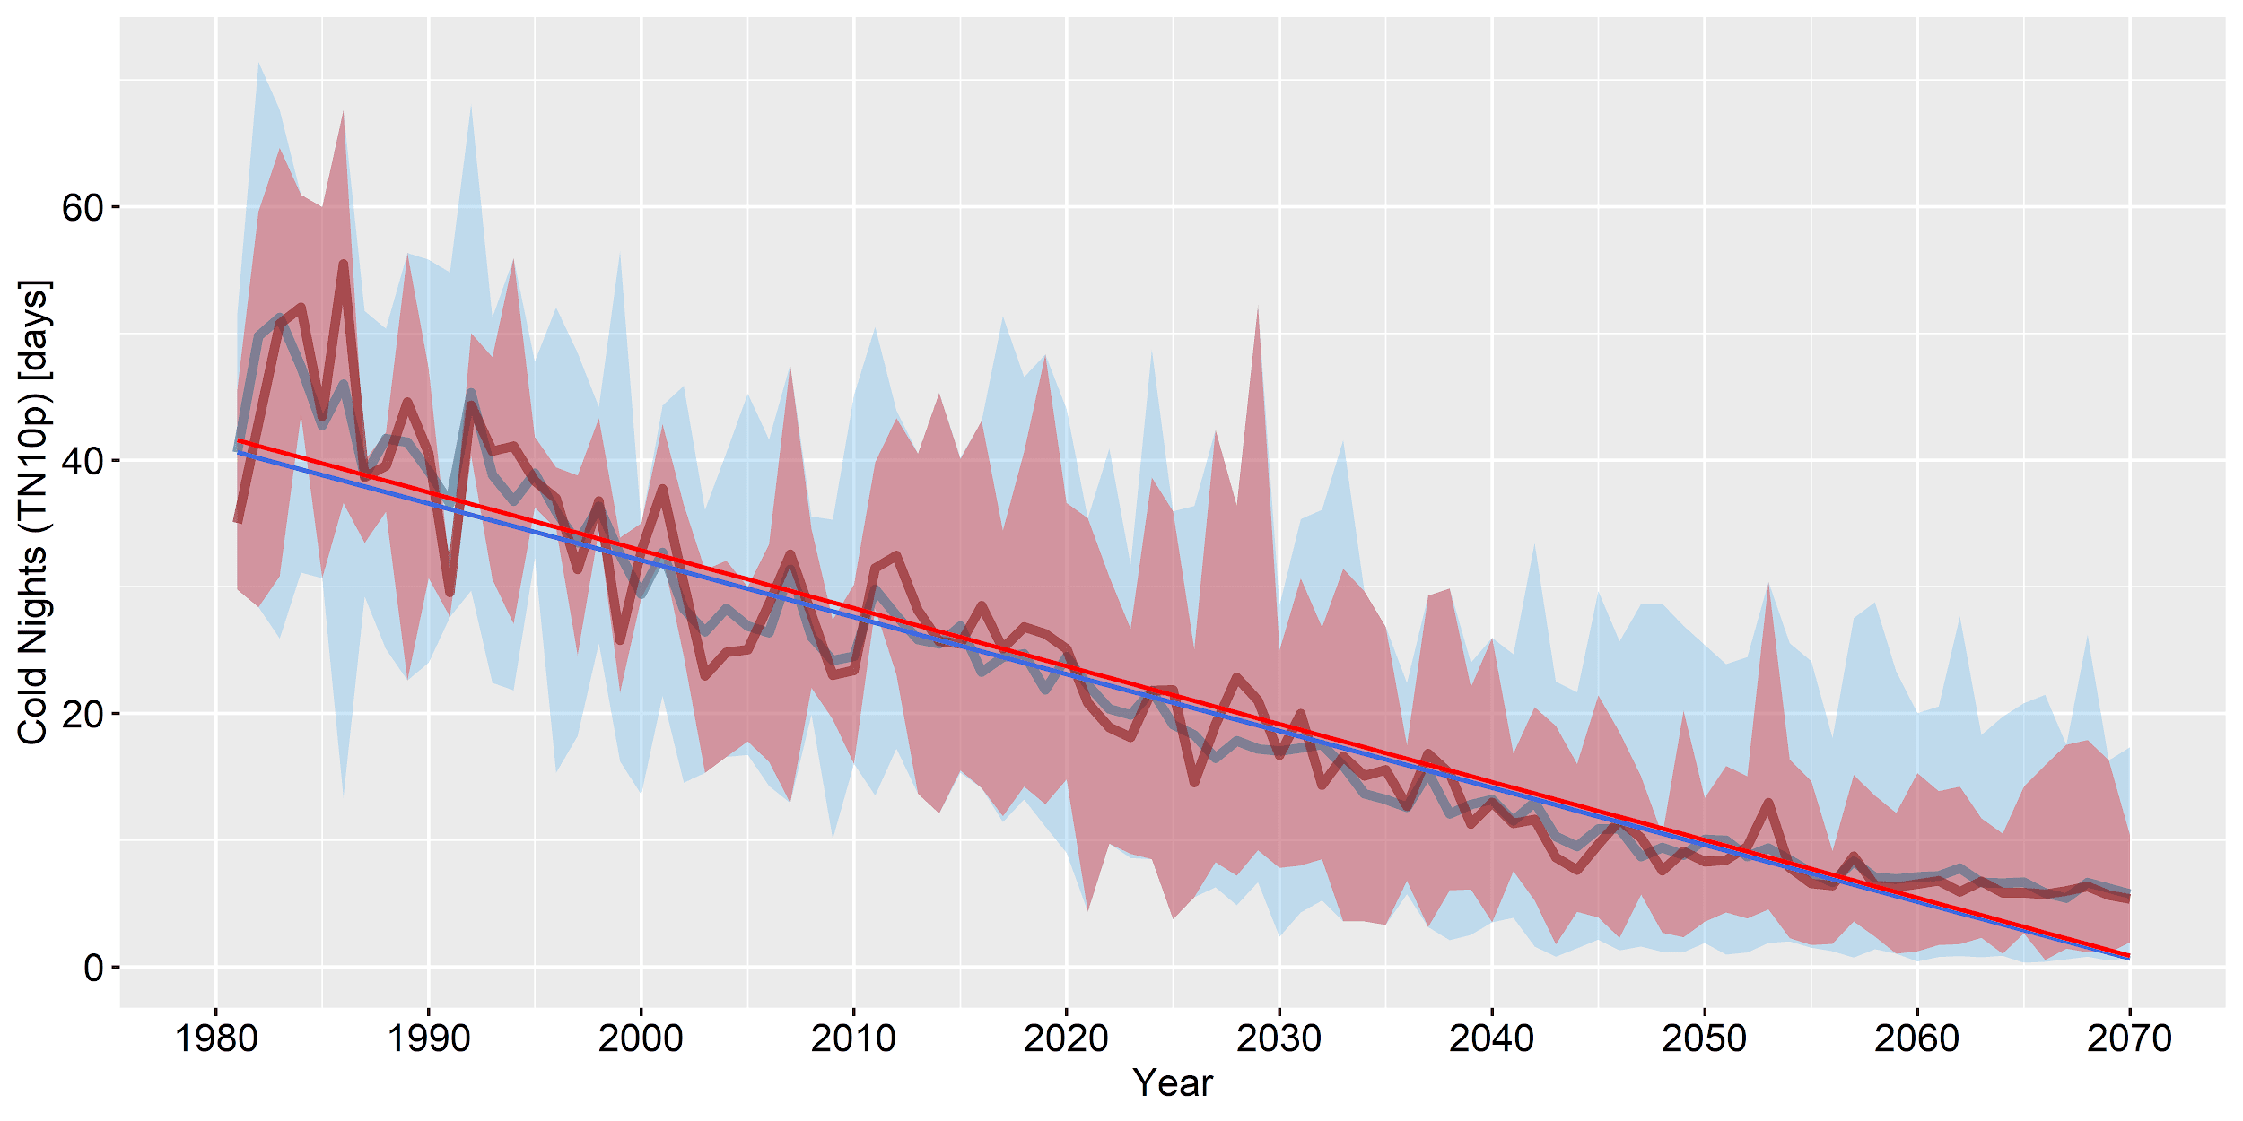
Figure S8. Trend in ENS and SUB TN10p annual means time series over the period 1981-2070.
The non-linear blue and red lines represent ENS and SUB means respectively; the solid linear blue and red lines show ENS and SUB Mann-Kendall significant trends respectively; the light blue and red shading highlight respectively ENS and SUB simulations data range.

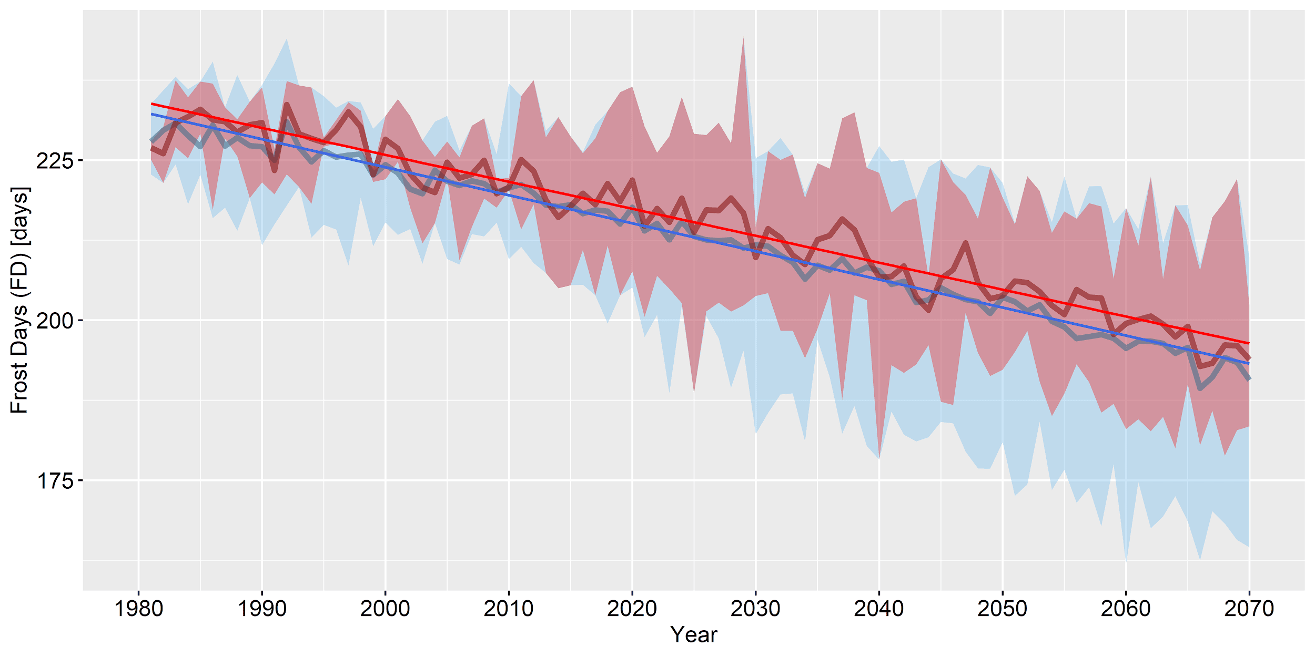
Figure S9. Trend in ENS and SUB FD annual means time series over the period 1981-2070.
The non-linear blue and red lines represent ENS and SUB means respectively; the solid linear blue and red lines show ENS and SUB Mann-Kendall significant trends respectively; the light blue and red shading highlight respectively ENS and SUB simulations data range.

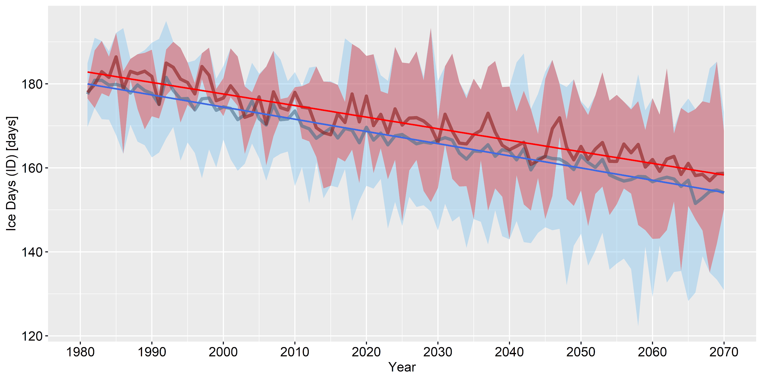
Figure S10. Trend in ENS and SUB ID annual means time series over the period 1981-2070.
The non-linear blue and red lines represent ENS and SUB means respectively; the solid linear blue and red lines show ENS and SUB Mann-Kendall significant trends respectively; the light blue and red shading highlight respectively ENS and SUB simulations data range.

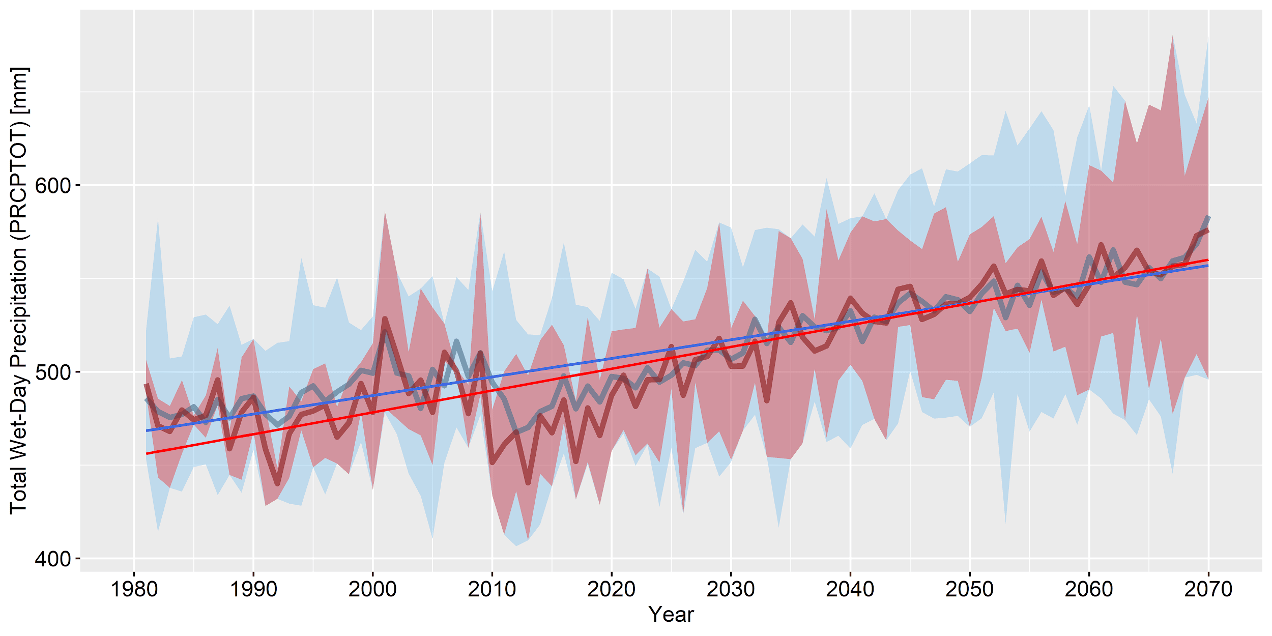
Figure S11. Trend in ENS and SUB PRCPTOT annual means time series over the period 1981-2070.
The non-linear blue and red lines represent ENS and SUB means respectively; the solid linear blue and red lines show ENS and SUB Mann-Kendall significant trends respectively; the light blue and red shading highlight respectively ENS and SUB simulations data range.

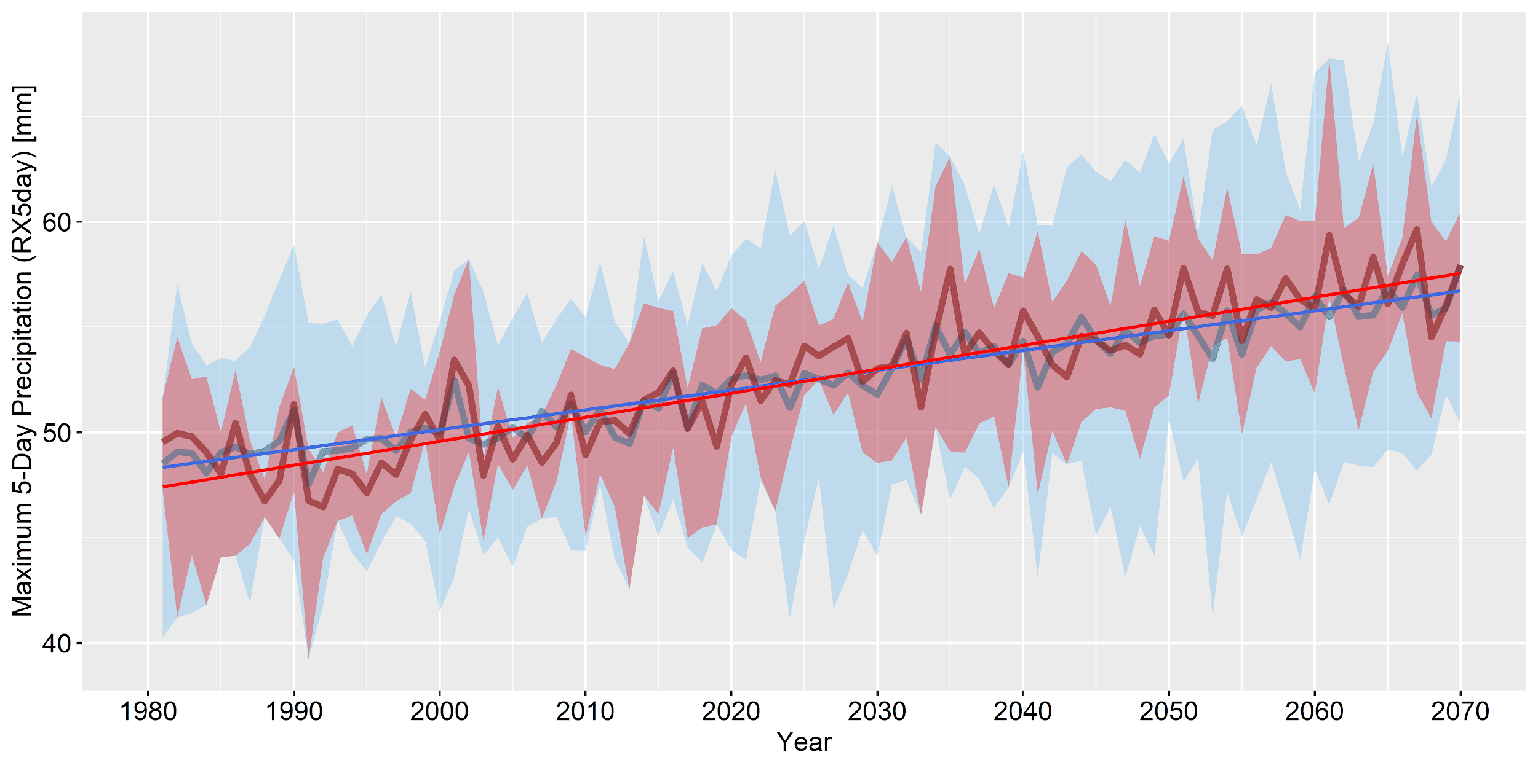
Figure S12. Trend in ENS and SUB RX5day annual means time series over the period 1981-2070.
The non-linear blue and red lines represent ENS and SUB means respectively; the solid linear blue and red lines show ENS and SUB Mann-Kendall significant trends respectively; the light blue and red shading highlight respectively ENS and SUB simulations data range.

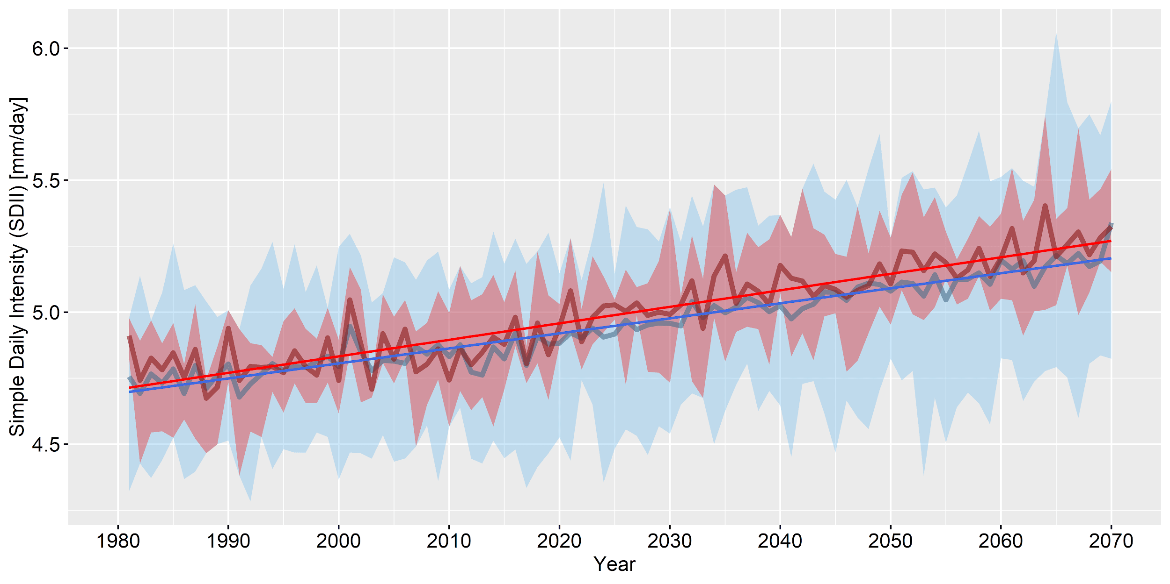
Figure S13. Trend in ENS and SUB SDII annual means time series over the period 1981-2070.
The non-linear blue and red lines represent ENS and SUB means respectively; the solid linear blue and red lines show ENS and SUB Mann-Kendall significant trends respectively; the light blue and red shading highlight respectively ENS and SUB simulations data range.

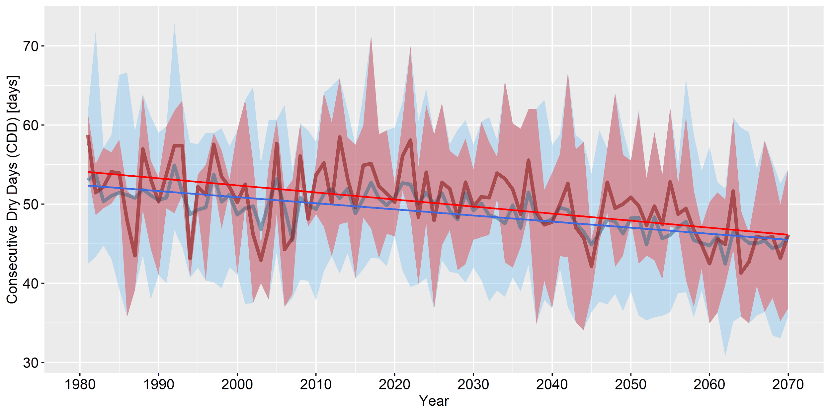
Figure S14. Trend in ENS and SUB CDD annual means time series over the period 1981-2070.
The non-linear blue and red lines represent ENS and SUB means respectively; the solid linear blue and red lines show ENS and SUB Mann-Kendall significant trends respectively; the light blue and red shading highlight respectively ENS and SUB simulations data range.

