Supplemental materials

Arctic cod (Boreogadus saida) hatching in the Hudson Bay system: testing of the freshwater winter refuge hypothesis
Sarah Schembri^{1*}, Inge Deschepper¹, Paul G. Myers², Pascal Sirois³, Louis Fortier¹, Caroline Bouchard^{1,4} and Frédéric Maps¹

1 – Université Laval, Québec, Canada
2 – University of Alberta, Alberta, Canada
3 – Université du Québec à Chicoutimi, Québec, Canada
4 – Greenland Climate Research Centre, Nuuk, Greenland
*sarah.schembri.1@ulaval.ca

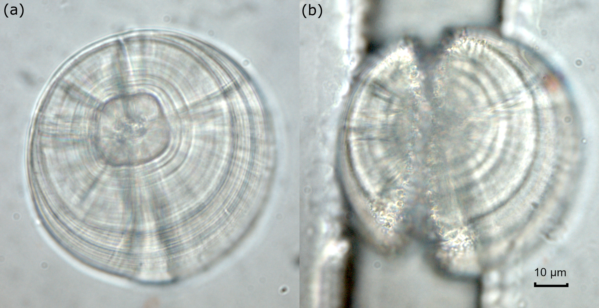
Figure S1. Left lapillus of Arctic cod larvae. (a) Intact otolith. (b) After taking a transect through the core via laser ablation for mass spectroscopy analysis.

Table S1. The gauged rivers in the Hudson Bay system, adapted from Stadnyk et al. (2021).
Location number (Figure 1) | Location name | Regulated (yes/no) | Data source | Drainage area (km²)ª | Observed mean monthly discharge (m³ s^{–1})^{b}
1 | Nelson River | Y | DERY | 1,111,890 | 3,343
2 | Churchill River | Y | DERY | 295,121 | 356
3 | Albany River | Y | DERY | 137,035 | 1,009
4 | Rivière Koksoak | Y | DERY | 136,262 | 1,458
5 | Moose River | Y | DERY | 109,440 | 1,182
6 | La Grande Rivière | Y | DERY | 100,729 | 3,039
7 | Rivière Eastmain | Y | DERY | 46,930 | 108
8 | Rivière Rupert | Y | DERY | 46,003 | 818
9 | Thelon and Kazan rivers | N | DERY | 246,371 | 1,354
10 | Hayes River | N | DERY | 105,042 | 611
11 | Severn River | N | DERY | 99,222 | 672
12 | Winisk River | N | DERY | 71,066 | 470
13 | Rivière Nottaway | N | DERY | 67,383 | 988
14 | Thlewiaza and Tha–anne rivers | N | DERY | 49,599 | 220
15 | Seal River | N | DERY | 49,263 | 371
16 | Attawapiskat River | N | DERY | 47,168 | 348
17 | Rivière Arnaud | N | DERY | 44,486 | 365
18 | Grande Rivière de la Baleine | N | DERY | 41,219 | 663
19 | Rivière George | N | DERY | 39,364 | 734
20 | Rivière aux Feuilles | N | DERY | 38,684 | 548
21 | Rivière Harricana | N | DERY | 33,873 | 57
22 | Rivière a la Baleine | N | DERY | 31,788 | 486
23 | Quoich River | N | DERY | 29,883 | 213
24 | Ekwan River | N | DERY | 21,546 | 83
25 | Rivière Broadback | N | DERY | 20,189 | 309
26 | Petite Rivière de la Baleine | N | DERY | 15,750 | 101
27 | Fergusson River | N | DERY | 15,556 | 83
28 | Rivière Innuksuac | N | DERY | 12,727 | 104
29 | Rivière Nastapoka | N | DERY | 12,417 | 257
30 | Rivière a l'Eau Claire | N | DERY | 12,388 | 90
31 | Lorillard River | N | DERY | 11,432 | 89
32 | Rivière Pontax | N | DERY | 3,020 | 99
ª The drainage area is as used in the simulation of the revised A-HYPE model.
^{b} Based on observations from 1981 to 2010

