Supplemental material

A global atlas of artificial light at night under the sea

T. J. Smyth¹*, A. E. Wright¹, D. McKee^{2,3}, S. Tidau⁴†^{,5}, R. Tamir^{6,7}, Z. Dubinsky⁶, D. Iluz^{6,8}, T. W. Davies⁴†^{,5}

- Plymouth Marine Laboratory, Prospect Place, Plymouth, Devon, UK, PL1 3DH
- Physics Department, University of Strathclyde, 107 Rottenrow, Glasgow, Scotland, G4 0NG
- Department Arctic and Marine Biology, Faculty for Bioscience, Fisheries and Economy, UiT The Arctic University of Norway, Tromsø, Norway
- School of Biological and Marine Sciences, University of Plymouth, Drake Circus, Plymouth, UK, PL4 8AA
- School of Ocean Sciences, University of Bangor, Menai Bridge, Anglesey, UK, LL59 5AB
- The Mina & Everard Goodman Faculty of Life Sciences, Bar-Ilan University, Ramat-Gan 5290002, Israel
- The Interuniversity Institute for Marine Sciences of Eilat, Eilat, Israel
- Department of Environmental Sciences and Agriculture, Beit Berl Academic College, Israel

* Corresponding author: tjsm@pml.ac.uk
† Present address

Figure S1. Critical depth (Z_{c}) for climatological May for North America. Entire dataset can be downloaded in netCDF format from Pangaea (https://doi.pangaea.de/10.1594/PANGAEA.929749)

Figure S2. Critical depth (Z_{c}) for climatological May for Central America. Entire dataset can be downloaded in netCDF format from Pangaea (https://doi.pangaea.de/10.1594/PANGAEA.929749)

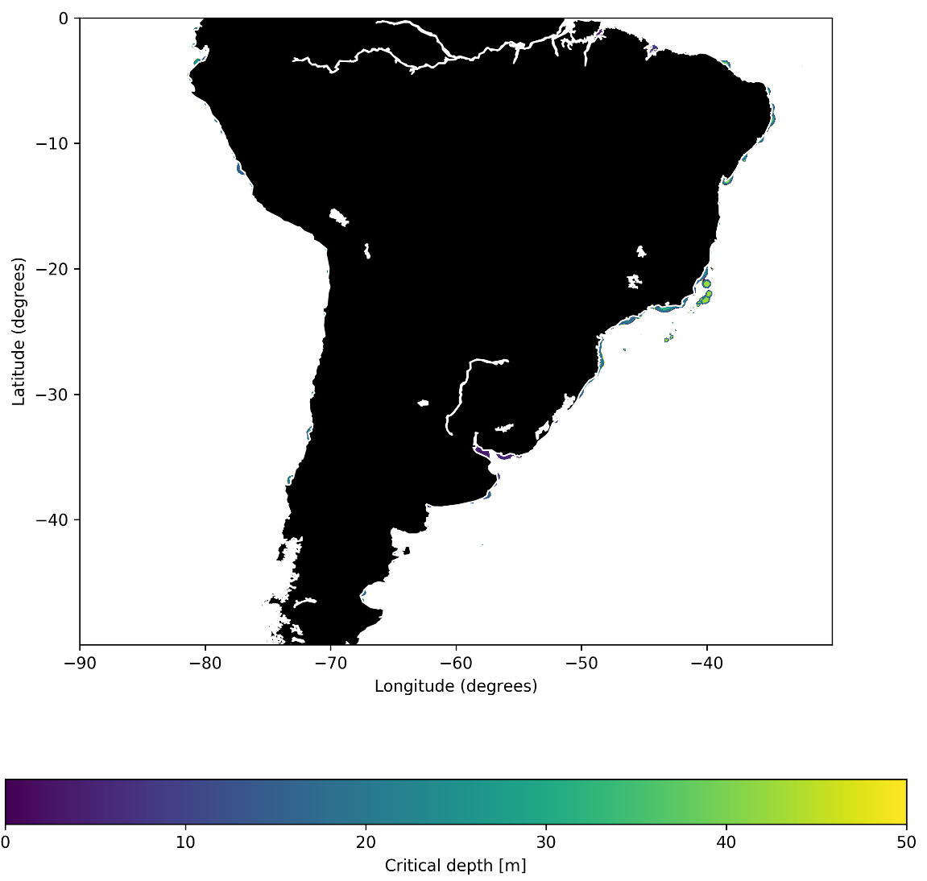
Figure S3. Critical depth (Z_{c}) for climatological May for South America. Entire dataset can be downloaded in netCDF format from Pangaea (https://doi.pangaea.de/10.1594/PANGAEA.929749).
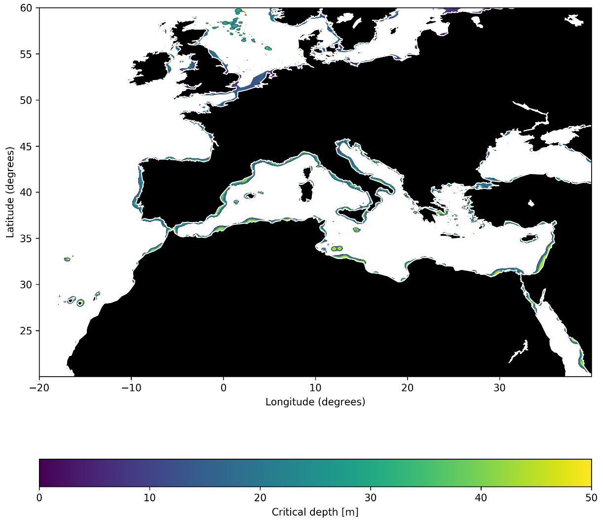
Figure S4. Critical depth (Z_{c}) for climatological May for Europe, Northern Africa and Mediterranean. Entire dataset can be downloaded in netCDF format from Pangaea (https://doi.pangaea.de/10.1594/PANGAEA.929749).
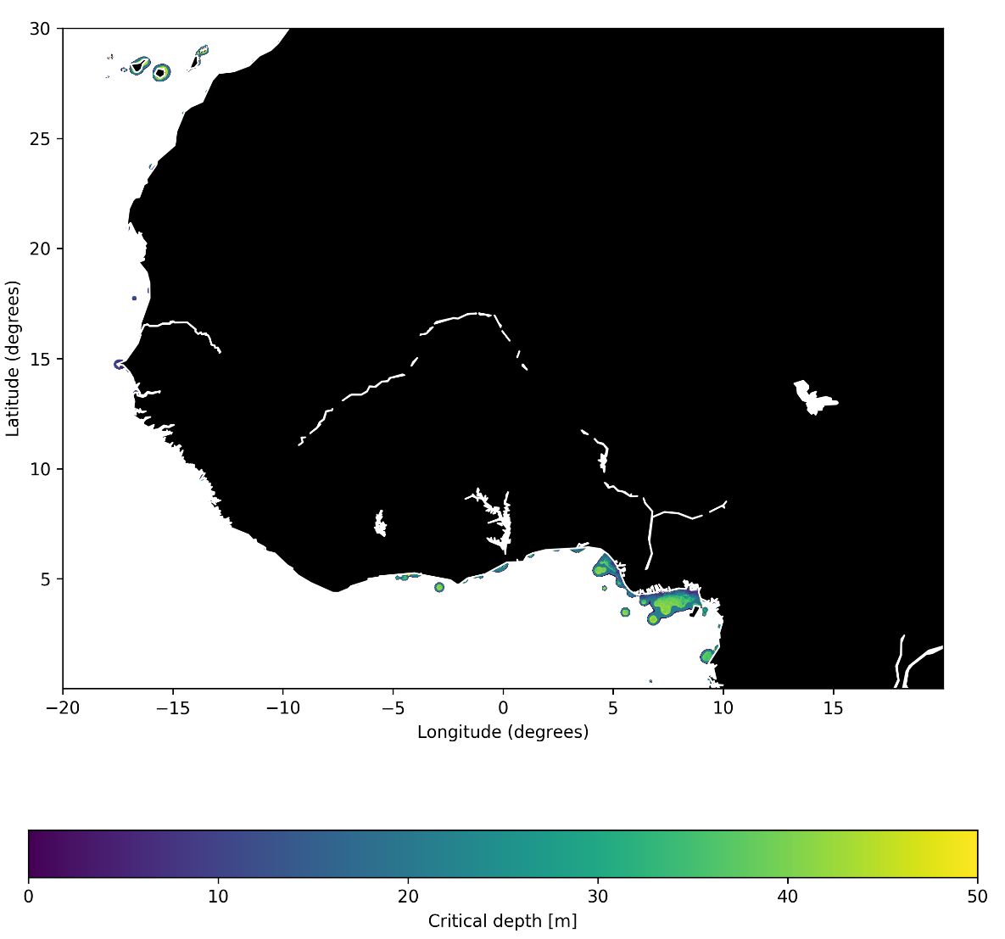
Figure S5. Critical depth (Z_{c}) for climatological May for northwest Africa. Entire dataset can be downloaded in netCDF format from Pangaea (https://doi.pangaea.de/10.1594/PANGAEA.929749).
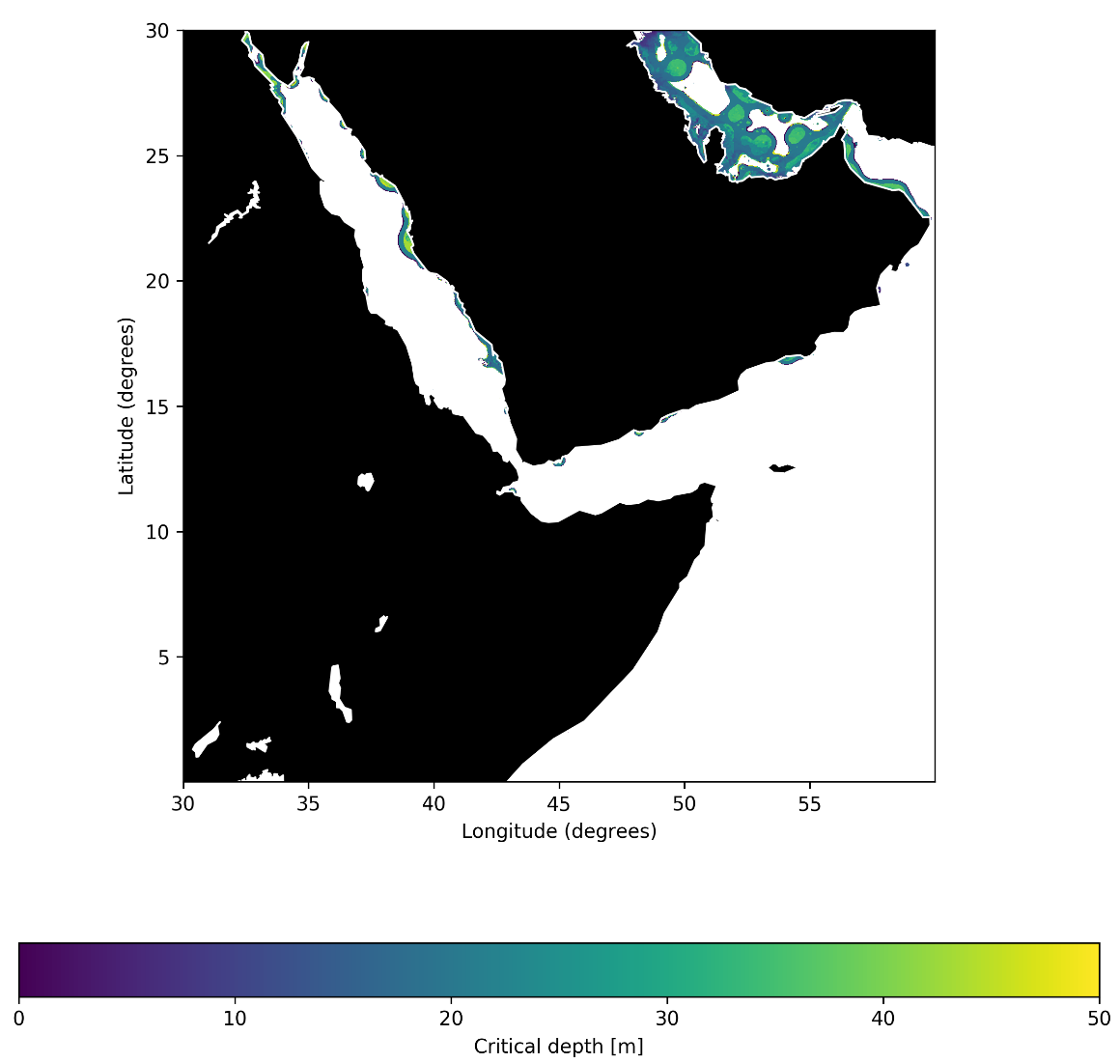
Figure S6. Critical depth (Z_{c}) for climatological May for northeast Africa and Arabian Peninsula. Entire dataset can be downloaded in netCDF format from Pangaea (https://doi.pangaea.de/10.1594/PANGAEA.929749)
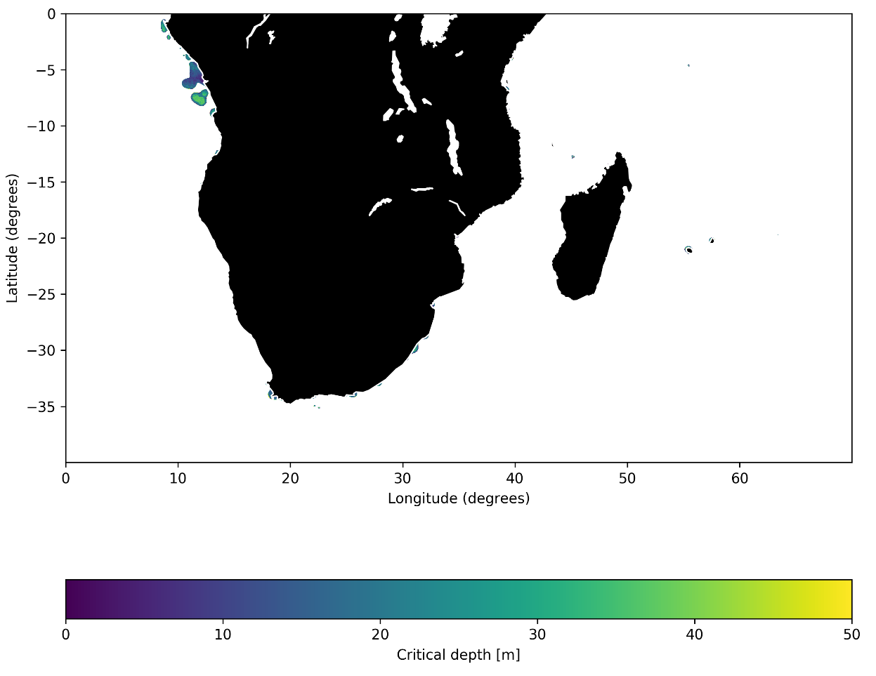
Figure S7. Critical depth (Z_{c}) for climatological May for southern Africa and Madagascar. Entire dataset can be downloaded in netCDF format from Pangaea (https://doi.pangaea.de/10.1594/PANGAEA.929749).
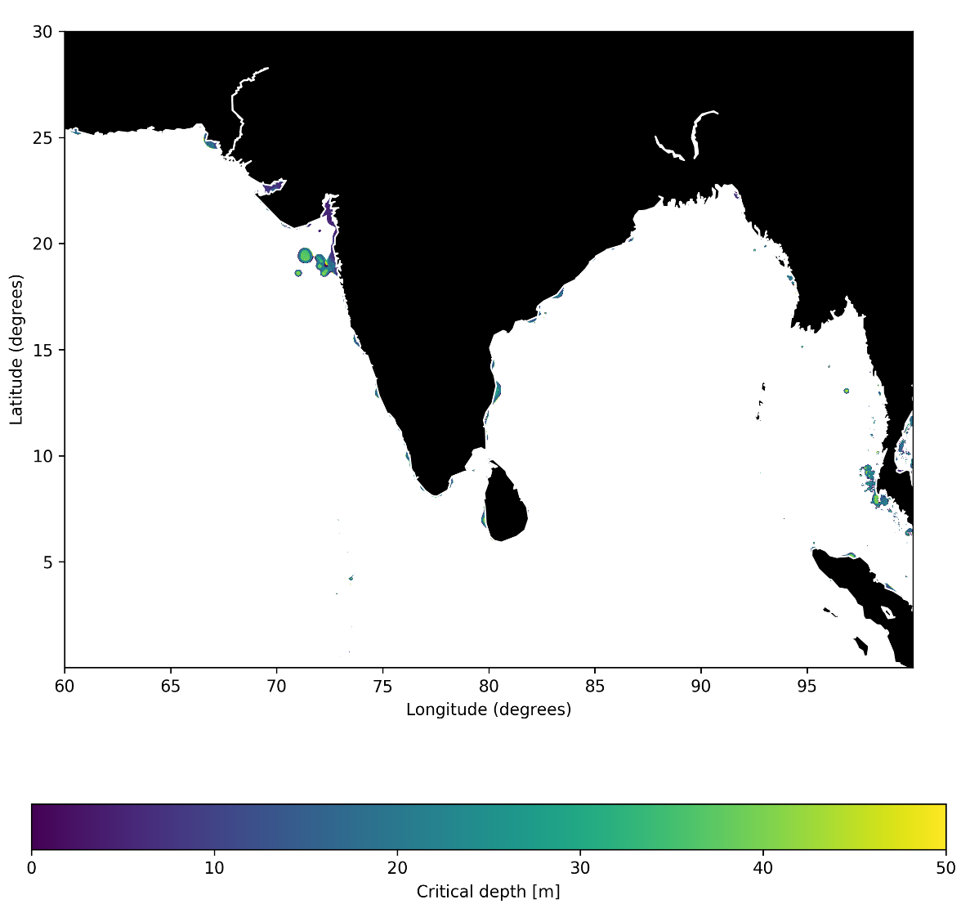
Figure S8. Critical depth (Z_{c}) for climatological May for northern Indian Ocean. Entire dataset can be downloaded in netCDF format from Pangaea (https://doi.pangaea.de/10.1594/PANGAEA.929749).
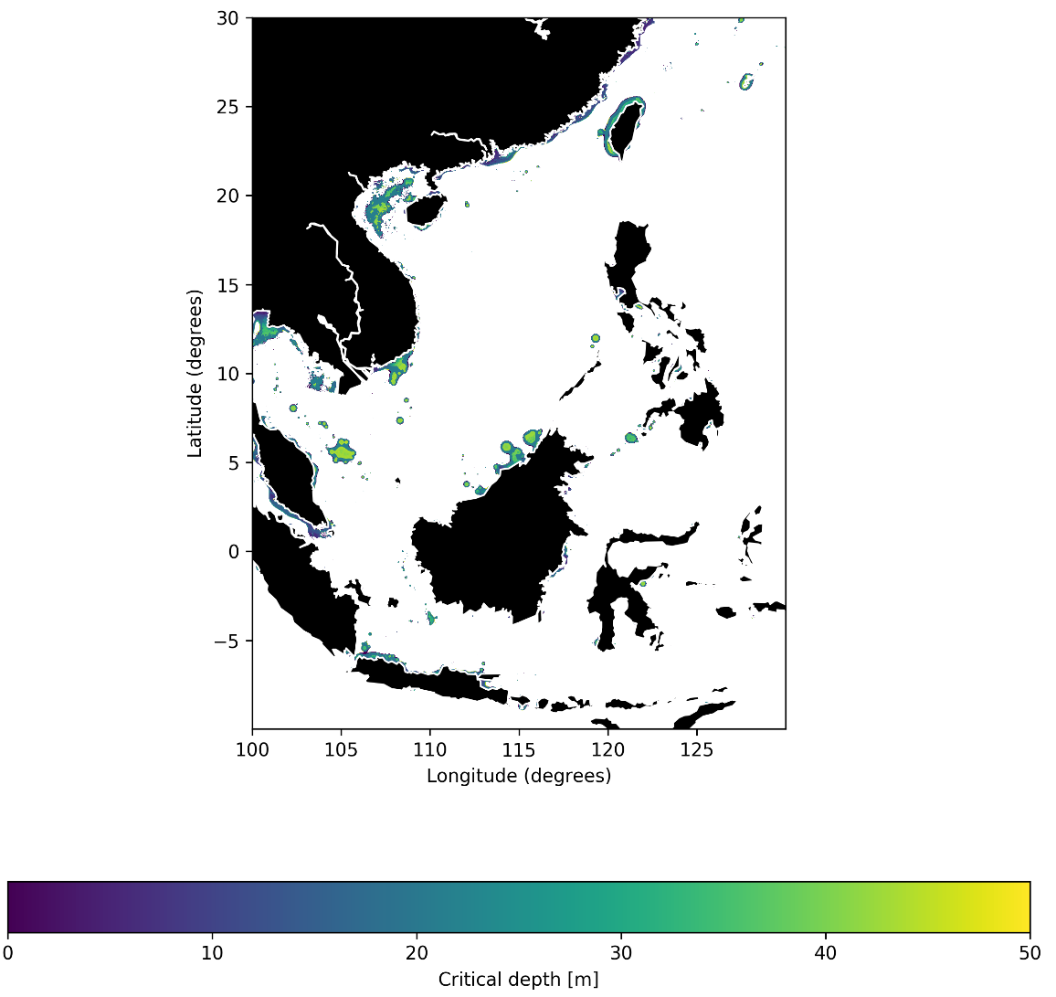
Figure S9. Critical depth (Z_{c}) for climatological May for Southeast Asia. Entire dataset can be downloaded in netCDF format from Pangaea (https://doi.pangaea.de/10.1594/PANGAEA.929749).
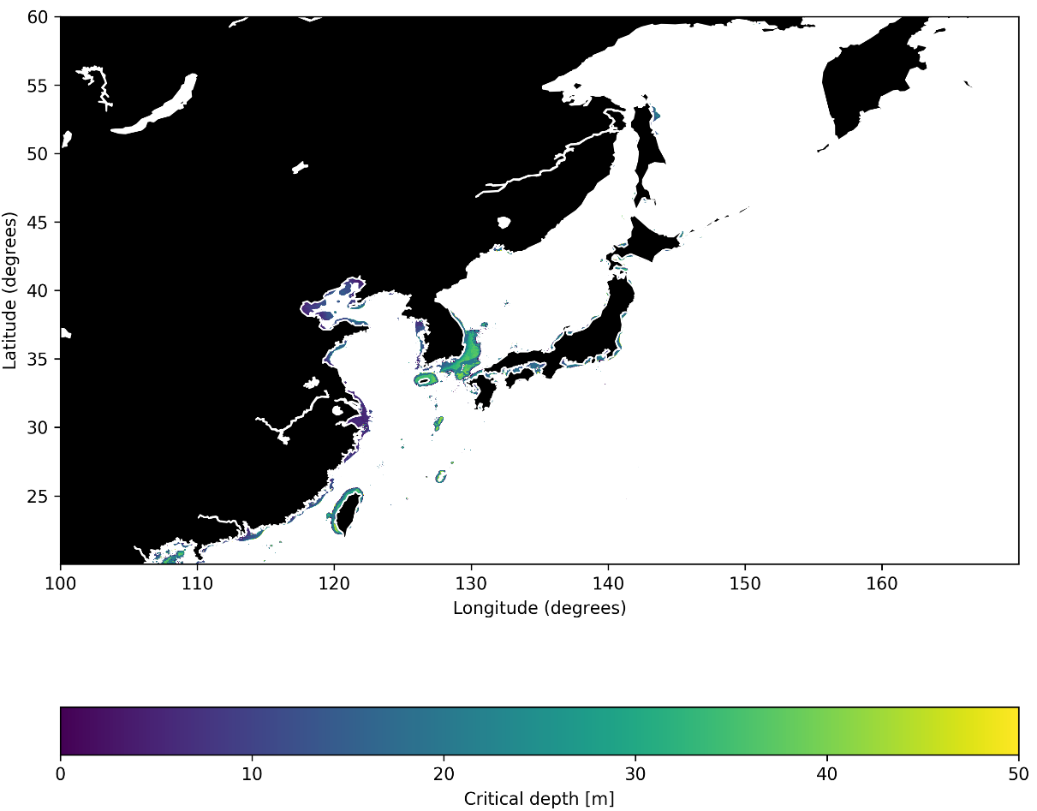
Figure S10. Critical depth (Z_{c}) for climatological May for northwest Pacific Ocean. Entire dataset can be downloaded in netCDF format from Pangaea (https://doi.pangaea.de/10.1594/PANGAEA.929749).
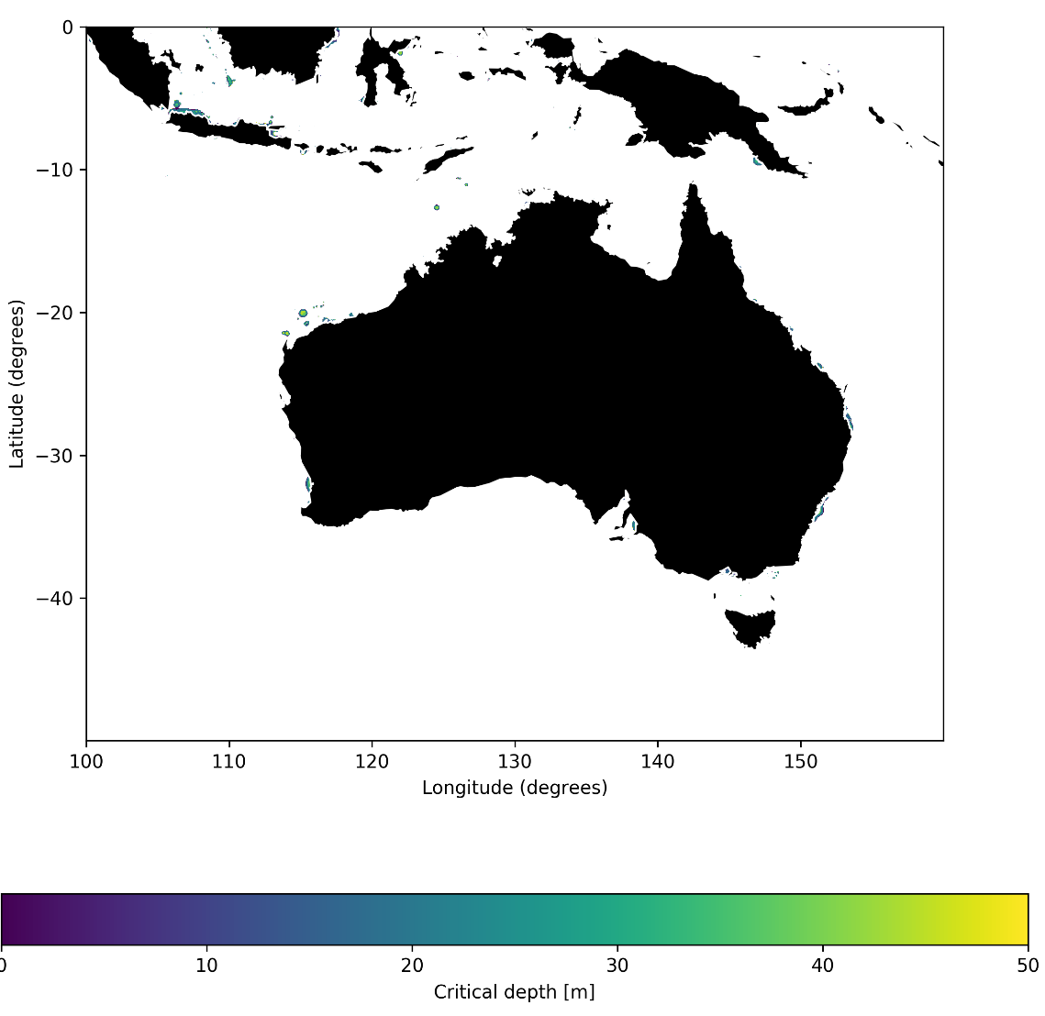
Figure S11. Critical depth (Z_{c}) for climatological May for Australia and southeast Asia Island chains. Entire dataset can be downloaded in netCDF format from Pangaea (https://doi.pangaea.de/10.1594/PANGAEA.929749)

