Supporting Information for
Seasonal marine carbon system processes in an Arctic coastal landfast sea ice environment observed with an innovative underwater sensor platform

P. J. Duke^{1,2}, B. G. T. Else¹, S. F. Jones¹, S. Marriot¹, M. M. M. Ahmed¹, V. Nandan^{1,3}, B. Butterworth^{1,4}, S. F. Gonski^{1,5}, R. Dewey⁶, A. Sastri^{7,8}, L. A. Miller⁸, K. G. Simpson⁸, H. Thomas^{9,10}

¹Department of Geography, University of Calgary, Calgary, AB, CA.
²School of Earth and Ocean Sciences, University of Victoria, Victoria, BC, CA.
³Centre for Earth Observation Science, University of Manitoba, Winnipeg, MB, CA.
⁴Department of Atmospheric and Oceanic Sciences, University of Wisconsin–Madison, Madison, WI, US.
⁵School of Marine Science and Policy, University of Delaware, Lewes, DE, USA.
⁶Ocean Networks Canada, University of Victoria, Victoria, BC, CA.
⁷Department of Biology, University of Victoria, Victoria, BC, CA.
⁸Institute of Ocean Sciences, Fisheries and Oceans Canada, Sidney, BC, CA.
⁹Department of Oceanography, Dalhousie University, Halifax, NS, CA.
¹⁰Helmholtz Center Geesthacht, Institute of Coastal Research, Geesthacht, Germany

Corresponding author: Patrick J. Duke (pjduke@ucalgary.ca)
https://orcid.org/0000-0001-9189-5134

Contents of this file
Text S1 to S2
Table S1 to S3
Figure S1

Introduction
This supporting information contains details of the discrete sampling (Text S1), as well as definitions of the seasonal transitions during the 2016–2017 deployment (Text S2), three extended tables, and two extended figures.

Text S1. Discrete sampling details
We collected discrete samples at ONC through all three deployments (Table S1). The sampling timetable for the oceanographic setting of the transect sites roughly corresponded to the ONC sampling during the 2016–2017 and 2017–2018 deployments (Table S1). During the 2015–2016 deployment, sampling took place opportunistically with samples taken at the start of deployment, at the start and end of a separate field campaign in February–March, weekly through May and early June, and at recovery. During the 2016–2017 deployment, samples were taken roughly weekly from the end of January until the start of August, with an emphasis on winter coverage. During the 2017–2018 deployment, samples were taken nearly monthly from September deployment to June recovery.
In determining the spatial and temporal representation of the ONC platform relative to the greater oceanography of CB, complete water column conductivity-temperature-depth (CTD) casts were taken throughout the year along a transect reaching further into the bay. CTD measurements were taken along a six station transect (Figure 1) in conjunction with the ONC sensor evaluation time series starting during the 2016–2017 deployment (Table S2). The CTD time series and additional discrete samples also provided a reference of conditions further offshore and near the seafloor. The B1 site was selected as it represents near maximum depth of CB (Figure 1). Intermediate sites were chosen collectively to represent different depths and cover spatial variability between the two water sampling sites in the bay (Figure 1). The steep drop from the shoreline into the deep basin of the bay happens quickly near shore. We clustered stations closer together in shallower waters, with MB at the midpoint between the ONC and B1 site, and CTD-3 at the midpoint between MB and B1 (Figure 1).
Discrete sampling to understand the broader chemical oceanographic context of the ONC site included depths of 2, 7, 30, and 70 m at station B1 further into the bay (0.65 km), as well as 2-m depth at the ONC platform location (Table S2). The 2-m depth was chosen as representative of the ocean/sea-ice interface. We shifted this depth to 0.5 m following ice breakup to better capture the surface ocean during the open water season. At B1, we also sampled at 7 m for comparability to the ONC platform sensor depth, while 30- and 70-m depths were sampled to capture deep waters below the pycnocline and near the seafloor (Lewis and Walker, 1970).

Text S2. Definitions of seasonal transitions used in the text
Investigating seasonally driven biogeochemical cycles can be facilitated by defining seasonally specific time intervals. Sea-ice draft from the ASL Shallow Water Ice Profiler, in conjunction with photosynthetically active radiation (PAR) from the WETLabs ECO-PARS sensor, both onboard the ONC platform (Table 1), served as proxy variables to differentiate seasonal endpoints (Table S3).
The “fall” period was defined as the interval from the platform deployment (28 Aug 2016) until the beginning of sea-ice freeze-up (4 Oct 2016) (Table S3), defined as the first date of reported sea ice in CB by the Candian Ice Sevice (CIS). “Early winter” was defined as beginning on this freeze-up date and ending when the light available under the ice first increased above 2 µmol m⁻² s⁻² (28 Feb 2017). We chose this value because it has been reported as the lower limit of ice algal compensation light intensities (Gosselin et al., 1986; Horner & Schrader, 1982). Ice algae are commonly thought to be the first algal bloom taking place in Arctic ice-covered seas as light returns at the end of winter (Leu et al., 2015). The actual polar sunrise in Cambridge Bay was 11 Jan 2017. “Late winter” was from under-ice “sunrise” until the sea ice reached a maximum thickness (24 May 2017), before the onset of net melt (Table S3). The “spring” interval ranged from the date of maximum sea-ice thickness until the first occurrence of a zero sea-ice draft measurement at the platform (27 Jun 2017) (Table S3), at which point we assumed the ice pack in CB had broken up and become mobile. “Summer” was defined as from the spring endpoint until the end of the deployment (2 Sept 2017) (Table S3). Unfortunately, due to failure of the CO2-Pro S/N 36-314-75 coincidentally on 27 Jun 2017, carbon system parameters were not available for summer interpretation.

Supplementary figure titles and legends

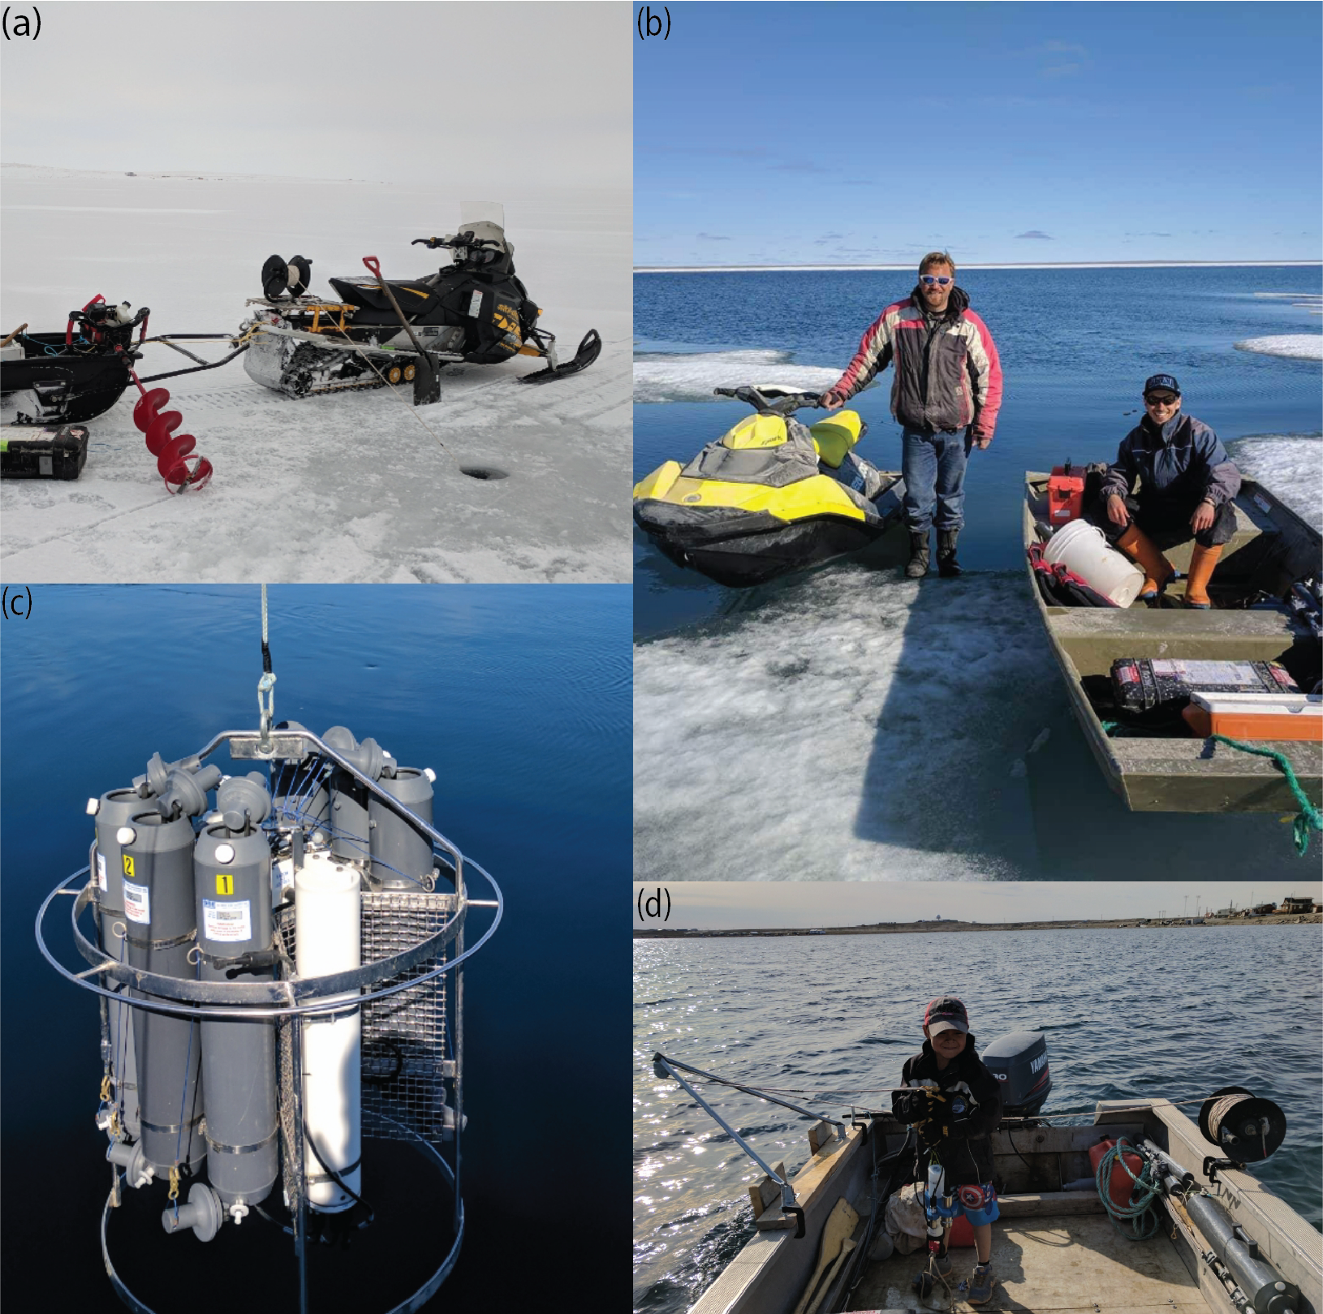
Figure S1. Seasonal discrete sampling methods.
(a) Winter, involving deployment through a hole in the ice; (b) spring, using small vessels; (c) summer, using a conductivity-temperature-depth/Niskin bottle rosette deployed from the RV Martin Bergmann; and (d) fall, again using small vessels.

Supplementary tables
Table S1. Discrete sampling dates (day-month-year) for carbon system sensor evaluations at the ONC site, which included dates covering the 2015, 2016, and 2017 ONC platform deployments.
Sampling season | Deployment year
 | 2015–2016 | 2016–2017 | 2017–2018
Fall | 28-08-2015 | 25-08-2016 | 14-09-2017
Early winter | 16-02-2016 | 28-01-2017, 02-02-2017 | 10-10-2017, 31-10-2017, 05-02-2018
Late winter | 13-03-2016, 15-05-2016, 22-05-2016 | 18-03-2017, 01-04-2017, 14-04-2017, 30-04-2017, 16-05-2017 | 18-05-2018
Spring | 28-05-2016, 08-06-2016 | 09-06-2017, 12-06-2017, 17-06-2017, 24-06-2017 | 04-06-2018, 18-06-2018
Summer | 25-08-2016 | 10-07-2017, 20-07-2017, 01-08-2017 | 24-11-2017
Table S2. CB transect sampling details, including station name, depth, geographic location, and sampling activities conducted.
Station information |  |  |  | DIC/TA discrete sampling depths (m)
Name | Depth (m) | Latitude (°N) | Longitude (°W)
ONC | 7 | 69.113 | 105.064 | surface, 7
CTD-1 | 21 | 69.112 | 105.064 | CTD cast only
CTD-2 | 34 | 69.111 | 105.062 | CTD cast only
MB | 52 | 69.110 | 105.062 | CTD cast only
CTD-3 | 65 | 69.109 | 105.061 | CTD cast only
B1 | 72 | 69.108 | 105.060 | surface, 7 , 30, 71
Table S3. Seasonal definitions, including dates that indicate the start (and end) of each seasonal time interval for the 2016–2017 ONC platform deployment (Text S2).
Defining feature | Fall | Early winter | Late winter | Spring | Summer
Number of days | 45 | 142 | 85 | 34 | 67ª
Start date (day-month-year) | 25-08-2016 | 09-10-2016 | 28-02-2017 | 24-05-2017 | 27-06-2017ª
Sea-ice condition | Open water (platform deployed) | First sea ice reported by CIS | Sunrise (PAR ≥ 2.0 µmol m⁻² s⁻¹) | Maximum sea-ice thickness | Mobile sea ice (0 sea-ice draft at platform)
ªPlatform recovered on 02-09-2017.

