Supplemental material

Top-down estimates of anthropogenic VOC emissions in South Korea using formaldehyde vertical measurements from aircraft during the KORUS-AQ campaign

Hyeong-Ahn Kwon¹, Rokjin J. Park^{1*}, Yujin J. Oak¹, Caroline R. Nowlan², Scott J. Janz³, Matthew G. Kowalewski³, Alan Fried⁴, James Walega⁴, Kelvin H. Bates⁵, Jinkyul Choi⁴, Donald R. Blake⁶, Armin Wisthaler^{7, 8}, and Jung-Hun Woo⁹

¹School of Earth and Environmental Science, Seoul National University, Seoul, Republic of Korea
²Atomic and Molecular Physics Division, Harvard-Smithsonian Center for Astrophysics, Cambridge, MA, USA
³Atmospheric Chemistry and Dynamics Laboratory, NASA Goddard Space Flight Center, Greenbelt, MD, USA
⁴Institute for Arctic and Alpine Research, University of Colorado, Boulder, CO, USA
⁵John A. Paulson School of Engineering and Applied Sciences, Harvard University, Cambridge, MA, USA
⁶Department of Chemistry, University of California at Irvine, Irvine, CA, USA
⁷Department of Chemistry, University of Oslo, Oslo, Norway
⁸Institute for Ion Physics and Applied Physics, University of Innsbruck, Innsbruck, Austria
⁹Department of Advanced Technology Fusion, Konkuk University, Seoul, Republic of Korea

*Corresponding author’s email: Rokjin J. Park (rjpark@snu.ac.kr)

List of Contents:

Tables:
Table S1. Limit of detection, precision, and accuracy for VOC measurements used in this study.
Table S2. VOC speciation of KORUS v5 and GEOS-Chem, KORUS v5 emissions in South Korea, and the VOC species used in top-down emission estimates.
Table S3. Chemical species for ethene chemistry in GEOS-Chem.
Table S4. Added kinetic and photolysis reactions for ethene chemistry in GEOS-Chem.
Table S5. The one-day HCHO yields per carbon for VOC species used for top-down estimates.

Figures:
Figure S1. Spatial distributions of VOC species in DC-8 observations below 2 km.
Figure S2. Spatial distributions of VOC species in the model using the bottom-up inventory below 2km.
Figure S3. Differences between the model and DC-8 (Fig. S2 – Fig. S1) below 2 km.

Table S1. Limit of detection, precision, and accuracy for VOC measurements used in this study.
Measurement | Species |  | LOD (pptv) | Precision (%) | Accuracy (%) | Reference
CAMS | HCHO |  | 28–80 | 28–80 pptv | 6 | Fried et al. (2020)
WAS | Aromatics | Benzene | 3 | 3 | 3 | Simpson et al. (2020)
 |  | Toluene
 |  | m/p Xylene
 |  | o-Xylene
 | Alkanes | Ethane | 3 | 1 | 5 | Simpson et al. (2020)
 |  | Propane | 3 | 2 | 5 | Simpson et al. (2020)
 |  | n-Butane | 3 | 3 | 5 | Simpson et al. (2020)
 |  | i-Butane
 |  | n-Pentane
 |  | i-Pentane
 |  | n-Heptane
 |  | n-Octane
 |  | n-Nonane
 |  | n-Decane
 | Alkenes | Ethene | 3 | 3 | 5 | Simpson et al. (2020)
 |  | Propene
 |  | 1-Butene
 |  | cis-2-Butene
 |  | trans-2-Butene
 |  | i-Butene
PTR-MS  (1 Hz) | Acetaldehyde |  | 85 | 122 pptvª | 10 | Simpson et al. (2020)
 | Acetone |  | 50 | 90 pptvª | 20
 | Methyl Ethyl Ketone (MEK) |  | 32 | 87 pptvª | 10 | Simpson et al. (2020)
 | Isoprene |  | 50 | 350 pptvª | 10
 | Methanol |  | 315 | 418 pptvª | 10 | Simpson et al. (2020)
ª The precision is estimated at 3 ppbv.

Table S2. VOC speciation of KORUS v5 and GEOS-Chem, KORUS v5 emissions in South Korea, and the VOC species used in top-down emission estimates.
Species | KORUS v5 inventory | Emission  (moles s⁻¹) | GEOS-Chem | Use in top-down estimates^{c}
Acetone | ACET | 1.6 | ACET | O
Alkanes, kOHª < 500 | ALK1 | 32 | Ethane (C₂H₆) | O
Alkanes, 500 < kOH < 2500 | ALK2 | 28 | Propane (C₃H₈) | O
Alkanes, 2500 < kOH < 5000 | ALK3 | 15 | ≥ C4 alkanes (ALK4) | O
Alkanes, 5000 < kOH < 10000 | ALK4 | 35 | ≥ C4 alkanes (ALK4) | O
Alkanes, kOH > 10000 | ALK5 | 37 | ≥ C4 alkanes (ALK4) | O
Aromatics, kOH < 2 × 10⁴ | ARO1 | 101 | Benzene^{b}  Toluene^{b} | O
Aromatics, kOH > 2 × 10⁴ | ARO2 | 43 | Xylene (XYLE) | O
Acetaldehyde | CCHO | 3.7 | ALD2 | O
Ethene | ETHE | 76 | C₂H₄ | O
Glyoxal | GLY | 0.92 | GLYX
Formaldehyde | HCHO | 9.7 | HCHO | O
Isoprene | ISOP | 1.7 | ISOP | O
Methacrolein | MACR | 0.17 | MACR
Methyl ethyl ketone | MEK | 2.2 | MEK | O
Methanol | MEOH | 2.9 | MOH | O
Methylglyoxyal | MGLY | 0.35 | MGLY
Methylvinylketone | MVK | 0.015 | MVK
Alkenes, kOH < 7 × 10⁴ | OLE1 | 24 | ≥ C3 alkenes (PRPE) | O
Alkenes, kOH > 7 × 10⁴ | OLE2 | 26 | ≥ C3 alkenes (PRPE) | O
≥ C3 aldehyde | RCHO | 1.4 | RCHO
Phenol | PHEN | 0.10
Cresols | CRES | 0.26
Terpenes | TERP | 0.065
Biacetyl | BACL | 0.1
Aromatic aldehyde | BALD | 0.093
Ketones (kOH > 0.73 × 10⁴) | PRD2 | 0.27
Other unsaturated aldehydes | IPRD | 0.053
ª unit is ppm⁻¹ min⁻¹
^{b} Benzene emissions are 0.07 times ARO1, and toluene emissions are 0.7 times ARO1.
^{c} “O” indicates species used in top-down estimates.

Table S3. Chemical species for ethene chemistry in GEOS-Chem.
Species | Description
C₂H₄ | Ethene (ethylene)
CH₂OO | Criegee intermediate
ETOO | Hydroxy-peroxy radical, formed from ethene + OH
ETO | Hydroxy-alkoxy radical, formed from ethene + OH
ETHP | Stable hydroxy-hydroperoxy-ethane
ETHN | Stable hydroxy-nitrooxy-ethane
GLYC | Glycolaldehyde
CH₃OOH | Methylhydroperoxide

Table S4. Added kinetic and photolysis reactions for ethene chemistry in GEOS-Chem†.
Reactant |  | Product(s) | Rateª
Ozone reaction
C₂H₄ + O₃ | $$→$$ | HCHO + CH₂OO | GCARR(9.10E-15, 0.0E+00, -2580.0)
OH reaction
C₂H₄ + OH | $$→$$ | ETOO | GCJPLPR(1.10E-28, 3.5E+00, 0.0, 8.4E-12, 1.75, 0.0, 0.5, 0.0, 0.0)
ETOO + HO₂ | $$→$$ | ETHP | GCARR(1.53E-13, 0.0E+00, 1300.0)
ETOO + NO | $$→$$ | 0.995ETO + 0.995NO₂ + 0.005ETHN | GCARR(2.7E-12, 0.0E+00, 360.0)
ETOO + NO₃ | $$→$$ | ETO + NO₂ | 2.30E-12
ETOO + MO₂ | $$→$$ | 0.6ETO + 0.6HO₂ + 0.8HCHO + 0.2MOH + 0.2ETHP + 0.2GLYC | 6.00E-13
ETO | $$→$$ | HO₂ + 2HCHO | GCARR(9.5E-13, 0.0E+00, -5988.0)
ETO + O₂ | $$→$$ | GLYC + HO₂ | GCARR(2.5E-14, 0.0E+00, -300.0)
ETHN + OH | $$→$$ | GLYC + NO₂ | 8.40E-13
ETHP + OH | $$→$$ | ETOO | GCARR(1.90E-12, 0.0E+00, 190.0)
ETHP + OH | $$→$$ | OH + GLYC | 1.38E-11
ETHP + $hν$ | $$→$$ | ETO + OH | CH₃OOH photolysis rate
†Please see the GEOS-Chem website (http://wiki.seas.harvard.edu/geos-chem/index.php/GEOS-Chem_chemistry_mechanisms) for rate formula descriptions and additional reactions not listed here.
ª GEOS-Chem reaction rate functions (cm³ molecules⁻¹ s⁻¹ or s⁻¹) and photolysis rate (s⁻¹).

Table S5. The one-day HCHO yields per carbon for VOC species used for top-down estimates.
Species | HCHO yields per carbon | References
Acetone (ACET) | 0.037 | Stavrakou et al. (2009)
Ethane (C₂H₆) | 0.05 | Dufour et al. (2009)
Propane (C₃H₈) | 0.01 | Stavrakou et al. (2009)
≥ C4 alkanes (ALK4) | 0.15 | Dufour et al. (2009)
Toluene (TOLU) | 0.17 | Zhu et al. (2014)
Xylene (XYLE) | 0.23 | Dufour et al. (2009)
Acetaldehyde (ALD2) | 0.49 | Dufour et al. (2009)
Ethene (C₂H₄) | 0.83 | Dufour et al. (2009)
Isoprene (ISOP) | 0.47 | Dufour et al. (2009)
Methyl ethyl ketone (MEK) | 0.22 | Dufour et al. (2009)
Methanol (MOH) | 0.38 | Dufour et al. (2009)
≥ C3 alkenes (PRPE) | 0.61 | Dufour et al. (2009)

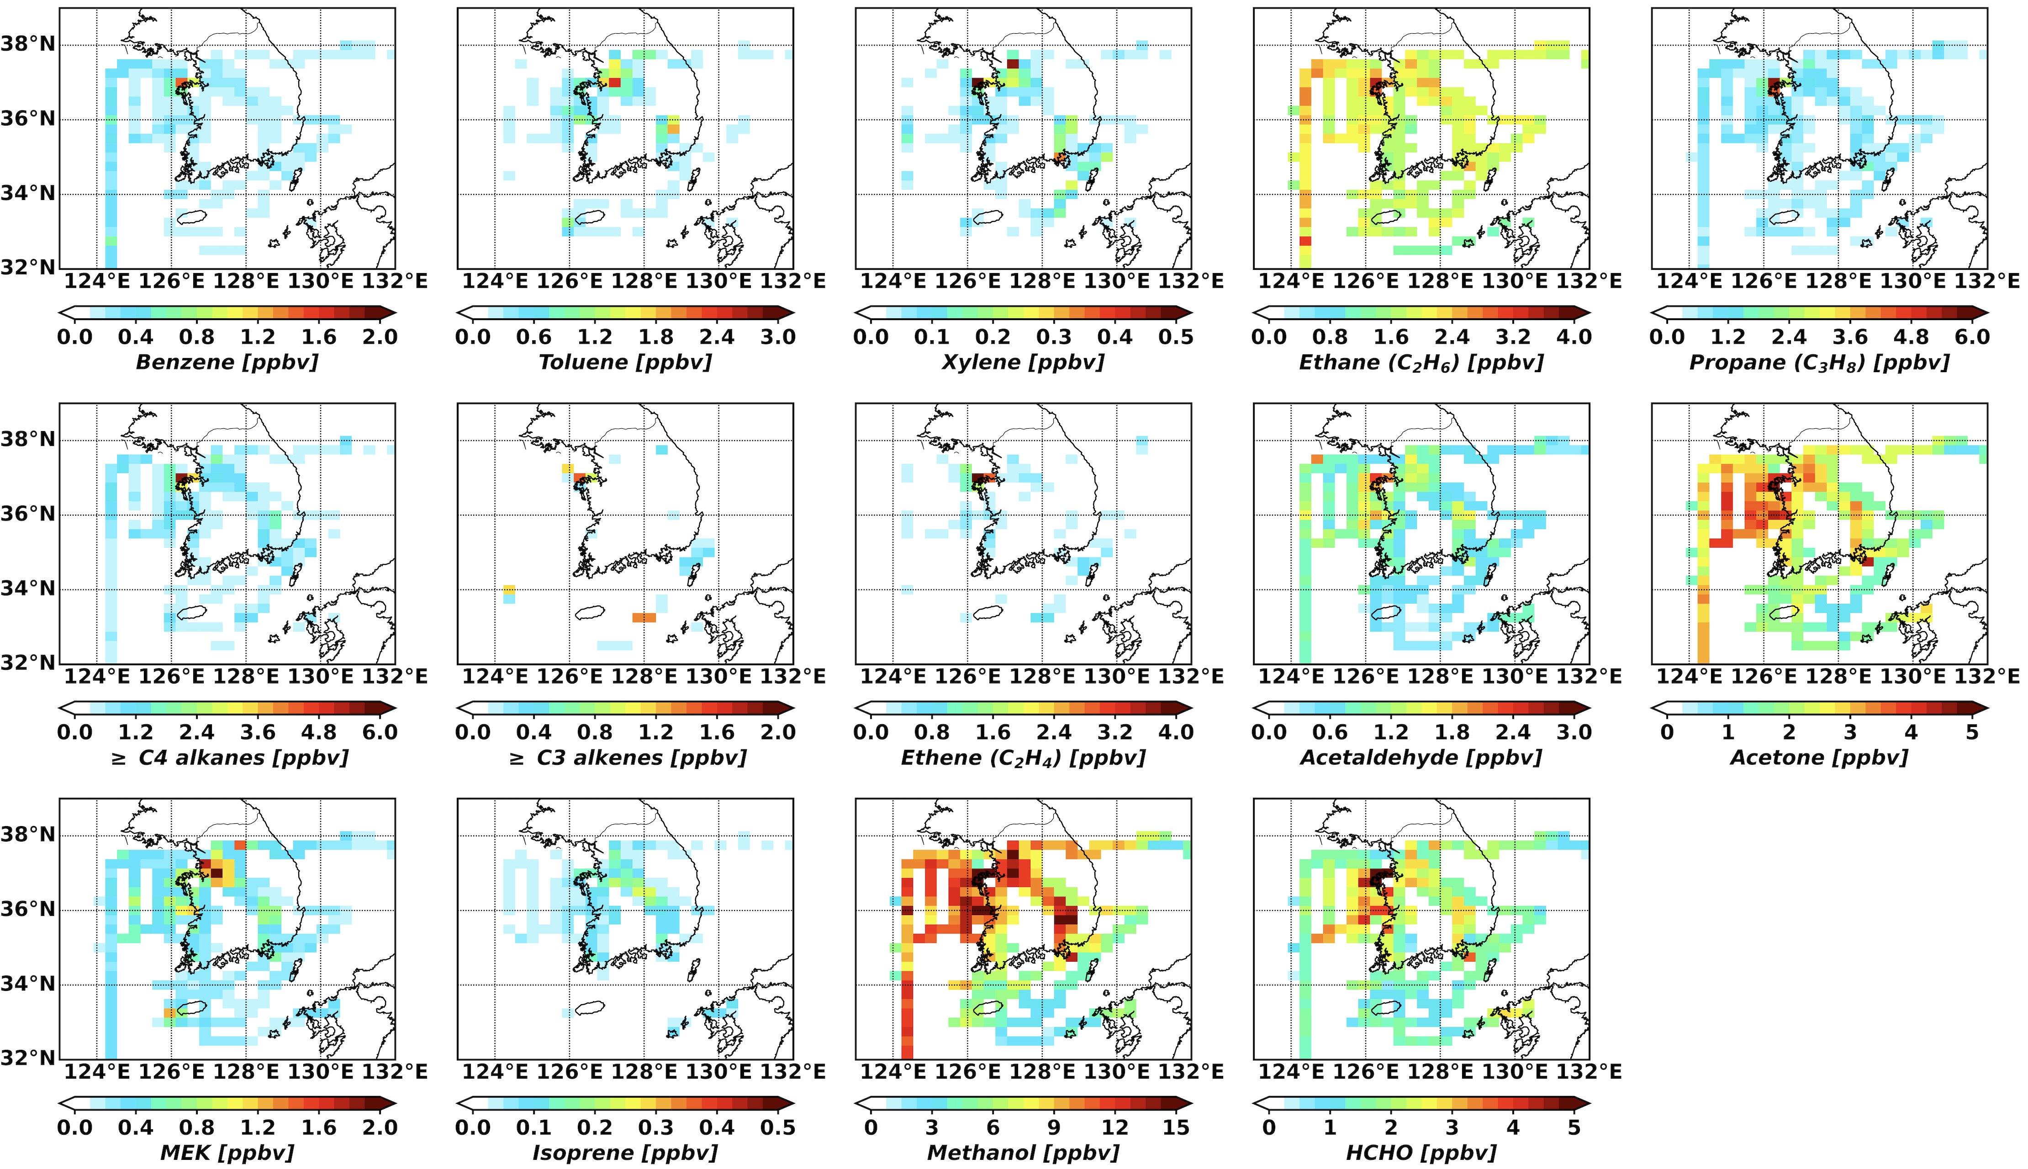
Figure S1. Spatial distributions of VOC species in DC-8 observations below 2 km.

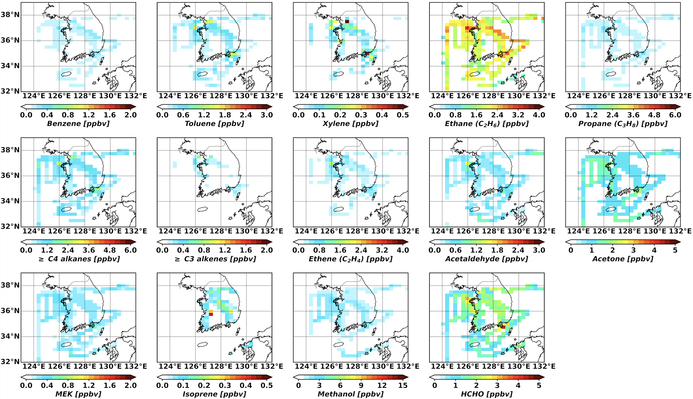
Figure S2. Spatial distributions of VOC species in the model using the bottom-up inventory below 2km.

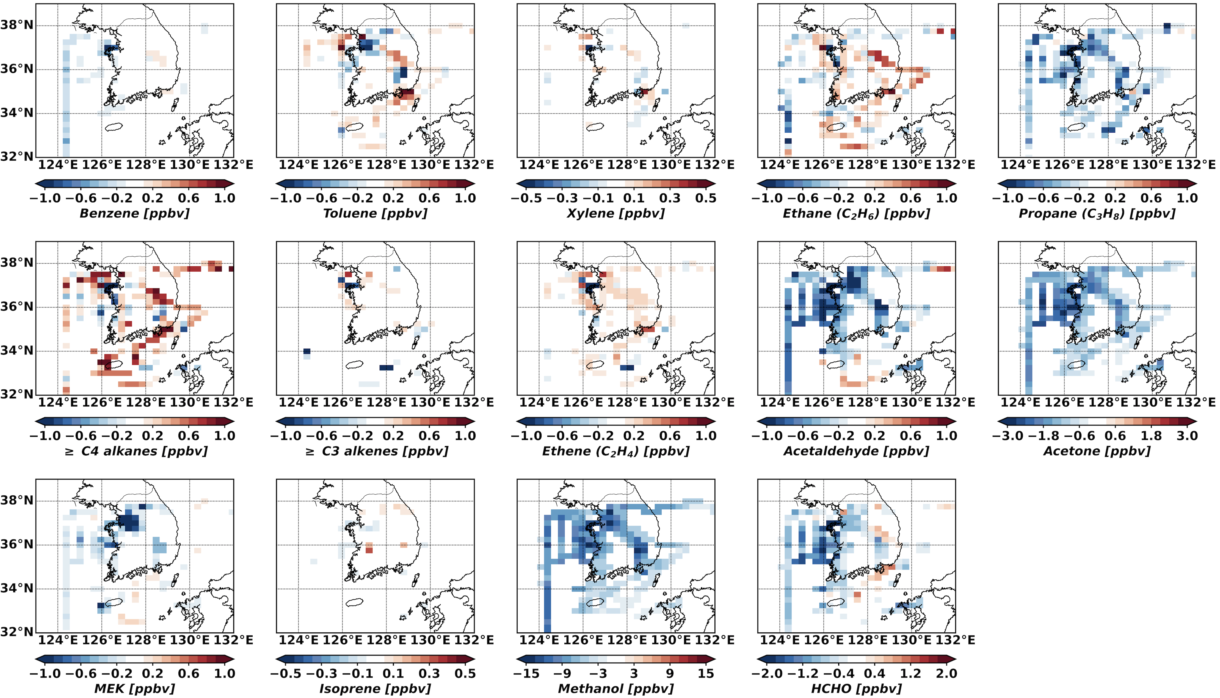
Figure S3. Differences between the model and DC-8 (Fig. S2 – Fig. S1) below 2 km.

