Supplementary material
Protist communities along freshwater-marine transition zones in Hudson Bay (Canada)
Jacquemot Loïc^{1,2}, Dimitri Kalenitchenko^{1,2}, Lisa C. Matthes³, Adrien Vigneron^{1,2}, Christopher J. Mundy³, Jean-Éric Tremblay ¹, and Connie Lovejoy^{1,2}.
- Département de Biologie, Université Laval, Québec, QC, Canada.
- Institut de Biologie Intégrative et des Systèmes (IBIS), Université Laval, Québec, QC, Canada.
- Centre for Earth Observation Science, University of Manitoba, Winnipeg, Manitoba, Canada.

Corresponding author: Loïc Jacquemot (loic.jacquemot42@gmail.com)

List of Contents:
Table S1. Station information on depth, location and time of sampling.
Table S2. Relative proportion (%) of Fungi in rDNA sequences based on total rDNA reads for each station.
Table S5. Significant indicator OTUs of offshore Groups 1, 2 and 3.
Figure S1. Potential temperature and salinity diagram of the Nelson and Churchill river waters. Grey lines are isopycnals with potential density anomalies in kg m^{–3}.
Figure S2. Nutrient concentrations along the Churchill, Nelson and Great Whale river systems.
Figure S3. Non-metric multidimensional scaling (NMDS) clustering of 37 stations along the three river systems. Clustering is based on a Bray-Curtis distance matrix of 6010 rDNA OTUs. Stress = 0.089. Symbols represent group as defined in the db-MRT analysis (Figure 4).
Figure S4. Proportion of rDNA 18S sequences along the transects of the Nelson, Churchill and Great Whale river systems.
Figure S5. Proportion of rRNA 18S sequences along the transects of the Nelson, Churchill and Great Whale river systems.
Figure S.6: Proportion of 18S sequences at surface stations assigned to heterotrophic taxa and Micromonas OTUs. A) percent of rDNA (top panel) and rRNA (bottom panel) sequences of Rhizaria, Telonemia and Katablepharidales in the three river systems. B) Proportion of 18S rDNA sequences assigned to Micromonas at the offshore Great Whale River station (GW-C).
Figure S7. Proportion of 18S rDNA and rRNA sequences at surface stations assigned to Ciliates in the three river systems.
Figure S8. Phylogenetic mapping of the most abundant Thalassiosira reads. The reference phylogenetic tree was constructed using maximum likelihood from an alignment of 24 sequences of 1167 characters. Short V4 18S rRNA reads were mapped onto the nodes marked with a red circle using the RAxML evolutionary placement algorithm; five short reads sequences (OTU 36, 2229, 970, 3018 and 4558) were placed. Only placements with null uncertainty (EDPL value of 0) were plotted (here OTU 970).
Figure S9. Phylogenetic mapping of the most abundant Skeletonema reads. The reference phylogenetic tree was constructed using maximum likelihood from an alignment of 14 sequences of 1161 characters. Short V4 18S rRNA reads were mapped onto the nodes marked with a red circle using the RAxML evolutionary placement algorithm; five short reads sequences were placed (OTU 3506, 2433, 643, 7273, 8016) on the same node (1). The five sequences had null uncertainty (EDPL value of 0) and were placed on the branch associated to S. potamos.
Figure S10. Phylogenetic mapping of the most abundant Rhizosolenia reads. The reference phylogenetic tree was constructed using maximum likelihood from an alignment of 25 sequences of 1182 characters. Short V4 18S rRNA reads were mapped onto the nodes marked with red symbols using the RAxML evolutionary placement algorithm; ten short reads sequences (OTU 184, 403, 14868, 145, 1962, 1595, 17969, 5788, 7592 and 2535) were placed. The triangle symbol corresponds to the best placement of OTUs 184 and 17969 (EDPL < 0.003). The circle symbol corresponds to the other OTUs (OTU 403, 14868, 145, 1962, 1595, 5788, 7592 and 2535, EDPL = 0).
Figure S11. Rhizosolenia cells observed on confocal laser scanning microscope. Red color represents chlorophyll a under blue laser excitation (488 nm). (A) sample from station NE-45 bottom (magnification 40X, zoom at 1.28); (B) sample from station NE-WE1 bottom (magnification 40X, zoom at 1.69). Images credited to Marianne Potvin.

Table S1. Station information on depth, location and time of sampling.
Stationª | Depth (m) | System | Latitude | Longitude | Date | Time | Sampling by | DNA^{b} | RNA^{b}
CH-A | Surface (0) | Churchill | 58.678 | –94.203 | 18-06-28 | 20h30 | Helicopter | 2 | 1
CH-B | Surface (0) | Churchill | 58.76 | –94.199 | 18-07-04 | 10h33 | Barge/Zodiac | 1 | 1
CH-B | Bottom (4) | Churchill | 58.76 | –94.199 | 18-07-04 | 10h33 | Barge/Zodiac | 1 | 1
CH-C | Surface (0) | Churchill | 58.802 | –94.193 | 18-07-04 | 13h40 | Barge/Zodiac | 1 | 1
CH-C | Bottom (7) | Churchill | 58.802 | –94.193 | 18-07-04 | 13h40 | Barge/Zodiac | 1 | 1
CH-D | Surface (0) | Churchill | 58.867 | –94.001 | 18-07-04 | 12h41 | Barge/Zodiac | 1 | 1
CH-D | Bottom (7) | Churchill | 58.867 | –94.001 | 18-07-04 | 12h41 | Barge/Zodiac | 1 | 1
CH-E | Surface (0) | Churchill | 58.934 | –93.797 | 18-07-04 | 11h53 | Barge/Zodiac | 1 | 1
CH-E | Bottom (7) | Churchill | 58.934 | –93.797 | 18-07-04 | 11h53 | Barge/Zodiac | 1 | 1
GW-A | Surface (0) | GWR | 77.729 | 304.729 | 17-07-07 | 17h30 | River edge | 2 | 1
GW-B | Surface (0) | GWR | 77.793 | 304.711 | 17-07-07 | 21h30 | Barge/Zodiac | 2 | 3
GW-C | Surface (0) | GWR | 77.992 | 304.612 | 17-07-07 | 23h51 | Ship | 2 | 1
GW-C | SCM (27) | GWR | 77.992 | 304.612 | 17-07-07 | 23h51 | Ship | 2 | 1
HA-A | Surface (0) | Nelson | 56.996 | –92.292 | 18-06-18 | 20h50 | Helicopter | 1 | 1
NE-45 | Surface (0) | Nelson | 57.241 | –91.956 | 18-06-30 | 9h30 | Ship | 2 | 2
NE-45 | Bottom (10) | Nelson | 57.221 | –91.956 | 18-06-30 | 10h00 | Ship | 1 | 1
NE-46 | Surface (0) | Nelson | 57.503 | –91.813 | 18-07-01 | 11h20 | Ship | 1 | 1
NE-46 | SCM (11) | Nelson | 57.503 | –91.813 | 18-07-01 | 11h20 | Ship | 1 | 1
NE-A | Surface (0) | Nelson | 56.966 | –92.631 | 18-06-18 | 18h55 | Helicopter | 1 | 1
NE-B | Surface (0) | Nelson | 57.056 | –92.531 | 18-06-29 | 11h00 | Barge/Zodiac | 1 | 1
NE-C | Surface (0) | Nelson | 57.116 | –92.421 | 18-06-29 | 13h00 | Barge/Zodiac | 1 | 1
NE-D | Surface (0) | Nelson | 57.206 | –92.282 | 18-06-30 | 12h00 | Barge/Zodiac | 1 | 1
NE-D | Bottom (5) | Nelson | 57.206 | –92.282 | 18-06-30 | 12h00 | Barge/Zodiac | 1 | 1
NE-E | Surface (0) | Nelson | 57.222 | –92.294 | 18-06-30 | 17h00 | Barge/Zodiac | 1 | 1
NE-E | Bottom (7) | Nelson | 57.222 | –92.294 | 18-06-30 | 17h00 | Barge/Zodiac | 1 | 1
NE-WE1 | Surface (0) | Nelson | 57.398 | –92.073 | 18-07-01 | 9h00 | Ship | 1 | 1
NE-WE1 | Bottom (7) | Nelson | 57.398 | –92.073 | 18-07-01 | 9h00 | Ship | 1 | 1
NE-WE2 | Surface (0) | Nelson | 57.396 | –91.976 | 18-07-01 | 9h00 | Ship | 1 | 1
NE-WE2 | Bottom (7) | Nelson | 57.396 | –91.976 | 18-07-01 | 9h00 | Ship | 1 | 1
NE-WE3 | Surface (0) | Nelson | 57.394 | –91.866 | 18-07-01 | 9h00 | Ship | 1 | 1
NE-WE3 | Bottom (7) | Nelson | 57.394 | –91.866 | 18-07-01 | 9h00 | Ship | 1 | 1
ª Station designations as in Figure 1 (main text)
^{b} Number of replicates

Table S2. Relative proportion (%) of Fungi in rDNA sequences based on total rDNA reads for each station.
Stationª | Depth | rDNA reads (%) | Chytridiomycota (%) | Cryptomycota (%) | Fungi, others (%) | Fungi unclassified (%)
NE-A | surface | 3.13 | 2.81 | 0.16 | 0.06 | 0.10
HA-A | surface | 3.03 | 0.14 | 2.61 | 0.12 | 0.16
NE-B | surface | 3.04 | 2.29 | 0.16 | 0.00 | 0.58
NE-C | surface | 2.01 | 1.62 | 0.03 | 0.01 | 0.34
NE-D | surface | 0.84 | 0.66 | 0.02 | 0.03 | 0.13
NE-D | bottom | 0.69 | 0.54 | 0.04 | 0.00 | 0.11
NE-E | surface | 0.42 | 0.22 | 0.07 | 0.02 | 0.11
NE-E | bottom | 0.13 | 0.04 | 0.01 | 0.00 | 0.08
NE-45 rep.1 | surface | 0.20 | 0.02 | 0.02 | 0.01 | 0.15
NE-45 rep.2 | surface | 0.20 | 0.03 | 0.03 | 0.00 | 0.15
NE-45 | bottom | 0.23 | 0.03 | 0.04 | 0.00 | 0.16
NE-WE1 | surface | 0.40 | 0.02 | 0.06 | 0.00 | 0.31
NE-WE1 | bottom | 0.08 | 0.00 | 0.01 | 0.01 | 0.05
NE-WE2 | surface | 0.10 | 0.00 | 0.02 | 0.00 | 0.08
NE-WE2 | bottom | 0.13 | 0.03 | 0.00 | 0.00 | 0.10
NE-WE3 | surface | 0.06 | 0.00 | 0.00 | 0.00 | 0.06
NE-WE3 | bottom | 0.09 | 0.01 | 0.00 | 0.00 | 0.08
NE-46 | surface | 0.12 | 0.00 | 0.00 | 0.00 | 0.12
NE-46 | bottom | 0.05 | 0.01 | 0.00 | 0.00 | 0.03
CH-A rep.1 | surface | 1.32 | 0.68 | 0.13 | 0.49 | 0.02
CH-A rep.2 | surface | 6.23 | 2.78 | 1.17 | 0.16 | 2.12
CH-B | surface | 1.32 | 0.73 | 0.41 | 0.01 | 0.16
CH-B | bottom | 0.38 | 0.15 | 0.09 | 0.04 | 0.10
CH-C | surface | 0.15 | 0.01 | 0.03 | 0.00 | 0.11
CH-C | bottom | 0.21 | 0.01 | 0.04 | 0.00 | 0.15
CH-D | surface | 0.53 | 0.00 | 0.05 | 0.00 | 0.47
CH-D | bottom | 0.04 | 0.00 | 0.00 | 0.00 | 0.04
CH-E | surface | 0.67 | 0.02 | 0.04 | 0.00 | 0.60
CH-E | bottom | 0.52 | 0.04 | 0.00 | 0.00 | 0.48
GW-A rep.1 | surface | 1.05 | 0.44 | 0.06 | 0.34 | 0.21
GW-A rep.2 | surface | 1.41 | 0.49 | 0.18 | 0.51 | 0.23
GW-B rep.1 | surface | 0.14 | 0.02 | 0.00 | 0.10 | 0.03
GW-B rep.2 | surface | 0.84 | 0.09 | 0.02 | 0.71 | 0.02
GW-C rep.1 | surface | 0.07 | 0.00 | 0.00 | 0.07 | 0.00
GW-C rep.2 | surface | 0.36 | 0.00 | 0.00 | 0.35 | 0.00
GW-C rep.1 | bottom | 0.24 | 0.03 | 0.00 | 0.01 | 0.21
GW-C rep.2 | bottom | 1.03 | 0.05 | 0.00 | 0.45 | 0.54
ª Station designations as in Figure 1 (main text)

Table S5. Significant indicator OTUs of offshore Groups 1, 2 and 3.
OTU ID | Order | Best classification | Gr 1 | Gr 2 | Gr 3 | indexª | stat^{b} | p-value
OTU_1595 | Bacillariophyta | Rhizosolenia sp. | 1 | 0 | 0 | 1 | 0.95 | 0.001
OTU_14868 | Bacillariophyta | Rhizosolenia sp. | 1 | 0 | 0 | 1 | 0.96 | 0.001
OTU_17969 | Bacillariophyta | Rhizosolenia sp. | 1 | 0 | 0 | 1 | 0.95 | 0.001
OTU_5788 | Bacillariophyta | Rhizosolenia sp. | 1 | 0 | 0 | 1 | 0.98 | 0.001
OTU_166 | Bacillariophyta | Rhizosolenia setigera | 1 | 0 | 0 | 1 | 1.00 | 0.001
OTU_1922 | Bacillariophyta | Rhizosolenia sp. | 1 | 0 | 0 | 1 | 0.95 | 0.001
OTU_7592 | Bacillariophyta | Rhizosolenia sp. | 1 | 0 | 0 | 1 | 0.95 | 0.001
OTU_2535 | Bacillariophyta | Rhizosolenia sp. | 1 | 0 | 0 | 1 | 0.97 | 0.001
OTU_184 | Eukaryota unclassified | Eukaryota unclassified | 1 | 0 | 0 | 1 | 0.98 | 0.001
OTU_96 | Spirotrichea | Strombidiida B | 1 | 0 | 0 | 1 | 0.98 | 0.001
OTU_1323 | Choanoflagellatea | Lagenoeca antarctica | 0 | 1 | 0 | 2 | 0.99 | 0.001
OTU_1393 | Cercozoa | Imbricatea clade 2 | 0 | 1 | 0 | 2 | 1.00 | 0.001
OTU_3029 | Cercozoa | Imbricatea clade 2 | 0 | 1 | 0 | 2 | 1.00 | 0.001
OTU_1771 | Cercozoa | Proaspa sp. | 0 | 1 | 0 | 2 | 0.99 | 0.001
OTU_1239 | Cercozoa | Ventricleftida sp. | 0 | 1 | 0 | 2 | 0.96 | 0.001
OTU_383 | Cercozoa | Ebriida sp. | 0 | 1 | 0 | 2 | 1.00 | 0.001
OTU_745 | MOCH | MOCH 2 | 0 | 1 | 0 | 2 | 1.00 | 0.001
OTU_2730 | MOCH | MOCH 2 | 0 | 1 | 0 | 2 | 1.00 | 0.001
OTU_1253 | Oomycota | Oomycota sp. | 0 | 1 | 0 | 2 | 1.00 | 0.001
OTU_587 | MAST | MAST 4D | 0 | 0 | 1 | 3 | 0.99 | 0.001
OTU_913 | Syndiniales | Group 1 – Clade 1 | 0 | 0 | 1 | 3 | 1.00 | 0.001
OTU_3280 | Syndiniales | Group 1 – Clade 5 | 0 | 0 | 1 | 3 | 0.98 | 0.001
ª Index reflects the belonging of the OTUs to one of the three groups.
^{b} Indicator statistic represent the strength of the association to a group, ranging from 0 to 1 (higher means the OTU is more strongly associated).

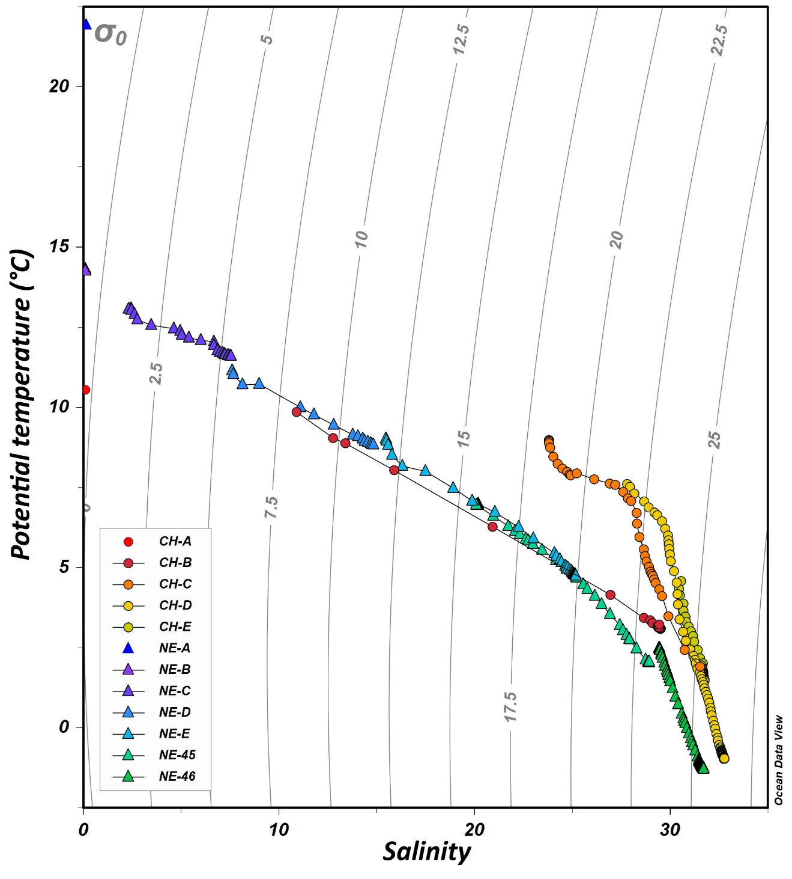
Figure S1. Potential temperature and salinity diagram of the Nelson and Churchill river waters. Grey lines are isopycnals with potential density anomalies in kg m^{–3}.

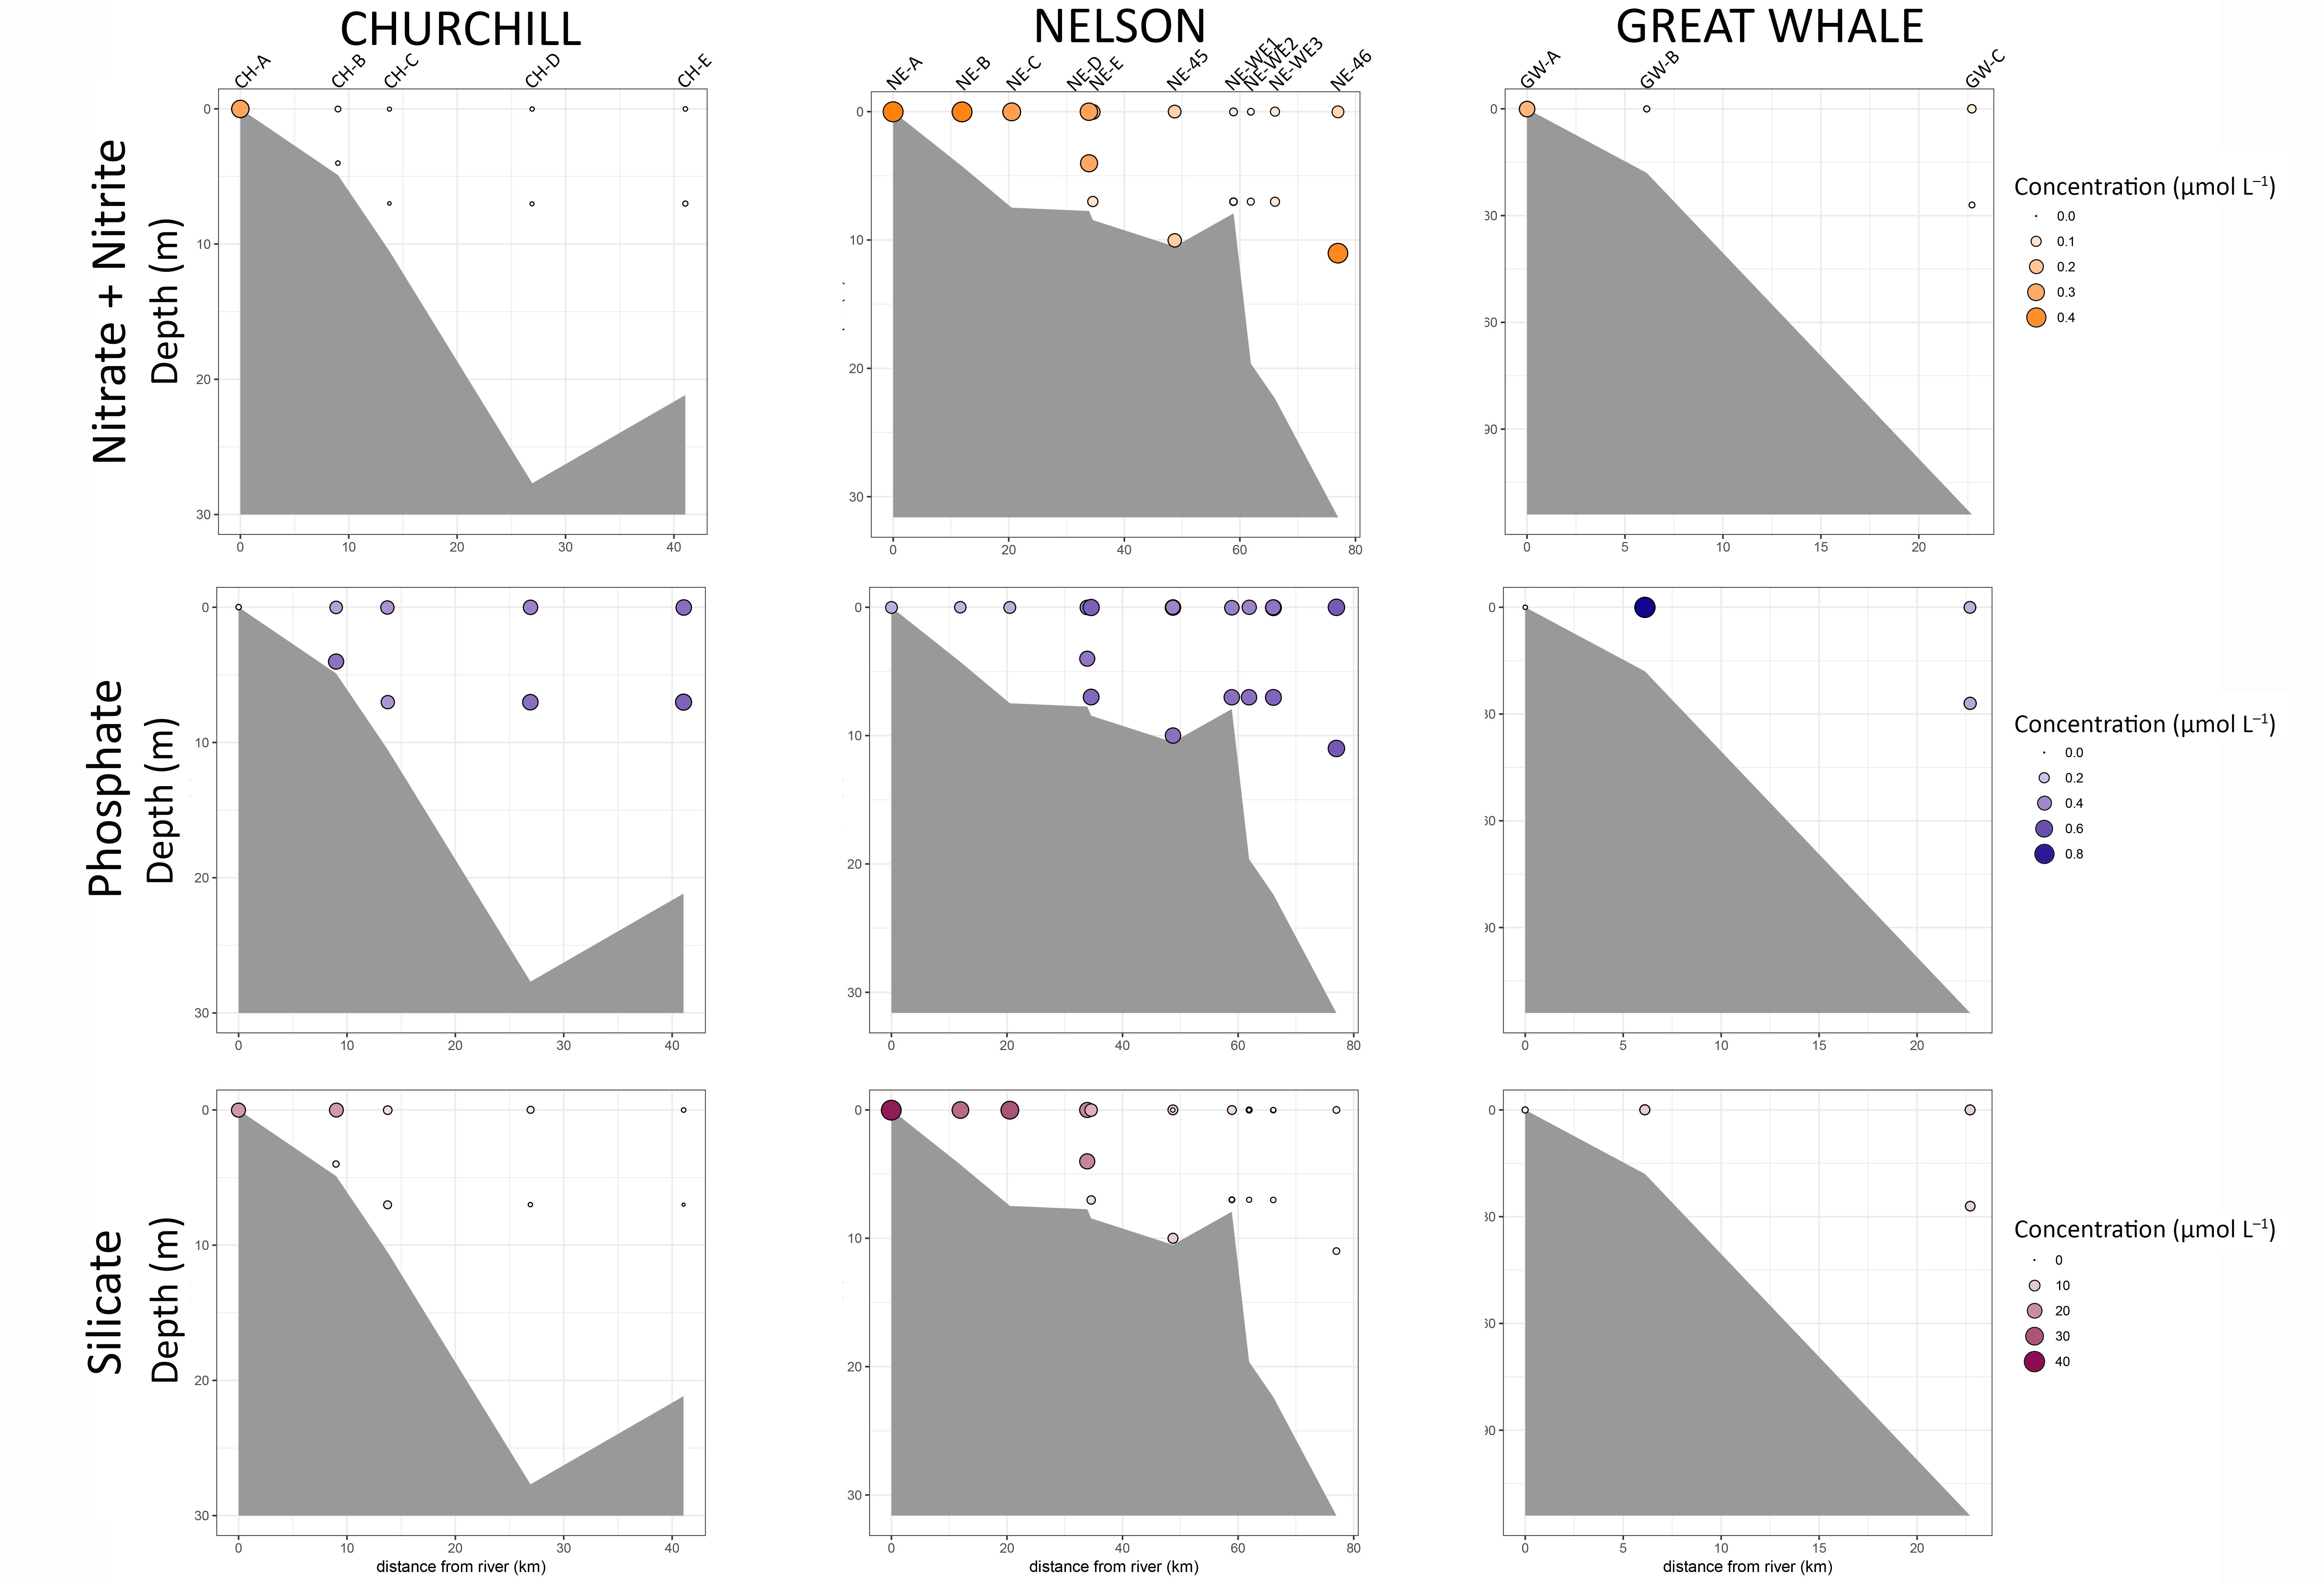
Figure S2. Nutrient concentrations along the Churchill, Nelson and Great Whale river systems.

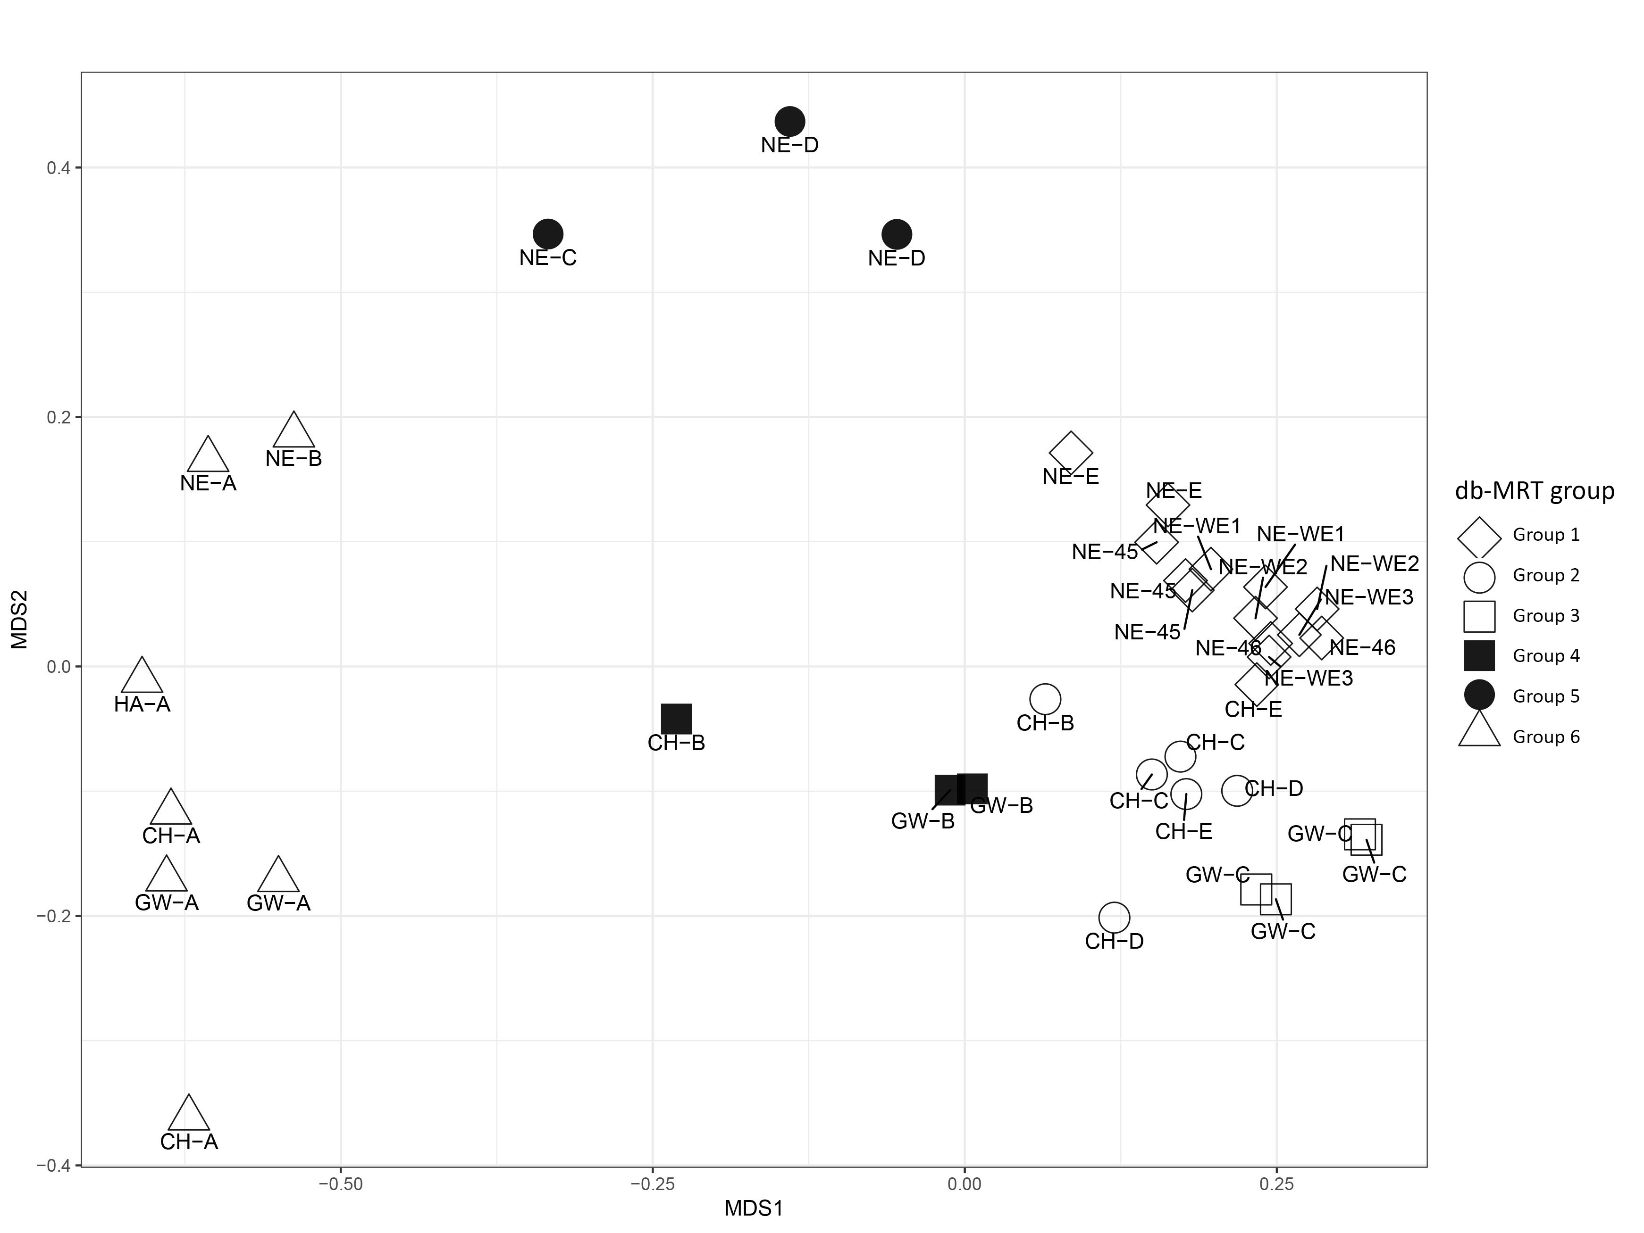Figure S3. Non-metric multidimensional scaling (NMDS) clustering of 37 stations along the three river systems. Clustering is based on a Bray-Curtis distance matrix of 6010 rDNA OTUs. Stress = 0.089. Symbols represent groups as defined in the db-MRT analysis (Figure 4).

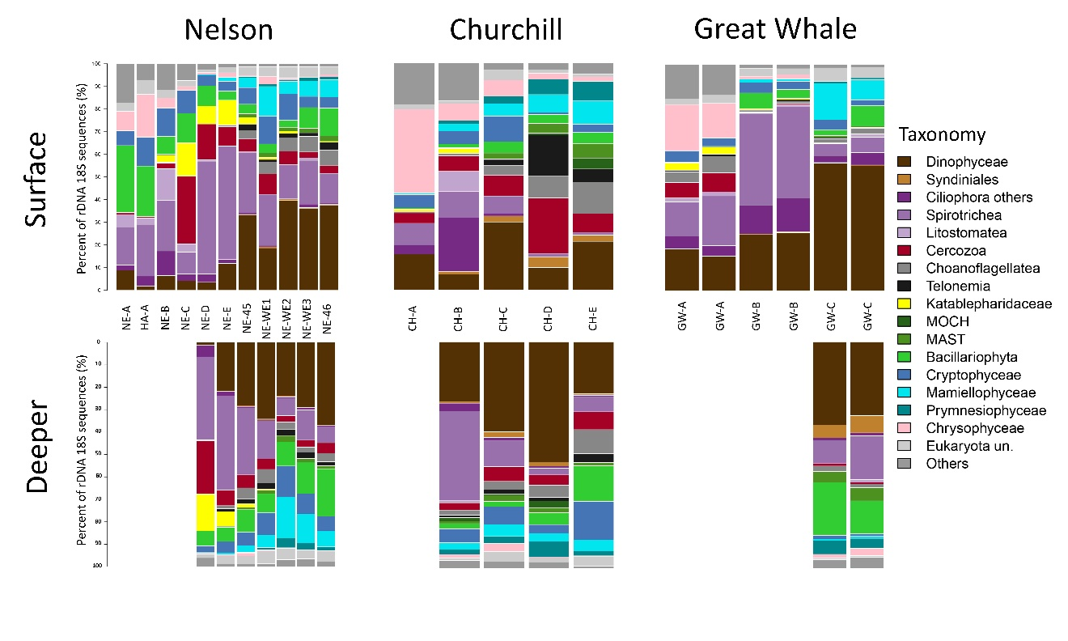
Figure S4. Proportion of rDNA 18S sequences along the transects of the Nelson, Churchill and Great Whale river systems.

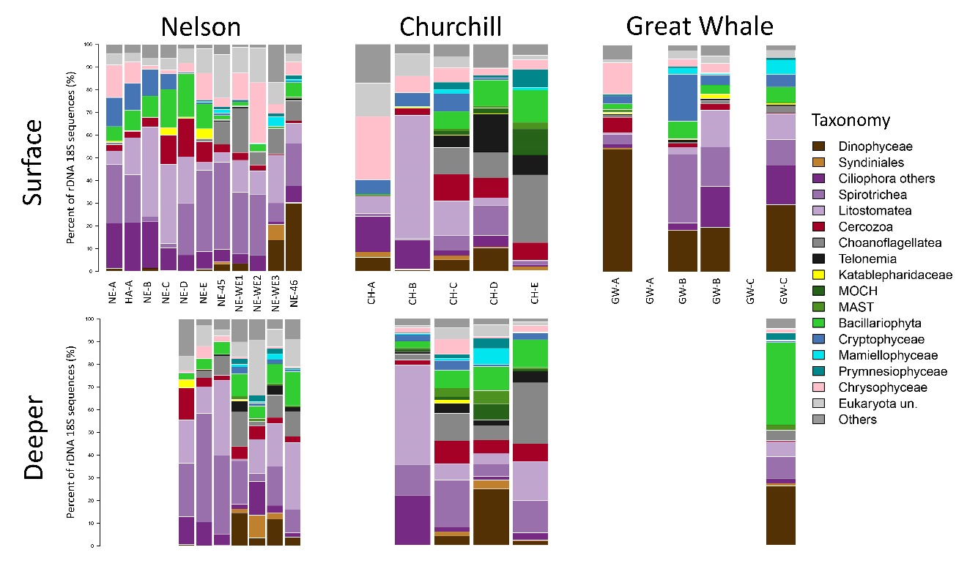
Figure S5. Proportion of rRNA 18S sequences along the transects of the Nelson, Churchill and Great Whale river systems.

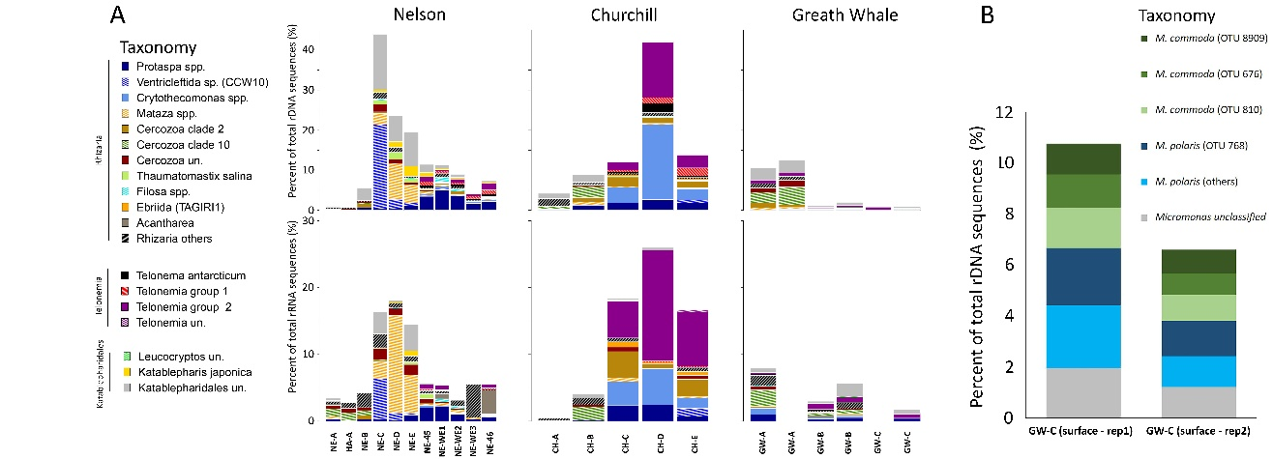
Figure S6. Proportion of 18S sequences at surface stations assigned to heterotrophic taxa and Micromonas OTUs. A) percent of rDNA (top panels) and rRNA (bottom panels) sequences of Rhizaria, Telonemia and Katablepharidales in the three river systems. B) Proportion of 18S rDNA sequences assigned to Micromonas at the offshore Great Whale River station (GW-C).

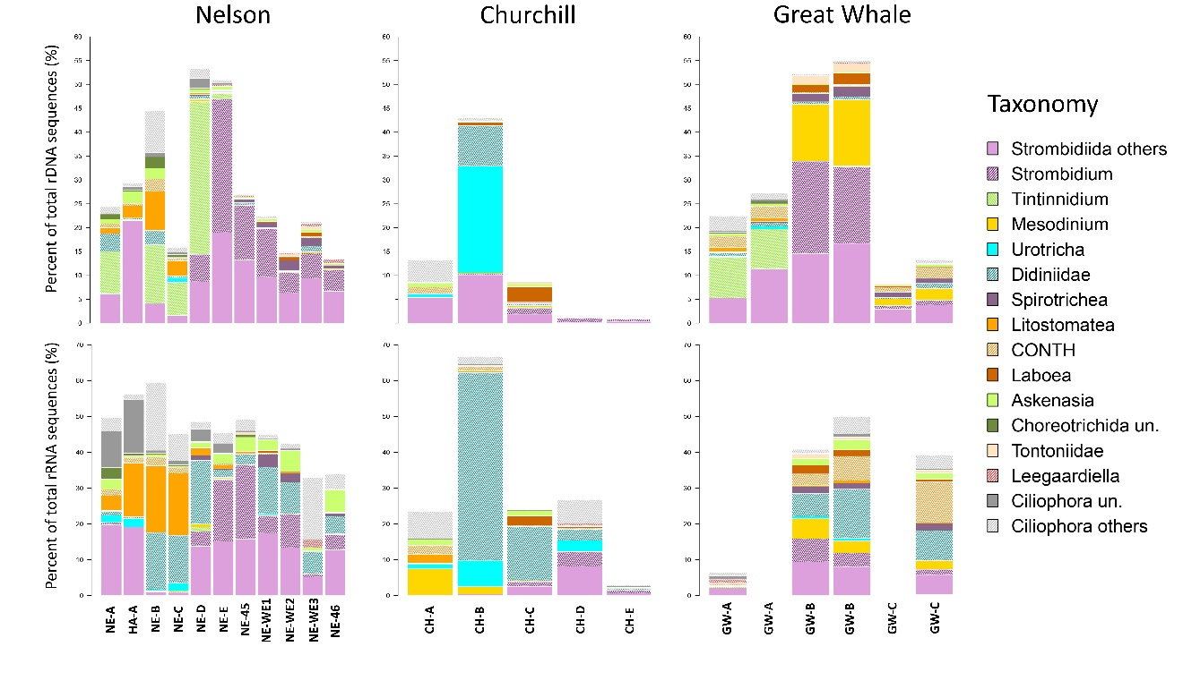Figure S7. Proportion of 18S rDNA and rRNA sequences at surface stations assigned to Ciliates in the three river systems.

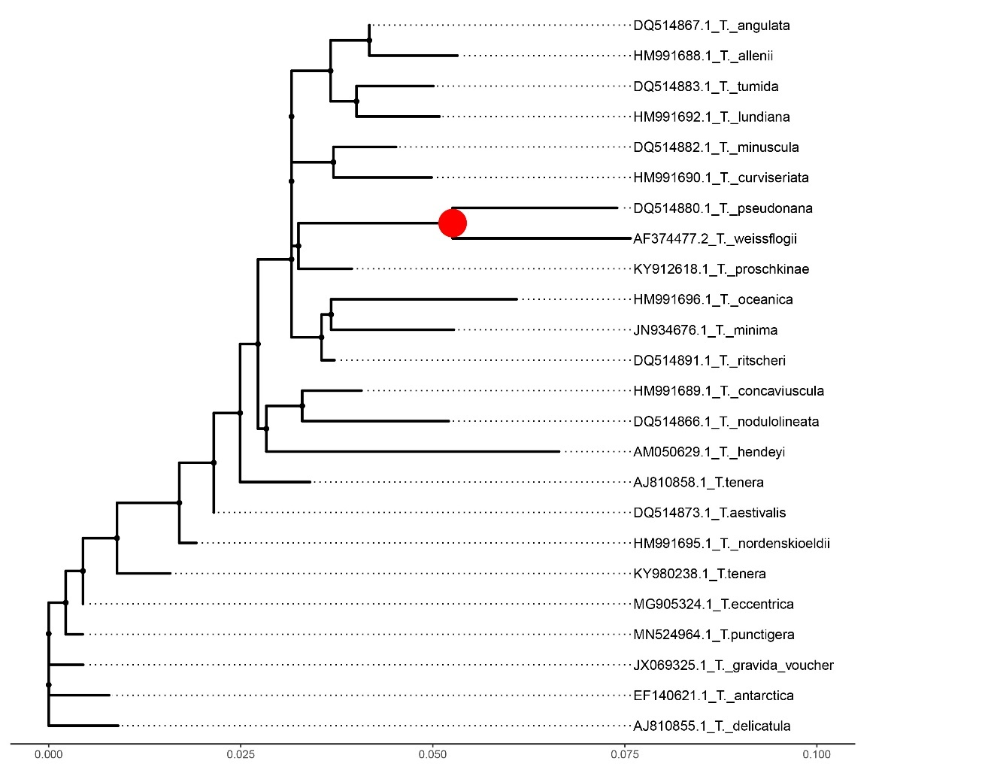
Figure S8. Phylogenetic mapping of the most abundant Thalassiosira reads. The reference phylogenetic tree was constructed using maximum likelihood from an alignment of 24 sequences of 1167 characters. Short V4 18S rRNA reads were mapped onto the node marked with a red circle using the RAxML evolutionary placement algorithm; five short reads sequences (OTU 36, 2229, 970, 3018 and 4558) were placed. Only placements with null uncertainty (EDPL value of 0) were plotted (here OTU 970).

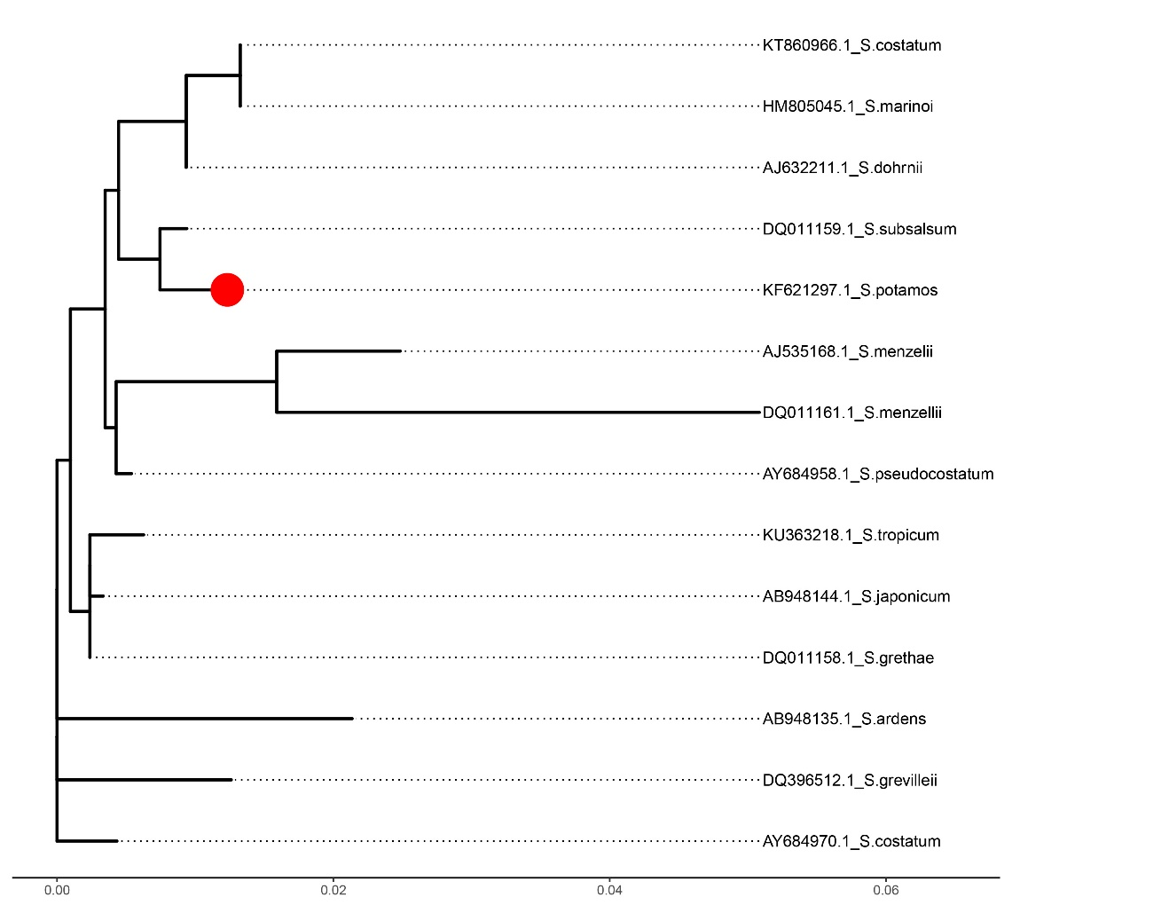
Figure S9. Phylogenetic mapping of the most abundant Skeletonema reads. The reference phylogenetic tree was constructed using maximum likelihood from an alignment of 14 sequences of 1161 characters. Short V4 18S rRNA reads were mapped onto the node marked with a red circle using the RAxML evolutionary placement algorithm; five short reads sequences were placed (OTU 3506, 2433, 643, 7273, 8016) on the same node (1). The five sequences had null uncertainty (EDPL value of 0) and were placed on the branch associated to S. potamos.

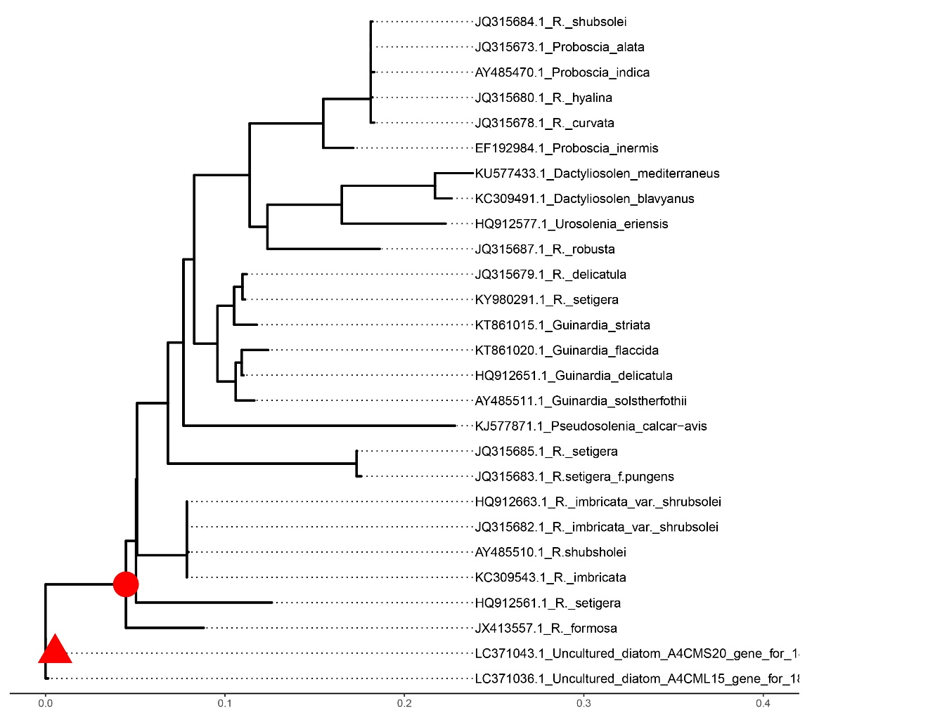
Figure S10. Phylogenetic mapping of the most abundant Rhizosolenia reads. The reference phylogenetic tree was constructed using maximum likelihood from an alignment of 25 sequences of 1182 characters. Short V4 18S rRNA reads were mapped onto the node marked with red symbols using the RAxML evolutionary placement algorithm; ten short reads sequences (OTU 184, 403, 14868, 145, 1962, 1595, 17969, 5788, 7592 and 2535) were placed. The red triangle symbol corresponds to the best placement of OTUs 184 and 17969 (EDPL < 0.003). The circle symbol correspondent to the other OTUs (OTU 403, 14868, 145, 1962, 1595, 5788, 7592 and 2535, EDPL = 0).

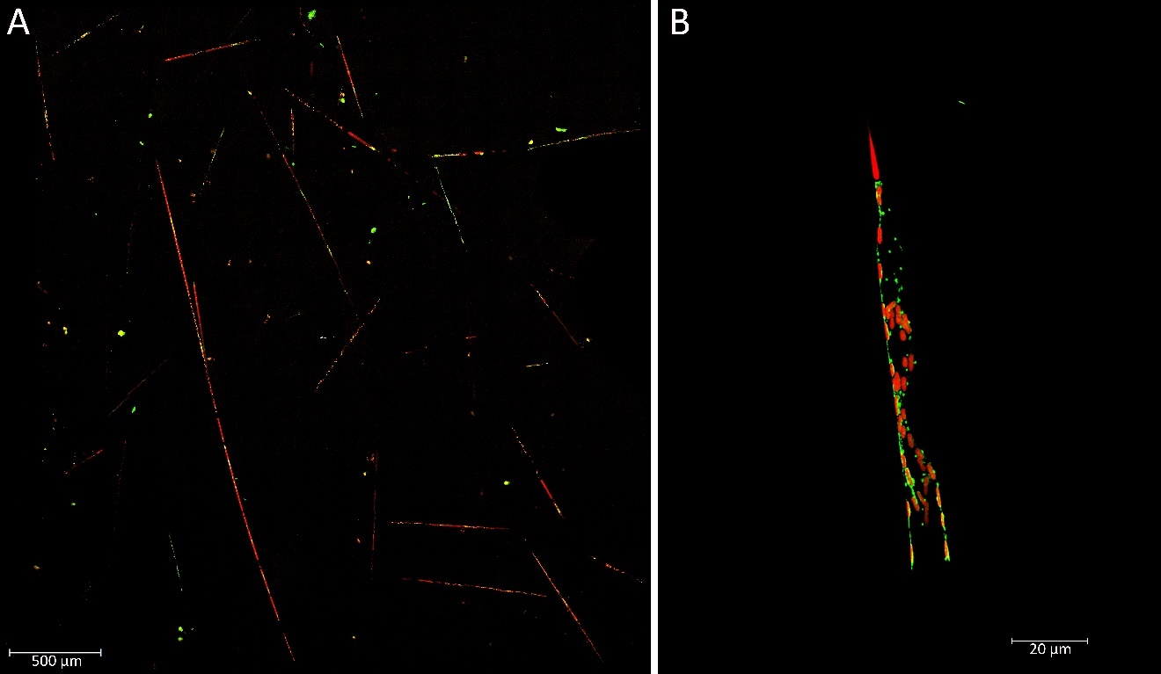
Figure S11. Rhizosolenia cells observed on confocal laser scanning microscope. Red color represents chlorophyll a under blue laser excitation (488 nm). (A) sample from station NE-45 bottom (magnification 40X, zoom at 1.28); (B) sample from station NE-WE1 bottom (magnification 40X, zoom at 1.69). Images credited to Marianne Potvin.

