Supplemental material

Multi-model inter-comparisons of air quality simulations for the KORUS-AQ campaign

Rokjin J. Park¹*, Yujin J. Oak¹, Louisa K. Emmons², Cheol-Hee Kim³, Gabriele G. Pfister², Gregory R. Carmichael⁴, Pablo E. Saide⁵, Seog-Yeon Cho⁶, Soontae Kim⁷, Jung-Hun Woo⁸, James H. Crawford⁹, Benjamin Gaubert², Hyo-Jung Lee³, Shin-Young Park³, Yu-Jin Jo³, Meng Gao¹⁰, Beiming Tang⁴, Charles O. Stanier⁴, Sung Soo Shin⁶, Hyeon Yeong Park⁶, Changhan Bae⁷, Eunhye Kim⁷
¹School of Earth and Environmental Sciences, Seoul National University, Seoul, South Korea
²Atmospheric Chemistry Observations and Modeling Lab, National Center for Atmospheric Research, Boulder, CO, USA
³Department of Atmospheric Sciences, Pusan National University, Busan, South Korea
⁴Center for Global & Regional Environmental Research, University of Iowa, Iowa City, IA, USA
⁵Department of Atmospheric and Oceanic Sciences and Institute of the Environment and Sustainability, University of California Los Angeles, Los Angeles, CA, USA
⁶Department of Environmental Engineering, Inha University, Incheon, South Korea
⁷Department of Environmental and Safety Engineering, Ajou University, Suwon, South Korea
⁸Department of Advanced Technology Fusion, Konkuk University, Seoul, South Korea
⁹NASA Langley Research Center, Hampton, VA, USA
¹⁰Department of Geography, Hong Kong Baptist University, Hong Kong SAR, China
*Correspondence to: Rokjin J. Park (rjpark@snu.ac.kr)

List of Contents:
Figure S1. Comparison of average vertical profiles of CO and O₃ mixing ratios from the lateral boundary conditions used in each model.
Figure S2. Comparison of mean diurnal profiles of observed (lidar) and simulated PBL height at Seoul National University (SNU; 37.46°N, 126.95°E) during the whole campaign period.
Figure S3. Comparison of simulated and observed mean vertical profiles of NO_{y} and its components (HNO₃, PAN, ANs) in the SMA (37-37.6°N, 126.6-127.7°E) during different synoptic conditions.
Figure S4. Model ensemble (background) and observed (overlaid circles) a) PM₁, b) secondary organic aerosol (SOA) concentrations, c) toluene, and d) HCHO mixing ratios along the DC-8 flight track averaged below 1.5 km in the SMA during the blocking period (June 1-10).
Figure S5. Comparison of simulated and observed mean PM_{2.5} chemical compositions in surface air at the Olympic park ground site (37.519°N, 127.122°E) for different synoptic regimes during the campaign.
Figure S6. Comparison of O₃ sonde observations at a) Olympic park, b) Taehwa research forest (37.280°N, 127.227°E), and c) 0-D photochemical boxmodel simulations along the DC-8 flight track in the SMA below 2 km.
Figure S7. Simulated CAM-Chem (magenta) O₃ mixing ratios during KORUS-AQ with stratospheric O₃ (blue) contributions.

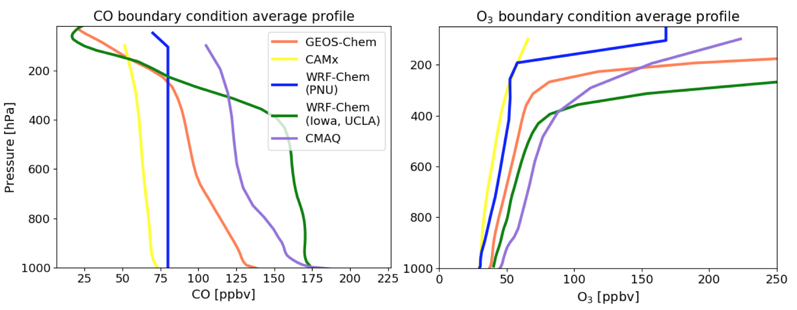Figure S1. Comparison of average vertical profiles of CO and O₃ mixing ratios from the lateral boundary conditions used in each model.
Sources of the lateral boundary conditions used in each model are presented in Table 1.
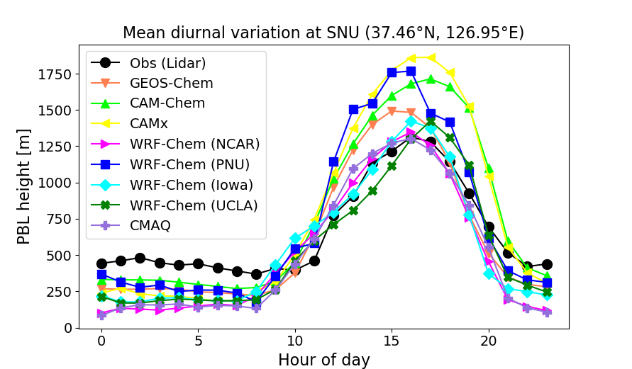Figure S2. Comparison of mean diurnal profiles of observed (lidar) and simulated PBL height at Seoul National University (SNU; 37.46°N, 126.95°E) during the whole campaign period.
Lidar backscatter profiles were observed and retrieved by Sang-Woo Kim (SNU) using the retrieval algorithm by Brooks (2003).

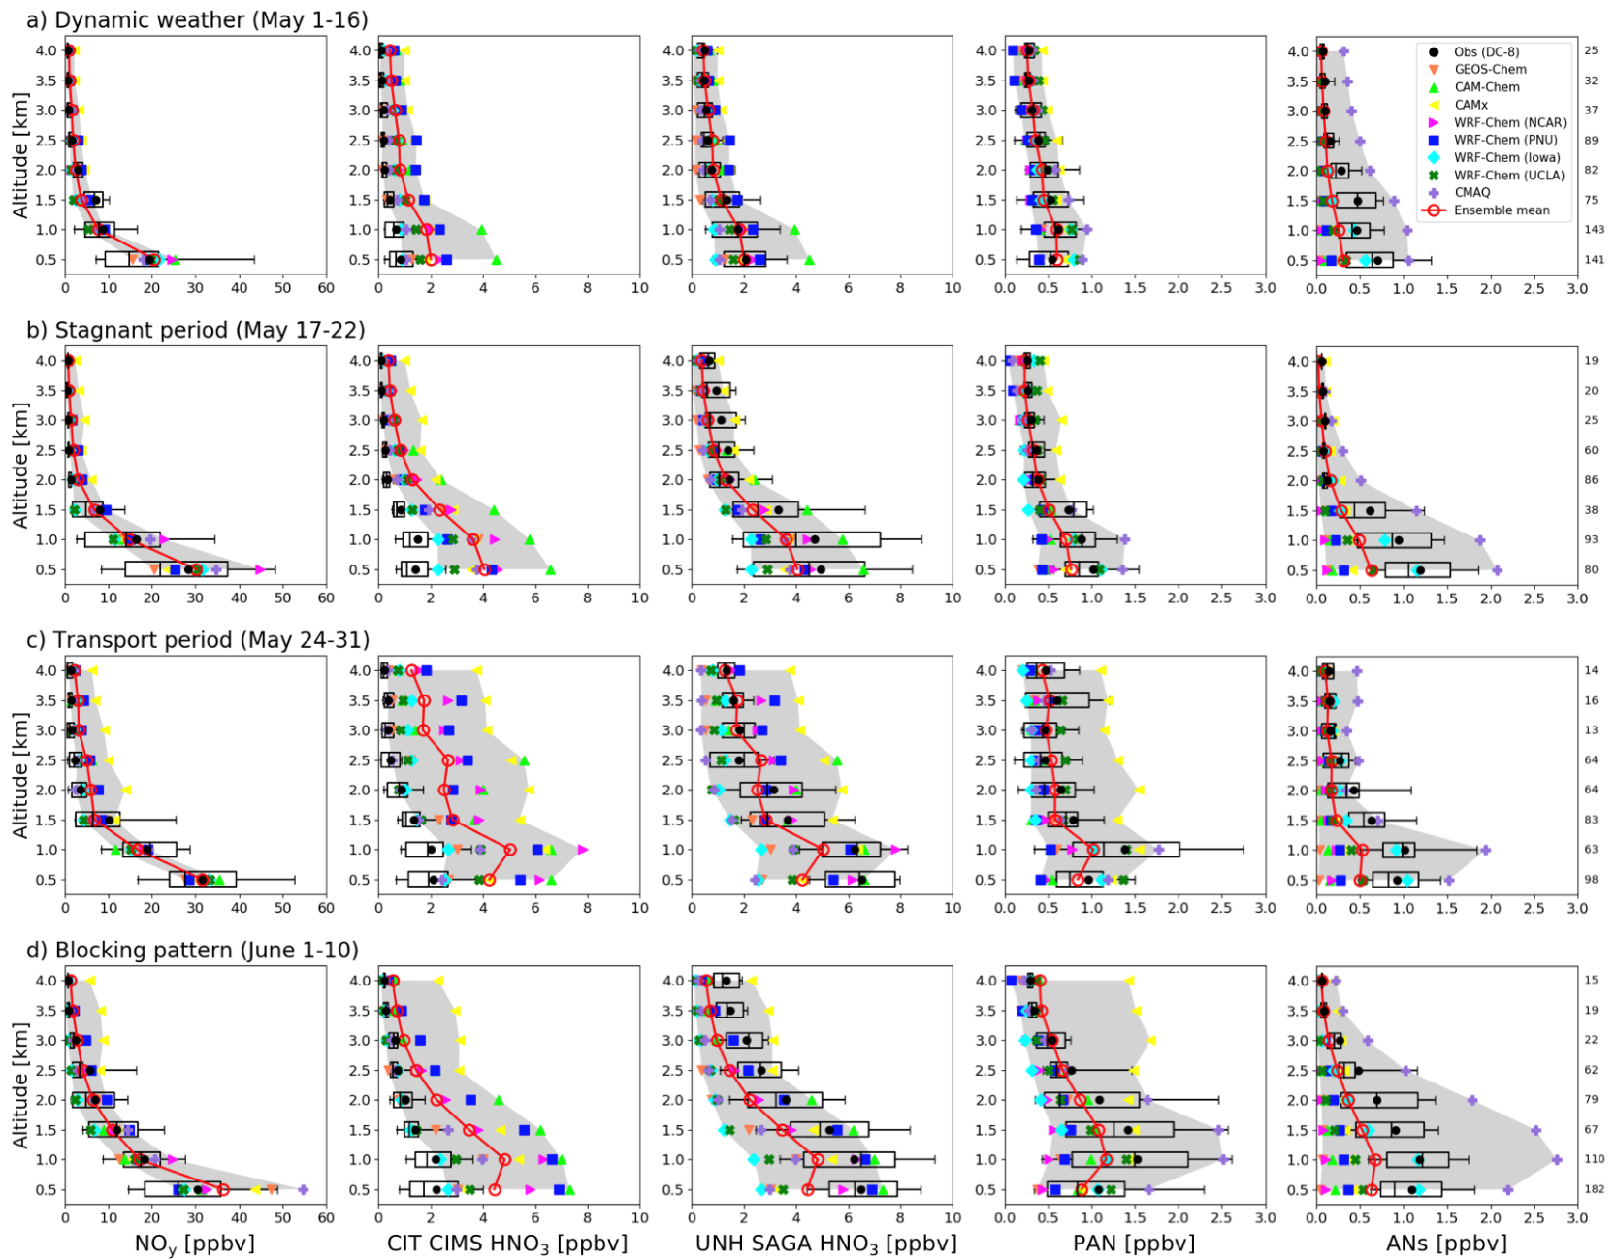
Figure S3. Comparison of simulated and observed mean vertical profiles of NO_{y} and its components (HNO₃, PAN, ANs) in the SMA (37-37.6°N, 126.6-127.7°E) during different synoptic conditions.
Boxplots and whiskers indicate the interquartile and 10-90 percentile ranges of observations. Vertical lines and closed black circles each indicate the median and mean values. Different colors represent the mean vertical profile of each model with solid lines in red indicating the model ensemble and model ranges in gray shades. HNO₃ mixing ratios measured by two different instruments (CIMS, SAGA) are shown for comparison. Data sampling and averaging methods are identical to Figure 7.

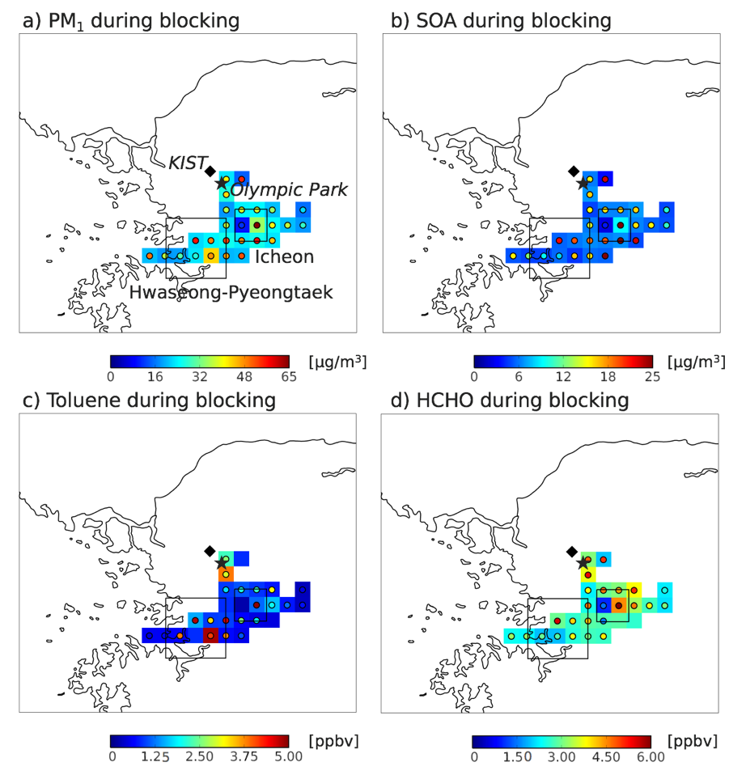
Figure S4. Model ensemble (background) and observed (overlaid circles) a) PM₁, b) secondary organic aerosol (SOA) concentrations, c) toluene, and d) HCHO mixing ratios along the DC-8 flight track averaged below 1.5 km in the SMA during the blocking period (June 1-10).
Squared areas indicate major industrial complexes (Hwaseong-Pyeongtaek and Icheon) in the Gyeonggi province. DC-8 observations and the ensemble model were gridded to 0.1º horizontal resolution.

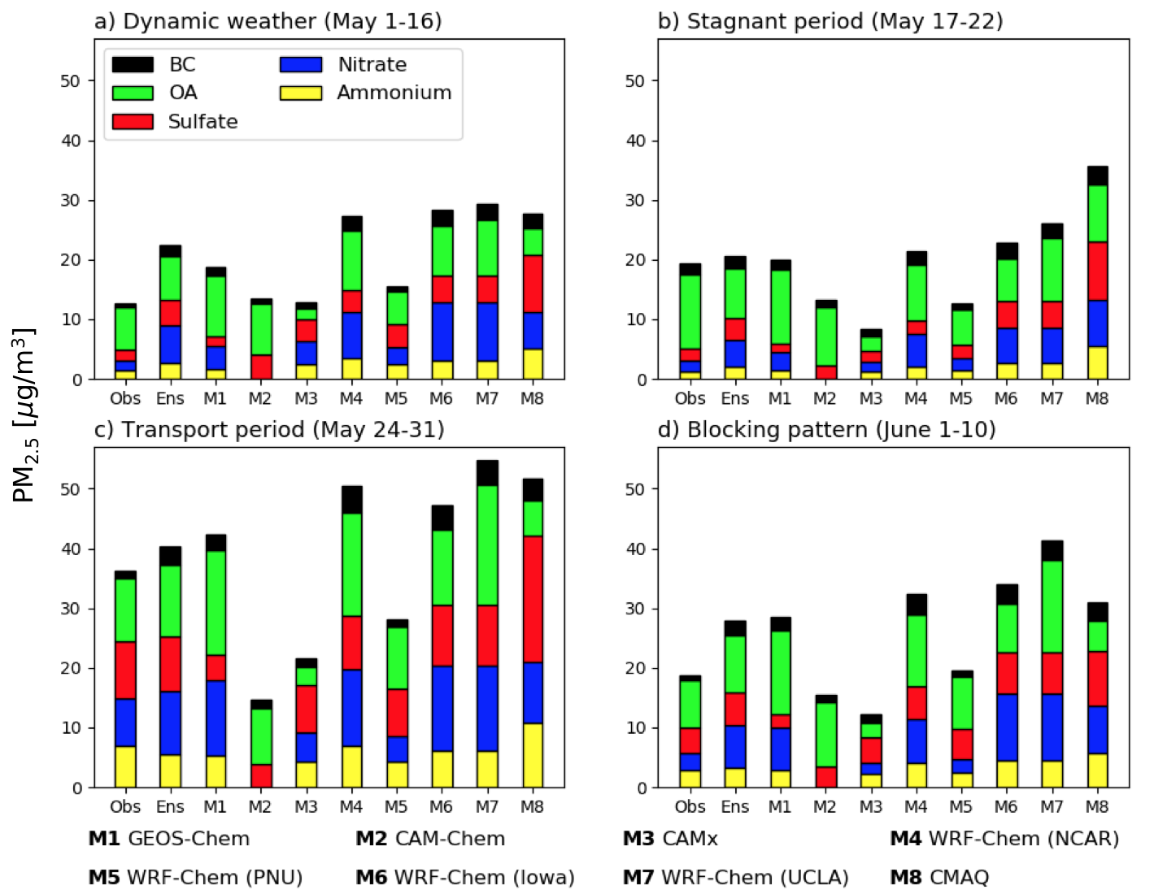
Figure S5. Comparison of simulated and observed mean PM_{2.5} chemical compositions in surface air at the Olympic park ground site (37.519°N, 127.122°E) for different synoptic regimes during the campaign.
Each chemical component is indicated in different colors and the observations are from the MARGA ADI2080 (DOGA Limited, Turkey) instrument for inorganic aerosols, and the OCEC Analyzer (Sunset Laboratory Inc., USA) for carbonaceous aerosols. We used OC/OM = 1.82 for calculating OA according to Kim et al. (2018). Model results from the lowest model layer were sampled coherently with the observations.

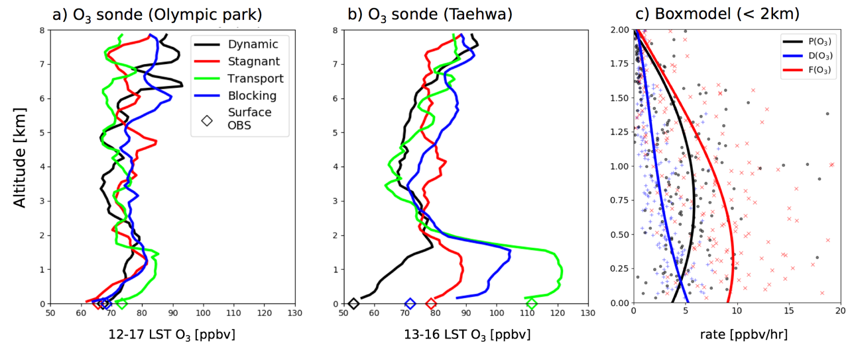
Figure S6. Comparison of O₃ sonde observations at a) Olympic park, b) Taehwa research forest (37.280°N, 127.227°E), and c) 0-D photochemical boxmodel simulations along the DC-8 flight track in the SMA below 2 km.
In a) and b) colors indicate different synoptic conditions and open diamonds indicate corresponding surface observations at each site. The NASA Langley Research Center (LaRC) 0-D observation-constrained photochemical boxmodel was used in c) to calculate the campaign average vertical distributions of simulated O₃ net production (black), destruction (blue), and formation (red) rates. Net O₃ production, P(O₃), is the difference between the formation rate, F(O₃), and destruction rate, D(O₃) (Schroeder et al., 2020). Simulated profiles were binned and averaged with 10 m intervals to retain the lowest aircraft altitudes and are displayed with different markers and colors for each variable. Solid lines indicate the 3rd degree least squares polynomial fit of each binned profile.

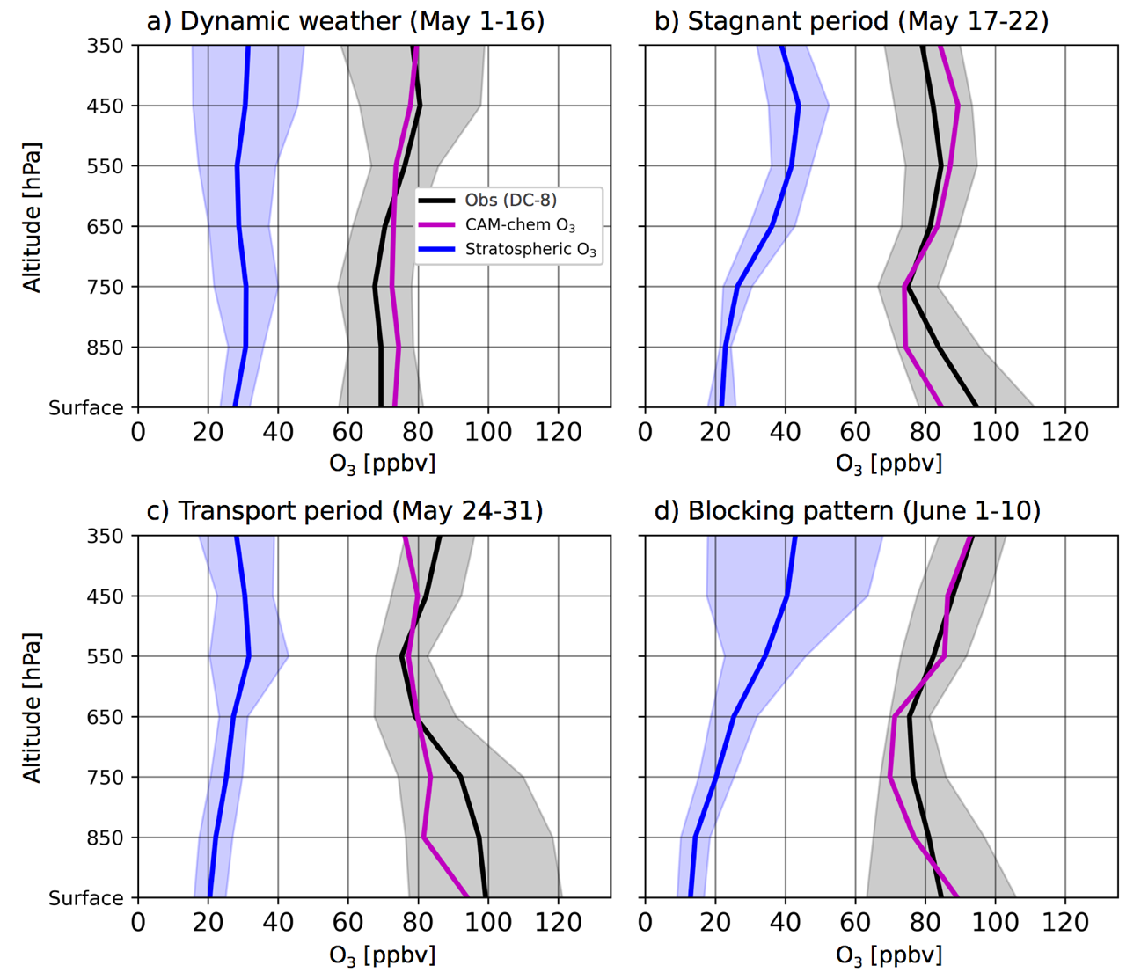
Figure S7. Simulated CAM-Chem (magenta) O₃ mixing ratios during KORUS-AQ with stratospheric O₃ (blue) contributions.
Stratospheric O₃ contributions are estimated using a tracer of stratospheric O₃ with tropospheric chemical loss and without dry deposition.

